(1) Propertion of pages with no inlinks (source nodes)

In file WG1: 0.003

In file WG2: 0.0780693212049

(2) Propertion of pages with no outlinks (sink nodes)

In file WG1: 0.006

In file WG2: 0.360016538727

(3)

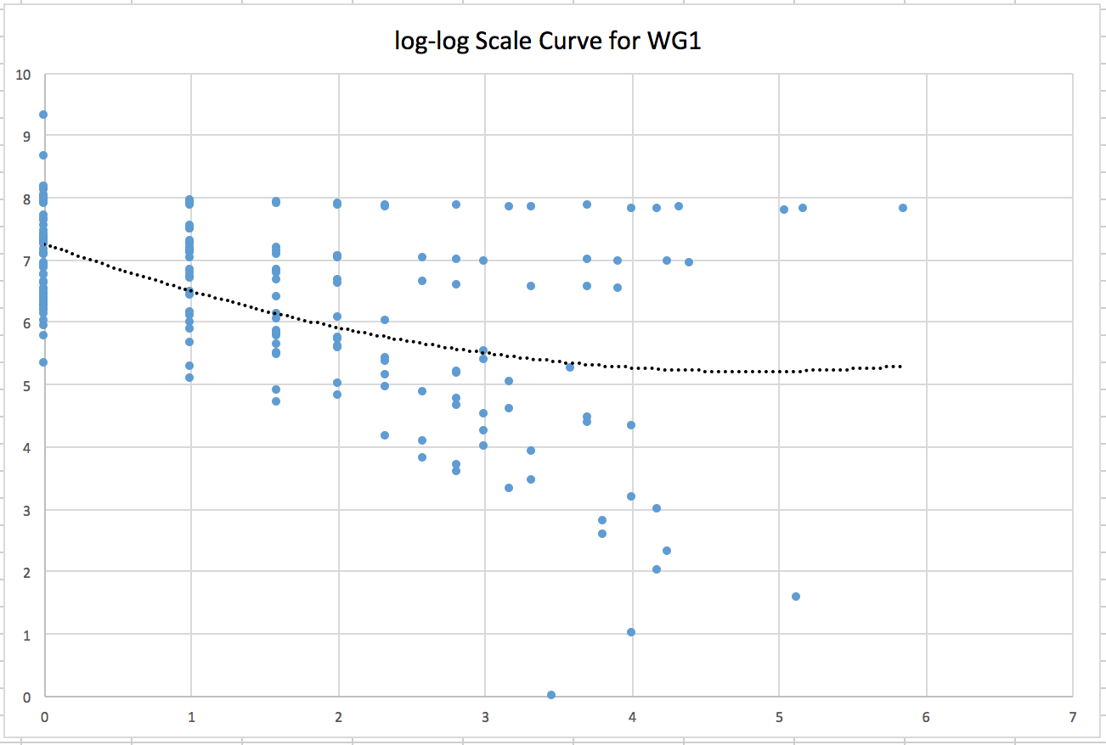

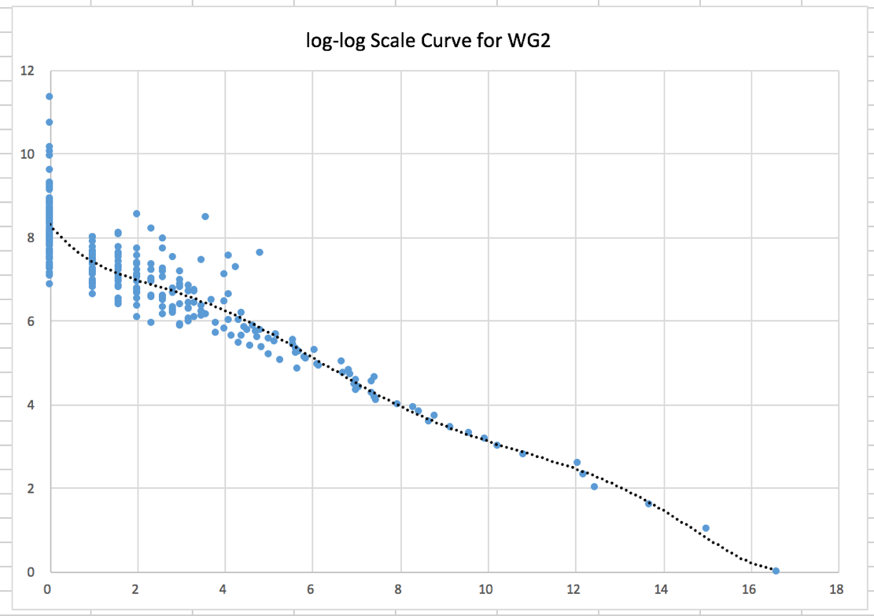

According to the trend line, we can find the curve for WG1 and WG2 follow Zipf’s law, that’s to say, they follow power-law distribution.