**Q1:**

**a)**

$∇_{u_{i}}RSE\left(U,V\right)=2\left({u_{i}}^{T}v_{j}-r_{ij}\right)v_{j}+2λu_{i}$

$$∇_{v_{j}}RSE\left(U,V\right)=2\left({u_{i}}^{T}v_{j}-r_{ij}\right)u_{j}+2μv_{j}$$

**b)**

$$l\left(u,v\right)={(u^{T}v-r)}^{2}$$

$$∇l\left(u,v\right)=2\left(uv-r\right)\left[\begin{matrix}u \\ v\end{matrix}\right]$$

$$∇^{2}l\left(u,v\right)=\left[\begin{matrix}2v^{2} & 4uv-2r \\ 4uv-2r & 2u^{2}\end{matrix}\right]$$

Suppose there’s a vector $x∈R$ and at u=v=0 we have

$${x^{T}∇}^{2}l\left(u,v\right)x=\left[\begin{matrix}x_{1} & x_{2}\end{matrix}\right]\left[\begin{matrix}0 & -2r \\ -2r & 0\end{matrix}\right]\left[\begin{matrix}x_{1} \\ x_{2}\end{matrix}\right]$$

$=-4rx_{1}x_{2}$

We don’t know if it’s greater or equal than 0. So l(u ,v) is not convex.

**c)**

If $∇_{u_{i}}RSE\left(U,V\right)=∇_{v_{j}}RSE\left(U,V\right)=0$

For all i and j, u* and v* would minimize the RSE but since RSE is not convex, u* and v* can only be the local minima instead of global minima.

**d)**

if ui = vj = 0 then

$∇_{u_{i}}RSE\left(U,V\right)=2\left({u_{i}}^{T}v_{j}-r_{ij}\right)v_{j}+2λu_{i}$ = 0

$∇_{v_{j}}RSE\left(U,V\right)=2\left({u_{i}}^{T}v_{j}-r_{ij}\right)u_{j}+2μv_{j}$ = 0

**Q2:**

**a)**

$$RSE\left(U^{k},V^{k}\right)=\sum_{δ_{ij}∈D}{{({δ_{ij}}^{k})}^{2}}+λ\sum_{i=1}^{n}{{{||{u_{i}}^{k}||}_{2}}^{2}}+μ\sum_{i=1}^{n}{{{||{v_{j}}^{k}||}_{2}}^{2}}$$

$∇_{u_{i}}RSE\left(U^{k},V^{k}\right)=2{δ_{ij}}^{k}{v_{j}}^{k}+2λ{u_{i}}^{k}$

$$∇_{v_{j}}RSE\left(U^{k},V^{k}\right)=2{δ_{ij}}^{k}{v_{j}}^{k}+2μ{v_{j}}^{k}$$

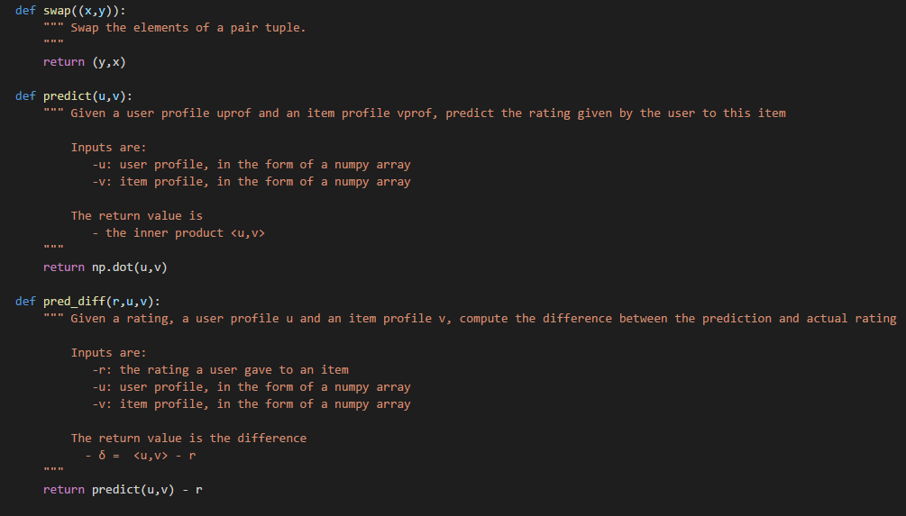**b)**

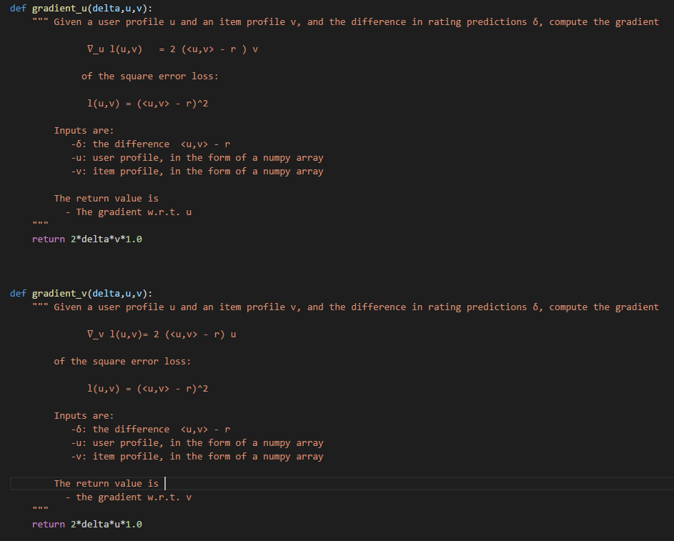

**c)**

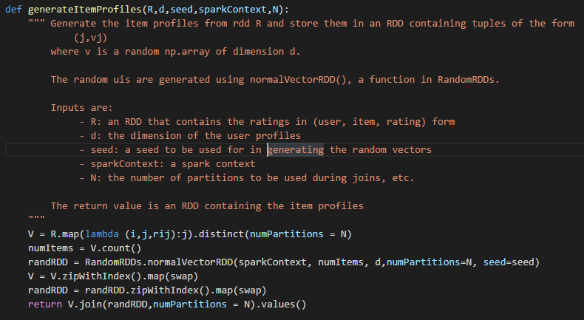

Since RSE is not convex so gradient descent would converge to a local minimum so the initial point can decide which local minimum to converge to. If we set all profiles to be zero. The gradient descent also converge to zero since zero is a stationary point so we would have no other information.

**Q3:**

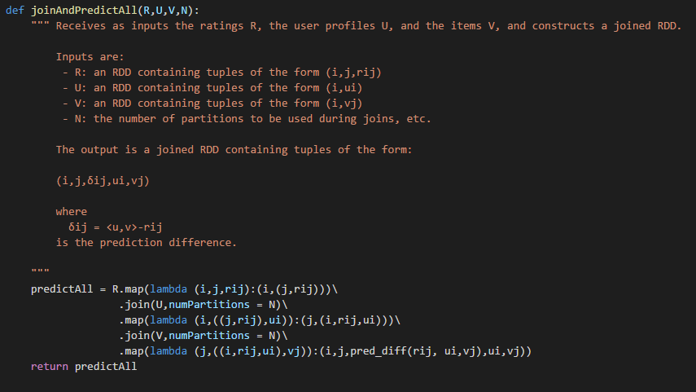**a)**

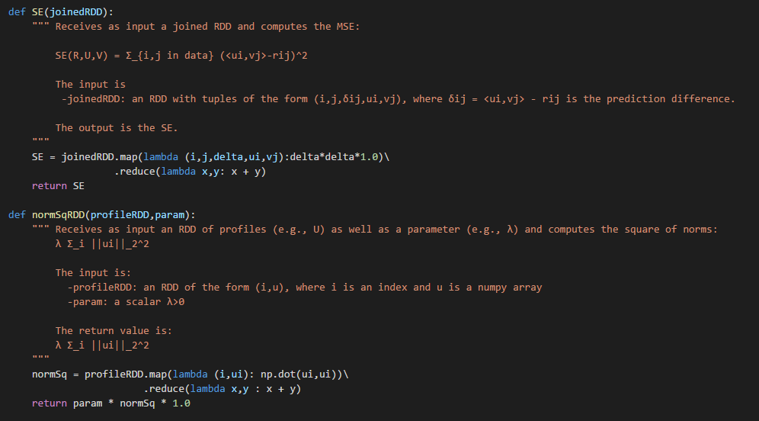**b)**

**c)**

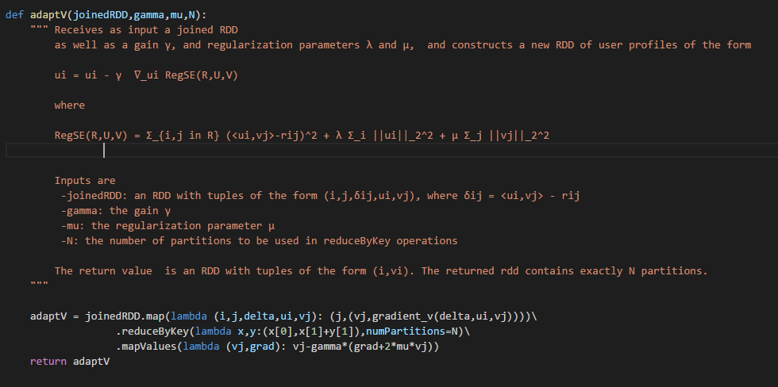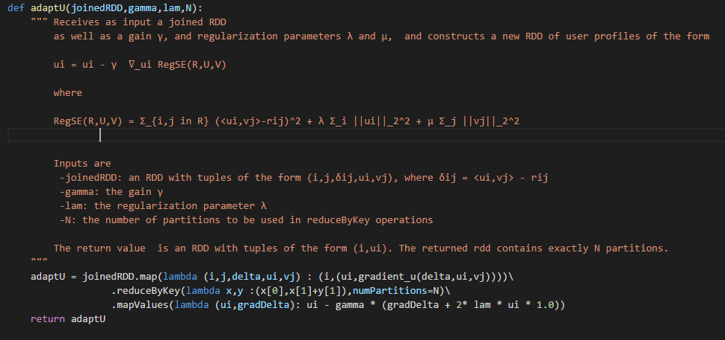

**Q4:**

**a)**

