Purpose :

Test of a single BOSEM with the Satellite box .
Easy way to connect the differential output of the satellite amplifier to a multimeter of oscilloscope.

Connection diagram
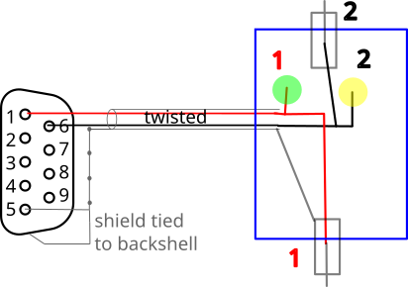

(blue is the box. )

Sub D 9 connector :
Adam Tech DE09-PD CONN D-SUB PLUG 9POS SLDR CUP , Digi key: 2057-DE09-PD-ND

shell :

MH Connectors MHDTZK9-RA-PC-K Description 9 WAY D-SUB HOOD DIE CAST TOP EN
digikey : 4672-MHDTZK9-RA-PC-K-ND

cable ~2m :
Alpha Wire 5471C SL033

box and connectors stock material not specified

