SiPm Amplifier to Atlys board connection

Table of Contents
1 Documentation information 1
1.1 Documentation history 1
1.1.1 published versions 1
1.2 document status 1
1.3 related documents 2
2 introduction 2
3 Connections 2
3.1 Connection overview 2
3.1.1 SiPm Amplifier signal connector 2
3.2 Atlys PMOD JB 2
3.3 pinning I2C cable ( gray one) 2
3.4 I2C connection 3
3.5 Signal connections 3

Documentation information

Documentation history
published versions are not consecutive
Version 4 Last saved 10. Apr. 2026 14:09 Wim Beaumont

published versions
No published versions

document status
Not released
Internal use but can be shared only after the document is released
for discussion
should not contain any private or sensitive information

related documents

orginal PCB design is on the EDF project dir projects\pcbs\SiPm_student

introduction

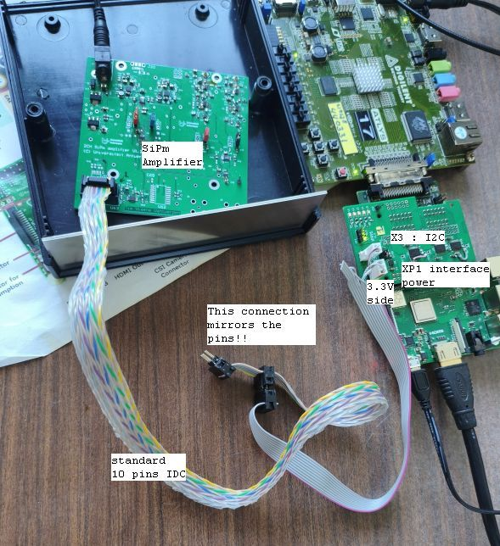
Connections

Signal Connection overview

SiPm Amplifier signal connector
Pin numbers as in the schematic
1 SCL 2 SDA
3 VI2C Ext (3.3V) 4 Trigger 0 (not used)
5 Trigger 1 (not used) 6 GND
7 LVDS1- 8 LVDSS0+
9 LVDS1+ 10 LVDS0-
Make sure that pin 5 will not be connected to the GND of the Atlys PMOD connector

Atlys PMOD JB
Pin numbers as in schematic ATLYS
( FPGA net name ) [logic name ]
1 JA1 not used 7 JA7 not used
2 JA2 not used 8 JA8 not used
3 JA3 (P6) [PextN(0) ] 9 JA9 (V4) [PextN(1)]
4 JA4 (N5) [PextP(0)] 10 JA10 ( T4) [PextP(1)]
5 GND 11 GND
6 VCCB2 12 VCCB2
SiPm signal to Atlys
SiPm Atlys
5 nc x
7 LVDS1- 10 PextP(1)
9 LVDS1+ 9 PextN(1)
8 LVDS0+ 4 PextP(0)
10 LVDS0- 3 PextN(1)

pinning I2C cable ( gray one)
To be done

I2C connection
Put the I2C bus voltage on 3.3 V ( in the SiPm Amp is a 3.3V to 5V translator ) :
jumper on X3 pin 1 and 2 , ( Pin1 is where X3 is printed) .
connect the 3 pins molex connector to XP1 . 3.3V , red on the cable connector , is at the corner side of the PCB.

Signal connections
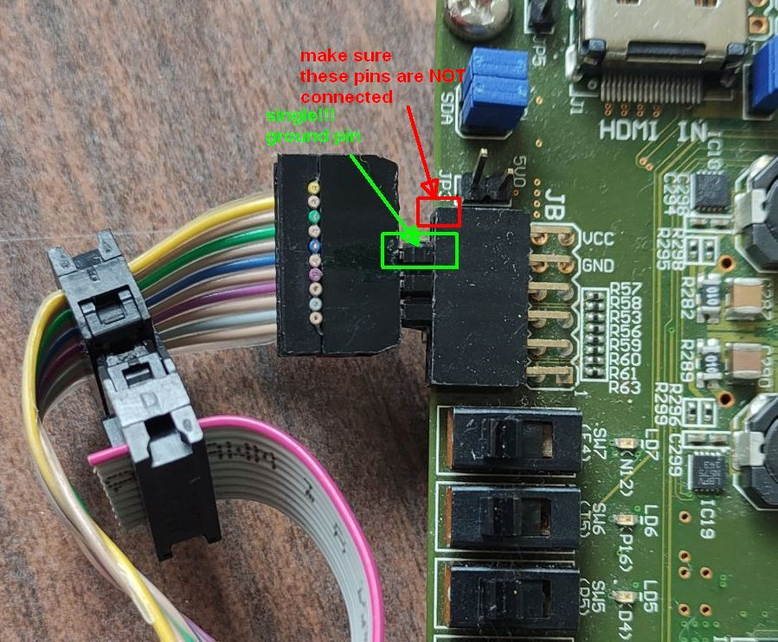
The LVDS output signals of the SiPm amplifier have to be connected to the LVDS inputs of the PMOD of the Atlys board.

