

WEATHER INFORMATION MANAGEMENT OF EAST AFRICA

WEATHER INFORMATION DISSEMINATION SYSTEM – [WIDS]

GROUP MEMBERS:

|  |  |  |
| --- | --- | --- |
| STUDENT NAME | REGISTRATION NUMBER | STUDENT NUMBER |
| KITENDA RAYMOND | 14/U/8066/EVE | 214005087 |
| KAMIRA MOSES | 14/U/23265/EVE | 214023761 |
| MUTANO SETH | 14/U/10115/EVE | 214005098 |
| SSENDAWULA STELLA | 14/U/14932/EVE | 214008697 |

Lab Section: Workstation: **WIMEA LAB**

04/ 05/2018

**TABLE OF CONTENT**

1. INTRODUCTION. 1

1.1 Purpose. 1

1.2 Scope. 2

1.3 Overview. 3

1.4 Reference Material. 4

1.5 Definitions and Acronyms. 5

2. SYSTEM OVERVIEW. 6

3. SYSTEM ARCHITECTURE. 9

3.1 Architectural Design. 9

3.2 Decomposition Description. 12

3.3 Design Rationale. 13

4. DATA DESIGN. 14

4.1 Data Description. 14

4.2 Data Dictionary 15

5. COMPONENT DESIGN. 17

5.1 The Login component. 17

5.2 View Forecast component 18

5.3 Create Advisory component. 19

5.4 View Advisory component 20

5.5 View Parameter Visualization component 21

5.6 Send Alert component 22

5.7 Create Feedback component 23

6. HUMAN INTERFACE DESIGN. 24

6.1 Overview of User Interface. 24

6.1.1. The WIDS Web Pages in a Tree Structure. 24

6.2 Screen Images. 26

6.3 Screen Objects and Actions. 29

7. REQUIREMENTS MATRIX. 32

8. APPENDICES 33

**LIST OF FIGURES**

Figure 2.1: Block Diagram for an Overview of the Weather Information Dissemination System 8

Figure 3.1: Component Model for Weather Information Dissemination System 9

Figure 3.2: Use case Diagram for Weather Information Dissemination System. 10

Figure 3.3: Complete Package Diagram for Weather Information Dissemination System. 12

Figure 4.1: Class Diagram for the Weather Information Dissemination System 14

Figure 5.1: Sequence Diagram for Login 17

Figure 5.2: View Forecast component 18

Figure 5.3: Sequence Diagram for Create Advisory component 19

Figure 5.4: Sequence Diagram for View Advisory component 20

Figure 5.5: Sequence Diagram for View Parameter Visualization component 21

Figure 5.6: Sequence Diagram for Send Alert component 22

Figure 5.7: Sequence Diagram for Create Feedback component. 23

Figure 6.1: Navigation through the WIDS’ User Interface. 25

Figure 6.2: Screen shot of a Map window 26

Figure 6.3: Screen shot for Search feature 27

Figure 6.4: Screen shot for Login feature 27

Figure 6.5: Screenshot of an Advisory window 28

Figure 6.6: Scheme of Weather Information Dissemination System Objects and Actions 31

**LIST OF TABLES**

Table 1.1: Definition and Acronyms 5

Table 3.1: Description of the Use Cases in the Weather Information Dissemination System 11

Table 4.1: Data Dictionary 15

Table 7.1: Requirements Matrix 32

# INTRODUCTION.

This Software Design Document presents the designs that shall be used in implementing the Weather Information Dissemination System (WIDS) for Uganda National Meteorological Authority.

The system is intended to automate the weather information dissemination process at UNMA.

The designs described follow the requirements specified in the Software Requirements Specifications document prepared for this particular project.1

## Purpose.

The purpose of this Software Design Document (SDD) is to present a detailed description of the designs of the Weather Information Dissemination System (WIDS), to be developed for Uganda National Meteorological Authority (UNMA).

The WIDS shall provide real-time weather forecast information and provide advisories to sector stakeholders in Agriculture including farmers, Farmers’ Associations and extension workers through the use of a live map. The other sectors to which the system can easily be extended include; Construction and Disaster Management sectors together with the interested general public.

Besides the end users that shall need this document to keep track of whether requirements are met and consistent, this document is also intended for use by the programmers under the WIMEA-ICT project, equally, this particular document could be used by designers who try to upgrade or modify the design of the WIDS.

Lastly, this document is also intended for use by other audience that include; Project Manager that needs to coordinate and monitor the progress of the software development process, Project Testers that shall test the system whether the implementation meets the specifications and Project Stakeholders that include; UNMA and the WIMEA-ICT project team.

## Scope.

The Weather Information Dissemination System shall be a web based system intended to automate the weather dissemination process at UNMA.

The WIDS shall interact with the Weather Research and Forecast (WRF) model which carries out weather forecasting and modeling and contains the data that will be required by the Weather Information Dissemination System as its input.

The WIDS is proposed for use in Uganda and shall be managed by Uganda National Meteorological Authority. It shall be used by stakeholders in Agriculture sector that include the farmers, Farmers’ Associations and their extension workers to access real time weather forecast information and advisories. The other sectors to which the system can easily be extended include; Construction, Disaster Management sectors etc.

Furthermore, the system shall interface with Google maps to fetch forecast data for specific locations and display results to the user. System information shall be maintained in a database located on a web-server.

* + 1. Goal of the project.

The goal of this project is to provide a fully implemented and functional Weather Information Dissemination System (WIDS) that shall automate the weather dissemination process at UNMA.

* + 1. Objectives of the project.

Main Objective:

1. To develop the Weather Information Dissemination System (WIDS) that is intended to automate the weather dissemination process at UNMA.

Specific objectives:

1. To provide a platform that shall enable the administrator to send alerts of extreme weather conditions to relevant system users.
2. To provide real time daily, dekadal and seasonal forecasts and advisories to stakeholders.
3. To provide a platform for users to submit feedback to UNMA.
4. To provide a platform for users to access and or share real time weather forecast information and advisories to other platforms like social media such as Facebook, twitter, whatsapp etc.
   * 1. Benefits of the project.

Some of the benefits of the project include;

1. Easier access to real-time forecast information as users shall be able to access the system using their computers and mobile devices from anywhere and at any time.
2. Reduced loss of lives especially through timely warnings of extreme weather conditions through the disaster preparedness sector.
3. Reduced economic damages to users’ economic activities such as those in Agriculture sector where most activities depend on weather patterns. Any misleading information may lead to poor decision making on whether to carry out an activity or not thereby affecting the economy of stakeholders in that particular sector.
4. Increased productivity in Agriculture sector due to the increased accuracy and timeliness of the availed seasonal forecast information and advisories.
5. Farmers, their associations and extension workers shall be provided with advisories and their impacts that can be used to inform their long-term decision making.
6. Increased number of informed people and integration of the youth into the activities carried out by the meteorological authority as users shall be in position to share weather forecast information and advisories to other platforms like social media.

## Overview.

In this Software Design Document, a detailed design of the Weather Information Dissemination System with user interfaces together with system implementation is described. The document is written according to the standards for Software Design Documentation explained in “IEEE Recommended Practice for Software Design Documentation”. 2

This SDD is divided into chapters that include;

1. Chapter 1: Introduction. This chapter covers the purpose of the SDD, Scope of the project and the Overview of the SDD.
2. Chapter 2: System Overview. This chapter gives a general description of the functionality, context and design of the project.
3. Chapter 3: System Architecture. This chapter covers the Architectural design, Design Decomposition and the Design rationale for the WIDS.
4. Chapter 4: Data Design. This chapter provides the description of the data and the data dictionary.
5. Chapter 5: Component Design. This chapter provides a closer look at what each component of the WIDS does in a systematic way.
6. Chapter 6: Human Interface Design. This chapter covers an overview of user interface, providing screen images together with screen objects and actions.
7. Chapter 7: Requirements Matrix.

## Reference Material.

The user of this SDD may need the following documents for reference:

[1] BSE 18- 27, 2017. Software Requirements Specification document, WEATHER INFORMATION DISSEMINATION SYSTEM – [WIDS]. Last modified: 24th/11/2017.

[2] IEEE Recommended Practice for Software Design Documentation

[3]Mokhov, S. (2010). Selected Project Requirements. In Concordia. Retrieved from http://users.encs.concordia.ca/~c55414/selected-project-requirements.txt

[4]XML Legal Documents Utility Software Development Plan, Version 1.0, Last Updated on 2007-01-3

## Definitions and Acronyms.

Table 1.1: Definition and Acronyms

|  |  |
| --- | --- |
| **TERM** | **DEFINITION** |
| User | Someone who interacts with the system. |
| Stakeholder | Any person who has interaction with the system who is not a developer |
| **ACRONYM** | **EXPLANATION** |
| SDD | Software Design Document |
| SRS | Software Requirements Specification |
| UNMA | Uganda National Meteorological Authority. |
| WIDS | Weather Information Dissemination System. |
| WIMEA | Improving East Africa’s Weather Information Management through the Application of Suitable ICTs. |
| WRF | Weather Research and Forecasting model |
| **ABBREVIATION** | **MEANING** |
| Admin | Administrator |
| Agric | Agriculture |

# SYSTEM OVERVIEW.

Due to the delays involved in creating and disseminating weather information to different sectors in Uganda, the project team decided to develop the Weather Information Dissemination System that is intended to automate the weather dissemination process. This shall involve creating a link between the modelling software and the dissemination tools in order to smoothen the provision of weather forecast information and advisories to stakeholders in Agriculture sector that include the farmers, Farmers’ Associations and their extension workers through the use of a live map that shall provide this information to exact locations on the map. Some other sectors to which service may be extended include the Construction and Disaster Management sector.

The WIDS consists of three major components that include; the Modelling, Conversion and Dissemination component together with a Database for data storage. It shall be built using an MVC design pattern from the Code Igniter framework and the computer for use during development shall be equipped with web browser such as internet Explorer, Mozilla and Google Chrome for preview of any system changes implemented.

The product shall be accessed and used only in the presence of an internet connection.

The web version of the Weather Information Dissemination System will be supported by browsers such as Mozilla Firefox, Google chrome and many more, working on most operating systems and accessible through any laptop and desktop, and other mobile computing device that is connected to internet.

The Dissemination Process:

A brief description of the dissemination process through the different components of WIDS include;

The WRF model is run at a particular point in time in order to make predictions of weather conditions including seasonal weather forecast modelling.

The data that is produced by the WRF model includes parameters that are non-vital to the process of coming up with advisories to various sectors therefore the Conversion or Filtering component contains a script that does the extraction of the vital parameters needed to provide accurate information to the different sectors. The data formats produced by the WRF model are; a) 6 hour weather forecast information on over 20 weather parameters including; convectional rainfall, non-convectional rainfall, temperature, humidity, etc.

b) Cumulative figures on the totals of the different weather parameters spread out over a period of a week.

This information is parsed with no formatting and no order and in a cumulative total format. This means that calculations have to be done to convert the cumulative numbers to the actual parameter figures of the specific day and the data needs to be formatted to extract only the parameters necessary to provide relevant information to the stakeholders. Such required and relevant parameters can include the average rainfall expected over the period of a week, the zones or locations that are to experience the conditions and well-formatted and organized information that can be used in the visualization process.

After the filtering and extraction is done, the default advisories for different sectors are then generated depending on the extracted results from the forecast model and are sent to the database after which the dissemination subsystem will relay them to the relevant stakeholders. These advisories are accompanied by the descriptions of the forecasted results and visualizations of the outlook of the seasons in terms of weather parameters like temperature and rainfall as predicted by the WRF model.

Figure 2.1 below shows a Block Diagram for an Overview of the Weather Information Dissemination System.

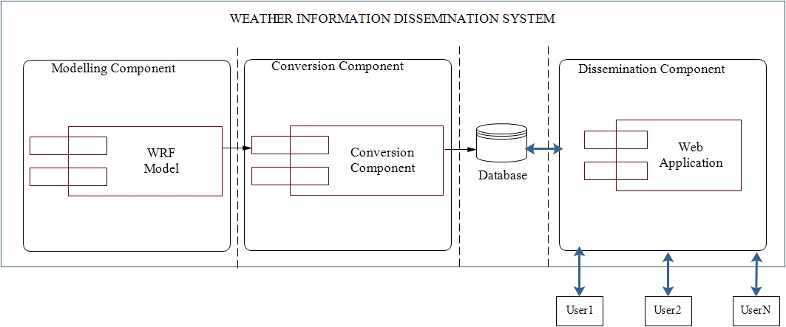

Figure 2.1: Block Diagram for an Overview of the Weather Information Dissemination System

N= any number of system users.

Data flows are represented by Arrows that are either unidirectional or bidirectional.

# SYSTEM ARCHITECTURE.

## Architectural Design.

The figure 3.1 below shows a Component Model of the Weather Information Dissemination System. 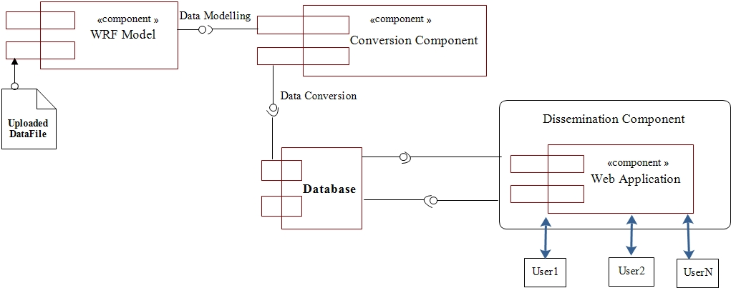

Required interface

Provided interface

Figure .: Component Model for Weather Information Dissemination System

The Architectural design in figure 3.1 above is described as below;

The Component model consists of the Modelling component which has the WRF model. The WRF Model depends on data from an uploaded file as its input. This model will be run to produce output that will be required to generate dissemination information.

The Conversion component will contain a script that will filter out the output from the modelling component and retain only the relevant data needed to generate advisories and other relevant information.

The Dissemination component consists of the web application subsystem. This is the component that the end users shall interact with in order to request for and acquire the relevant information.

The figure 3.2 below shows a Use Case Diagram of the Weather Information Dissemination System.

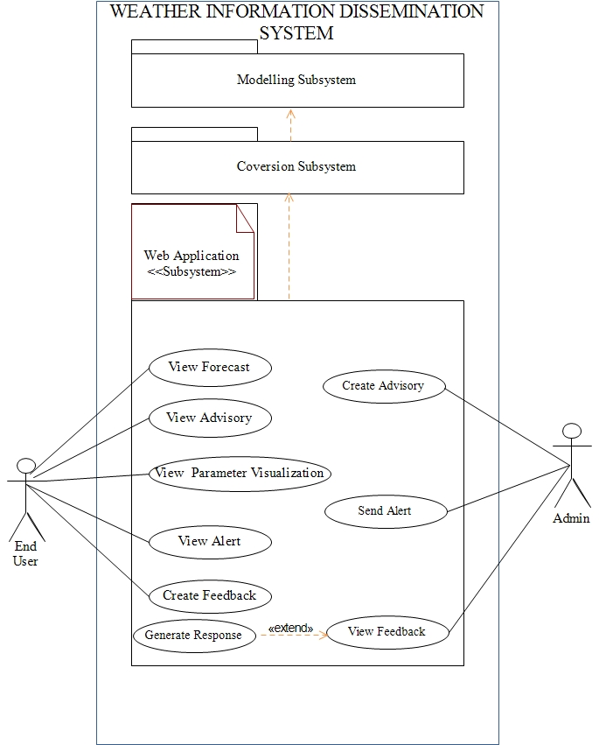

Figure 3.2: Use case Diagram for Weather Information Dissemination System.

Use Case Description:

Table 3.1: Description of the Use Cases in the Weather Information Dissemination System.

|  |  |  |  |  |
| --- | --- | --- | --- | --- |
| **Use Case ID** | **Name** | **Description** | **Precondition** | **Post condition** |
| UC-1 | View Forecast | User shall view weather forecasts and impact. | User must have selected Region, Category and Type of Forecast | A window with requested forecast and impact should be displayed. |
| UC-2 | Create Advisory | Admin and the relevant sector expert will formulate and enter advisory into the system | Admin/sector expert should have logged onto the system | A confirmation message should be sent to the admin/ sector expert. |
| UC-3 | View Advisory | User shall download specific advisories | user should have selected Region and Advisory category | A window containing requested advisories should be displayed. |
| UC-4 | View Parameter Visualization | A user shall have a graphical visualization of the weather parameter | A user should have selected the View Weather Parameter feature. | A graphical visualization and information about the selected weather parameter distribution should be displayed. |
| UC-5 | Send Alert | An alert about an extreme weather condition be sent to relevant stakeholders | Admin should have logged onto the system | Admin should receive a confirmation message. |
| UC-6 | View Alert | User shall view Alert on extreme weather conditions | User should have received an Alert message | User should receive an alert with a message explaining the intent of the alert |
| UC-7 | Create Feedback. | A User shall create and submit feedback | A user should have information to deliver to UNMA. | User should receive a confirmation message. |
| UC-8 | View Feedback | Admin shall view forwarded feedback by the user. | Admin should have logged onto the system | Admin shall mark feedback as viewed. |
| UC-9 | Generate Response | Admin shall create response to received query | Admin should have logged onto the system | Admin shall receive a notification of success or failure |

## Decomposition Description.

The figure 3.3 below shows a complete Package Diagram of the Weather Information Dissemination System.

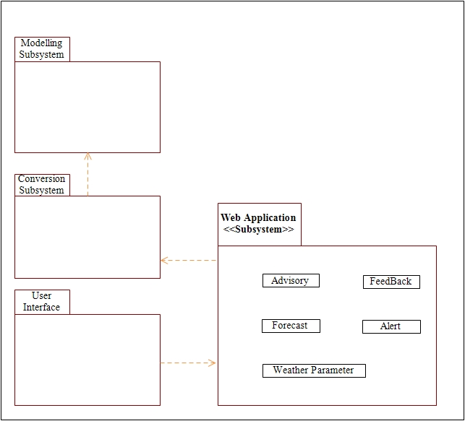

Figure 3.3: Complete Package Diagram for Weather Information Dissemination System.

## Design Rationale.

The Architecture described in figure 3.1 above using a component diagram is a Centralized Architectural Model for the WIDS.

Rationale.

Some of the rationale for selecting the Architecture include;

1. Centralization: The architecture provides a centralized control. Servers help on administering the whole system with access rights and resource allocation done by the server.
2. Proper management: With this architecture, all files are stored in one place which makes management of files easy. Also it becomes easier to find a specific file.
3. Back-up and recovery possible: As all data files are stored on a server, it becomes easy to make a back-up of it. Also in case of some breakdown when data is lost, it can be recovered easily and efficiently.
4. Up gradation and scalability: Changes can be made easily by just up grading the server.
5. Accessibility: From the various platforms in the network, server can be accessed remotely.

Critical Issues/ Trade off.

Some of the critical issues and Trade-offs considered include;

1. Network congestion: Too many requests may lead to congestion on the network with the overload causing breakdown of the server.
2. Cost: it is very expensive to install and manage this type of computing.
3. There is need for professional people that shall maintain the server and technical details of the network.

# DATA DESIGN.

## Data Description.

Figure 4.1below shows a Class Diagram of the Weather Information Dissemination System.

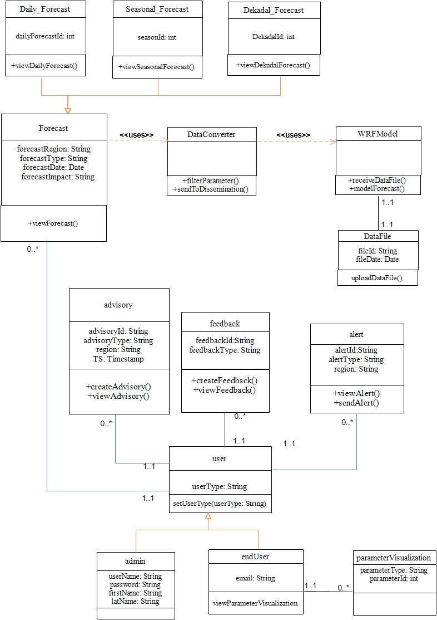

Figure 4.1: Class Diagram for the Weather Information Dissemination System

## Data Dictionary

Table 4.1: Data Dictionary

|  |  |  |  |  |
| --- | --- | --- | --- | --- |
|  | **FIELD** | **TYPE** | **NULL** | **DEFAULT** |
| Admin | adminId  firstName  lastName  userName | Int (11)  Varchar (250)  Varchar (250)  Varchar (250) | No  Yes  Yes  No | None  Null  Null  None |
| Advisory | advisoryId  advisoryType  region  TS | Int (11)  Varchar (30)  Varchar (30)  timestamp | No  No  No  Yes | None  None  None  CURRENT_TIMESTAMP |
| Forecast | forecastType  forecastRegion  forecastDate  forecastImpact | Varchar (30)  Varchar (45)  timestamp  Varchar (100) | No  No  yes  yes | None  None  Null  Null |
| Daily_Forecast | dailyForecastid | Int (11) | No | None |
| Seasonal_Forecast | seasonalForecastId | Int (11) | No | None |
| Decadal_Forecast | DekadalForecastId | Int (11) | No | None |
| Weather_Parameter | parameterType  parameterId | Varchar (45)  Int (11) | No  No | None  None |
| Feedback | feedbackId | Int (11) | No | none |
| Alert | alertId  alertType  region | Int (11)  Varchar (30)  Varchar (45) | No  No  yes | None  None  Null |
| User | userId  userType | Varchar (100)  Varchar (100) | No  No |  |

# COMPONENT DESIGN.

## The Login component.

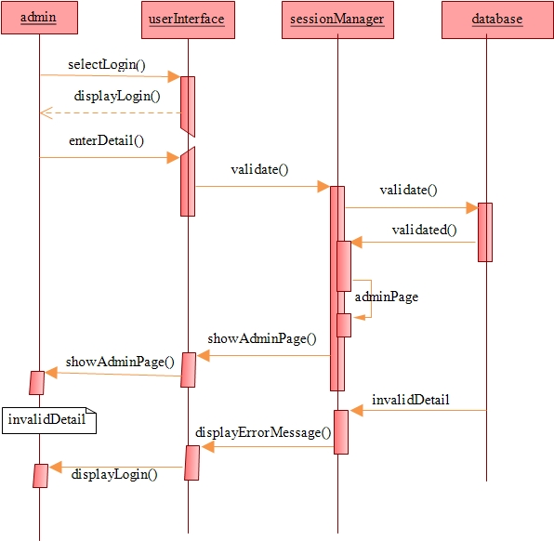

Figure 5.1: Sequence Diagram for Login

## View Forecast component

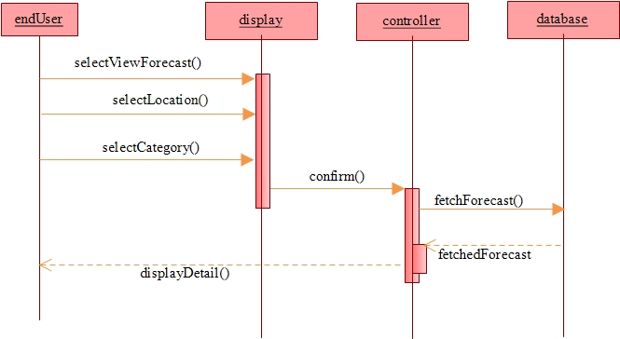

Figure 5.2: View Forecast component

## Create Advisory component.

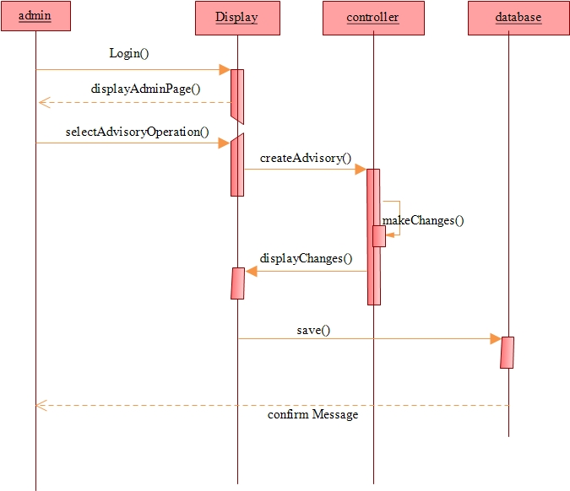

Figure 5.3: Sequence Diagram for Create Advisory component

## View Advisory component

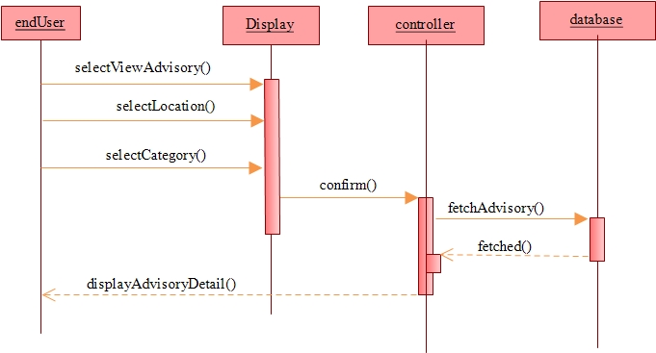

Figure 5.4: Sequence Diagram for View Advisory component

## View Parameter Visualization component

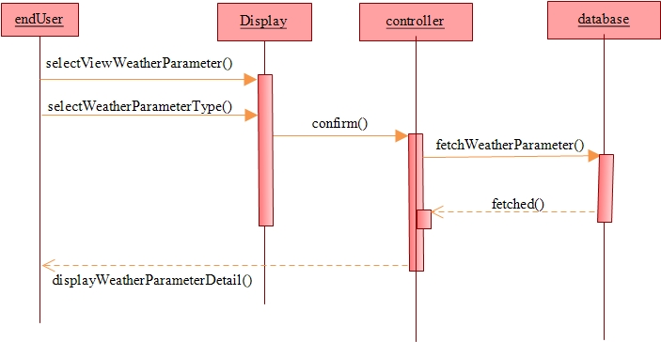

Figure 5.5: Sequence Diagram for View Parameter Visualization component

## Send Alert component

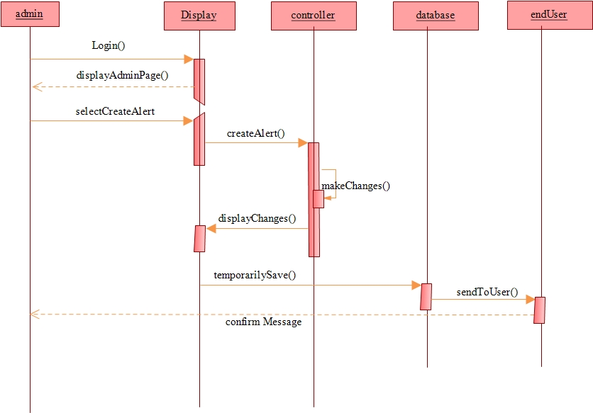

Figure 5.6: Sequence Diagram for Send Alert component

## Create Feedback component

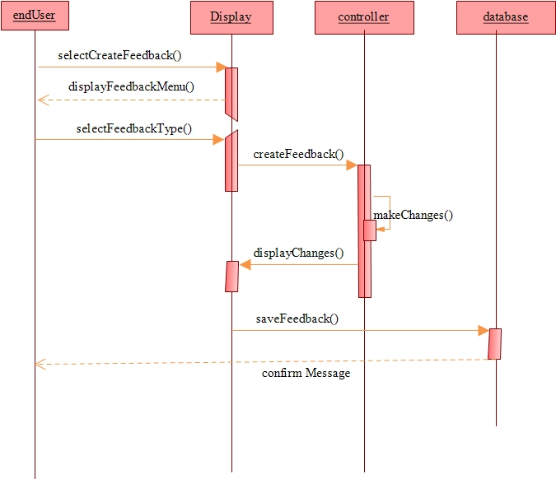

Figure 5.7: Sequence Diagram for Create Feedback component.

# HUMAN INTERFACE DESIGN.

## Overview of User Interface.

The User Interface for the Weather Information Dissemination System is designed according to User Interface Design principles that include;

1. The structure principle: User Interface is organized in such a way that related things are combined together and unrelated things are separated.
2. The simplicity principle: It is easy to follow the provided interface and in the case of any mistake, the system shall display an error message.
3. The visibility principle: All system’s functions are available through User Interface. It does not overwhelm users with too many alternatives.
4. The feedback principle: Through the system of messages, the design keeps users informed of actions, errors, or exceptions.
5. The reuse principle: In design, same names were used to perform the same operations with different objects in order to reduce ambiguity.

## The WIDS Web Pages in a Tree Structure.

The Weather Information Dissemination System’s web pages are presented in a tree structure. From “Main” page user can reach either “Advisory Live Map” page, “Weather Live Map” page or “Login” page, and each branch leads to other pages as seen in figure 6.1 below.

All the pages cover necessary functionality of the system and it is easy to navigate between these pages.

Figure 6.1 below is a Tree Diagram showing Navigation through the User Interface of the Weather Information Dissemination System.

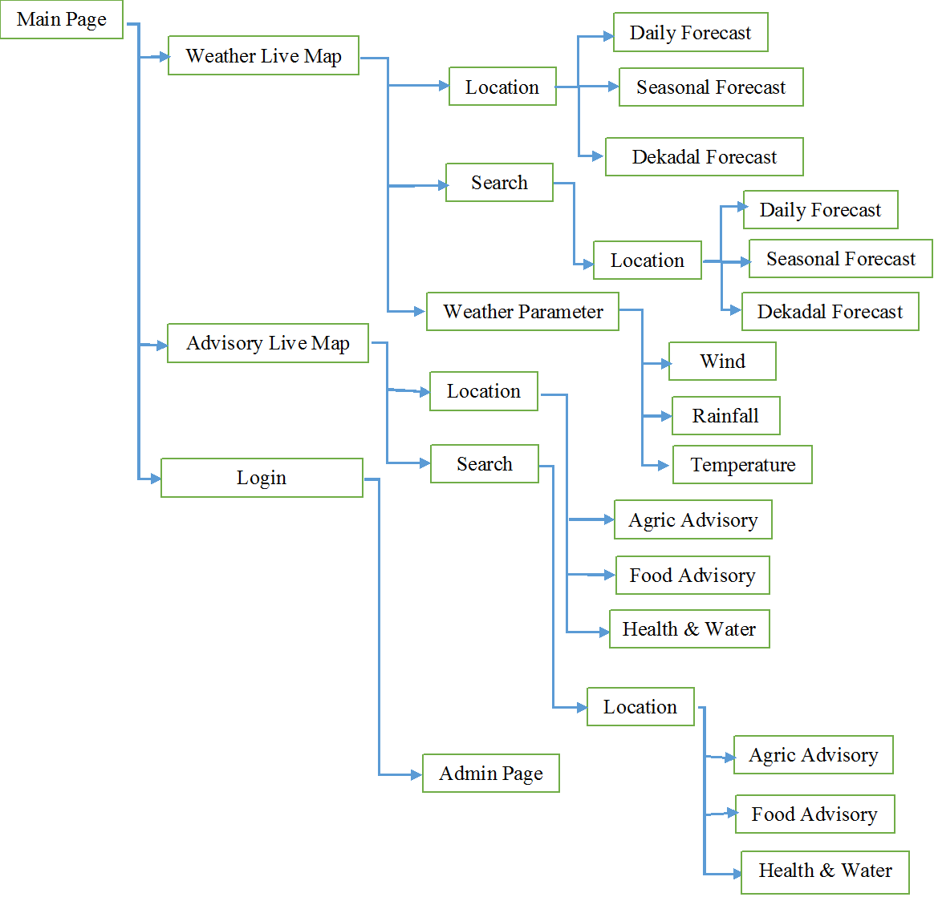

Figure 6.1: Navigation through the WIDS’ User Interface.

Brief Description:

A brief description of some of the main pages on the Weather Information Dissemination System include;

1. The “Main” page. This is the starting page that appears as soon as the system is loaded. It has links to other pages.
2. The “Weather Live Map” page. This page has a clickable live map of Uganda from which users can get weather forecasts and visualization of weather parameters from the various sectors and also get approved advisories relative to their location.
3. The “Login” page. This pages prompts a user, specifically an administrator to enter login credentials that are validated before given access to the administrator (admin) page.

## Screen Images.

Map Window: A user shall interact with the Live Map in order to obtain the required weather forecast information and or Advisories by clicking on a region of interest such as Mbarara and then follows the prompt.

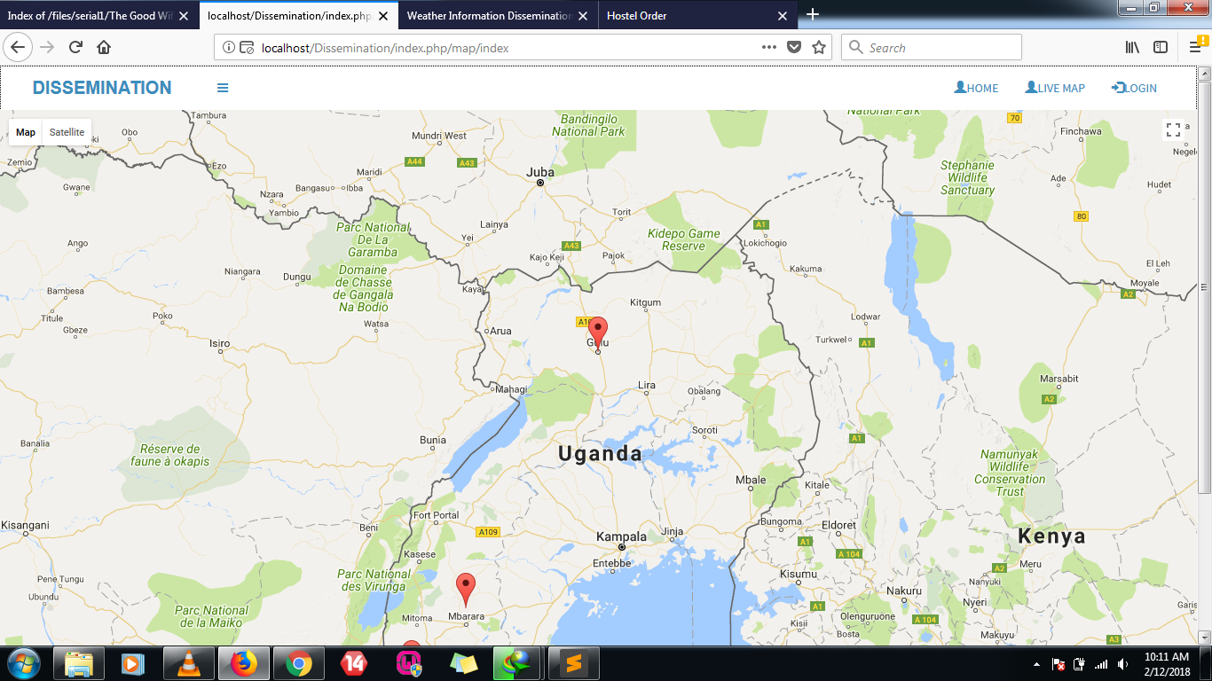

Figure 6.2: Screen shot of a Map window

Search Feature: User shall key in a particular location for which weather forecast information or Advisories are required.

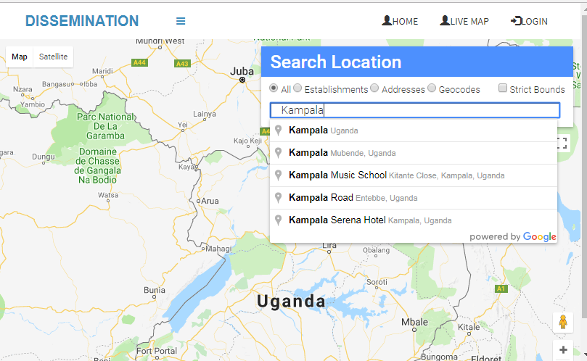

Figure 6.3: Screen shot for Search feature

Login Feature: Admin shall be prompted to enter valid credentials that include username and password. 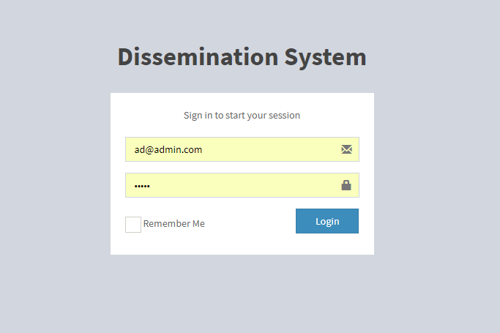

Figure 6.4: Screen shot for Login feature

Advisory Window: Having selected a category such as Agriculture, user shall be presented with a window as shown in figure 6.5 below.

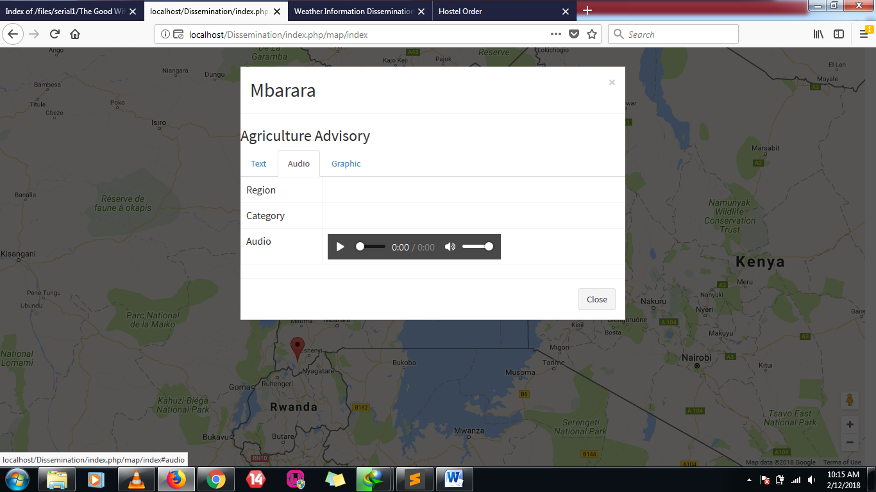

Figure 6.5: Screenshot of an Advisory window

## Screen Objects and Actions.

Having typed the WIDS’ url in a web browser, the “Main” page is loaded and availed to the user. The “Main” page contains menu that include; the “Advisory Live Map”, “Weather Live Map” and the “Login” page as screen objects. A user clicks on the necessary item in the menu so as to move to the next page.

1. The “Weather Live Map” Object.

Some of the possible actions performed on this object actions include;

1. Select Advisory or Forecast- This action enables a user to choose the desired weather parameter for which weather forecast information and/or advisories should be availed and the parameters include;

* Temperature
* Rainfall

1. Click Location- Performing this action presents a user with a drop down list containing the categories to select that include;

* Daily Forecast
* Dekadal Forecast
* Advisories

1. Search Location- This action enables a user to search for a specific location of interest if no directly visible on the map. The searched location is displayed and when clicked on, displays a drop down list showing the various Advisory categories.

* Daily Forecast
* Dekadal Forecast

1. The page “Login” Object.

After login is validated, the administrator (admin) is directed to the admin page.

Figure 6.6 below shows the scheme of the main web pages (objects) and main actions that can be performed on each object.

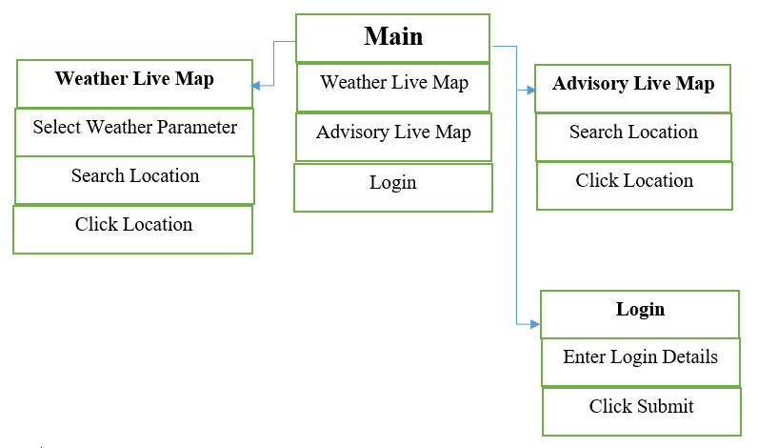

Figure 6.6: Scheme of Weather Information Dissemination System Objects and Actions

**KEY**

Bold Rectangle = Main pages.

Un-bold Rectangle = Actions performed on the web pages.

Blue Arrow = Connection between Objects.

# REQUIREMENTS MATRIX.

Table 7.1: Requirements Matrix

|  |  |  |  |  |  |  |  |  |  |
| --- | --- | --- | --- | --- | --- | --- | --- | --- | --- |
| **REQUIREMENT** | **USECASE 1D** | | | | | | | | |
| **UC-1** | **UC-2** | **UC-3** | **UC-4** | **UC-5** | **UC-6** | **UC-7** | **UC-8** | **UC-9** |
| View Forecast | **X** |  |  |  |  |  |  |  |  |
| Create Advisory |  | X |  |  |  |  |  |  |  |
| Download Advisory |  |  | X |  |  |  |  |  |  |
| View Parameter Visualization |  |  |  | X |  |  |  |  |  |
| Send Alert |  |  |  |  | X |  |  |  |  |
| View Alert |  |  |  |  |  | X |  |  |  |
| Create Feedback. |  |  |  |  |  |  | X |  |  |
| View Feedback |  |  |  |  |  |  |  | X |  |
| Generate Response |  |  |  |  |  |  |  |  | X |

X= Corresponds to a Requirement and a Use case that captured that particular Requirement