Trapping Dashboard Project - Reference and Planning Document
Purpose: Capture agreed requirements, architecture, implementation approach and future roadmap for a public trapping dashboard based on Trap.NZ data.

Objectives
- Provide a public website showing trapping results and trends.
- Use a static site with nightly updates.
- Support historical analysis from 2020 onwards.
- Retain all original Trap.NZ data fields.

Recommended Architecture
- GitHub Pages hosts the static website.
- GitHub Actions runs nightly scheduled updates.
- Python downloads and processes Trap.NZ data.
- Browser-based charts render data from JSON summary files.
- No database or continuously running server required.

Data Strategy
- Keep all raw annual CSV exports and future API data.
- Never discard source fields.
- Generate derived JSON datasets for charting.
- Store weekly, monthly and annual aggregations as required.
- Maintain a single master dataset all_catches.parquet
- Create a species model
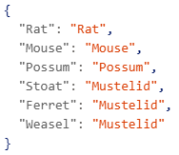

Folder Structure
Initially
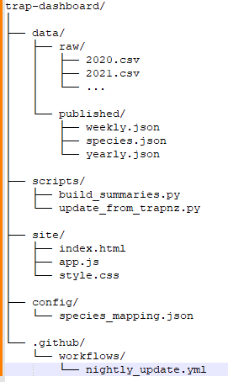
Then as in foklder_structure_v2.txt

Dashboard Requirements
- Default view: Last 6 Months.
- User selects Species and Period/Year.
- Species include Rat, Mouse, Possum, Mustelid and All Species.
- Years available from 2020 onward.

Charts
- Weekly catches for selected species and period.
- Same Species, All Years comparison chart.
- Species totals for selected period.
- Summary metrics and trend indicators.

Stage 2 Enhancements
- Analyse by trap line.
- Compare catches per trap.
- Compare catches per visit.
- Investigate optimal rebait frequency.
- Support operational decision making.

Coding Methodology and Environment
- Primary IDE: VS Code.
- AI Assistant: GitHub Copilot Pro.
- Programming Language: Python.
- Data Processing: Pandas.
- Charting: Chart.js.
- Source Control: Git and GitHub.
- Website Hosting: GitHub Pages.
- Automation: GitHub Actions.
- Develop iteratively with small, testable increments and version control from the start.

Proposed Delivery Phases
- Phase 1: Load historical CSVs and create core dashboard.
- Phase 2: Add rolling-period views and year comparisons.
- Phase 3: Integrate Trap.NZ API and automate updates.
- Phase 4: Add trap line and optimisation analytics.

Next Steps
- Establish GitHub repository and project structure.
- Set up VS Code with GitHub Copilot Pro.
- Import historical datasets from 2020 onward.
- Build a proof-of-concept dashboard using local data.
- Design JSON summary file formats.
- Investigate Trap.NZ API authentication and limits.
- Implement GitHub Actions nightly processing.
- Develop same-species all-years comparison charts.
- Review opportunities for trap-line and rebait-frequency analytics.

