The Big Picture 2
This picture shows how the various elements of the complete framework fit together:
Administration System
Definitions Admin
Components Admin
Work Management Admin
Store
Remote Platform Manager
Remote Platform 1
Remote Platform n
Object Management Interface Layer
Remote Platform Manager
Remote Platform 1
Remote Platform n
Repository Manager

The Management System
The Management System is the user interface and the database of the framework. The information consists of Definitions which tell the framework what and how can be managed by whom. The Components contain the component information and configuration and the Work Management handles the day to day management of the system, e.g. by using tasks and a workflow. Actual management commands go through the OMIL layer.

OMIL
OMIL describes the vocabulary of the framework. OMIL requests are routed to the correct place.

Repository Manager
The Repository Manager is responsible for the save keeping of the managed components.

Platform Manager
The platform manager manages the different platforms on one location.

Platform
The Platform is the actual place containing components that the platform owner wants to have managed.
The nasdasdme of this shall be:
CMF

Starting Points
The CMF is an abstraction. All stakeholders are defined by the CMF model and there shall be no dependencies on any particular implementation.

Platform
The Platform object is one of the bases of the model. Through this object all relevant parts of the model can be reached.

The Management System
The Administration object can be reached through Platform and it will give access to all the administration parts of the system. From here a reference to the Store can be obtained through which the data is retrieved. Administration also gives access to DefinitionsAdmin, ComponentsAdmin, and WorkManagementAdmin

The Object Managament Interface Language and Protocol
The OMILFactory object can also be reached through Platform and with it the user can create Request objects which are Sendable objects. These objects hold the required request and hold a back reference to the requester which is a member of the Administration.

Hello Word!

The Repository
The Repository stores component versions.

The Queue Manager
The QueueManager can add information to and schedule incoming Requests and is able to contact the DefinitionsAdmin for information about the target system, should this not be clear from the Request. The QueueManager will contact the RemotePlatformManager and will pass it the request. The QueueManager must store all pending and handled requests in the Store. If an Request cannot be handled in a timely manner then the QueueManager must report this back to the requesting Administration Member. Internal queue affairs, like canceling an outstanding Request must be catered for, preferably by an internal QueueRequest.

The Remote Platform Manager
The RemotePlatformManager accepts requests from any authenticated and authorized QueueManager. Although unauthorized request should not be able to make it into the queue, there also needs to be a form of authentication by the RemotePlatformManager itself to confirm that the Platform has access to the RemotePlatform.The RemotePlatform is the specific layer and will do all the real work. This consists of putting information into the Repository and getting information out of the Repository, listing information and performing all object management tasks thinkable. Results from the RemotePlatform are communicated to the PlaformManager by using a Reply. This is defined by the vocabulary of the OMILFactory.
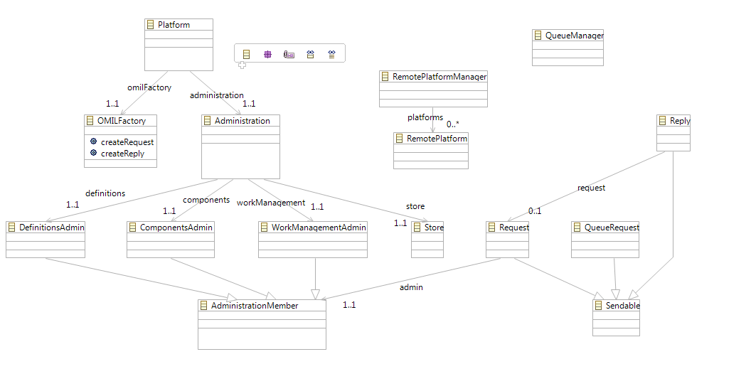

SCCM Management Patterns
There are several Management Patterns in use. The Platform must be able to manage these patterns. In this chapter the currently known patterns are described.

Single Repository
This pattern does not distribute changes. Changes are applied manually or directly.

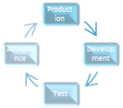
Fix Based Flow
This pattern delivers updates to production on a daily basis. Typically the end-user enters a change request, the change request is evaluated and the programmer starts working on the problem. If the problem is fixed it is transferred to production.

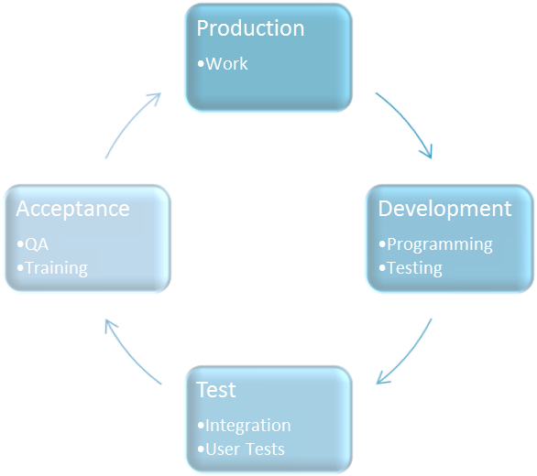
Project Flow
Emergency
This pattern delivers updates to production in batches. The time between each batch may vary but upgrades and new functions are implemented together. An emergency environment can be part of the pattern.
Production
Work
Development
Programming
Testing
Test
Integration
User Tests
Acceptance
QA
Training
Development
Programming
Testing
Test
Integration
User Tests
Acceptance
QA
Training

Project Flow + Fix Based Flow
This pattern combines the two patterns. One application is maintained in two separate branches which need to be synchronized by compare and merge functionality.

Multiple Project Flow
Production
Work
Development
Programming
Testing
Test
Integration
User Tests
Acceptance
QA
Training
Development
Programming
Testing
Test
Integration
User Tests
Acceptance
QA
Training
This pattern enables the creation of multiple projects all based on the same code base. Normally a fixed base flow is also used in this pattern. An emergency environment can be part of the pattern and the branches need to be carefully merged before they can be placed in production. The more simultaneous projects the harder it is to manage this pattern.
V1
BASE
V2

Base Version and Variants
Multiple branches fork of the main code base. Changes in the main code base must be merged into the variants if that change is required in the variant.

Software House
V1
V2
V3
This pattern maintains multiple versions of the same application. Changes in each version could have impact on all other versions.

OMIL Factory

Company goals

Use Cases

Company goals
The company wants to manage a certain business application. To do this, the company requires that the application be maintained in a process so that the quality can be ensured. The company draws a picture of the infrastructure of the application. It defines the global characteristics like the name of the application and the pattern to use. Then the company wants to define the stages of the application and for each stage the component locations are defined.
The company wants to define who is responsible for each part of the application. Roles can be programmers, users, testers, ratifiers, etcetera. Roles can be assigned to people and the capability of each role can be tuned to the requirements of the company.
Work management must take place in a defined workflow and information must be pushed to the parties as much as possible. All actions are logged as events and people can subscribe to events.
All relevant auditing information can be obtained quickly. The company must be able to revert to the previous state of the application after an upgrade in a rollback. Data must be restored as well during rollback but no data may get lost.
Users must be able to quickly participate in the development process.
Proposed changes must be tracked and must be assigned to people. People must be able to estimate and book hours. Preferably the systems should keep track of the hours worked. All relevant documentation must be added to the change administration.
Proposed changes should be backed by a requirements management workflow. Impact of changes must be determined and a project planning must be made.
The software must be able to administrate test results and not allow for implementation until the final sign-off is given.
Implementation of the software should be automatic. Build (compilation) of the software must be supported.

