BASF UI Coding Challenge

This interview challenge is designed to allow you to showcase your technical skills and expertise.

It is probably underspecified and a little bit vague and we don’t expect you to create a perfect solution, but we are curious about your approach.

## Task

The objective is to

1. create a front-end web app
2. using a common JavaScript framework (preferably React, but Vue or others are also good),
3. that meets the requirements below (buttons, color, layout, dialog boxes, warning/error messages, etc.)
4. and creates a great user experience.

The purpose of the example application is to give simple access to some chemical data.

## Deliverables

Please provide us with

1. your code as github repo (otherwise as local git repo via email)
2. a readme explaining how to easily deploy/run your UI
3. a brief explanation of the UI concept/design you followed

## Data

The data to be displayed by the application are from two spread sheets with the following data:

* patent no, patent title, chemical name
* both the spread sheets differ in their chemical types (type 1 and type 2)

## UI Features

The application should offer the following:

* Read the data from spread sheets and make them accessible to the UI
* A google like search box for querying the chemical names from both the excel sheets
* As soon as a query (chemical name search) has been entered:
  + Provide a box with the number of patents where the searched chemical appears (in screenshot named as “Total Documents”)
  + Display two tables, one for each of the excel files:
    - Fetch the patent nos. for the searched chemical
    - Display other chemicals found in these patent nos. (separately for each excel, see screenshot)
* The tables should contain two columns: found chemical names, count of patents in which they appear
* Each table column should contain an order option
* On row click, create a second view that displays the document information
* Document information are the patent no., title, and a hyperlink to the google patents page
* (based on the patent number like this <https://patents.google.com/patent/US10623476>)
* Provide appropriate error messages for handling non-availability of data

# Backend Bonus points

# In case you have some more skills, you might want to showcase them by implementing one of these ideas.

# Design: The screenshots above a from a techy obviously. Impress our Art Director with some great UI design!

# Backend and databases: Import the spreadsheets data into a suitable database and create an API backend for providing the data to the frontend

# User management: Implement authentication using OAuth2 (e.g. using Google, GitHub, etc…) and display basic user information in the application.

# Example of the UI pages:

1. Search page

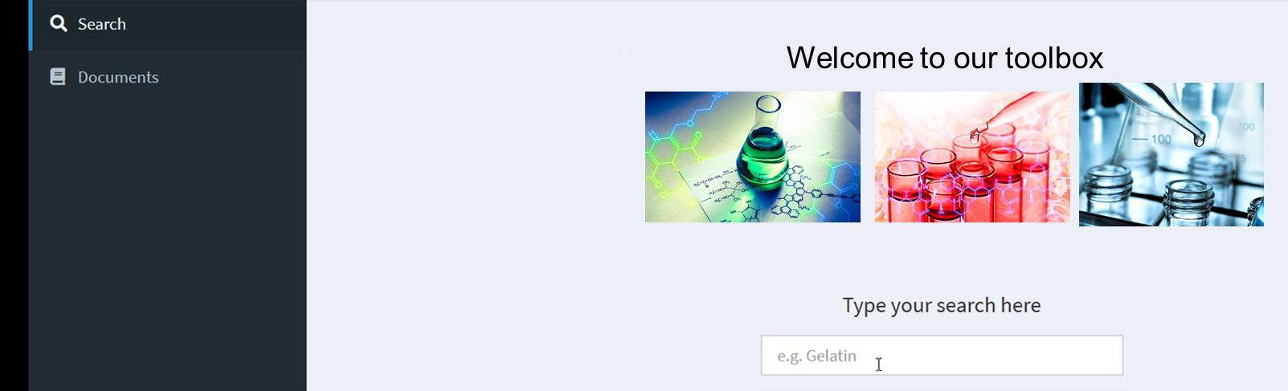

1. Tables with counts

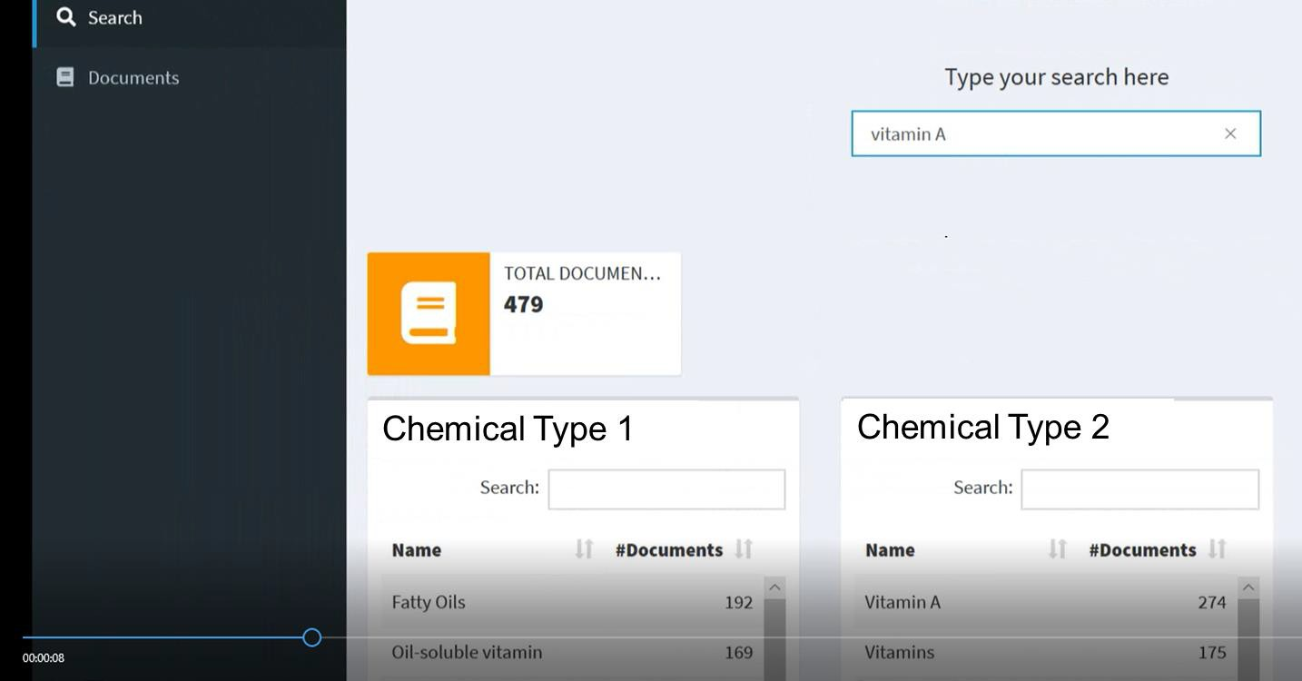

1. Document name and title display with hyperlinks to either PDFs or google patents

