SPHY model Din Gad

24 March 2021
- Create a GitHub repository - https://github.com/wimmerzeel/SPHY_DINGAD. This contains a SPHY3.0 clone as a starting point for the code
- Created a clone map at 50 meter resolution a UTM 43N projection
  - Upper left corner -> 849350,3425200
  - Lower right corner -> 869300,3412100
- Created a DEM at clone extent, projection and resolution based on SRTM 1 arcsec

4 May 2021
- Reprojected and clipped to clone band 2,3,4,8 of Sentinel image of 2020-10-16 (10 meter resolution)
- Reprojected and clipped to clone band 11 of Sentinel image of 2020-10-16 (20 meter resolution)
- Reproject and clip to clone for SWIR band 11 (20 meter)
- Compute NDVI (B8-B4/(B8+B4) (10 meter)
- Resample band 11 to 10 meter resolution (cubic)
- Compute NDSI (B3–B11) / B3+B11) (10 meter)
- Create snow mask
  - NDSI > 0.42
  - DEM > 4500
- Reclassify NDVI
  - -1.0 – 0.0 : 1
  - 0.0 – 0.2 : 2 (grass)
  - 0.2 – 0.4: 3 (shrubs)
  - 0.4 – 0.6: 4 (forest)
  - 0.6 - 1.0: 5 (evergreen forest)

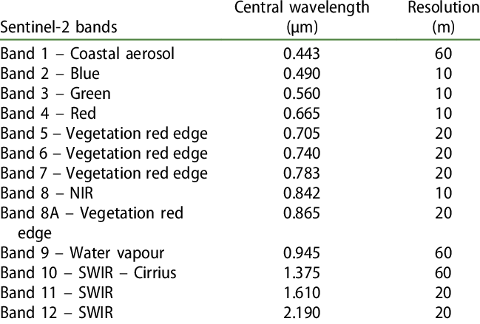

5 May 2021
- Reproject and clip PK’s debris mask to clone
  - 0 = no glacier
  - 1 = clean ice
  - 2 = debris
- Aggregate NDVI map to 50 meter clone extent
- Combine debris mask and NDVI map to land use map
  - 1 = clean ice glacier
  - 2 = debris covered glacier
  - 3 = bare rock
  - 4 = grass
  - 5 = shrubs
  - 6 = mixed forest
  - 7 = dense forest

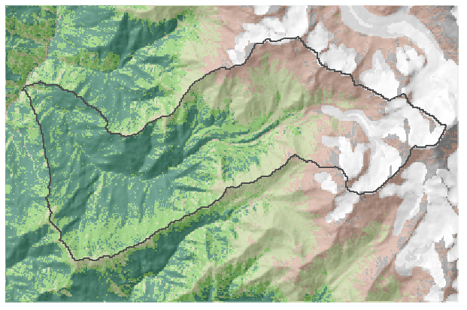
6 May 2021
Landuse
- Made final landuse map and kc.tbl at 60 meter resolution
  - 1 = clean ice glacier = 0
  - 2 = debris covered glacier = 0
  - 3 = bare rock = 0.2
  - 4 = grass = 0.4
  - 5 = shrubs = 0.7
  - 6 = mixed forest = 1.0
  - 7 = dense forest = 1.2
- Converted to luse.map and moved to inputs folder

Soil
- Downloaded the HiHydroSoil_250m
- Clipped, projected and resampled FC, WP, PWP, KSAT and WCSAT for top and subsoil using ArcMap batch processing
- Converted all soils maps to .map format and copied to SPHY input folder

Latitude
- Created fishnet.shp with model cell polygons
- Created model_id.map and copied to SPHY input folder
- Created latitude.map and copied to SPHY input folder

Glaciers
- Select all cells in fishnet that intersect a glacier polygon: fishnet_glacier.shp
- Computed mean elevation per model cell and add to fishnet table -> MOD_H
- Computed MOD_ID,GLAC_FRAC, DEBRIS, GLAC_ID, GLAC_H
- Downloaded ice thickness data from Farinotti (2019) for RGI zone 15
- Selected RGIIDs for Langtang
- Mosaicked all glacier rasters (maximum value retained)
- Clipped to clone and new glacier outlines at 25 meter resolution
- Resampled to 5 meter resolution
- Computed mean ice thickness per 60 meter fishnet polygon
- Selected only fishnet polygons with thickness > 0
- Created glacier.csv model input file ("U_ID","MOD_ID","GLAC_ID","MOD_H","GLAC_H","DEBRIS","FRAC_GLAC","ICE_DEPTH")

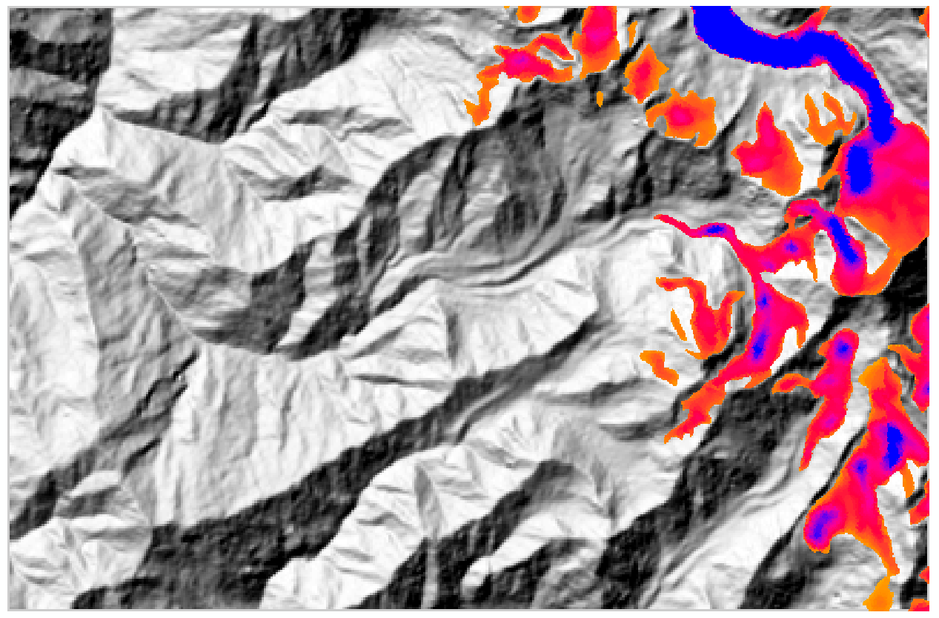

20 December 2020
- Created fishnet.shp with model cell polygons
- Created modid.map based on fishnet.shp and copied to SPHY input folder
- Select all cells in fishnet that intersect a glacier polygon: fishnet_glac_intercept.shp
- Computed mean elevation per model cell and add to fishnet table -> MOD_H
- Computed MOD_ID,GLAC_FRAC, DEBRIS, GLAC_ID, GLAC_H

23 December 2020
- Created glac_id.map and copied to SPHY inputs folder
- Downloaded ice thickness data
- Downloaded ice thickness data from Farinotti (2019) for RGI zone 15
- Selected RGIIDs for Langtang
- Mosaicked all glacier rasters (maximum value retained)
- Clipped to clone and new glacier outlines at 25 meter resolution
- Resampled to 5 meter resolution
- Computed mean ice thickness per 60 meter fishnet polygon
- Selected only fishnet polygons with thickness > 0
- TODO: Created glacier.csv model input file ("U_ID","MOD_ID","GLAC_ID","MOD_H","GLAC_H","DEBRIS","FRAC_GLAC","ICE_DEPTH")

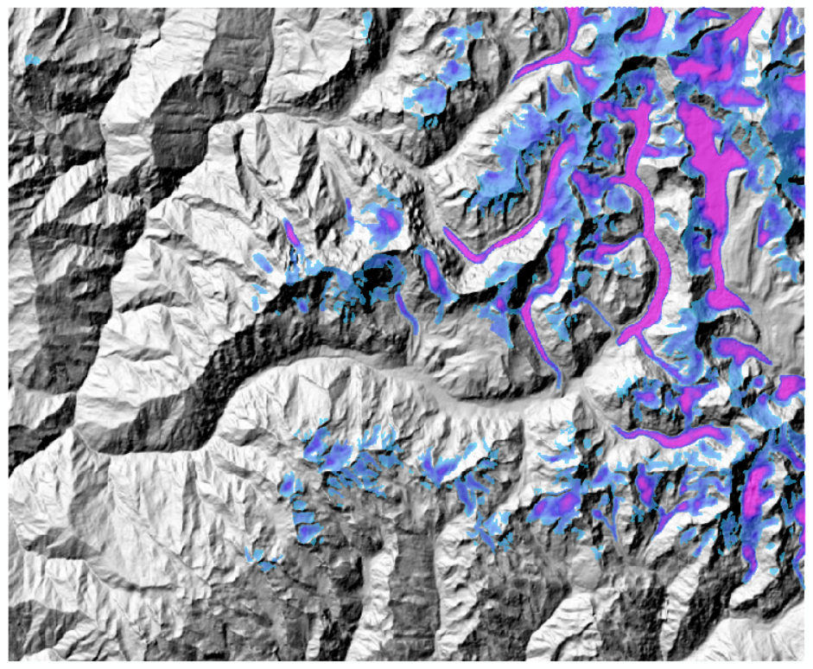

27 December 2020
- Start preparing daily forcing based on ERA5
- Precipitation and temperature (avg,min, max) finished and generate for 2018 a time series of ASCI grids in clone projection and resolution (see create_SPHY_forcing_daily.r)
- Created a batch file to convert ASCI grids to PCRaster input files

2 January 2021
- Run the model from Visual Studio Code
- CTRL+Shift+P to select interpreter!
- Install some packages in the correct conda environment: pcraster43 (netCDF4, pyproj)
- Got stuck with reading glacier module

5 January 2021
- Debugging with Sonu. The issue was the PCRaster version
- Installed PCRaster 4.2.1 and Python 3.6.6
- Added PCraster to the PATH environment variable
- Installed numpy, pandas, netCDF4, pyplot using pip
- Included the lapse rate table
- Included a dummy latitude map – NEED TO FIX
- Moved the forcing folder inside the input folder
- Model runs 😊

5 January 2021
- Created new latitude map
- One year model run takes about 950 seconds, so switching to an hourly timestep means one year run takes about 6 hours

7 January 2021
- Extract hourly ERA5 data for T, P, (solar) using create-series-table-for-gridcell.r (made by Philip for Ymke Lathouwers)
- Use corrected precipitation and temperature data from Sanne Veldhuijsen (see repository)
- Annual ESD for P, Tavg, Tmin and Tmax -> create_SPHY_forcing_daily_ERA5_stations.r

8 January 2021
- Used final dataset of Sanne – climate_data_sanne.csv
- Compute monthly lapse rates based on monthly-hour lapse rates of Sanne Veldhuijsen
- Replace input\lapse rate table
- Using lapse rates, ESD downscaled ERA time series and DEM generated Tmin, Tamx and Tavg forcing for 2018 -> create_SPHY_forcing_daily_ERA5_stations.r
- Started a new test run with the new temperature forcing for 2018

- TO DO Fix precipitation forcing
  - Use monthly spatial patterns from WRF to creates spatial input

