INIT

ABOUT:

Init is an app based on the idea of workplace optimization, it is targeted at a working audience which make use of labs and workplaces or just about any meeting point to work on projects of all kind and want to optimize and enhance their working efficiency.

Init not only helps in increasing efficiency but also the productivity of the team as a whole.

Init aims to provide better collaborating experience and smooth flow through out the project development.

PREVIEW:

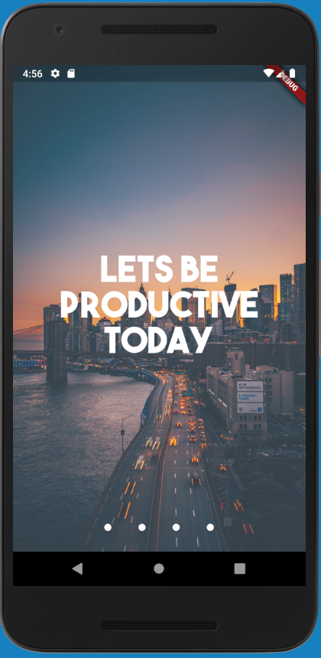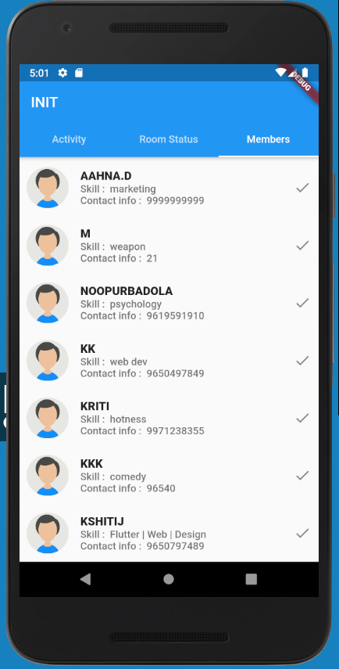

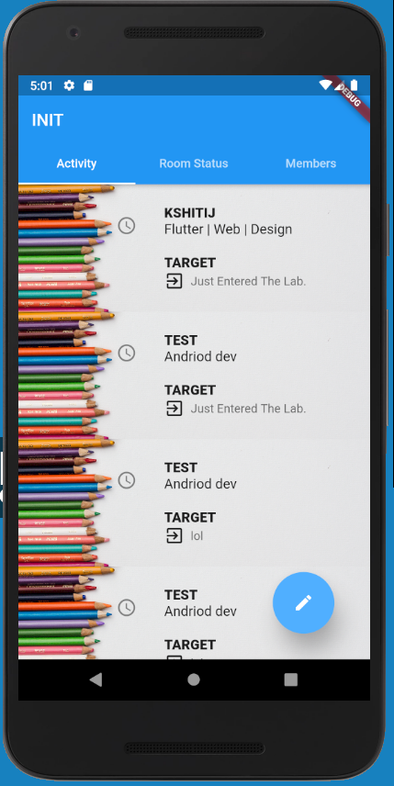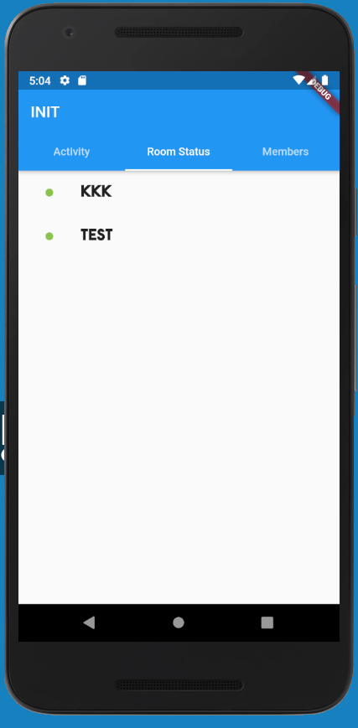

FEATURES:

Init currently has features that will definitely boost work productivity. Few of them include:

1. Live Feed which tracks the contribution and inputs of the each and every member in the project. It can be treated as live record of how your project has progressed and developed through the course of time. It further records the visits of each member to the workplace which can be treated as virtual log book for the workplace.
2. Secondly it gives the current status of the workplace wiz the people currently present in the workplace, this kills the need of cumbersome Collab calls which are often missed by the receiving end and those dreadful waiting time period for the Collab party to arrive , you do not need to be constantly calling people up to check whether they are in for work. You can just check who is in for work, sitting on the pot in the morning.
3. Init also provides a feature which gives you details of all the members associated with the project (skillset, name, contact details). Stuck somewhere with your multidomain project? just go to member’s tab and find the right person with the right skill set. Simply call them up bring light to your problem.
4. There many upcoming features such as multi project management. Currently our app is limited to the VIIT lab of VIT Vellore and hence has a single project framework, but we are working towards opening it to the world.

FUTURE UPDATES:

Although the app is now stable but there is always room for improvement and we understand that our app is far from perfect and required multiple revisions, but we are committed to providing best user experience and have many upcoming exciting features:

*1.Validation in Form Fields.*

*2.Room status bug fix for multiple login*

*3.Scrollable signup page.*

CREATOR’s AFTERWORD:

Kshitij Dhyani

18BIT0131

I draw immense pleasure in bringing to you my first ever creation and it motivates me to keep on delivering to the country and this globe as a whole.

I will enthusiastically bring regular updates and try to maintain the servers to my best.

The app will only get better with time.

Signing off in the hope that at least a few people reap benefit of this otherwise bogus creation.

**Special Thanks to:**

My parents who provided me with all the resources, my sister for always keeping me happy, my dog for sitting beside me through all of it, my friends who uplifted my mood, and my Girlfriend Sanskriti who always supported, and motivated me throughout the process.

**Resources Used:**

Humble respect and thanks to all the resource providers.

Background Photos: <https://unsplash.com/>

Tech Help : <https://www.youtube.com/channel/UCSJbGtTlrDami-tDGPUV9-w/featured>

Code help: <https://stackoverflow.com/>

Backend help: <https://firebase.google.com/>

Any Form of feedback is appreciated:

Contact me:

Email: [wimpycodes@gmail.com](mailto:wimpycodes@gmail.com)

Help me out at:

Git Repo: <https://github.com/wimpywarlord/workplace_optimization>