SmartIntern Project Report
Rule Based Internship Matching System

Item | Details
Project | SmartIntern: Rule Based Internship Matching System
Group | NEXORA
Members | Hein Htet Aung; Win Khant Ko Ko; Ye Lin Aung
Database | MySQL Community Server with MySQL Workbench
Application | Node.js, Express, HTML, CSS and JavaScript

Database implementation and application demonstration report

1 Introduction and Business Background

1.1 Business Background
SmartIntern is a small university internship matching platform designed for a pilot involving approximately 100 students, 10 companies, 20 internship opportunities and around 50 applications per month. Students maintain structured profiles containing education, skills, projects, certifications and experience. Companies create internship records and specify required skills, minimum proficiency, minimum GPA and minimum study year. The project demonstrates how a relational database can support the recruitment workflow with consistent records, foreign-key relationships and repeatable SQL reports.
The platform uses one authenticated user account for each participant. A user account has either a Student or Company role, and the selected role determines the corresponding profile. Students can review internships, inspect matching evidence and submit applications. Companies can manage internships, define skill requirements and review applications. The project does not include an administrator workflow, AI resume parsing, notifications, password reset, payment or paid cloud deployment.

1.2 Business Problem
Students often search across unrelated internship websites, company pages, career pages and messages. They may apply without knowing whether they satisfy a required skill, GPA or study-year condition. Companies also need a consistent way to compare applicants and identify missing requirements. A relational database addresses these problems by storing structured profile data, connecting applications to specific internships and supporting transparent matching calculations instead of unexplained recommendations.

1.3 Project Scope
In scope | Out of scope
Authentication and role-based access; Student and Company profiles; skills; education; projects; certifications; experience; internships; applications; rule-based matching; SQL reports. | Admin accounts; internship publication status; AI matching; resume parsing; notifications; password reset; email verification; payment; paid cloud hosting.

2 Motivation
The project is motivated by the need to replace scattered profile information and manual internship comparison with a controlled relational database. SmartIntern gives students one place to maintain evidence of their capabilities and gives companies structured requirements that can be compared consistently. The database also provides a practical demonstration of normalization, foreign keys, many-to-many bridge tables, data validation and SQL reporting in a realistic recruitment scenario.

3 Objectives and Business Questions
ID | Objective
O1 | Record student profiles, reusable education records, projects, certifications, experience and skills.
O2 | Record company internships and their required skills, minimum GPA and minimum study year.
O3 | Calculate a transparent match score using skills 60%, GPA 20% and study year 20%.
O4 | Allow users to submit and track internship applications by status.
O5 | Answer the three business questions using SQL queries and reports.

The three business questions are: (1) Which students are the best qualified for each internship? (2) Which mandatory skills are missing or insufficient for a selected student and internship? (3) What is the match score for every student-internship pair?

4 Business Rules
Rule | Category | Business rule
BR1 | Relationship | Each Student profile and each Company profile belongs to exactly one User account. The profile tables use a unique user_id foreign key.
BR2 | Relationship | One Company may post zero or more Internships; each Internship belongs to exactly one Company.
BR3 | Relationship | A Student may have many Skills, and a Skill may belong to many Students through Student_Skill.
BR4 | Relationship | An Internship may require many Skills, and a Skill may be required by many Internships through Internship_Skill.
BR5 | Relationship | A Student may apply to many Internships, and an Internship may receive many Applications.
BR6 | Relationship | A Student may be linked to many Education records through Student_Education.
BR7 | Relationship | A Student may contribute to many Projects, and a Project may include many Students through Student_Project.
BR8 | Relationship | A Student may hold many Certification records, and a Certification may belong to many Students.
BR9 | Relationship | A Student may have many Experience records, and an Organization record may be linked to many Students through Student_Experience.
BR10 | Participation | Each Application references exactly one Student and exactly one Internship.
BR11 | Participation | Each Internship must have at least one Internship_Skill record before students can apply. Applications are rejected until a requirement is added.
BR12 | Participation | A Student may have zero or more records in Education, Project, Certification and Experience.
BR13 | Attribute | Each User email is unique and each password is stored as a password hash.
BR14 | Attribute | GPA is between 0.00 and 4.00, and study_year is a positive year level.
BR15 | Attribute | Skill proficiency is an integer from 1 to 5 and required years cannot be negative.
BR16 | Attribute | match_score is between 0 and 100 and status is Pending, Under Review, Accepted or Rejected.
BR17 | Specialization | User is the supertype. Student and Company are subtypes. The relationship is implemented using separate profile primary keys and unique user_id foreign keys. The specialization is disjoint and partial in the database: a profile can belong to only one matching role, while a User row may have no subtype profile. Supported role values are Student and Company; Admin and career-support accounts/workflows are out of scope. Seeded demo accounts each have a matching profile.
BR18 | Matching | A student may have multiple education records, but at most one is current (is_current = TRUE). A unique functional index enforces this rule, and the application updates the current record transactionally.
BR19 | Matching | If a mandatory skill fails, the skill component becomes zero. GPA and study-year components independently become zero when below their internship minimums.
BR20 | Integrity | A student may submit at most one application for the same internship, enforced by UNIQUE(student_id, internship_id).

5 Database System Architecture
SmartIntern uses a local three-layer architecture. The browser provides the user interface for authentication, profile management, internship discovery and application workflows. Node.js with Express receives HTTP requests, validates input, enforces session and role rules, calculates or retrieves matching information and calls the database models. MySQL Community Server stores normalized relational data, integrity constraints, sample data and SQL reports. MySQL Workbench is used to create the schema, inspect tables and run SQL queries.
Layer | Main responsibility | Technology
Presentation | Login, dashboards, profiles, internship browsing, applications and company review screens. | HTML, CSS, JavaScript
Application | Authentication, sessions, role checks, validation, CRUD operations and matching workflow. | Node.js and Express
Data | Tables, primary keys, foreign keys, constraints, sample data and business queries. | MySQL Community Server
Development and testing | Schema execution, query testing, code versioning and team collaboration. | MySQL Workbench and GitHub

6 ER and EER Design
The EER design treats User as the supertype and Student and Company as subtypes. The specialization is disjoint and partial in the relational schema: profile triggers reject role mismatches, and unique user_id foreign keys prevent one User from having multiple profiles of the same subtype. The schema permits a User row without a Student or Company profile; each seeded demo account has its matching profile. Admin and career-support workflows are out of scope. The design includes bridge tables for every agreed many-to-many relationship. Student-specific attributes remain on bridge records where they describe the relationship rather than a shared catalog record.
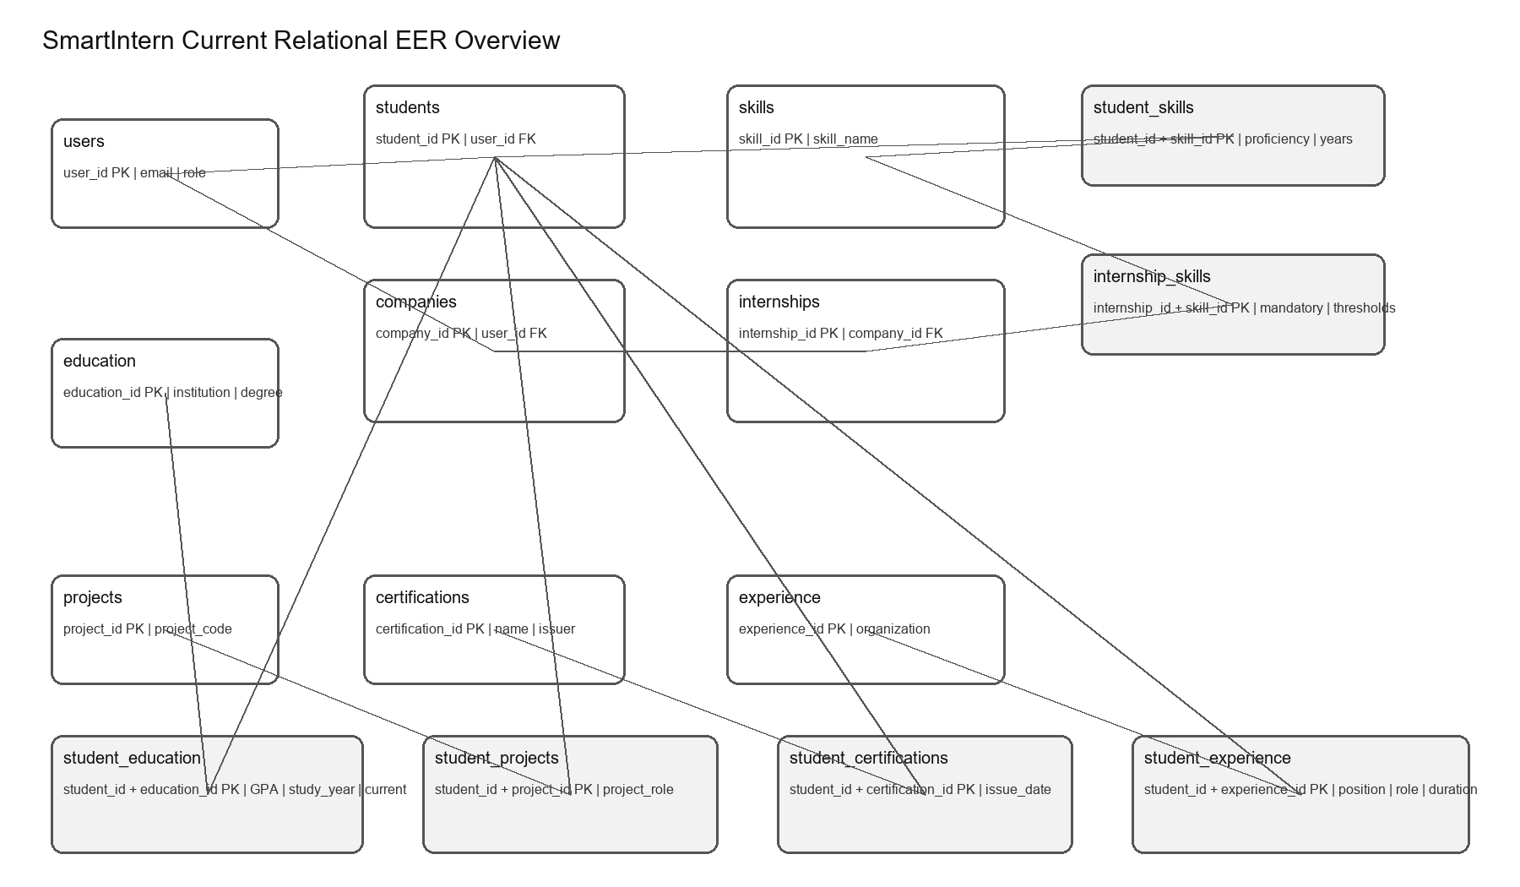
Figure 1. Current relational EER overview. Applications connect Students and Internships and are described in the schema tables below.

7 Entity and Relationship Tables
Table | Primary key | Important attributes | Purpose
users | user_id | email, password_hash, role | Authentication account
students | student_id | user_id, first_name, last_name | Student subtype profile
companies | company_id | user_id, company_name, description | Company subtype profile
internships | internship_id | company_id, title, min_gpa, min_study_year | Company opportunity
skills | skill_id | skill_name, category, description | Reusable skill catalog
education | education_id | institution, degree | Reusable education catalog
projects | project_id | project_code, project_name, description, technologies | Shared group project
certifications | certification_id | certification_name, issuer | Reusable certification catalog
experience | experience_id | organization | Reusable organization record
student_skills | student_id + skill_id | proficiency_level, years_experience, last_used_year | Student-skill bridge
internship_skills | internship_id + skill_id | is_mandatory, minimum_proficiency, required_years | Internship-skill bridge
student_education | student_id + education_id | gpa, study_year, graduation_year, is_current | Student education bridge
student_projects | student_id + project_id | project_role | Student project bridge
student_certifications | student_id + certification_id | issue_date | Student certification bridge
student_experience | student_id + experience_id | position_title, role, duration_months | Student experience bridge
applications | application_id | student_id, internship_id, application_date, status, match_score | Application transaction

8 Relational Schema Mapping
The conceptual entities are mapped to relations by assigning a primary key to every strong entity and carrying the parent key into dependent relations as a foreign key. Many-to-many relationships are converted into associative relations with composite primary keys. Student-specific attributes such as GPA, project role, issue date and experience position are stored in the associative relations because those values vary by student.
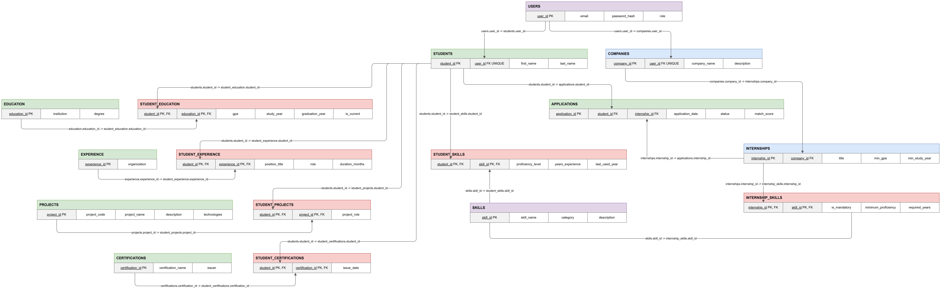
Figure 2. Relational schema mapping with connectors terminating at the exact primary-key and foreign-key cells.
Conceptual relationship | Relational mapping | Implementation detail
User - Student | users(user_id) to students(user_id) | 1:1; students.user_id is UNIQUE and FK
User - Company | users(user_id) to companies(user_id) | 1:1; companies.user_id is UNIQUE and FK
Student - Skill | student_skills(student_id, skill_id) | M:N bridge with proficiency data
Internship - Skill | internship_skills(internship_id, skill_id) | M:N bridge with requirement data
Student - Education | student_education(student_id, education_id) | M:N bridge with GPA and current flag
Student - Project | student_projects(student_id, project_id) | M:N bridge with project_role
Student - Certification | student_certifications(student_id, certification_id) | M:N bridge with issue_date
Student - Experience | student_experience(student_id, experience_id) | M:N bridge with position and role
Student - Internship | applications(student_id, internship_id) | M:N transaction with unique application pair

9 Functional Dependencies
Functional dependencies describe which attributes determine other attributes. They support the normalization analysis and explain why catalog data is separated from student-specific relationship data.
Relation | Functional dependencies
users | user_id -> email, password_hash, role; email -> user_id, password_hash, role
students | student_id -> user_id, first_name, last_name; user_id -> student_id, first_name, last_name
companies | company_id -> user_id, company_name, description; user_id -> company_id, company_name, description
education | education_id -> institution, degree; (institution, degree) -> education_id
skills | skill_id -> skill_name, category, description; skill_name -> skill_id, category, description
projects | project_id -> project_code, project_name, description, technologies; project_code -> project_id, project_name, description, technologies
certifications | certification_id -> certification_name, issuer; (certification_name, issuer) -> certification_id
experience | experience_id -> organization; organization -> experience_id
student_skills | (student_id, skill_id) -> proficiency_level, years_experience, last_used_year
internship_skills | (internship_id, skill_id) -> is_mandatory, minimum_proficiency, required_years
student_education | (student_id, education_id) -> gpa, study_year, graduation_year, is_current
student_projects | (student_id, project_id) -> project_role
student_certifications | (student_id, certification_id) -> issue_date
student_experience | (student_id, experience_id) -> position_title, role, duration_months
applications | application_id -> student_id, internship_id, application_date, status, match_score; (student_id, internship_id) -> application details

10 Normalization

10.1 Unnormalized form
A single recruitment record could contain repeated skills, education, projects, certifications, experience and applications. These repeating groups cause duplication and update anomalies.

10.2 First normal form
All fields are atomic, and repeating groups are moved into separate relations. No skills, education, projects, certifications, experience or applications are stored as lists.

10.3 Second normal form
Attributes depending on only part of a composite key are moved to their entity relations. Relationship-specific attributes remain in bridge tables and depend on the complete composite key.

10.4 Third normal form
Transitive dependencies are removed by separating accounts, profiles, internships and reusable catalog records. The final relations keep non-key attributes dependent only on their relation's key.

10.5 Detailed normalization decomposition
The following tables show the main decomposition and dependency checks.

From an unnormalized relation to 1NF
A possible unnormalized relation could be written as StudentProfile(StudentID, StudentName, Email, EducationList, SkillList, ProjectList, CertificationList, ExperienceList, ApplicationList). The list attributes contain repeating groups, so a student with several skills or applications would require multiple values inside one field. This creates update and deletion anomalies.
To reach 1NF, all repeating groups are made atomic and stored as separate rows. Student details move to students, account details move to users, and each relationship list becomes a separate bridge or transaction relation. No relation stores a comma-separated list of skills, projects, certifications, experiences or applications.
1NF relation | Atomic attributes
users | user_id, email, password_hash, role
students | student_id, user_id, first_name, last_name
companies | company_id, user_id, company_name, description
student_skills | student_id, skill_id, proficiency_level, years_experience, last_used_year
student_education | student_id, education_id, gpa, study_year, graduation_year, is_current
applications | application_id, student_id, internship_id, application_date, status, match_score

From 1NF to 2NF
Partial dependencies are removed from composite-key bridge relations by moving shared entity attributes to their own tables.
Partial dependency found | Decomposition | Result
student_id -> first_name, last_name | Move student attributes from a combined profile relation to students. | students(student_id, user_id, first_name, last_name)
skill_id -> skill_name, category, description | Move shared skill details to skills. | skills(skill_id, skill_name, category, description)
education_id -> institution, degree | Move shared education details to education. | education(education_id, institution, degree)
project_id -> project_code, project_name, description, technologies | Move shared project details to projects. | projects(project_id, project_code, project_name, description, technologies)
certification_id -> certification_name, issuer | Move shared certification details to certifications. | certifications(certification_id, certification_name, issuer)
experience_id -> organization | Move shared organization details to experience. | experience(experience_id, organization)
internship_id -> title, company_id, min_gpa, min_study_year | Move internship details to internships. | internships(internship_id, company_id, title, min_gpa, min_study_year)

Relationship-specific attributes now depend on the complete composite key. For example, (student_id, skill_id) determines proficiency_level and years_experience.
Fully dependent relation | Functional dependency
student_skills | (student_id, skill_id) -> proficiency_level, years_experience, last_used_year
internship_skills | (internship_id, skill_id) -> is_mandatory, minimum_proficiency, required_years
student_education | (student_id, education_id) -> gpa, study_year, graduation_year, is_current
student_projects | (student_id, project_id) -> project_role
student_certifications | (student_id, certification_id) -> issue_date
student_experience | (student_id, experience_id) -> position_title, role, duration_months

From 2NF to 3NF
The final check removes dependencies between non-key attributes by keeping each subject in its own relation.
Transitive dependency risk | 3NF solution
user_id -> role -> profile type | Keep role in users and keep student or company attributes in their subtype table.
company_id -> company_name -> internship description | Keep company_name in companies and internship attributes in internships.
skill_id -> skill_name -> skill category | Keep all shared skill catalog attributes in skills.
education_id -> institution -> degree | Keep the institution and degree pair together in education.
experience_id -> organization -> student position | Keep organization in experience and position_title, role and duration in student_experience.
student_id, internship_id -> application details | Keep application-specific values in applications and enforce the unique student-internship pair.

Therefore, the final schema is in 3NF. Unique constraints also prevent duplicate education, certification and application records.

11 Matching and Business SQL
The matching query generates every student-internship pair, joins each pair to the internship requirements and the student profile, counts satisfied and failed mandatory skills, and calculates the score. Skills contribute 60 points, GPA contributes 20 points and study year contributes 20 points. A failed mandatory skill sets only the skill component to zero. GPA and study year components are independently set to zero when their minimum is not met.
Skill points = (satisfied skills / total required skills) * 60; this component is zero if any mandatory skill fails. Internships without skill requirements are excluded from matching and cannot receive applications.
GPA points = (GPA / 4.00) * 20 when GPA >= minimum GPA; otherwise zero.
Study-year points = (MIN(study year, 4) / 4.00) * 20 when study year >= minimum study year; otherwise zero.
Match score = skill points + GPA points + study-year points.
The three main business queries are stored in database/03_business_queries.sql. They answer the best qualified students per internship, missing mandatory skills for a selected pair, and match scores for all student-internship pairs.

12 DDL Implementation
The DDL is stored in database/01_create_schema.sql. It creates the smartintern_db database and the tables in parent-to-child order. Primary keys identify records, unique constraints prevent duplicate catalog values, foreign keys enforce relationships, CHECK constraints validate ranges and ON DELETE rules protect important records.
-- Final schema for MySQL 8.0.13+ (functional index enforces one current education row per student).
-- Role/profile triggers enforce the disjoint subtype mapping; the application
-- must create the matching profile as part of account creation.
CREATE DATABASE IF NOT EXISTS smartintern_db;
USE smartintern_db;
CREATE TABLE users (
user_id INT AUTO_INCREMENT PRIMARY KEY,
email VARCHAR(255) NOT NULL UNIQUE,
password_hash VARCHAR(255) NOT NULL,
role ENUM('Student', 'Company') NOT NULL
);
CREATE TABLE students (
student_id INT AUTO_INCREMENT PRIMARY KEY,
user_id INT NOT NULL UNIQUE,
first_name VARCHAR(100) NOT NULL,
last_name VARCHAR(100) NOT NULL,
CONSTRAINT fk_students_user
FOREIGN KEY (user_id) REFERENCES users(user_id)
ON DELETE RESTRICT ON UPDATE CASCADE
);
CREATE TABLE companies (
company_id INT AUTO_INCREMENT PRIMARY KEY,
user_id INT NOT NULL UNIQUE,
company_name VARCHAR(255) NOT NULL,
description TEXT,
CONSTRAINT fk_companies_user
FOREIGN KEY (user_id) REFERENCES users(user_id)
ON DELETE RESTRICT ON UPDATE CASCADE
);
CREATE TABLE skills (
skill_id INT AUTO_INCREMENT PRIMARY KEY,
skill_name VARCHAR(100) NOT NULL UNIQUE,
category VARCHAR(100),
description TEXT
);
CREATE TABLE education (
education_id INT AUTO_INCREMENT PRIMARY KEY,
institution VARCHAR(255) NOT NULL,
degree VARCHAR(255) NOT NULL,
UNIQUE KEY uq_education_institution_degree (institution, degree)
);
CREATE TABLE projects (
project_id INT AUTO_INCREMENT PRIMARY KEY,
project_code VARCHAR(30) NOT NULL UNIQUE,
project_name VARCHAR(255) NOT NULL,
description TEXT,
technologies TEXT
);
CREATE TABLE certifications (
certification_id INT AUTO_INCREMENT PRIMARY KEY,
certification_name VARCHAR(255) NOT NULL,
issuer VARCHAR(255) NOT NULL,
UNIQUE KEY uq_certification_name_issuer (certification_name, issuer)
);
CREATE TABLE experience (
experience_id INT AUTO_INCREMENT PRIMARY KEY,
organization VARCHAR(255) NOT NULL,
UNIQUE KEY uq_experience_organization (organization)
);
CREATE TABLE internships (
internship_id INT AUTO_INCREMENT PRIMARY KEY,
company_id INT NOT NULL,
title VARCHAR(255) NOT NULL,
min_gpa DECIMAL(3,2) NOT NULL,
min_study_year TINYINT UNSIGNED NOT NULL,
CONSTRAINT chk_internships_min_gpa
CHECK (min_gpa BETWEEN 0.00 AND 4.00),
CONSTRAINT chk_internships_min_study_year
CHECK (min_study_year >= 1),
CONSTRAINT fk_internships_company
FOREIGN KEY (company_id) REFERENCES companies(company_id)
ON DELETE RESTRICT ON UPDATE CASCADE
);
CREATE TABLE student_skills (
student_id INT NOT NULL,
skill_id INT NOT NULL,
proficiency_level TINYINT UNSIGNED NOT NULL,
years_experience DECIMAL(4,1) NOT NULL,
last_used_year YEAR,
PRIMARY KEY (student_id, skill_id),
CONSTRAINT chk_student_skills_proficiency
CHECK (proficiency_level BETWEEN 1 AND 5),
CONSTRAINT chk_student_skills_years
CHECK (years_experience >= 0),
CONSTRAINT fk_student_skills_student
FOREIGN KEY (student_id) REFERENCES students(student_id)
ON DELETE CASCADE ON UPDATE CASCADE,
CONSTRAINT fk_student_skills_skill
FOREIGN KEY (skill_id) REFERENCES skills(skill_id)
ON DELETE CASCADE ON UPDATE CASCADE
);
CREATE TABLE internship_skills (
internship_id INT NOT NULL,
skill_id INT NOT NULL,
is_mandatory BOOLEAN NOT NULL DEFAULT FALSE,
minimum_proficiency TINYINT UNSIGNED NOT NULL,
required_years DECIMAL(4,1) NOT NULL,
PRIMARY KEY (internship_id, skill_id),
CONSTRAINT chk_internship_skills_proficiency
CHECK (minimum_proficiency BETWEEN 1 AND 5),
CONSTRAINT chk_internship_skills_years
CHECK (required_years >= 0),
CONSTRAINT fk_internship_skills_internship
FOREIGN KEY (internship_id) REFERENCES internships(internship_id)
ON DELETE CASCADE ON UPDATE CASCADE,
CONSTRAINT fk_internship_skills_skill
FOREIGN KEY (skill_id) REFERENCES skills(skill_id)
ON DELETE RESTRICT ON UPDATE CASCADE
);
CREATE TABLE student_education (
student_id INT NOT NULL,
education_id INT NOT NULL,
gpa DECIMAL(3,2) NOT NULL,
study_year TINYINT UNSIGNED NOT NULL,
graduation_year YEAR,
is_current BOOLEAN NOT NULL DEFAULT TRUE,
PRIMARY KEY (student_id, education_id),
UNIQUE KEY uq_student_one_current_education ((CASE WHEN is_current = TRUE THEN student_id ELSE NULL END)),
CONSTRAINT chk_student_education_gpa
CHECK (gpa BETWEEN 0.00 AND 4.00),
CONSTRAINT chk_student_education_study_year
CHECK (study_year >= 1),
CONSTRAINT fk_student_education_student
FOREIGN KEY (student_id) REFERENCES students(student_id)
ON DELETE CASCADE ON UPDATE CASCADE,
CONSTRAINT fk_student_education_education
FOREIGN KEY (education_id) REFERENCES education(education_id)
ON DELETE RESTRICT ON UPDATE CASCADE
);
CREATE TABLE student_projects (
student_id INT NOT NULL,
project_id INT NOT NULL,
project_role VARCHAR(255) NOT NULL,
PRIMARY KEY (student_id, project_id),
CONSTRAINT fk_student_projects_student
FOREIGN KEY (student_id) REFERENCES students(student_id)
ON DELETE CASCADE ON UPDATE CASCADE,
CONSTRAINT fk_student_projects_project
FOREIGN KEY (project_id) REFERENCES projects(project_id)
ON DELETE RESTRICT ON UPDATE CASCADE
);
CREATE TABLE student_certifications (
student_id INT NOT NULL,
certification_id INT NOT NULL,
issue_date DATE NOT NULL,
PRIMARY KEY (student_id, certification_id),
CONSTRAINT fk_student_certifications_student
FOREIGN KEY (student_id) REFERENCES students(student_id)
ON DELETE CASCADE ON UPDATE CASCADE,
CONSTRAINT fk_student_certifications_certification
FOREIGN KEY (certification_id) REFERENCES certifications(certification_id)
ON DELETE RESTRICT ON UPDATE CASCADE
);
CREATE TABLE student_experience (
student_id INT NOT NULL,
experience_id INT NOT NULL,
position_title VARCHAR(255) NOT NULL,
role VARCHAR(255) NOT NULL,
duration_months INT UNSIGNED NOT NULL,
PRIMARY KEY (student_id, experience_id),
CONSTRAINT fk_student_experience_student
FOREIGN KEY (student_id) REFERENCES students(student_id)
ON DELETE CASCADE ON UPDATE CASCADE,
CONSTRAINT fk_student_experience_experience
FOREIGN KEY (experience_id) REFERENCES experience(experience_id)
ON DELETE RESTRICT ON UPDATE CASCADE
);
CREATE TABLE applications (
application_id INT AUTO_INCREMENT PRIMARY KEY,
student_id INT NOT NULL,
internship_id INT NOT NULL,
application_date DATE NOT NULL,
status ENUM('Pending', 'Under Review', 'Accepted', 'Rejected') NOT NULL,
match_score DECIMAL(5,2) NOT NULL,
UNIQUE KEY uq_application_student_internship (student_id, internship_id),
CONSTRAINT chk_applications_match_score
CHECK (match_score BETWEEN 0.00 AND 100.00),
CONSTRAINT fk_applications_student
FOREIGN KEY (student_id) REFERENCES students(student_id)
ON DELETE RESTRICT ON UPDATE CASCADE,
CONSTRAINT fk_applications_internship
FOREIGN KEY (internship_id) REFERENCES internships(internship_id)
ON DELETE RESTRICT ON UPDATE CASCADE
);
-- Enforce the disjoint User subtype mapping. Total participation is completed
-- by the app creating the matching profile in the same account workflow.
DELIMITER $$
CREATE TRIGGER trg_applications_require_skill
BEFORE INSERT ON applications
FOR EACH ROW
BEGIN
IF NOT EXISTS (
SELECT 1 FROM internship_skills
WHERE internship_id = NEW.internship_id
) THEN
SIGNAL SQLSTATE '45000'
SET MESSAGE_TEXT = 'Internship requires at least one skill before applications';
END IF;
END$$
CREATE TRIGGER trg_users_role_update
BEFORE UPDATE ON users
FOR EACH ROW
BEGIN
IF NEW.role <> OLD.role
AND (EXISTS (SELECT 1 FROM students WHERE user_id = OLD.user_id)
OR EXISTS (SELECT 1 FROM companies WHERE user_id = OLD.user_id)) THEN
SIGNAL SQLSTATE '45000'
SET MESSAGE_TEXT = 'Account role cannot change while a profile exists';
END IF;
END$$
CREATE TRIGGER trg_students_role_insert
BEFORE INSERT ON students
FOR EACH ROW
BEGIN
IF NOT EXISTS (SELECT 1 FROM users WHERE user_id = NEW.user_id AND role = 'Student') THEN
SIGNAL SQLSTATE '45000' SET MESSAGE_TEXT = 'Student profile requires a Student user account';
END IF;
END$$
CREATE TRIGGER trg_students_role_update
BEFORE UPDATE ON students
FOR EACH ROW
BEGIN
IF NOT EXISTS (SELECT 1 FROM users WHERE user_id = NEW.user_id AND role = 'Student') THEN
SIGNAL SQLSTATE '45000' SET MESSAGE_TEXT = 'Student profile requires a Student user account';
END IF;
END$$
CREATE TRIGGER trg_companies_role_insert
BEFORE INSERT ON companies
FOR EACH ROW
BEGIN
IF NOT EXISTS (SELECT 1 FROM users WHERE user_id = NEW.user_id AND role = 'Company') THEN
SIGNAL SQLSTATE '45000' SET MESSAGE_TEXT = 'Company profile requires a Company user account';
END IF;
END$$
CREATE TRIGGER trg_companies_role_update
BEFORE UPDATE ON companies
FOR EACH ROW
BEGIN
IF NOT EXISTS (SELECT 1 FROM users WHERE user_id = NEW.user_id AND role = 'Company') THEN
SIGNAL SQLSTATE '45000' SET MESSAGE_TEXT = 'Company profile requires a Company user account';
END IF;
END$$
DELIMITER ;
The complete schema file includes primary and foreign keys, uniqueness and range constraints, current-education enforcement, role/profile consistency triggers, and a trigger that rejects applications until the internship has at least one skill requirement.

13 DML and Sample Data
The DML is stored in database/02_sample_data.sql. It inserts fabricated users, student and company profiles, skills, education, projects, certifications, experience, internships, bridge-table records and applications. The sample records are designed to demonstrate qualified and not-fully-qualified matching outcomes without using real personal data.
-- Demo rows match each account role to one profile and provide one current
-- education record for each student with education data.
USE smartintern_db;
INSERT INTO users (user_id, email, password_hash, role) VALUES
(1, 'alice@example.com', '$2a$12$tWnymM1EprRp4p6R0mhk.e3GMFUOMlpQKGSG0J0cz0kpuHzN9jMe.', 'Student'),
(2, 'bob@example.com', '$2a$12$tWnymM1EprRp4p6R0mhk.e3GMFUOMlpQKGSG0J0cz0kpuHzN9jMe.', 'Student'),
(3, 'chen@example.com', '$2a$12$tWnymM1EprRp4p6R0mhk.e3GMFUOMlpQKGSG0J0cz0kpuHzN9jMe.', 'Student'),
(4, 'recruiter@techbridge.example', '$2a$12$1fRSV5YhK9t1//./SzfgfetQ0AQ5iXeSg15nGmhCtGn.0jU3.jwgW', 'Company'),
(5, 'hr@dataspark.example', '$2a$12$1fRSV5YhK9t1//./SzfgfetQ0AQ5iXeSg15nGmhCtGn.0jU3.jwgW', 'Company');
INSERT INTO students (student_id, user_id, first_name, last_name) VALUES
(1, 1, 'Alice', 'Tan'),
(2, 2, 'Bob', 'Lim'),
(3, 3, 'Chen', 'Ong');
INSERT INTO companies (company_id, user_id, company_name, description) VALUES
(1, 4, 'TechBridge Solutions', 'Software development and consulting company.'),
(2, 5, 'DataSpark Analytics', 'Data analytics and business intelligence company.');
INSERT INTO skills (skill_id, skill_name, category, description) VALUES
(1, 'SQL', 'Database', 'Writing queries and working with relational databases.'),
(2, 'JavaScript', 'Programming', 'Programming for web applications.'),
(3, 'Git', 'Tools', 'Version control and collaboration.'),
(4, 'Python', 'Programming', 'General-purpose programming and data work.'),
(5, 'Data Analysis', 'Analytics', 'Cleaning, exploring, and interpreting data.'),
(6, 'HTML/CSS', 'Web', 'Building and styling web pages.');
INSERT INTO education (education_id, institution, degree) VALUES
(1, 'Smart University', 'BSc Computer Science'),
(2, 'Smart University', 'BSc Information Technology'),
(3, 'City College', 'Diploma in Computing');
INSERT INTO projects (project_id, project_code, project_name, description, technologies) VALUES
(1, 'PRJ-0001', 'SmartIntern', 'A rule-based internship matching database project.', 'MySQL, Node.js, HTML, CSS, JavaScript'),
(2, 'PRJ-0002', 'Campus Event Portal', 'A portal for managing university events.', 'MySQL, JavaScript, HTML/CSS');
INSERT INTO certifications (certification_id, certification_name, issuer) VALUES
(1, 'Database Fundamentals', 'Smart University'),
(2, 'Cloud Practitioner Basics', 'Training Provider');
INSERT INTO experience (experience_id, organization) VALUES
(1, 'University IT Help Desk'),
(2, 'Community Technology Group');
INSERT INTO internships (internship_id, company_id, title, min_gpa, min_study_year) VALUES
(1, 1, 'Junior Web Developer Intern', 3.00, 2),
(2, 1, 'Data Engineering Intern', 3.50, 3),
(3, 2, 'Business Intelligence Intern', 3.00, 2);
INSERT INTO student_skills
(student_id, skill_id, proficiency_level, years_experience, last_used_year)
VALUES
(1, 1, 4, 2.0, 2026),
(1, 2, 3, 1.0, 2026),
(1, 3, 2, 1.0, 2026),
(1, 4, 3, 1.0, 2026),
(1, 5, 3, 1.0, 2026),
(2, 1, 3, 1.0, 2026),
(2, 2, 2, 0.5, 2026),
(2, 4, 2, 0.5, 2025),
(3, 1, 4, 2.0, 2026),
(3, 2, 3, 1.0, 2026),
(3, 3, 3, 1.0, 2026),
(3, 4, 3, 1.0, 2026),
(3, 5, 4, 2.0, 2026);
INSERT INTO internship_skills
(internship_id, skill_id, is_mandatory, minimum_proficiency, required_years)
VALUES
(1, 1, TRUE, 3, 1.0),
(1, 2, TRUE, 2, 0.0),
(1, 3, FALSE, 2, 0.0),
(2, 1, TRUE, 3, 1.0),
(2, 4, TRUE, 3, 1.0),
(2, 5, FALSE, 3, 1.0),
(3, 1, TRUE, 3, 1.0),
(3, 5, TRUE, 3, 1.0),
(3, 3, FALSE, 2, 0.0);
INSERT INTO student_education
(student_id, education_id, gpa, study_year, graduation_year, is_current)
VALUES
(1, 1, 3.60, 3, 2027, TRUE),
(1, 3, 3.20, 1, 2025, FALSE),
(2, 2, 3.20, 2, 2028, TRUE),
(3, 1, 2.80, 2, 2028, TRUE);
INSERT INTO student_projects (student_id, project_id, project_role) VALUES
(1, 1, 'Database designer'),
(2, 1, 'Backend contributor'),
(3, 1, 'Query and report developer'),
(1, 2, 'Frontend contributor');
INSERT INTO student_certifications (student_id, certification_id, issue_date) VALUES
(1, 1, '2026-03-15'),
(2, 1, '2026-04-20'),
(3, 2, '2026-05-10');
INSERT INTO student_experience
(student_id, experience_id, position_title, role, duration_months)
VALUES
(1, 1, 'IT Support Assistant', 'Support assistant', 8),
(2, 1, 'IT Support Assistant', 'Support assistant', 5),
(3, 2, 'Volunteer Developer', 'Developer', 6);
INSERT INTO applications
(application_id, student_id, internship_id, application_date, status, match_score)
VALUES
(1, 1, 1, '2026-09-20', 'Under Review', 93.00),
(2, 2, 1, '2026-09-21', 'Pending', 66.00),
(3, 3, 1, '2026-09-22', 'Pending', 70.00),
(4, 1, 2, '2026-09-23', 'Accepted', 93.00),
(5, 3, 3, '2026-09-24', 'Under Review', 70.00);
The optional database/04_seed_demo_opportunities.sql file adds 8 companies and 17 internships after the base schema and sample data, bringing the demo catalog to 10 companies and 20 internships. It can be rerun safely.

14 Technology Stack
Technology | Use in SmartIntern
MySQL Community Server | Relational database engine for persistent data, constraints and SQL queries.
MySQL Workbench | Schema execution, table inspection, query execution and database demonstrations.
Node.js and Express | Backend server, REST endpoints, sessions, role checks and database access.
HTML, CSS and JavaScript | Browser interface for student and company workflows.
GitHub | Version control and collaboration among team members.
Localhost | Zero-cost environment for the term-project demonstration.

15 User Interface Evidence
The application provides the live demonstration layer for the database project. The screenshots below show database-backed workflows. They should be replaced or supplemented with final screenshots captured from the team’s latest build before submission.
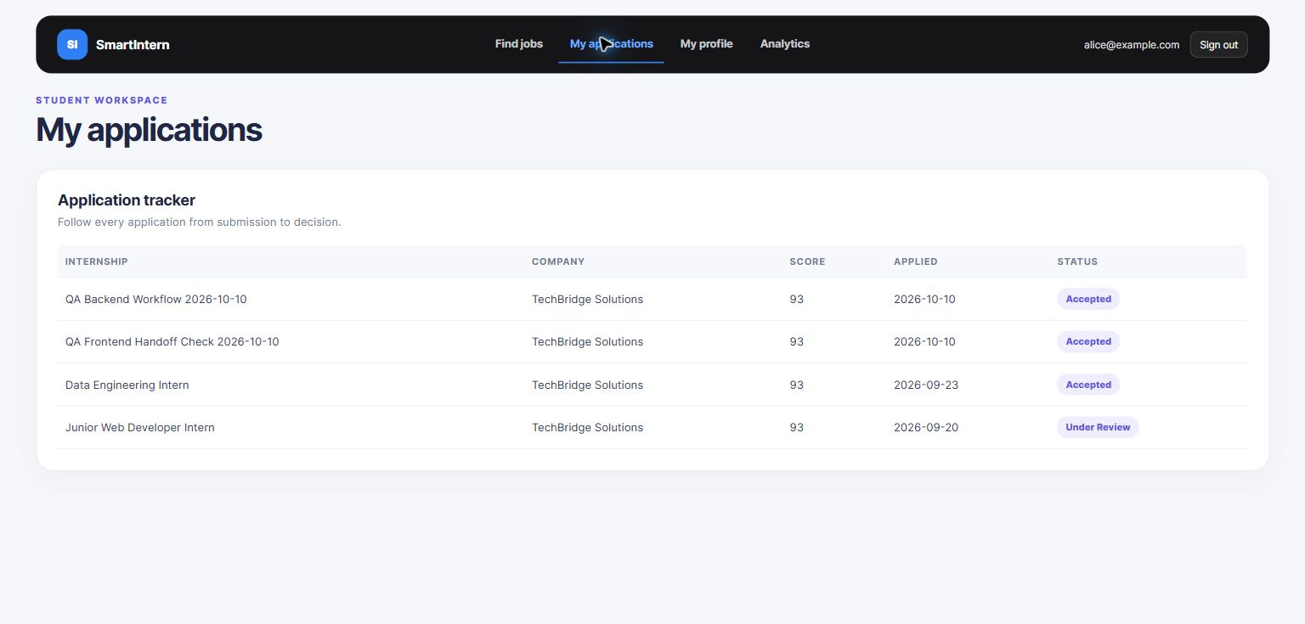
Figure 3. Student application and accepted-status workflow.
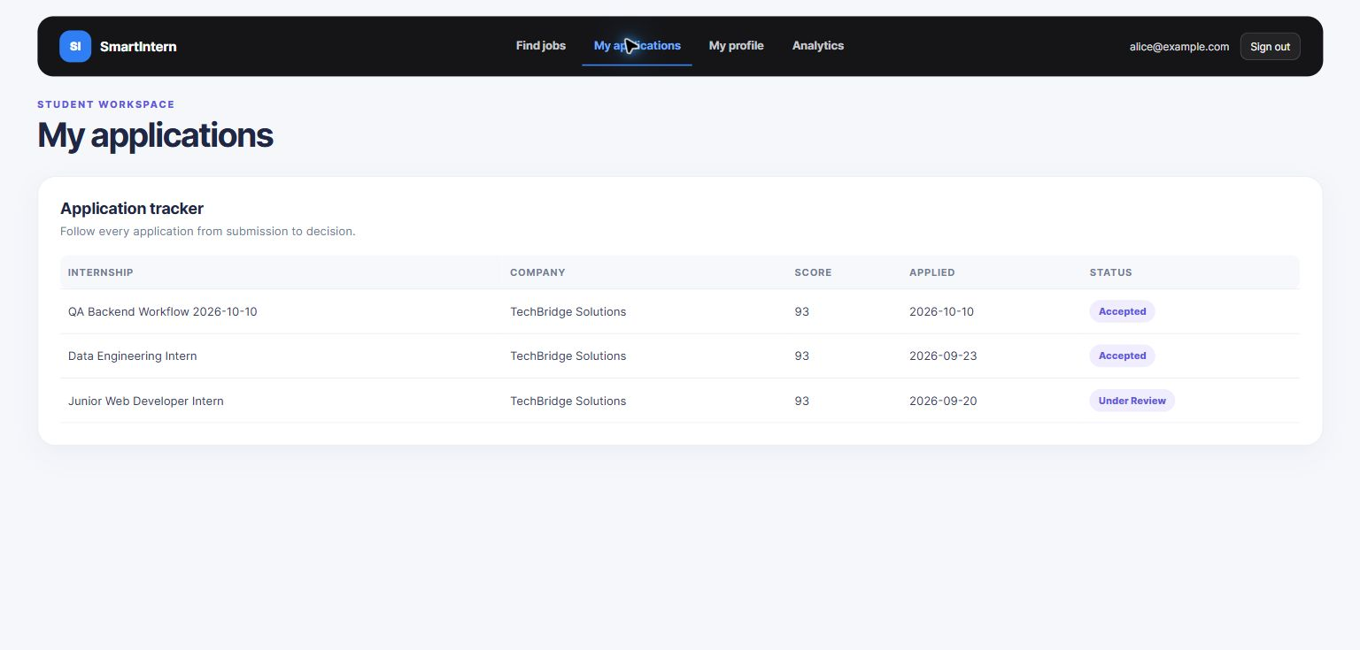
Figure 4. Student view showing an accepted application.
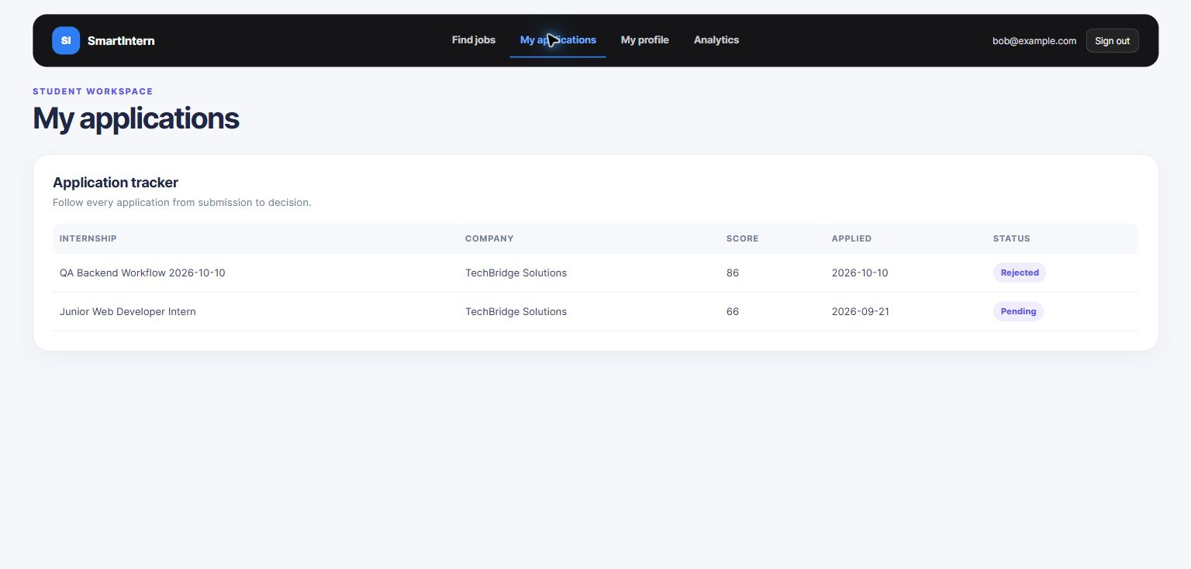
Figure 5. Student view showing a rejected application.
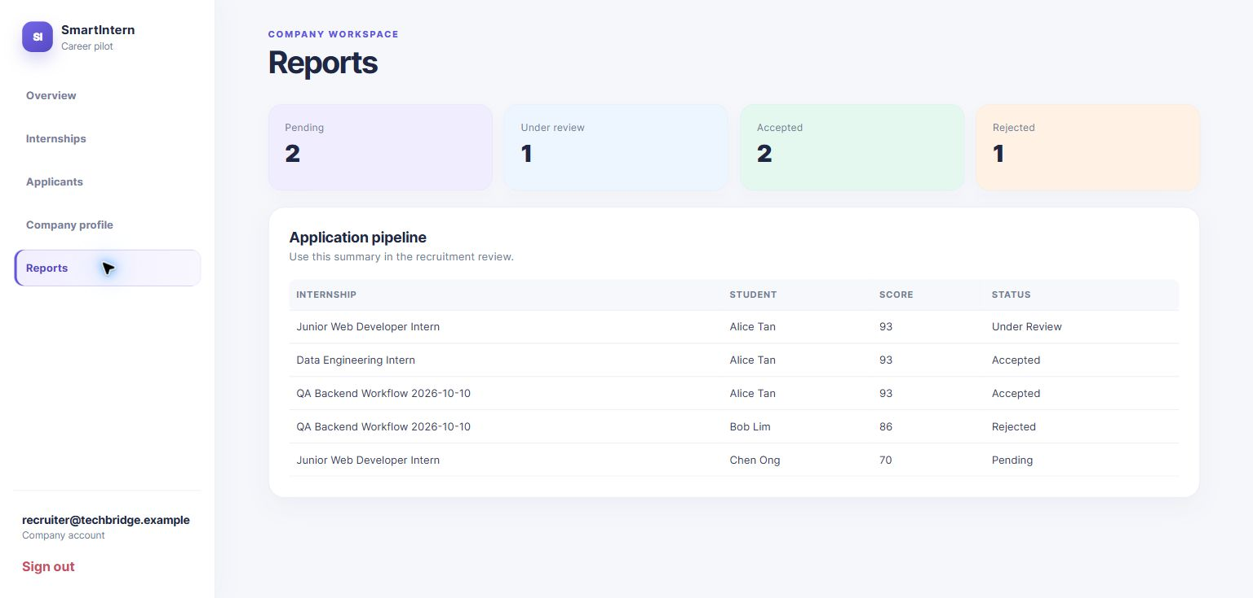
Figure 6. Company reporting and applicant analysis view.

16 Milestones
Milestone | Deliverable | Owner
M1 Proposal and requirements | Approved project scope, business rules and database requirements. | All members
M2 EER and relational design | Updated EER diagram, entity descriptions and relational schema mapping. | Ye Lin Aung and Win Khant Ko Ko
M3 Normalization and SQL design | Functional dependencies, 1NF to 3NF analysis, DDL and FK review. | Hein Htet Aung and Win Khant Ko Ko
M4 SQL implementation | MySQL schema, sample data and business queries. | Hein Htet Aung and Win Khant Ko Ko
M5 Application integration | Backend endpoints, frontend workflows and database-backed matching. | All members
M6 Presentation and report | Final documentation, UI screenshots, SQL evidence and recorded demonstration. | All members

17 Conclusion
SmartIntern demonstrates how a normalized MySQL database can support a complete internship matching workflow. The design separates account, profile, catalog, bridge and transaction data; enforces relationships with primary and foreign keys; prevents important duplicates; and produces transparent match scores using stored requirements and current education information. The web application provides a practical interface for testing the database rules and showing how changes made through the UI are reflected in reports and application records.

Appendix A SQL File Map
File | Purpose
database/01_create_schema.sql | Fresh database creation, relational schema, and integrity triggers.
database/02_sample_data.sql | Fabricated sample records for demonstration.
database/04_seed_demo_opportunities.sql | Optional seed for the larger demo catalog.
database/03_business_queries.sql | Three business questions and matching reports.

Appendix B Evidence Checklist
- Fresh schema executes successfully in MySQL Workbench.
- Sample data loads successfully after the schema.
- Business queries return match scores and qualification outcomes.
- Student and Company role boundaries work through the UI.
- A student can add or select reusable catalog records.
- A company can create internships and skill requirements.
- Applications are unique per student and internship.
- Final ERD image matches the current database schema.
- Final UI screenshots are captured from the latest team build.

