AI4I 2020 — Predictive Maintenance
Exploratory Data Analysis Report
Prepared by: Win | Project #1 of 3 — Industrial Data Analyst Portfolio | May 2026
1. Executive Summary
This report explores the AI4I 2020 dataset — 10,000 records of synthetic but realistic machine sensor readings designed to mirror real predictive-maintenance scenarios. The goal: understand how, when, and why machines fail, and turn that understanding into a foundation for a predictive model and a Looker Studio dashboard.
Top-line numbers
Records analyzed  10,000  0 missing, 0 duplicates | Failure rate  3.39%  339 of 10,000 machines | Most common cause  HDF  Heat Dissipation — 33.9% | Highest-risk variant  L (Low)  3.92% fail rate

Bottom line
Failures are rare (3.4%) but predictable. Heat dissipation issues drive a third of all failures, and lower-grade machines fail almost twice as often as high-grade ones.

2. Key Findings
Finding 1 — Failures are rare but real
Out of 10,000 machine cycles, 339 ended in failure. That is a 3.39% failure rate.
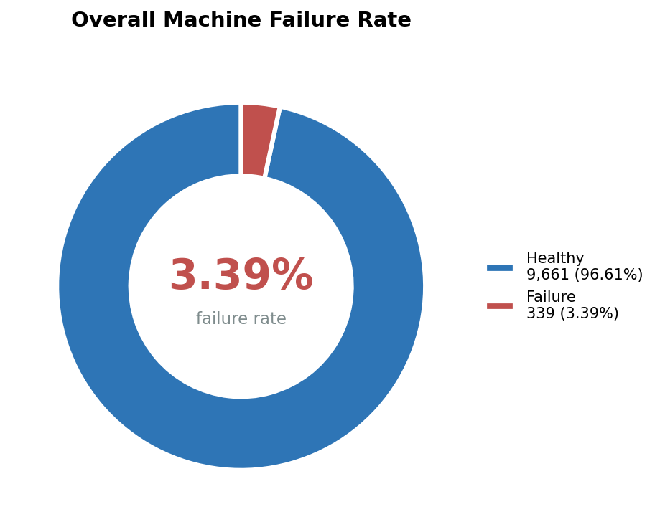
Figure 1 — Overall machine failure rate (339 / 10,000)
Finding 2 — Heat dissipation is the single biggest cause
When a machine does fail, the most likely reason is HDF — 115 of the 339 failures.
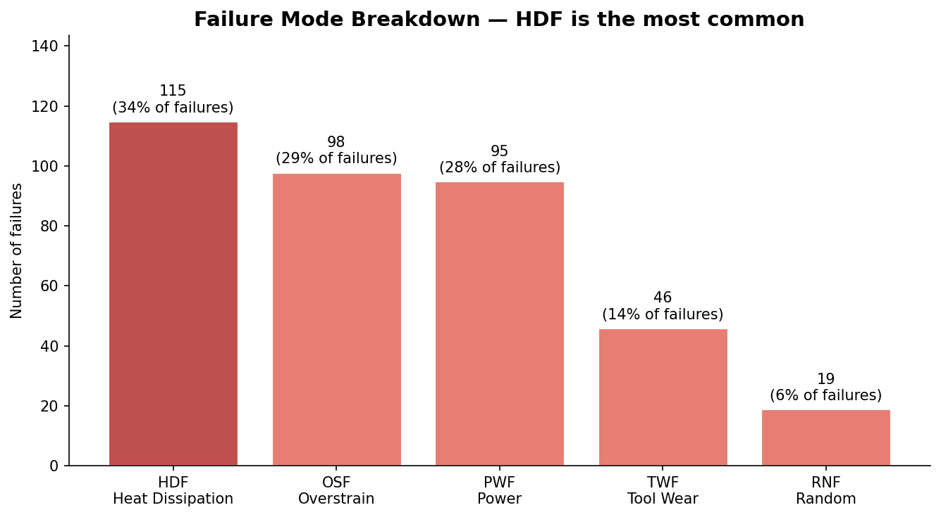
Figure 2 — Failure breakdown by cause
Finding 3 — Lower-quality machines fail nearly 2× more
L (Low) variant fails at 3.92% — almost double the H (High) variant's 2.09%.
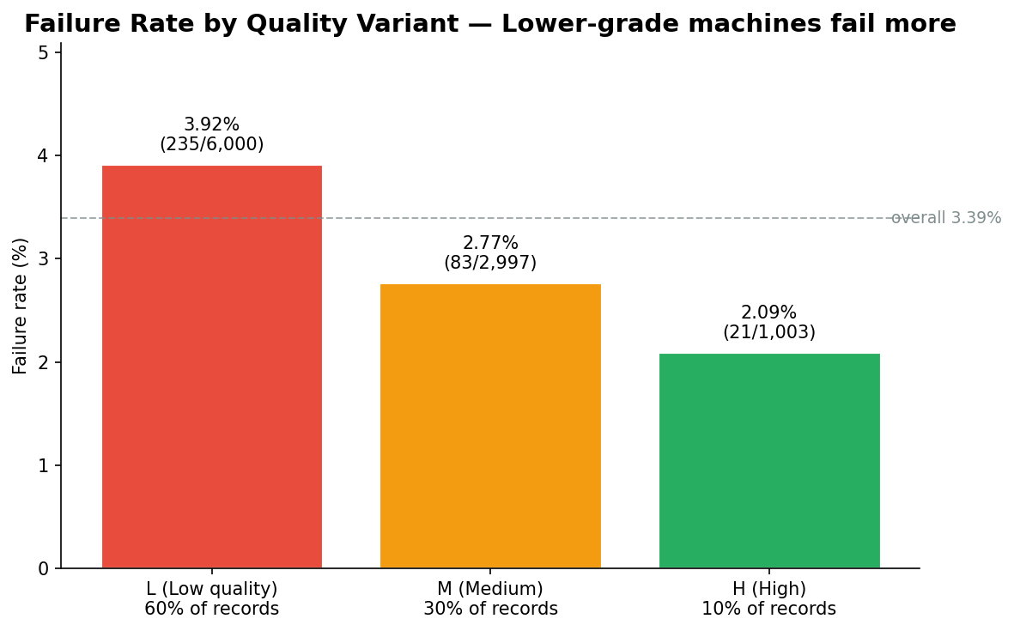
Figure 3 — Failure rate by quality variant

Finding 4 — Failures cluster in a clear operating window
Failures concentrate where torque is high AND rotational speed is low — the danger zone.
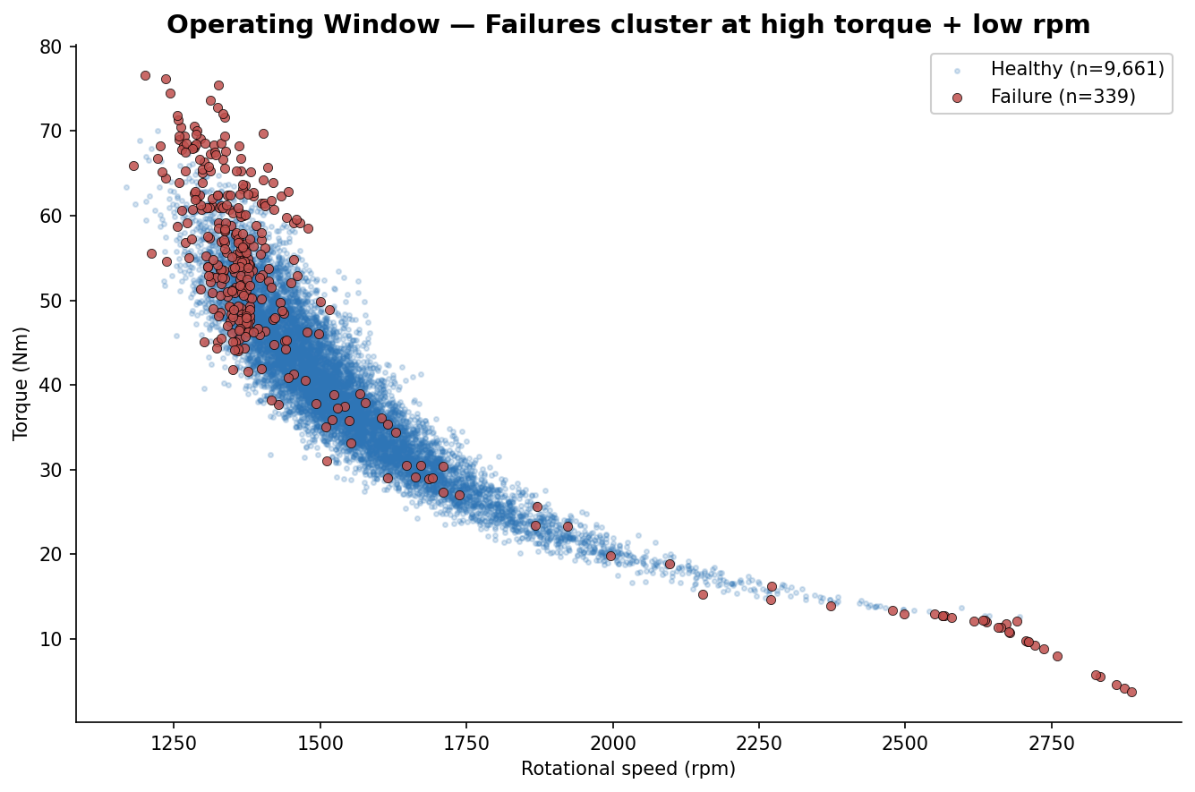
Figure 4 — Operating window
Operational rule of thumb
If torque > 60 Nm AND rotational speed < 1,400 rpm, the machine is in the high-risk zone — 40% failure rate vs 3.4% baseline.

Finding 5 — No single sensor predicts failure alone
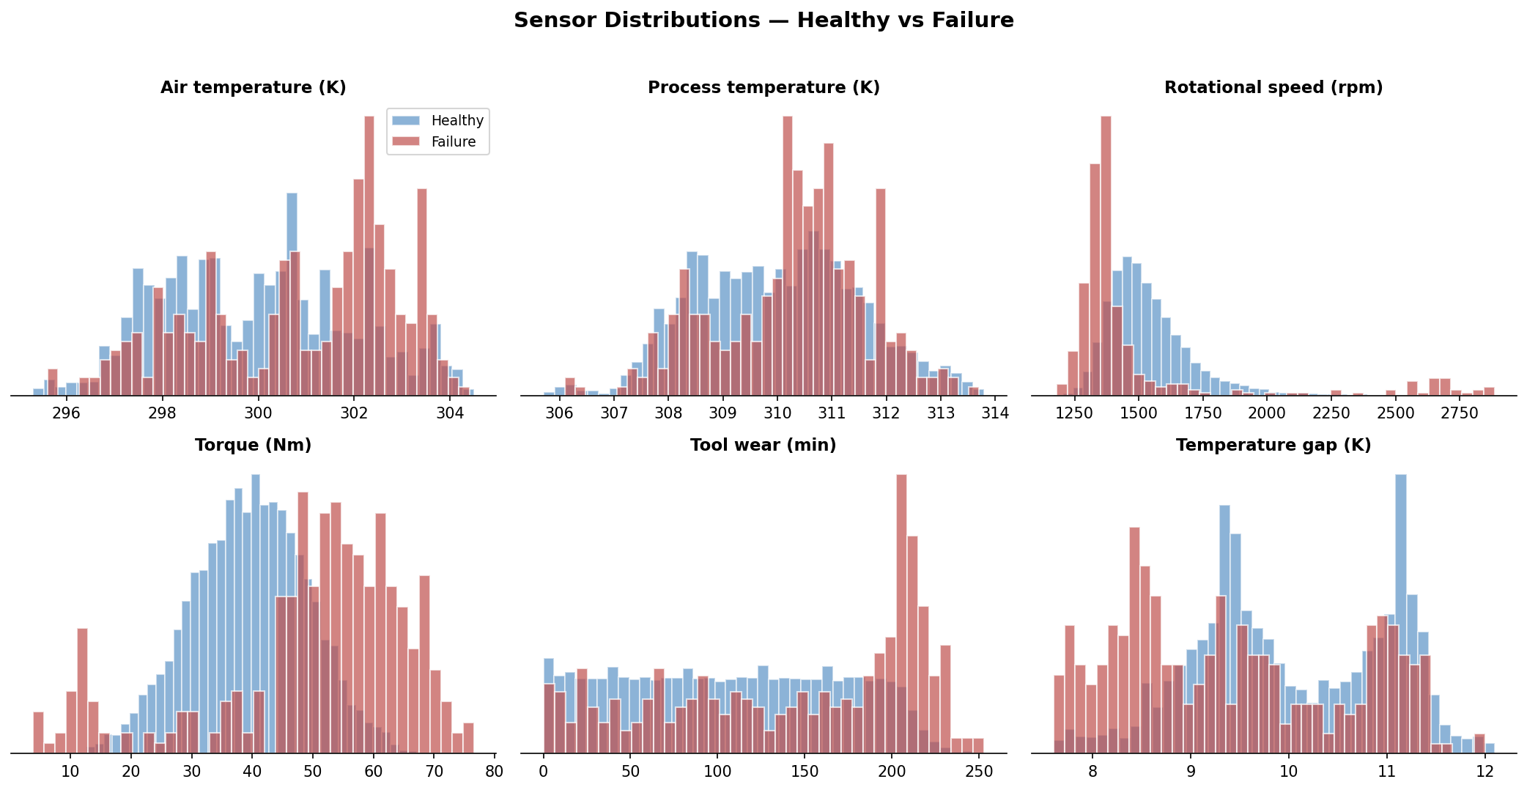
Figure 5 — Sensor distributions: healthy vs failure
3. Business Impact
A predictive model targeting HDF + OSF + PWF could catch ~85% of all failures. If a Thai factory loses THB 50,000 per hour of unplanned downtime and currently averages 8 failures per day at 30 minutes each, that is THB 200,000 per day in losses. A model preventing half of those failures saves ~THB 3M per month per line.
4. Next Steps
1. Build Looker Studio dashboard from data/processed/ai4i_clean.csv
2. Project #2 — Predictive ML model (Random Forest / XGBoost)
3. Apply to NEXPIE, Siemens Thailand, PTT/IRPC

