**Fan Control Application**

**Steps :**

**For measuring the speed of fan using IR sensor :**

**1. Initialized the EXTI interrupt at GPIO port A pin 0. It used to count the pulses generated through IR sensor to calculate the speed of fan. Count is a variable incremented each time when this interrupt occurs.**

**2. Timer 2 (TIM2) is used to generate the interrupt every second to calculate the speed of in RPS(Revolution per second) by the formula (IrGetSpeed = Count/3) and reset the value of Count. Here I am considering 3 blade fan.**

**For setting the speed of fan by controlling the triggering time of TRIAC just after the ZCD point**

**1. Initialized UART1 in interrupt mode to take the Speed value of fan from user in a variable named UserSetSpeed.**

**2. Initialized the EXTI interrupt at GPIO port A pin 1. This interrupt is generated by ZCD circuit at rising edge when the AC signal crosses zero point. In the ISR of this interrupt it is setting the zero_cross flag to give the reference to the timer to trigger the TRIAC.**

**3. Comparing the User Set Speed (UserSetSpeed) with fan current(actual) speed (IrGetSpeed) in the while loop triggering time of TRIAC (ChopTime) is adjusting.**

**4. If actual speed is greater than the user set speed ChopTime will increase to lower the power to the fan and vice-versa.**

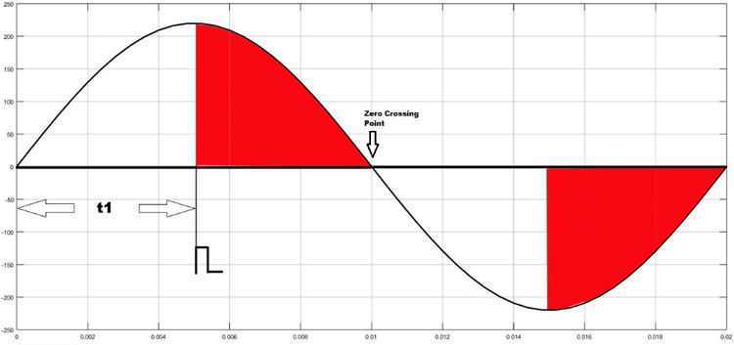

**here t1 is ChopTime**

**5. For 50Hz AC signal the time period is 20ms and half cycle is 10ms.**

**6. I have divided this 10ms in 1000 parts i.e. 10us. ChopTime can be between 0-1000 i.e. 0 to 10ms. And I have initialized a timer(TIM4) to generate an interrupt every 10us.**

**7. ChopTime is adjusted automatically by comparing the user entered speed and calculated speed. By counting down this ChopTime by timer(TIM4) TRIAC is triggered just after the ZCD point.**

**And by doing so the speed of fan adjusted to the user set value . It’s like a close loop system.**