upload plugin



Install Plugin



Create new page to display

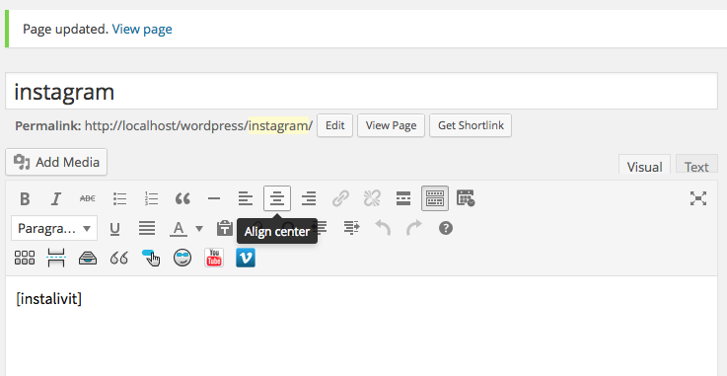

create read page , make sure your permalink is postname

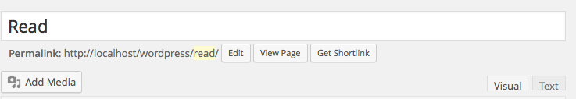

In read page edit, choose the template “page Read More Instalivit”

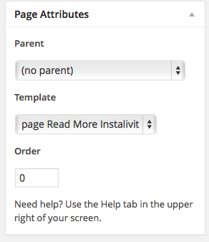

Do the querys

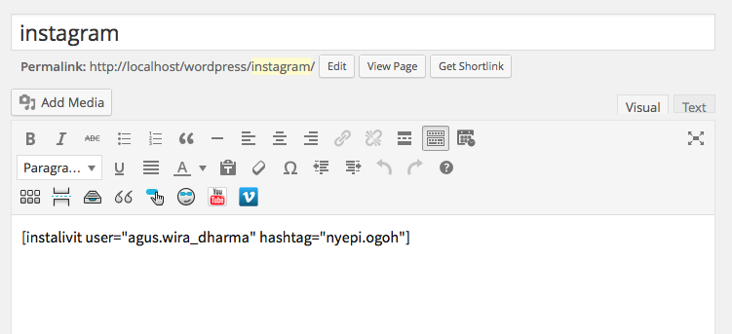

And the result

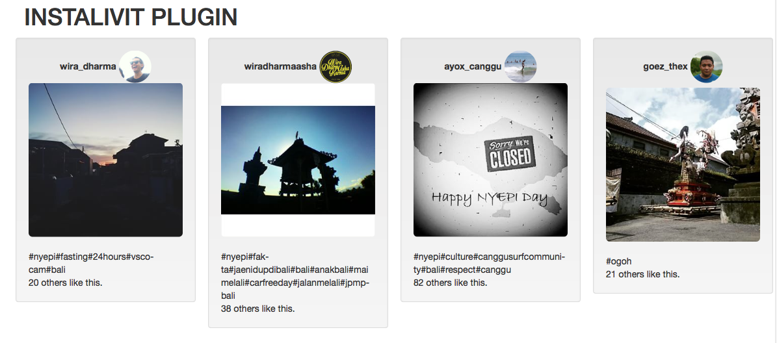

Pop up show the post , top 3 comment and custom rate comment



this is link read more in order to make all things works



Custom comment box on readmore page

