**S7+ - Device**

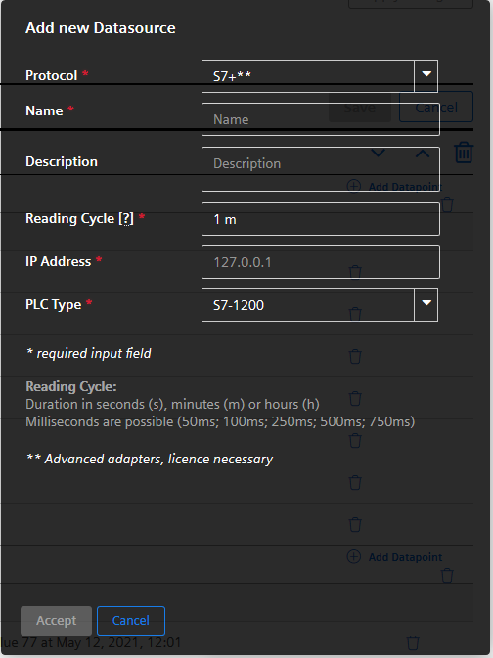

Parameters:

* IP Address: IP address or hostname of the device
* PLC Type: The following PLCs are supported:
  + S7-1200
  + S7-1500
  + S7-1500 Software Controller
  + ET200SP
  + PLCSIM (Advanced)

**S7+ - Datapoint**

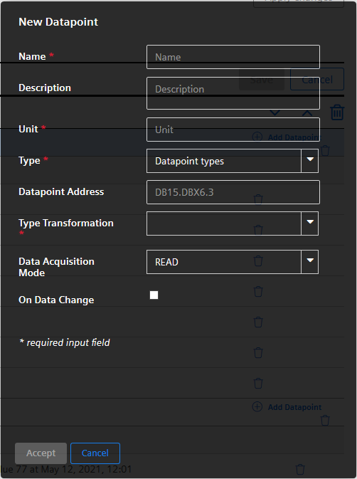

Parameters:

* Type: The following datapoint types are supported:
  + int
  + long
  + double
  + boolean
  + string
* Datapoint Address: The PLC connection must be available (symbolic addressing is used).
* Type Transformation: The transformation type is the interpretation of data of the peripheral device.

For the datatypes above the following transformation types are available (see also table below):

* + int: UINT, USINT, UDINT, SINT, INT, DINT, WORD, BYTE, DWORD
  + long: UINT, USINT, UDINT, ULINT, SINT, INT, DINT, LINT, WORD, BYTE, DWORD, LWORD, DATE, DATETIME, TIME, TIME_OF_DAY, LDATETIME, LTIME, LTOD, DTL, S5TIME
  + double: REAL, LREAL
  + boolean: BOOL
  + string: STRING, WSTRING, DATE, DATETIME, TIME, TIME_OF_DAY, LDATETIME, LTIME, LTOD, DTL, S5TIME
* Data Acquisition Mode: The following modes are supported:
  + READ
  + WRITE
  + READ&WRITE

|  |  |
| --- | --- |
| **Transformation type** | **Description** |
| BOOL | Boolean |
| BYTE | 8 bit integer unsigned |
| WORD | Bit field (16 bit) |
| DWORD | Bit field (32 bit) |
| LWORD | Bit field (64 bit) |
| USINT | 8 bit integer unsigned |
| UINT | 16 bit integer unsigned |
| UDINT | 32 bit integer unsigned |
| ULINT | 64 bit integer unsigned |
| SINT | 8 bit integer signed |
| INT | 16 bit integer signed |
| DINT | 32 bit integer signed |
| LINT | 64 bit integer signed |
| REAL | 32 bit float |
| LREAL | 64 bit float |
| DATE | Date, number of days since 1.1.1970 |
| DATETIME | Date and time |
| TIME | Time in milliseconds (32 bit), value range from -24d 20h 31m 23s 648ms to +24d 20h 31m 23s 647ms |
| TIME_OF_DAY | Number of milliseconds since start of the day (32 bit) |
| LDATETIME | Date and time |
| LTIME | Time in nanoseconds (64 bit), value range from -106751d 23h 47m 16s 854ms 775us 808ns to +106751d 23h 47m 16s 854ms 775us 807ns |
| LTOD | Number of milliseconds since start of the day (64 bit) |
| DTL | 12 Byte struct, value range from 1970-01-01-00:00:00.0 to 2554-12-31-23:59:59.999999999 (steps in nanoseconds) |
| S5TIME | Time in milliseconds (16 bit), value range from 0h 0m 0s 0ms to 2h 46m 30s 0ms |
| STRING | String (8 bit characters) |
| WSTRING | String (16 bit characters) |

**Fanuc Focas -Device**

The following device types are supported:

FS31i-A

FS35i-B

FS0i-D

FS32i-B

PMi-A

FS30i-B

FS0i-F Plus iHMI

FS0i-F

FS0i-F Plus

FS30i-B 32AX

FS30i-B 48AX

FS30i-B iHM

FS30i-B Plus

FS31i-B Plus

FS31i-B

FS31i-B5 Plus

FS31i-B5

FS31i-LB

FS31i-PB

FS31i-WB

FS32i-B Plus

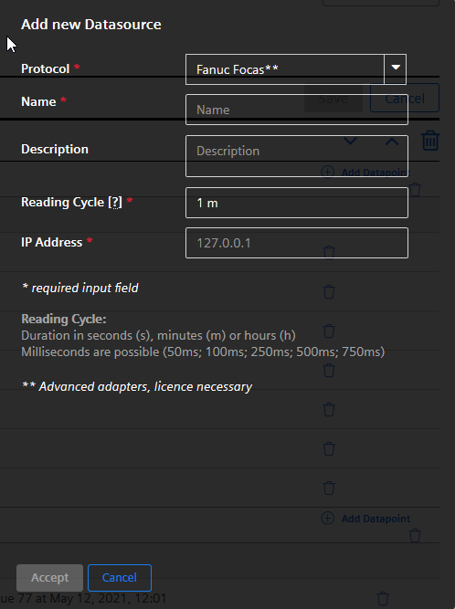

Parameters:

* The IP address (and optional port – separated by ‘:’ ) of the device must be filled in

**Fanuc Focas Datapoint**

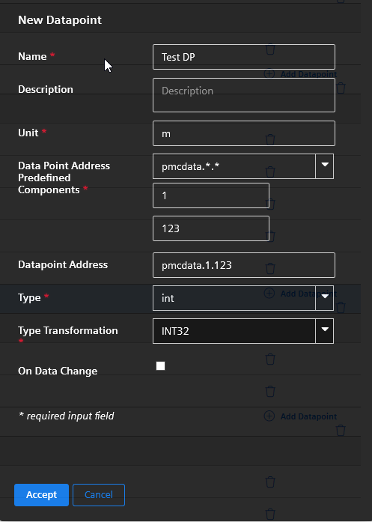

The filling out of the parameters follows simple rules:

1. Choose a predefined component for the Datapoint Address
2. For every * or ? in the listed item an extra field is displayed, which has to be filled out (see screenshot with example above)
3. The field Datapoint Address is the final address string is displayed read only (is the result of selected address with combo boxes and user defined parts).
4. The fields Type and Type Transformation is limited to the possible types, depending on the selection of the address component

Below you find a table with all components, including possible datatype, explanation and example.

|  |  |  |
| --- | --- | --- |
| Address | Data type | Comment |
| position.<axisnumber>  Example:  position.2 | int32  default  supported | The function can read the position of a defined axis or of all axis.  Note: When reading ALL_AXIS the  output structure is model dependent. |
| programblock.<number>  number values:  1…Program name  2…Block number | string(1)  int32(2)  default  supported | The function reads always both items. |
| alarmstring | string  default  supported | These two alarm functions are  mapped to a string. |
| pmcdata.<adr_type>.  <startaddress>  Example:  pmcdata.1.123 | Depends on  transformation:  int8  int16  int32  float  double | With this function you can read  different type of data from PMC  address range.  The adr_type specifies different  address ranges. For the various  models of CNC machines different  ranges of different size exist. It is the  responsibility of the user to configure  the address in the correct range. The  driver will not check ranges depending  on the model. |
| modal.<blocknumber>.<number>  number values:  1…data  2…flag1  3…flag2 | int32(1)  uint8(2)  uint8(3)  default  supported | This function call is rather complex  and comprises a lot or variation. The  Focas driver only supports the type =  108 variant for current active T code.  The resulting data comprises a 4-byte  data field and two 1-byte flag fields.  The interpretation of this fields is  machine model dependent, but this  must be done by the application. |
| statinfo.<number>  number values:  [1..9] see comment for value  meaning. | int16  default  supported | All elements are read with one  function call.  There are several more but according  to requirements they are not needed.  1 hdck: Status of manual handle retrace  2 tmmode: T/M mode selection  3 aut: AUTO/MANUAL mode selection  4 run: Status of automatic operation  5 motion: Status of axis movement,dwell  6 mstb: Status of M,S,T,B function  7 emergency: Status of emergency  8 alarm: Status of alarm  9 edit: Status of program editing |
| param.<paramnumber>.  <axisnumber>  Example:  param.10.0 | Depends on  transformation:  boolean  int8  int16  int32 | There are parameters, which are per  axis and there are parameters, which  are axis independent (axisnumber 0).  For axis specific parameter it is  possible to read the parameter for all  axis or only for a specific axis. |
| diag.<diagnumber>.  <axisnumber> | Depends on  transformation:  boolean  int8  int16  int32  float | There are diagnosis values, which are  per axis and there are diagnosis  values, which are axis independent  (axisnumber 0).  For axis specific diagnosis values it is  possible to read the values for all axis  or only for a specific axis. |
| feedrate | int32  default  supported | One function for one value. |
| spindlespeed | int32  default  supported | One function for one value. |

**Sinumerik - Device**

Device types:

The supported device types are S7 SINUMERIK, e.g. S7 840D sl.

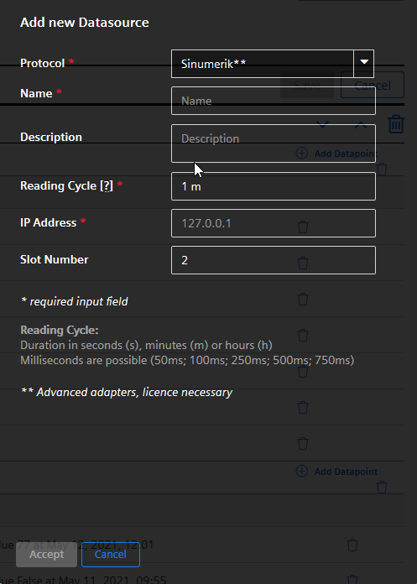

Parameters:

* IP Address: IP address of the device
* Slot Number: The correct slot number, where the “NC unit” of the device is mounted

**Sinumerik - Datapoint**

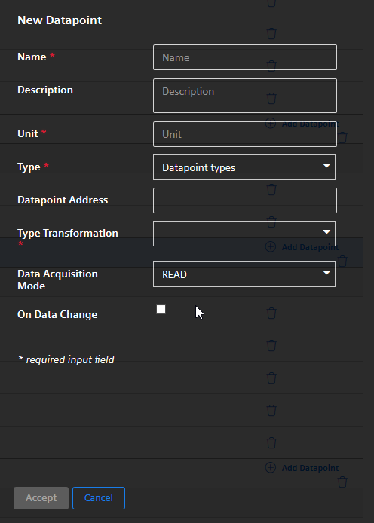

Parameters:

* Datapoint Address:

Peripheral Address strings in WinCC OA must be entered in a symbolic manner using the Siemens BTSS format.

Examples:

S7Conn1./Nck/Spindle/speedOvr[1]

NCK2.@SinumerikErrors@

* Type: The following datapoint types are supported:
  + int
  + long
  + double
  + boolean
  + string
* Type Transformation:

For the datatypes above the following transformation types are available (see also table below):

* + int: INT16, INT32, UINT16, UINT32, BYTE
  + long: INT16, INT32, UINT16, UINT32, BYTE, DATETIMELONG
  + double: FLOAT, DATETIMELONG
  + boolean: BIT
  + string: STRING, DATETIMELONG, BLOB
* Data Acquisition Mode: The following modes are supported:
  + READ
  + WRITE
  + READ&WRITE

|  |  |
| --- | --- |
| **Transformation type** | **Description** |
| UNDEFINED | Default |
| INT16 | 16 Bit Integer signed |
| INT32 | 32 Bit Integer signed |
| UINT16 | 16 Bit Integer unsigned |
| BYTE | Byte |
| FLOAT | Floating-point value |
| BIT | Boolean |
| STRING | Text |
| UINT32 | 32 Bit Integer unsigned |
| DATETIME | Date/Time variable (used for S7 300 and S7 400 models) |
| BLOB | Blob |
| BITSTRING | Bit pattern |
| DATETIMELONG | Date/Time variable (used for S7 1200 models) |

**IEC61850 - Device**

IEC 61850 defines an architecture for meeting the needs of electrical substation automation. It defines a data model and the communication services for the interaction with and between elements of a substation such as feeders, breakers, protection devices etc.

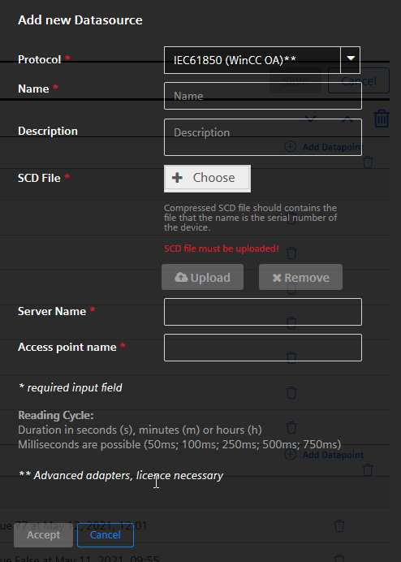

Parameters:

* SCD File: choose a valid SCD file. It contains the connection details (IP address, server name, access point) and the data (logical nodes, data types, data points, …).

The SCD File must have a valid extension: *.xml, *.zip, *.tgz, *.tar.gz

* Server Name: name of the IED (Intelligent Electronic Devices), which must match to the SCD file
* Access point name: name of the access point, which must match to the SCD file

Remark: The iedName within the SCD file must be set to “MindSphereClient” or to the serial number of the device.

Server Name and Access point must match with the data in the SCD file. It is necessary for a double check of the configuration.

**IEC61850 - Datapoint**

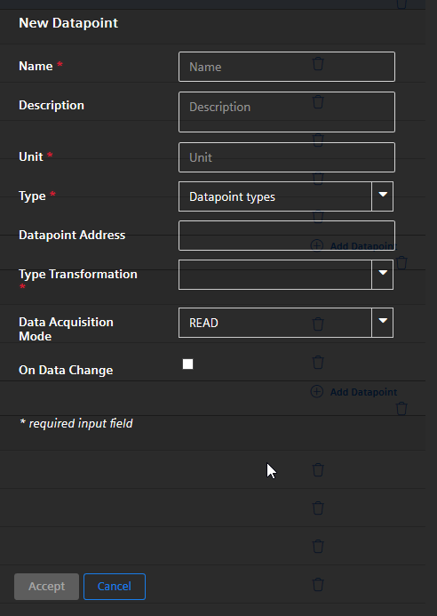

Parameters:

* Datapoint Address: The browse string, as defined in the SCD file.

Example:

MSC_SRV01CTRL/ATCC1$ST$HiTapPos$stVal

* Type: The following datapoint types are supported:
  + int
  + long
  + double
  + boolean
  + string
* Type Transformation:

For the datatypes above the following transformation types are available (see also table below):

* + int: INT8, INT16, INT32, INT64, UINT8, UINT16, UINT32
  + long: INT8, INT16, INT32, INT64, UINT8, UINT16, UINT32, BITSTRING, TIMESTAMP
  + double: FLOAT32, FLOAT64, INT32, INT64, UINT8, UINT16, UINT32, BITSTRING, TIMESTAMP
  + boolean: BOOL
  + string: OCTET_STRING64, VISIBLE_ STRING64, VISIBLE_ STRING255, TIMESTAMP
* Data Acquisition Mode: The following modes are supported:
  + READ (spontaneous / reports)
  + WRITE
  + READ&WRITE

**MT Connect - Device**

MTConnect is a manufacturing technical standard to retrieve process information from numerically controlled machine tools.

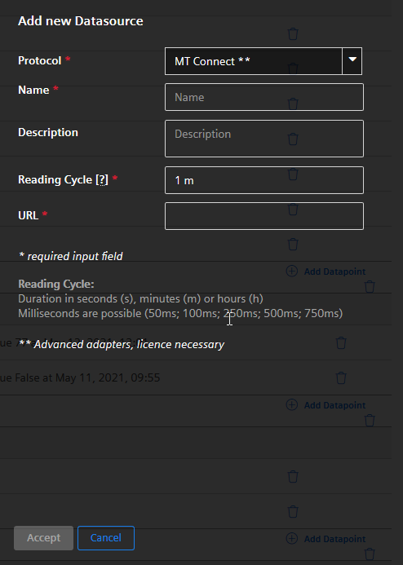

Parameters:

* URL: The URL of the MTConnect device. The port is also part of the URL.

E.g. http://mtconnect.mazakcorp.com:5610/

**MT Connect - Datapoint**

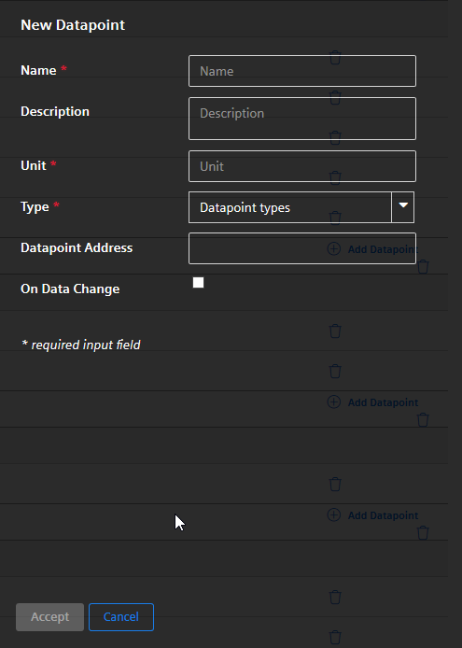

Parameters:

* Datapoint Address: ID of the DataItem from the MTConnect device.

Example (excerpt of an xml-file):

<DataItem category="SAMPLE" coordinateSystem="MACHINE" **id="xpm"** name="Xabs" nativeUnits="MILLIMETER" subType="ACTUAL" type="POSITION" units="MILLIMETER"/>

* Datapoint Address: xpm
* Type: The following datapoint types are supported:
  + int
  + long
  + double
  + boolean
  + string