**Sprint 1**

Only one User Story was taken for Sprint 1

This User Story was completed successfully during the Sprint

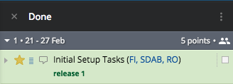

Description of User Story

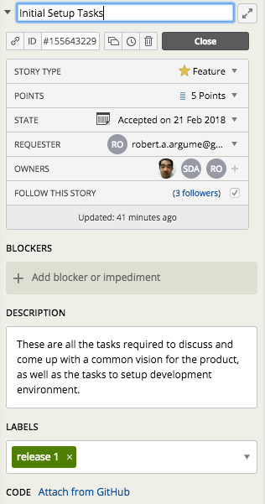

**Tasks completed**

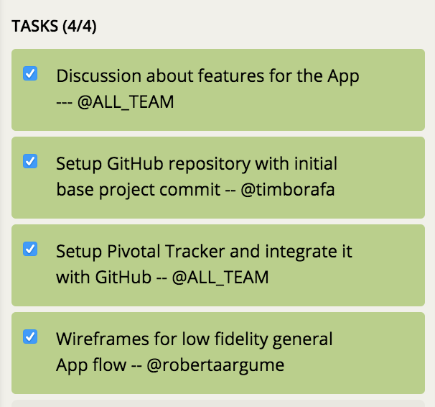

**Tasks Not Completed**

None