**Sprint 2 Report**

Three User Stories were taken for Sprint 2.

All of them were completed successfully.

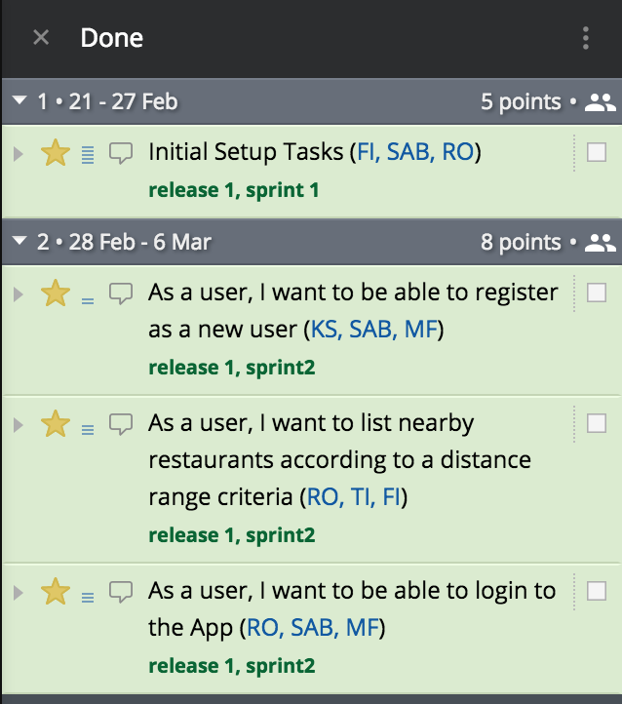

**Description of User Stories**

|  |  |
| --- | --- |
|  | **Tasks completed**    **Tasks Not Completed**  None |

|  |  |
| --- | --- |
|  | **Tasks completed**    **Tasks Not Completed**  None |

|  |  |
| --- | --- |
|  | **Tasks completed**    **Tasks Not Completed**  None |