**December Diet**

A consultancy company is subcontracted to assess the feasibility of producing power and heat from a geothermal reservoir in country Z. From geochemical, petrophysical, seismic and environmental analysis, the multidisciplinary team of consultants concluded that brine’s temperature would not be high enough for feasible direct generation of power. They proposed the following system (Fig. 1) to exploit the thermal potential of the reservoir with conditions as shown in Table 1. Thermal energy is transferred from the geothermal fluid (hot brine) to 1000 kg.s-1 of propane (working fluid in the ideal Rankine cycle, stages 1-4).

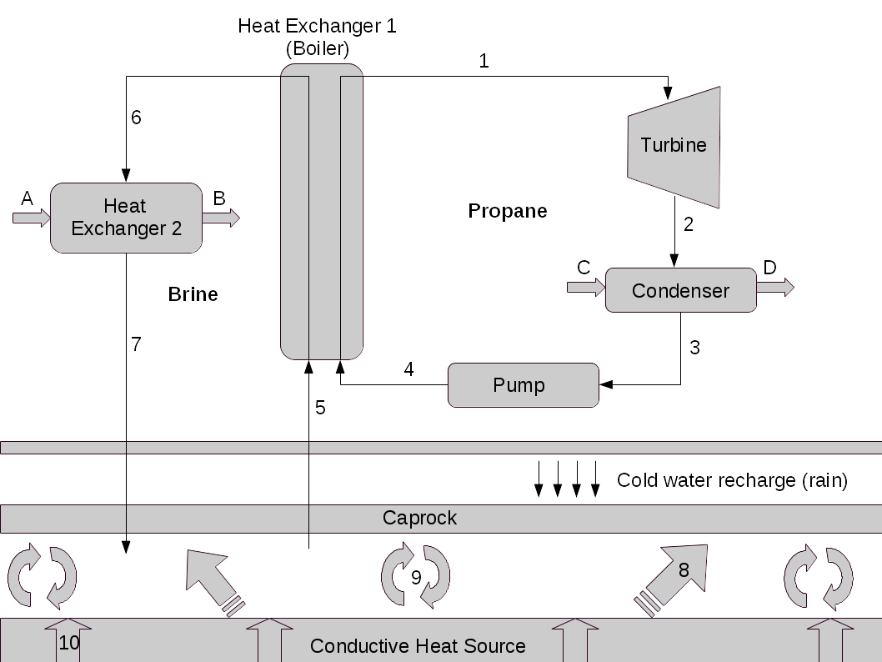

**Figure 1:** Schematics of geothermal source exploration for power and heat production.

1. What type of geothermal power plant was suggested by the consultant team? [ 1 Mark]
2. Calculate the conditions (i)-(x) shown in Table 1; [10 Marks]
3. What is the power produced by the turbine (in MW)? [ 1 Mark]
4. Calculate the mass flow rate of brine (in kg.s-1) extracted from the reservoir; [ 2 Marks]
5. Calculate the residual heat extracted from the brine before injection in the “Heat Exchanger 2” (in MW) [ 1 Mark]
6. All three heat transfer mechanisms (radiative, conduction and convection) act together in geothermal reservoirs. In Fig. 1, conduction and convection heat transfer are shown in (8)-(10). Explain the physical mechanisms in which thermal energy is transferred from Earth’s core to the geothermal fluid (brine); [ 5 Marks]
7. In country Z, condition for residue discharge into the environment (air, water bodies and subsurface) are strictly controlled by environmental laws. Brine temperature (re-injection), emission of gaseous sulphur oxides (SOx), and solid waste with relatively large concentration of heavy metals (e.g., arsenic) are just a few of a long list of controlled environmental parameters. Discuss these three potential pollutant emission sources.

[ 5 Marks]

|  |  |  |  |  |  |  |
| --- | --- | --- | --- | --- | --- | --- |
| **Stream** | **Pressure (bar)** | **Temperature (ºC)** | **Fluid** | **Quality** | **Specific enthalpy (kJ.kg-1)** | **Specific entropy (kJ.kg-1.K-1)** |
| **1** | 16 | 70 | Superheated vapour | – | (i) | (ii) |
| **2** | 0.25 | – | (iii) | (iv) | (v) | (vi) |
| **3** | (vii) | – | (viii) | – | (ix) | – |
| **4** | 16 | – | – | – | (x) | – |
| **5** | – | 120 | – | – | – | – |
| **6** | – | 80 | – | – | – | – |
| **7** | – | 35 | – | – | – | – |

**Table 1:** Thermal-physical conditions of all streams from Figure 1.

Given:

* Heat capacity of brine and propane: 4.18 and 73.60X10-3 kJ.kg-1.K-1, respectively;
* Quality of vapour:
* Fundamental thermodynamic relation:

where T, P, s, h and v are temperature, pressure, specific entropy, enthalpy and volume, respectively.

**Solution (December Diet)**

1. As brine inlet temperature is relatively low and can not be used to generate power directly, it is necessary to use a secondary fluid (e.g., Rankine organic fluid as propane) with relatively low boiling temperature. The geothermal power plant with such characteristics is called **binary geothermal power plant**. **[1 Mark]**
2. Following the streams:
   1. Superheated vapour at P1=16 bar and T1=70ºC: (i,ii)

From the superheated vapour table of propane:

**s1= 1.871 kJ.kg-1.K-1 and h1 = 568.5 kJ.kg-1.** **[2 Marks]**

* 1. P2=0.25 bar:(iii-vi)

Isentropic expansion in the turbine, i.e., **s2=**s1**= 1.871 kJ.kg-1.K-1** . At such pressure, the saturation table gives: sf= -0.297 kJ.kg-1.K-1; sg= 1.927 kJ.kg-1.K-1 ; hf =-64.9 kJ.kg-1; and hg = 387.8 kJ.kg-1, as s2<sg therefore the fluid is **wet vapour**. In order to calculate the enthalpy of this stream, we first need to obtain the quality of the vapour through,

and **[4 Marks]**

* 1. The condenser: (vii-ix)

It removes heat from the fluid with no pressure drop, therefore **P3**=P2**=0.25 bar**. Fluid leaving the condenser is **saturated liquid** with **h3 =**hf **= -64.90 kJ.kg-1.** **[3 Marks]**

* 1. Pump: (x)

At P4=P1=16 bar, the fluid undertakes an isentropic compression, and from the fundamental thermodynamic relation:

with dS = 0 and assuming that the fluid is incompressible,

**[1 Mark]**

1. Power produced by the turbine is

**[1 Mark]**

1. In order to calculate the mass flow rate of brine, we first should obtain the heat transferred to the propane stream in the boiler,

Assuming that there is no heat loss to the environment,

**[2 Marks]**

1. Residual thermal energy extracted from brine before injection:

**[1 Mark]**

1. There are three main heat exchange mechanisms in geo-fluids:
   * thermal conduction;
   * convection (or interphase heat transfer), and;
   * thermal radiation from Earth's core to rock formations at (relatively) large depths.

Conduction mechanisms occur within the same phase (e.g., solid-solid, liquid-liquid phases) and depend on surface contact between materials (i.e., rocks of distinct geological nature) and are proportional to the temperature gradient,

where Qcond is the heat transferred due to conduction and κ is the thermal conductivity coefficient. Thus heat from geothermal rock formations at great depth is transported through surface contact between rocks. Heat transferred to lower depths lead to rock temperature at the interface with the rock saturated with fluids. As the temperature of such saturated geological formation is smaller than the rock at greater depth, heat is transferred from the interfacial layer to the saturated rock. Conductive heat transfer is also responsible for heat losses in the upper level of the geothermal reservoir, as conductive heat loss).

The difference in temperature between the interface rock and the temperature of rock saturated with fluids leads to the forced convective heat transfer. Here, assuming that rocks and fluids close to the interface are in thermal equilibrium, the convective (or interphase) heat transfer can be defined as

where *h* is the convective heat transfer coefficient. As the fluid is heated up (and partially / totally vaporised), it becomes less dense and is moved upward by sinking `cold' denser fluid. This thermally induced circulation of fluids is called natural convection and is due to thermal buoyancy.  **[5 Marks]**

1. After heat is extracted from the geothermal fluid (brine), the excess of salts that were eventually concentrated during the process needs to be eliminated. This is due to environmental laws that constraint the maximum quantity of specific contaminants that can be discharge to the environment and/or (re-)injected into the groundwater system. Environmental laws also determine the maximum temperature of the (re-)injected brine. Specific waste treatment is necessary to ensure that heavy metal contaminants are safely removed from brine and stored according to environmental regulations. Sulphur oxides and hydrogen sulfide (SOx and H2S) also need to be removed from the brine stream before re-injection and treated (to produce insoluble solid salts of sulfur) in order to avoid formation and precipitation of acidic rain with further acidification of the soil. **[ 5 Marks]**

**Resit Diet**

Scientists in China are investigating the feasibility of novel enhanced geothermal system (EGS) technology to produce power and heat in the Gonghe basin in the northwestern province of Qinghai. Their initial well test demonstrated that at a depth of 3705 meters, the geological formation temperature is of 235ºC. They predicted that brine at the top of the well is at 15 bar and 200ºC. In their initial dry-rock plant design (Fig. 1), 2 turbines would produce 3.5 MW of power, whilst a condenser (fed with cold water, A, at 20ºC) would extract 9.75 MW of heat from the brine before re-injection into the subsurface. The condenser has a thermal efficiency of 60%.

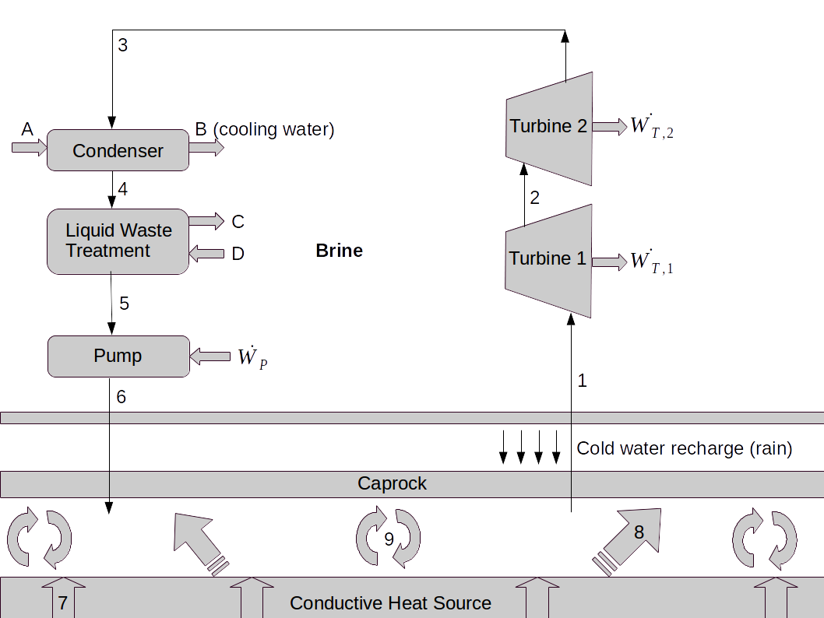

**Figure 1:** Schematics of geothermal source exploration for power and heat production.

Before re-injection, contaminants are removed from the brine stream at a rate of 0.1 kg.s-1 (stream C) and, in order to replenish the geothermal reservoir, 10 kg.s-1 is added into the brine stream (D). Your task is to check if their power and heat production predictions are correct, therefore:

1. Calculate the conditions (i)-(xi) shown in Table 1; [11 Marks]
2. Calculate the power produced by the turbines (in MW); [ 2 Marks]
3. Calculate the power required by the pump (in MW); [ 1 Mark]
4. Is the proposed design (Fig. 1) able to deliver the required power and heat (3.5 MW and 9.75 MW, respectively)? If negative, suggest modifications in the design that may help meeting heat and power requirements (no calculation required); [ 7 Marks]
5. Conditions for residue discharge into the environment are strictly controlled by environmental laws. Assume that in China the maximum temperature for brine re-injection is 80ºC, does the current design match such environmental requirement? If negative, suggest modifications that meet the environmental criteria. [4 Marks]

In order to solve this problem, assume that brine has the same thermodynamic properties as water. Also,

* Heat capacity of water: 4.18 kJ.kg-1.K-1, respectively;
* Given:
* Quality of vapour:
* Fundamental thermodynamic relation:

where T, P, s, h and v are temperature, pressure, specific entropy, enthalpy and volume, respectively.

|  |  |  |  |  |  |
| --- | --- | --- | --- | --- | --- |
| **Stream** | **Pressure**  **(bar)** | **Temperature**  **(ºC)** | **Mass flow rate (kg.s-1)** | **Fluid** | **Specific enthalpy (kJ.kg-1)** |
| 1 | 15.00 | 200 | (i) | (ii) | (iii) |
| 2 | 7.00 | 180 | -- | dry vapour | (iv) |
| 3 | 5.00 | -- | -- | (v) | (vi) |
| 4 | -- | (vii) | -- | -- | (viii) |
| 5 | 4.50 | 147.9 | -- | -- | (ix) |
| 6 | 25.00 | -- | -- | (x) | (xi) |
| A | -- | 20 | 50.00 | Cold water | -- |
| B | -- | 60 | -- | Hot water | -- |
| C | -- | -- | 0.10 | Liquid residue | -- |
| D | -- | -- | 1.00 | Cold water | -- |

**Table 1:** Thermal-physical conditions of all streams from Fig. 1.

**Solution (Resit Diet)**

1. Following the streams:
   1. P1=15 bar and T1=200ºC are **superheated vapour** (ii,iii) with

s1= 6.4546 kJ.kg-1.K-1and **h1 = 2796.8 kJ.kg-1.** **[2 Marks]**

* 1. Dry vapour at P2=7 bar (iv):

s2= 6.7080 kJ.kg-1.K-1and **h2 = 2763.5 kJ.kg-1.** **[1 Mark]**

* 1. P3=5 bar (v-vi),

Isentropic expansion in the turbine, i.e., s3=s2= 6.7080 kJ.kg-1.K-1. At such pressure, the saturation table gives: sf= 1.8607 kJ.kg-1.K-1; sg= 6.8212 kJ.kg-1.K-1 ; hf = 640.23 kJ.kg-1; and hg = 2748.7 kJ.kg-1, as s3<sg therefore the fluid is **wet vapour**. In order to calculate the enthalpy of this stream, we first need to obtain the quality of the vapour through,

and **[2 Marks]**

* 1. The condenser (i, vii-viii) removes heat from the brine with no pressure drop, therefore P4=P3=5 bar with **T4=Tsat=151.9ºC**. Fluid leaving the condenser is saturated liquid with **h4 =hf = 640.23 kJ.kg-1.** Heat is transferred from the brine stream (3-4) to the water (A-B), in which TA = 20ºC, TB=60ºC and mAB=50 kg.s-1, thus

Heat transferred from the brine to the water has efficiency of 60%, thus

**[3 Marks]**

* 1. At the liquid waste treatment plant 0.1 kg.s-1 of waste is removed from the brine stream whilst 1 kg.s-1 of water is added, thus (ix)

At P5=4.5 bar, the saturation temperature is Tsat=T5=147.9ºC, thus the brine is at saturated liquid state with **h5 = 623.25 kJ.kg-1** and v5 = 1.0882x10-3 m3.kg-1

**[ 1 Mark]**

* 1. At the pump (x-xi), P6=25 bar, the fluid undertakes an isentropic compression, and from the fundamental thermodynamic relation:

with ds = 0 and assuming that the fluid is incompressible,

**[1 Mark]**

At 25 bar, the saturated liquid enthalpy, hf, is 962.11kJ.kg-1 > h5, therefore the brine is at **subcooled liquid state**. **[1 Mark]**

1. Power produced by thes turbine is

Thus, the power produced is **0.5463 MW [2 Marks]**

1. Power required by the pump is

**[1 Mark]**

1. No, heat transferred from the brine to the water for heating is 8.34 MW whereas the power produced is 0.5463 MW, therefore much lower than the expected, 9.75 MW and 3.5 MW. **[1 Marks]**

Several strategies could be tried to improve both heat extraction and power production:

* 1. Power: **[3 Marks]**
     + use different turbine(s) with larger pressure drop (current ΔP are 8 and 2 bars for both turbines);
     + coupling the current system with an organic Rankine cycle (low boiling temperature) to extract residual energy;
  2. Heat: **[3 Marks]**
     + Redesign the condenser with larger thermal efficiency;
     + Add another heat exchanger (after the waste treatment unit) to further extract residual heat before the re-injection;

1. No, temperature at stream 5 (saturated liquid) is of 147.9ºC, and after the isentropic compression in the pump (subcooled liquid) temperature should be just marginally small, therefore substantially larger than the allowed by environmental regulations. **[1 Mark]**

The designed liquid waste treatment unit should remove contaminants from the brine stream and replenish any water loss. In order to ensure that the water temperature is appropriate for re-injection, a heat exchanger should be placed either before the unit or between the unit and the pump. Addition of a heat exchanger could also improve the production of heat (closer to the required 9.75 MW). **[3 Marks]**.