**December Diet**

A consultantancy company is subcontracted to assess the feasibility of producing power and heat from a geothermal reservoir in country Z. From geochemical, petrophysical, seismic and environmental analysis, the multidisciplinary team of consultants concluded that brine’s temperature would not be high enough for feasible direct generation of power. They proposed the following system (Fig. 1) to exploit the thermal potential of the reservoir with conditions as shown in Table 1. Thermal energy is transferred from the geothermal fluid (hot brine) to 1000 kg.s-1 of propane (working fluid in the ideal Rankine cycle, stages 1-4).

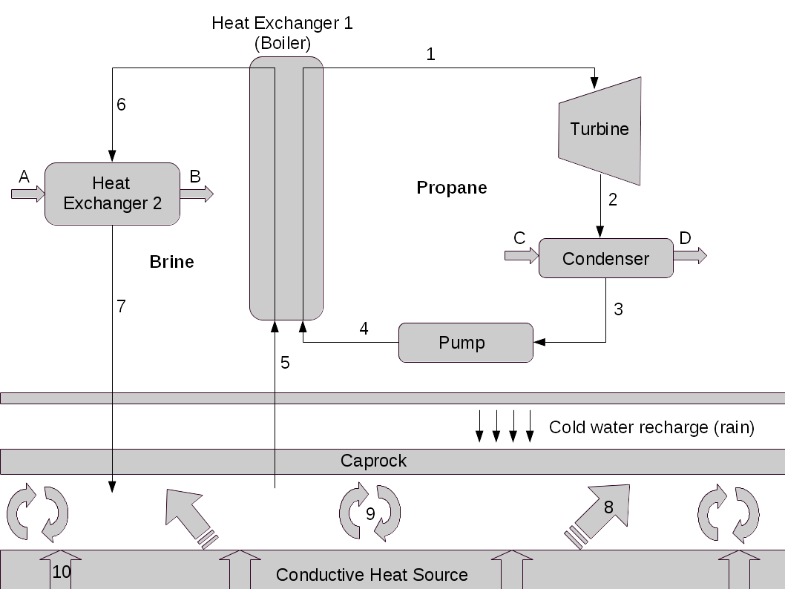

**Figure 1:** Schematics of geothermal source exploration for power and heat production.

1. What type of geothermal power plant was suggested by the consultant team? [ 1 Mark]
2. Calculate the conditions (i)-(x) shown in Table 1; [10 Marks]
3. What is the power produced by the turbine (in MW)? [ 1 Mark]
4. Calculate the mass flow rate of brine (in kg.s-1) extracted from the reservoir; [ 2 Marks]
5. Calculate the residual heat extracted from the brine before injection in the “Heat Exchanger 2” (in MW); [ 1 Mark]
6. All three heat transfer mechanisms (radiative, conduction and convection) act together in geothermal reservoirs. In Fig. 1, conduction and convection heat transfer are shown in (8)-(10). Explain the physical mechanisms in which thermal energy is transferred from Earth’s core to the geothermal fluid (brine); [ 5 Marks]
7. In country Z, condition for fluids discharge into the environment (air, water bodies and subsurface) are strictly controlled by environmental laws. Brine temperature (re-injection), emission of gaseous sulphur oxides (SOx), and solid waste with relatively large concentration of heavy metals (e.g., arsenium) are just a few of a long list of controlled environmental parameters. Discuss these three potential pollutant emission sources.

[ 5 Marks]

|  |  |  |  |  |  |  |
| --- | --- | --- | --- | --- | --- | --- |
| **Stream** | **Pressure (bar)** | **Temperature (ºC)** | **Fluid** | **Quality** | **Specific enthalpy (kJ.kg-1)** | **Specific entropy (kJ.kg-1.K-1)** |
| **1** | 16 | 70 | Superheated vapour | – | (i) | (ii) |
| **2** | 0.25 | – | (iii) | (iv) | (v) | (vi) |
| **3** | (vii) | – | (viii) | – | (ix) | – |
| **4** | 16 | – | – | – | (x) | – |
| **5** | – | 120 | – | – | – | – |
| **6** | – | 80 | – | – | – | – |
| **7** | – | 35 | – | – | – | – |

**Table 1:** Thermal-physical conditions of all streams from Figure 1.

Given:

* Heat capacity of brine and propane: 4.18 and 73.60X10-3 kJ.kg-1, respectively;
* Quality of vapour:
$x_{i}=\frac{Ψ_{i}−Ψ_{f}}{Ψ_{g}−Ψ_{f}},whereΨ=\left\{h,s\right\}$

* Fundamental thermodynamic relation:

$Tds=dh−vdP$

where T, P, s, h and v are temperature, pressure, specific entropy, enthalpy and volume, respectively.

**Solution**

1. As brine inlet temperature is relatively low and can not be used to generate power directly, it is necessary to use a secondary fluid (e.g., Rankine organic fluid as propane) with relatively low boiling temperature. The geothermal power plant with such characteristics is called **binary geothermal power plant**. **[1 Mark]**
2. Following the streams:
   1. Superheated vapour at P1=16 bar and T1=70ºC: (i,ii)

From the superheated vapour table of propane: **s1= 1.871 kJ.kg-1.K-1 and h1 = 568.5 kJ.kg-1.** **[2 Marks]**

* 1. P2=0.25 bar:(iii-vi)

Isentropic expansion in the turbine, i.e., **s2=**s1**= 1.871 kJ.kg-1.K-1** . At such pressure, the saturation table gives: sf= -0.297 kJ.kg-1.K-1; sg= 1.927 kJ.kg-1.K-1 ; hf =-64.9 kJ.kg-1; and hg = 387.8 kJ.kg-1, as s2<sg therefore the fluid is **wet vapour**. In order to calculate the enthalpy of this stream, we first need to obtain the quality of the vapour through,

$x_{2}=\frac{s_{2}−s_{f}}{s_{g}−s_{f}}=0.9748$ and $x_{2}=\frac{h_{2}−h_{f}}{h_{g}−h_{f}}→h_{2}=376.3920kJ.{kg}^{−1}$**[4 Marks]**

* 1. The condenser: (vii-ix)

It removes heat from the fluid with no pressure drop, therefore **P3**=P2**=0.25 bar**. Fluid leaving the condenser is **saturated liquid** with **h3 =**hf **= -64.90 kJ.kg-1.** **[3 Marks]**

* 1. Pump: (x)

At P4=P1=16 bar, the fluid undertakes an isentropic compression, and from the fundamental thermodynamic relation:

$Tds=dh−vdP$ with dS = 0 and assiming that the fluid is incompressible,

$\int{dh}=\int{vdP}→h_{4}=h_{3}+v_{3}\left(P_{4}−P_{3}\right)=−62.3265kJ.{kg}^{−1}$**[1 Mark]**

1. Power produced by the turbine is

$\overset{˙}{W_{T}}=\overset{˙}{m_{C3}}\left(h_{2}−h_{1}\right)=192.1080MW$**[1 Mark]**

1. In order to calculate the mass flow rate of brine, we first should obtain the heat transferred to the propane stream in the boiler,

$\overset{˙}{Q_{C3}}=\overset{˙}{m_{C3}}\left(h_{1}−h_{4}\right)=630826.50kJ.{kg}^{−1}=630.83MW$

Assuming that there is no heat loss to the environment,

$\overset{˙}{Q_{C3}}=−\overset{˙}{Q_{w}}=\overset{˙}{m_{w}}C_{p,w}\left(T_{6}−T_{5}\right)→\overset{˙}{m_{w}}=1886.4429kg.s^{−1}$**[2 Marks]**

1. Residual thermal energy extracted from brine before injection:

$\overset{˙}{Q_{HE2}}=\overset{˙}{m_{w}}\left(T_{7}−T_{6}\right)=354.8399MW$**[1 Mark]**

1. There are three main heat exchange mechanisms in geo-fluids:
   * thermal conduction;
   * convection (or interphase heat transfer), and;
   * thermal radiation from Earth's core to rock formations at (relatively) large depths.

Conduction mechanisms occur within the same phase (e.g., solid-solid, liquid-liquid phases) and depend on surface contact between materials (i.e., rocks of distinct geological nature) and are proportional to the temperature gradient,

$Q_{cond}=−κ∇T$

where Qcond is the heat transferred due to conduction and κ is the thermal conductivity coefficient. Thus heat from geothermal rock formations at great depth is transported through surface contact between rocks. Heat transferred to lower depths lead to rock temperatureat the interface with the rock saturated with fluids. As the temperature of such saturated geological formation is smaller than the rock at greater depth, heat is transferred from the interfacial layer to the saturated rock. Conductive heat transfer is also responsible for heat losses in the upper level of the geothermal reservoir, as conductive heat loss).

The difference in temperature between the interface rock and the temperature of rock saturated with fluids leads to the forced convective heat transfer. Here, assuming that rocks and fluids close to the interface are in thermal equilibrium, the convective (or interphase) heat transfer can be defined as

$\overset{˙}{Q_{conv}}=hΔT$

where *h* is the convective heat transfer coefficient. As the fluid is heated up (and partially / totally vaporised), it becomes less dense and is moved upward by sinking `cold' denser fluid. This thermally induced circulation of fluids is called natural convection and is due to thermal buoyancy.  **[5 Marks]**

1. After heat is extracted from the geothermal fluid (brine), the excess of salts that were eventually concentrated during the process needs to be eliminated. This is due to environmental laws that constraint the maximum quantity of specific contaminants that can be discharge to the environment and/or (re-)injected into the groundwater system. Environmental laws also determine the maximum temperature of the (re-)injected brine. Specific waste treatment is necessary to ensure that heavy metal contaminants are safely removed from brine and stored according to environmental regulations. Sulphur oxydes and hydrogen sulfide (SOx and H2S) also need to be removed from the brine stream before re-injection and treated (to produce insoluble solid salts of sulfer) in order to avoid formation and precipitation of acidic rain with further acidification of the soil. **[ 5 Marks]**