- 加一个客户的标记和名称S&B，放在第五个。
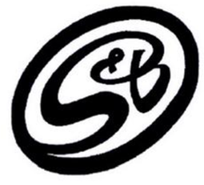
- OVER VIEW不要了，按照第一次的网页把下面放在HOME的最后一段
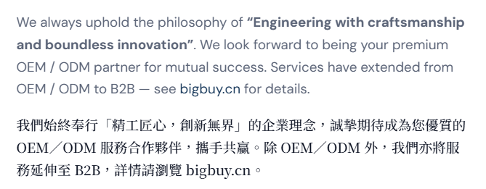
3.将Products 放在Development and optimization 前面
4.Development and Optimization. 现在是3+1排列，改成2+2排列
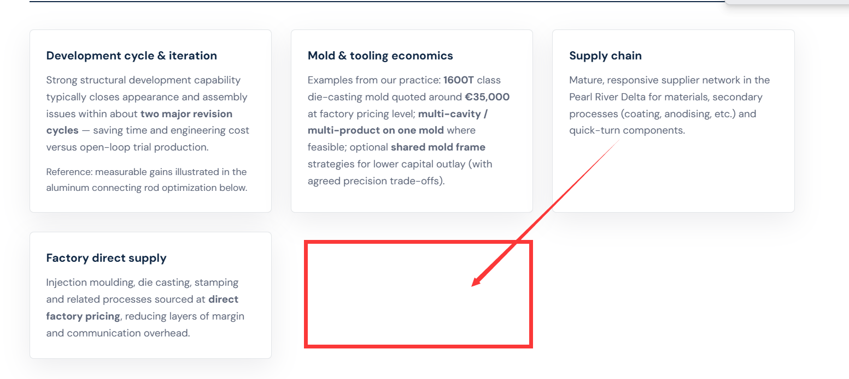
5.Mould design
Case1.
Product name: Holding cup with extremely high quality appearance(delivered to Japan)
产品名称：高外观要求的容纳杯（货交日本）
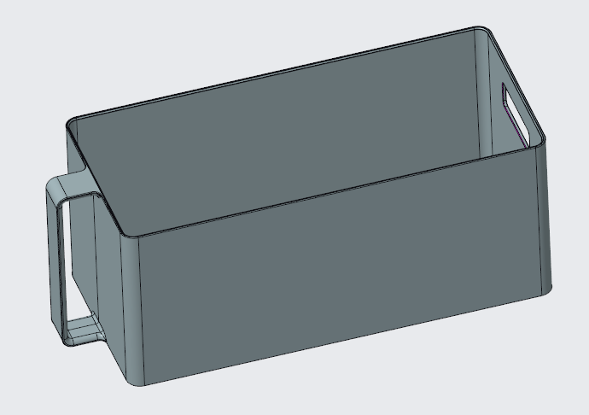
Product requirement: 产品要求
1. The contour lines are extremely fine, visible to the eye, and barely felt when touched.合摸线极微小，眼可以看到，手摸基本无感觉。
2. The product must have no unevenness. 产品不能有任何不饱满。
3. The product must have no any shrinkage at all. 产品不能有任何一点缩水
4. The surface texture of the product is VDI21, uniform. 产品外观晒纹VDI21，均匀。
Mould design:模具设计
Use sliding blocks on all sides of the product and inner core pulling.四周滑块，内抽芯
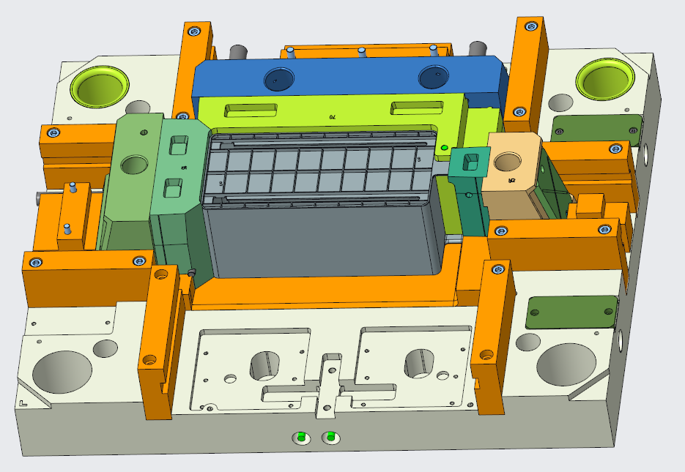
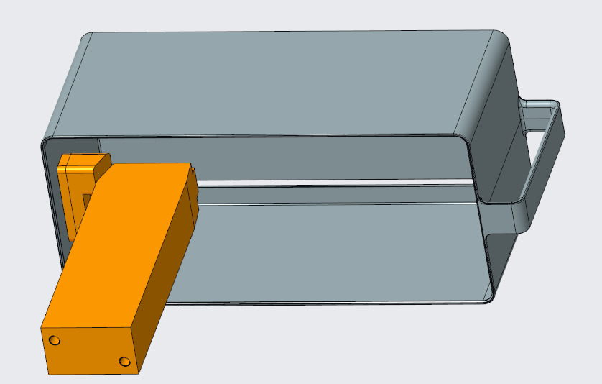

Case2
Product: left and right supports of BC BC左右支架
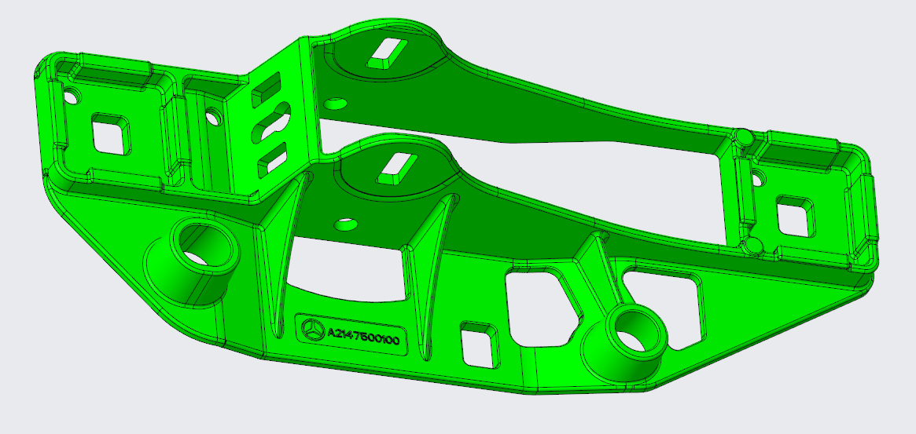
注意奔驰标记可以保留，但是产品编号一定要打码。
产品要求
模具设计：Inclined tunnel slider + 2 tunnel sliders. The mold was fabricated and the trial run lasted for 30 days. The trial run was successful on the first attempt.
