**使用NuGet管理项目类库引用**

 NuGet 是微软开发平台（包括.NET平台）的一个包管理器，这里只介绍和.NET相关的NuGet Visual Studio扩展客户端, 在VS2010 ,VS2012 ,VS2013中默认集成了NuGet 工具， 有了它，管理项目中的第三方库变得异常简单和便捷。

 NuGet 提供用户两种交互方式， 一是用户界面， 二是powershell命令行. 从vs的工具->包管理器 我们可以看到这两个选项

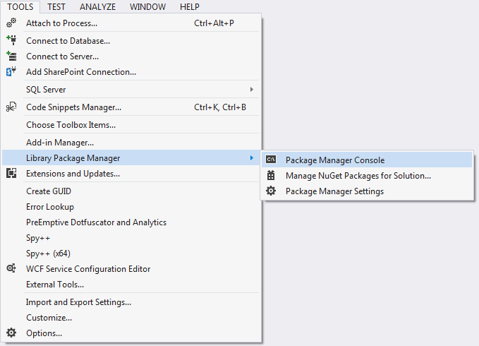

 NuGet用户界面

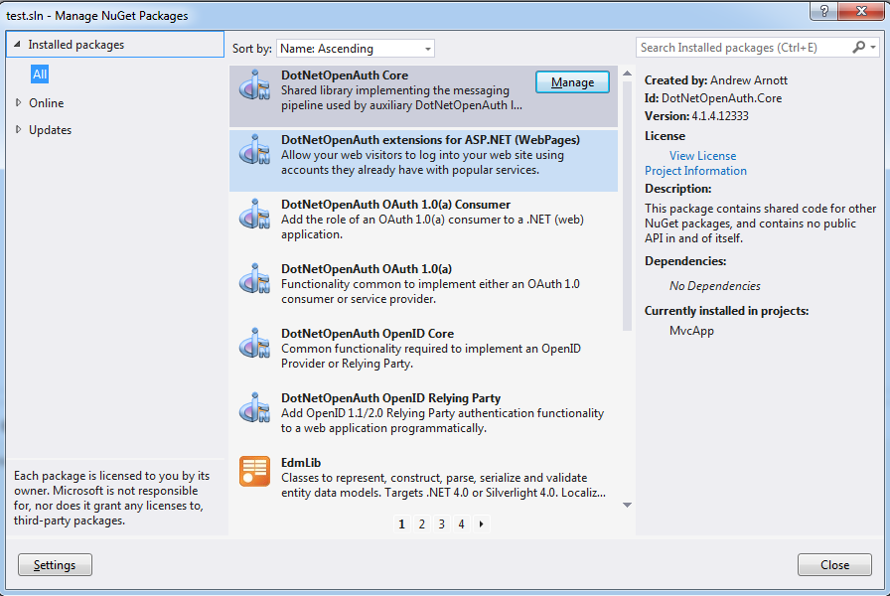

NuGet命令行

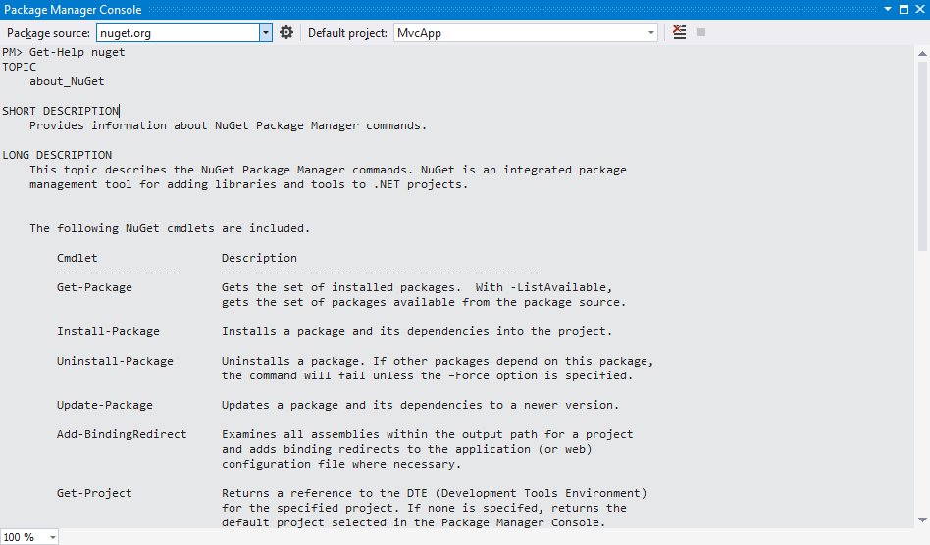

 下面主要介绍命令行的使用：

 Get-Help nuget  , 打印NuGet包含的命令, 比如获得项目中引用的库文件Get-Package, 安装，卸载，更新库 Install/Uninstall/Update-Package等

PM> Get-Help nuget

TOPIC

about_NuGet

SHORT DESCRIPTION

Provides information about NuGet Package Manager commands.

LONG DESCRIPTION

This topic describes the NuGet Package Manager commands. NuGet is an integrated package

management tool for adding libraries and tools to .NET projects.

The following NuGet cmdlets are included.

Cmdlet Description

------------------ ----------------------------------------------

Get-Package Gets the set of installed packages. With -ListAvailable,

gets the set of packages available from the package source.

Install-Package Installs a package and its dependencies into the project.

Uninstall-Package Uninstalls a package. If other packages depend on this package,

the command will fail unless the –Force option is specified.

Update-Package Updates a package and its dependencies to a newer version.

Add-BindingRedirect Examines all assemblies within the output path for a project

and adds binding redirects to the application (or web)

configuration file where necessary.

Get-Project Returns a reference to the DTE (Development Tools Environment)

for the specified project. If none is specifed, returns the

default project selected in the Package Manager Console.

Open-PackagePage Open the browser pointing to ProjectUrl, LicenseUrl or

ReportAbuseUrl of the specified package.

Register-TabExpansion Registers a tab expansion for the parameters of a command.

SEE ALSO

Online documentation: http://go.microsoft.com/fwlink/?LinkID=206619

Get-Package

Install-Package

Uninstall-Package

Update-Package

Add-BindingRedirect

Get-Project

Open-PackagePage

Register-TabExpansion

Get-Help ，打印命令帮助， 相当于linux bash的 man / get-help ,比如我们想看Get-Package 可以干嘛，输入get-help get-package ,输出如下：

PM> get-help get-package

NAME

Get-Package

SYNOPSIS

Gets the set of installed packages. Use the -ListAvailable flag to list packages available from the package source.

SYNTAX

Get-Package -Source <string> [-ListAvailable] [-Updates] [-ProjectName <string>] [-Filter <string>] [-First <int>] [-Skip <in

t>] [-AllVersions] [-IncludePrerelease] [<CommonParameters>]

DESCRIPTION

Gets the set of installed packages. Use the -ListAvailable flag to list packages available from the package source.

RELATED LINKS

Online version: http://docs.nuget.org/

Get-Package

REMARKS

To see the examples, type: "get-help Get-Package -examples".

For more information, type: "get-help Get-Package -detailed".

For technical information, type: "get-help Get-Package -full".

　　NuGet命令使用PowerShell， 所以对PowerShell熟悉的同学可以很快上手使用。

Install-Package ，用于安装包 ， 比如我们想在名称为MvcApp的 asp.net mvc项目中引用jquery ,直接输入Install-Package jquery即可安装NuGet资源中最新版jquery , 当然我们也可以指定安装某个版本的jquery, 比如1.8.2 版jquery , 安装到MvcApp中

PM> Install-Package jquery -Version 1.8.2 -ProjectName MvcApp

'jQuery 1.8.2' already installed.

Adding 'jQuery 1.8.2' to MvcApp.

Successfully added 'jQuery 1.8.2' to MvcApp.

　　安装好后，你去mvc项目的Scripts目录就可以看到添加的jquery引用（包括智能提示文件和min文件及未经压缩的文件），另外你可以看到packages.config文件里面新增了一条引用记录：

<?xml version="1.0" encoding="utf-8"?>

<packages>

<package id="DotNetOpenAuth.AspNet" version="4.1.4.12333" targetFramework="net45" />

<package id="DotNetOpenAuth.Core" version="4.1.4.12333" targetFramework="net45" />

<package id="DotNetOpenAuth.OAuth.Consumer" version="4.1.4.12333" targetFramework="net45" />

<package id="DotNetOpenAuth.OAuth.Core" version="4.1.4.12333" targetFramework="net45" />

<package id="DotNetOpenAuth.OpenId.Core" version="4.1.4.12333" targetFramework="net45" />

<package id="DotNetOpenAuth.OpenId.RelyingParty" version="4.1.4.12333" targetFramework="net45" />

<package id="EntityFramework" version="5.0.0" targetFramework="net45"></package>

<package id="jQuery" version="1.8.2" targetFramework="net45" />

<package id="knockoutjs" version="2.2.0" targetFramework="net45" />

<package id="Microsoft.AspNet.Mvc" version="4.0.30506.0" targetFramework="net45" />

<package id="Microsoft.AspNet.Mvc.FixedDisplayModes" version="1.0.0" targetFramework="net45" />

<package id="Microsoft.AspNet.Razor" version="2.0.30506.0" targetFramework="net45" />

<package id="Microsoft.AspNet.Web.Optimization" version="1.0.0" targetFramework="net45" />

<package id="Microsoft.AspNet.WebApi" version="4.0.30506.0" targetFramework="net45" />

<package id="Microsoft.AspNet.WebApi.Client" version="4.0.30506.0" targetFramework="net45" />

<package id="Microsoft.AspNet.WebApi.Core" version="4.0.30506.0" targetFramework="net45" />

<package id="Microsoft.AspNet.WebApi.OData" version="4.0.30506" targetFramework="net45" />

<package id="Microsoft.AspNet.WebApi.WebHost" version="4.0.30506.0" targetFramework="net45" />

<package id="Microsoft.AspNet.WebPages" version="2.0.30506.0" targetFramework="net45" />

<package id="Microsoft.AspNet.WebPages.Data" version="2.0.20710.0" targetFramework="net45" />

<package id="Microsoft.AspNet.WebPages.OAuth" version="2.0.30506.0" targetFramework="net45" />

<package id="Microsoft.AspNet.WebPages.WebData" version="2.0.30506.0" targetFramework="net45" />

<package id="Microsoft.Data.Edm" version="5.2.0" targetFramework="net45" />

<package id="Microsoft.Data.OData" version="5.2.0" targetFramework="net45" />

<package id="Microsoft.jQuery.Unobtrusive.Ajax" version="2.0.30506.0" targetFramework="net45" />

<package id="Microsoft.jQuery.Unobtrusive.Validation" version="2.0.30506.0" targetFramework="net45" />

<package id="Microsoft.Net.Http" version="2.0.20710.0" targetFramework="net45" />

<package id="Microsoft.Web.Infrastructure" version="1.0.0.0" targetFramework="net45" />

<package id="Modernizr" version="2.6.2" targetFramework="net45" />

<package id="Newtonsoft.Json" version="4.5.11" targetFramework="net45" />

<package id="System.Spatial" version="5.2.0" targetFramework="net45" />

<package id="WebGrease" version="1.3.0" targetFramework="net45" />

</packages>

 另外如果引用的包存在依赖， NuGet会包含下载所有的依赖文件。

* **Update-Package** ，更新包, 比如我们要使用1.9版的jquery,如下

PM> Update-Package jquery -Version 1.9 -ProjectName MvcApp

Updating 'jQuery' from version '1.8.2' to '1.9.0' in project 'MvcApp'.

Removing 'jQuery 1.8.2' from MvcApp.

Successfully removed 'jQuery 1.8.2' from MvcApp.

Adding 'jQuery 1.9.0' to MvcApp.

Installing 'jQuery 1.9.0'.

Successfully installed 'jQuery 1.9.0'.

Successfully added 'jQuery 1.9.0' to MvcApp.

Uninstalling 'jQuery 1.8.2'.

Successfully uninstalled 'jQuery 1.8.2'.

　　我们之前装的1.8.2被删除， 1.9.0版的jquery被引用， 同时packages.config文件也会更新。

* **Uninstall-Package** ，卸载包， 比如我们不用jquery了， 删除之 （如果有其他包引用jquery ,那么应该先删除依赖jquery的包，不然会报错。）

PM> Uninstall-Package jQuery

Removing 'jQuery 1.9.0' from MvcApp.

Successfully removed 'jQuery 1.9.0' from MvcApp.

Uninstalling 'jQuery 1.9.0'.

Successfully uninstalled 'jQuery 1.9.0'.

　　同样，packages.config会删除jquery记录。

* **Get-Package** ，获得项目引用的包列表，或NuGet资源中心的包列表,比如获得MvcApp引用了那些包

PM> Get-Package -ProjectName MvcApp

Id Version Description/Release Notes

-- ------- -------------------------

DotNetOpenAuth.AspNet 4.1.4.12333 Enables web site visitors to log into an ASP.NET web application via popular identity provi...

DotNetOpenAuth.Core 4.1.4.12333 This package contains shared code for other NuGet packages, and contains no public API in a...

DotNetOpenAuth.OAuth.Consumer 4.1.4.12333 Improve usability, reliability, conversion rates and security simultaneously by simply aski...

DotNetOpenAuth.OAuth.Core 4.1.4.12333 This package contains shared code for other NuGet packages, and contains no public API in a...

DotNetOpenAuth.OpenId.Core 4.1.4.12333 This package contains shared code for other NuGet packages, and contains no public API in a...

DotNetOpenAuth.OpenId.Relyi... 4.1.4.12333 Increase conversion rates to your web site by lowering the bar to create an account with yo...

EntityFramework 5.0.0 Entity Framework is Microsoft's recommended data access technology for new applications.

knockoutjs 2.2.0 A JavaScript MVVM library to help you create rich, dynamic user interfaces with clean maint...

Microsoft.AspNet.Mvc 4.0.30506.0 This package contains the runtime assemblies for ASP.NET MVC. ASP.NET MVC gives you a power...

Microsoft.AspNet.Mvc.FixedD... 1.0.0 This package contains a workaround for a bug affecting mobile view caching in ASP.NET MVC 4...

Microsoft.AspNet.Razor 2.0.30506.0 This package contains the runtime assemblies for ASP.NET Web Pages. ASP.NET Web Pages and t...

Microsoft.AspNet.Web.Optimi... 1.0.0 ASP.NET Optimization introduces a way to bundle and optimize css/js files.

Microsoft.AspNet.WebApi 4.0.30506.0 This package contains everything you need to host ASP.NET Web API on IIS. ASP.NET Web API i...

Microsoft.AspNet.WebApi.Client 4.0.30506.0 This package adds support for formatting and content negotiation to System.Net.Http. It inc...

Microsoft.AspNet.WebApi.Core 4.0.30506.0 This package contains the core runtime assemblies for ASP.NET Web API. This package is used...

Microsoft.AspNet.WebApi.OData 4.0.30506 This package contains everything you need to create OData endpoints using ASP.NET Web API a...

Microsoft.AspNet.WebApi.Web... 4.0.30506.0 This package contains everything you need to host ASP.NET Web API on IIS. ASP.NET Web API i...

Microsoft.AspNet.WebPages 2.0.30506.0 This package contains core runtime assemblies shared between ASP.NET MVC and ASP.NET Web Pa...

Microsoft.AspNet.WebPages.Data 2.0.20710.0 This package contains the runtime assemblies for ASP.NET Web Pages. ASP.NET Web Pages and t...

Microsoft.AspNet.WebPages.O... 2.0.30506.0 This package contains the runtime assemblies for ASP.NET Web Pages. ASP.NET Web Pages and t...

Microsoft.AspNet.WebPages.W... 2.0.30506.0 This package contains the runtime assemblies for ASP.NET Web Pages. ASP.NET Web Pages and t...

Microsoft.Data.Edm 5.2.0 Classes to represent, construct, parse, serialize and validate entity data models. Targets ...

Microsoft.Data.OData 5.2.0 Classes to serialize, deserialize and validate OData payloads. Enables construction of ODat...

Microsoft.jQuery.Unobtrusiv... 2.0.30506.0 jQuery plugin that unobtrusively sets up jQuery.Validation.

Microsoft.Net.Http 2.0.20710.0 This package provides a programming interface for modern HTTP applications. This package in...

Microsoft.Web.Infrastructure 1.0.0.0 This package contains the Microsoft.Web.Infrastructure assembly that lets you dynamically r...

Modernizr 2.6.2 Modernizr adds classes to the <html> element which allow you to target specific browser fun...

Newtonsoft.Json 4.5.11 Json.NET is a popular high-performance JSON framework for .NET

System.Spatial 5.2.0 Contains a number of classes and canonical methods that facilitate geography and geometry s...

WebGrease 1.3.0 Web Grease is a suite of tools for optimizing javascript, css files and images.

以上几个命令是NuGet管理包的几个常用命令，当然我们也可以选择在用户界面中进行相应操作，有兴趣探索更多命令和功能的同学可以参考NuGet官方网站 http://docs.nuget.org/。

总结：

 有了NuGet, 包和包之间的依赖管理从此变得异常简单和便捷， 在团队开发中， 大家只用共享一份相同的packages.config 配置文件即可避免库引用错乱的局面。 我们甚至可以编写一小段powershell代码，为所有项目自动引用需要的包。