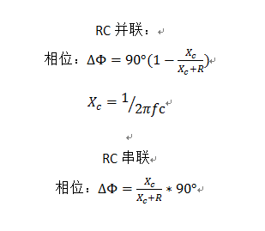

**串联：**

**C = phase/(180*PI*f*R);**

$$R_{总}^{2}=X_{c}^{2}+R_{0}^{2}$$

$$X_{C}=\frac{1}{2πfC}$$

**并联：**

**C = phase/(2*PI*f*R)**