2018年9月4日星期二

上午10时59分

说明：

本文档主要用于分析CERT5.2的数据特点，并进一步猜测假设工作满意度作为潜在变量影响用户行为的方式。

根据重新阅读的论文，发现其中表明工作满意度影响着跳槽，而人际关系中被临时解雇的员工朋友对用户的满意度有影响，是否还有其他影响，暂不可知，需要进一步分析验证数据统计特征。

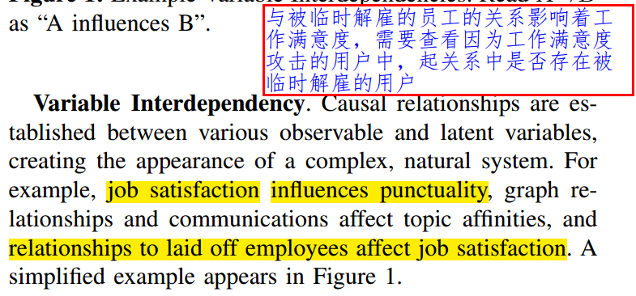

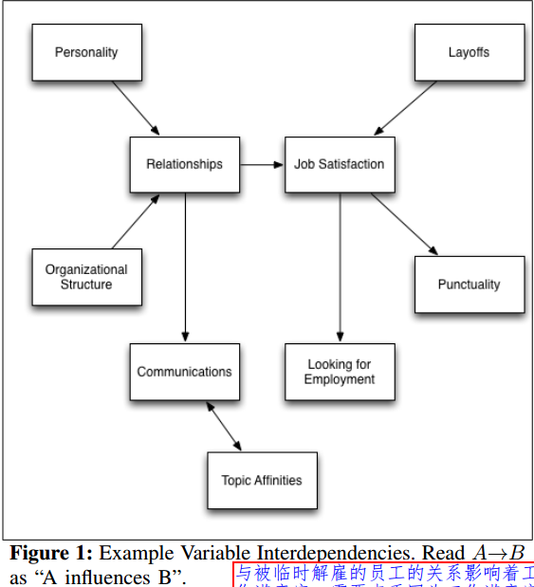

2018年9月4日星期二

下午4时45分

下午继续上午的工作。

从Figure1可以知道，图表中标识出了一些变量与行为的因果关系，对于我们而言重要的有：

* 人格特征与组织架构影响着用户的人际关系（即每天接触什么人）
* 与被临时解雇的员工的人际关系影响着用户的工作满意度（比如看到周围熟悉的同事或者好友被突然解雇，心中生出对单位的不满）
* 工作满意度影响着用户的守时性，因而不能用迟到早退返过来检测不满；

接下来，需要验证工作满意度如何影响用户跳槽的行为？

* 假设1：原先自己假设的是周围人的反生产行为造成的不好的示范和糟糕的人际交互导致用户工作满意度下降；
* 假设2：说明文件中指出用户人际关系网中被临时解雇的人会提升用户的工作不满；

文献[10]中涉及的大五人格中的NAC与反生产行为的相关性分析，为了揭示因果更好地预测，引入了工作满意度作为中间变量：

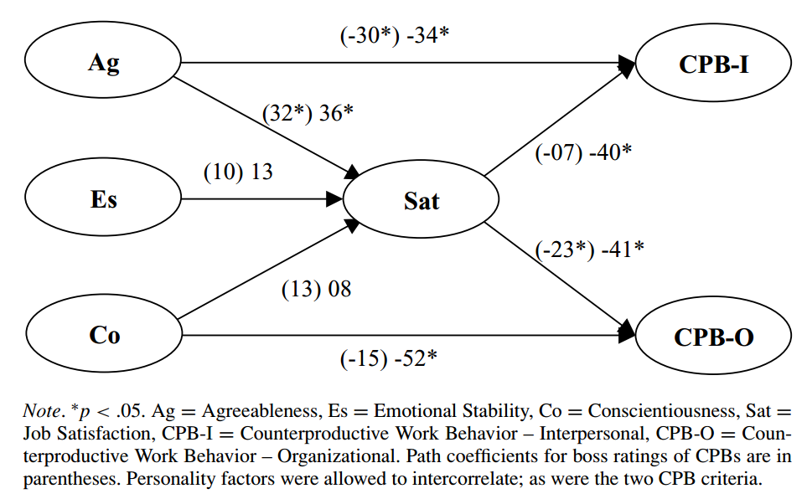

接下来，需要的做的工作是验证分析跳槽类内部用户的工作满意度是隐藏在其周围人的CPB-I中？还是隐藏在周围人存在的解雇员工中呢？

2018年9月10日星期一

上午10时18分

继续上次的分析。

请看下面几张图（由于scale改变原有数据方差，故先分析MinMax归一图像）

可以发现：

从C－A－N的维度分析所有2000个用户，看出低于/高于均值的用户均各有一半，即不能简单找到一个明显的阈值线性划分出高低CAN的用户，直接作为划分工作满意度高低的标准。

此时要么存在一个更加深奥的阴性变量表示JobSatisfactory，要么考虑团队人际的影响。

为了后续分析的需要，首先输出30个Insiders对应的OCEAN分数

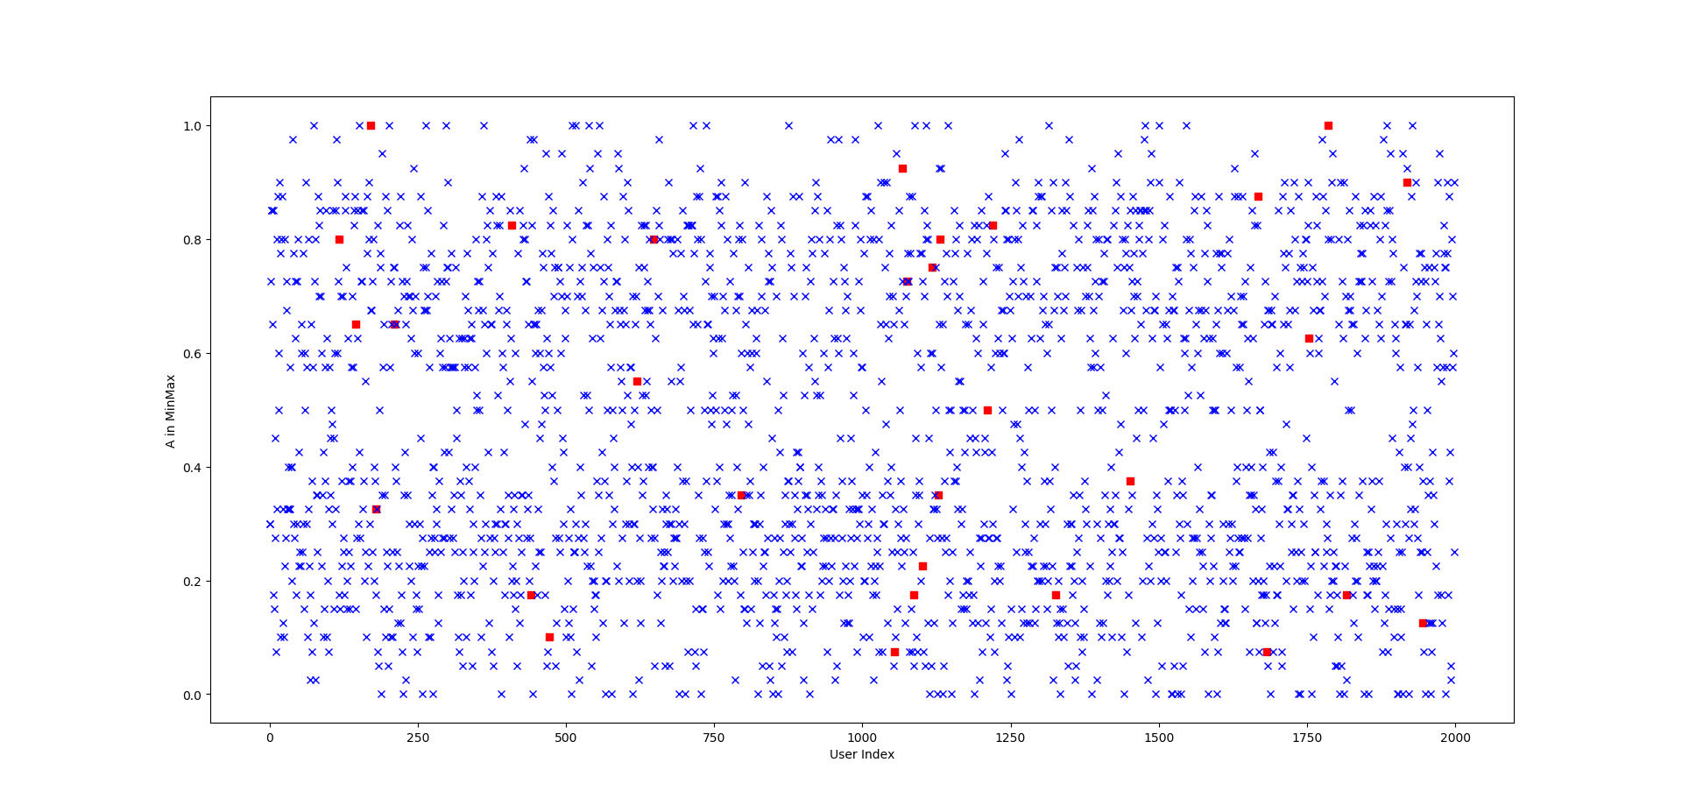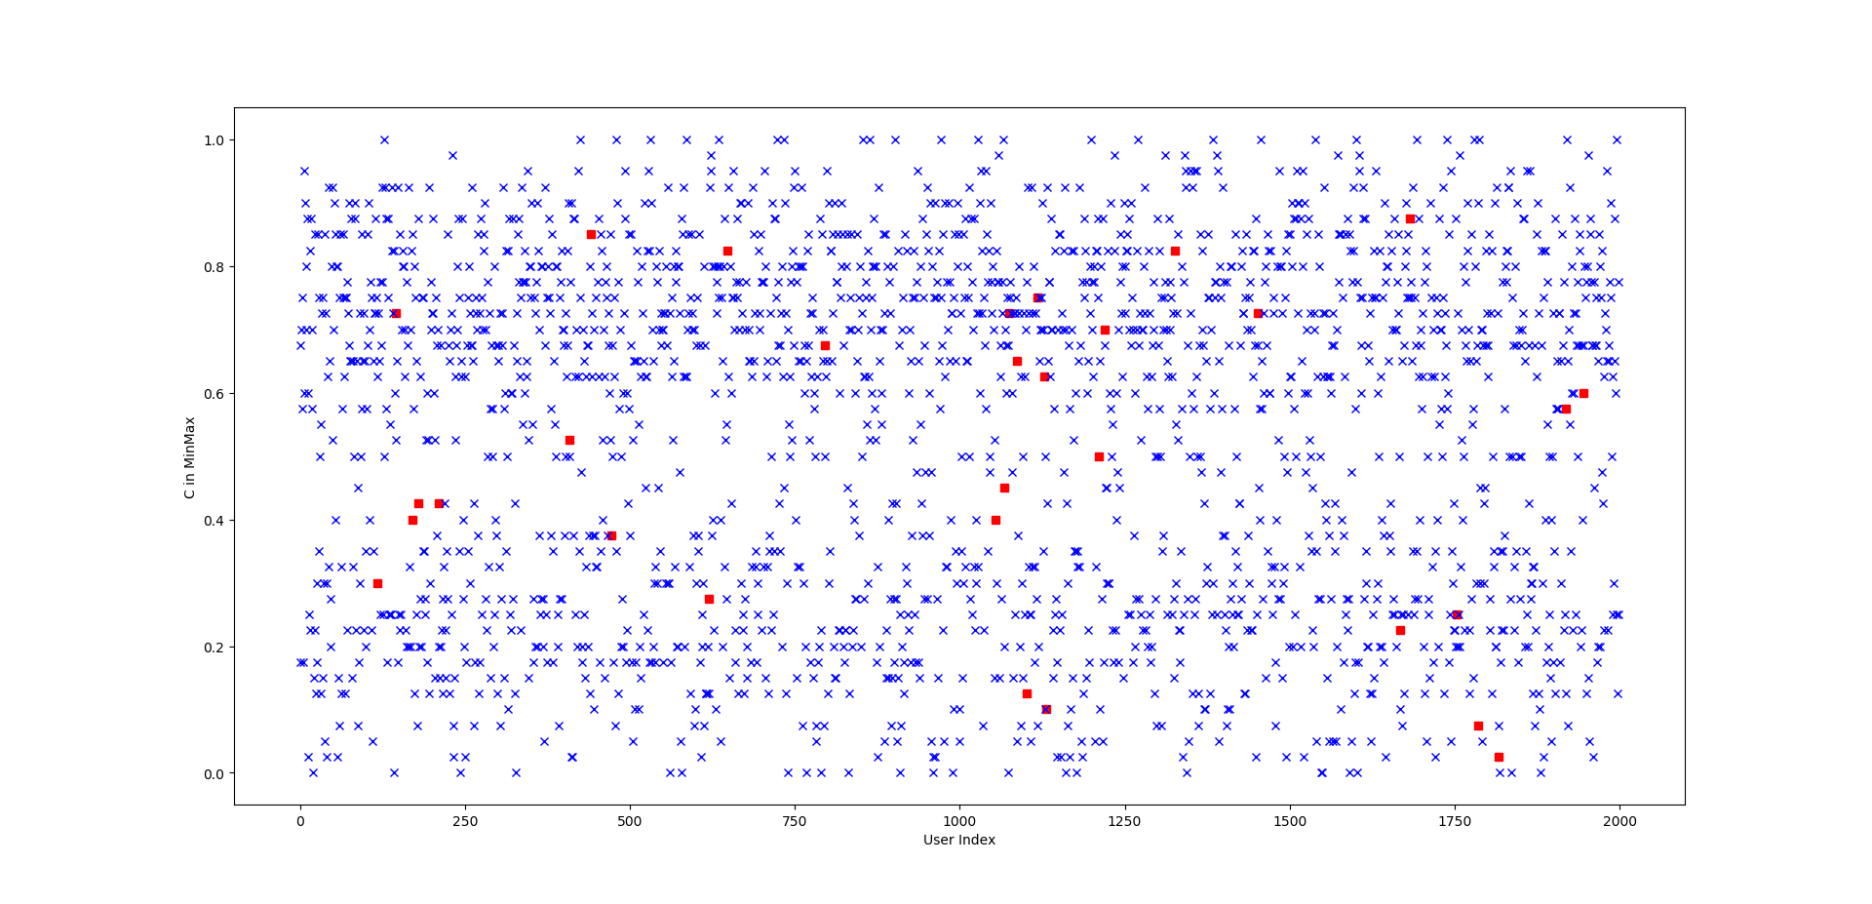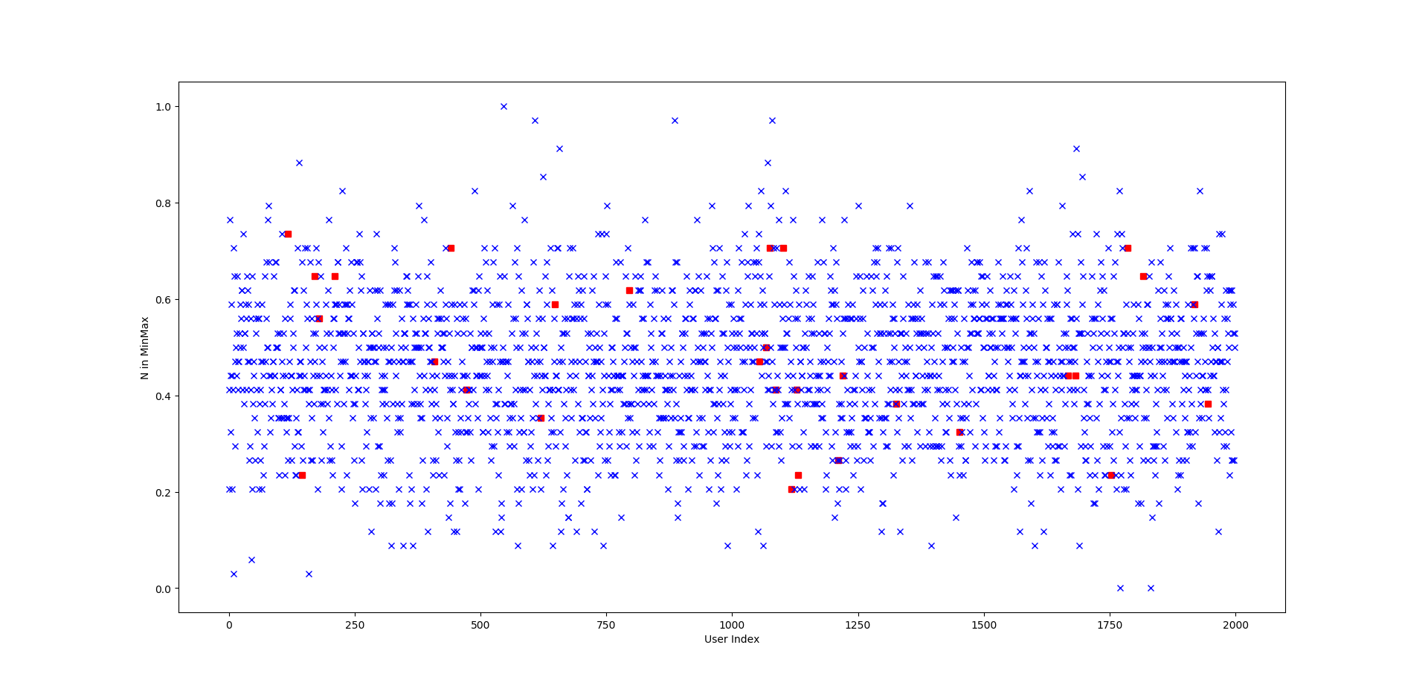

上图是关于尽责性C在所有2000个用户中的分布，红色代表场景二的30个跳槽员工，而蓝色代表其他员工（包含其他的内部攻击者）

可以初步看出有5个用户位于0.2较低的水平附近，但是有25个左右的用户位于0.5左右中等偏上，猜测下部由用户的人格决定不满度，而上部则来自于周围解雇员工的影响。

2018年9月10日星期一

下午3时44分

通过初步分析用户OCEAN的结果，发现简单依靠初始静态人格特质分数无法线性区分出目标Insiders。

依据CERT数据构造的说明，其工作满意度决定于用户所处人际关系及其中被解雇的用户，而人际关系由用户的人格特质与组织架构决定。因此，接下来决定先以一个具体的Insider为例，建模出其人际关系，并从中分析存在的laid off用户及其跳槽时间。

基本假设工作步骤如下：

1. 解构CERT数据集中的组织架构结构，确定目标用户所处的分层组织人员集合——工作关系；
2. 从邮件出发，分析目标用户邮件通讯来往关系图，从通讯频率（收/发）与收发比例来识别出可能的好友关系（如不在一个部门，却频繁通讯）；
3. 分析LDAP，识别出目标用户关联的laid off用户员工，并分析后续跳槽的时间关联性（laid off员工与目标用户的亲密度）
4. 可以试着定义一个“人际关系亲密度”，从而分析对于一个用户而言，其亲密人员被解雇对其造成的工作满意度影响；
5. 程序实现时注意通用性，可以后续分析剩余29个目标用户，以及所有的2000个用户，识别出工作满意度低却仅仅表现为迟到早退的用户；

2018年9月11日星期二

上午9时19分

现在手头的工作是明确出用户的“人际关系”到底是啥？

从论文图上看出的结果是，组织结构与用户人格特质共同影响了用户的人际关系，而人际关系又影响着其邮件通讯网络。故需要进行一个初步的验证：

是否用户的邮件通讯图都来自于于其组织架构决定的人际关系呢？

具体步骤为：

1. 选择一个场景二的攻击用户；
2. 依据LDAP结构，分析结构间存在的隶属关系

employee_name,user_id,email,role,projects,business_unit,functional_unit,department,team,supervisor

小实验1：事业部/职能部/部门/团队/监督者集合

经过初步分析，总体假设事业部为顶级编制，每个事业部下属不同的职能部，然后再下面是部门，再次是团队。

事业部层次：

Business Unit List:2

1 - Executive

2 - Executive

职能部层次：

Functional Unit List:6

1 - Adminstration

2 - ResearchAndEngineering

3 - Manufacturing

4 - Finance

5 - SalesAndMarketing

6 - PurchasingAndContracts

部门层次

Department List:20

1 - Accounting

1 - IndustrialEngineering

1 - MarketAnalysis

1 - Personnel

1 - ProjectManagement

1 - Purchasing

2 - EmployeeRelations

2 - ManufacturingEngineering

2 - Payroll

2 - Pricing

2 - Sales

3 - Assembly

3 - Contracts

3 - FieldService

3 - FinancialPlanning

3 - SoftwareManagement

3 - Training

4 - Engineering

4 - QualityControl

6 - Security

监督管理层：

Supervisor List:54

而LDAP中存在缺失的大部分是没有参与Project信息，该信息不能作为组织架构划分依据

而是作为单独的一个工作项目维度划分

不考虑Project空白，单单考虑其余各项组织结构空白，有

Others in abnormal format LDAP : ,214

上述存在空白项的用户多数是Team字段空缺，总共情况为：

Lack Flags: 0-projects, 1-BU, 2-FU, 3-Department, 4-Team, 5-Supervisor

0

1

4

24

184

1

唯一的一个CEO信息只到role字段，后续皆无

['Anjolie Evangeline Houston', 'AEH0001', 'Anjolie.Evangeline.Houston@dtaa.com', 'ChiefExecutiveOfficer']

2018年9月11日星期二

下午2时55分

下午继续上午的工作。

在进一步落实了CERT5.2中的层级结构后，尝试建立所有事业部的员工列表，计划：

1. 先统计形成每个事业部的部门列表，形式为[BU-X, FU-Y, DPT-Z, TEAM-P]，先列出部门列表，按顺序排列；
2. 然后重新遍历2009-12的初始LDAP（2000用户），将其中LDAP不全的用户归为Others列表，剩余的按照第一步得到的部门列表进行分别对应构成成员列表
3. 由于比照的部门列表，因此可以用用户的LDAP字段在部门列表中进行index匹配确定位置，然后写入到对应的列表即可；
4. 最后依据部门列表将所有用户成员列表输出到一个CSV文件；

实验已经完成，基本思路就是以上述四元组作为一个部门标签，从而统计所有用户位于不同部门的信息。当然，由于事先已经统计到Team层次，因此可以根据需求定制化分析特定用户的人际关系信息。

先看几个比较明显的数据事例。

['', '', '', ''],ETW0002,

该用户LDAP信息为：

Eden Tanisha Woodward,

ETW0002,Eden.Tanisha.Woodward@dtaa.com,AdministrativeAssistant,,,,,,Anjolie Evangeline Houston

其上司是企业的最高领导者CEO，因此其不属于任何一个部门

Anjolie Evangeline Houston,

[AEH0001,Anjolie.Evangeline.Houston@dtaa.com,ChiefExecutiveOfficer,,,,,,](mailto:AEH0001,Anjolie.Evangeline.Houston@dtaa.com,ChiefExecutiveOfficer,,,,,,)

而一个事业部看似有主席职位和一个配套的行政助理，CEO也有相应的行政助理，对于二人来说就仅属于第一事业部，而不属于任意一个职能部门、具体部门和小组

['1 - Executive', '', '', ''],NJC0003,PTH0005,

Nichole Jane Conner,NJC0003,Nichole.Jane.Conner@dtaa.com,President,,1 - Executive,,,,Anjolie Evangeline Houston

Pearl Tatiana Hickman,PTH0005,Pearl.Tatiana.Hickman@dtaa.com,AdministrativeAssistant,,1 - Executive,,,,Nichole Jane Conner

我们继续看下职能部门办公室

['1 - Executive', '1 - Adminstration', '', ''],BBB0012,CWC0006,

Blythe Bree Bowen,BBB0012,Blythe.Bree.Bowen@dtaa.com,AdministrativeAssistant,,1 - Executive,1 - Adminstration,,,Cade Wesley Clayton

Cade Wesley Clayton,CWC0006,Cade.Wesley.Clayton@dtaa.com,VicePresident,Project 39,1 - Executive,1 - Adminstration,,,Nichole Jane Conner

第二个职能部门研究发展办公室

['1 - Executive', '2 - ResearchAndEngineering', '', ''],GMC0051,VBK0007,

Gannon Macaulay Conrad,

GMC0051,Gannon.Macaulay.Conrad@dtaa.com,AdministrativeAssistant,,1 - Executive,2 - ResearchAndEngineering,,,Vladimir Buckminster King

Vladimir Buckminster King,VBK0007,Vladimir.Buckminster.King@dtaa.com,VicePresident,,1 - Executive,2 - ResearchAndEngineering,,,Nichole Jane Conner

我们发现，CEO下管理两个事业部，每个事业部的管理者为president和配套秘书，然后每个事业部下属的职能部门中，配套的管理者为vice president和对应的秘书

我们继续向下探索，如果进一步一个具体部门内呢？

这里面有四个人力专家，一个秘书，一个Director，主任领导其秘书与四个人力专家，向职能部门的副主席CWC0006汇报

['1 - Executive', '1 - Adminstration', '1 - Personnel', ''],

ABB0019,COB0021,HBF0022,JJS0013,TAJ0023,WCO0020,

Asher Benjamin Butler,ABB0019,Asher.Benjamin.Butler@dtaa.com,AdministrativeAssistant,,1 - Executive,1 - Adminstration,1 - Personnel,,Julian Joseph Shaw

Charde Olivia Baxter,COB0021,Charde.Olivia.Baxter@dtaa.com,HumanResourceSpecialist,Project 8,1 - Executive,1 - Adminstration,1 - Personnel,,Julian Joseph Shaw

Howard Brent Frost,HBF0022,Howard.Brent.Frost@dtaa.com,HumanResourceSpecialist,Project 21,1 - Executive,1 - Adminstration,1 - Personnel,,Julian Joseph Shaw

Julian Joseph Shaw,JJS0013,Julian.Joseph.Shaw@dtaa.com,Director,,1 - Executive,1 - Adminstration,1 - Personnel,,Cade Wesley Clayton

Tatyana Aimee Johnston,

TAJ0023,Tatyana.Aimee.Johnston@dtaa.com,HumanResourceSpecialist,Project 18,1 - Executive,1 - Adminstration,1 - Personnel,,Julian Joseph Shaw

William Ciaran Ortega,

WCO0020,William.Ciaran.Ortega@dtaa.com,HumanResourceSpecialist,Project 21,1 - Executive,1 - Adminstration,1 - Personnel,,Julian Joseph Shaw

我们再看看一个具体的Team

['1 - Executive', '1 - Adminstration', '6 - Security', '1 - BuildingSecurity']

Althea Sonya Hobbs,ASH0458,Althea.Sonya.Hobbs@dtaa.com,SecurityGuard,,1 - Executive,1 - Adminstration,6 - Security,1 - BuildingSecurity,*Owen Denton Barber*

Cora Tallulah Kelly,CTK0037,Cora.Tallulah.Kelly@dtaa.com,SecurityGuard,,1 - Executive,1 - Adminstration,6 - Security,1 - BuildingSecurity,*Owen Denton Barber*

其领导是Owen Denton Barber，即组长

Owen Denton Barber,ODB0034,Owen.Denton.Barber@dtaa.com,Manager,Project 29,1 - Executive,1 - Adminstration,6 - Security,1 - BuildingSecurity,Dane Elton Mcmahon

而DEM是部门主任，下管三个组长

Dane Elton Mcmahon,DEM0018,Dane.Elton.Mcmahon@dtaa.com,Director,,1 - Executive,1 - Adminstration,6 - Security,,Cade Wesley Clayton

因此CERT5.2的组织架构关系是：

CEO

事业部层次：主席+秘书

职能部层次：副主席+秘书

具体部门：主任+秘书+人力专家

团队层次：组长+秘书

2018年9月12日星期三

下午2时24分

昨天已经搞清了CERT5.2中的组织架构方式，那么接下来我们分析所有30个跳槽的内部威胁用户，其所处的人际关系网络中是否存在提前被解雇的用户。

为此，自己决定做一下两个小工作：

1. 列出CERT5.2中所有中途被解雇的用户名单信息以及离开的月份
2. 列出30个跳槽用户的LDAP信息
3. 将被解雇用户与30个跳槽用户的信息进行比对，发现其中组织关系（是否一一对应就可以发现是否存在Email联系）

通过程序实现，发现2009-12到2011-05总共有238名员工先后离职，自己将离职员工的时间（缺岗时间，即该月已不再上班）、LDAP信息一并写入了文件CERT5.2-LaidOff-Users，并且经过测算，CERT5.2数据集中没有员工新入职，故无需考虑新员工问题。

接下来需要验证30个跳槽Insiders是否全部在统计出的离职员工中（几乎是肯定的），并选定一个Insiders来查看在其离职时间前离职的员工。

经过分析，离职的238个员工包含场景二跳槽的30个员工！（从数量上就已经相互验证了，肯定的！：））

针对实验用户

['BYO1846', '2010-12', ['Buffy Yolanda Ortiz', 'BYO1846', 'Buffy.Yolanda.Ortiz@dtaa.com', 'Salesman', '', '1 - Executive', '5 - SalesAndMarketing', '2 - Sales', '5 - RegionalSales', 'Donna Erin Black']] 分析

首先进行时间过滤，即离职时间等于大于其离职时间2010-12的全部排除，第一轮筛选得到用户163个

['BYO1846', '2010-12', ['Buffy Yolanda Ortiz', 'BYO1846', 'Buffy.Yolanda.Ortiz@dtaa.com', 'Salesman', '', '1 - Executive', '5 - SalesAndMarketing', '2 - Sales', '5 - RegionalSales', 'Donna Erin Black']] 分析

经过部门筛选分析，得到

不同事业部的离职员工为: 82

**同一事业部下不同职能部的离职员工为: 46**

**同一团队的离职员工为: 3**

**相同部门下不同个团队的离职员工为: 16**

**相同职能部下不同部门的离职员工为: 15**

**相同职能部下不同部门的离职员工为: 15**

分析新的一个内部跳槽用户：

['CHP1711', '2010-10', ['Cody Hall Phelps', 'CHP1711', 'Cody.Hall.Phelps@dtaa.com', 'Salesman', '', '2 - Executive', '5 - SalesAndMarketing', '2 - Sales', '4 - RegionalSales', 'Ethan Branden Garrett']]

同一团队的离职员工为: 2

相同部门下不同个团队的离职员工为: 7

相同职能部下不同部门的离职员工为: 10

同一事业部下不同职能部的离职员工为: 43

不同事业部的离职员工为: 61

['RMB1821', '2010-02', ['Rose Maisie Blackwell', 'RMB1821', 'Rose.Maisie.Blackwell@dtaa.com', 'Salesman', '', '1 - Executive', '5 - SalesAndMarketing', '2 - Sales', '5 - RegionalSales', 'Donna Erin Black']]

['FDS1841', '2010-03', ['Fatima Dakota Santana', 'FDS1841', 'Fatima.Dakota.Santana@dtaa.com', 'Salesman', '', '1 - Executive', '5 - SalesAndMarketing', '2 - Sales', '5 - RegionalSales', 'Donna Erin Black']]

['TRC1838', '2010-09', ['Tana Rose Curry', 'TRC1838', 'Tana.Rose.Curry@dtaa.com', 'Salesman', '', '1 - Executive', '5 - SalesAndMarketing', '2 - Sales', '5 - RegionalSales', 'Donna Erin Black']]

**相同部门下不同个团队的离职员工为: 16 相同职能部下不同部门的离职员工为: 15**

['NWP1609', '2010-03', ['Naida Willa Perry', 'NWP1609', 'Naida.Willa.Perry@dtaa.com', 'Salesman', '', '1 - Executive', '5 - SalesAndMarketing', '2 - Sales', '4 - RegionalSales', 'Freya Mara Gould']]

['ZAD1621', '2010-04', ['Zorita Ashely Delaney', 'ZAD1621', 'Zorita.Ashely.Delaney@dtaa.com', 'Salesman', '', '1 - Executive', '5 - SalesAndMarketing', '2 - Sales', '4 - RegionalSales', 'Freya Mara Gould']]

['TAG1610', '2010-06', ['Tiger Axel Gates', 'TAG1610', 'Tiger.Axel.Gates@dtaa.com', 'Salesman', '', '1 - Executive', '5 - SalesAndMarketing', '2 - Sales', '4 - RegionalSales', 'Freya Mara Gould']]

['MAR1075', '2010-06', ['MacKenzie Alma Ruiz', 'MAR1075', 'MacKenzie.Alma.Ruiz@dtaa.com', 'Salesman', '', '1 - Executive', '5 - SalesAndMarketing', '2 - Sales', '2 - RegionalSales', 'Carl John Graham']]

['JXH1061', '2010-06', ['Jayme Xandra Harvey', 'JXH1061', 'Jayme.Xandra.Harvey@dtaa.com', 'Salesman', '', '1 - Executive', '5 - SalesAndMarketing', '2 - Sales', '2 - RegionalSales', 'Carl John Graham']]

['KEW0198', '2010-07', ['Kiara Emerald Watson', 'KEW0198', 'Kiara.Emerald.Watson@dtaa.com', 'Salesman', '', '1 - Executive', '5 - SalesAndMarketing', '2 - Sales', '1 - RegionalSales', 'Chaney Daquan Lee']]

['LSM1382', '2010-07', ['Leandra Sage Moran', 'LSM1382', 'Leandra.Sage.Moran@dtaa.com', 'Salesman', '', '1 - Executive', '5 - SalesAndMarketing', '2 - Sales', '3 - RegionalSales', 'Cody Lyle Salinas']]

['VCF1602', '2010-08', ['Vanna Charde Fowler', 'VCF1602', 'Vanna.Charde.Fowler@dtaa.com', 'Salesman', '', '1 - Executive', '5 - SalesAndMarketing', '2 - Sales', '4 - RegionalSales', 'Freya Mara Gould']]

['KBC1390', '2010-08', ['Kamal Bernard Chen', 'KBC1390', 'Kamal.Bernard.Chen@dtaa.com', 'Salesman', 'Project 5', '1 - Executive', '5 - SalesAndMarketing', '2 - Sales', '3 - RegionalSales', 'Cody Lyle Salinas']]

['TNB1616', '2010-09', ['Thomas Nasim Bender', 'TNB1616', 'Thomas.Nasim.Bender@dtaa.com', 'Salesman', '', '1 - Executive', '5 - SalesAndMarketing', '2 - Sales', '4 - RegionalSales', 'Freya Mara Gould']]

['IVS1411', '2010-09', ['Ivana Vivien Shepherd', 'IVS1411', 'Ivana.Vivien.Shepherd@dtaa.com', 'Salesman', '', '1 - Executive', '5 - SalesAndMarketing', '2 - Sales', '3 - RegionalSales', 'Cody Lyle Salinas']]

['SLL0193', '2010-09', ['Samson Louis Lynch', 'SLL0193', 'Samson.Louis.Lynch@dtaa.com', 'Salesman', '', '1 - Executive', '5 - SalesAndMarketing', '2 - Sales', '1 - RegionalSales', 'Chaney Daquan Lee']]

['MFM1400', '2010-10', ['Madaline Fallon Murphy', 'MFM1400', 'Madaline.Fallon.Murphy@dtaa.com', 'Salesman', '', '1 - Executive', '5 - SalesAndMarketing', '2 - Sales', '3 - RegionalSales', 'Cody Lyle Salinas']]

['CTT0639', '2010-11', ['Christine TaShya Thomas', 'CTT0639', 'Christine.TaShya.Thomas@dtaa.com', 'Salesman', '', '1 - Executive', '5 - SalesAndMarketing', '2 - Sales', '1 - RegionalSales', 'Chaney Daquan Lee']]

['HIS1394', '2010-12', ['Hu Ira Shepard', 'HIS1394', 'Hu.Ira.Shepard@dtaa.com', 'Salesman', '', '1 - Executive', '5 - SalesAndMarketing', '2 - Sales', '3 - RegionalSales', 'Cody Lyle Salinas']]

['MZO1066', '2010-12', ['Matthew Zachary Oneill', 'MZO1066', 'Matthew.Zachary.Oneill@dtaa.com', 'Salesman', '', '1 - Executive', '5 - SalesAndMarketing', '2 - Sales', '2 - RegionalSales', 'Carl John Graham']]

相同部门下不同个团队的离职员工分析完毕...

**相同职能部下不同部门的离职员工为: 15**

['WSW1091', '2010-02', ['Wing Scott Weeks', 'WSW1091', 'Wing.Scott.Weeks@dtaa.com', 'Technician', '', '1 - Executive', '5 - SalesAndMarketing', '3 - FieldService', '2 - RegionalFieldService', 'Moana Gemma Talley']]

['JHP1654', '2010-03', ['Jolie Harriet Perkins', 'JHP1654', 'Jolie.Harriet.Perkins@dtaa.com', 'Technician', '', '1 - Executive', '5 - SalesAndMarketing', '3 - FieldService', '4 - RegionalFieldService', 'Dacey Zenaida Miles']]

['JDM0208', '2010-03', ['Jonathan Driscoll Mckee', 'JDM0208', 'Jonathan.Driscoll.Mckee@dtaa.com', 'Technician', '', '1 - Executive', '5 - SalesAndMarketing', '3 - FieldService', '1 - RegionalFieldService', 'Chastity Emerald Sweet']]

['HSF1115', '2010-03', ['Hedda Suki Fulton', 'HSF1115', 'Hedda.Suki.Fulton@dtaa.com', 'Technician', '', '1 - Executive', '5 - SalesAndMarketing', '3 - FieldService', '2 - RegionalFieldService', 'Moana Gemma Talley']]

['UAM1108', '2010-07', ['Urielle Amy Middleton', 'UAM1108', 'Urielle.Amy.Middleton@dtaa.com', 'Technician', '', '1 - Executive', '5 - SalesAndMarketing', '3 - FieldService', '2 - RegionalFieldService', 'Moana Gemma Talley']]

['CIM1095', '2010-07', ['Colette Iris Mullen', 'CIM1095', 'Colette.Iris.Mullen@dtaa.com', 'Technician', '', '1 - Executive', '5 - SalesAndMarketing', '3 - FieldService', '2 - RegionalFieldService', 'Moana Gemma Talley']]

['ZHB1104', '2010-08', ['Zephania Hu Bridges', 'ZHB1104', 'Zephania.Hu.Bridges@dtaa.com', 'Technician', '', '1 - Executive', '5 - SalesAndMarketing', '3 - FieldService', '2 - RegionalFieldService', 'Moana Gemma Talley']]

['PTM1432', '2010-08', ['Phyllis Tamekah Meadows', 'PTM1432', 'Phyllis.Tamekah.Meadows@dtaa.com', 'Technician', '', '1 - Executive', '5 - SalesAndMarketing', '3 - FieldService', '3 - RegionalFieldService', 'Michelle Yoshi Booker']]

['CIF1430', '2010-09', ['Colette Isabelle Frye', 'CIF1430', 'Colette.Isabelle.Frye@dtaa.com', 'Technician', '', '1 - Executive', '5 - SalesAndMarketing', '3 - FieldService', '3 - RegionalFieldService', 'Michelle Yoshi Booker']]

['WDT1634', '2010-09', ['Willa Deborah Tyson', 'WDT1634', 'Willa.Deborah.Tyson@dtaa.com', 'Technician', '', '1 - Executive', '5 - SalesAndMarketing', '3 - FieldService', '4 - RegionalFieldService', 'Dacey Zenaida Miles']]

['DHS0204', '2010-09', ['Dean Hop Stevenson', 'DHS0204', 'Dean.Hop.Stevenson@dtaa.com', 'Technician', '', '1 - Executive', '5 - SalesAndMarketing', '3 - FieldService', '1 - RegionalFieldService', 'Chastity Emerald Sweet']]

['DDR1649', '2010-10', ['Daquan Dominic Riddle', 'DDR1649', 'Daquan.Dominic.Riddle@dtaa.com', 'Technician', '', '1 - Executive', '5 - SalesAndMarketing', '3 - FieldService', '4 - RegionalFieldService', 'Dacey Zenaida Miles']]

['HMK0653', '2010-11', ['Hillary Madaline Kaufman', 'HMK0653', 'Hillary.Madaline.Kaufman@dtaa.com', 'Technician', '', '1 - Executive', '5 - SalesAndMarketing', '3 - FieldService', '1 - RegionalFieldService', 'Chastity Emerald Sweet']]

['MIB0203', '2010-11', ['Mufutau Ivor Bryant', 'MIB0203', 'Mufutau.Ivor.Bryant@dtaa.com', 'Technician', '', '1 - Executive', '5 - SalesAndMarketing', '3 - FieldService', '1 - RegionalFieldService', 'Chastity Emerald Sweet']]

['HMS1658', '2010-12', ['Hedda Melissa Slater', 'HMS1658', 'Hedda.Melissa.Slater@dtaa.com', 'Technician', '', '1 - Executive', '5 - SalesAndMarketing', '3 - FieldService', '4 - RegionalFieldService', 'Dacey Zenaida Miles']]

相同职能部下不同部门的离职员工分析完毕...

**同一事业部下不同职能部的离职员工为: 46**

['FAM0495', '2010-02', ['Fuller Armando Murray', 'FAM0495', 'Fuller.Armando.Murray@dtaa.com', 'SoftwareEngineer', 'Project 13', '1 - Executive', '2 - ResearchAndEngineering', '3 - SoftwareManagement', '2 - DesktopSoftware', 'Shay Kitra Cash']]

['SDL0541', '2010-02', ['Silas Dylan Luna', 'SDL0541', 'Silas.Dylan.Luna@dtaa.com', 'MechanicalEngineer', '', '1 - Executive', '2 - ResearchAndEngineering', '4 - Engineering', '2 - MechanicalEngineering', 'Blythe Deborah Pugh']]

['CTH1812', '2010-02', ['Cole Travis Hubbard', 'CTH1812', 'Cole.Travis.Hubbard@dtaa.com', 'ProductionLineWorker', '', '1 - Executive', '3 - Manufacturing', '3 - Assembly', '7 - AssemblyDept', 'Preston Declan Barry']]

['JBG1375', '2010-02', ['Jeremy Byron Greene', 'JBG1375', 'Jeremy.Byron.Greene@dtaa.com', 'ProductionLineWorker', '', '1 - Executive', '3 - Manufacturing', '3 - Assembly', '5 - AssemblyDept', 'Kuame Dale Graves']]

['LRF0549', '2010-02', ['Lois Rinah Fuentes', 'LRF0549', 'Lois.Rinah.Fuentes@dtaa.com', 'MechanicalEngineer', '', '1 - Executive', '2 - ResearchAndEngineering', '4 - Engineering', '2 - MechanicalEngineering', 'Blythe Deborah Pugh']]

['NTV1777', '2010-04', ['Nicholas Todd Vincent', 'NTV1777', 'Nicholas.Todd.Vincent@dtaa.com', 'Physicist', '', '1 - Executive', '2 - ResearchAndEngineering', '2 - Research', '5 - Lab', 'Quinn Dana Bradshaw']]

['GMM1037', '2010-04', ['Gray Mason Mccray', 'GMM1037', 'Gray.Mason.Mccray@dtaa.com', 'ProductionLineWorker', '', '1 - Executive', '3 - Manufacturing', '3 - Assembly', '4 - AssemblyDept', 'Evangeline Yoko Malone']]

['MAF0467', '2010-04', ['Morgan Alma Fowler', 'MAF0467', 'Morgan.Alma.Fowler@dtaa.com', 'ITAdmin', 'Project 19', '1 - Executive', '1 - Adminstration', '6 - Security', '2 - ElectronicSecurity', 'Justine Paula Mccullough']]

['XMG1579', '2010-04', ['Xandra Mia Gilmore', 'XMG1579', 'Xandra.Mia.Gilmore@dtaa.com', 'ProductionLineWorker', '', '1 - Executive', '3 - Manufacturing', '3 - Assembly', '6 - AssemblyDept', 'Daniel Aquila Chandler']]

['HBH0111', '2010-05', ['Heidi Brianna Hartman', 'HBH0111', 'Heidi.Brianna.Hartman@dtaa.com', 'AdministrativeAssistant', '', '1 - Executive', '2 - ResearchAndEngineering', '4 - Engineering', '3 - ElectricalEngineering', 'Colby Christian Warren']]

['KBC0818', '2010-05', ['Kenneth Brandon Curtis', 'KBC0818', 'Kenneth.Brandon.Curtis@dtaa.com', 'StockroomClerk', 'Project 28', '1 - Executive', '3 - Manufacturing', '3 - Assembly', '3 - Stockroom', 'Alma Nola Tillman']]

['EAL1813', '2010-06', ['Erich Alan Luna', 'EAL1813', 'Erich.Alan.Luna@dtaa.com', 'ProductionLineWorker', '', '1 - Executive', '3 - Manufacturing', '3 - Assembly', '7 - AssemblyDept', 'Preston Declan Barry']]

['WBP0828', '2010-06', ['William Brady Parsons', 'WBP0828', 'William.Brady.Parsons@dtaa.com', 'StockroomClerk', 'Project 28', '1 - Executive', '3 - Manufacturing', '3 - Assembly', '3 - Stockroom', 'Alma Nola Tillman']]

['NWH0960', '2010-06', ['Nolan Wayne Hawkins', 'NWH0960', 'Nolan.Wayne.Hawkins@dtaa.com', 'HardwareEngineer', '', '1 - Executive', '2 - ResearchAndEngineering', '3 - SoftwareManagement', '6 - EmbeddedSoftware', 'Todd Rajah Peterson']]

['BRM0126', '2010-06', ['Britanni Rebecca Martin', 'BRM0126', 'Britanni.Rebecca.Martin@dtaa.com', 'AdministrativeAssistant', '', '1 - Executive', '2 - ResearchAndEngineering', '4 - Engineering', '6 - TestAndEvalualtion', 'Kuame Nathaniel Maxwell']]

['GWH0961', '2010-06', ['Garrett William Holland', 'GWH0961', 'Garrett.William.Holland@dtaa.com', 'HardwareEngineer', '', '1 - Executive', '2 - ResearchAndEngineering', '3 - SoftwareManagement', '6 - EmbeddedSoftware', 'Todd Rajah Peterson']]

['HFF0560', '2010-06', ['Hyatt Fritz Flynn', 'HFF0560', 'Hyatt.Fritz.Flynn@dtaa.com', 'ElectricalEngineer', '', '1 - Executive', '2 - ResearchAndEngineering', '4 - Engineering', '3 - ElectricalEngineering', 'Colby Christian Warren']]

['MMB0556', '2010-06', ['Mollie Michelle Blankenship', 'MMB0556', 'Mollie.Michelle.Blankenship@dtaa.com', 'ElectricalEngineer', '', '1 - Executive', '2 - ResearchAndEngineering', '4 - Engineering', '3 - ElectricalEngineering', 'Colby Christian Warren']]

['BNS0484', '2010-07', ['Beverly Neve Simon', 'BNS0484', 'Beverly.Neve.Simon@dtaa.com', 'SoftwareQualityEngineer', 'Project 38', '1 - Executive', '2 - ResearchAndEngineering', '3 - SoftwareManagement', '1 - SQA', 'Lars Tarik Patterson']]

['GFM1815', '2010-07', ['George Finn Morin', 'GFM1815', 'George.Finn.Morin@dtaa.com', 'ProductionLineWorker', '', '1 - Executive', '3 - Manufacturing', '3 - Assembly', '7 - AssemblyDept', 'Preston Declan Barry']]

['CKP0630', '2010-08', ['Carissa Kaye Parsons', 'CKP0630', 'Carissa.Kaye.Parsons@dtaa.com', 'ProductionLineWorker', '', '1 - Executive', '3 - Manufacturing', '3 - Assembly', '2 - AssemblyDept', 'Bradley Tyrone Nieves']]

['JKM1790', '2010-08', ['Jeremy Kevin Mcleod', 'JKM1790', 'Jeremy.Kevin.Mcleod@dtaa.com', 'ProductionLineWorker', '', '1 - Executive', '3 - Manufacturing', '3 - Assembly', '7 - AssemblyDept', 'Preston Declan Barry']]

['PBC0077', '2010-08', ['Pearl Bertha Cortez', 'PBC0077', 'Pearl.Bertha.Cortez@dtaa.com', 'AdministrativeAssistant', '', '1 - Executive', '2 - ResearchAndEngineering', '3 - SoftwareManagement', '1 - SQA', 'Lars Tarik Patterson']]

['PTV0067', '2010-08', ['Penelope TaShya Vinson', 'PTV0067', 'Penelope.TaShya.Vinson@dtaa.com', 'Physicist', '', '1 - Executive', '2 - ResearchAndEngineering', '2 - Research', '1 - Lab', 'Kimberly Molly Graves']]

['MGM0539', '2010-09', ['Marcia Galena Mendoza', 'MGM0539', 'Marcia.Galena.Mendoza@dtaa.com', 'TechnicalWriter', 'Project 38', '1 - Executive', '2 - ResearchAndEngineering', '4 - Engineering', '1 - Publications', 'Brenda Paloma Allison']]

['IHC0561', '2010-09', ['Indigo Halee Christensen', 'IHC0561', 'Indigo.Halee.Christensen@dtaa.com', 'MaterialsEngineer', '', '1 - Executive', '2 - ResearchAndEngineering', '4 - Engineering', '4 - MaterialsEngineering', 'Kaitlin Riley Craft']]

['OJC0930', '2010-09', ['Orson John Coleman', 'OJC0930', 'Orson.John.Coleman@dtaa.com', 'Mathematician', '', '1 - Executive', '2 - ResearchAndEngineering', '2 - Research', '2 - Lab', 'Anthony Buckminster Maxwell']]

['SIS0042', '2010-09', ['Shelby Isabelle Saunders', 'SIS0042', 'Shelby.Isabelle.Saunders@dtaa.com', 'ITAdmin', 'Project 12', '1 - Executive', '1 - Adminstration', '6 - Security', '2 - ElectronicSecurity', 'Justine Paula Mccullough']]

['KLB0918', '2010-09', ['Kadeem Leroy Butler', 'KLB0918', 'Kadeem.Leroy.Butler@dtaa.com', 'ITAdmin', '', '1 - Executive', '1 - Adminstration', '6 - Security', '3 - ElectronicSecurity', 'Keith Jelani Morse']]

['MTD0971', '2010-10', ['Madeline Tatum Donaldson', 'MTD0971', 'Madeline.Tatum.Donaldson@dtaa.com', 'ElectricalEngineer', '', '1 - Executive', '2 - ResearchAndEngineering', '3 - SoftwareManagement', '6 - EmbeddedSoftware', 'Todd Rajah Peterson']]

['TTR1792', '2010-10', ['Thaddeus Theodore Ruiz', 'TTR1792', 'Thaddeus.Theodore.Ruiz@dtaa.com', 'ProductionLineWorker', '', '1 - Executive', '3 - Manufacturing', '3 - Assembly', '7 - AssemblyDept', 'Preston Declan Barry']]

['GWG0497', '2010-10', ['Graham Wade Gordon', 'GWG0497', 'Graham.Wade.Gordon@dtaa.com', 'ComputerScientist', 'Project 30', '1 - Executive', '2 - ResearchAndEngineering', '3 - SoftwareManagement', '2 - DesktopSoftware', 'Shay Kitra Cash']]

['MCP0611', '2010-10', ['Marvin Carl Perkins', 'MCP0611', 'Marvin.Carl.Perkins@dtaa.com', 'ProductionLineWorker', '', '1 - Executive', '3 - Manufacturing', '3 - Assembly', '2 - AssemblyDept', 'Bradley Tyrone Nieves']]

['VVG0624', '2010-11', ['Vivien Vielka Gregory', 'VVG0624', 'Vivien.Vielka.Gregory@dtaa.com', 'ProductionLineWorker', '', '1 - Executive', '3 - Manufacturing', '3 - Assembly', '2 - AssemblyDept', 'Bradley Tyrone Nieves']]

['LLW0179', '2010-11', ['Lyle Lionel Wade', 'LLW0179', 'Lyle.Lionel.Wade@dtaa.com', 'Statistician', '', '1 - Executive', '4 - Finance', '3 - FinancialPlanning', '', 'Yolanda Jane Branch']]

['RAT0514', '2010-11', ['Rogan Alden Talley', 'RAT0514', 'Rogan.Alden.Talley@dtaa.com', 'ElectricalEngineer', '', '1 - Executive', '2 - ResearchAndEngineering', '3 - SoftwareManagement', '3 - EmbeddedSoftware', 'Jakeem Ferris Cash']]

['GKW0043', '2010-11', ['Gage Kieran Warner', 'GKW0043', 'Gage.Kieran.Warner@dtaa.com', 'ITAdmin', '', '1 - Executive', '1 - Adminstration', '6 - Security', '2 - ElectronicSecurity', 'Justine Paula Mccullough']]

['NAH1366', '2010-11', ['Norman Akeem Harmon', 'NAH1366', 'Norman.Akeem.Harmon@dtaa.com', 'ProductionLineWorker', '', '1 - Executive', '3 - Manufacturing', '3 - Assembly', '5 - AssemblyDept', 'Kuame Dale Graves']]

['PLF1030', '2010-11', ['Patrick Leroy Farmer', 'PLF1030', 'Patrick.Leroy.Farmer@dtaa.com', 'ProductionLineWorker', '', '1 - Executive', '3 - Manufacturing', '3 - Assembly', '4 - AssemblyDept', 'Evangeline Yoko Malone']]

['TPO1049', '2010-12', ['Tana Portia Orr', 'TPO1049', 'Tana.Portia.Orr@dtaa.com', 'ProductionLineWorker', '', '1 - Executive', '3 - Manufacturing', '3 - Assembly', '4 - AssemblyDept', 'Evangeline Yoko Malone']]

['ICB1354', '2010-12', ['Isaiah Cody Baker', 'ICB1354', 'Isaiah.Cody.Baker@dtaa.com', 'ProductionLineWorker', '', '1 - Executive', '3 - Manufacturing', '3 - Assembly', '5 - AssemblyDept', 'Kuame Dale Graves']]

['RRS0056', '2010-12', ['Ross Raphael Schwartz', 'RRS0056', 'Ross.Raphael.Schwartz@dtaa.com', 'AdministrativeAssistant', '', '1 - Executive', '2 - ResearchAndEngineering', '1 - ProjectManagement', '', 'Rina Adena Horn']]

['MJA1784', '2010-12', ['Mona Judith Alford', 'MJA1784', 'Mona.Judith.Alford@dtaa.com', 'Physicist', '', '1 - Executive', '2 - ResearchAndEngineering', '2 - Research', '5 - Lab', 'Quinn Dana Bradshaw']]

['EJV0094', '2010-12', ['Eagan Jarrod Vega', 'EJV0094', 'Eagan.Jarrod.Vega@dtaa.com', 'AdministrativeAssistant', '', '1 - Executive', '2 - ResearchAndEngineering', '4 - Engineering', '', 'Gwendolyn Darrel Camacho']]

['GCB0118', '2010-12', ['Gloria Carolyn Baird', 'GCB0118', 'Gloria.Carolyn.Baird@dtaa.com', 'MaterialsEngineer', '', '1 - Executive', '2 - ResearchAndEngineering', '4 - Engineering', '4 - MaterialsEngineering', 'Kaitlin Riley Craft']]

['HXP0976', '2010-12', ['Hilel Xenos Peterson', 'HXP0976', 'Hilel.Xenos.Peterson@dtaa.com', 'SoftwareDeveloper', 'Project 5', '1 - Executive', '2 - ResearchAndEngineering', '3 - SoftwareManagement', '7 - WebSoftware', 'Eliana Patience Bonner']]

同一事业部下不同职能部的离职员工分析完毕...

2018年9月14日星期五

上午9时55分

昨天初步分析了所有用户五个层次的离职人员的情况。