**[OS172][WEEK: 00 01 02 03 04 05 06 07 08 09 10 ]**

[======================== 27Aug 06Sep 13Sep 24Sep 01Okt 08Okt 25Okt 01Nov 08Nov 15Nov 22Nov

**[Minggu 00 mailto:os172@vlsm.org?subject:W00 9999999999]**

**[CLASS: A E I M X ][ID: 9999999999 ][NAME: Cicak bin Kadal ][ REV05 ]**

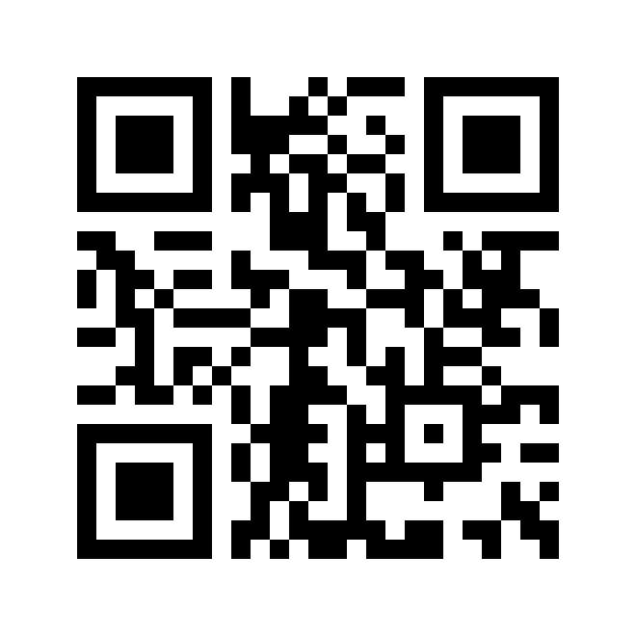

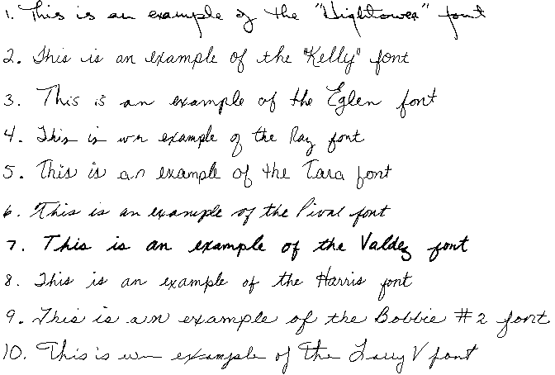

*) This handwriting image may be subject to copyright (**http://www.walterware.com/samples.html**).