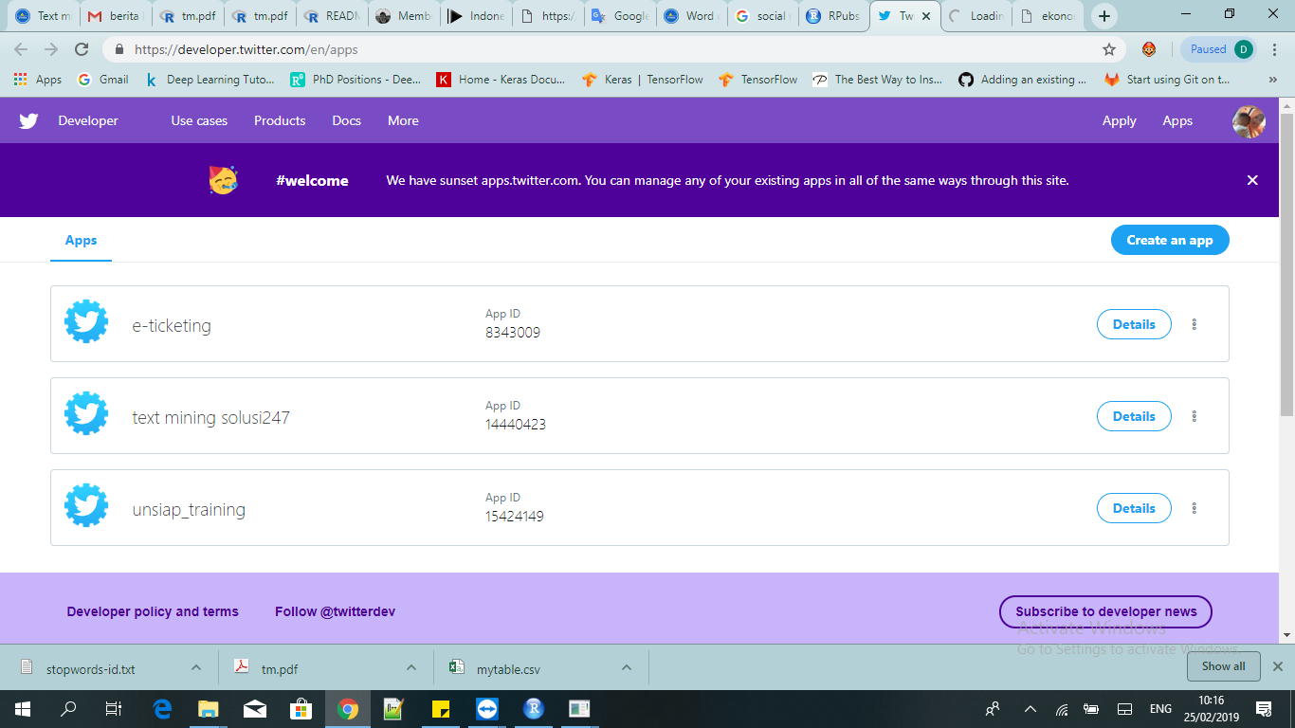

**e-ticketing**

**Keys and tokens**

Keys, secret keys and access tokens management.

**Consumer API keys**

fEWFJBvpOx7fCXvztRys6uJ8s (API key)

zM3i8hwDwejtf1FJXZaZqiRniYol5C60Bvzc2CO8L0zLA1eaIR (API secret key)

Regenerate

**Access token & access token secret**

2896928972-AiF8tupNzhxCiz7VSj23U8p54bMQmnyoVfsuD0L (Access token)

iYWtJNQ8HurG95rxhMVGMay96pMAn08FA7YCxYa8KVs6Z (Access token secret)

Read and write (Access level)

**Text mining solusi 247**

**Keys and tokens**

Keys, secret keys and access tokens management.

**Consumer API keys**

pJ8fyRKpxDjWX1DKErDnWzkZc (API key)

ngTslRCNgMD50TqFGp8Vhtw2QEorFW3B1XIuW3IloLWxZgv1F7 (API secret key)

Regenerate

**Access token & access token secret**

2896928972-lgd2X0DpZU5VqPOMuJxqHnMtQfK60e3xt2pkABQ (Access token)

65leySoKOwmoBXkGhayoC9gc0G3U6XJWOZc5mz24BIJR3 (Access token secret)

Read and write (Access level)

**UNSIAP TRAINING**

**Keys and tokens**

Keys, secret keys and access tokens management.

**Consumer API keys**

Z7fv825L0mcMCPzWm5XlhUMMA (API key)

oV1k0zfDEkqMvVa8ZXWscfJ7vwfBXCXzCrxqeptMkMEm9fJrbj (API secret key)

Regenerate

**Access token & access token secret**

2896928972-9kONHYE6QApnAvY7AiU8p0sFPCSLiMpX2xHkwyu (Access token)

DqWJAsS9Qz57v19LDbOEMSYaiAqUV6hOxiI20ktYigEdN (Access token secret)