上机1 输入一个年份，输出这一年中每个月的天数

using System;

namespace PPT23test

{

class Program

{

static void Main(string[] args)

{

int year;

int[] month = { 31, 28, 31, 30, 31, 30, 31, 31, 30, 31, 30, 31 };

Console.Write("请输入一个年份：");

year = Convert.ToInt32(Console.ReadLine());

if ((year % 4 == 0 && year % 100 != 0) || (year % 400 == 0))

{

for (int i = 0; i < 12; i++)

{

if (i == 1)

{

month[i] = 29;

}

Console.WriteLine("第" + (i + 1) + "月有" + month[i] + "天");

}

}

else

{

for (int i = 0; i < 12; i++)

{

Console.WriteLine("第" + (i + 1) + "月有" + month[i] + "天");

}

}

Console.ReadLine();

}

}

}

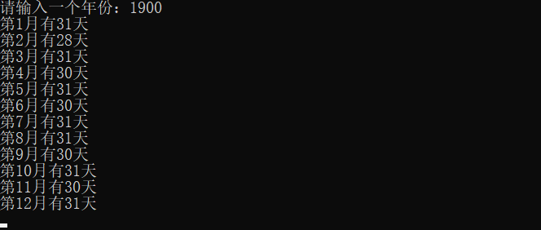

上机2 客车售票系统

using System;

namespace PPT23test

{

class Program

{

static void Main(string[] args)

{

string[][] vs = new string[5][];

vs[0] = new string[5] { "车次", "出发站-终点站", "出发时间", "到达时间", "历时" };

vs[1] = new string[5] { "T40", "长春-北京", "00:06", "10:50", "10:44" };

vs[2] = new string[5] { "T298", "长春-黑龙江", "00:12", "12:20", "12:08" };

vs[3] = new string[5] { "Z158", "郑州-北京", "12:48", "21:06", "08:18" };

vs[4] = new string[5] { "K1084", "四川-黑龙江", "12:39", "02:16", "13:37" };

Console.Title = "客车售票系统";

for (int i = 0; i < 5; i++)

{

Console.Write(vs[0][i]+" ");

}

Console.WriteLine();

for (int key = 1; key < vs.Length; key++)

{

for (int index = 0; index < vs[0].Length; index++)

{

Console.Write(vs[key][index]+"\t");

}

Console.WriteLine();

}

Console.WriteLine("请输入要购买的车次：");

string t = Console.ReadLine();

Console.WriteLine("请输入乘车人（用逗号分隔）：");

string person = Console.ReadLine();

for (int i = 1; i < 5; i++)

{

if (vs[i][0]==t)

{

Console.WriteLine("您已购{0}次列车 {1} {2}开，请{3}尽快换取纸质车票。【铁路客服】",t,vs[i][1],vs[i][2],person);

break;

}

}

Console.ReadLine();

}

}

}

