1计算圆的面积

using System;

namespace O

{

class Program

{

static double r;

const double PI = 3.14;

static void Main(string[] args)

{

Console.Write("请输入半径:");

Program.r = Convert.ToDouble(Console.ReadLine());//输入圆半径

Console.WriteLine("圆面积为：" + PI \* Math.Pow(r, 2));//计算圆面积

Console.ReadLine();

}

}

}



2通过属性控制年龄的输入范围

using System;

namespace O

{

class Program

{

private int age;

public int Age

{

get

{

return age;

}

set

{

if (value > 0 && value < 70)

{

age = value;

}

else

{

Console.WriteLine("输入数据不合理！");

}

}

}

static void Main(string[] args)

{

Program p = new Program();

while (true)

{

Console.Write("请输入年龄:");

p.Age = Convert.ToInt16(Console.ReadLine());

}

}

}

}

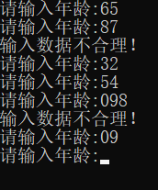

3静态构造函数应用

using System;

namespace O

{

public class Program

{

static Program()

{

Console.WriteLine("static");

}

private Program()

{

Console.WriteLine("实例构造函数");

}

static void Main(string[] args)

{

Program p1 = new Program();

Program p2 = new Program();

Program p3 = new Program();

Console.ReadLine();

}

}

}

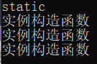

4使用静态方法计算两数之合

using System;

namespace O

{

class Program

{

public static int Add(int x, int y)

{

return x + y;

}

static void Main(string[] args)

{

Console.WriteLine("{0}+{1}={2}", 23, 24, Program.Add(23, 24));

Console.ReadLine();

}

}

}

