  - PROJECT DOCUMENTATION

Home, navigation, settings and help
A visual guide to the installed MyICA staging app's home screen, service hubs, navigation drawer, settings and support destinations, including loaded privacy/terms pages and the home scam-advisory link.
27 screen captures • Pixel 7 Pro emulator • Android 16 • English
Captured from the installed staging app on 7 September 2026. Screenshots are original device PNGs. This is a screen walkthrough; it does not certify every test case or every input combination.

Coverage and outcomes
Flow / branch | Observed outcome
Home and service hubs | Home, favourite shortcuts, Citizen and Resident hub, and Foreign Visitor hub opened.
Home external links | Scam-advisory banner opened ScamShield. The translation-feedback link opened ICA Contact Us.
About | About MyICA, About Us and ICA website opened. The app identifies itself as 2.0.0(13) (STAGING).
Privacy and terms | Both external pages fully loaded. Privacy overview text, the Terms section list and expanded General text captured.
Help | Contact Us, Feedback, FAQ on AskGov, GovTech Report Vulnerability, and native Troubleshooting captured. No message or report sent.
Settings | Language, tutorial and favourite-shortcut settings opened. English retained; no exhaustive language rerun.
The Android package reports versionName 2.0.0 and versionCode 420. The in-app version label uses a different suffix; both values are retained in environment.json.
Screens reflect this emulator's existing configuration. First-install onboarding and every language variant were not exercised.
The resumed session completed the remaining support and About destinations and returned to MyICA Home. External pages are entry/content snapshots, not submitted support forms.

How to use this document
Each following page records one screen, the action used to reach it, and any relevant observation. Screen numbers match the category manifest and PNG filenames. Source XML and SHA-256 hashes are retained beside the screenshots for traceability. Open the original PNG when you need to zoom into small text.

001 Home and favourite shortcuts
Launch MyICA Mobile.
Citizen and Resident, Foreign Visitor and customisable favourite shortcuts are available.
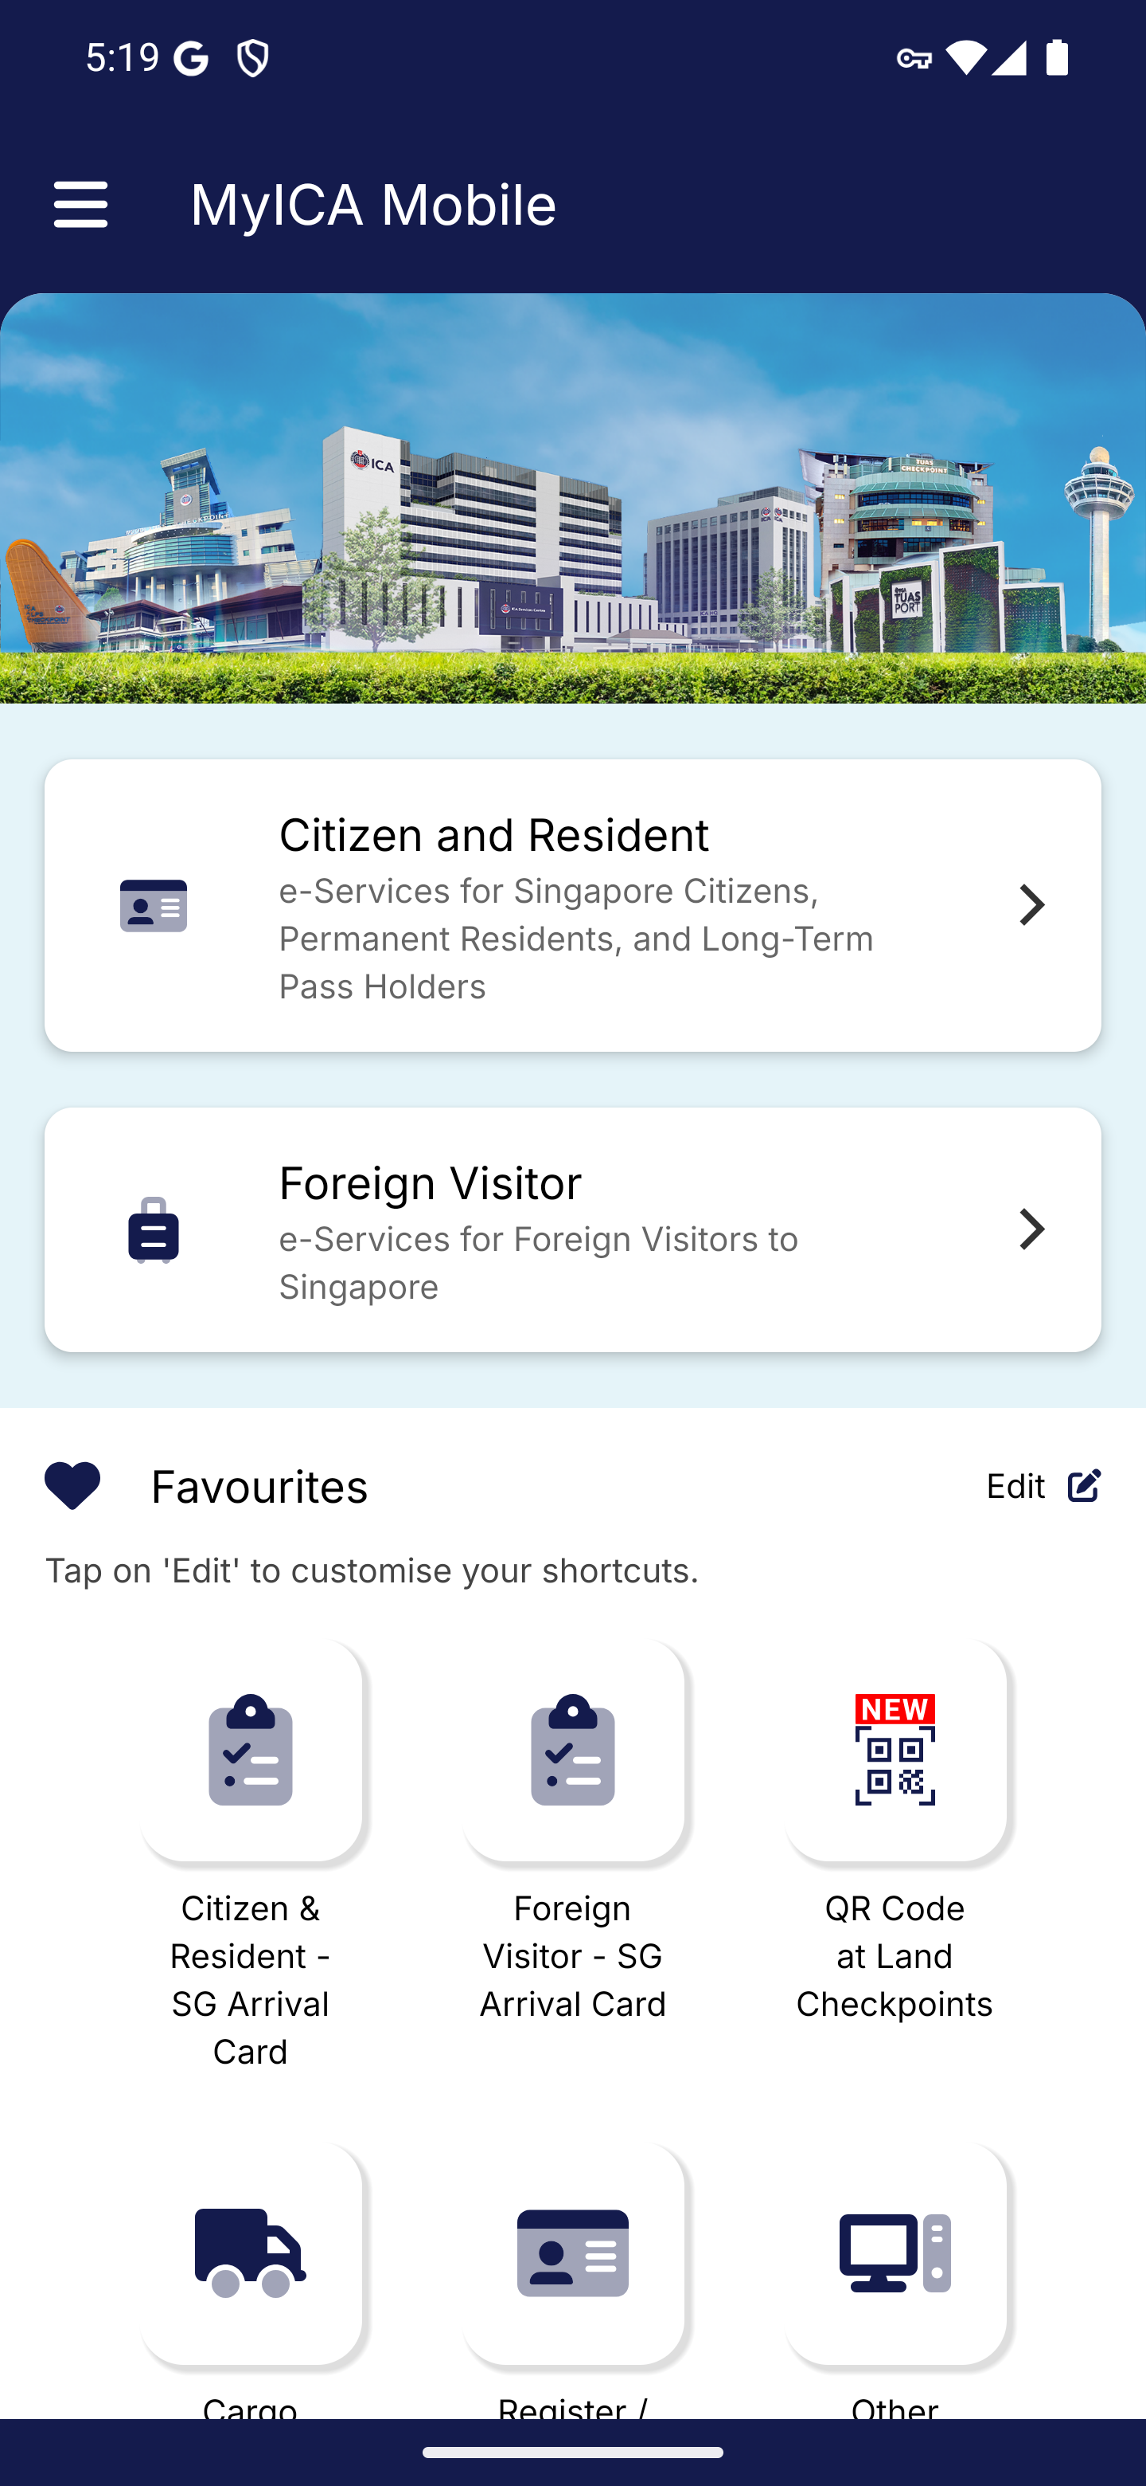
Screen 001 • 2026-09-07 17:19:05 • Captured

002 Home lower section and scam advisory
Scroll down on the home screen.
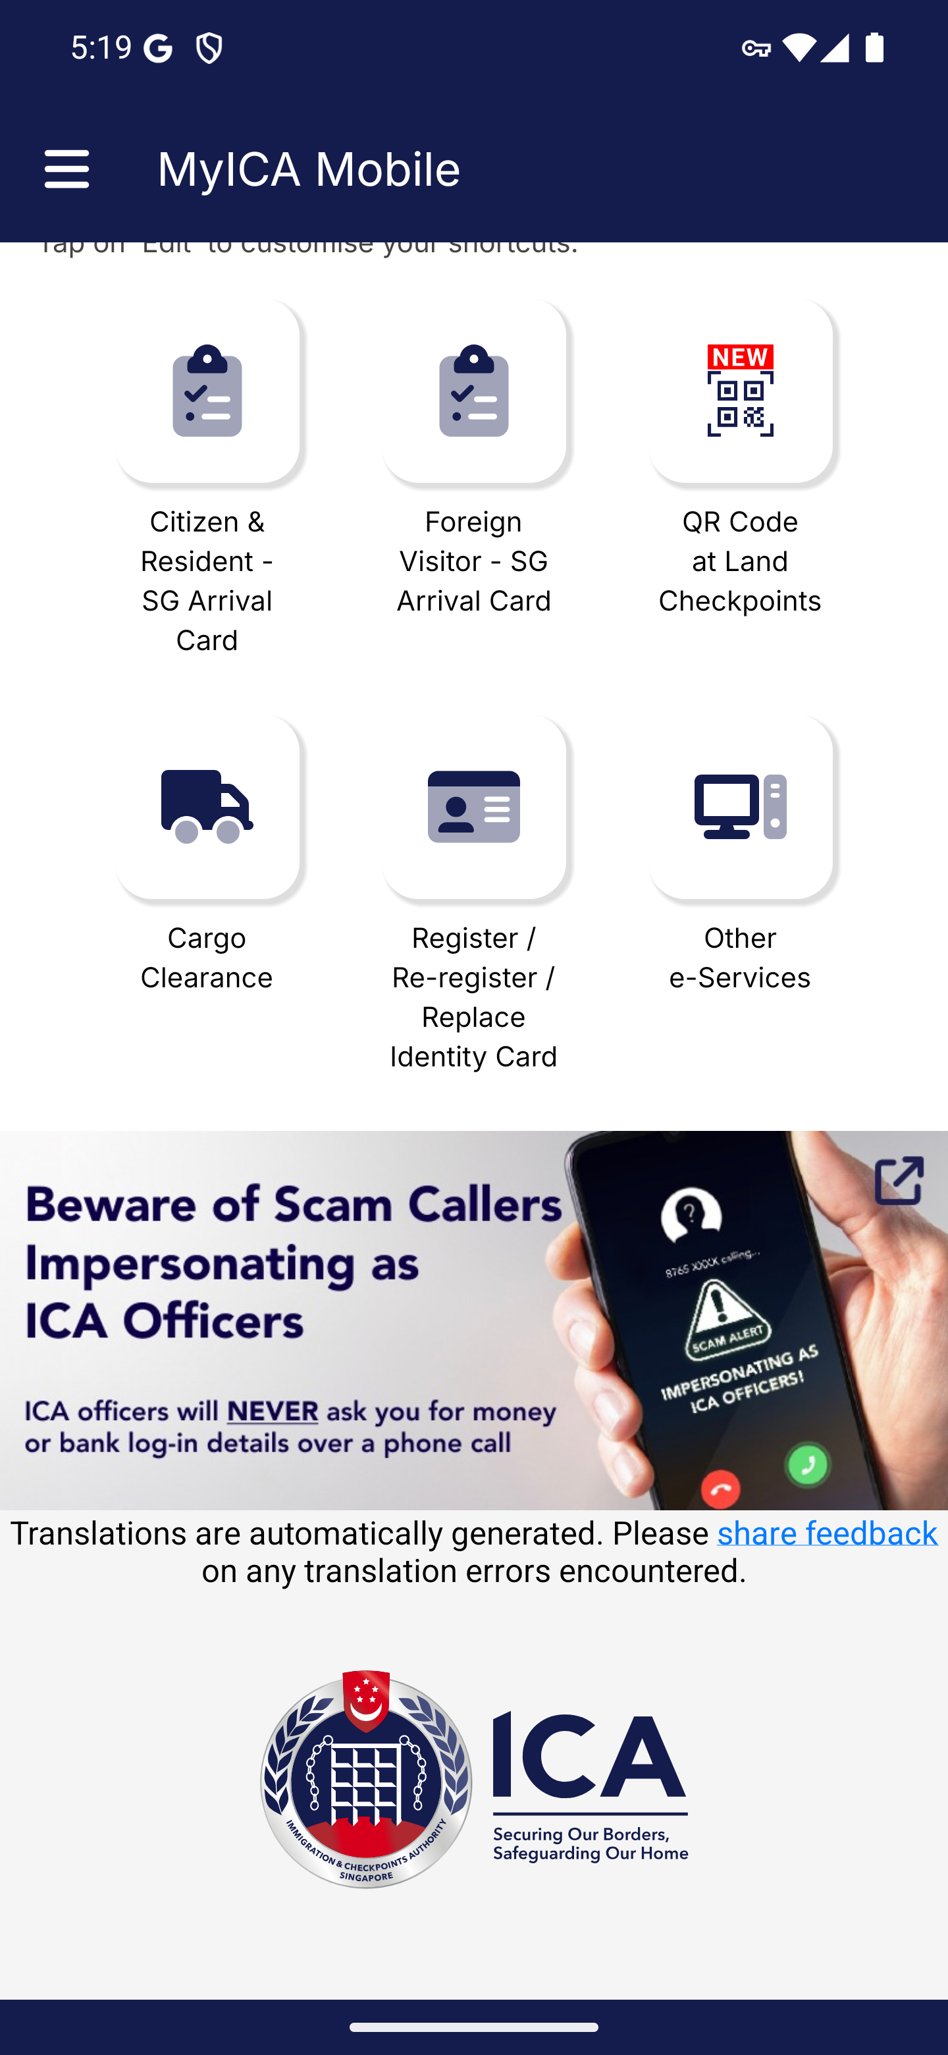
Screen 002 • 2026-09-07 17:19:08 • Captured

003 Navigation drawer
Open the navigation drawer from the top left.
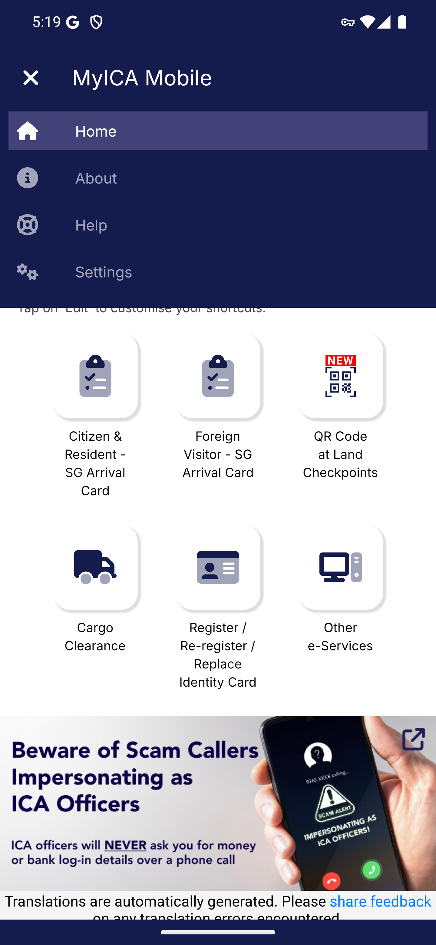
Screen 003 • 2026-09-07 17:19:14 • Captured

004 About MyICA
Choose About in the navigation drawer.
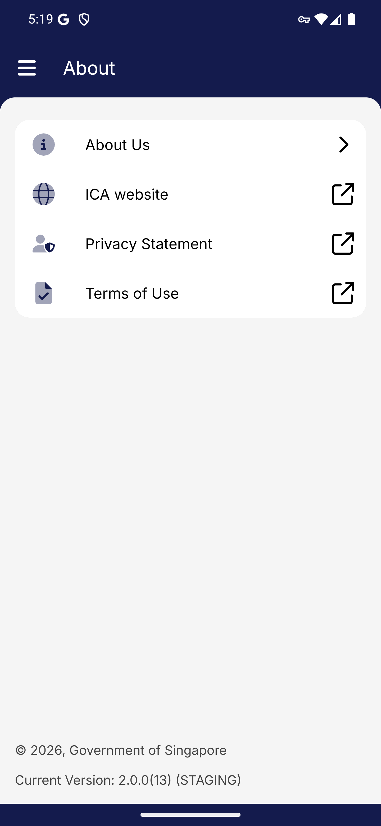
Screen 004 • 2026-09-07 17:19:37 • Captured

005 About Us
Open About Us.
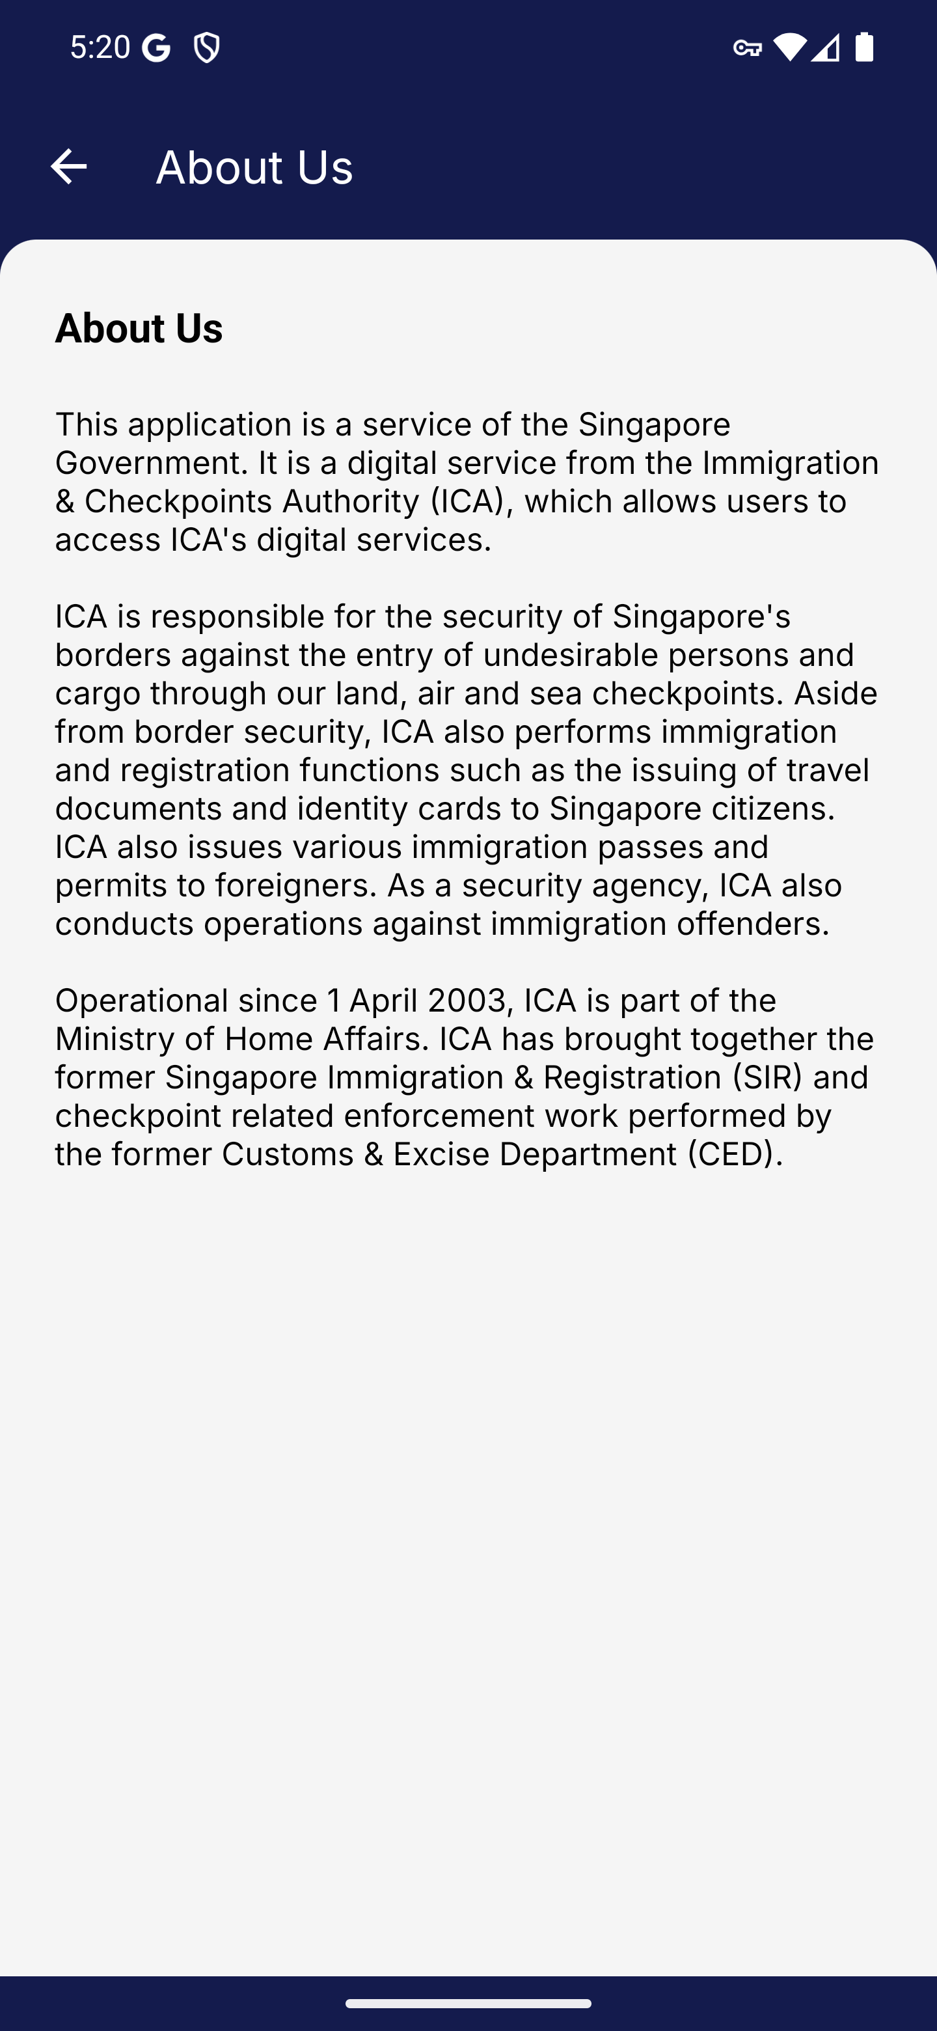
Screen 005 • 2026-09-07 17:20:07 • Captured

006 Privacy statement browser handoff
Open Privacy Statement.
Initial-session browser handoff. The loaded Privacy Statement and its text are captured in screens 021–022.
Outcome: Browser handoff only
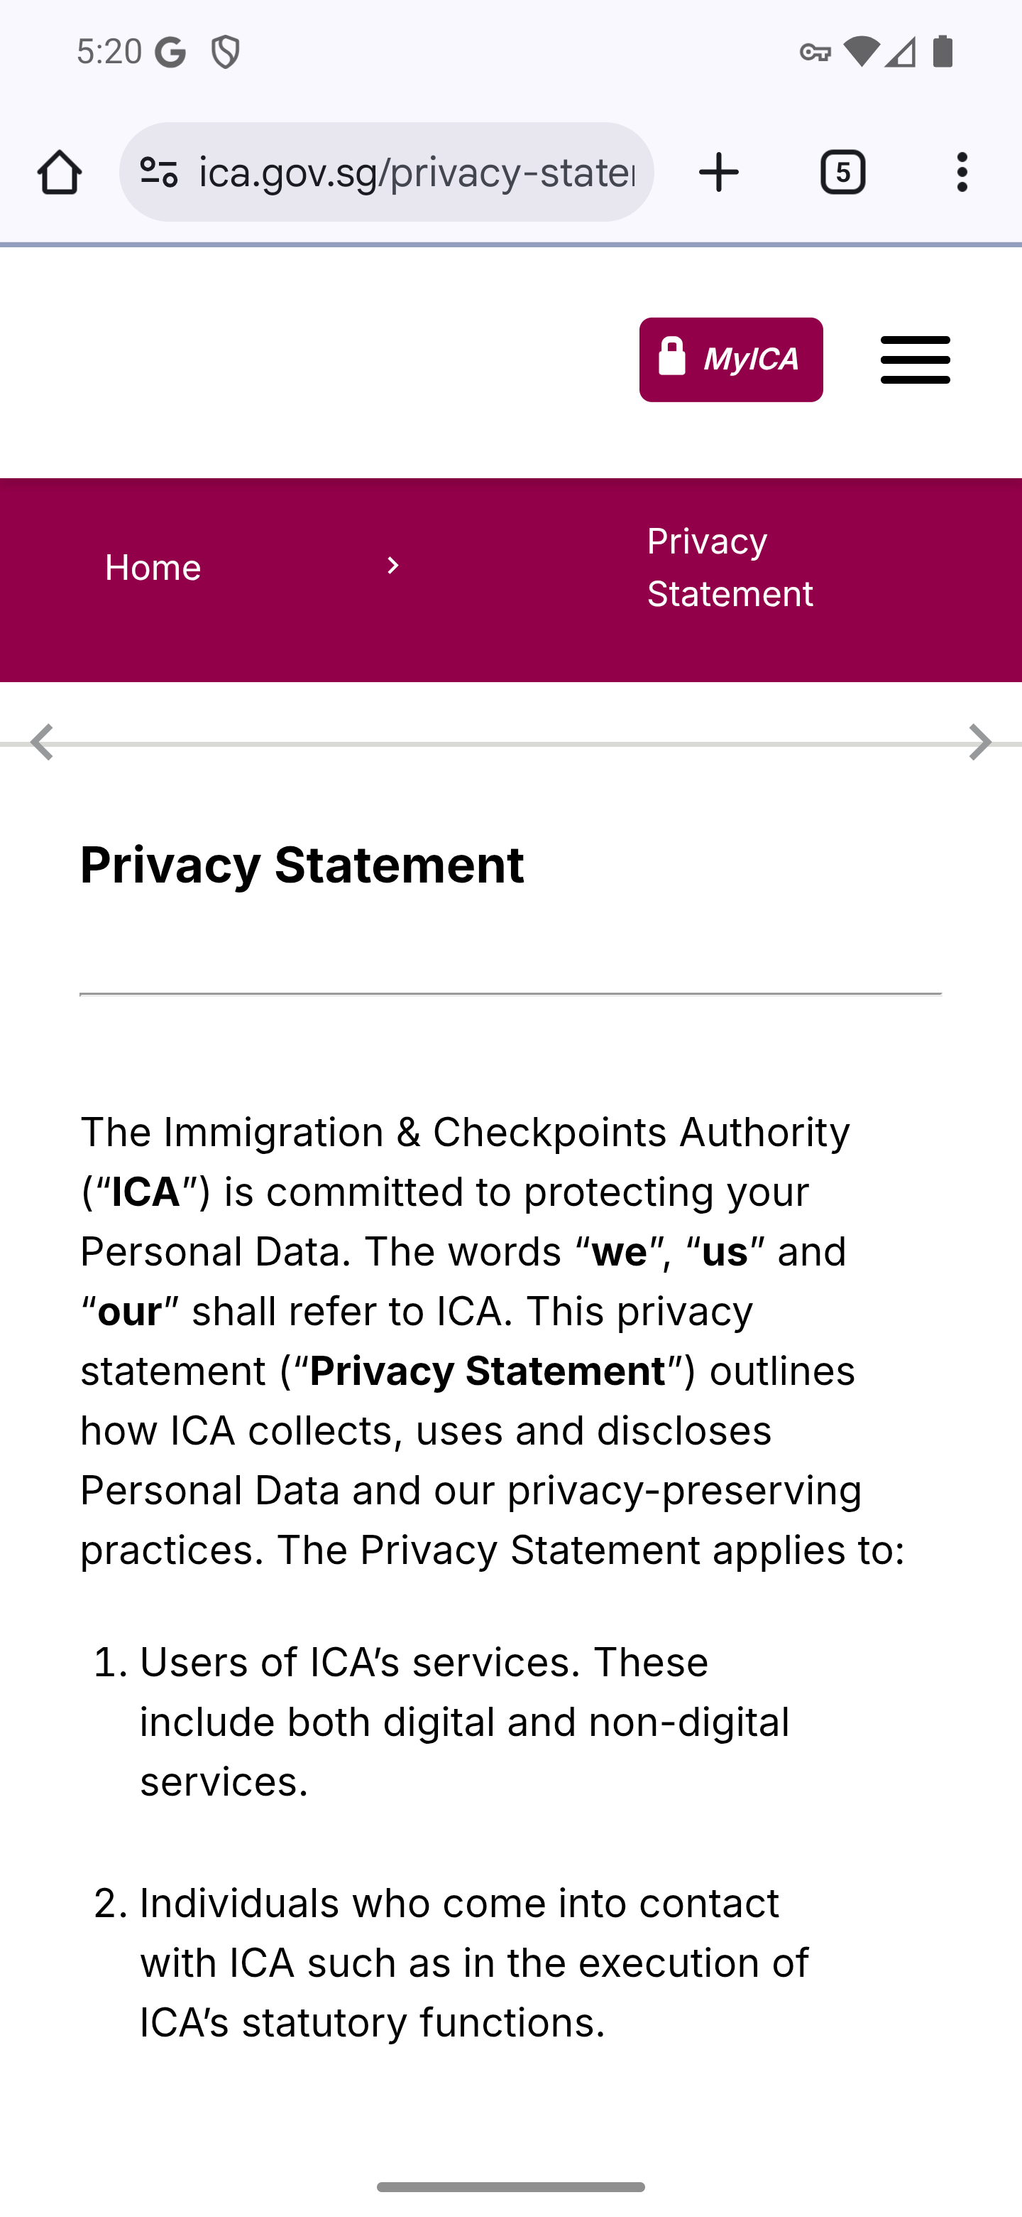
Screen 006 • 2026-09-07 17:20:13 • Browser handoff only

007 Terms of use browser handoff
Open Terms of Use.
Initial-session browser handoff. The loaded Terms of Use, section list and expanded General text are captured in screens 023–024 and 027.
Outcome: Browser handoff only
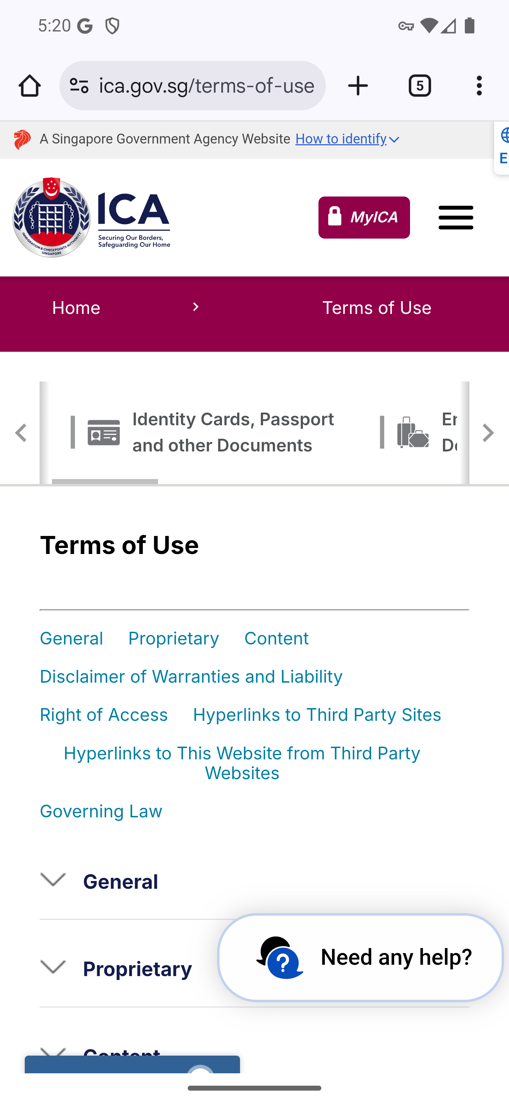
Screen 007 • 2026-09-07 17:20:19 • Browser handoff only

008 Help menu
Choose Help in the navigation drawer.
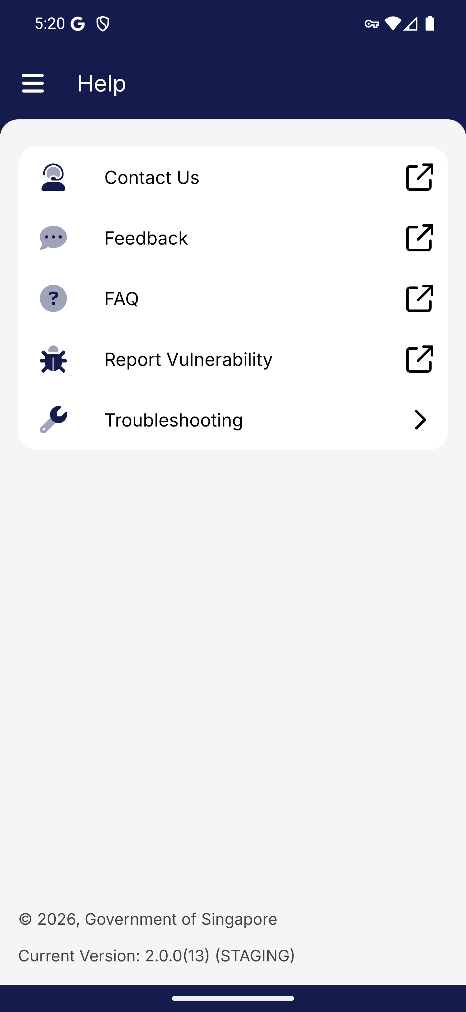
Screen 008 • 2026-09-07 17:20:28 • Captured

009 Troubleshooting
Open Help then Troubleshooting.
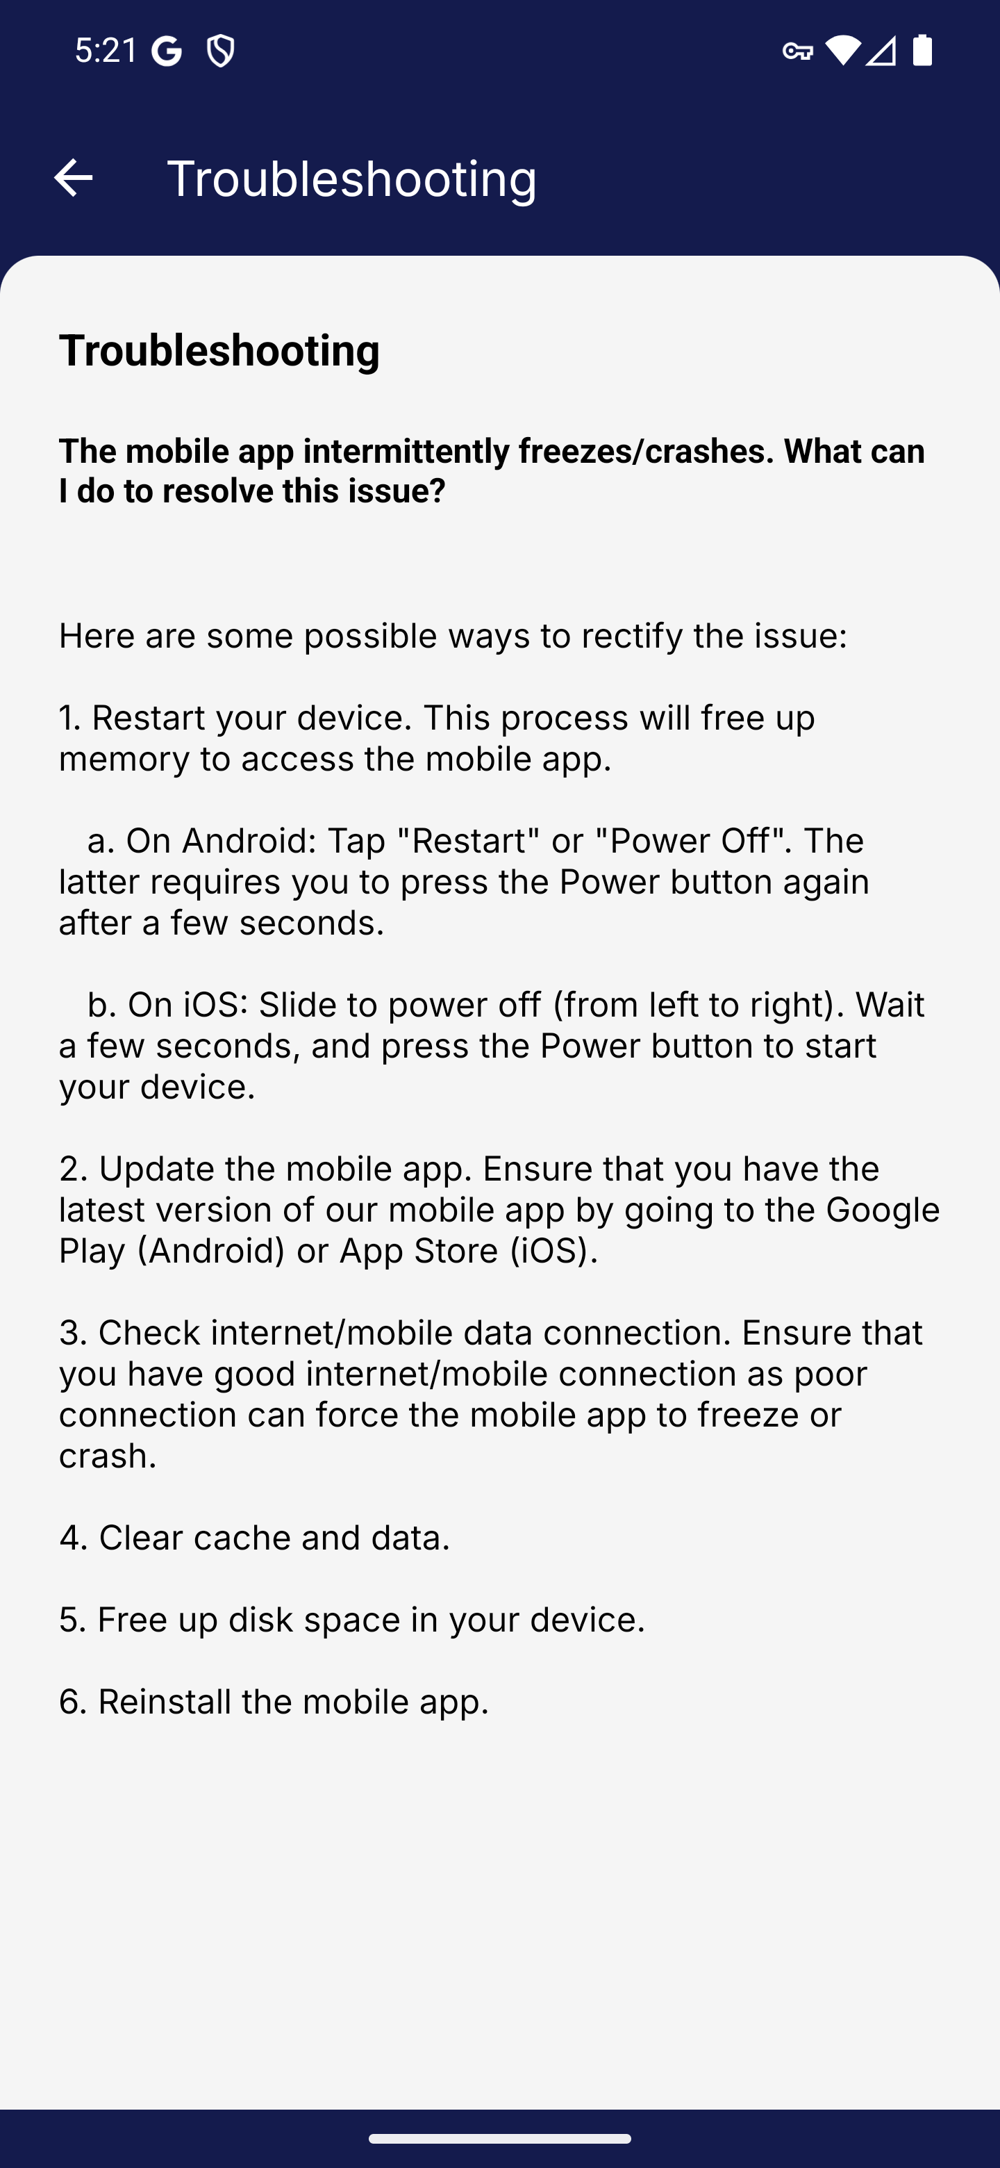
Screen 009 • 2026-09-07 17:21:28 • Captured

010 Settings menu
Choose Settings in the navigation drawer.
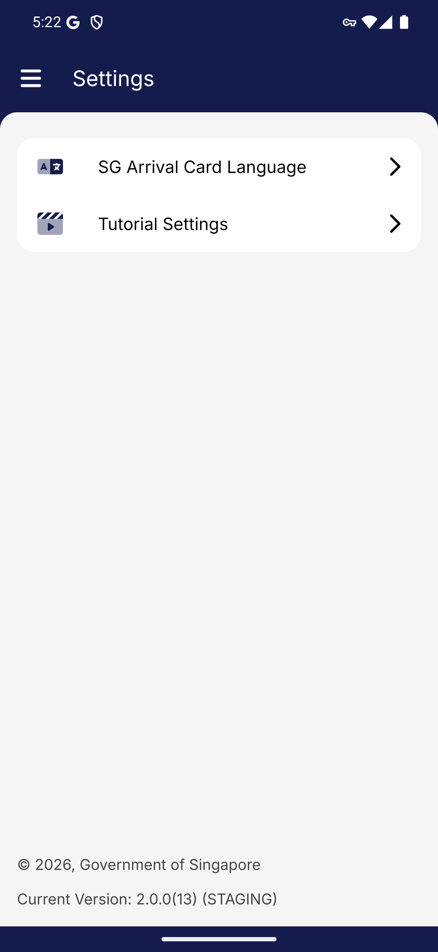
Screen 010 • 2026-09-07 17:22:00 • Captured

011 SG Arrival Card language selector
Open SG Arrival Card Language in Settings.
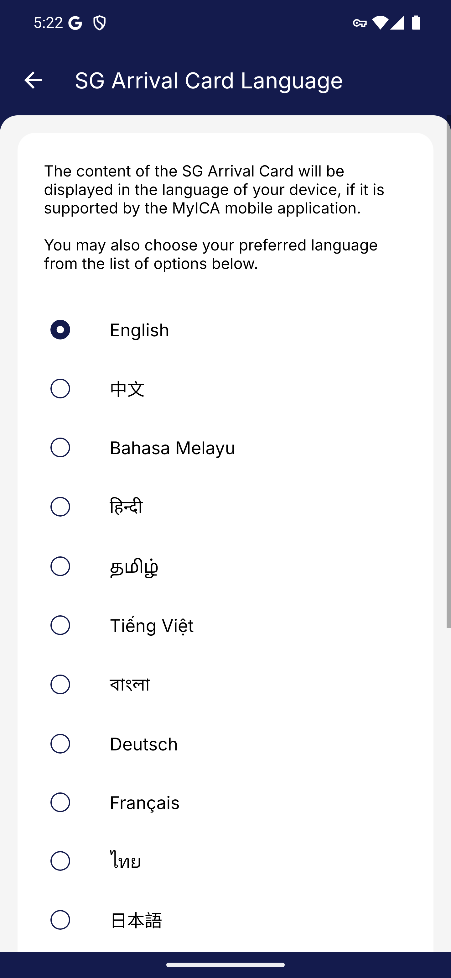
Screen 011 • 2026-09-07 17:22:17 • Captured

012 Tutorial settings
Open Tutorial Settings.
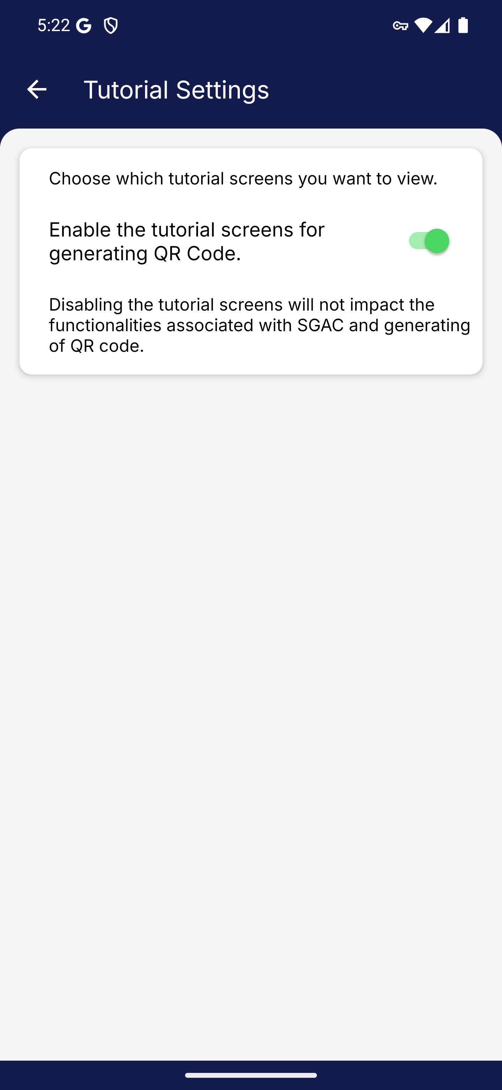
Screen 012 • 2026-09-07 17:22:19 • Captured

013 Edit favourite shortcuts
On the home screen choose Edit beside Favourites.
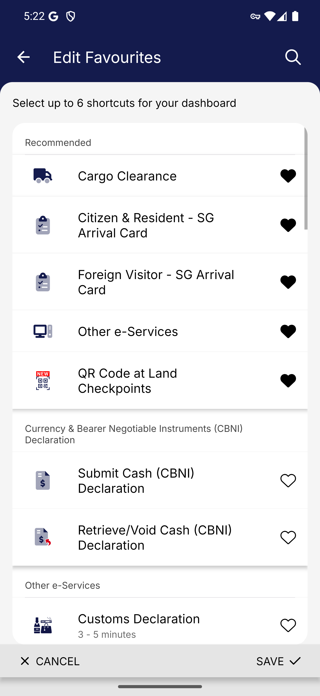
Screen 013 • 2026-09-07 17:22:23 • Captured

014 Citizen and Resident service hub
Open Citizen and Resident from Home.
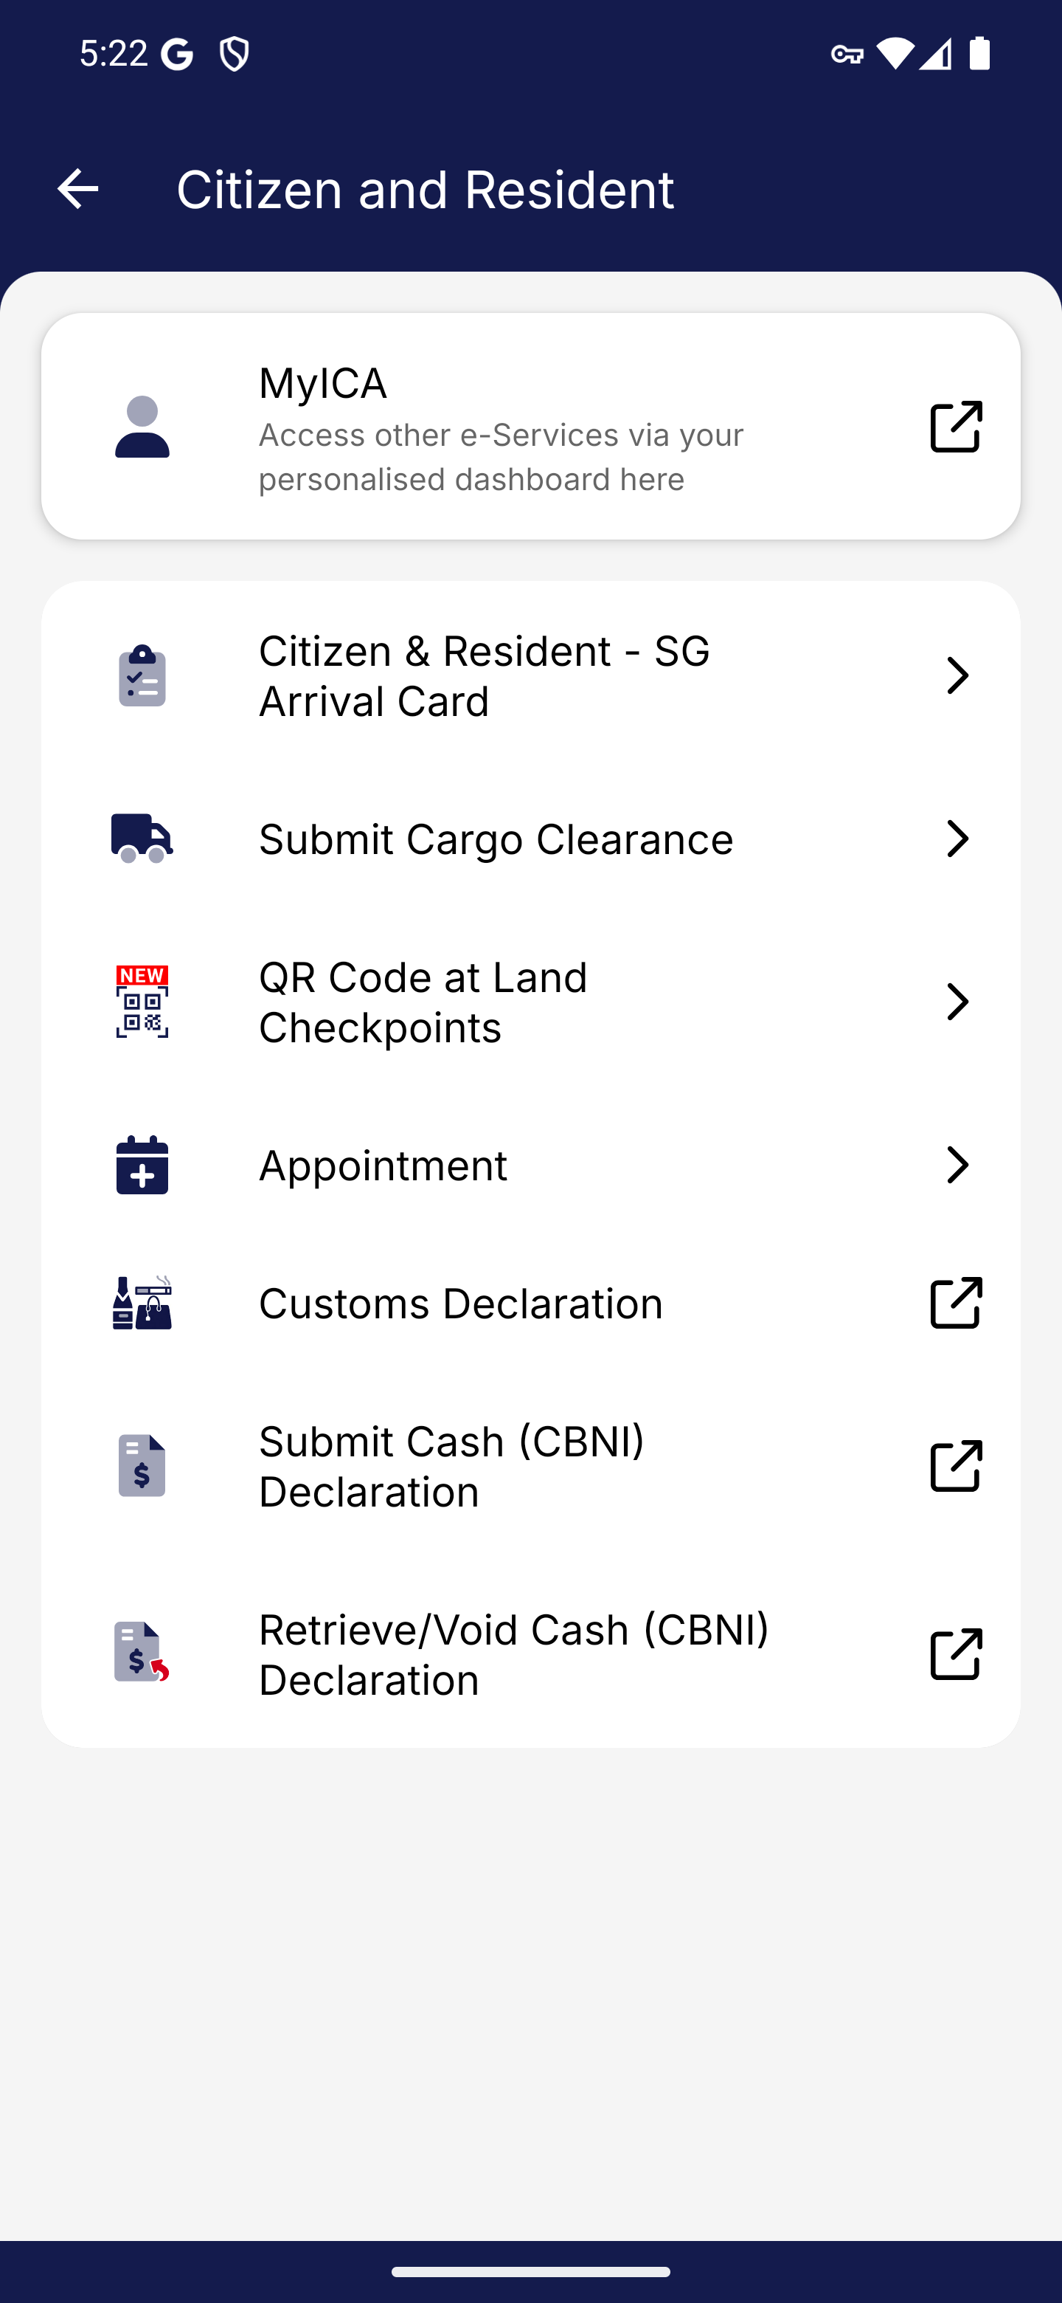
Screen 014 • 2026-09-07 17:22:43 • Captured

015 Foreign Visitor service hub
Open Foreign Visitor from Home.
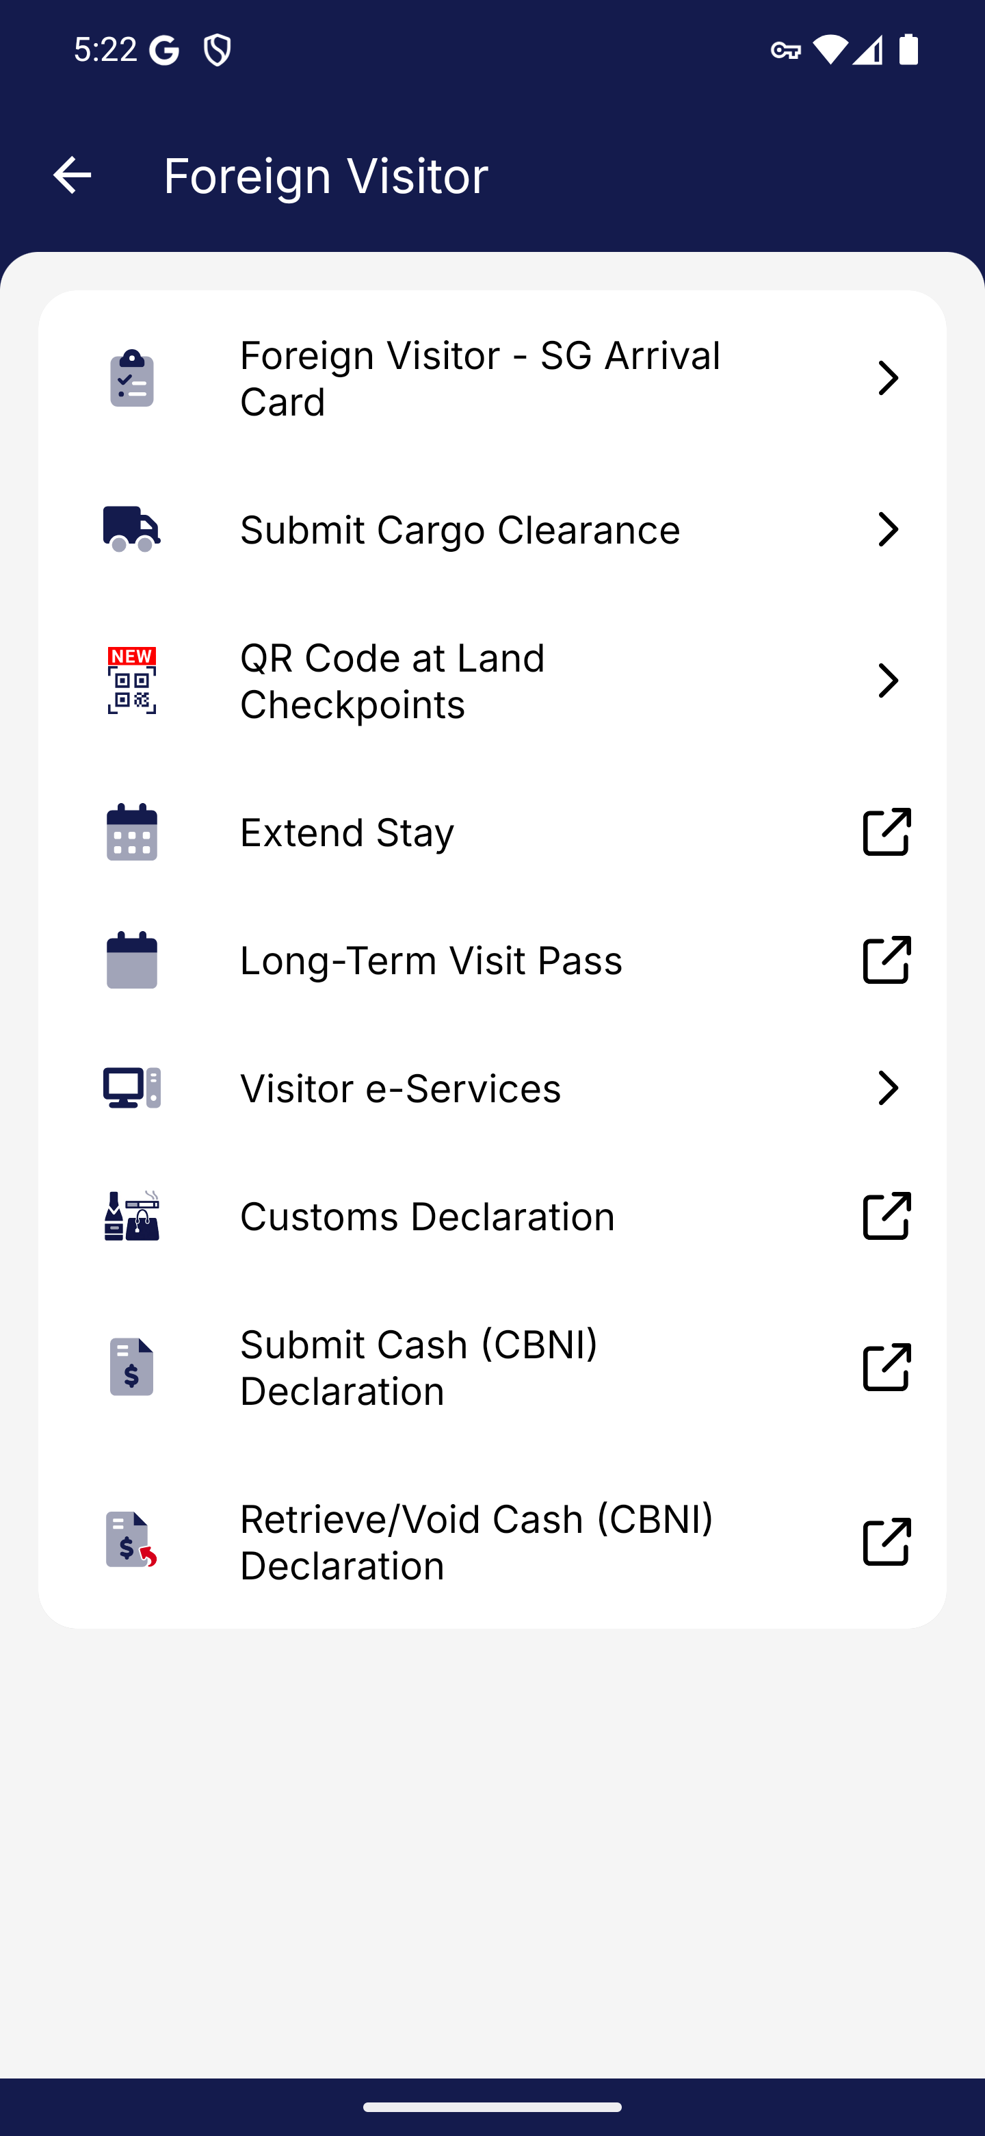
Screen 015 • 2026-09-07 17:22:46 • Captured

016 Contact Us destination
Navigation drawer → Help → Contact Us.
Browser page: ICA — Contact Us. Address: ica.gov.sg/contact-us?.
Outcome: External support entry
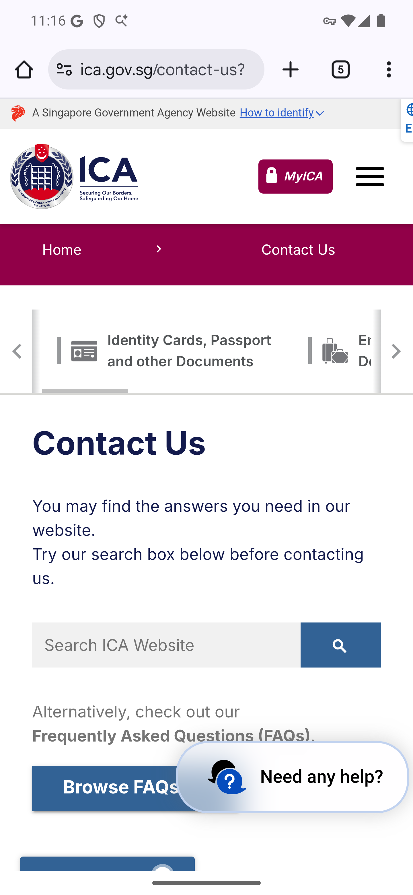
Screen 016 • 2026-09-07 23:16:04 • External support entry

017 Feedback destination
Help → Feedback; wait for the destination to load.
Browser page: ICA — Feedback. Address: ica.gov.sg/feedbackform.
Outcome: External support entry
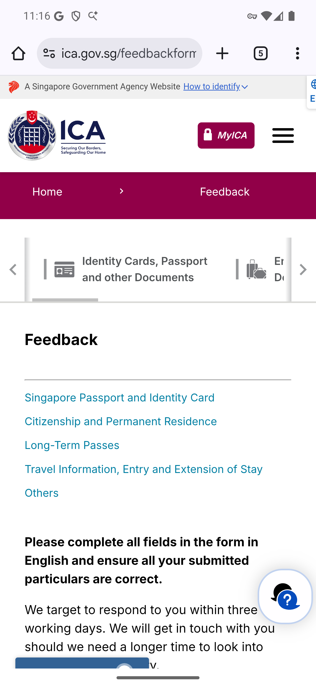
Screen 017 • 2026-09-07 23:16:19 • External support entry

018 FAQ destination
Help → FAQ.
Browser page: Immigration & Checkpoints Authority — FAQ: Official answers to your questions. Address: ask.gov.sg/ica.
Outcome: External support entry
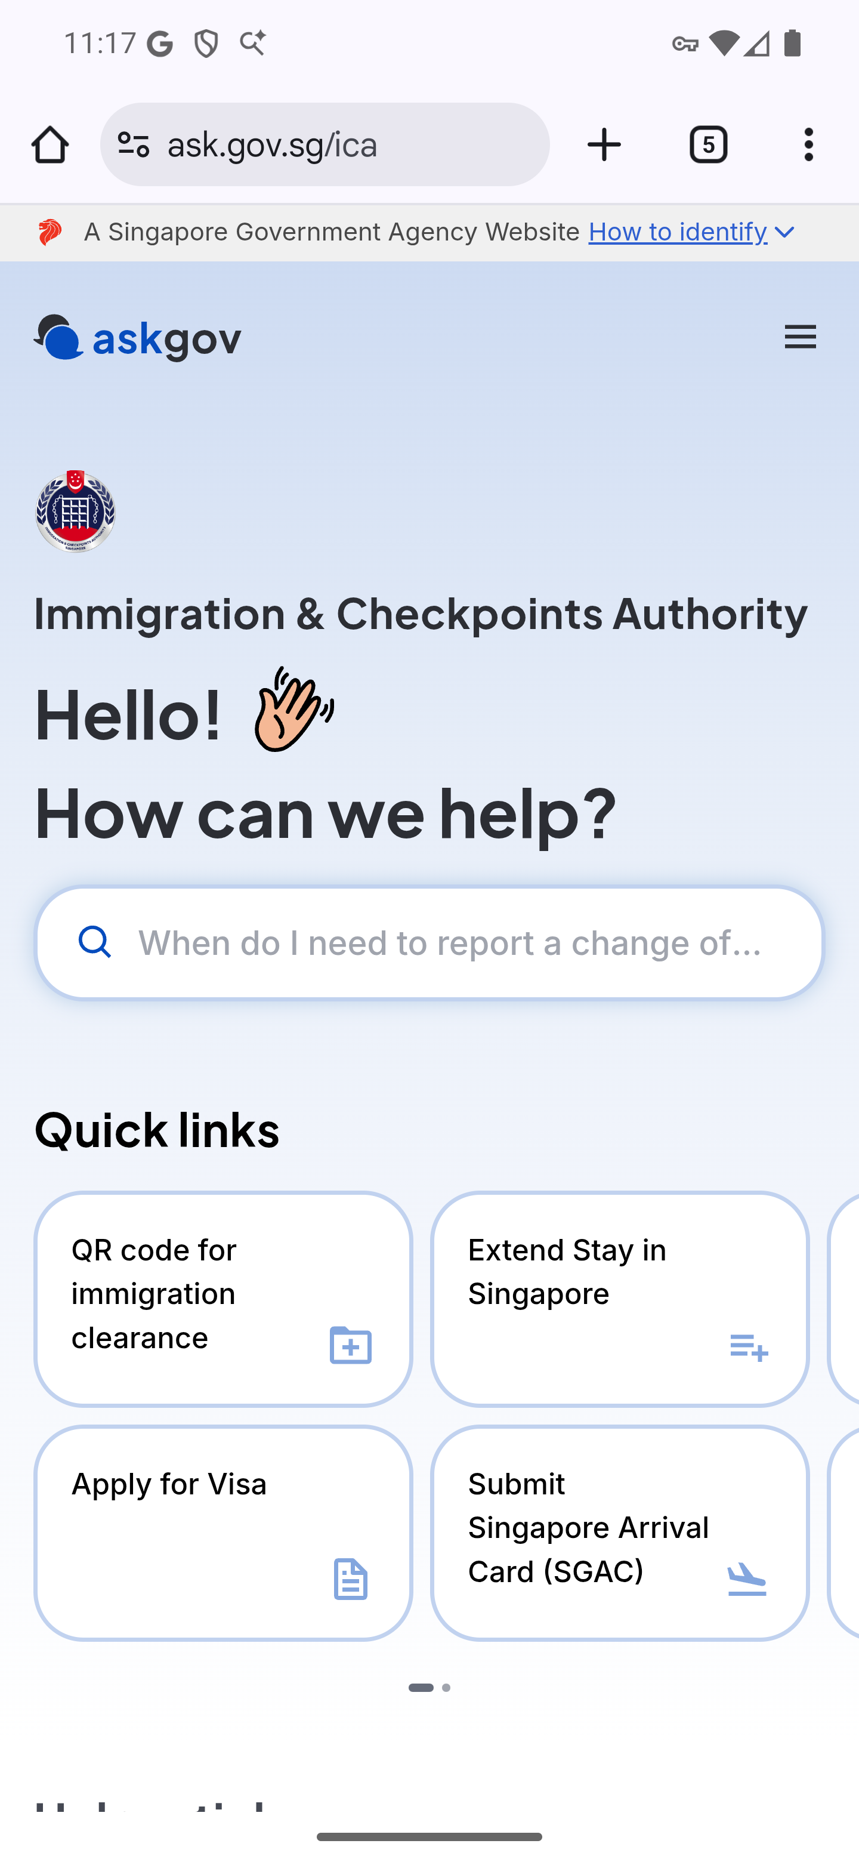
Screen 018 • 2026-09-07 23:17:13 • External support entry

019 Report Vulnerability destination
Help → Report Vulnerability.
Browser page: Report vulnerability — Government Technology Agency of Singapore (GovTech Singapore). Address: tech.gov.sg/report-vulnerability/.
Outcome: External support entry
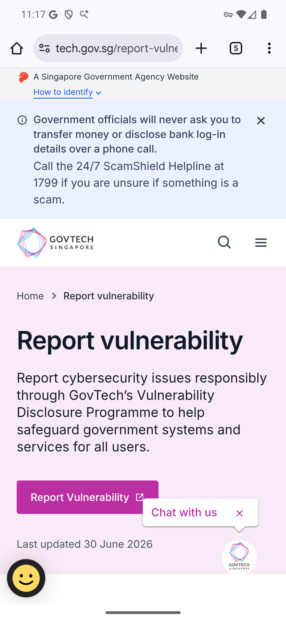
Screen 019 • 2026-09-07 23:17:32 • External support entry

020 ICA website destination
Navigation drawer → About → ICA website.
Browser page: Immigration & Checkpoints Authority (ICA). Address: ica.gov.sg.
Outcome: External website entry
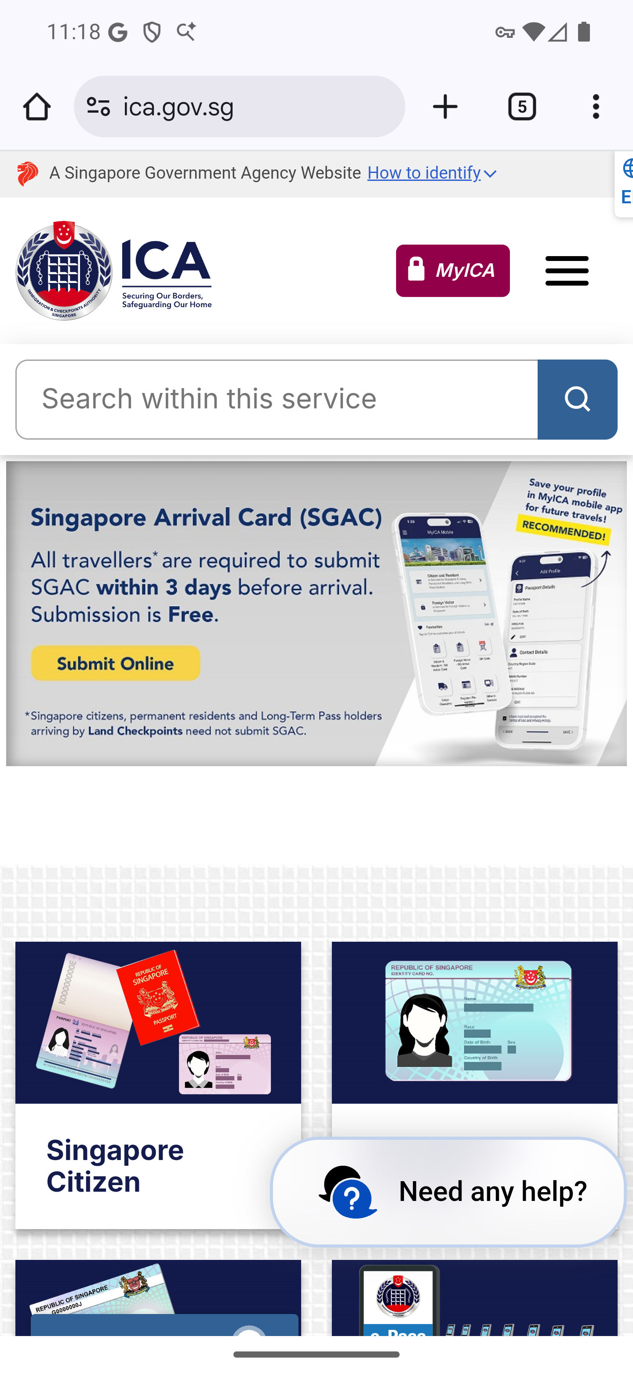
Screen 020 • 2026-09-07 23:18:11 • External website entry

021 Privacy Statement loaded
About → Privacy Statement; wait for the page to load.
Browser page: ICA — Privacy Statement. Address: ica.gov.sg/privacy-statement.
Outcome: Loaded external page
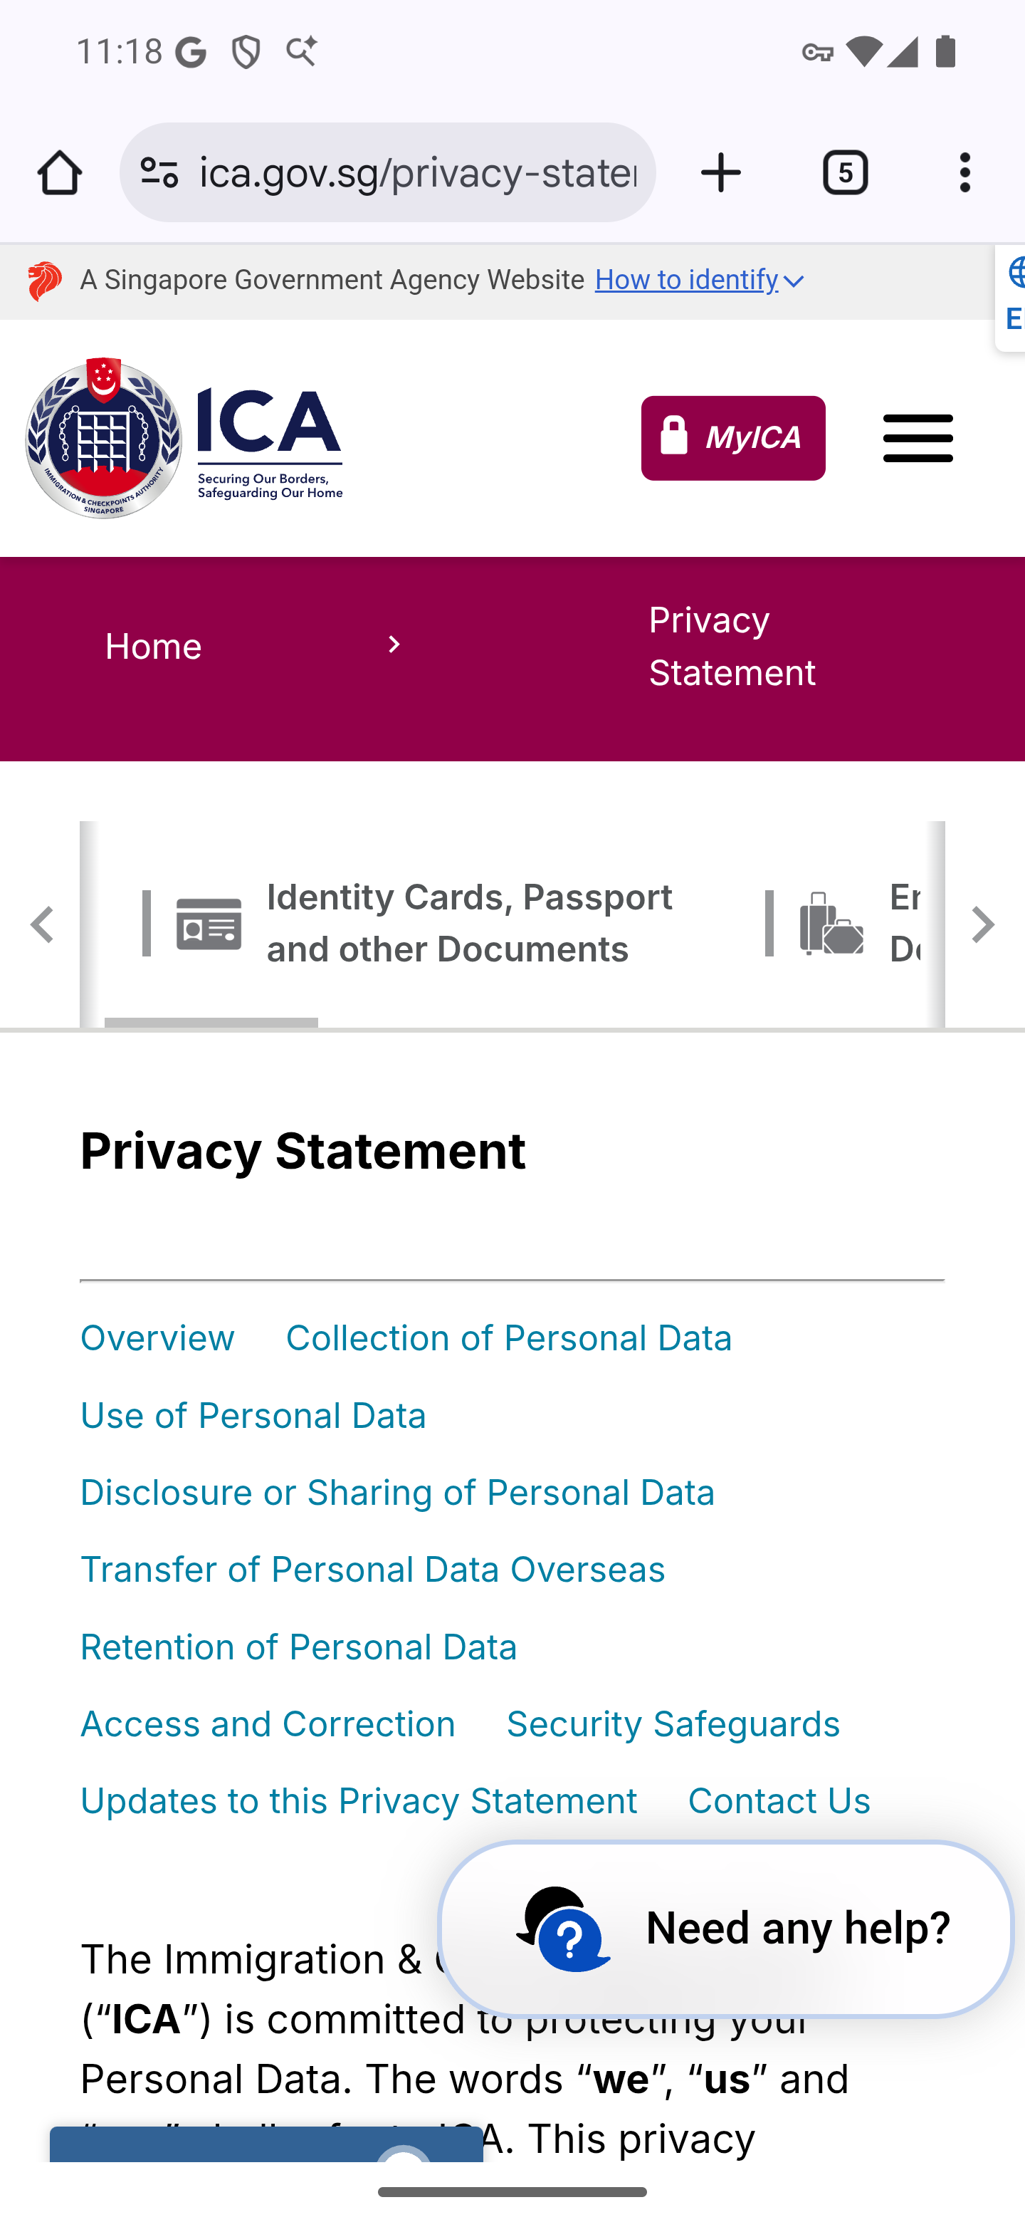
Screen 021 • 2026-09-07 23:18:23 • Loaded external page

022 Privacy Statement content
Scroll the loaded Privacy Statement.
The Privacy Statement overview text is visible after scrolling the loaded page.
Outcome: Loaded external page
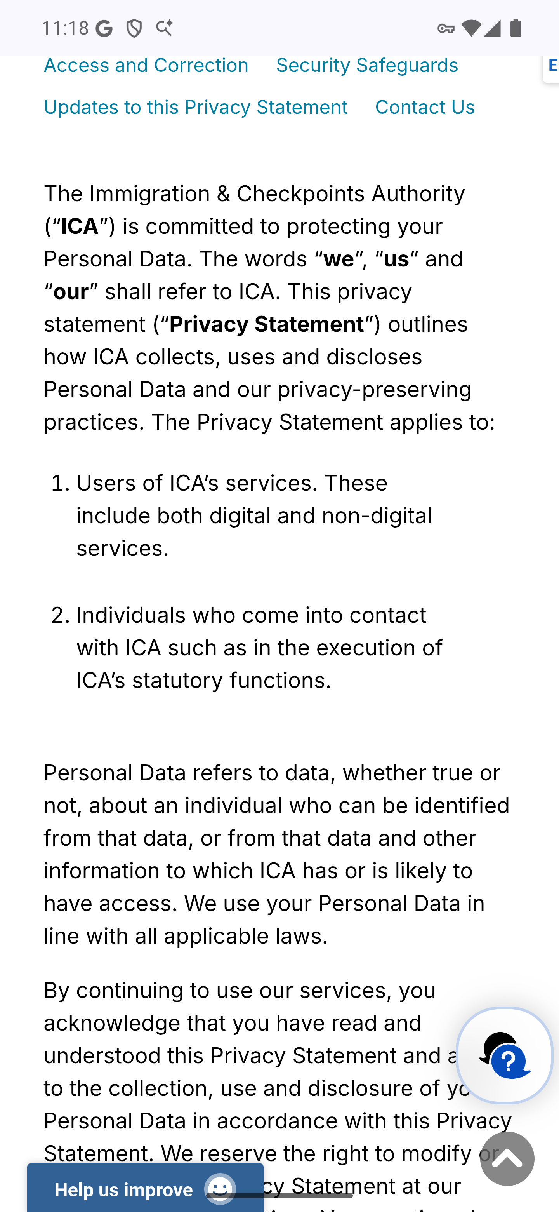
Screen 022 • 2026-09-07 23:18:26 • Loaded external page

023 Terms of Use loaded
About → Terms of Use; wait for the page to load.
Browser page: ICA — Terms of Use. Address: ica.gov.sg/terms-of-use.
Outcome: Loaded external page
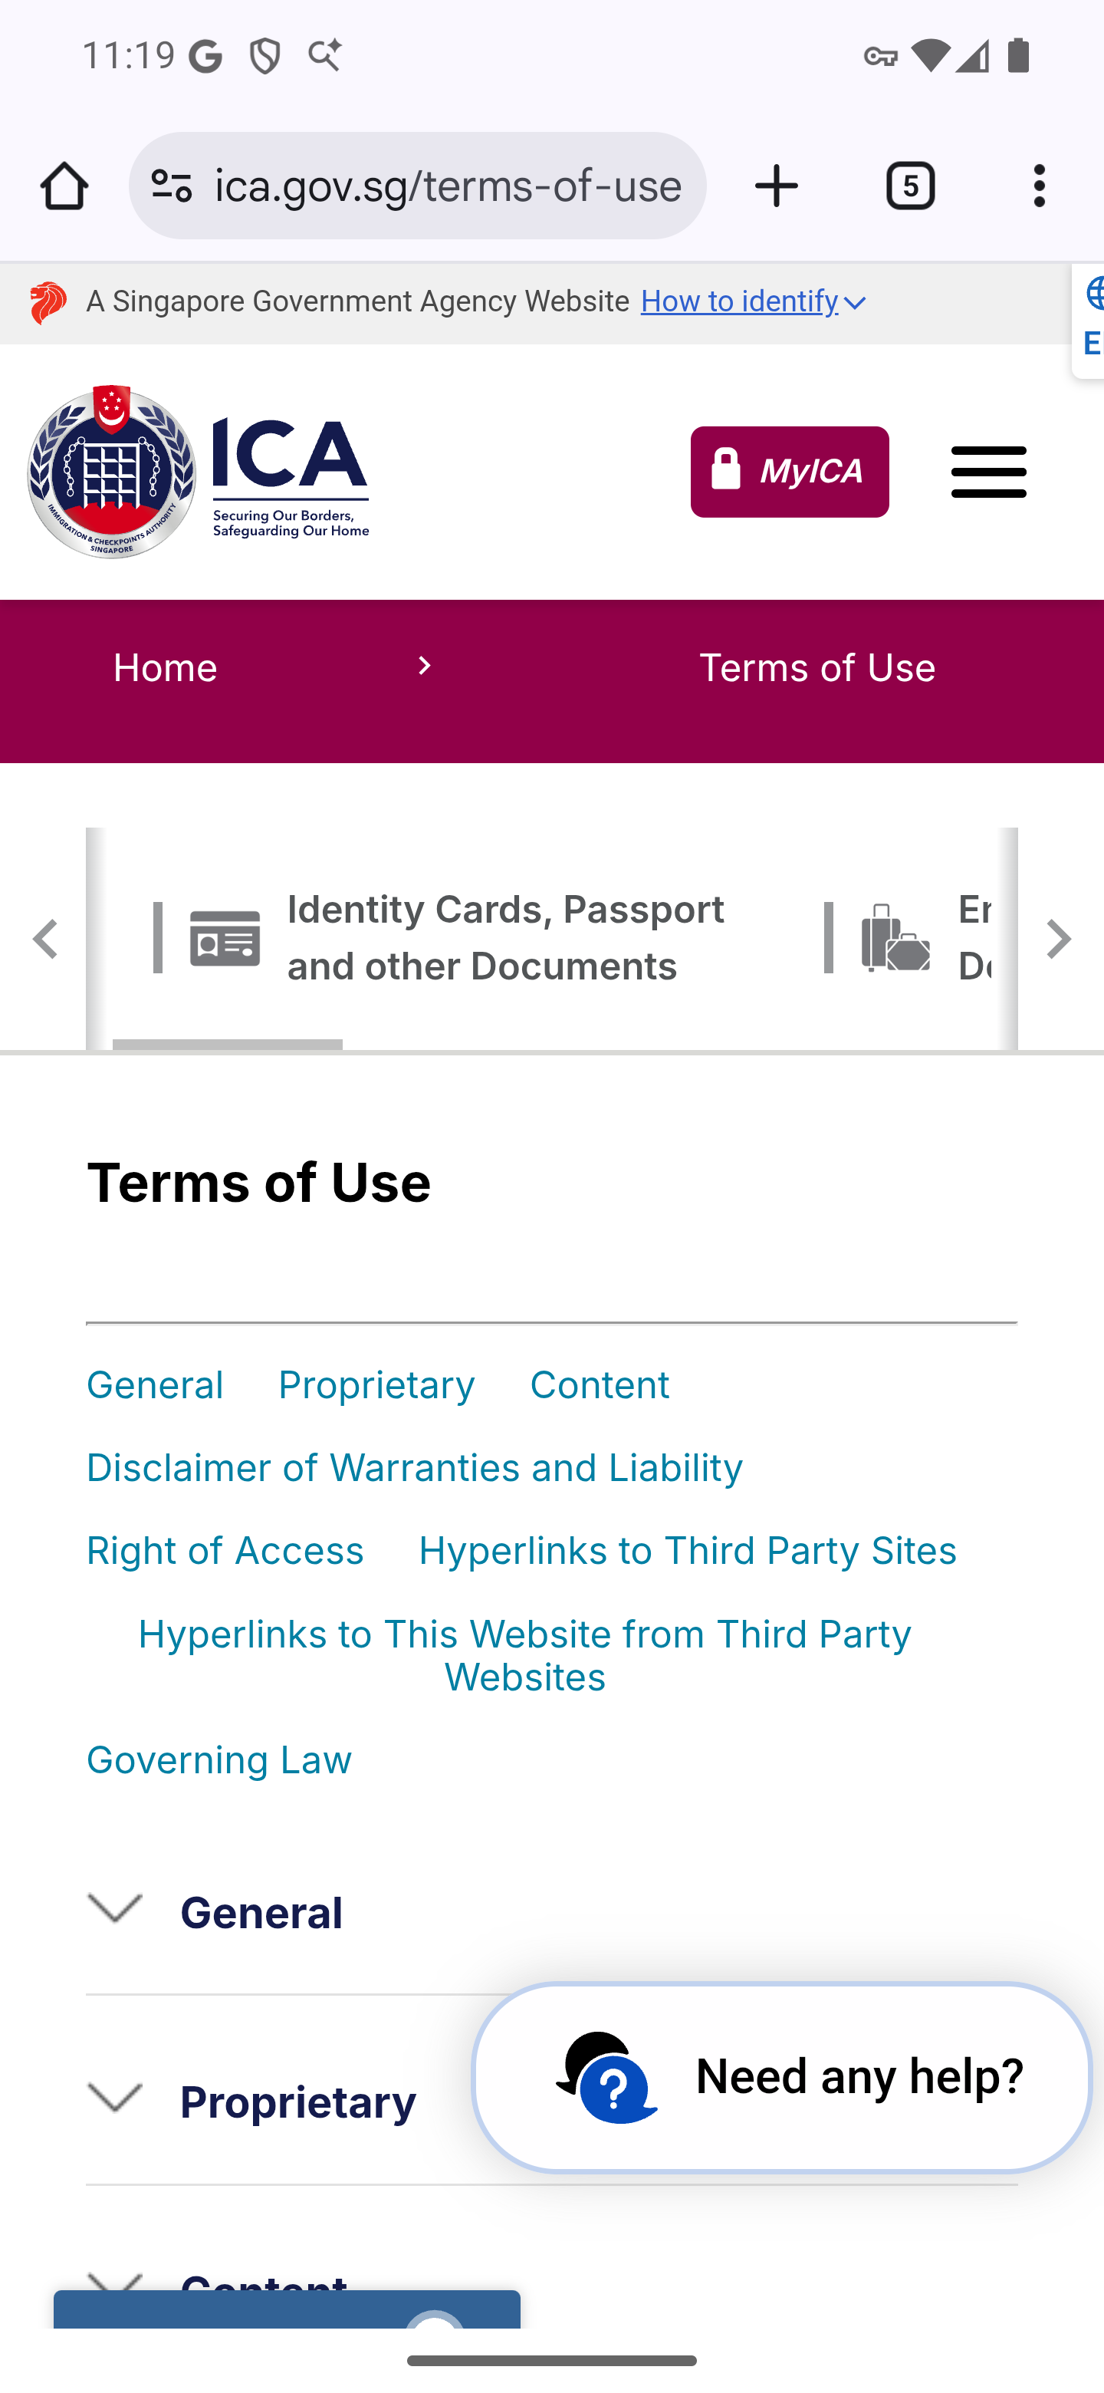
Screen 023 • 2026-09-07 23:19:25 • Loaded external page

024 Terms of Use section list
Scroll the loaded Terms of Use.
The page lists collapsed sections including General, Proprietary, Content and Governing Law. Screen 027 shows General expanded.
Outcome: Loaded external page
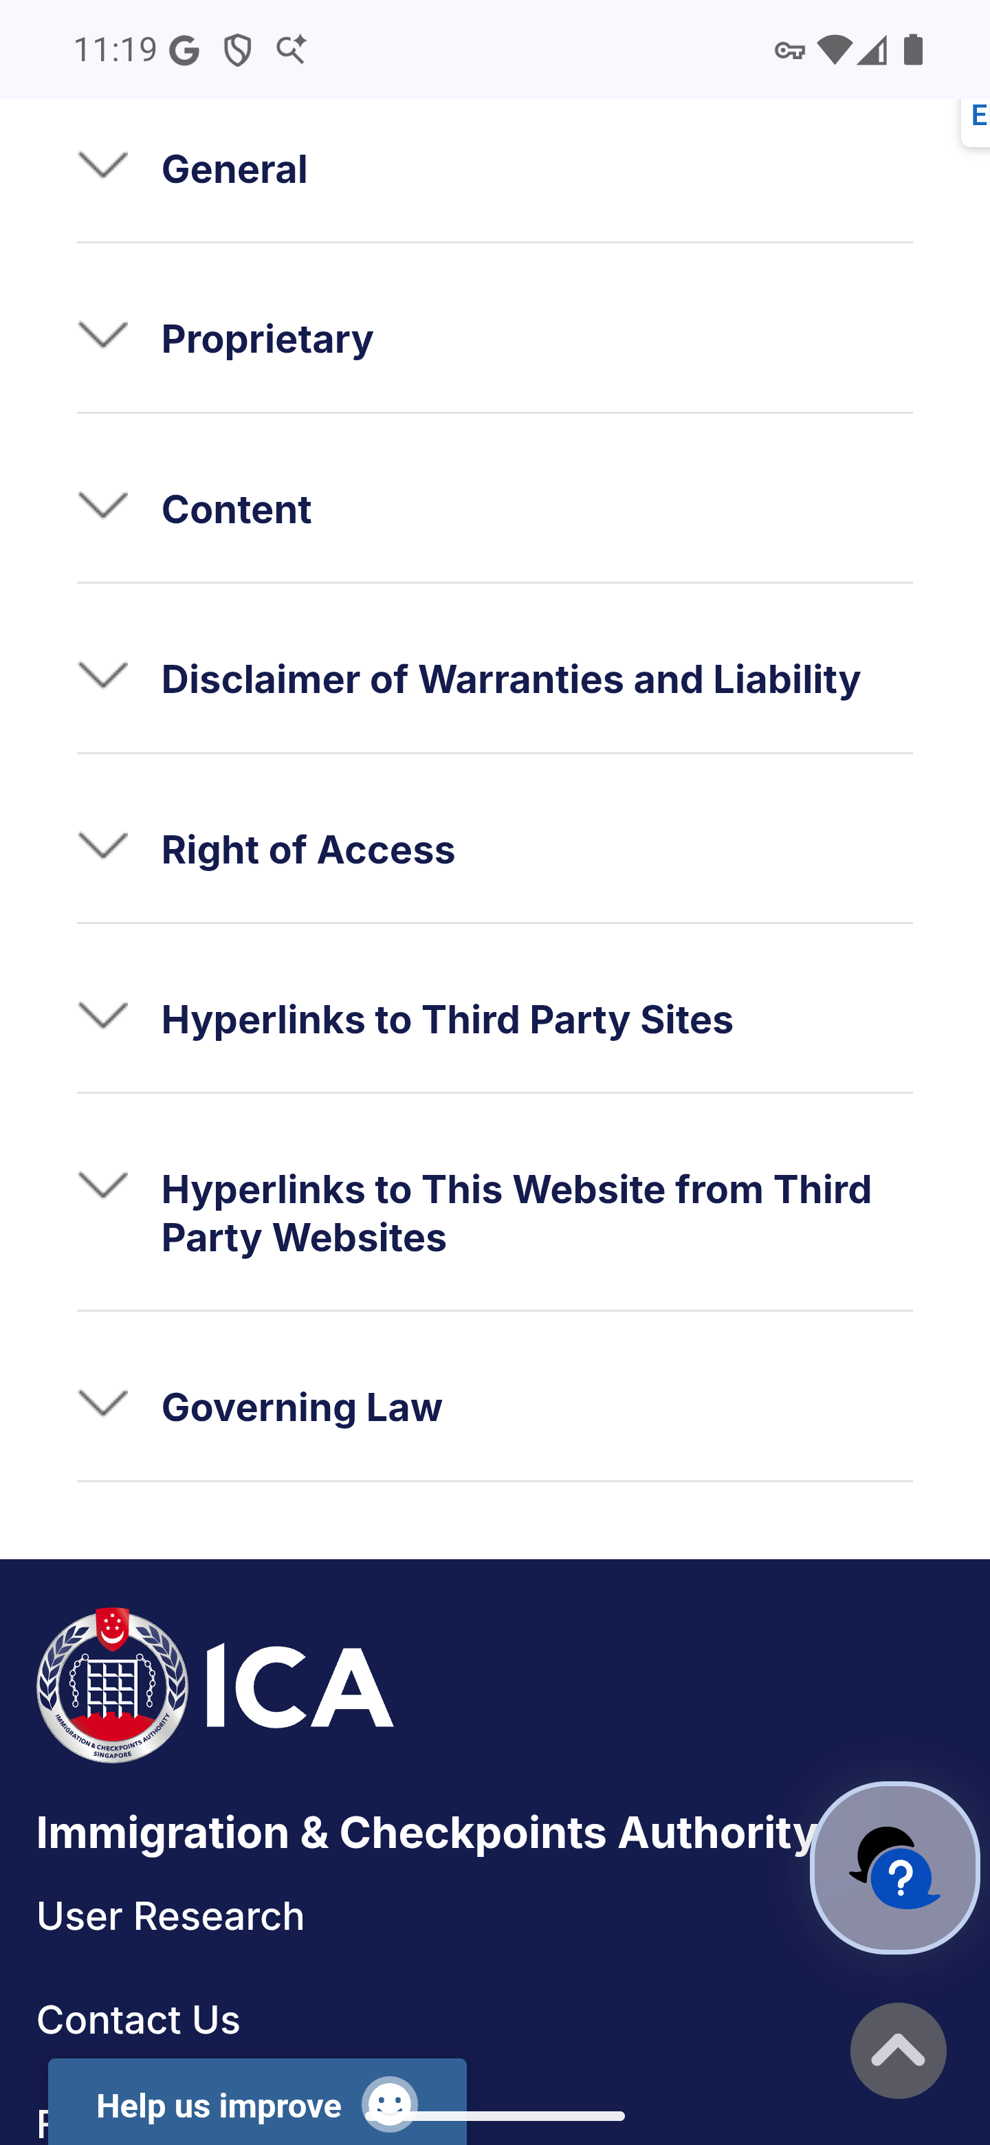
Screen 024 • 2026-09-07 23:19:28 • Loaded external page

025 Home scam-advisory destination
Home → scroll down → tap the scam-advisory image banner.
The home scam-advisory image opens the Government Officials Impersonation Scams page on scamshield.gov.sg.
Outcome: External advisory entry
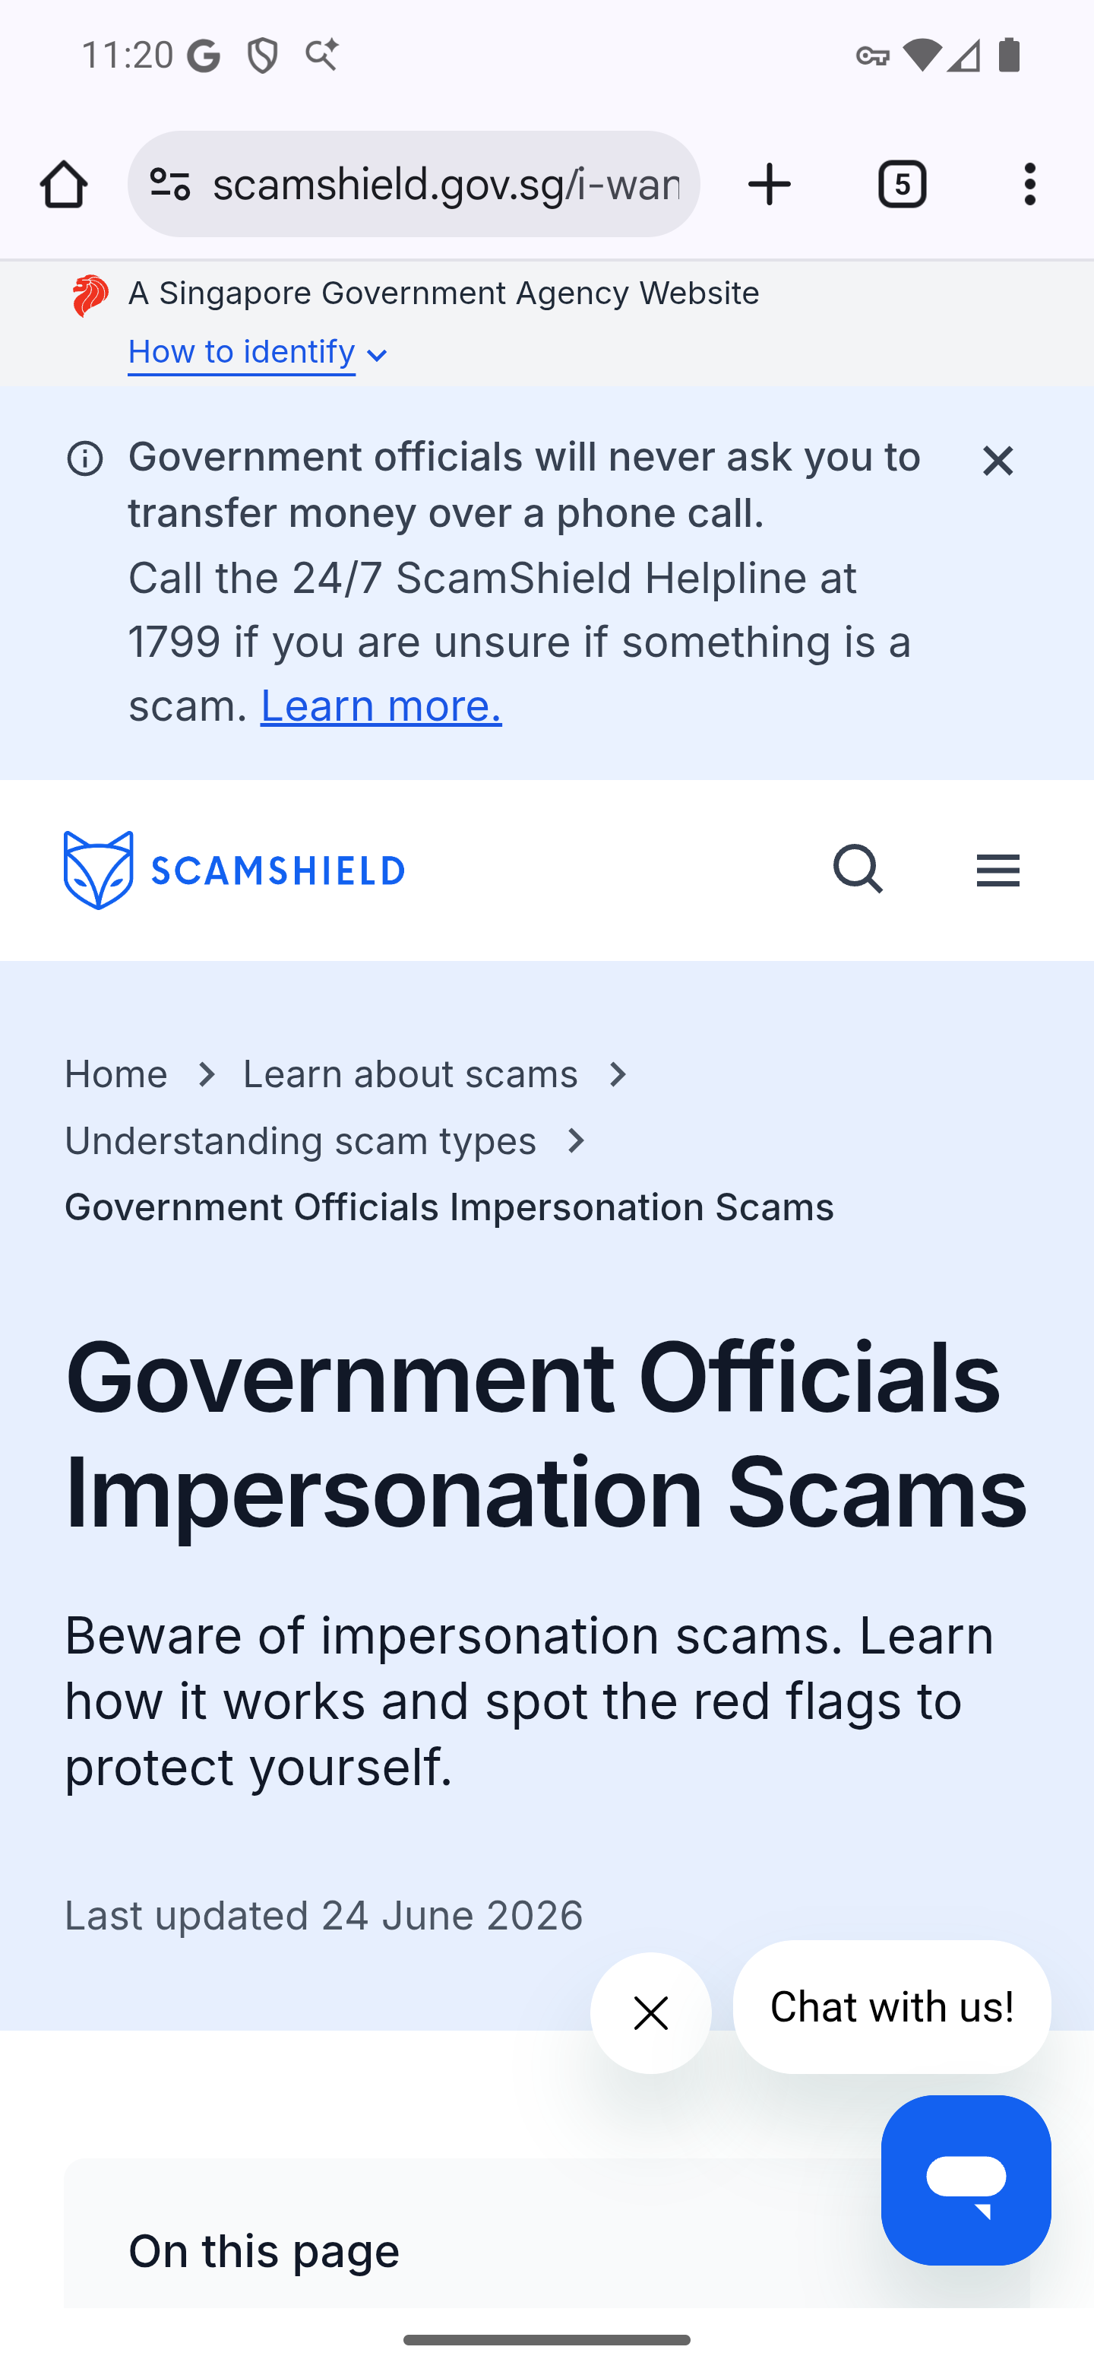
Screen 025 • 2026-09-07 23:20:13 • External advisory entry

026 Translation feedback destination
Home → share feedback below the scam-advisory banner.
The translation-feedback link opens the ICA Contact Us page, the same destination as Help → Contact Us. No feedback was sent.
Outcome: External support entry
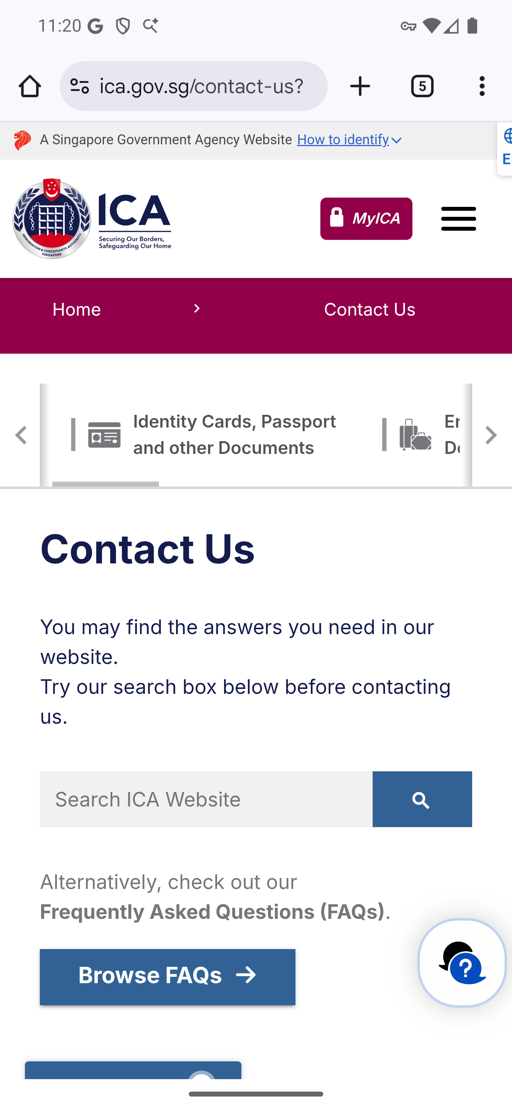
Screen 026 • 2026-09-07 23:20:29 • External support entry

027 Terms of Use General section expanded
About → Terms of Use → expand General and scroll into its text.
The General accordion expands and displays its body text. Other sections were not exhaustively expanded.
Outcome: Loaded external page
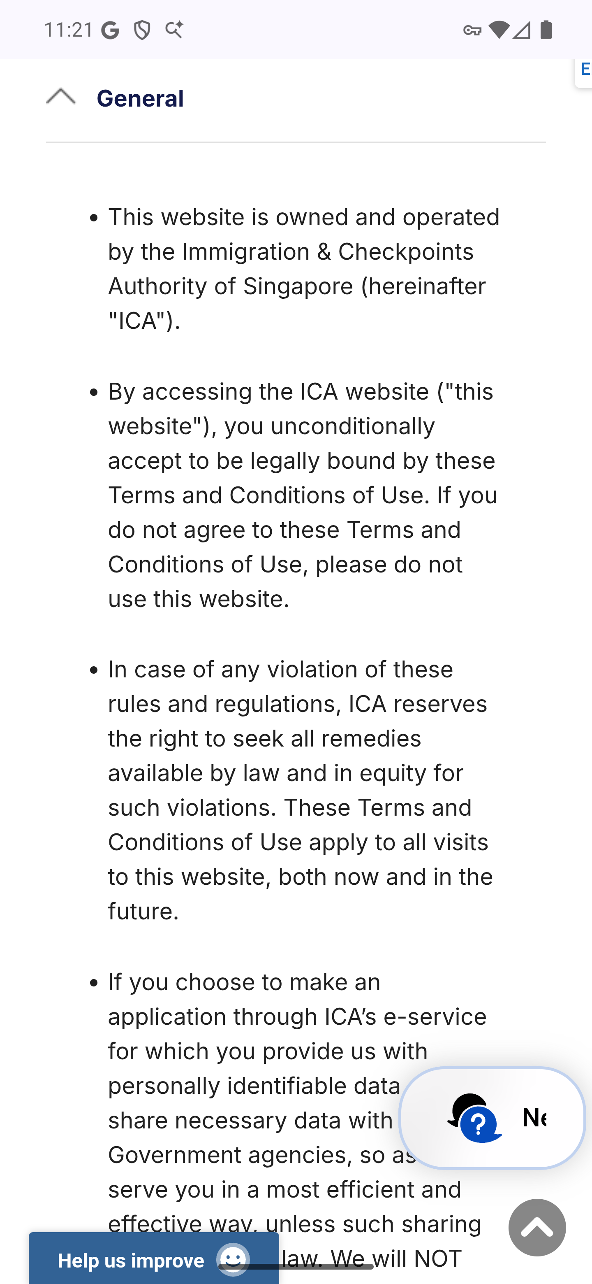
Screen 027 • 2026-09-07 23:21:18 • Loaded external page

