  - PROJECT DOCUMENTATION

Resident profiles and SG Arrival Cards
Resident profile creation, validation, management, Singpass and passport-scanner entry points, plus the reached arrival-card web screens. Native arrival-card progression is blocked by a repeatable profile-update loop.
29 screen captures • Pixel 7 Pro emulator • Android 16 • English
Captured from the installed staging app on 7 September 2026. Screenshots are original device PNGs. This is a screen walkthrough; it does not certify every test case or every input combination.

Coverage and outcomes
Flow / branch | Observed outcome
Create profile manually | Completed: WALKTHROUGH RESIDENT saved with synthetic identity and contact details.
Required fields and dates | Empty-form validation and an invalid date format captured; corrected DD/MM/YYYY input accepted.
View and update profile | Profile details opened and an update reported success.
Select profile for arrival card | Blocked: Profile update required repeats after updating and saving. Native arrival date, health declaration and submission confirmation were not reached.
Retrieve through Singpass | Staging Singpass login reached. No authenticated retrieval without supplied test credentials.
Scan passport | Tutorial, permission denial, permission request, full-screen hint and landscape MRZ scanner captured. A passport fixture is needed to verify extraction.
Update existing arrival card | Resident web retrieval instructions and NRIC/FIN plus arrival-date fields opened. No matching submitted record was available.
New web submission link | Arrival-date, personal-information, contact and health fields opened. No arrival declaration was submitted.
Reproduction: create a resident profile manually, return to the SGAC dashboard, select it, choose UPDATE PROFILE, advance through Contact Details, accept the terms and SAVE, return to the dashboard and select it again. The same update-required alert returns.
Manual entry succeeded; the repeated update prompt is an observed blocker, not an inferred failure of all possible profiles. Profile data created during this walkthrough remains available on the emulator.

How to use this document
Each following page records one screen, the action used to reach it, and any relevant observation. Screen numbers match the category manifest and PNG filenames. Source XML and SHA-256 hashes are retained beside the screenshots for traceability. Open the original PNG when you need to zoom into small text.

001 Resident SG Arrival Card landing
Choose Citizen and Resident SG Arrival Card from Home.
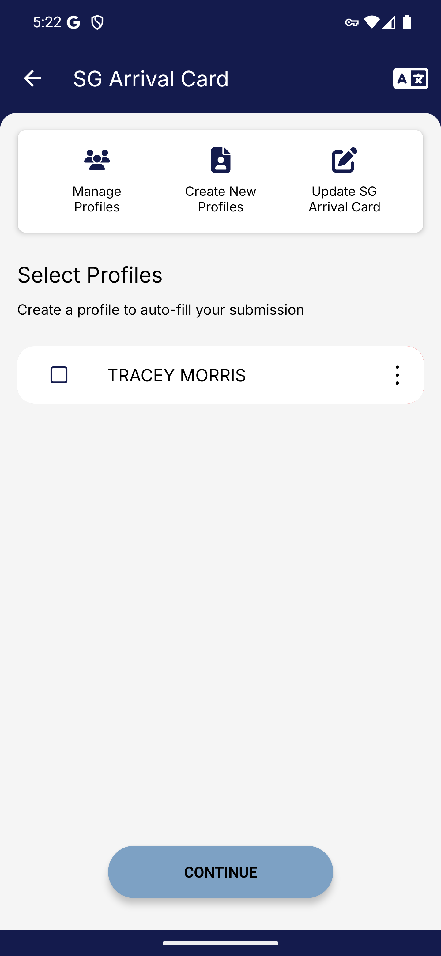
Screen 001 • 2026-09-07 17:22:48 • Captured

002 Resident profile creation methods
Choose Create New Profile.
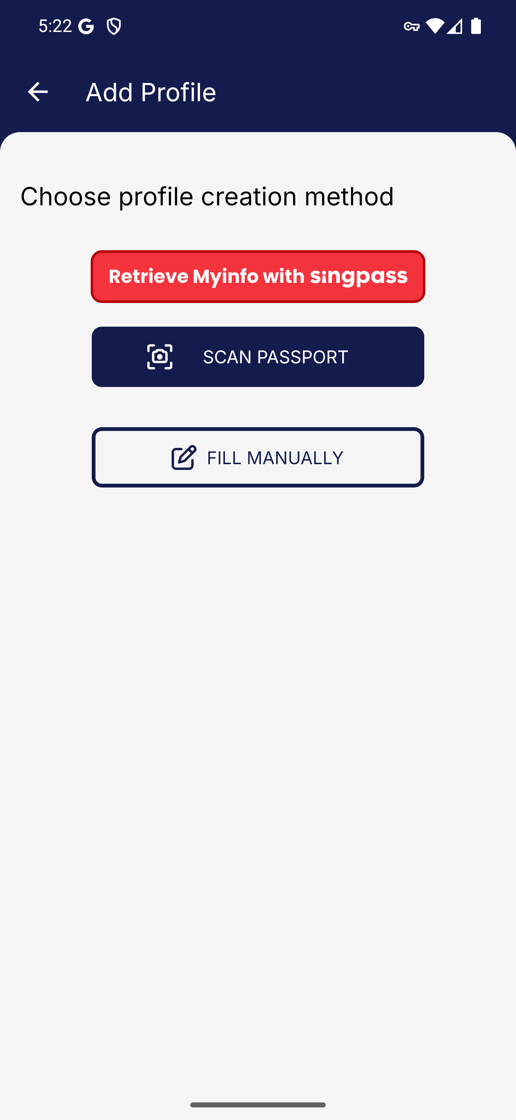
Screen 002 • 2026-09-07 17:22:50 • Captured

003 Singpass profile retrieval handoff
Choose Retrieve Myinfo with Singpass.
Retrieval requires a Singpass session; no credentials were supplied.
Outcome: Authentication boundary
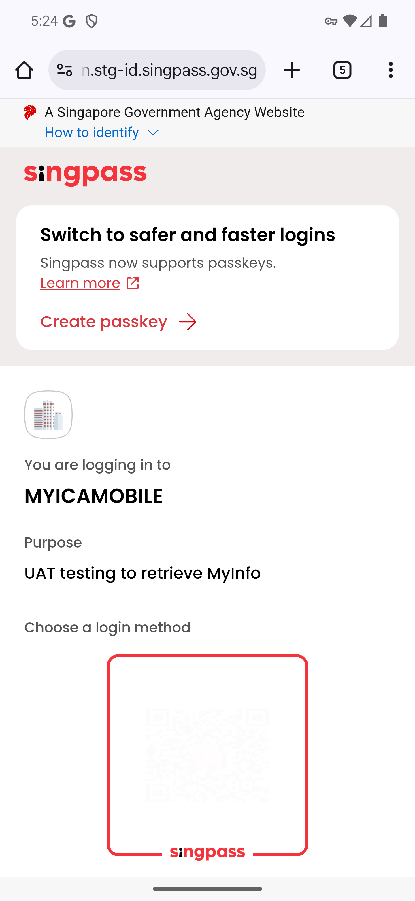
Screen 003 • 2026-09-07 17:24:14 • Authentication boundary

004 Passport scan entry
Choose Scan Passport.
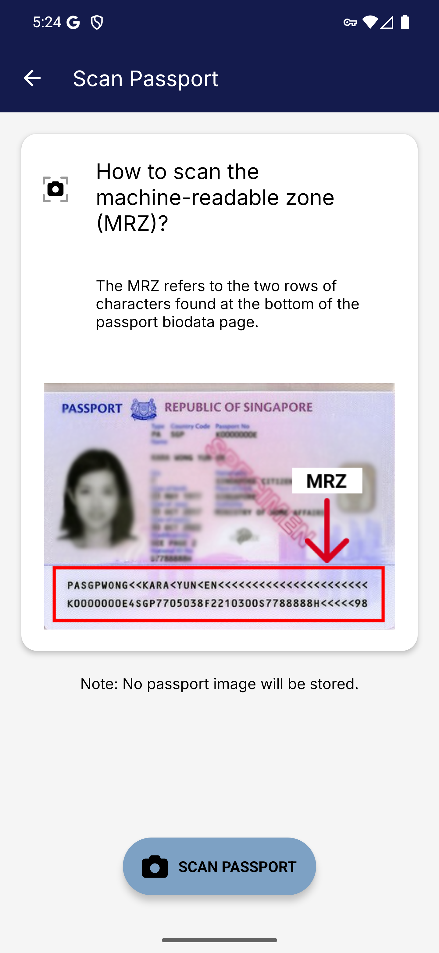
Screen 004 • 2026-09-07 17:24:17 • Captured

005 Camera permission denied
Starting the passport scanner requests camera access.
The first scanner attempt reported that camera usage was denied. The scanner was reopened and permission granted in the following steps.
Outcome: Permission denial observed
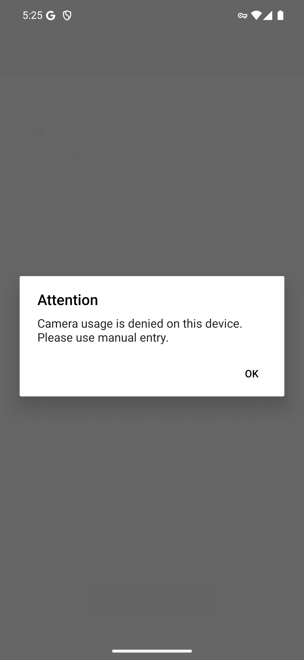
Screen 005 • 2026-09-07 17:25:18 • Permission denial observed

006 Passport camera permission dialog
Start Scan Passport and wait for the Android permission dialog.
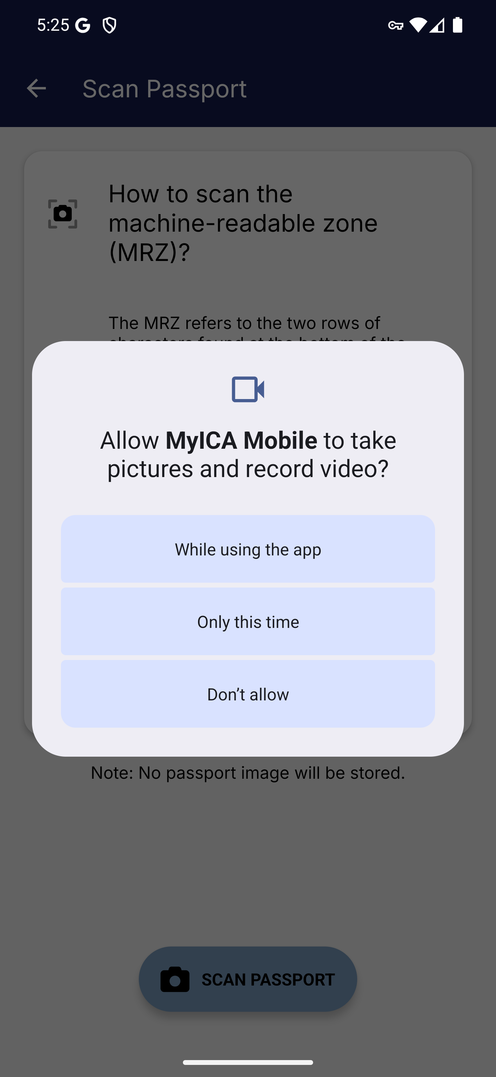
Screen 006 • 2026-09-07 17:25:57 • Captured

007 Android full-screen camera hint
Allow camera access for this session.
Android shows its full-screen navigation hint before the landscape scanner.
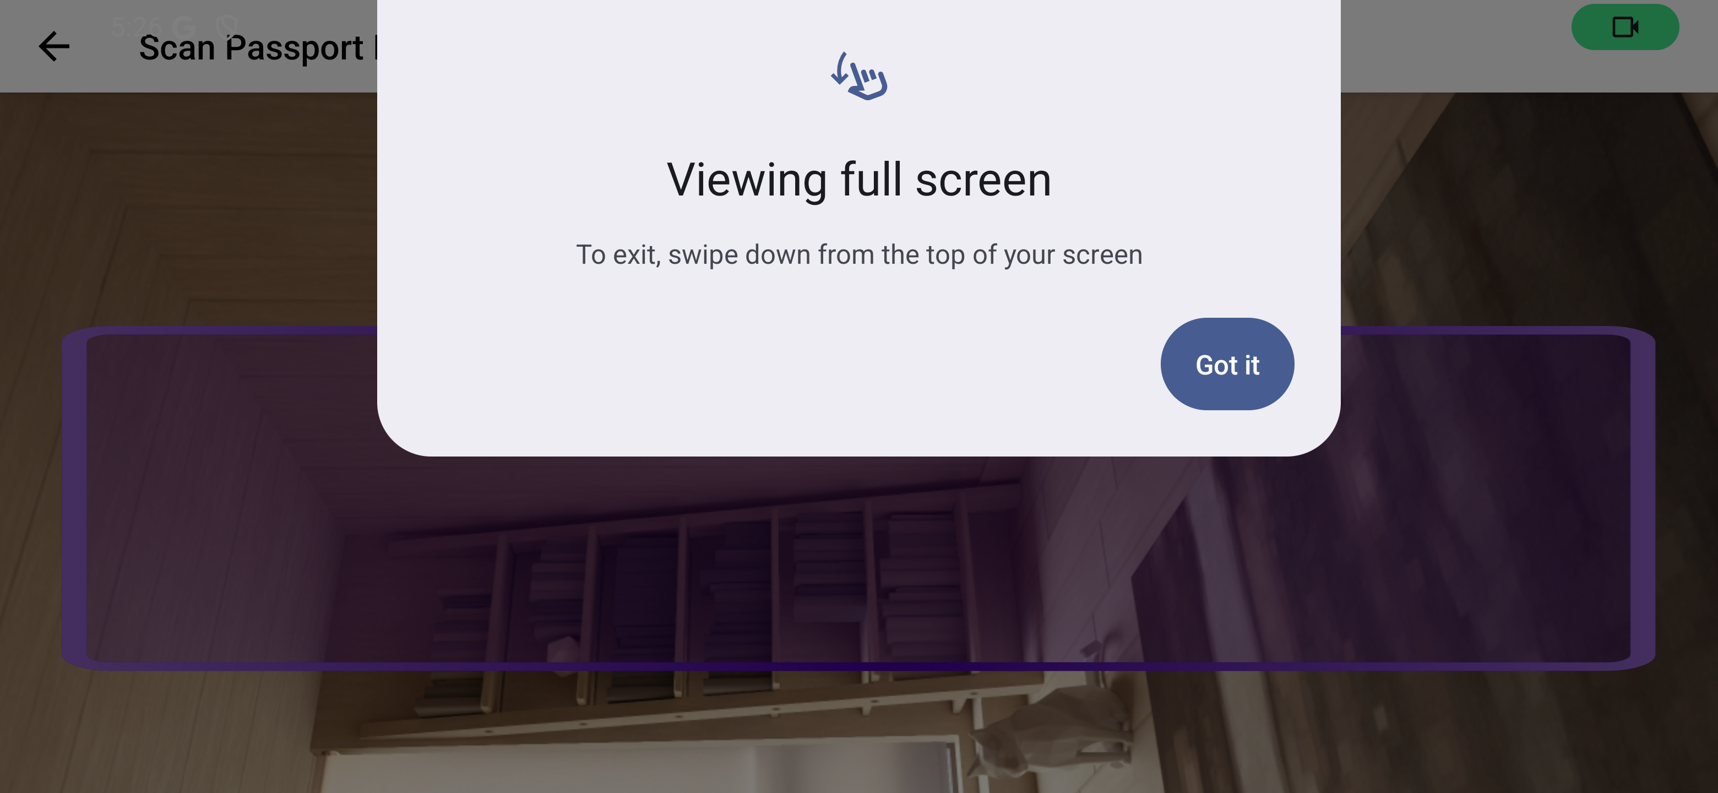
Screen 007 • 2026-09-07 17:26:00 • Captured

008 Passport MRZ scanner in landscape
Dismiss the Android full-screen hint.
The camera viewfinder opened after permission was granted. No passport fixture was supplied to complete extraction.
Outcome: Passport fixture required
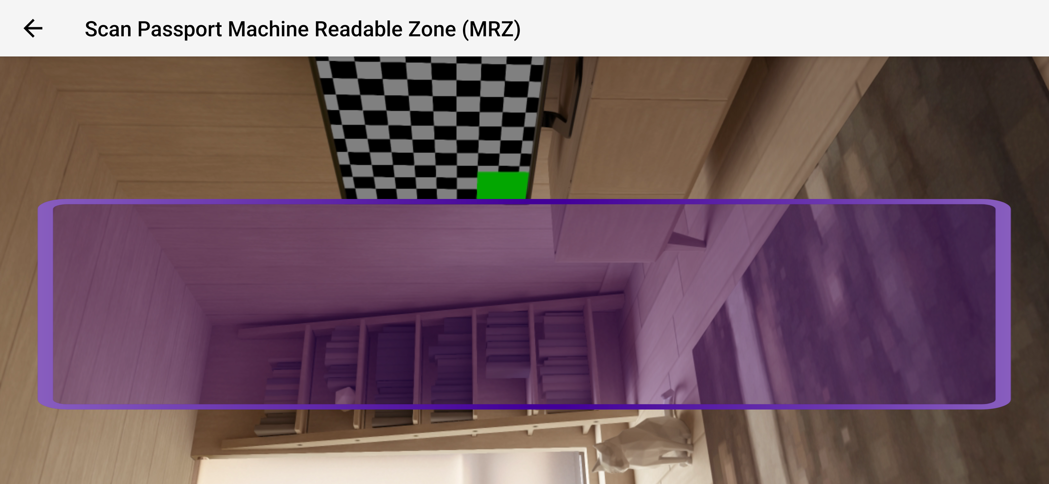
Screen 008 • 2026-09-07 17:26:30 • Passport fixture required

009 Resident profile details empty form
Choose Fill Manually.
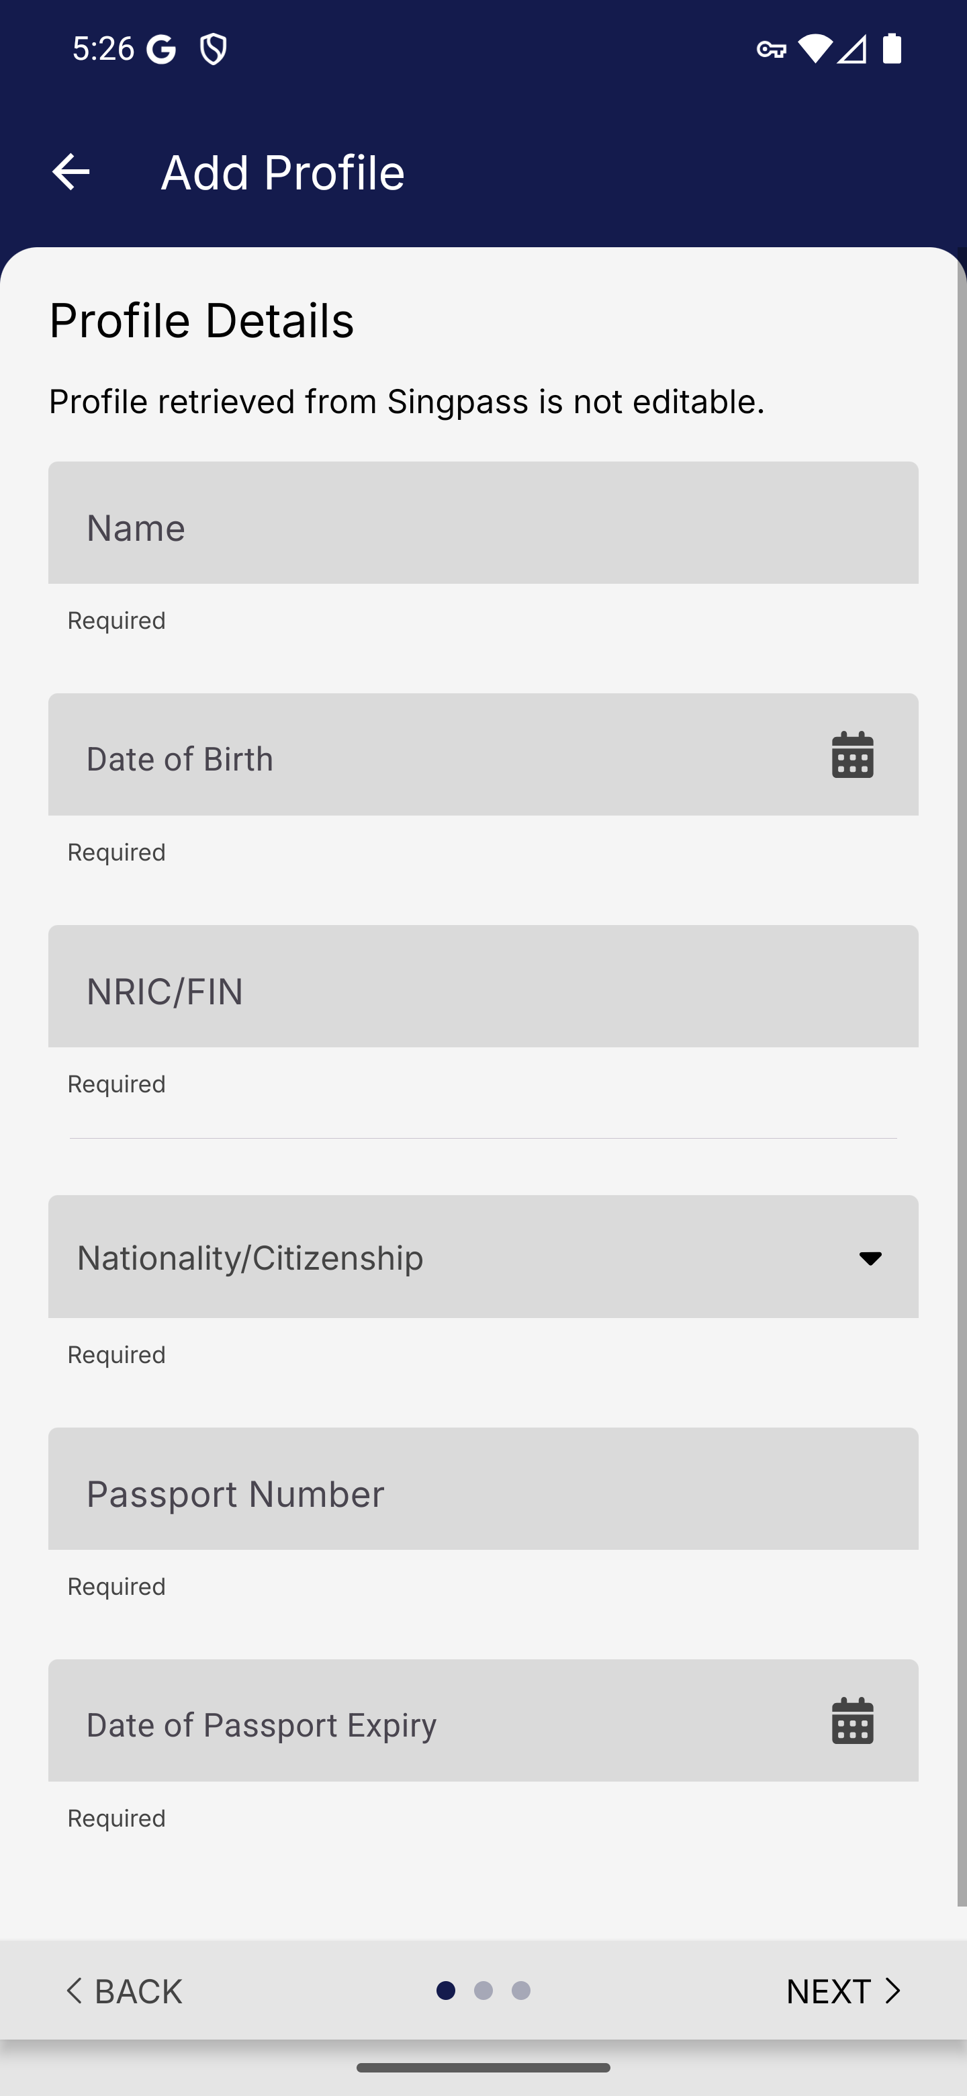
Screen 009 • 2026-09-07 17:26:55 • Captured

010 Resident required field validation
Choose Next with the profile form empty.
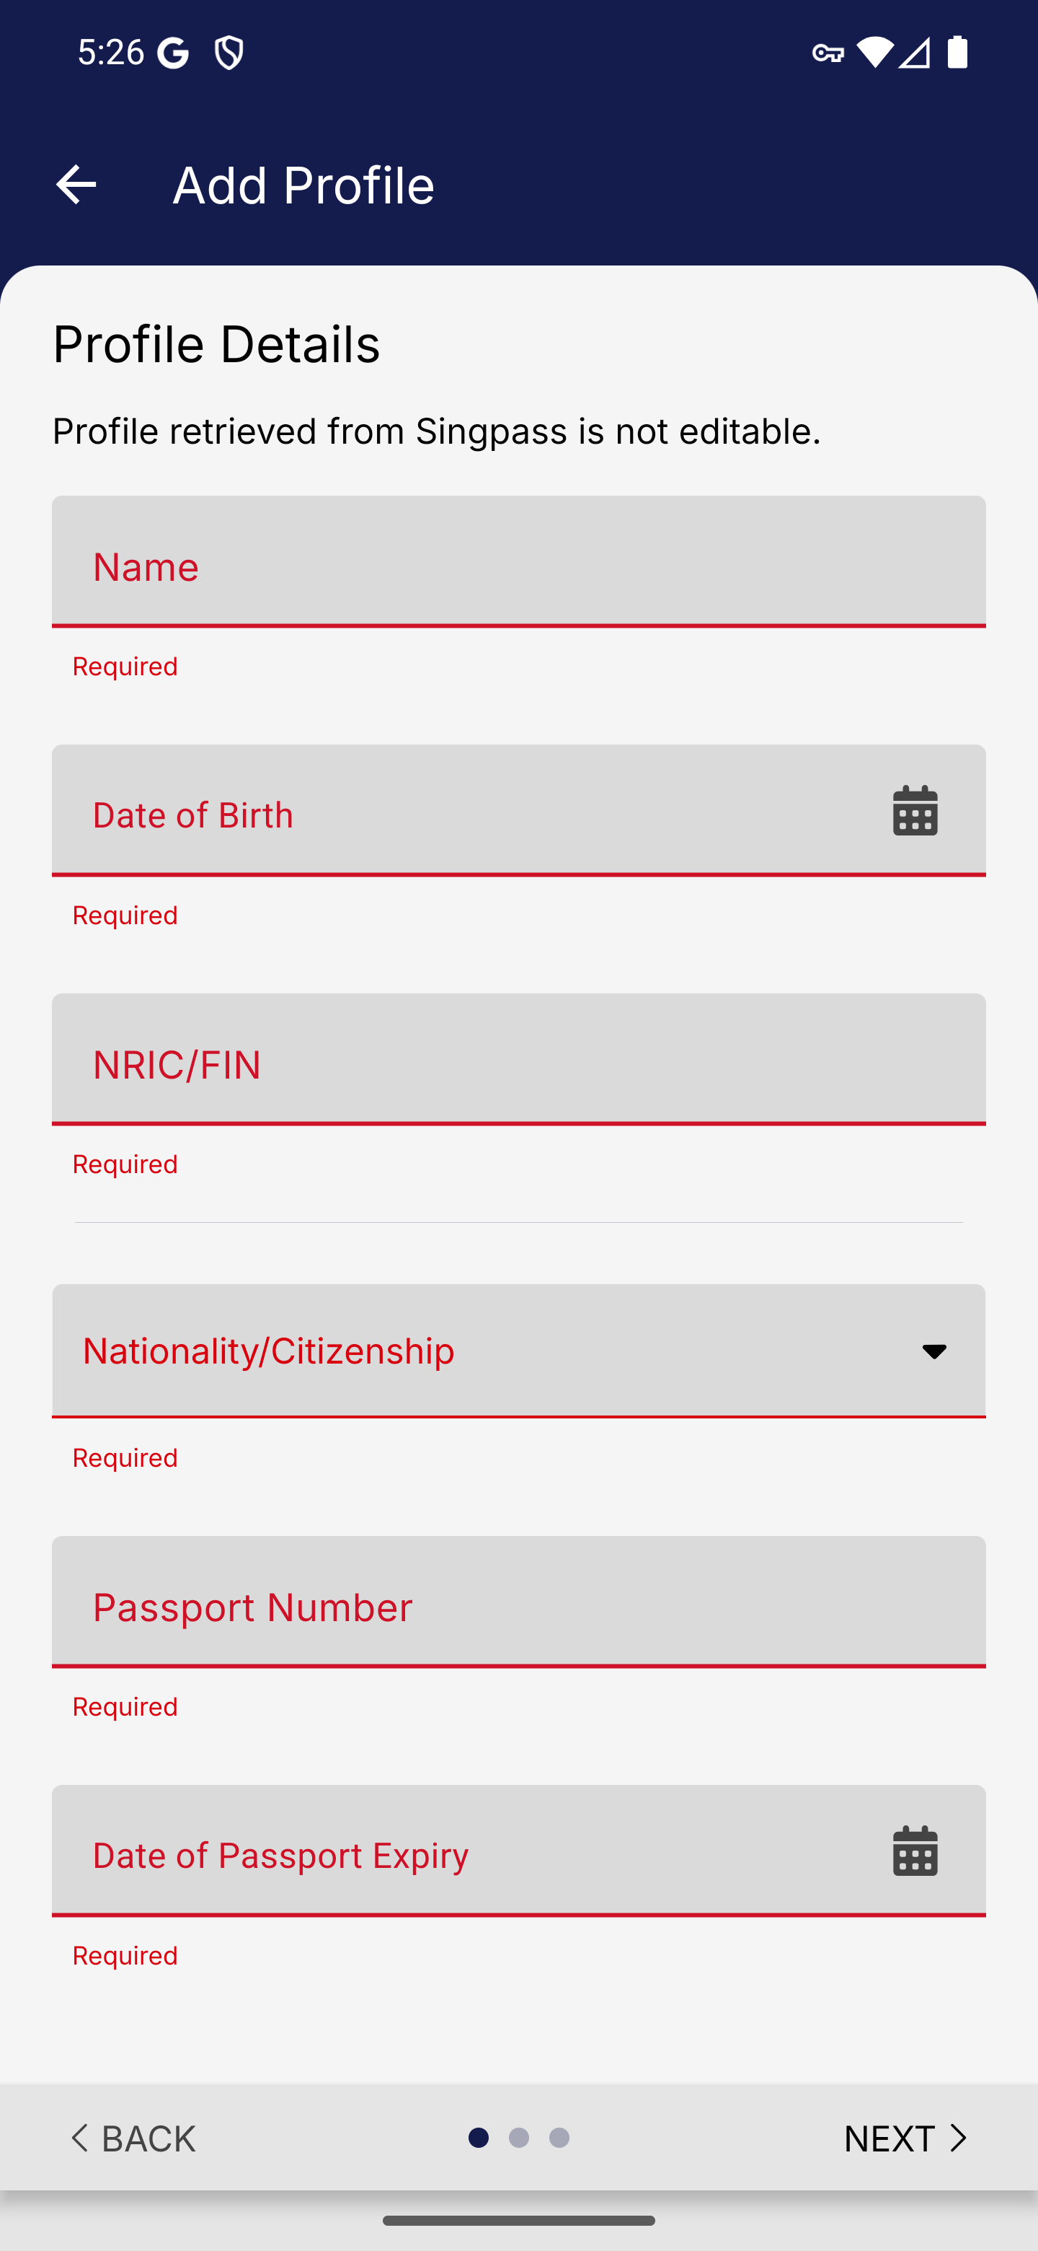
Screen 010 • 2026-09-07 17:26:56 • Captured

011 Resident date format validation
Enter synthetic full name, NRIC and date of birth.
Input without slashes produced Invalid date format (DD/MM/YYYY). The identity fields were corrected before saving.
Outcome: Validation observed
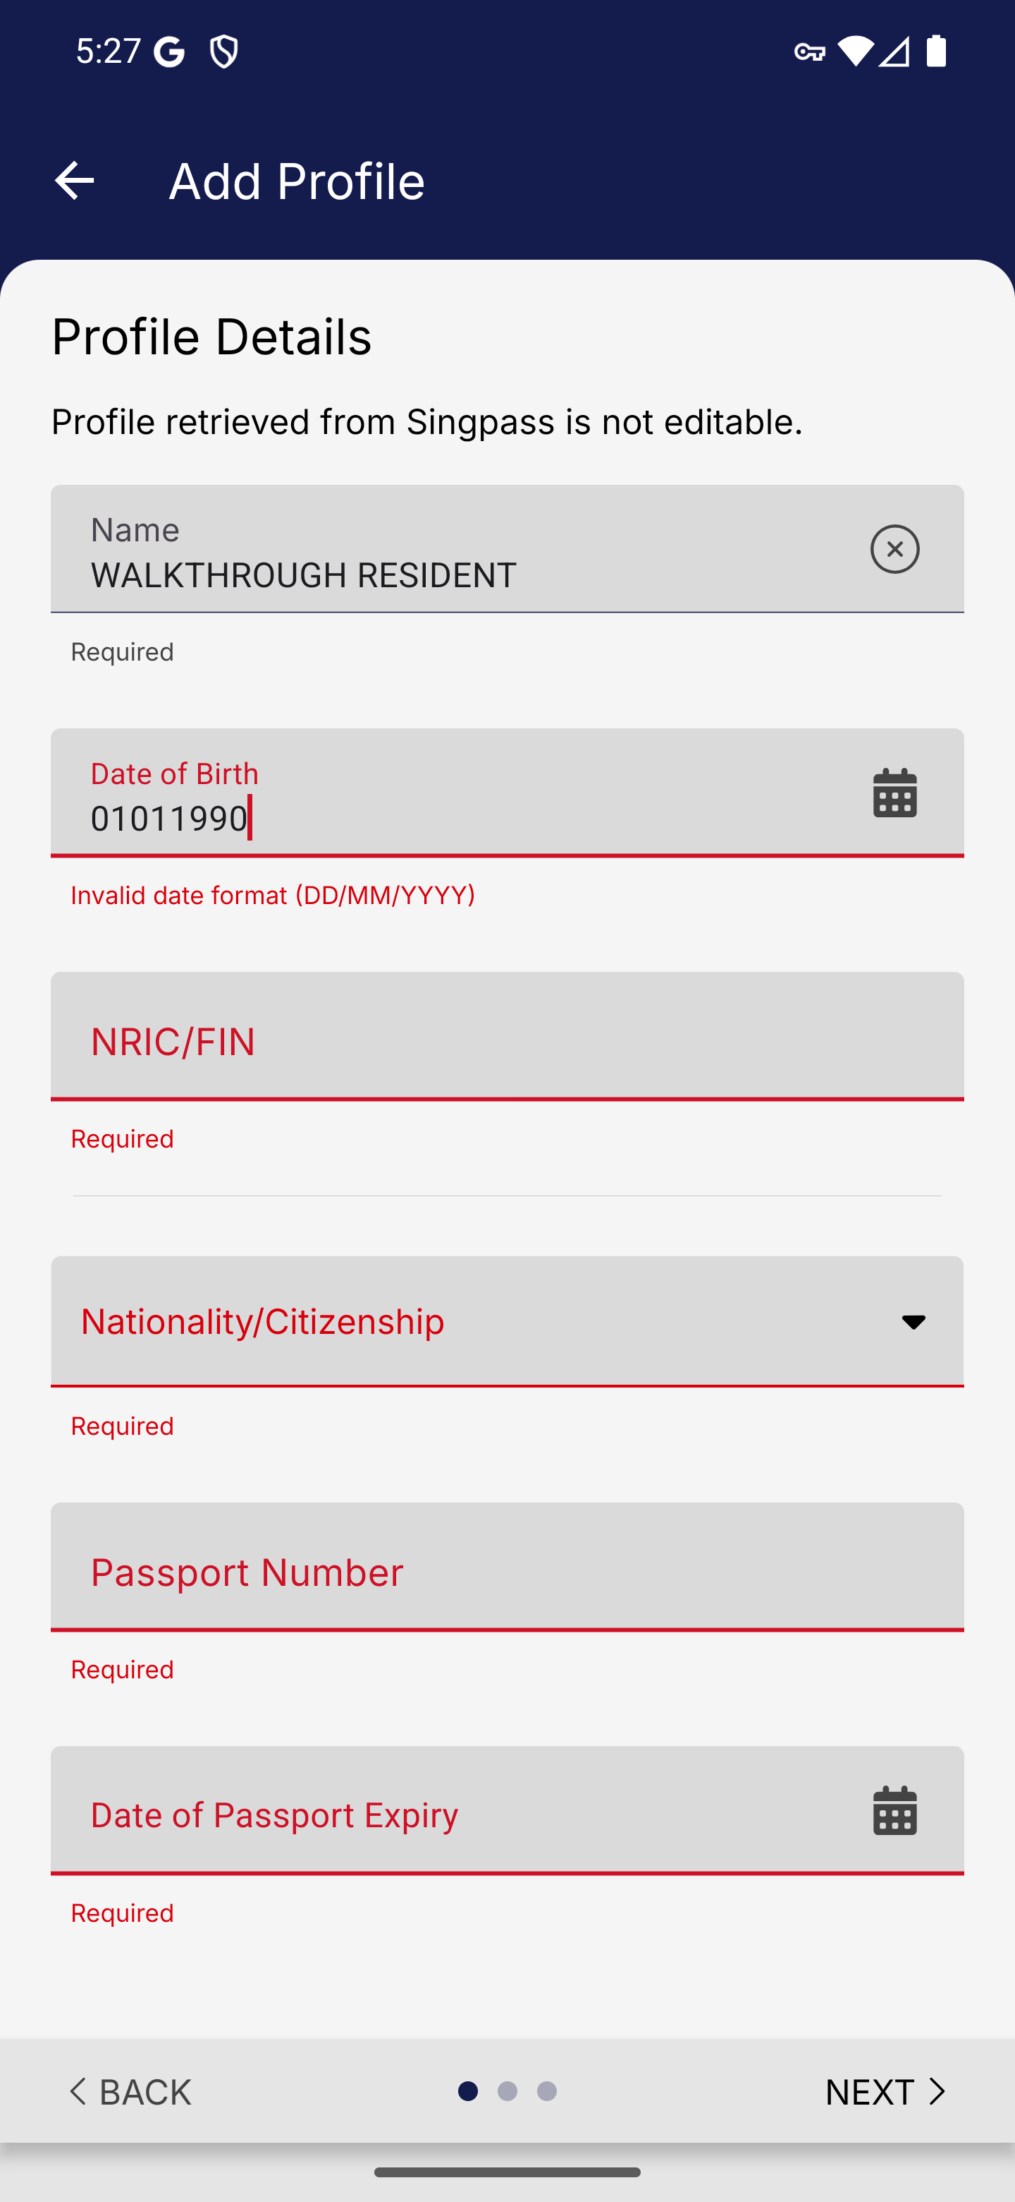
Screen 011 • 2026-09-07 17:27:02 • Validation observed

012 Resident nationality picker
Open Nationality or Citizenship.
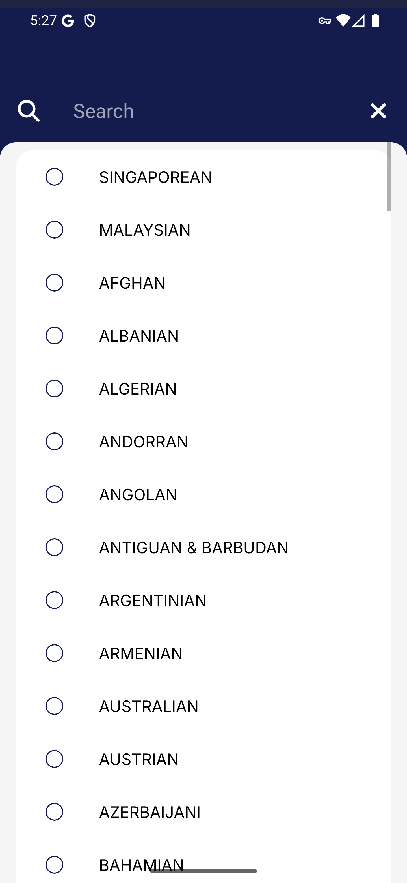
Screen 012 • 2026-09-07 17:27:04 • Captured

013 Resident profile completed details
Complete the identity and passport fields with synthetic test data.
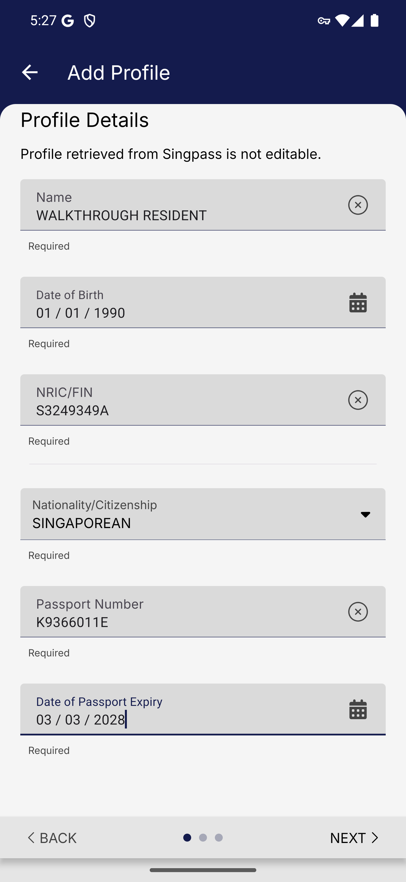
Screen 013 • 2026-09-07 17:27:44 • Captured

014 Resident contact details
Continue to Contact Details.
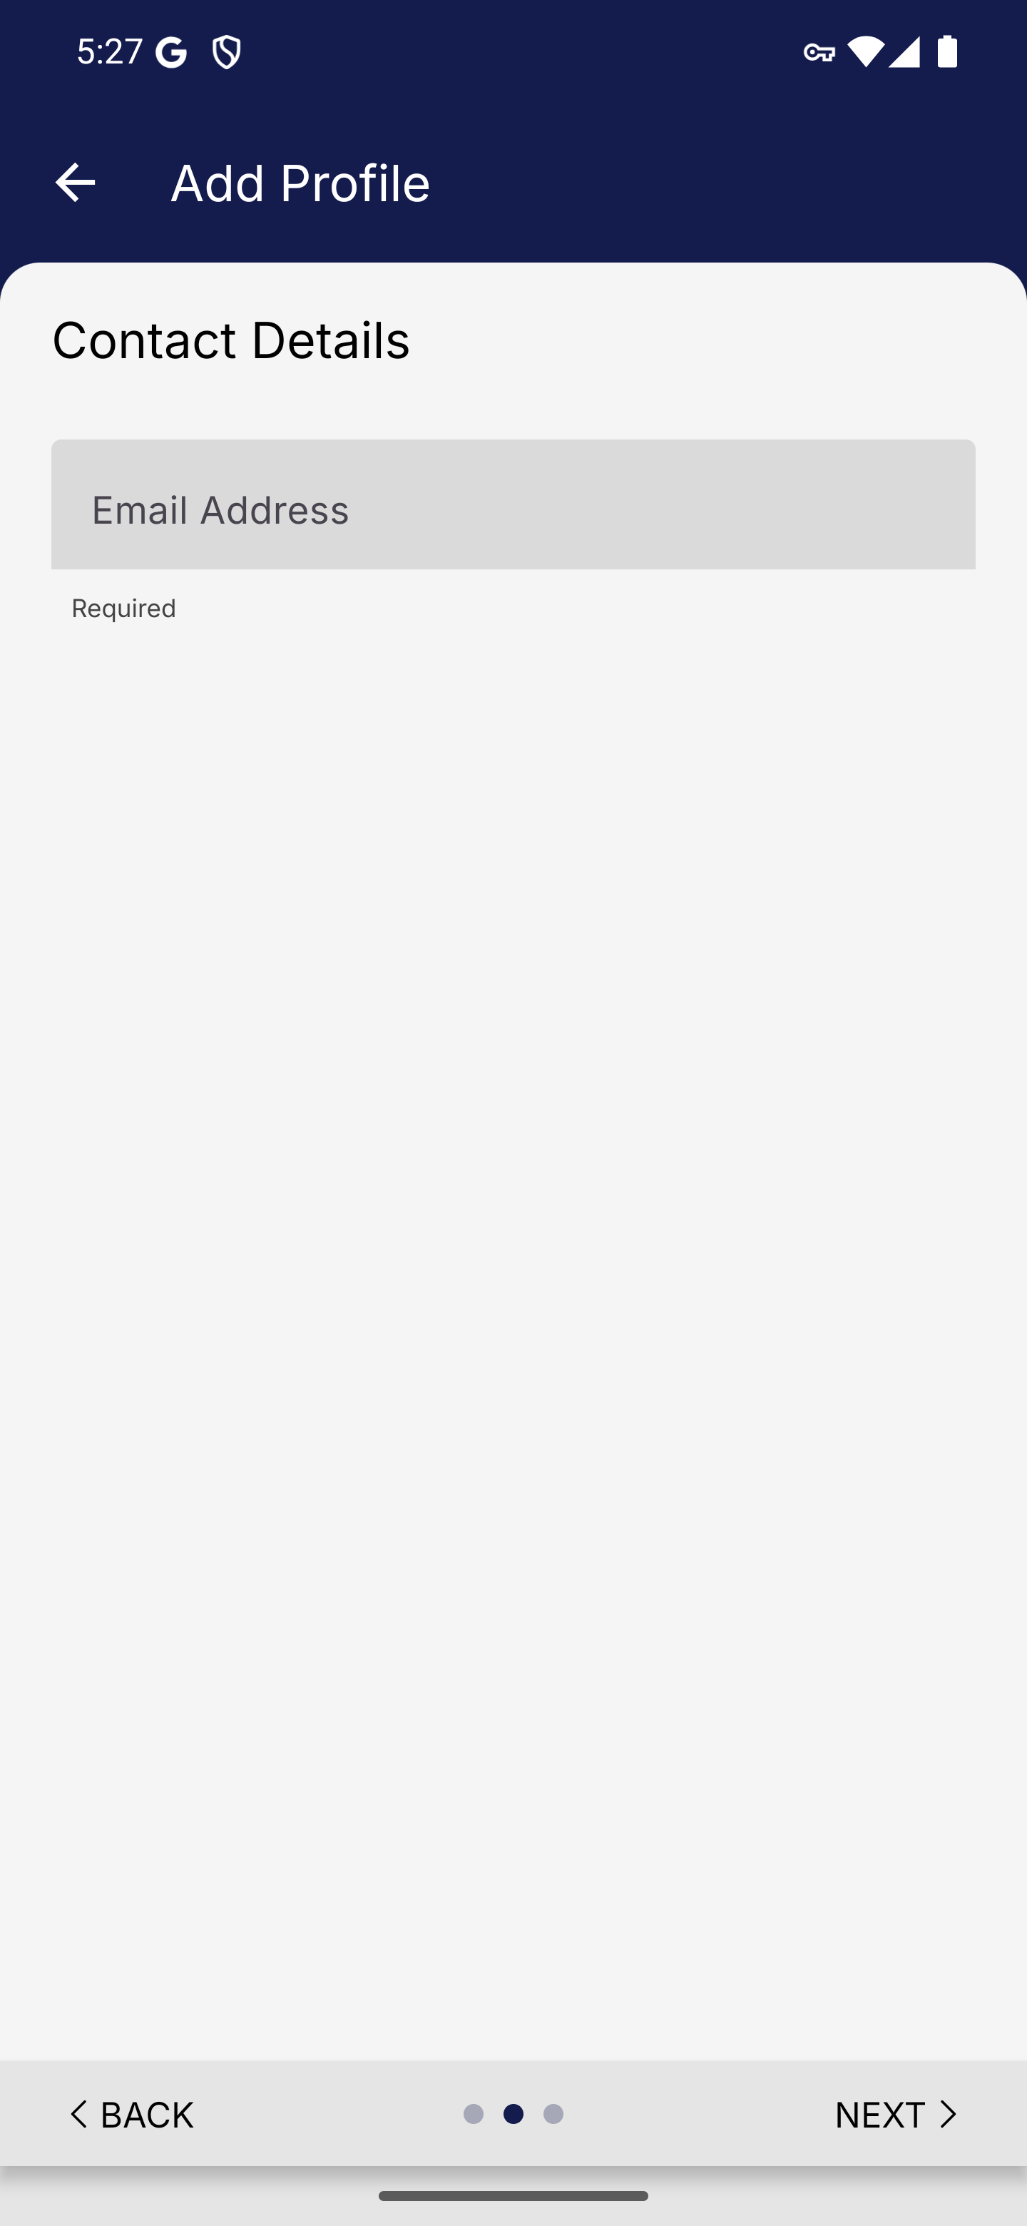
Screen 014 • 2026-09-07 17:27:46 • Captured

015 Resident contact details completed
Enter the synthetic example.com email address.
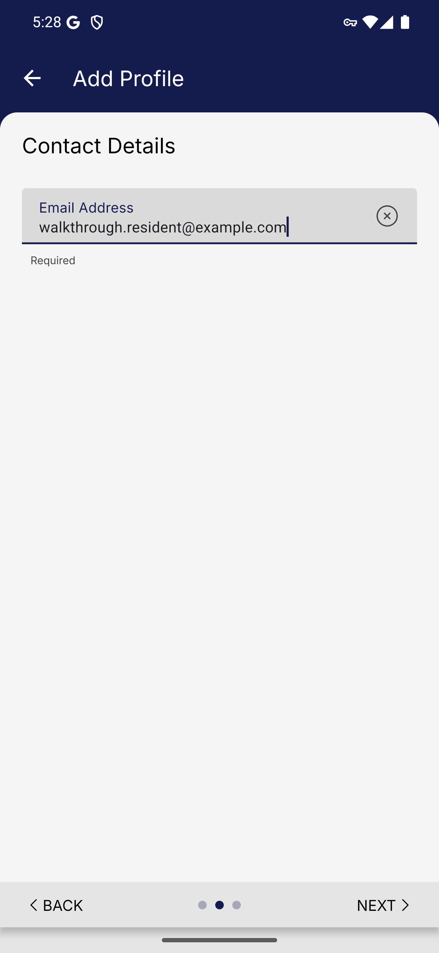
Screen 015 • 2026-09-07 17:28:06 • Captured

016 Resident profile confirmation
Review Passport Details and Contact Details before saving.
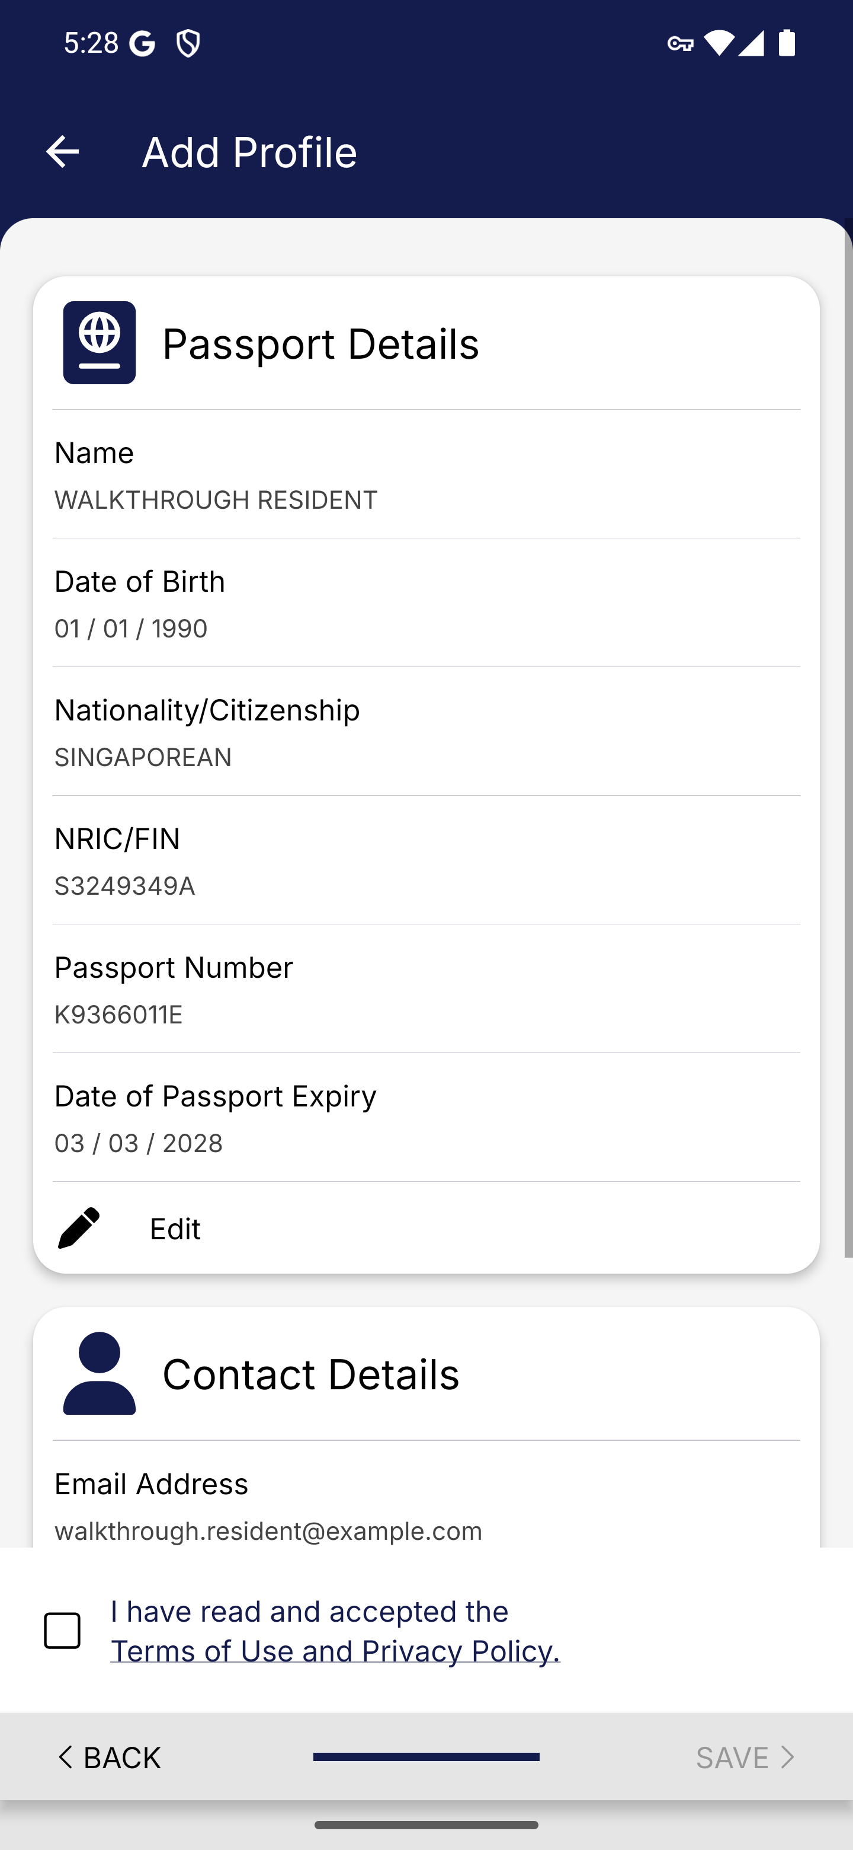
Screen 016 • 2026-09-07 17:28:07 • Captured

017 Resident profile saved
Accept the profile terms and choose Save.
The app reports that WALKTHROUGH RESIDENT was created successfully.
Outcome: Completed
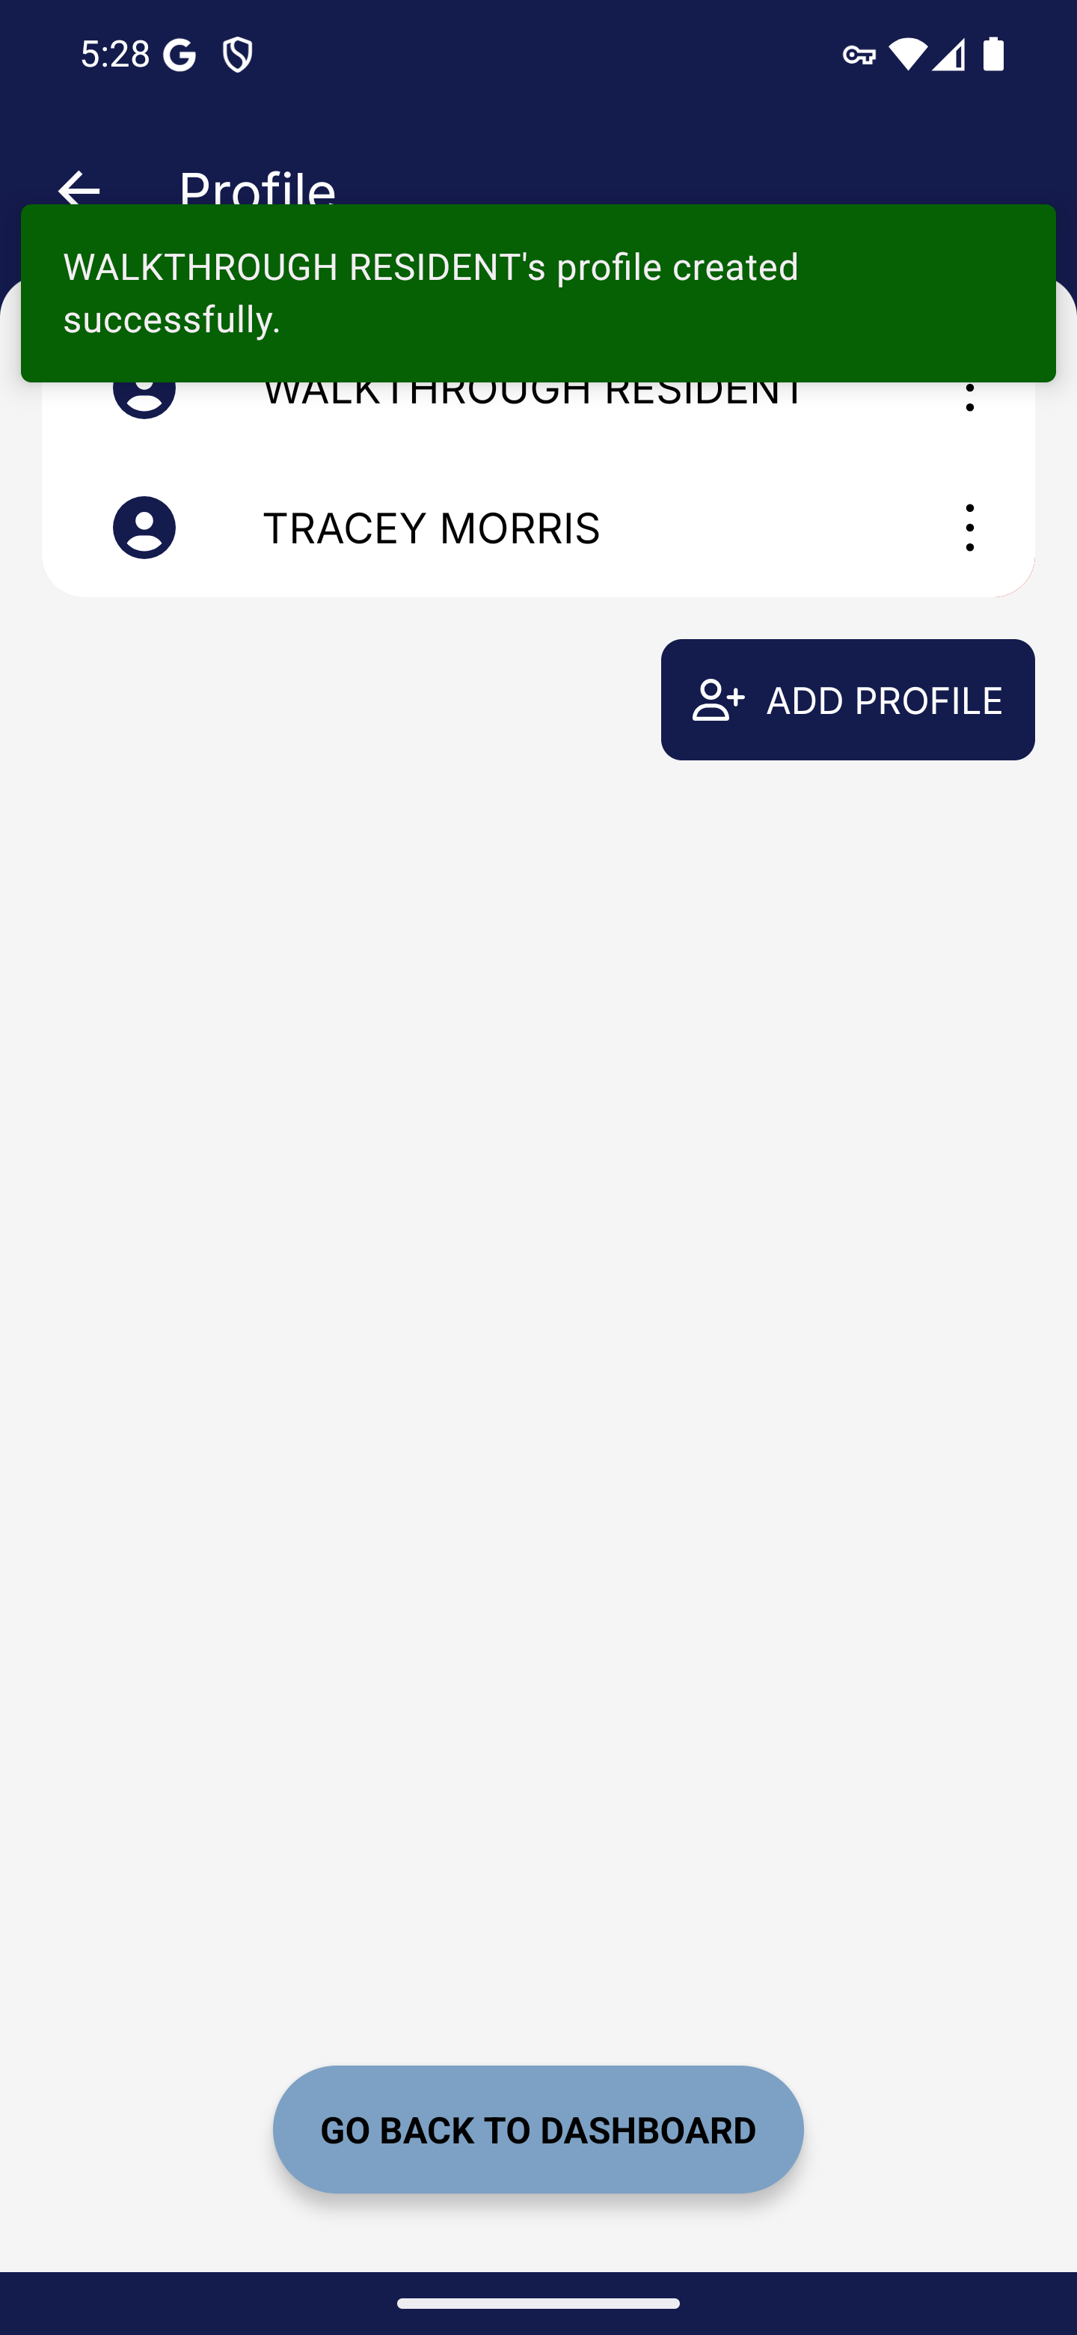
Screen 017 • 2026-09-07 17:28:30 • Completed

018 Resident profile management menu
Select the new walkthrough profile.
Selecting the saved profile opens View / Edit and Delete actions.
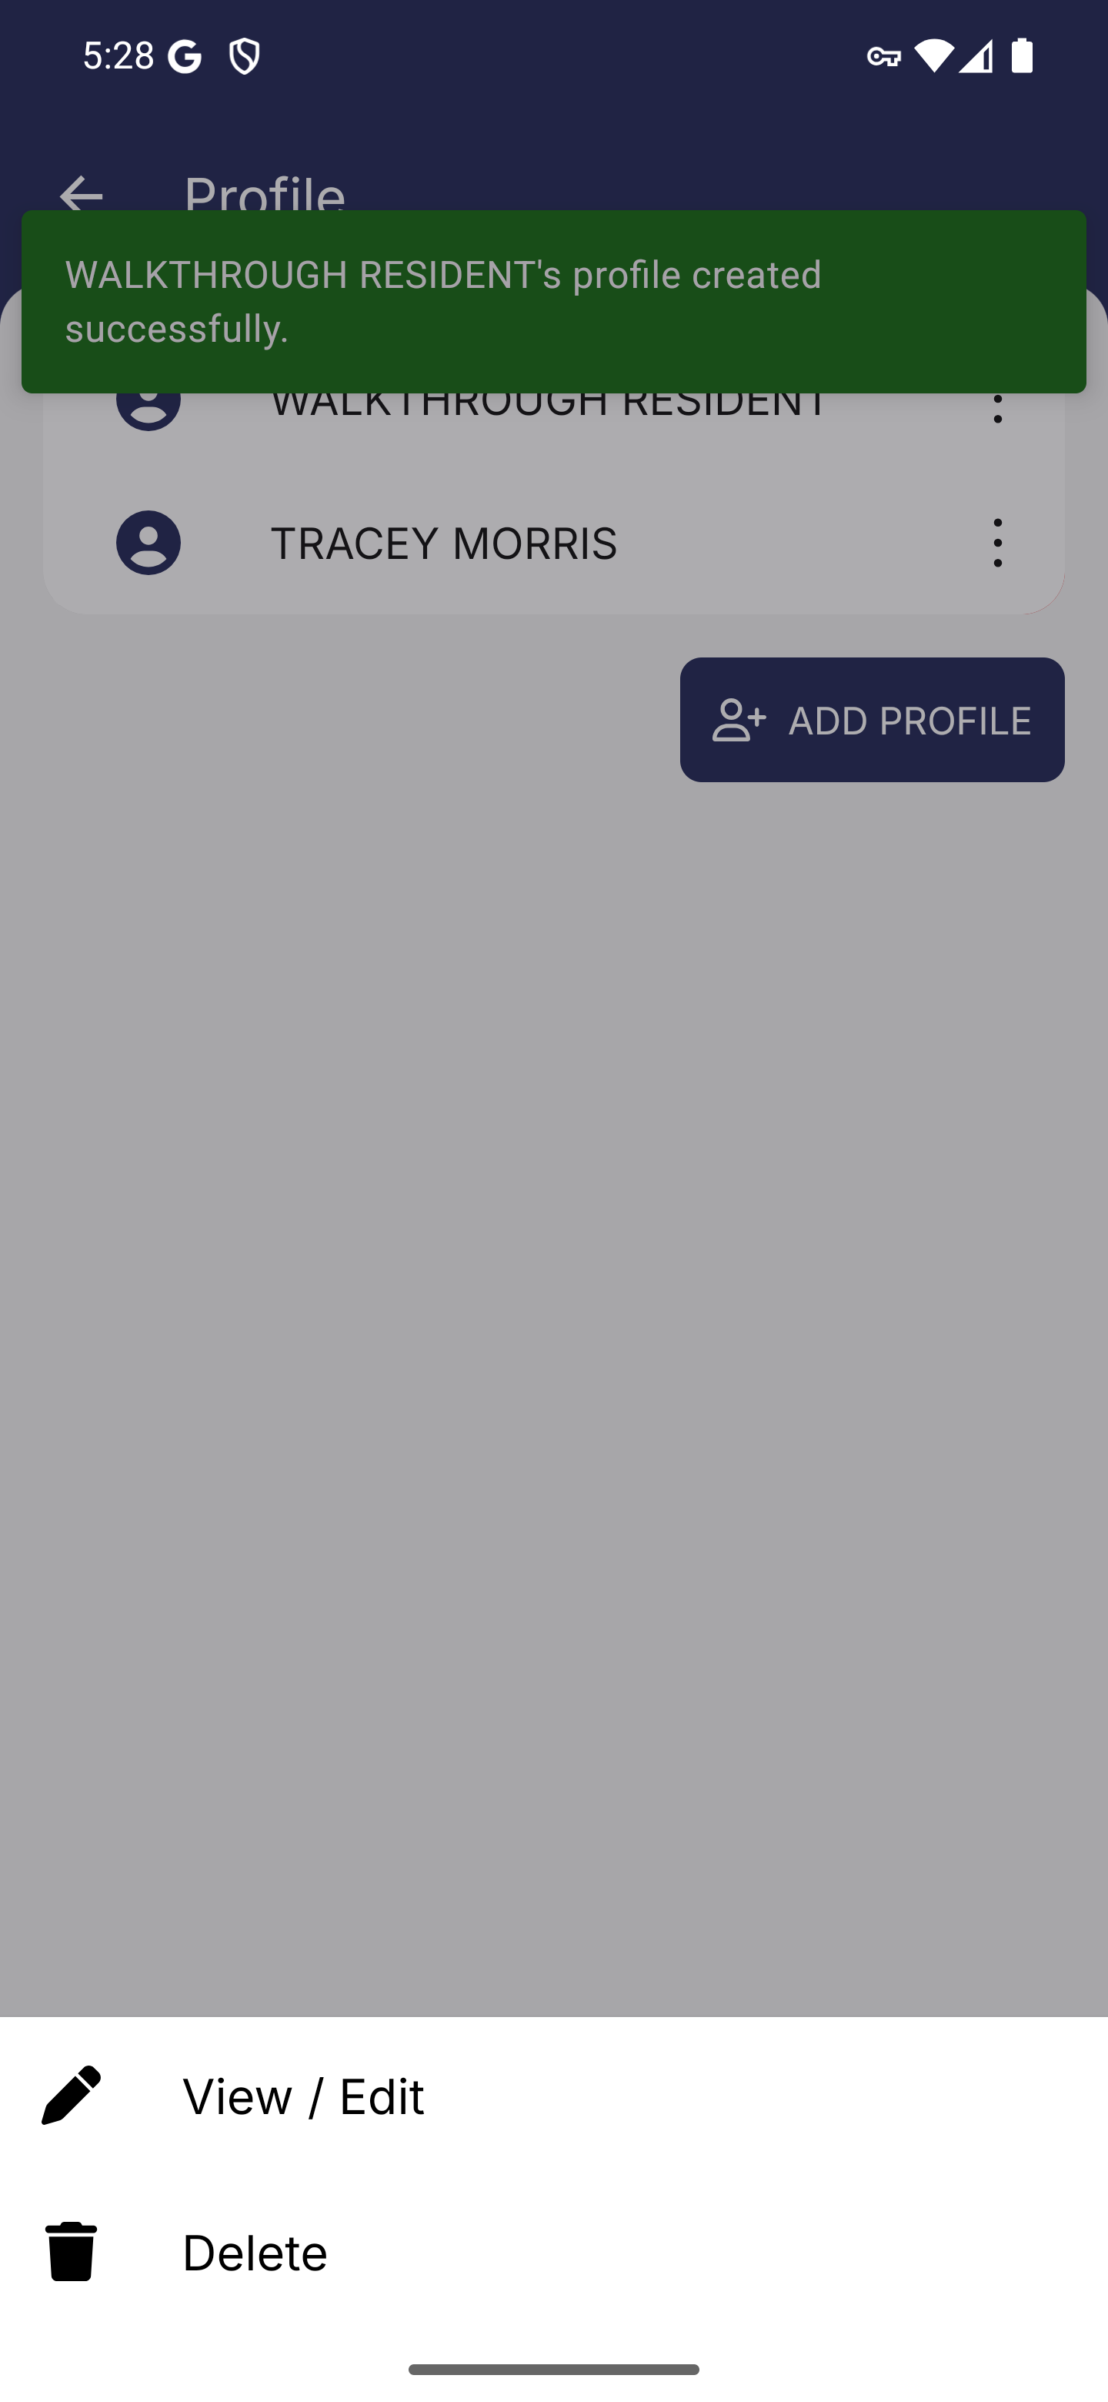
Screen 018 • 2026-09-07 17:28:31 • Captured

019 Resident profile view and edit
Open the saved profile menu and choose View / Edit.
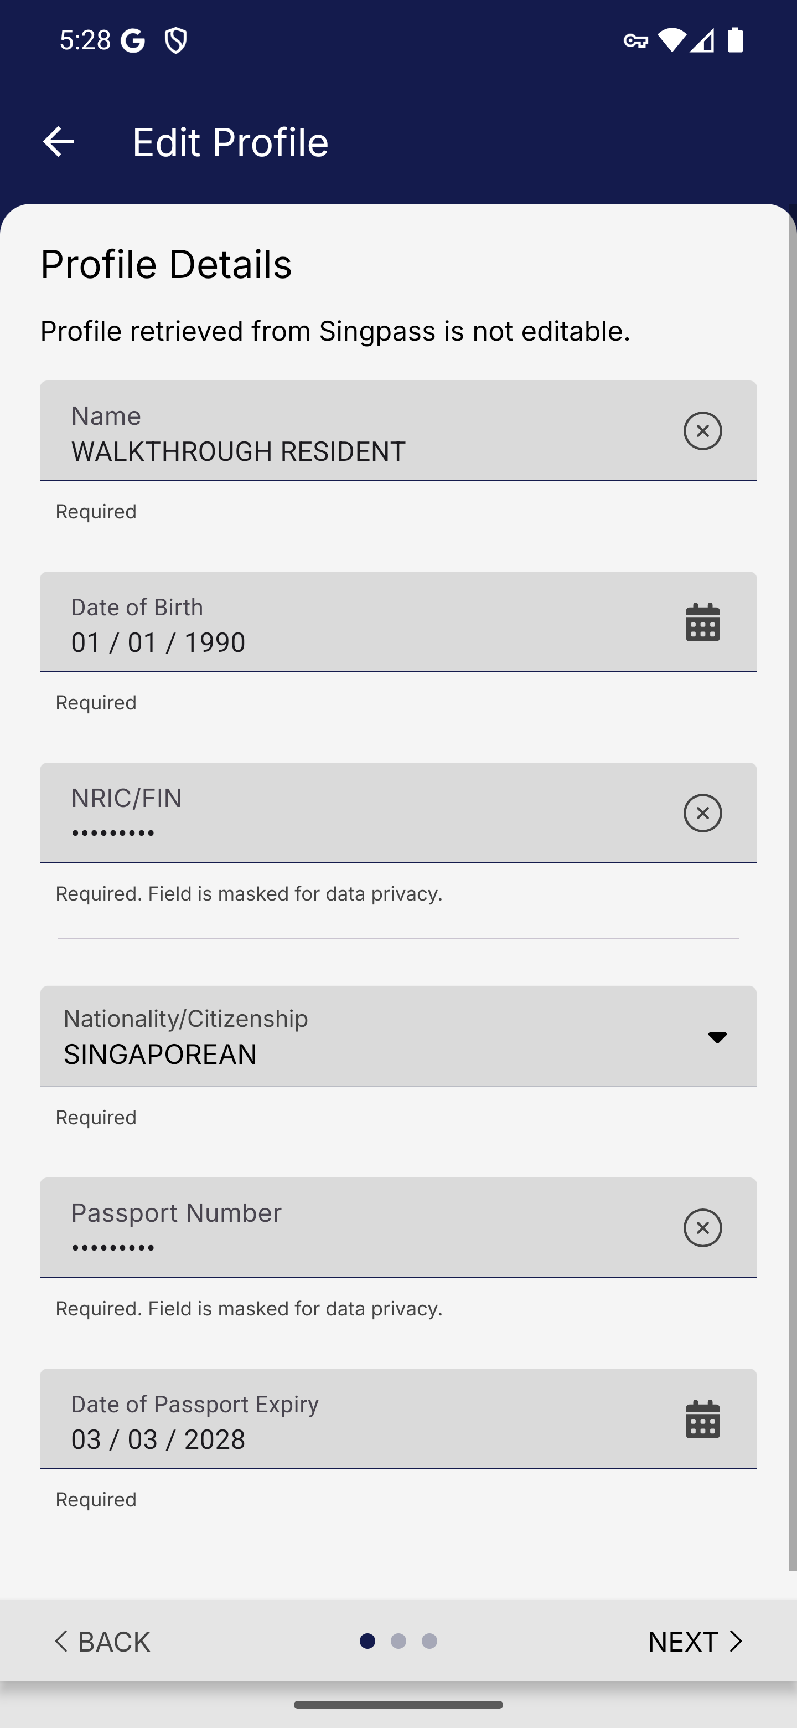
Screen 019 • 2026-09-07 17:28:53 • Captured

020 Resident profile update required
Return to the dashboard and select WALKTHROUGH RESIDENT.
Selecting the saved profile on the arrival-card dashboard opens an update-required alert.
Outcome: Blocked
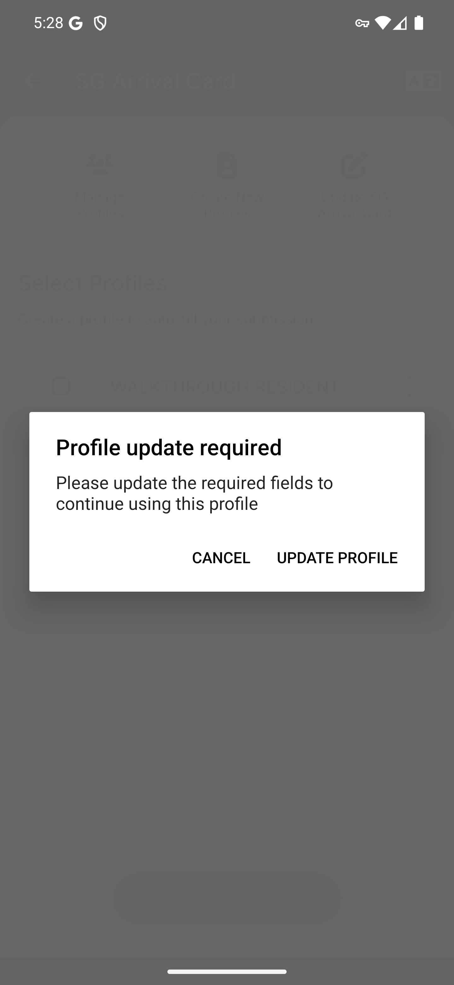
Screen 020 • 2026-09-07 17:28:55 • Blocked

021 Resident contact update form
Choose Update Profile when the arrival dashboard requests additional details.
UPDATE PROFILE opens Contact Details with the previously saved email.
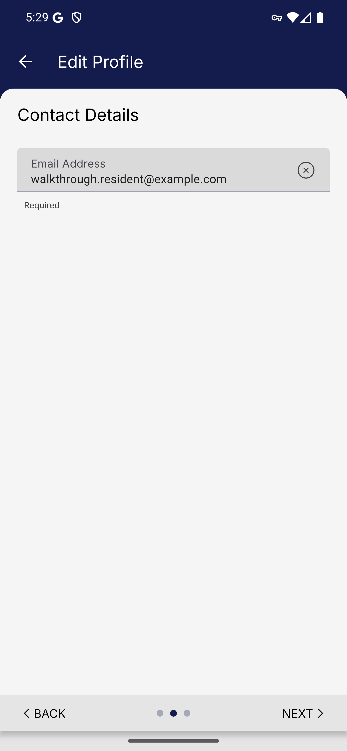
Screen 021 • 2026-09-07 17:29:11 • Captured

022 Resident update confirmation
Continue through the requested profile update.
The update summary lists the saved identity and contact information and requires accepting the terms before SAVE.
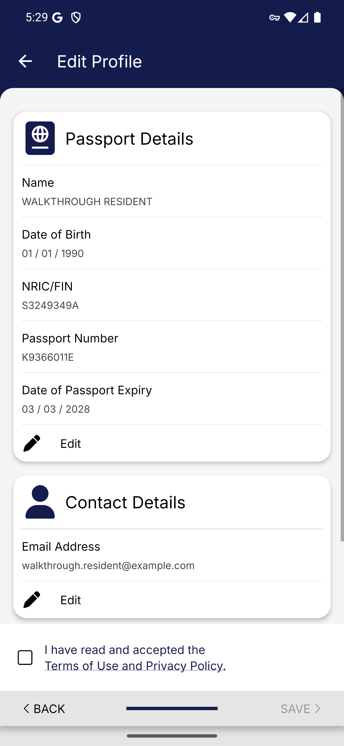
Screen 022 • 2026-09-07 17:29:13 • Captured

023 Resident profile update saved
Save the requested profile update.
The app reports the profile was updated successfully.
Outcome: Completed
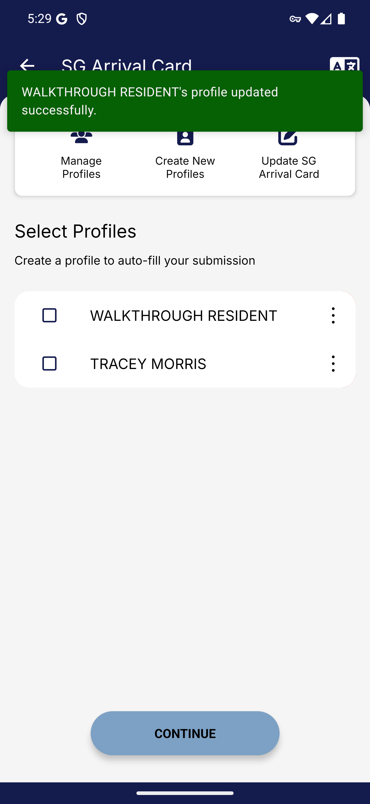
Screen 023 • 2026-09-07 17:29:29 • Completed

024 Resident update loop blocks arrival card
Select the profile again after saving the required update.
The app repeats Profile update required after reporting a successful update; arrival-date and declaration screens cannot be reached with this new profile.
Outcome: Blocked by app behaviour
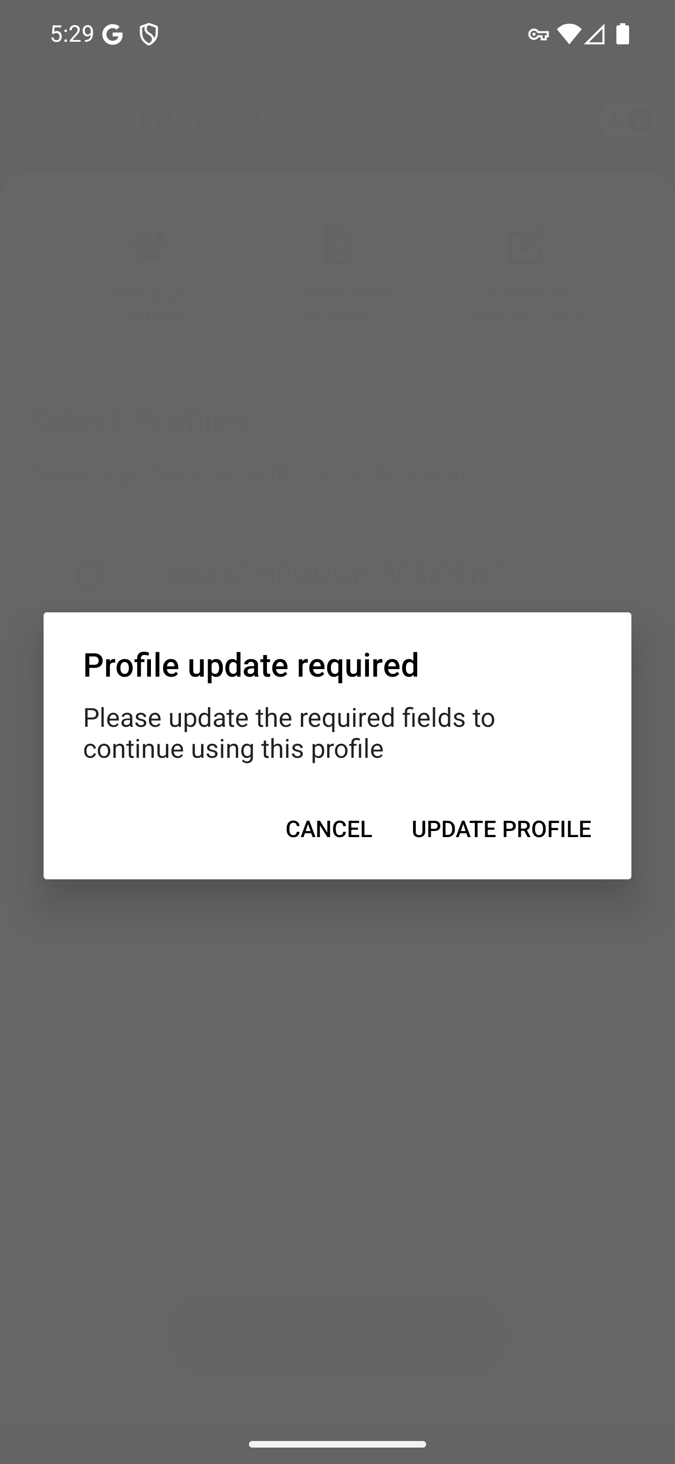
Screen 024 • 2026-09-07 17:29:56 • Blocked by app behaviour

025 Resident arrival-card retrieval instructions
Wait for the in-app update portal to load.
The update portal explains which fields cannot be amended and requests NRIC/FIN and arrival date to retrieve a submission.
Outcome: Existing submission required
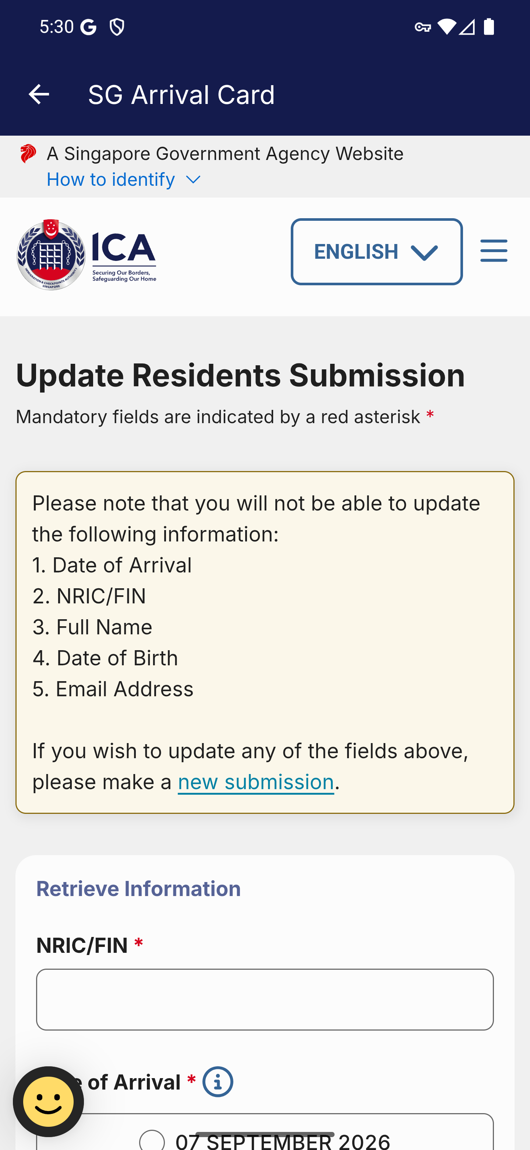
Screen 025 • 2026-09-07 17:30:27 • Existing submission required

026 Resident retrieval arrival-date choices
Scroll to the NRIC, arrival date and email retrieval form.
The lower part of the retrieval form offers arrival dates and Next. This belongs to the update portal, before following the new-submission link.
Outcome: Existing submission required
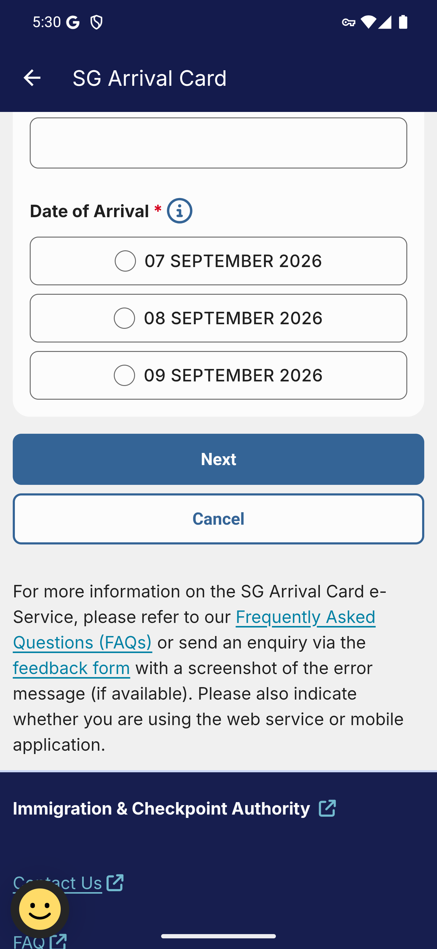
Screen 026 • 2026-09-07 17:30:29 • Existing submission required

027 Resident web new-submission arrival date
Wait for the web submission form to load.
The separate new-submission link opens resident arrival-date choices.
Outcome: Form entry reached
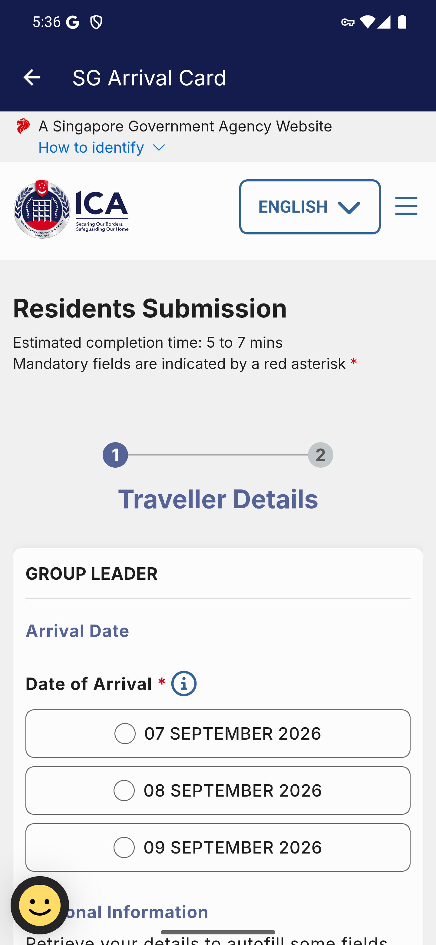
Screen 027 • 2026-09-07 17:36:46 • Form entry reached

028 Resident web personal information
Scroll through the web form.
The web form requests full name, NRIC/FIN, date of birth and email. No declaration was sent.
Outcome: Form entry reached
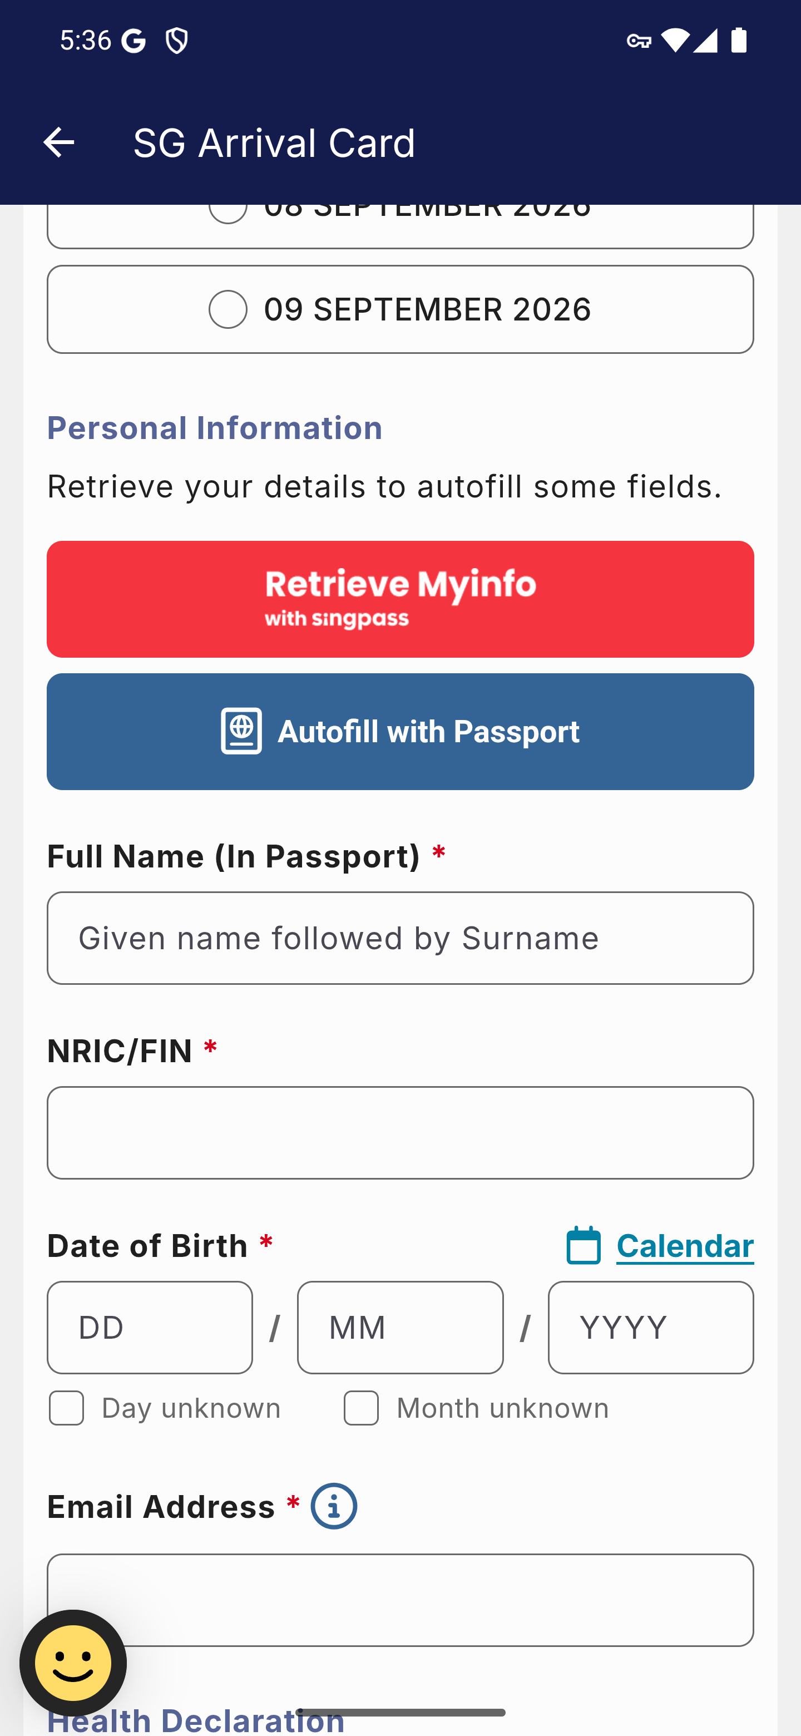
Screen 028 • 2026-09-07 17:36:49 • Form entry reached

029 Resident web contact and health information
Scroll through the remaining web fields.
The lower form contains contact and health information, Add Traveller and Next. Later submission screens were not exercised.
Outcome: Form entry reached
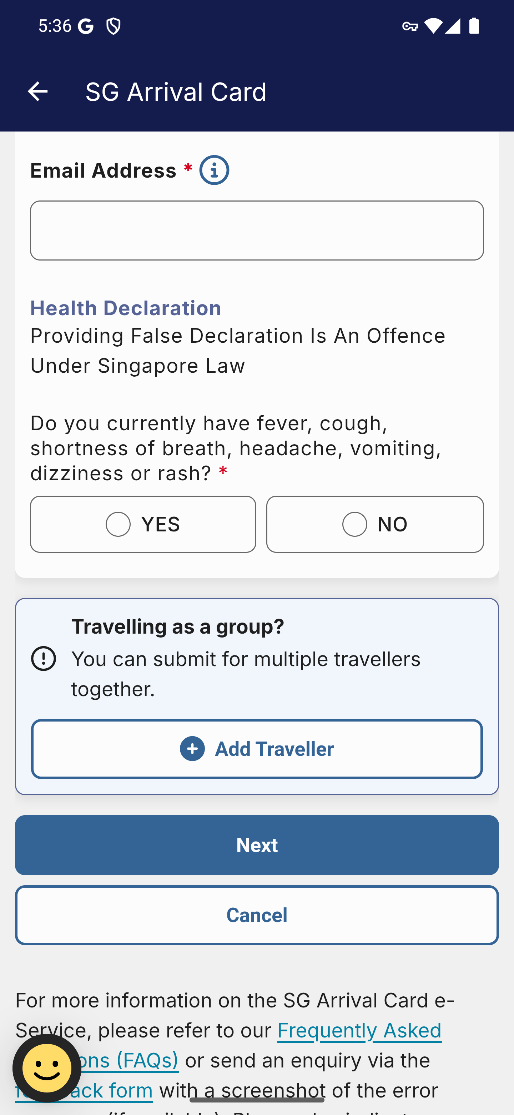
Screen 029 • 2026-09-07 17:36:52 • Form entry reached

