  - PROJECT DOCUMENTATION

Foreign visitor profiles and SG Arrival Cards
The foreign visitor manual-entry journey, including conditional Malaysian identity details, searchable location lists, residence and email, confirmation, profile update and arrival-card retrieval.
21 screen captures • Pixel 7 Pro emulator • Android 16 • English
Captured from the installed staging app on 7 September 2026. Screenshots are original device PNGs. This is a screen walkthrough; it does not certify every test case or every input combination.

Coverage and outcomes
Flow / branch | Observed outcome
Create visitor profile manually | Completed: WALKTHROUGH VISITOR saved with synthetic Malaysian identity, passport, residence and contact details.
Sex, birthplace and nationality | Selection screens and a country search captured. Malaysian nationality reveals an additional identity-card field.
Conditional identity field | The required Malaysian identity-card field was supplied before continuing.
Residence and contact | A searchable Malaysian city of residence and email were accepted; both sections appear in the confirmation.
Profile update | Update saved successfully, but selecting the profile for an arrival card repeats Profile update required.
Native arrival-card submission | Blocked by the repeated profile-update prompt. Arrival, trip, accommodation, declaration and success screens beyond that point were not reached.
Update existing arrival card | Web retrieval form opened. It requests DE number, nationality, date of birth, passport number and passport expiry. No submitted record was supplied.
Passport scan | Creation method is visible. The shared scanner is documented in the resident walkthrough; passport extraction requires a test fixture.
The profile-update loop was reproduced after a successful save, independently of the resident profile. The documents report this boundary instead of inventing later screens.
Other nationalities and every location option were not exhaustively tested. This captures the observed Malaysian conditional branch.

How to use this document
Each following page records one screen, the action used to reach it, and any relevant observation. Screen numbers match the category manifest and PNG filenames. Source XML and SHA-256 hashes are retained beside the screenshots for traceability. Open the original PNG when you need to zoom into small text.

001 Foreign visitor SG Arrival Card landing
Choose Foreign Visitor SG Arrival Card from Home.
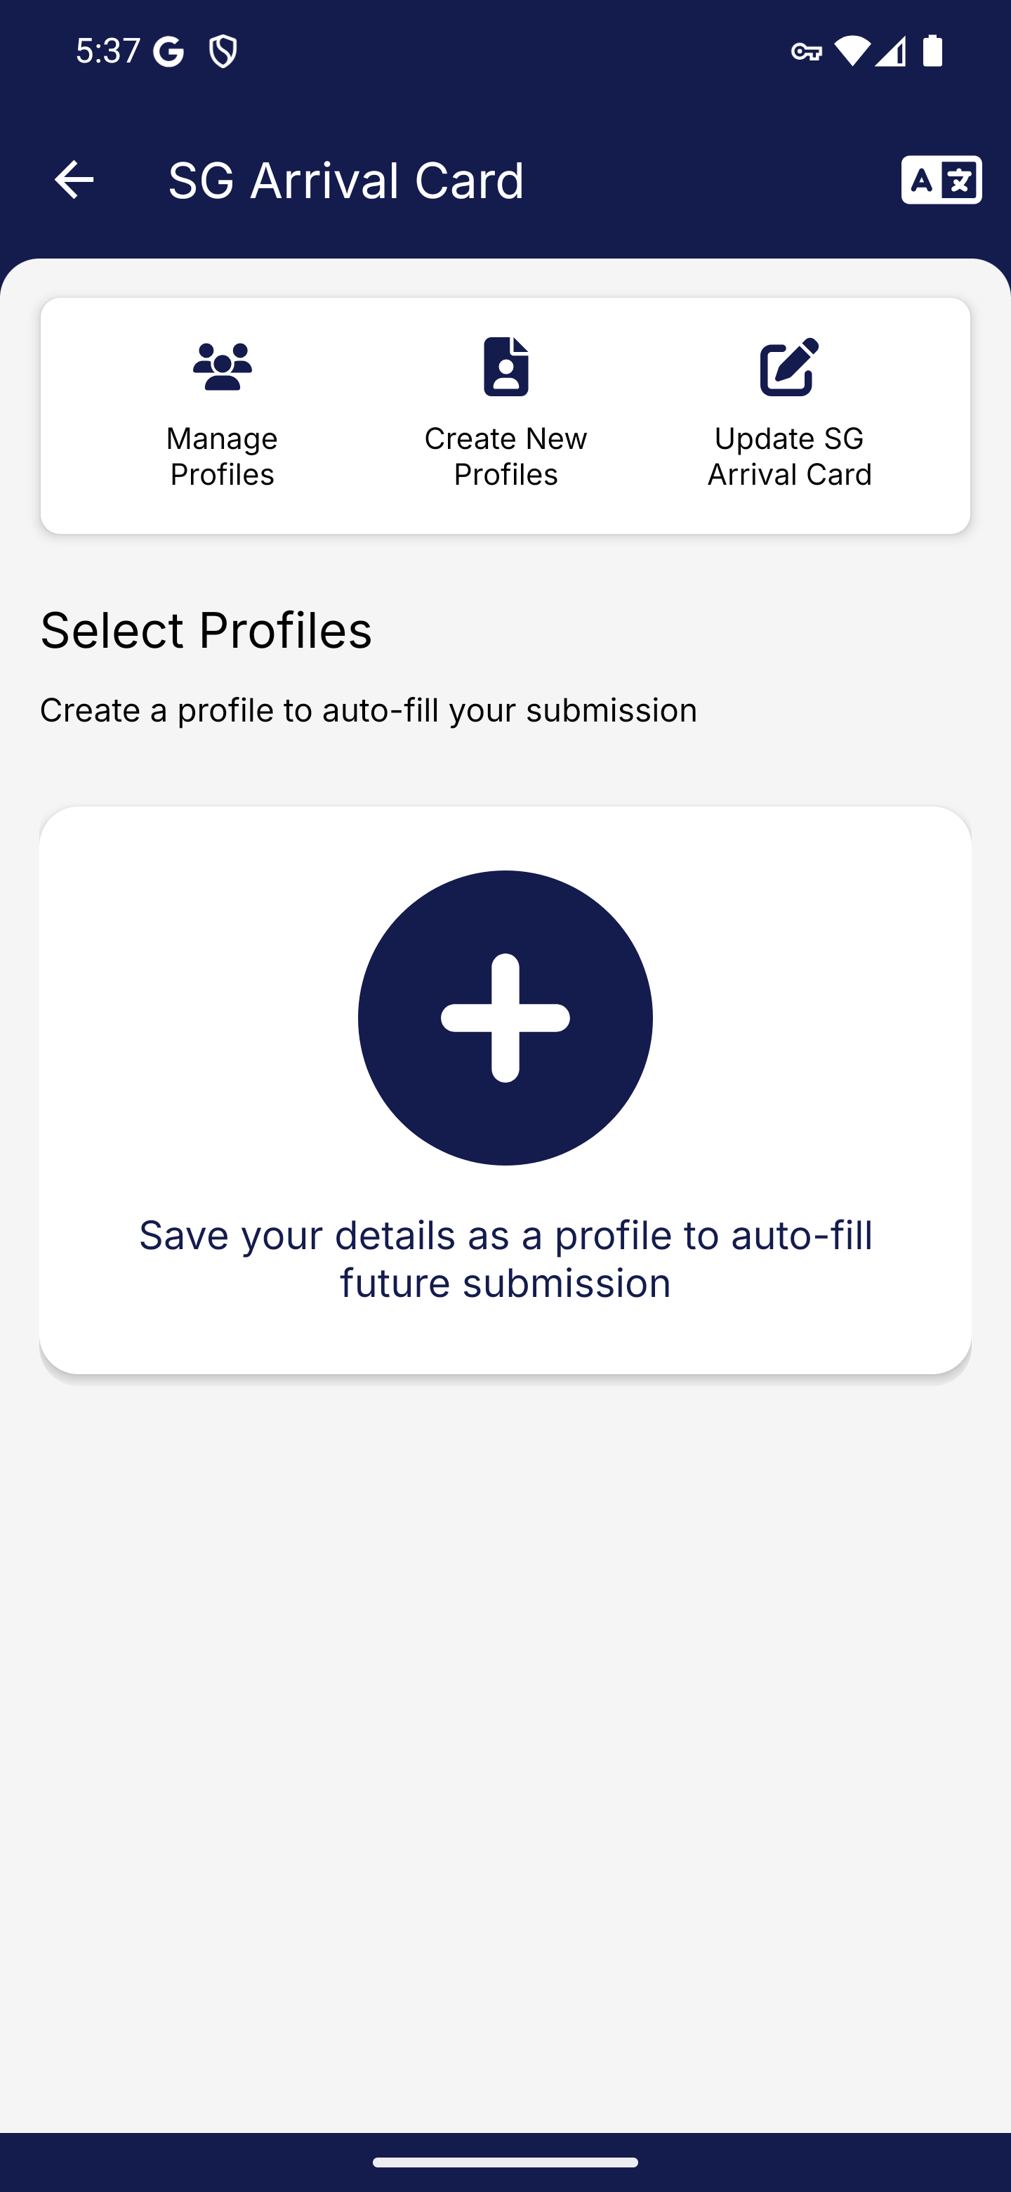
Screen 001 • 2026-09-07 17:37:25 • Captured

002 Foreign visitor creation methods
Choose Create New Profile.
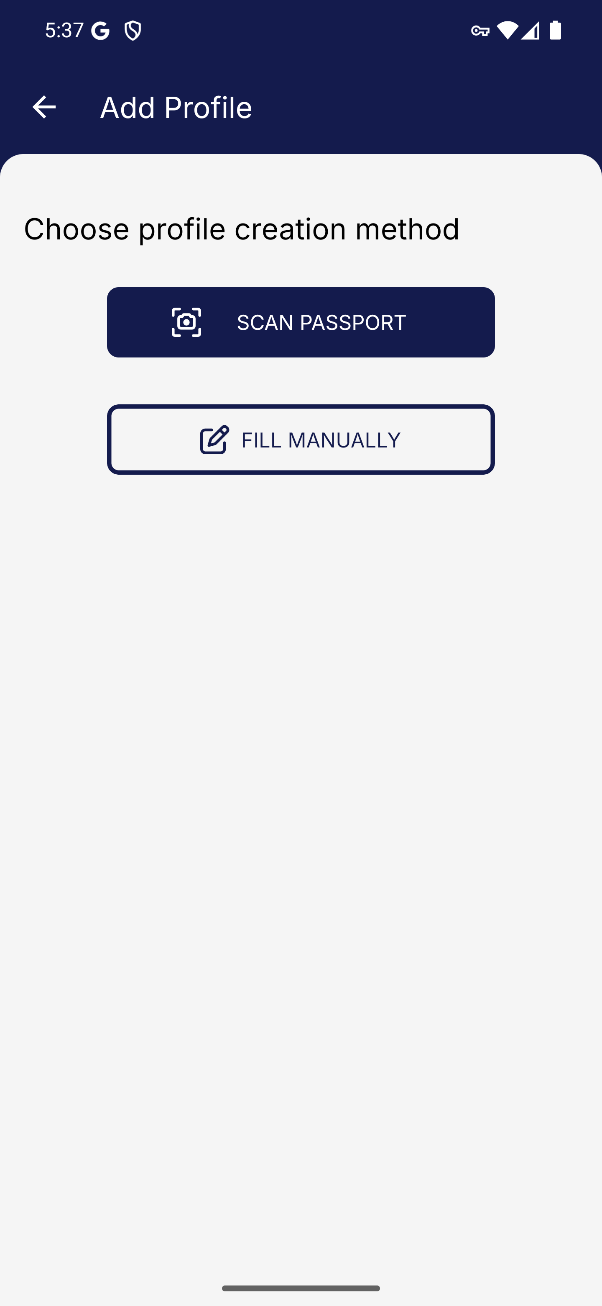
Screen 002 • 2026-09-07 17:37:27 • Captured

003 Foreign visitor profile details
Choose Fill Manually.
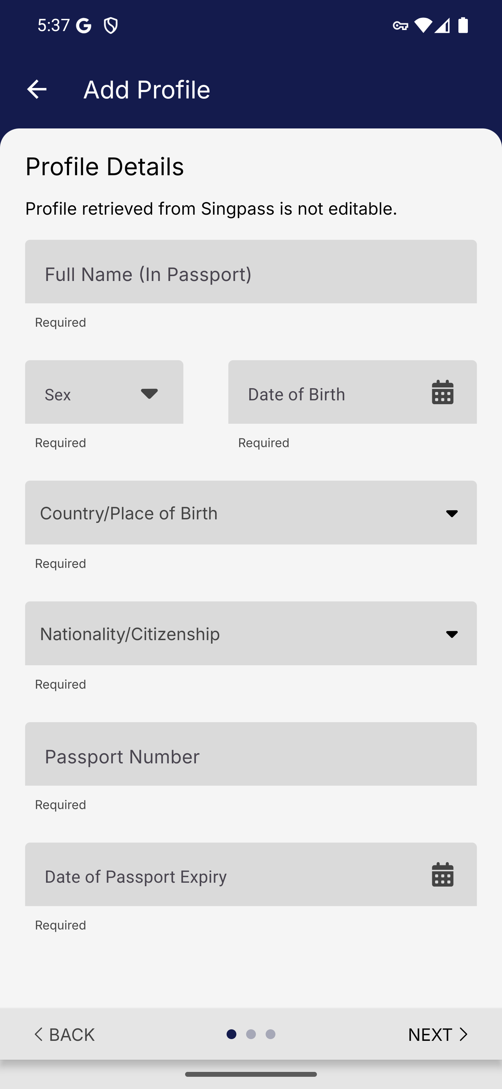
Screen 003 • 2026-09-07 17:37:28 • Captured

004 Foreign visitor sex selection
Open the Sex dropdown.
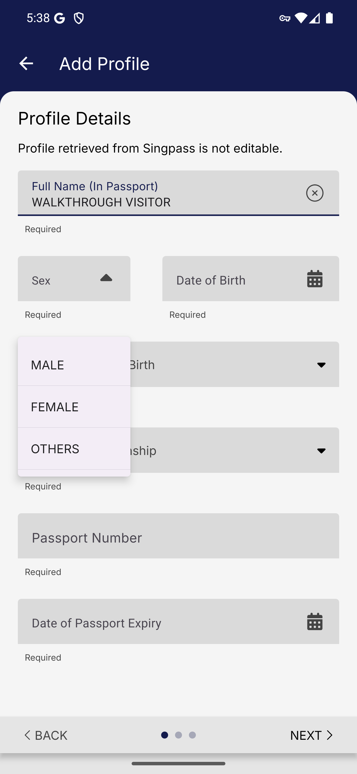
Screen 004 • 2026-09-07 17:38:01 • Captured

005 Country or place of birth picker
Open the searchable Country or Place of Birth picker.
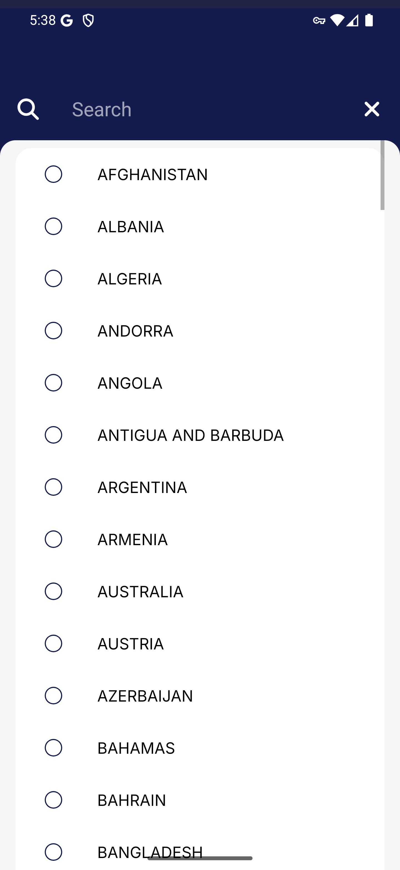
Screen 005 • 2026-09-07 17:38:05 • Captured

006 Search country or place of birth
Open Nationality or Citizenship.
Searching MALAYSIA narrows the birthplace list. This is a country picker, before selecting nationality.
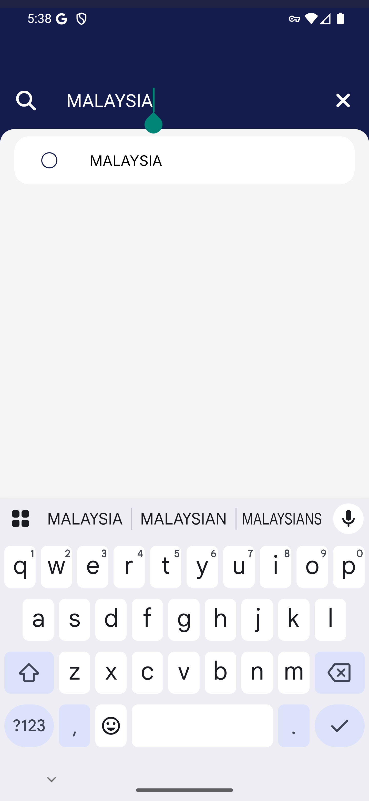
Screen 006 • 2026-09-07 17:38:09 • Captured

007 Foreign visitor nationality list
Open the Nationality or Citizenship options.
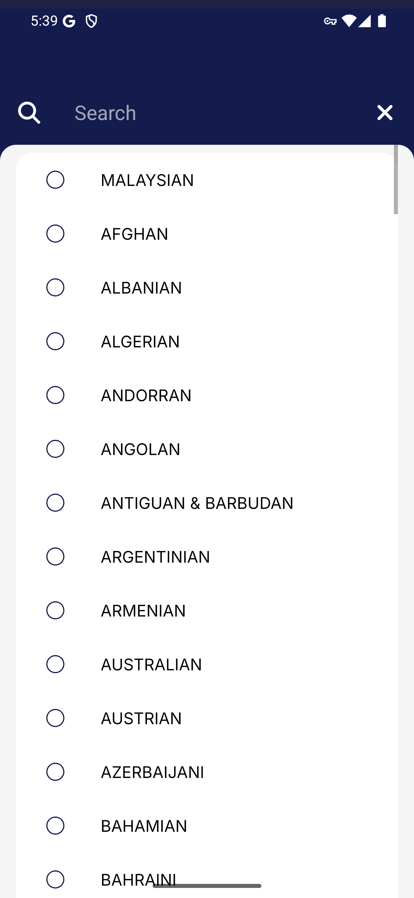
Screen 007 • 2026-09-07 17:39:34 • Captured

008 Malaysian identity field revealed
Complete the synthetic Malaysian visitor identity and passport details.
Selecting MALAYSIAN adds Identity Card Number (For Malaysians Only). The field has not yet been filled in this capture.
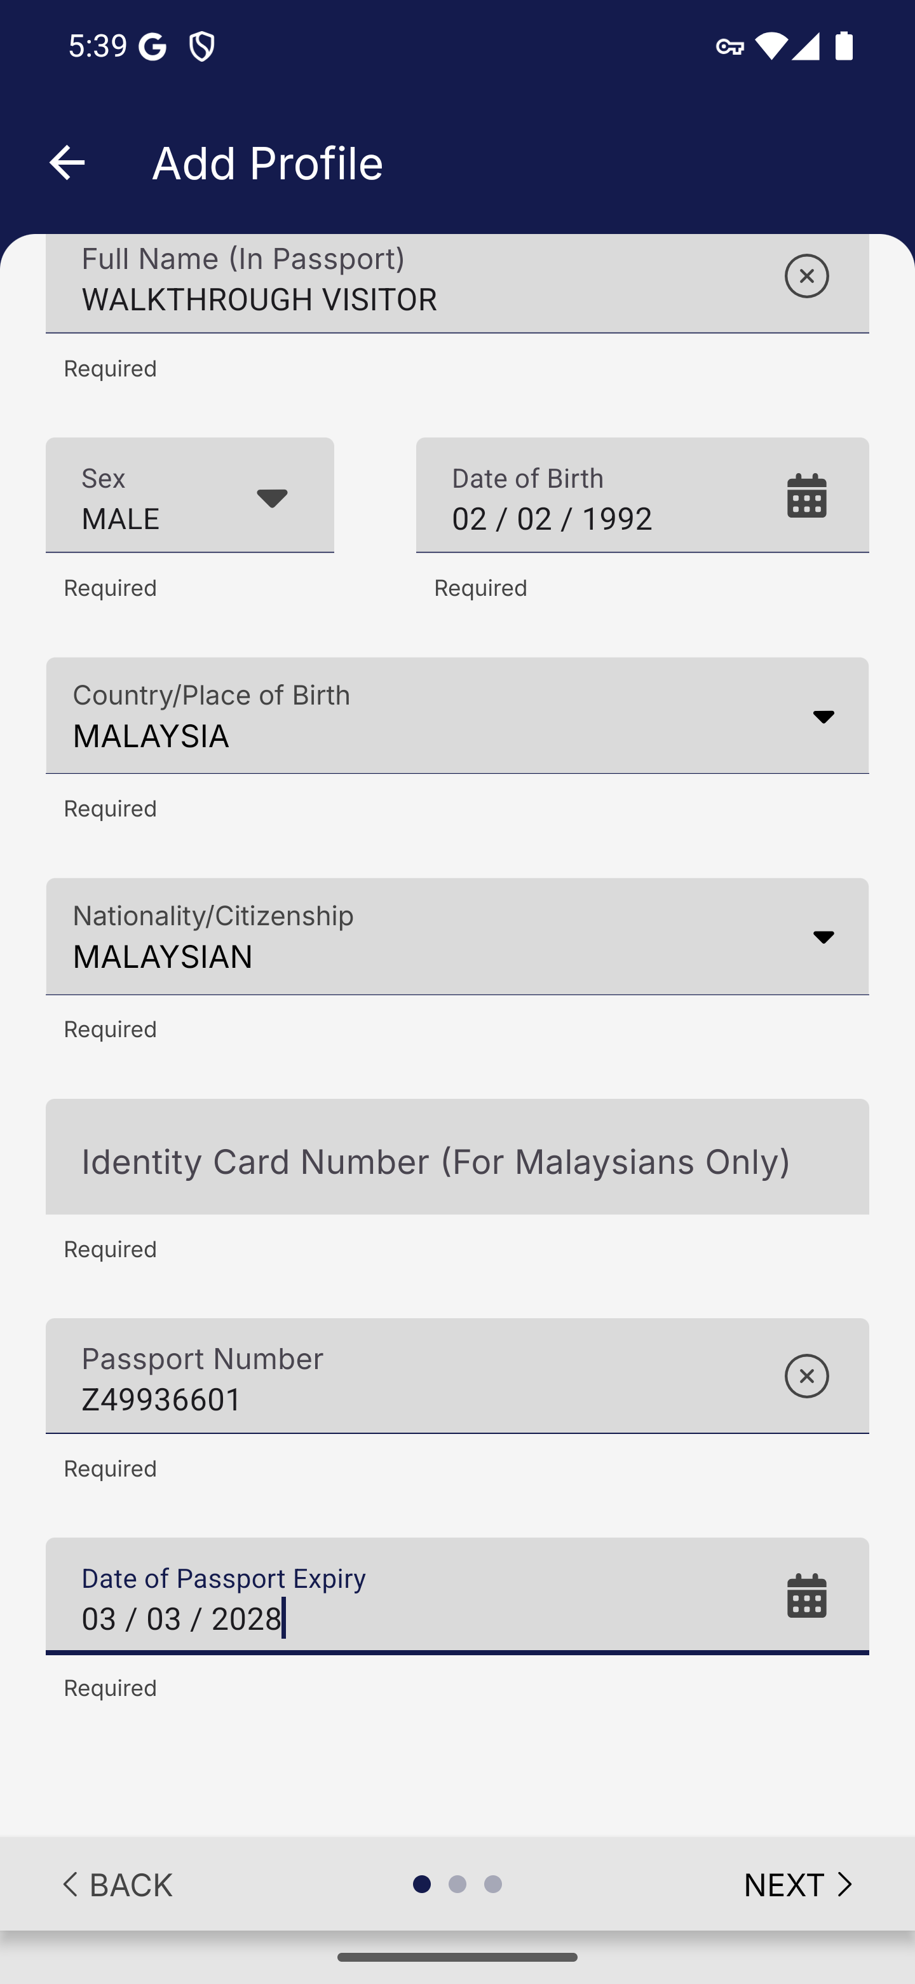
Screen 008 • 2026-09-07 17:39:40 • Captured

009 Malaysian identity field required
Continue to Contact Details.
Next remains on Profile Details while the required Malaysian identity-card field is empty.
Outcome: Validation observed
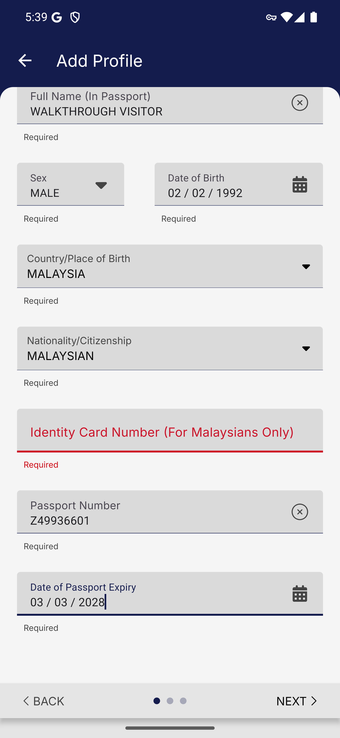
Screen 009 • 2026-09-07 17:39:41 • Validation observed

010 Malaysian identity card detail
Provide the additional synthetic identity number required for Malaysian nationality.
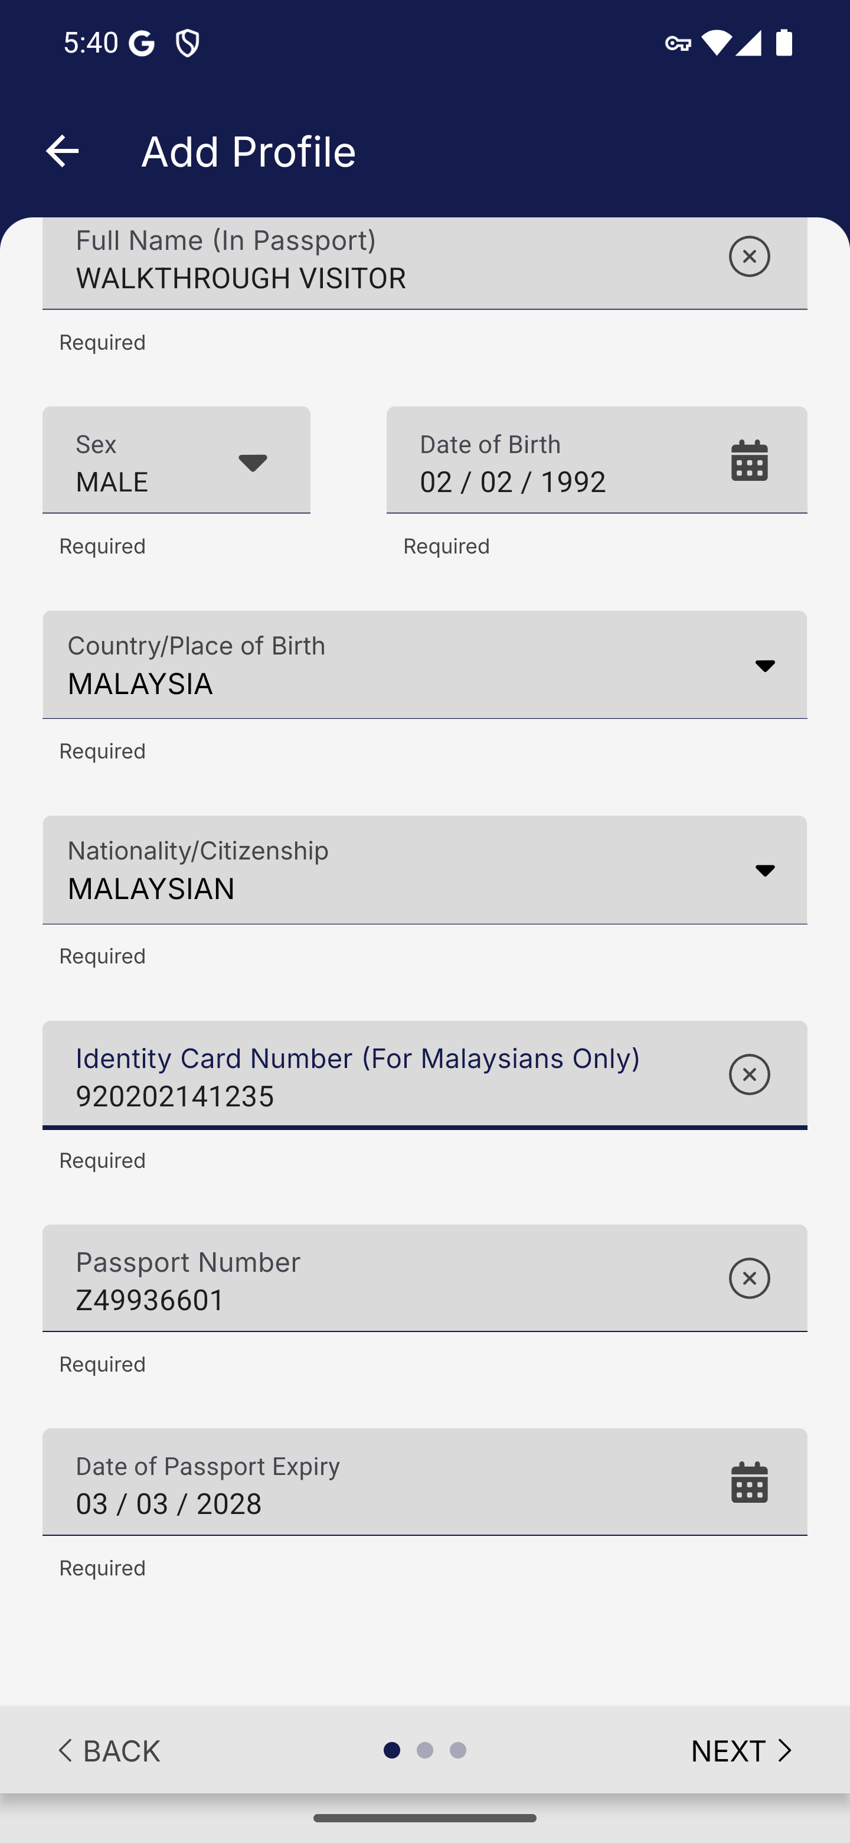
Screen 010 • 2026-09-07 17:40:00 • Captured

011 Visitor residence and email form
Continue to Contact Details.
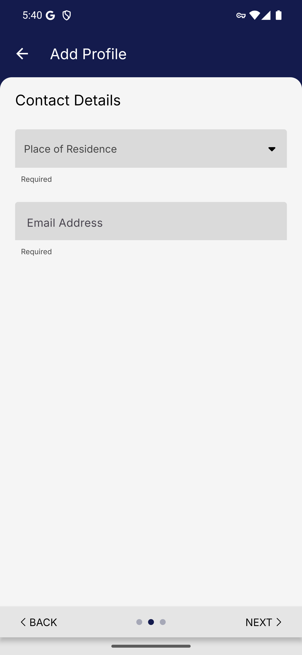
Screen 011 • 2026-09-07 17:40:01 • Captured

012 Place of residence picker
Open Place of Residence.
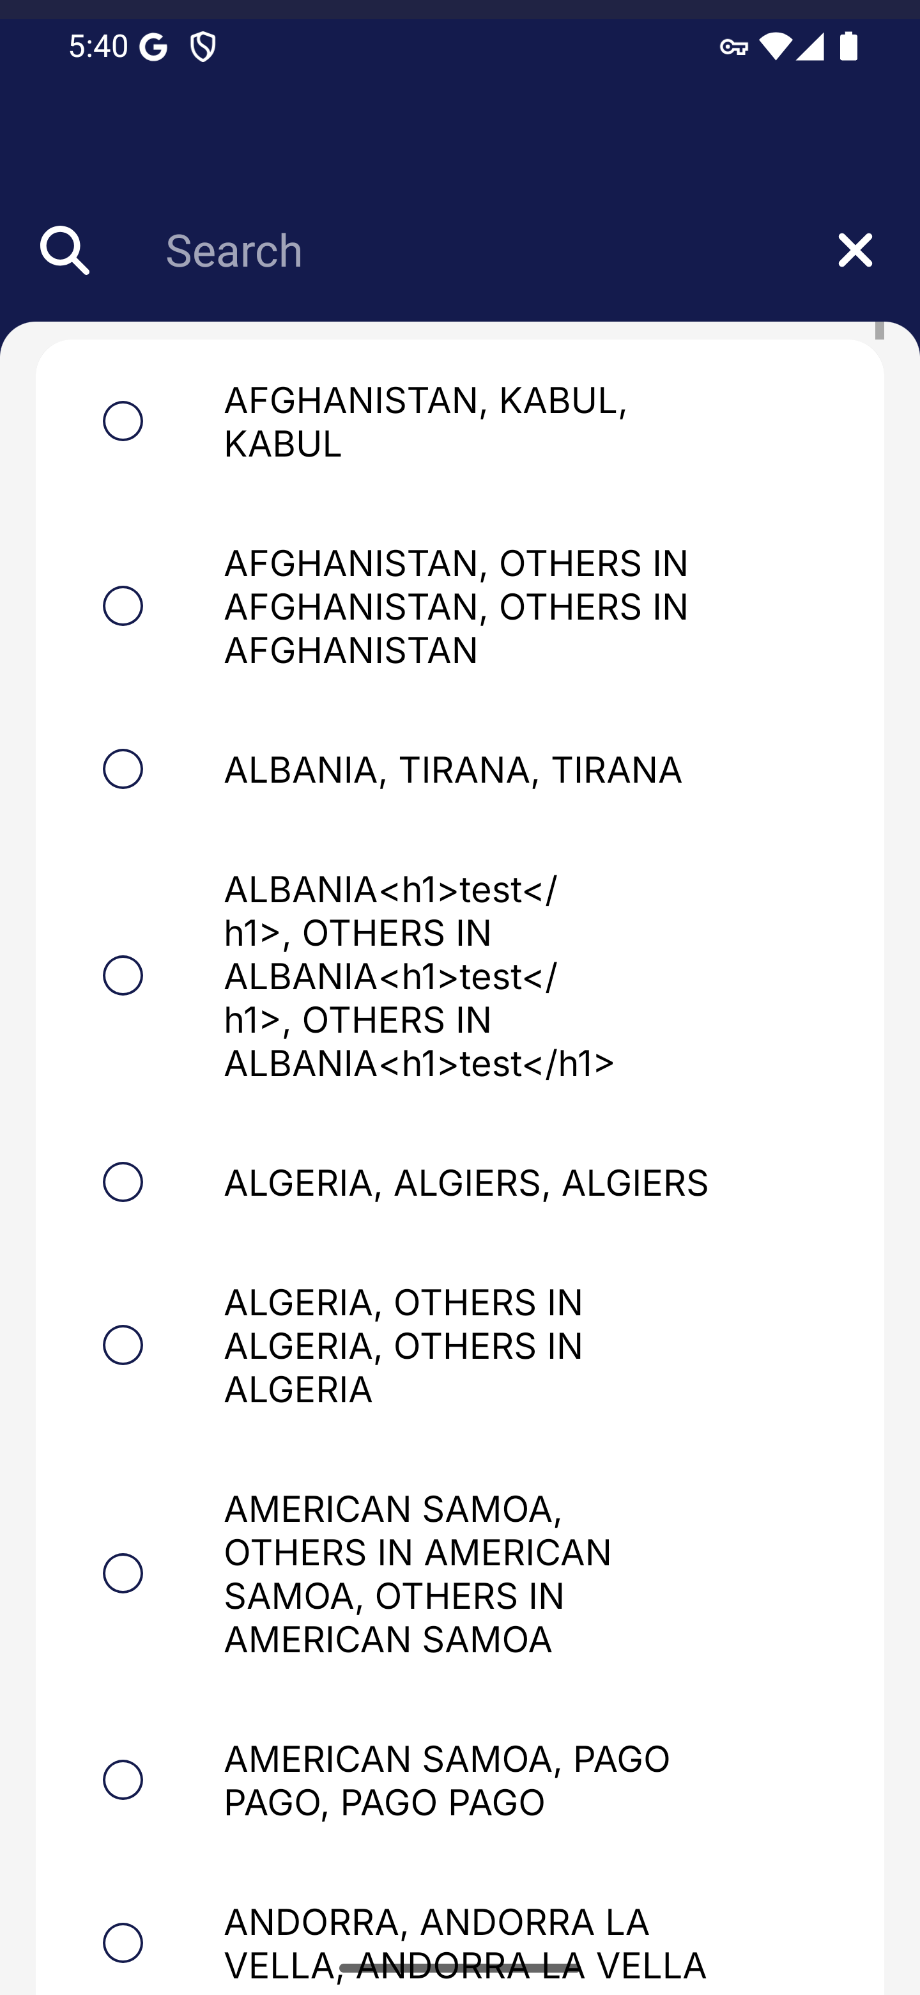
Screen 012 • 2026-09-07 17:40:03 • Captured

013 Visitor residence and contact details completed
Choose Kuala Lumpur and enter the synthetic email address.
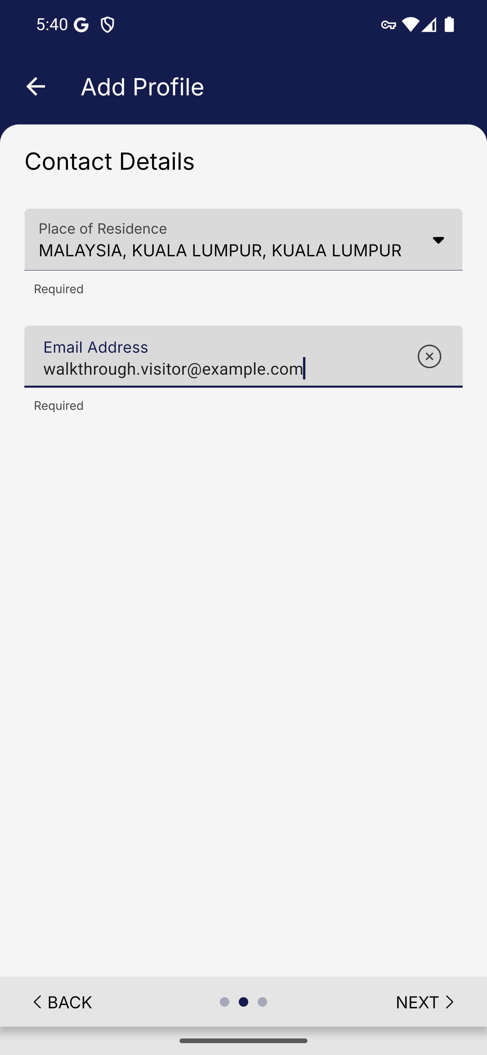
Screen 013 • 2026-09-07 17:40:41 • Captured

014 Visitor profile confirmation upper section
Review the visitor Passport Details card.
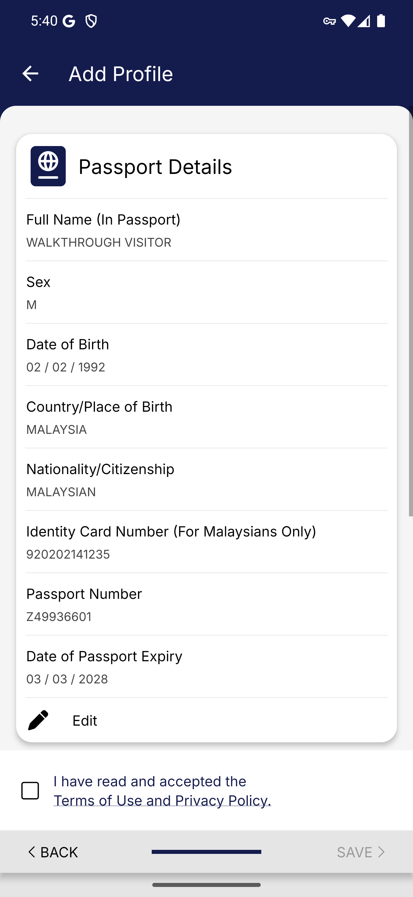
Screen 014 • 2026-09-07 17:40:42 • Captured

015 Visitor profile confirmation contact section
Scroll to Contact Details and the profile terms.
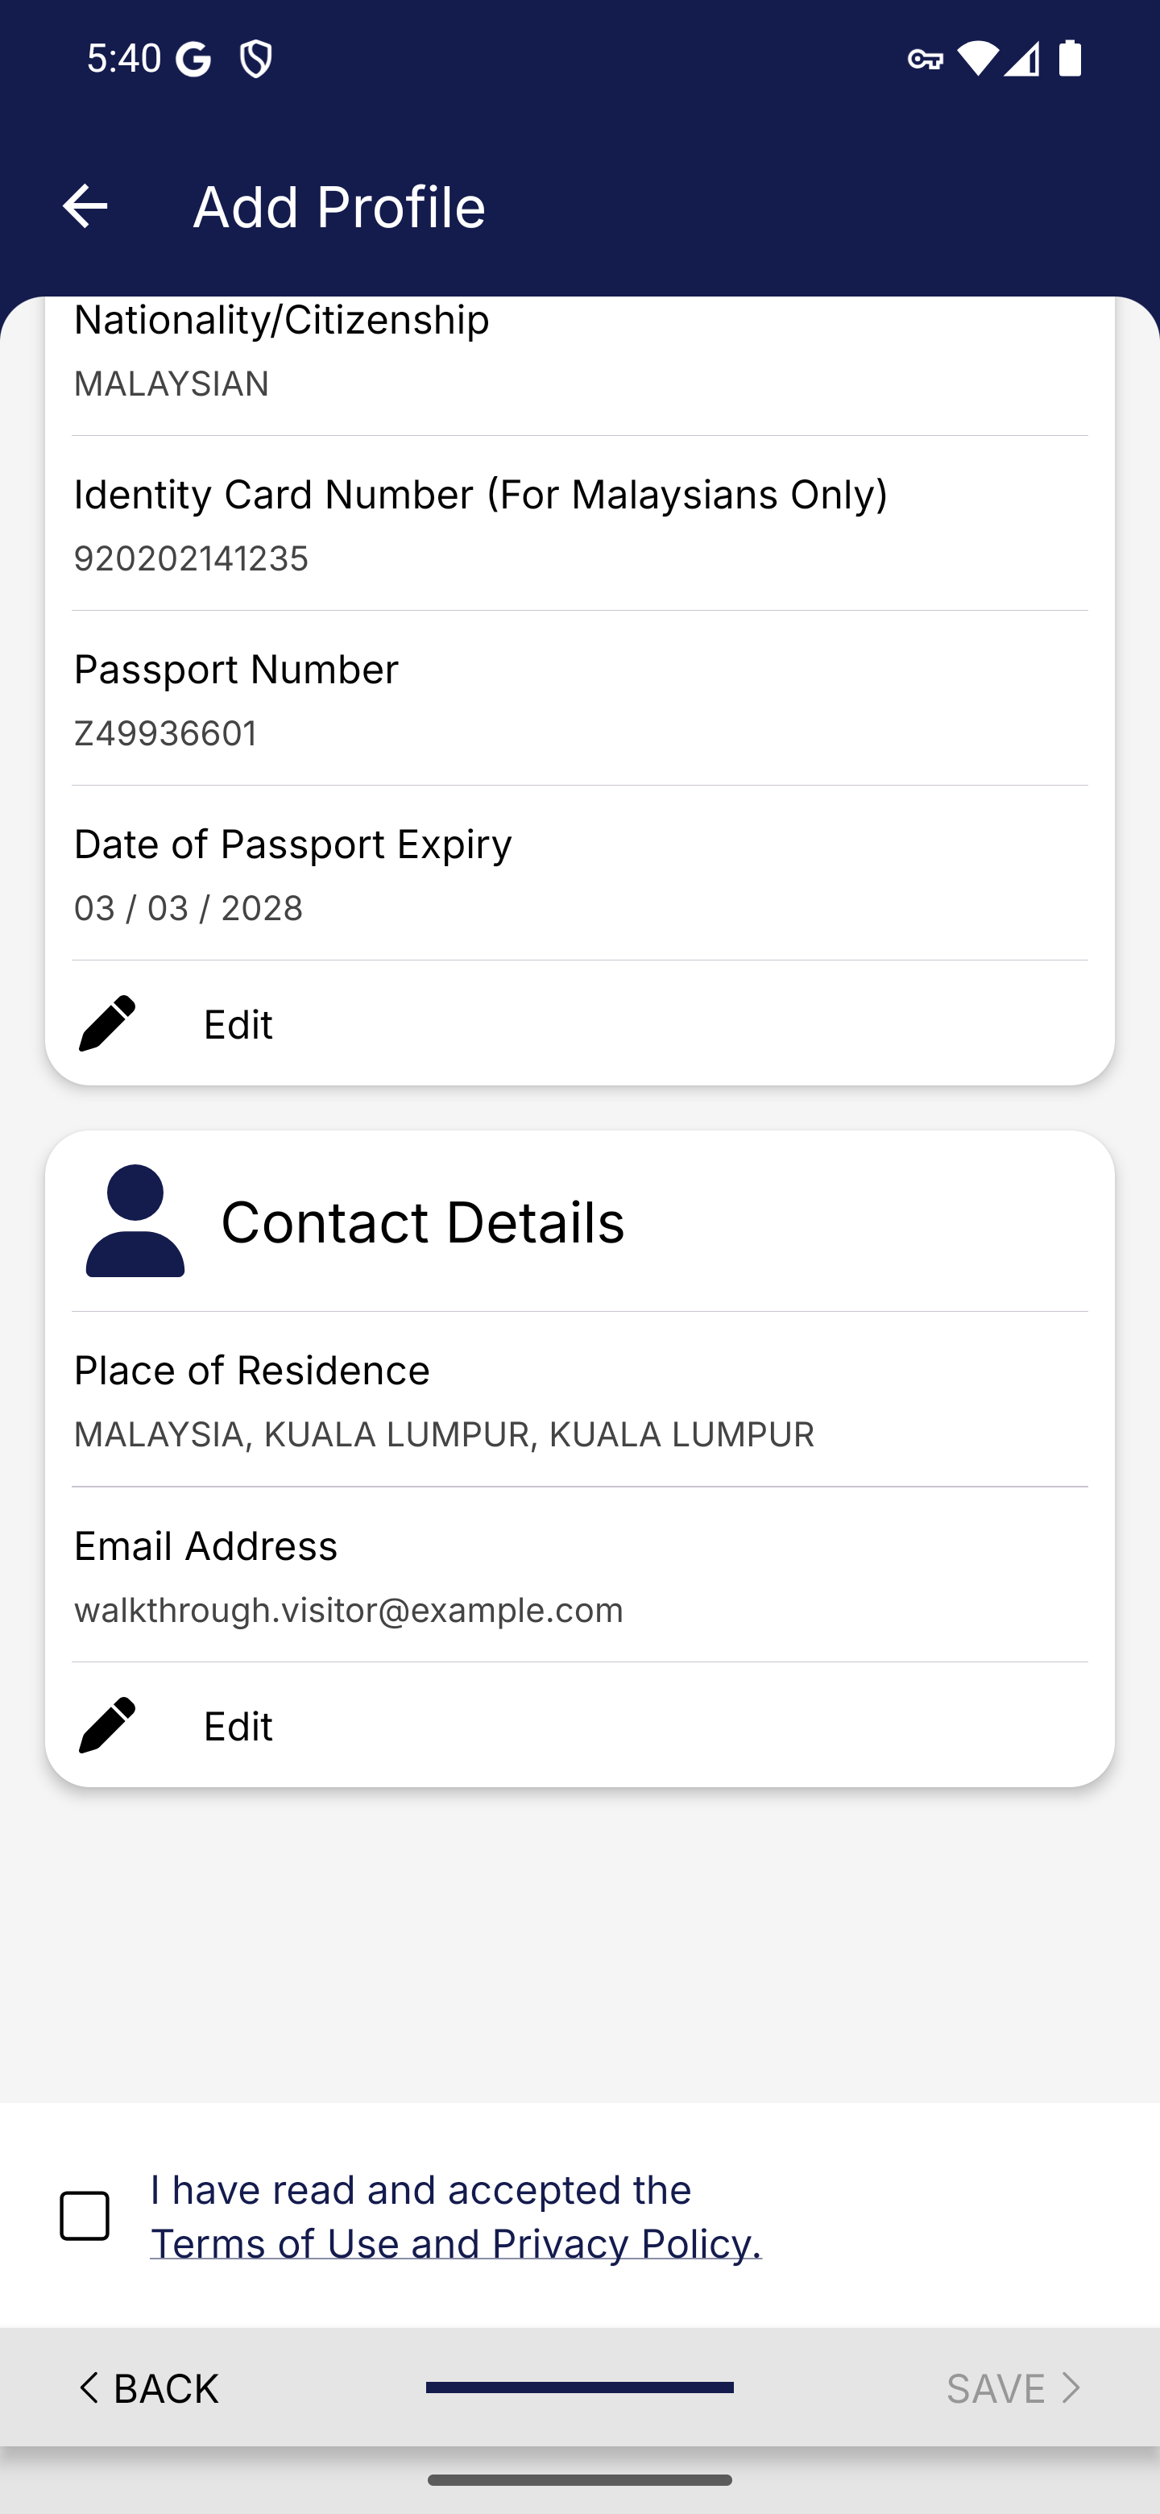
Screen 015 • 2026-09-07 17:40:44 • Captured

016 Foreign visitor profile saved
Accept the profile terms and save.
The app reports that WALKTHROUGH VISITOR was created successfully.
Outcome: Completed
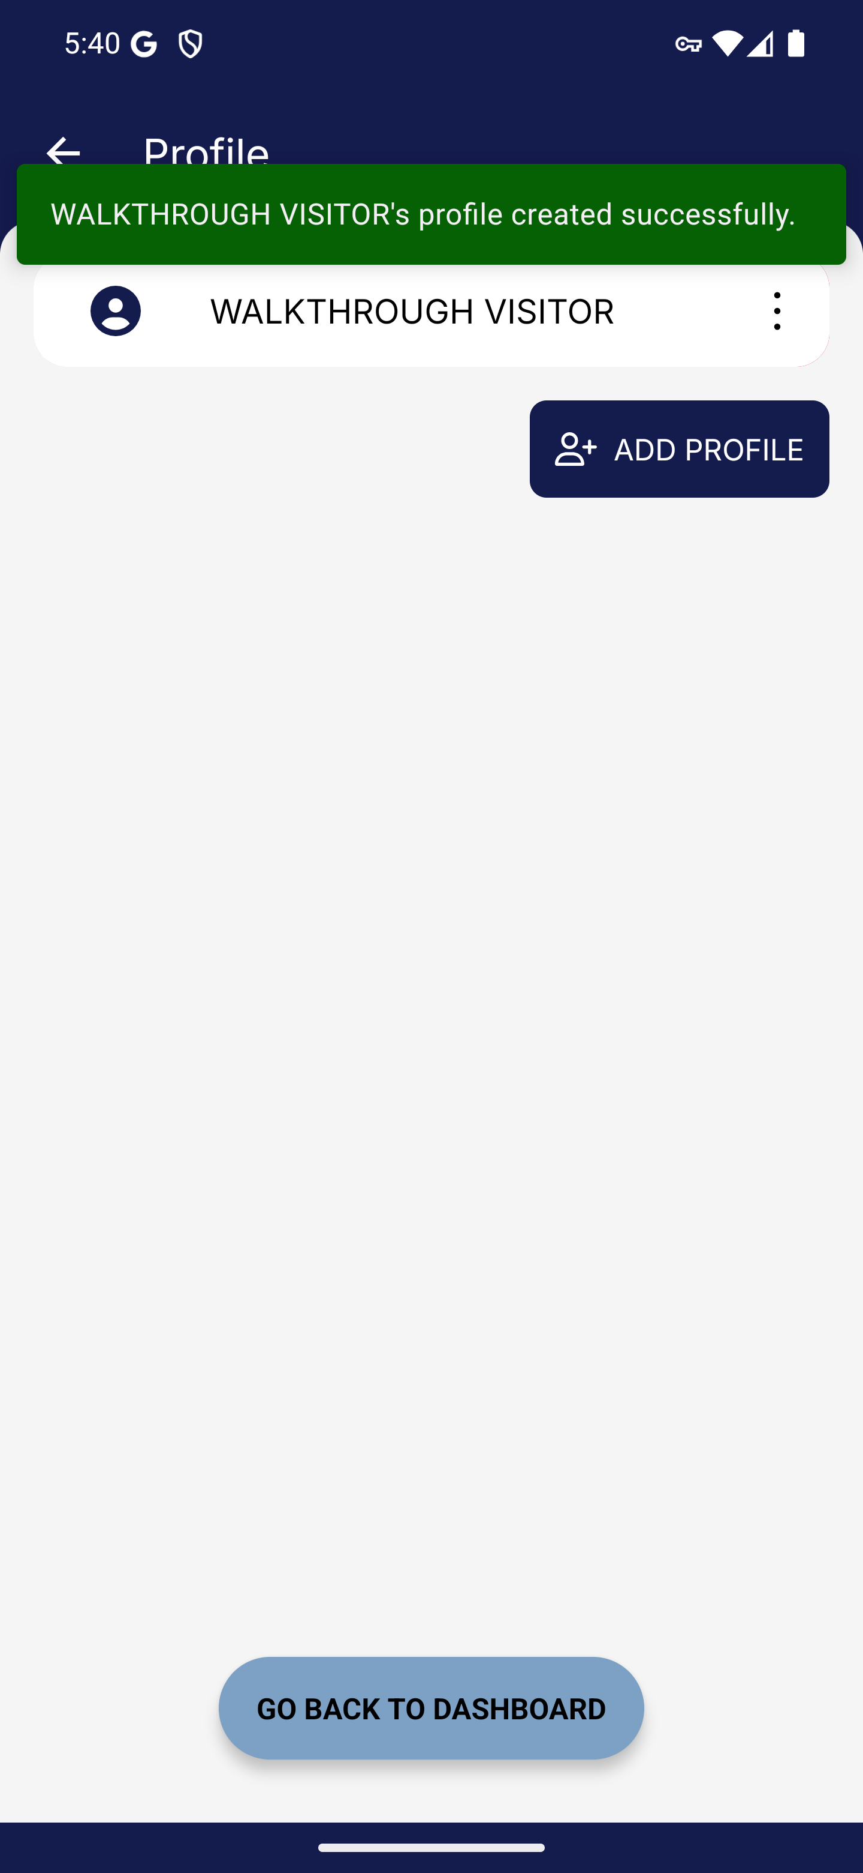
Screen 016 • 2026-09-07 17:40:47 • Completed

017 Visitor profile update required
Return to the dashboard and select the saved visitor.
Selecting the saved visitor profile for an arrival card opens the update-required alert.
Outcome: Blocked
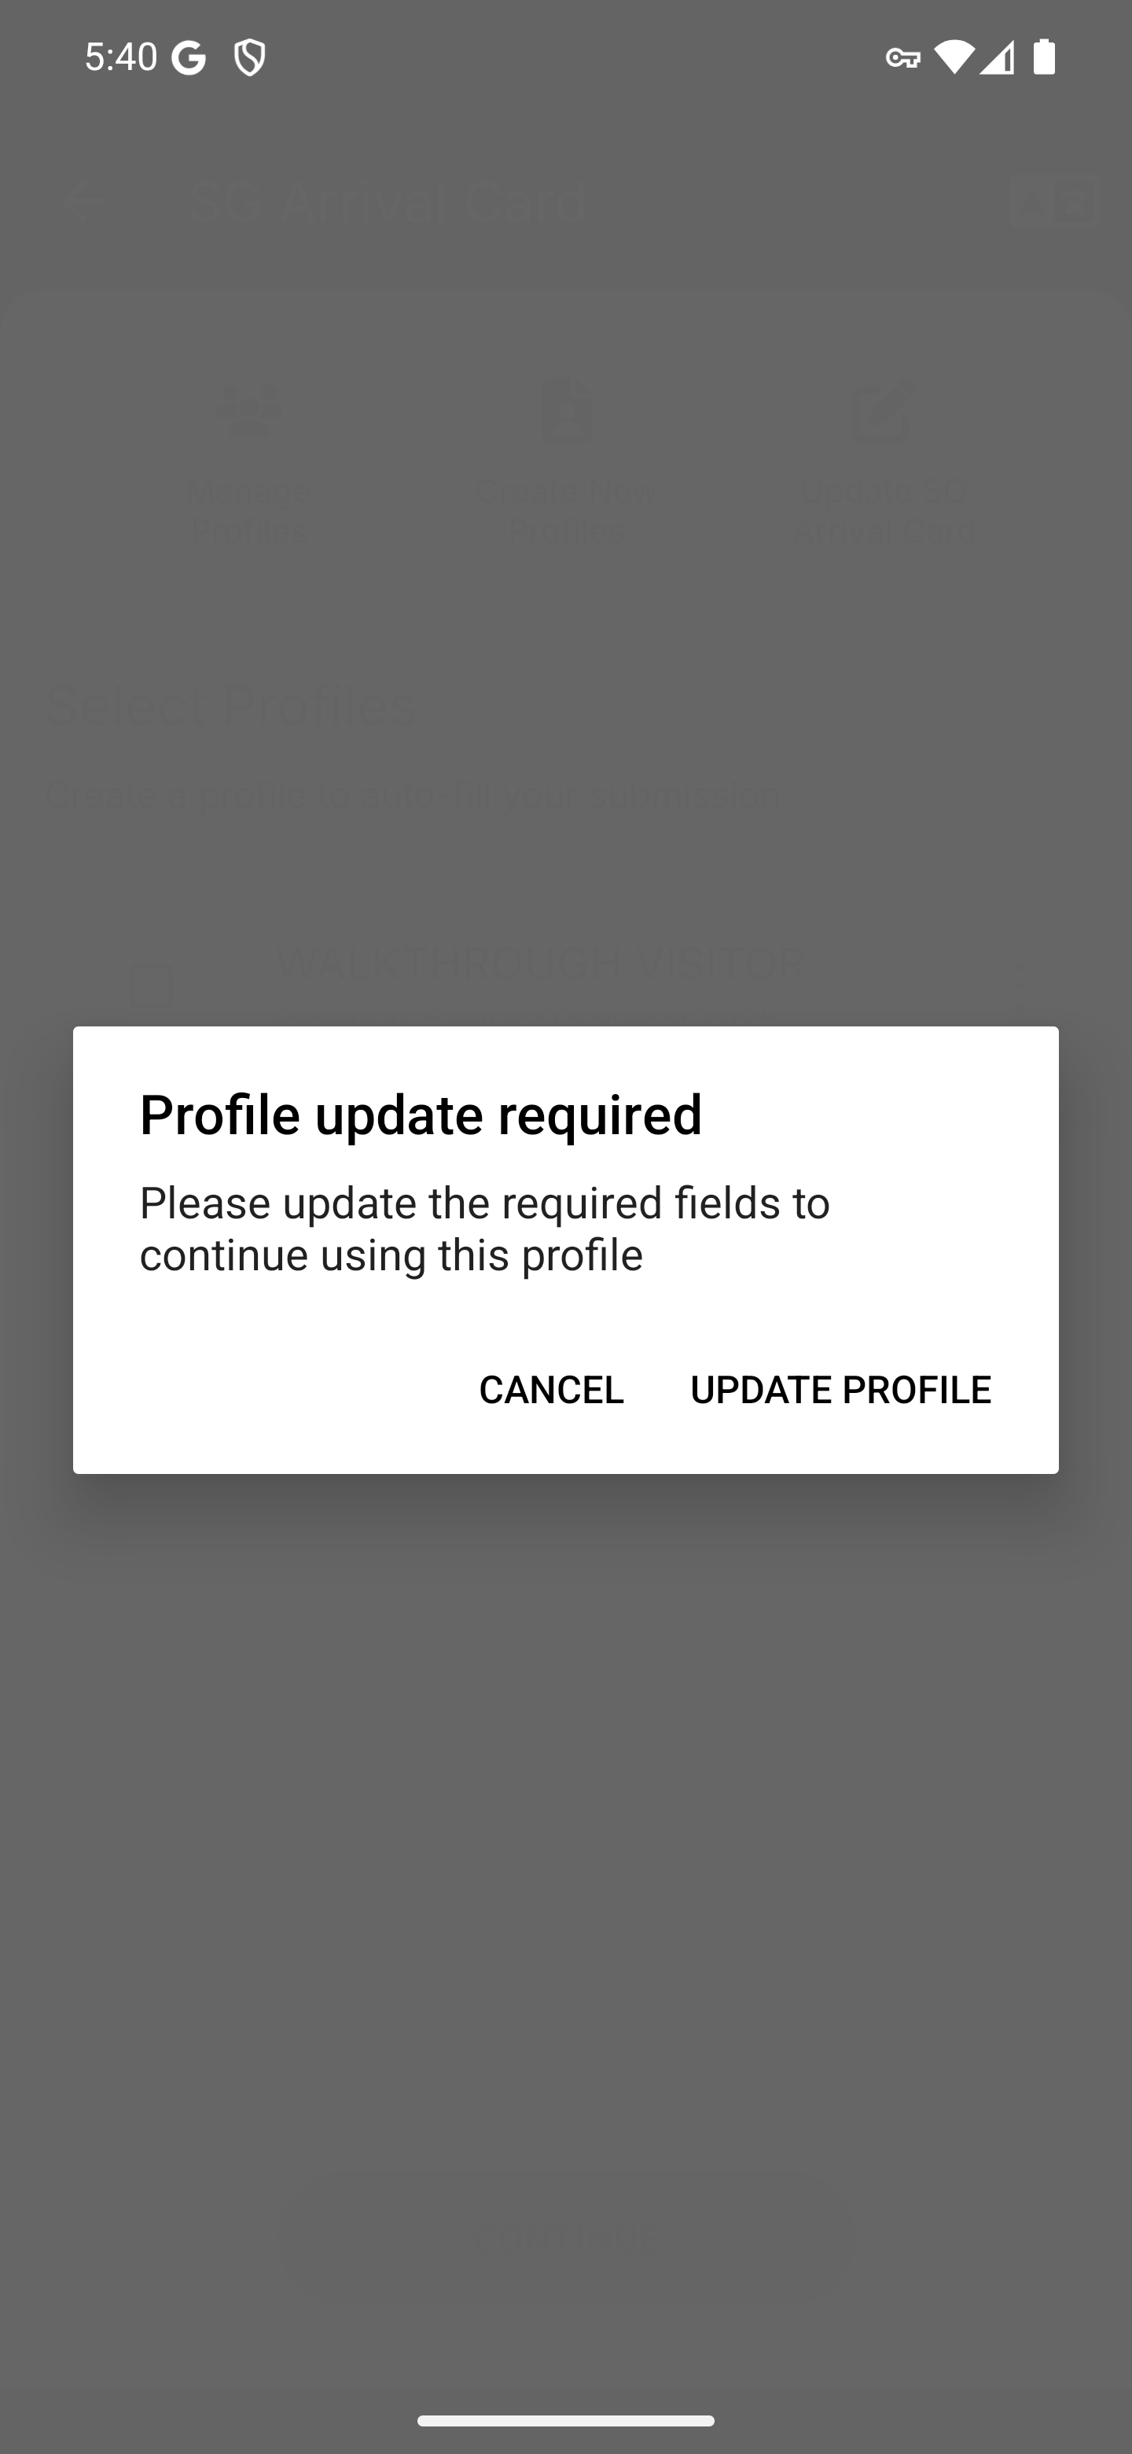
Screen 017 • 2026-09-07 17:40:48 • Blocked

018 Visitor profile update requested
Open the required update after selecting the saved profile.
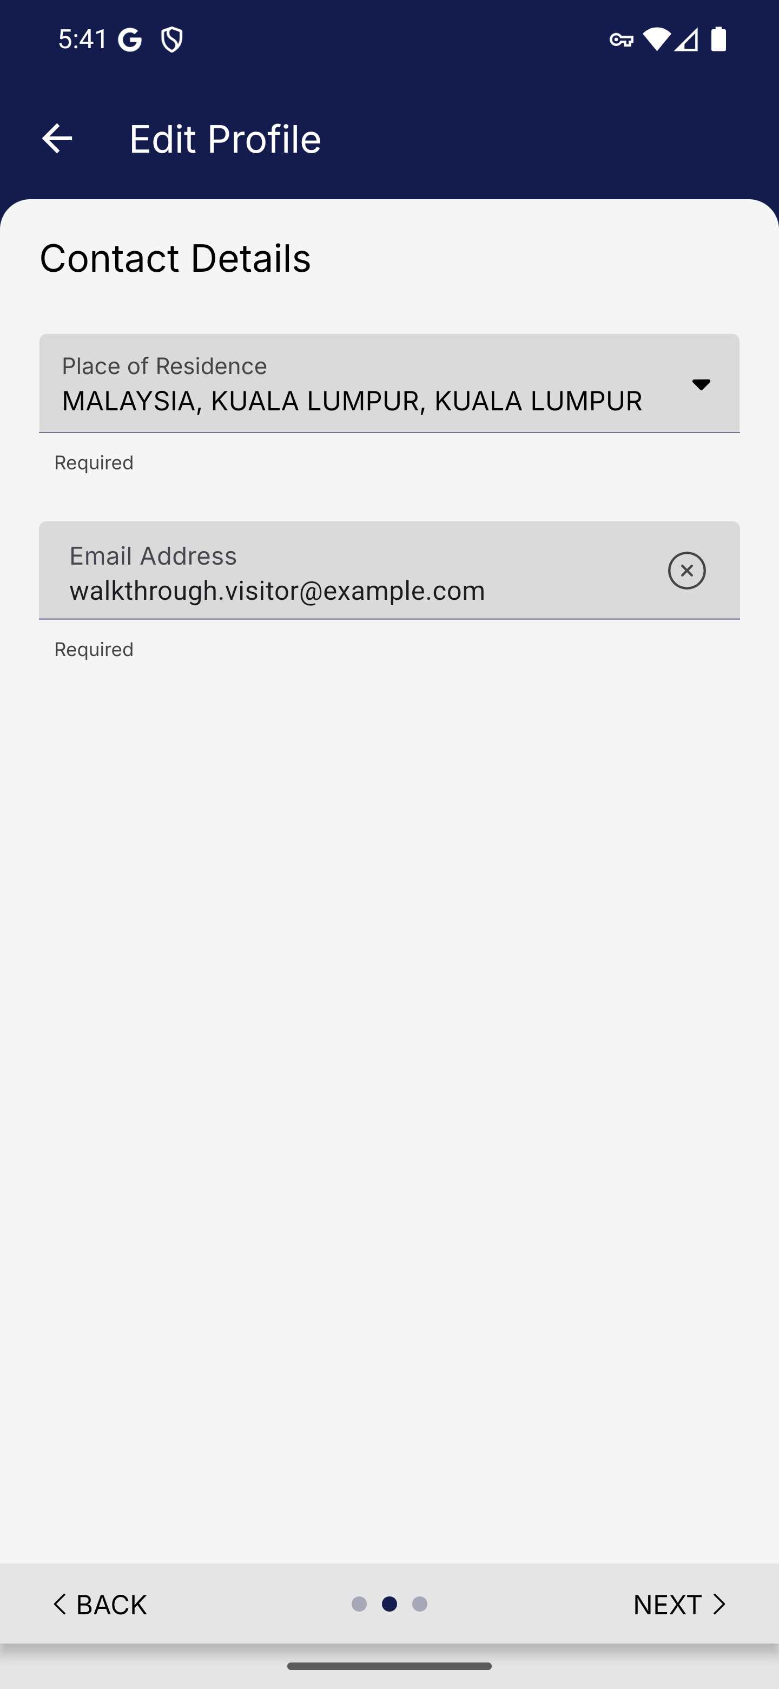
Screen 018 • 2026-09-07 17:41:13 • Captured

019 Visitor profile update saved
Save the requested visitor profile update.
The app reports a successful update before the same alert recurs on selection.
Outcome: Completed
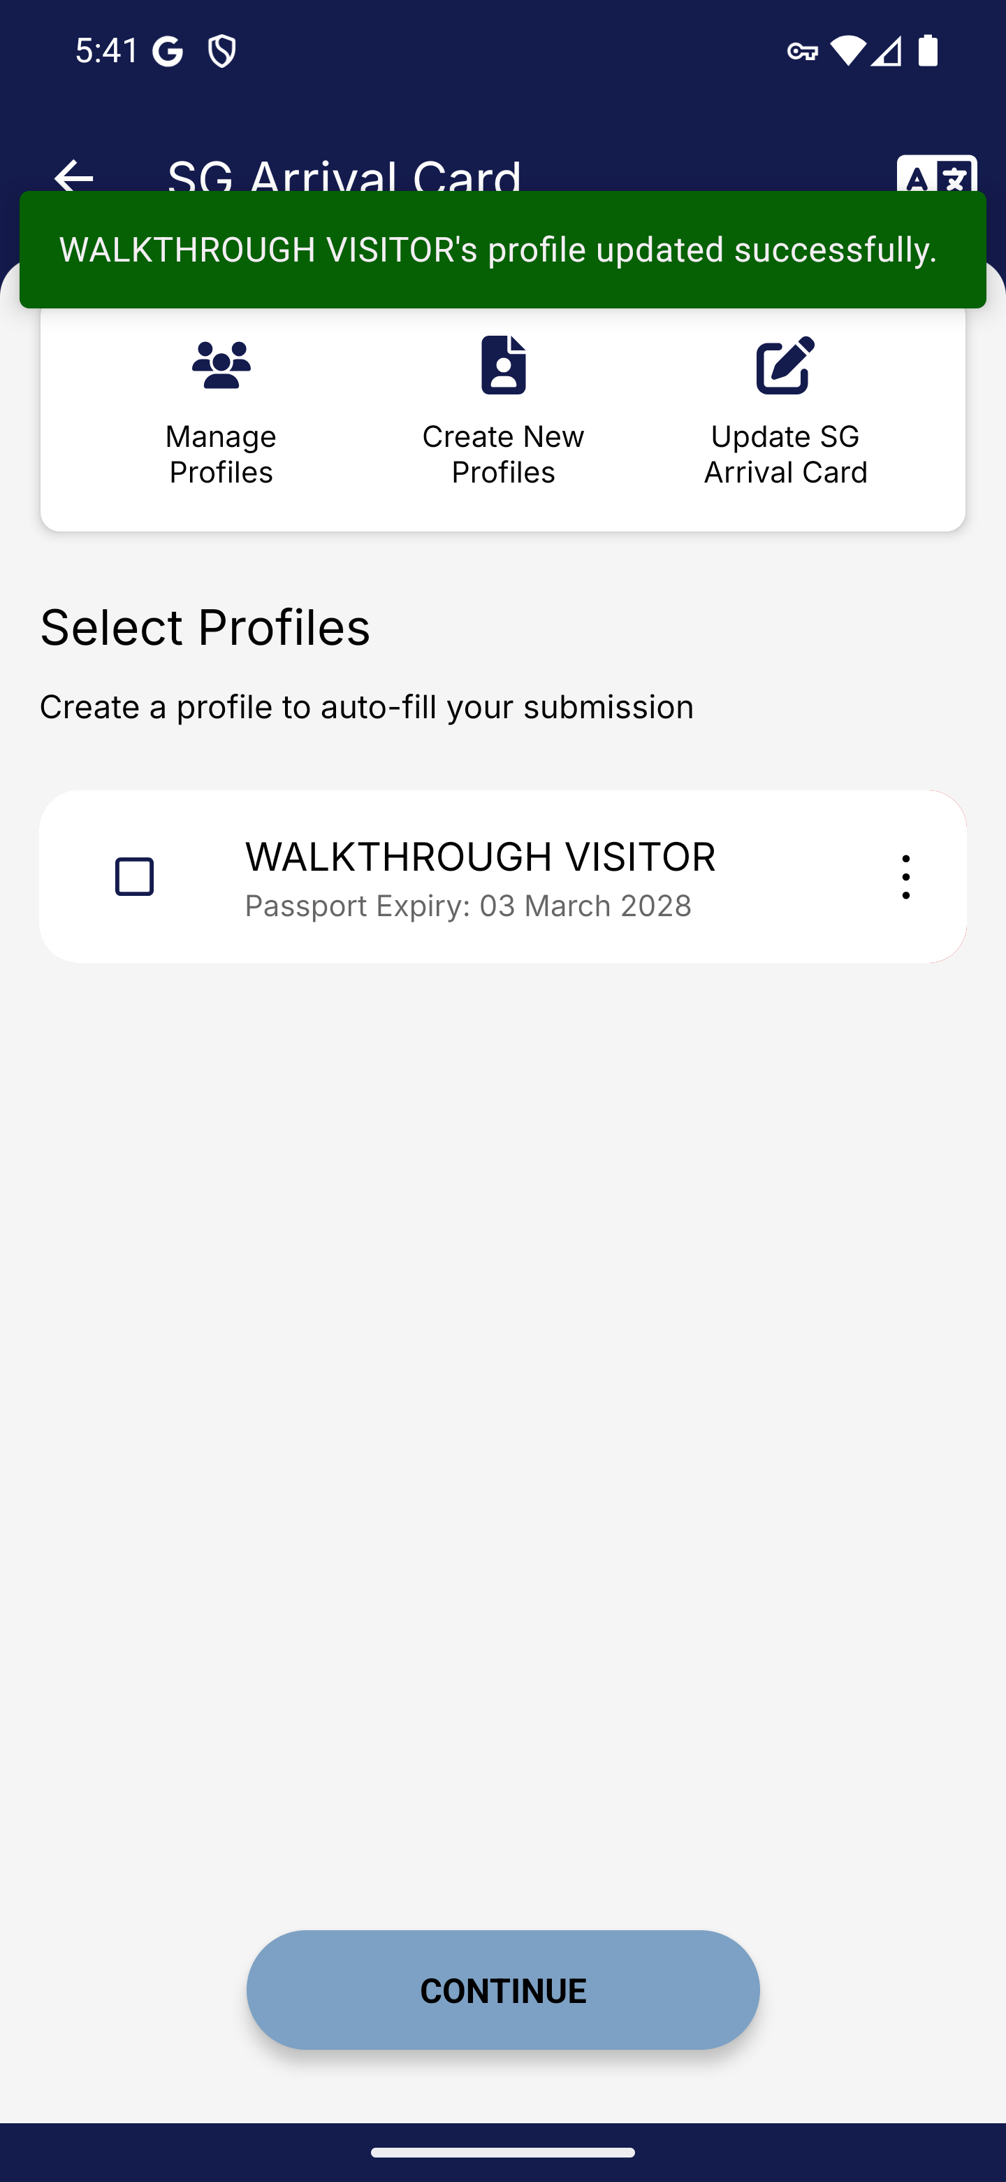
Screen 019 • 2026-09-07 17:41:17 • Completed

020 Visitor arrival card update loop
Select the visitor again after the successful update.
Profile update required repeats after saving; this prevents advancing to the native arrival-card form.
Outcome: Blocked by app behaviour
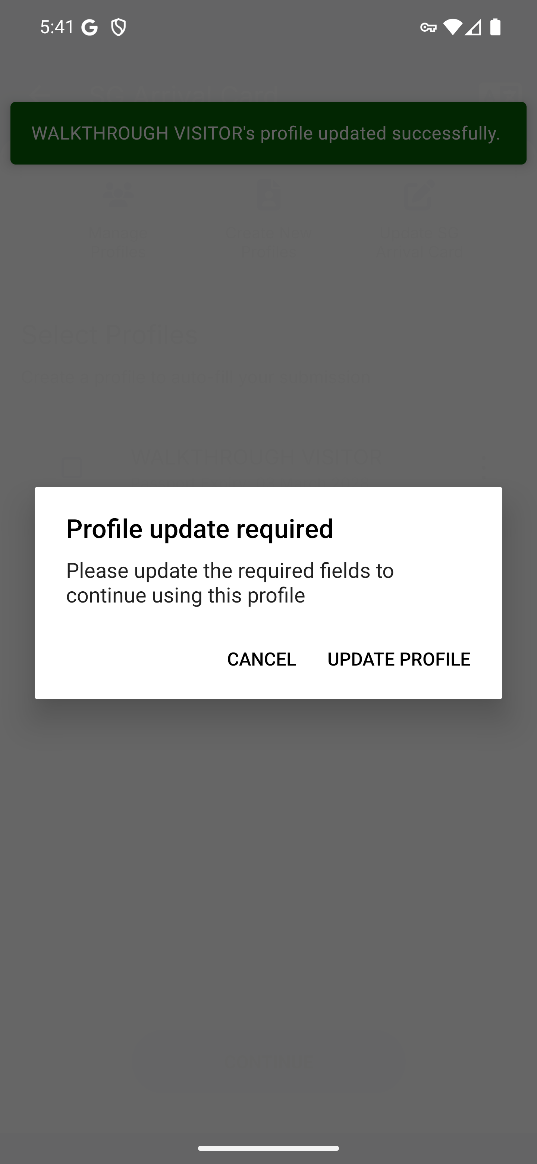
Screen 020 • 2026-09-07 17:41:18 • Blocked by app behaviour

021 Visitor arrival-card retrieval form
Scroll to the existing-arrival-card retrieval fields.
The update form requests DE number, nationality, date of birth, passport number and passport expiry. No matching submitted record was available.
Outcome: Existing submission required
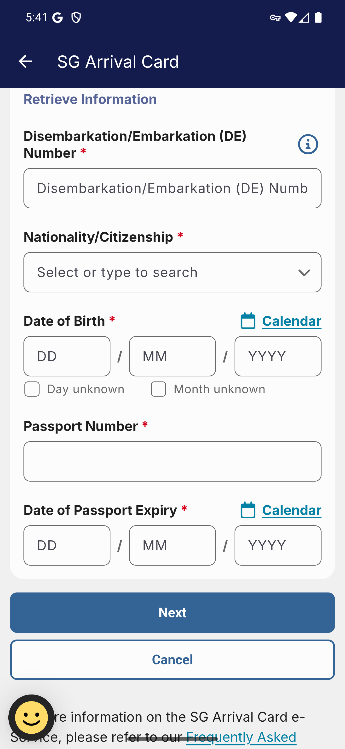
Screen 021 • 2026-09-07 17:41:27 • Existing submission required

