  - PROJECT DOCUMENTATION

QR codes at land checkpoints
QR onboarding, manual profile creation, an individual QR, and car, motorcycle, lorry and bus group journeys, including group editing, deletion and the foreign visitor SGAC reminder.
41 screen captures • Pixel 7 Pro emulator • Android 16 • English
Captured from the installed staging app on 7 September 2026. Screenshots are original device PNGs. This is a screen walkthrough; it does not certify every test case or every input combination.

Coverage and outcomes
Flow / branch | Observed outcome
QR tutorial | Welcome and all seven tutorial steps captured through Finish.
Individual resident profile and QR | Completed: WALKTHROUGH QR RESIDENT saved as the own profile and an individual QR generated.
Email validation | Required email feedback captured before completing the profile.
Car group | A two-person car group saved, including the foreign visitor. Generation displayed an SGAC reminder and its handoff was followed.
Motorcycle group | Two-person group and QR generated. The form displays a two-person maximum.
Lorry group | Two-person group and QR generated. The form displays a four-person maximum.
Bus group | Two-person group and QR generated. The form displays a four-person maximum.
Manage group | Bus group renamed to WALKTHROUGH BUS EDITED, regenerated and deleted after confirmation.
Checkpoint use | QR presentation screens reached; actual immigration clearance requires checkpoint hardware and was not performed.
The car form displays a ten-person maximum. Capacity limits are observed labels, not tested maximum-size groups. All generated groups used two members.
The group picker exposed profiles created through SGAC as well as QR. Existing unrelated profiles were preserved. These synthetic QR codes are walkthrough evidence and must not be used for travel.

How to use this document
Each following page records one screen, the action used to reach it, and any relevant observation. Screen numbers match the category manifest and PNG filenames. Source XML and SHA-256 hashes are retained beside the screenshots for traceability. Open the original PNG when you need to zoom into small text.

001 QR code entry and tutorial
Choose QR Code at Land Checkpoints from Home.
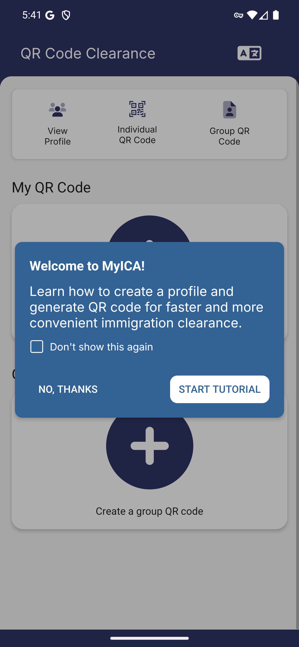
Screen 001 • 2026-09-07 17:41:36 • Captured

002 QR tutorial first step
Start the QR clearance tutorial.
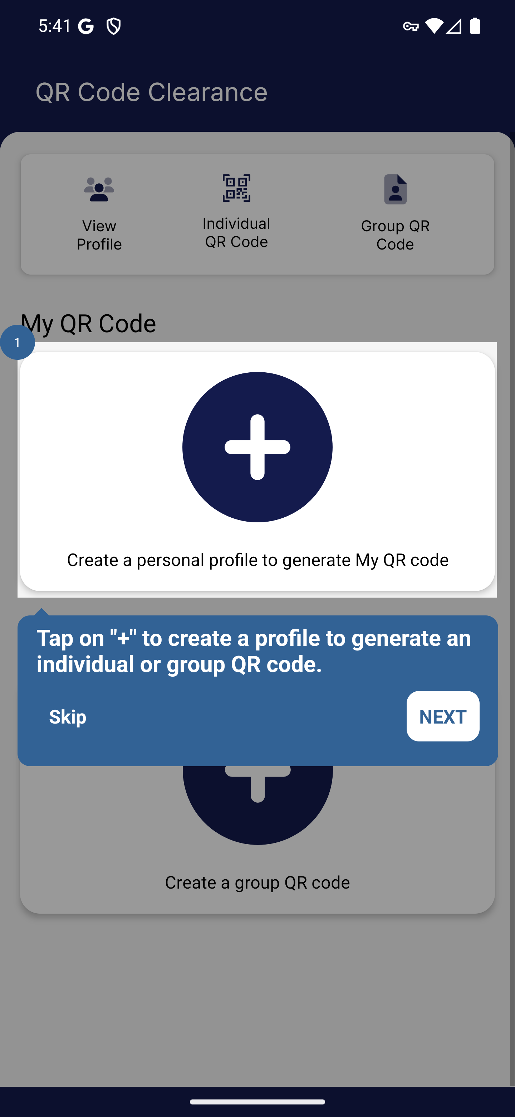
Screen 002 • 2026-09-07 17:41:56 • Captured

003 QR tutorial second step
Continue the QR tutorial.
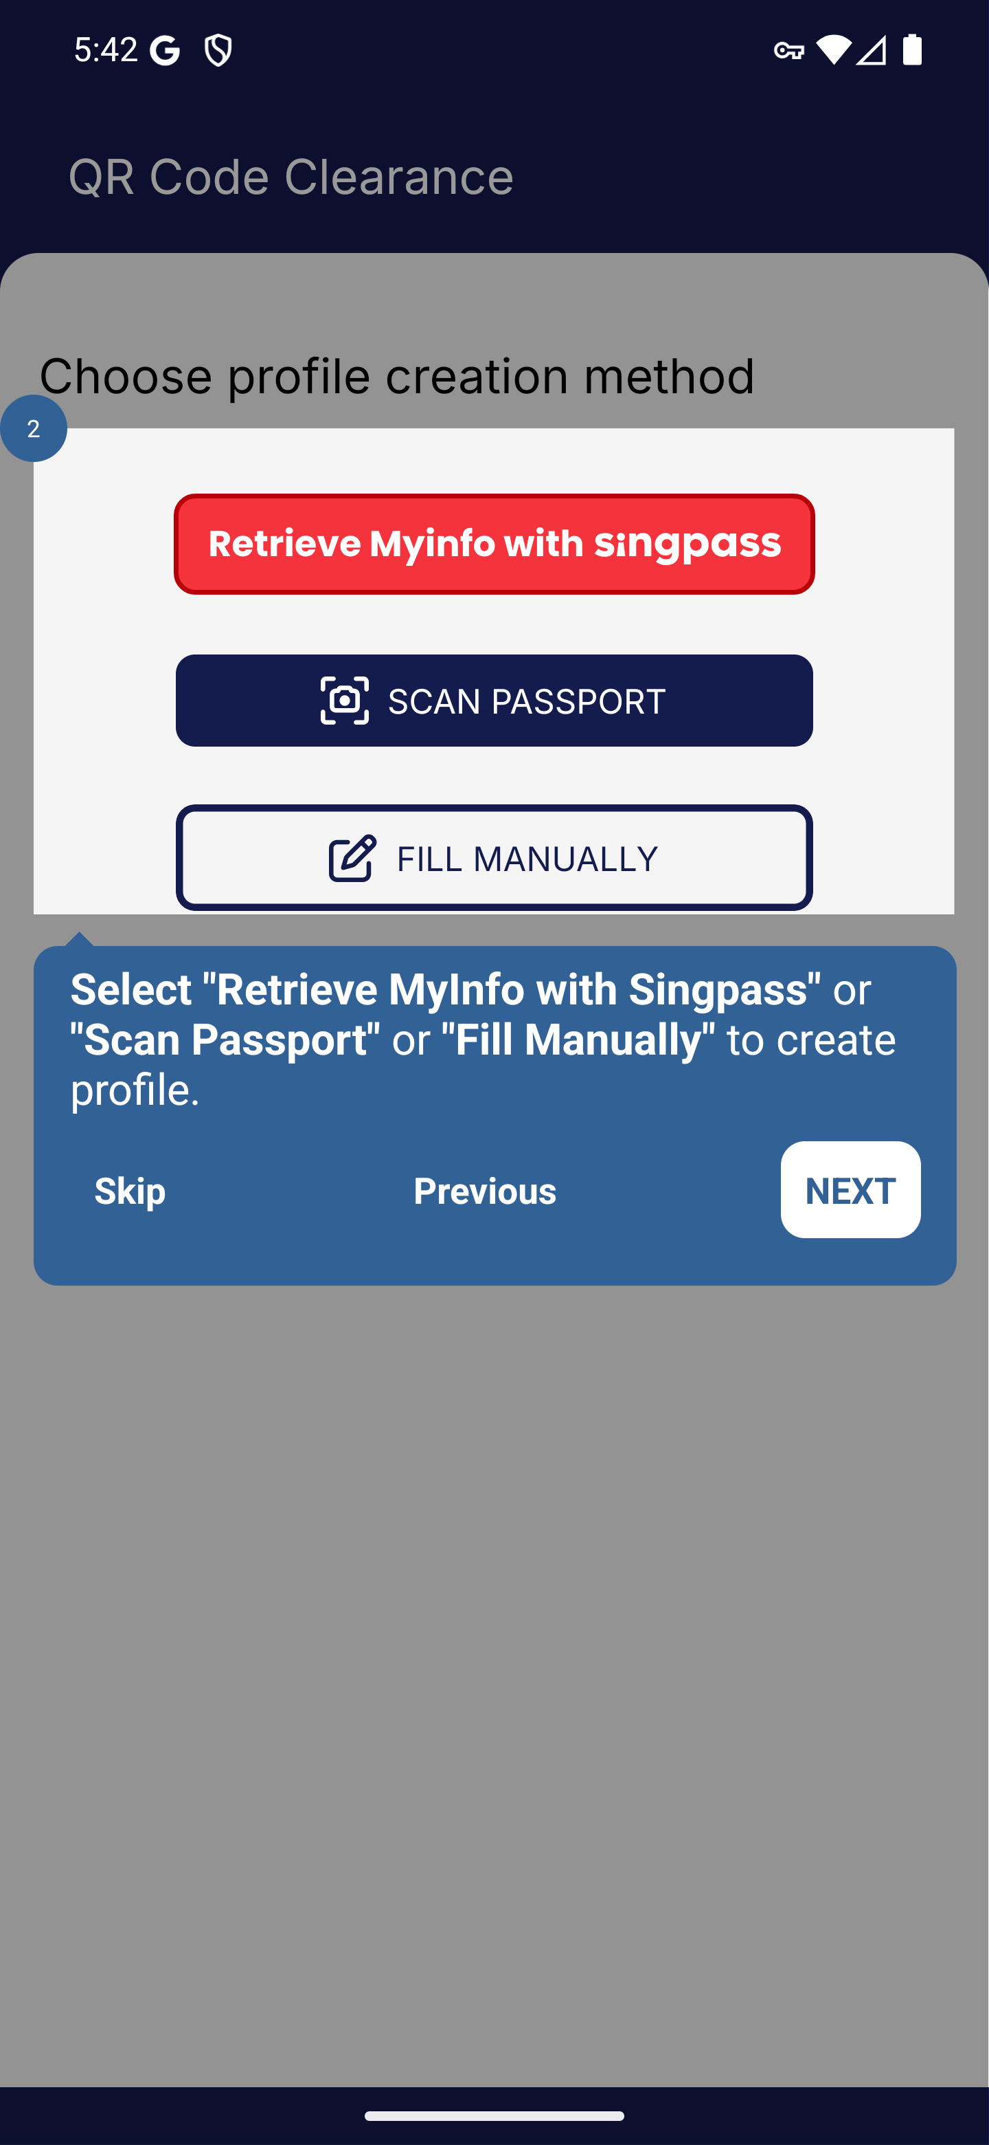
Screen 003 • 2026-09-07 17:42:16 • Captured

004 QR tutorial third step
Continue the QR tutorial.
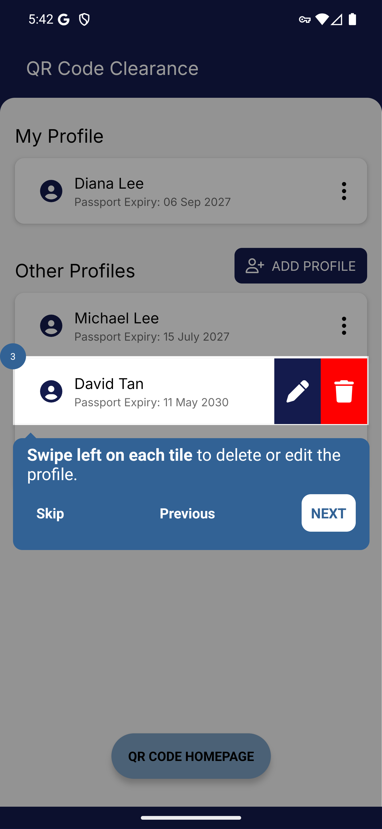
Screen 004 • 2026-09-07 17:42:17 • Captured

005 QR tutorial fourth step
Continue the QR tutorial.
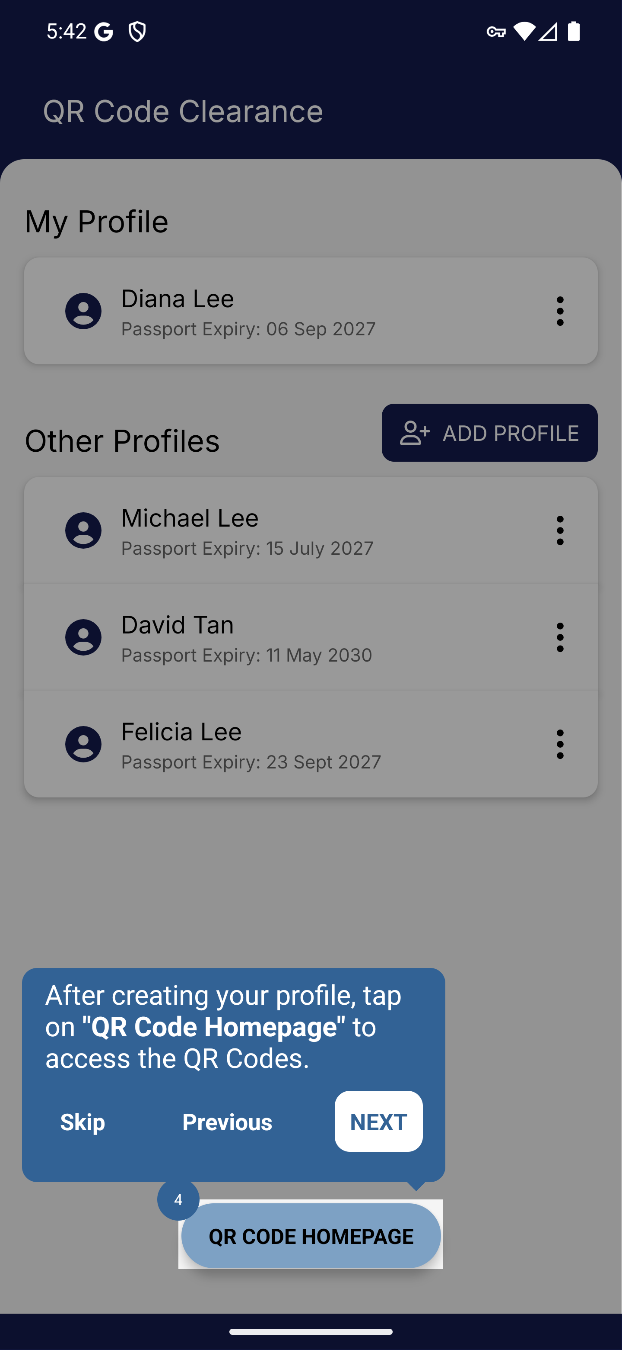
Screen 005 • 2026-09-07 17:42:19 • Captured

006 QR tutorial fifth step
Continue the QR tutorial.
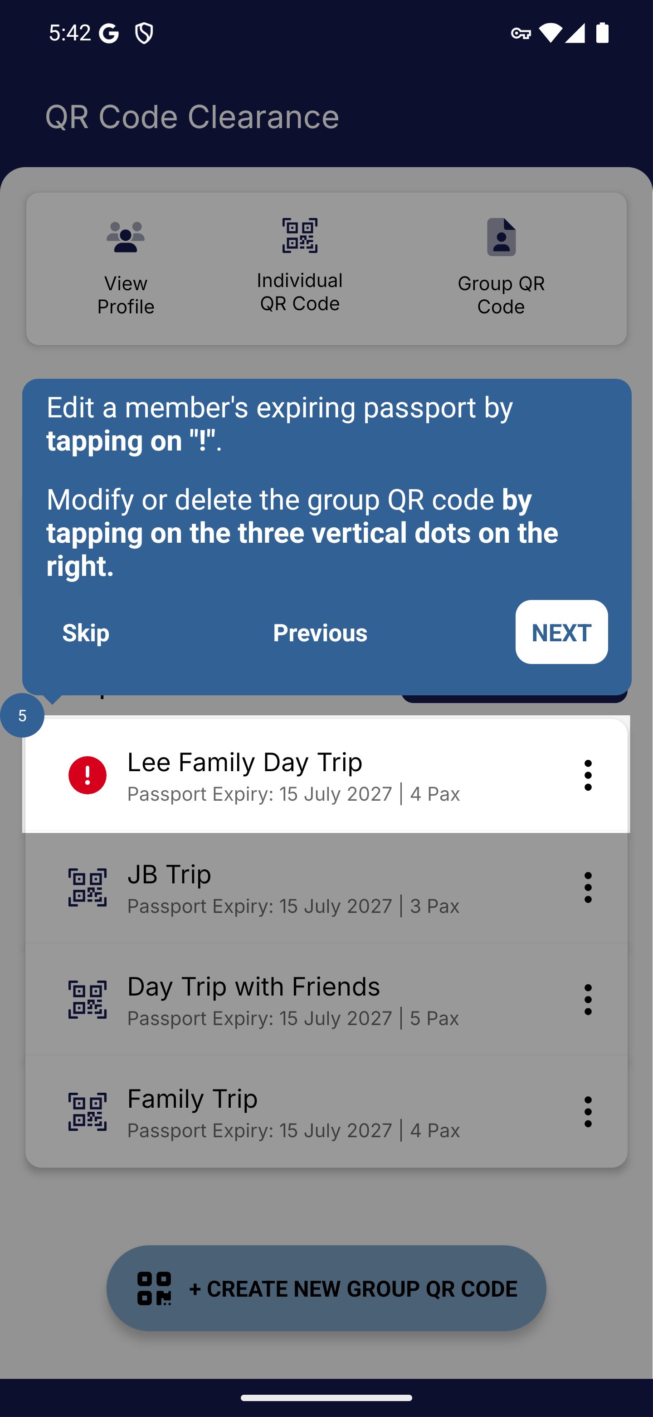
Screen 006 • 2026-09-07 17:42:37 • Captured

007 QR tutorial sixth step
Continue the QR tutorial.
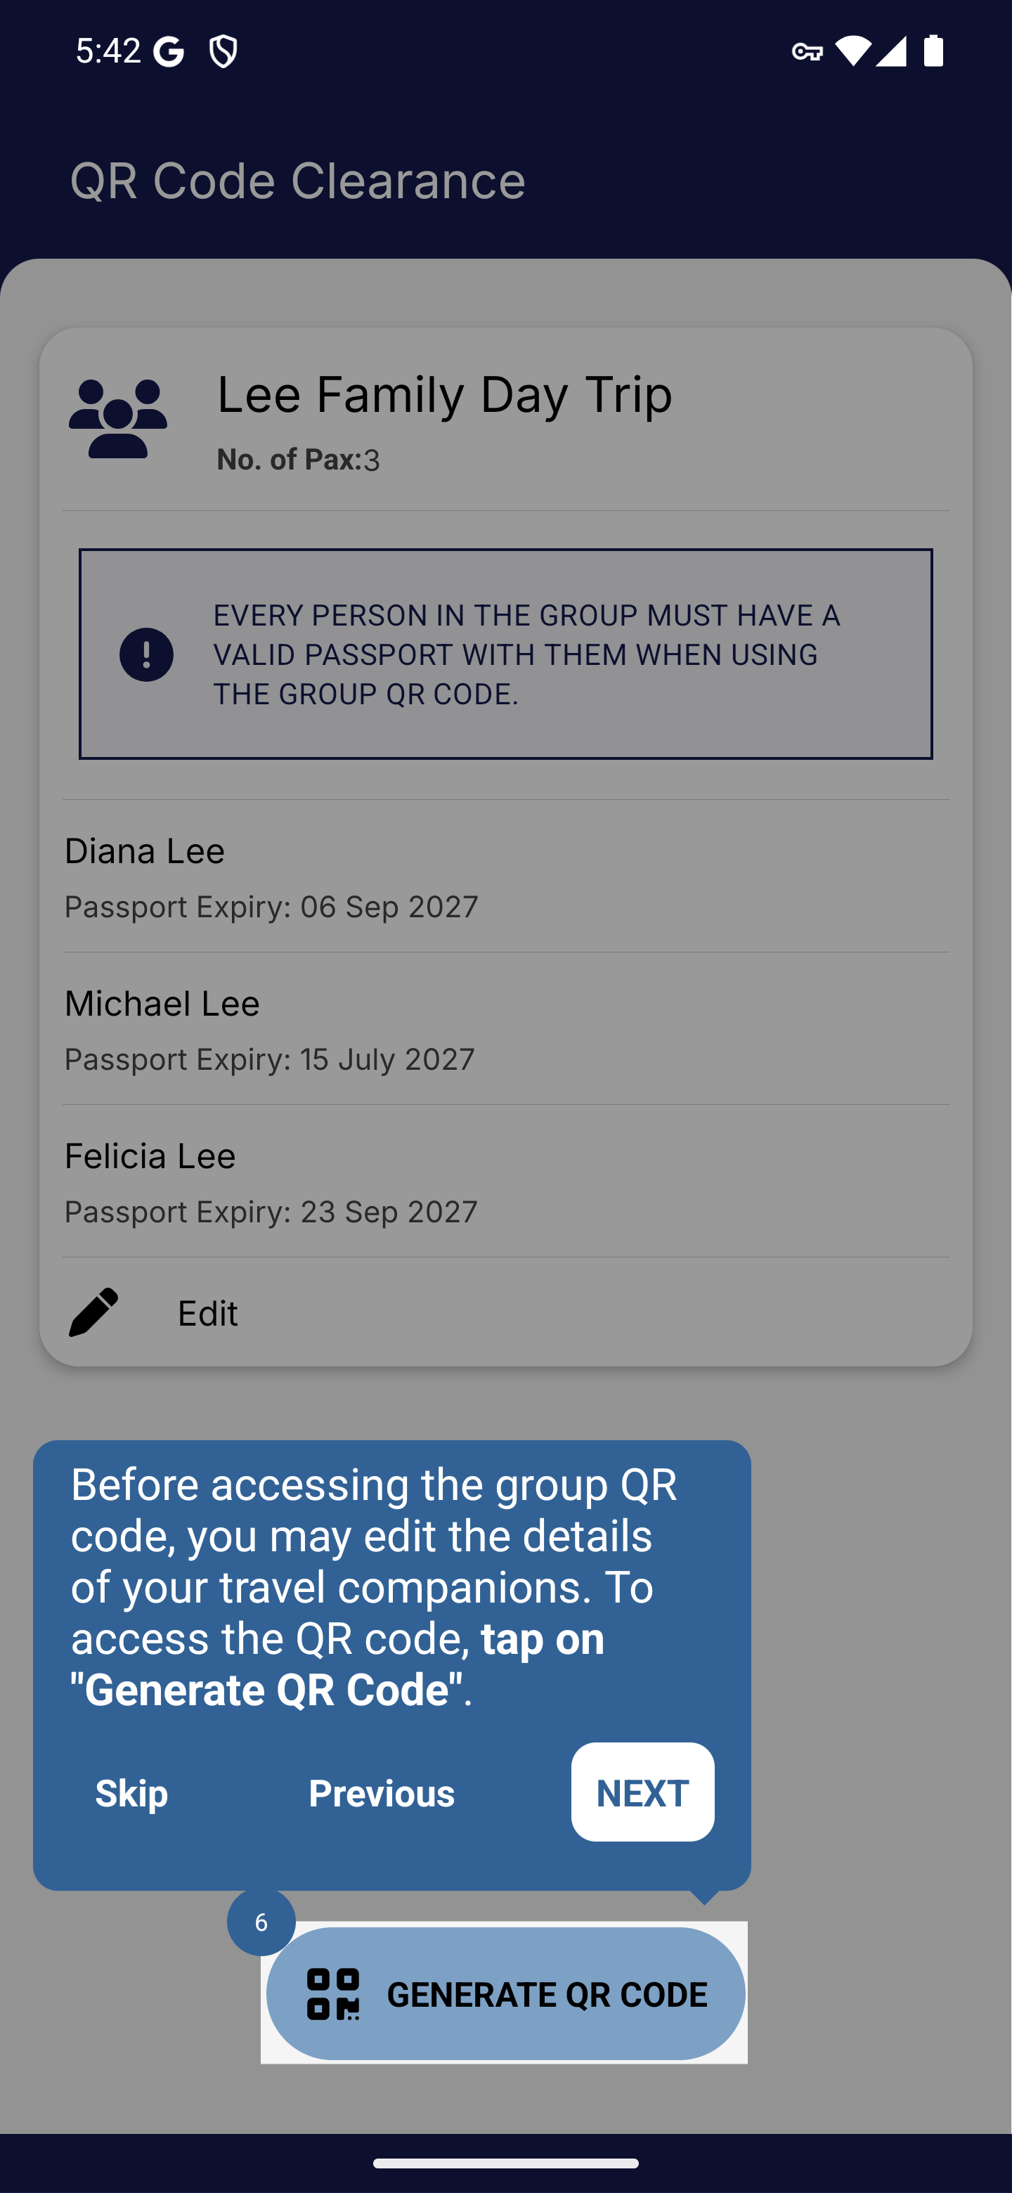
Screen 007 • 2026-09-07 17:42:38 • Captured

008 QR tutorial seventh step
Continue the QR tutorial.
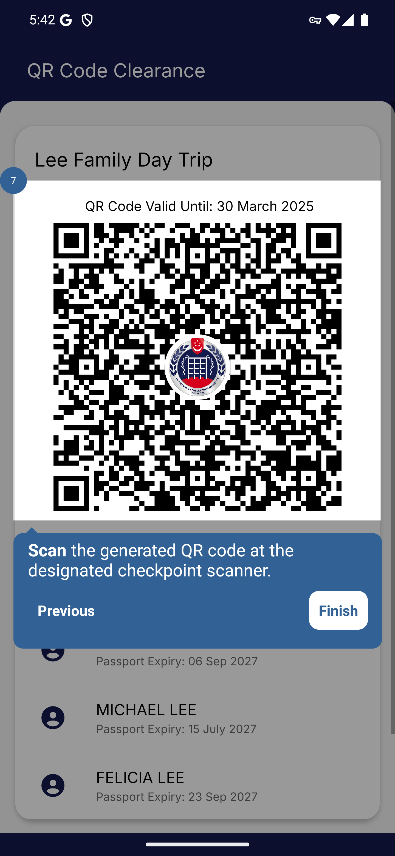
Screen 008 • 2026-09-07 17:42:40 • Captured

009 QR clearance dashboard
Finish the seven-step tutorial.
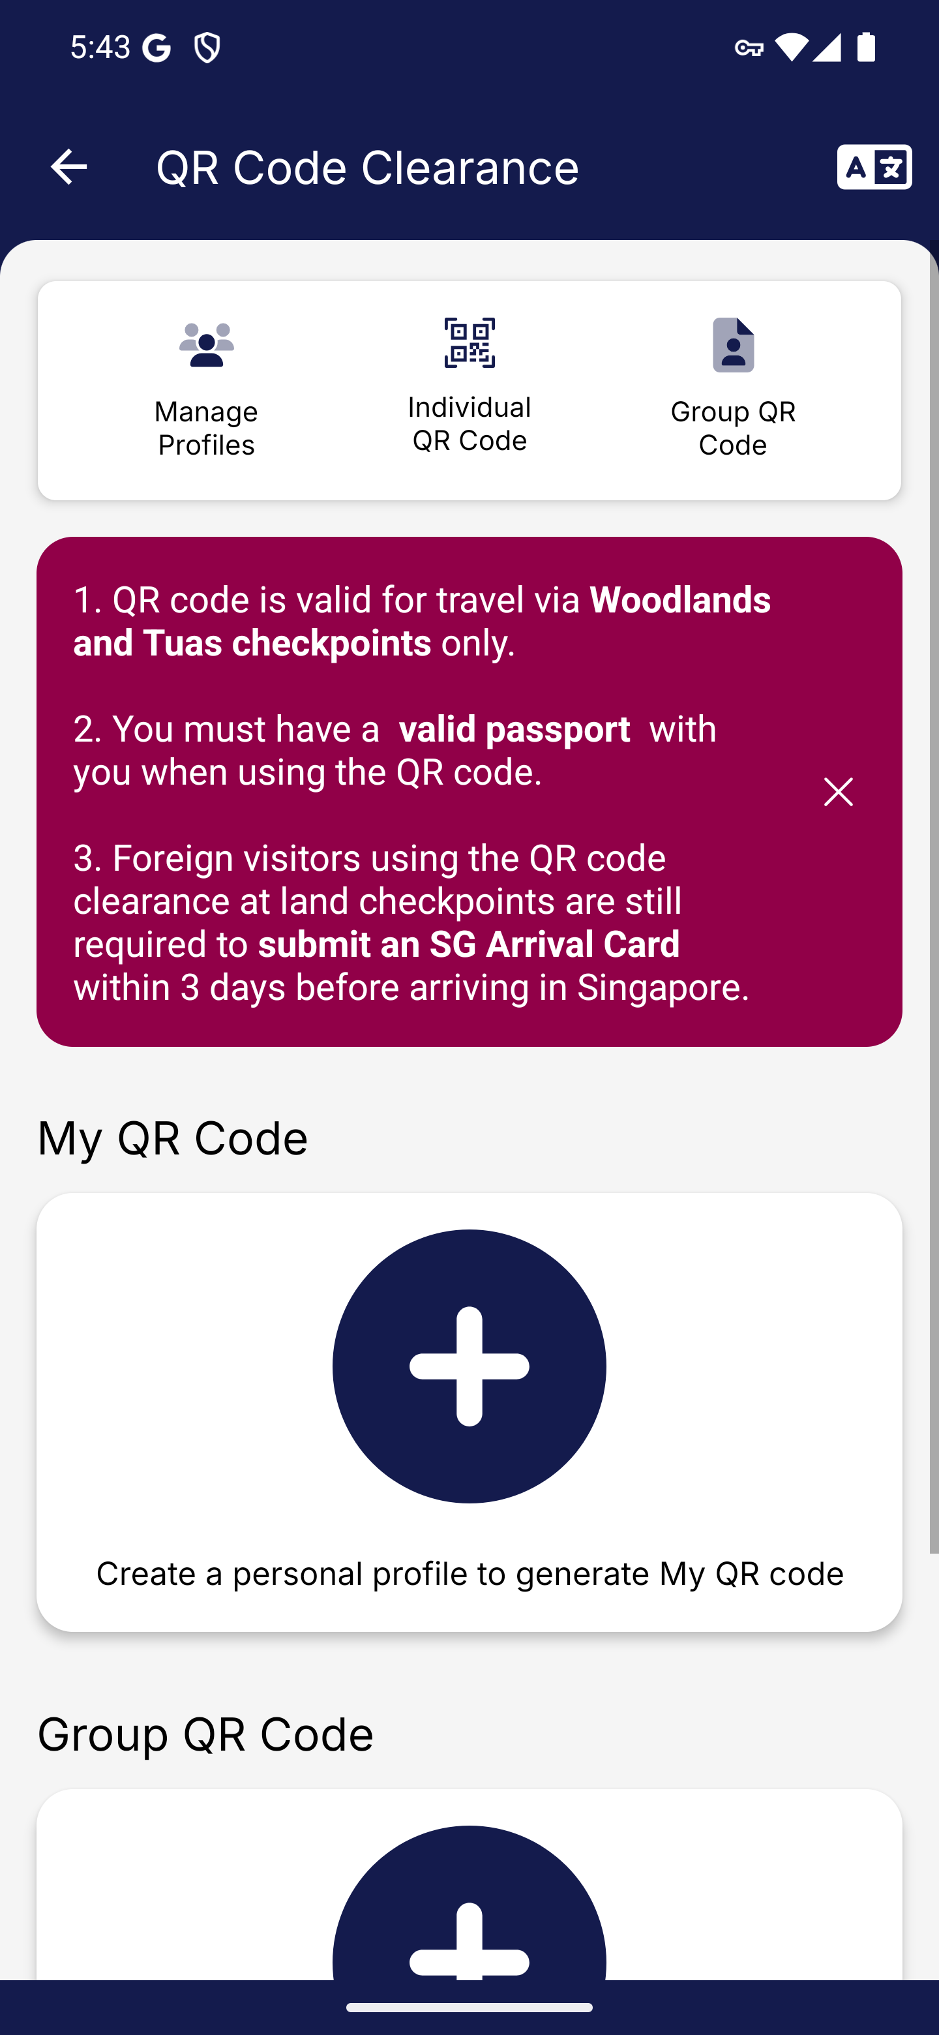
Screen 009 • 2026-09-07 17:43:03 • Captured

010 Individual QR profile creation methods
Create a personal profile for My QR Code.
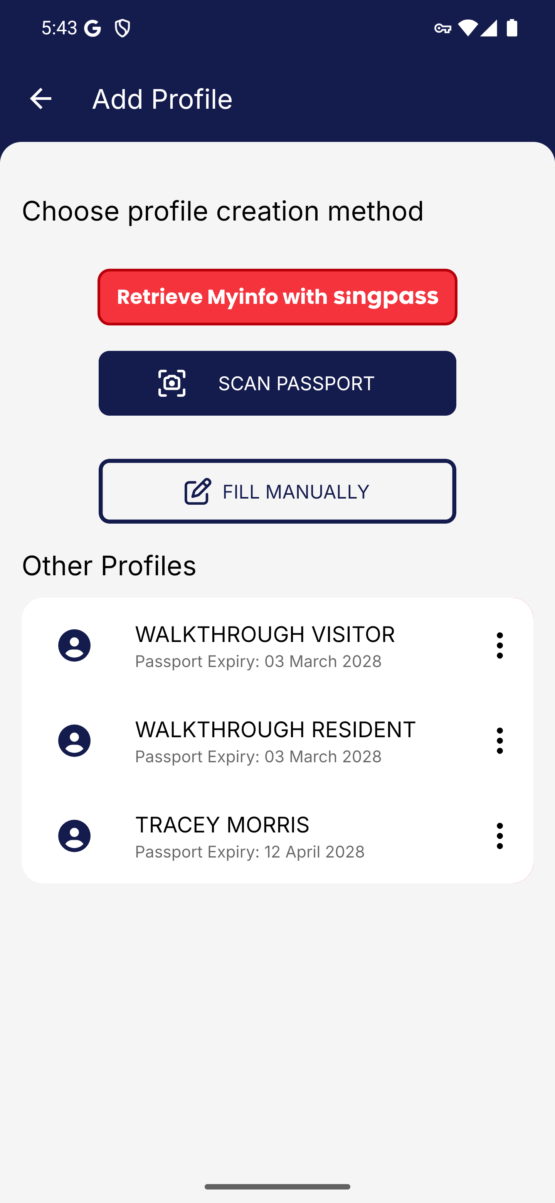
Screen 010 • 2026-09-07 17:43:05 • Captured

011 QR profile NRIC choice
Choose manual entry for the QR profile.
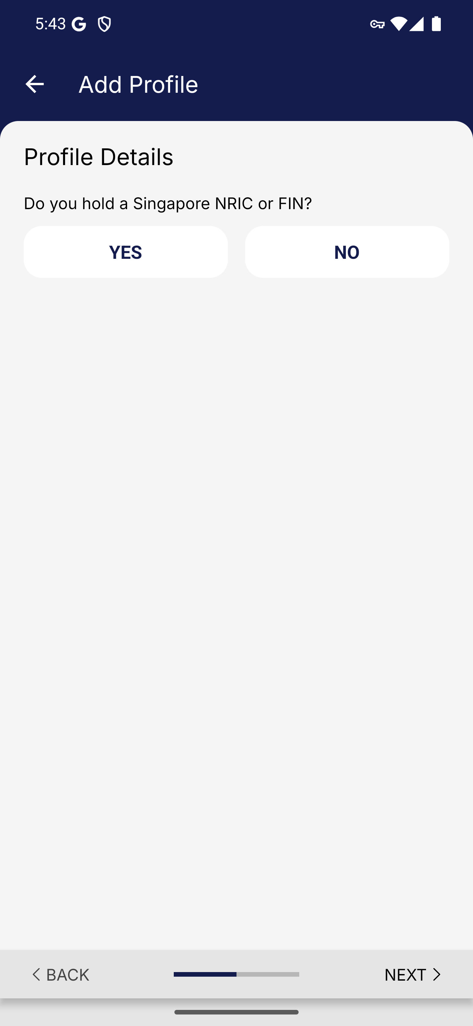
Screen 011 • 2026-09-07 17:43:06 • Captured

012 Manual resident QR profile form
Choose Yes for holding a Singapore NRIC or FIN.
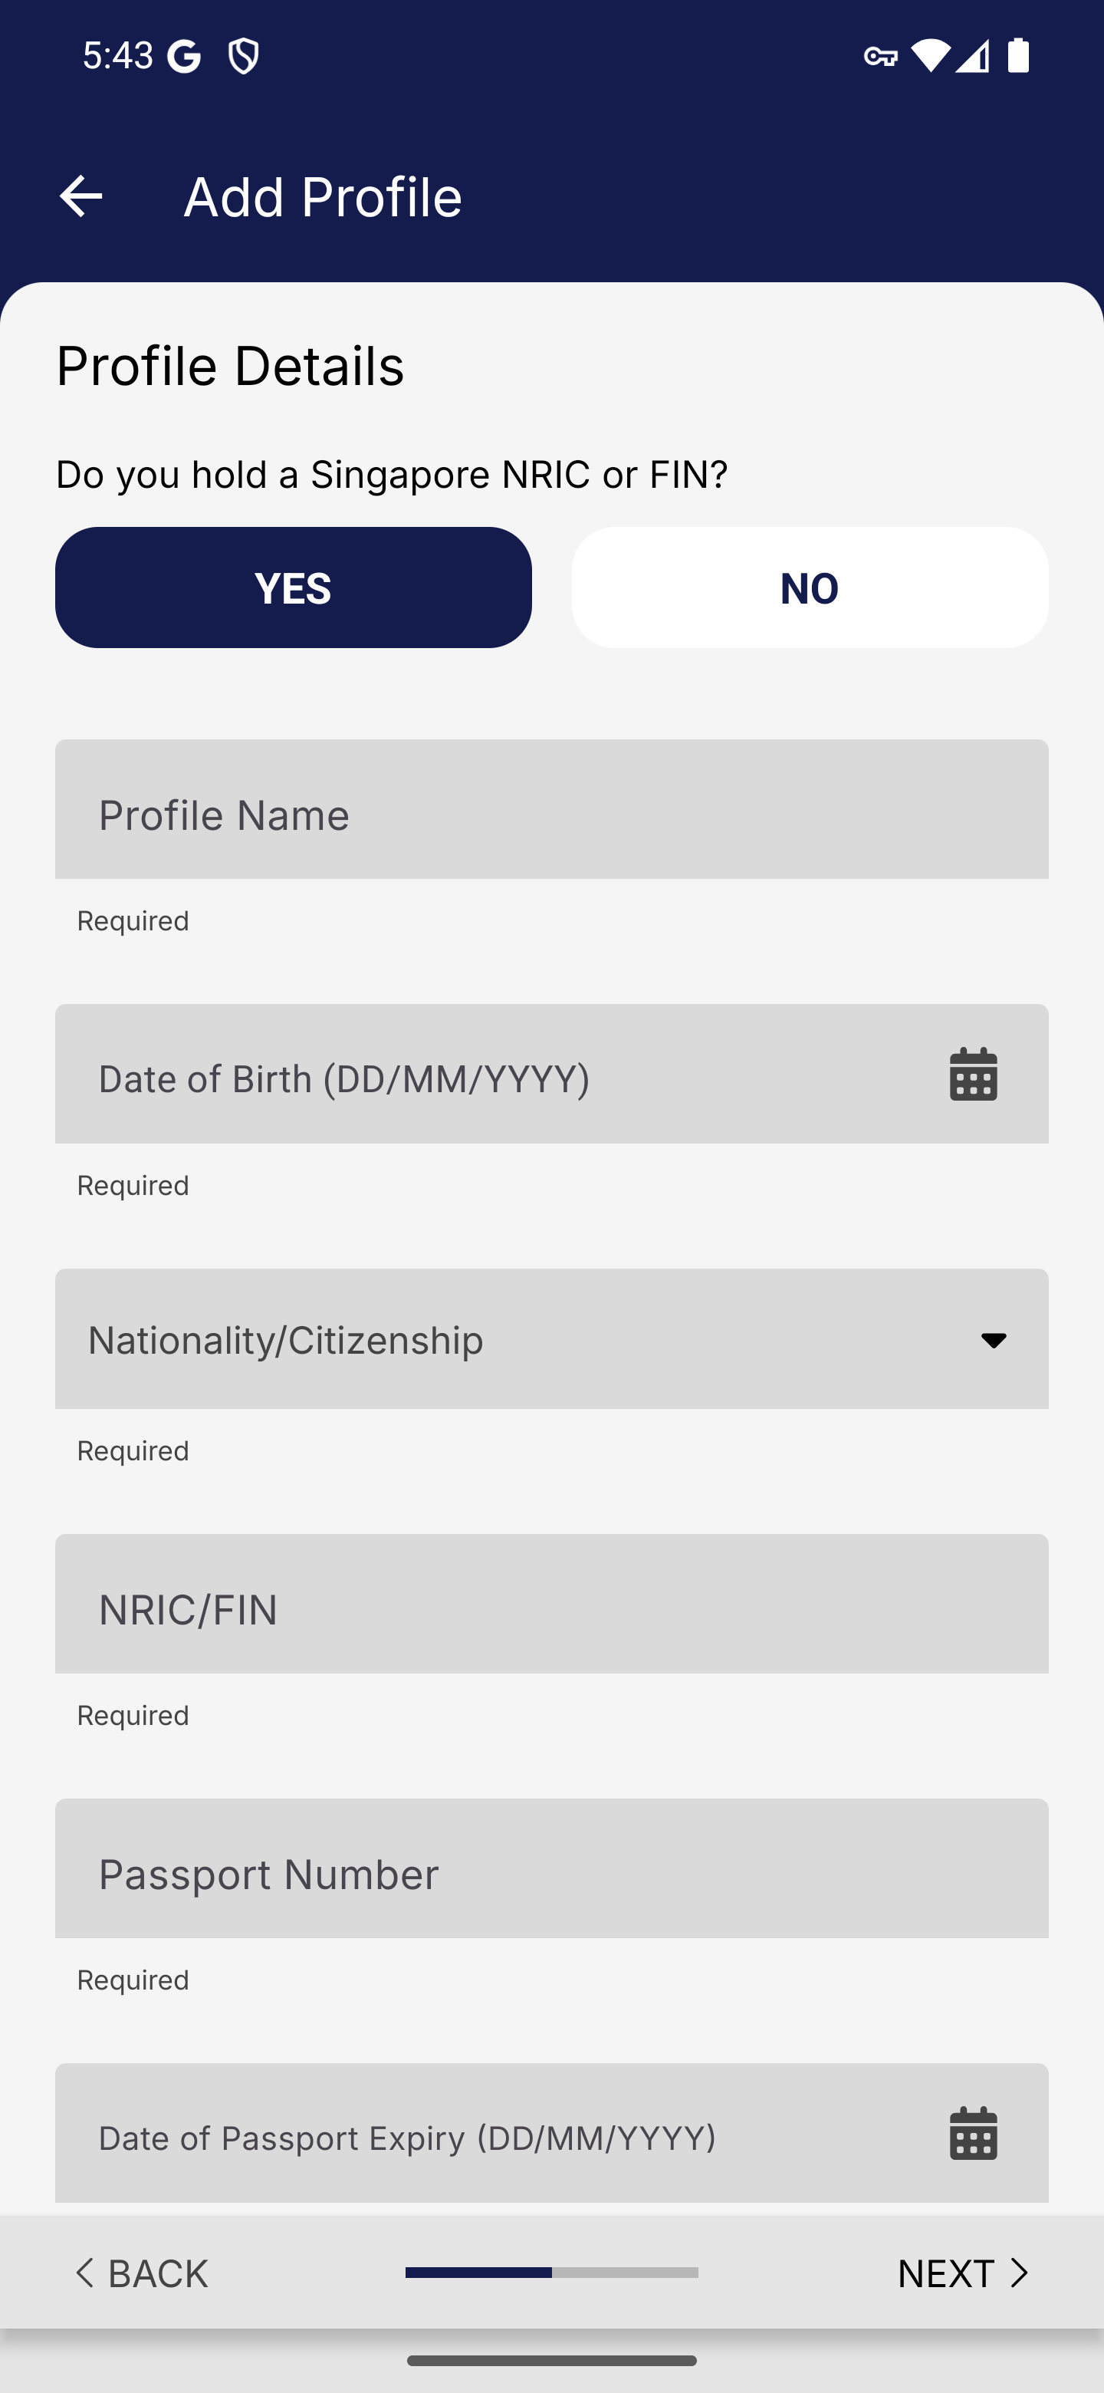
Screen 012 • 2026-09-07 17:43:29 • Captured

013 QR resident passport fields completed
Enter synthetic resident identity and passport details.
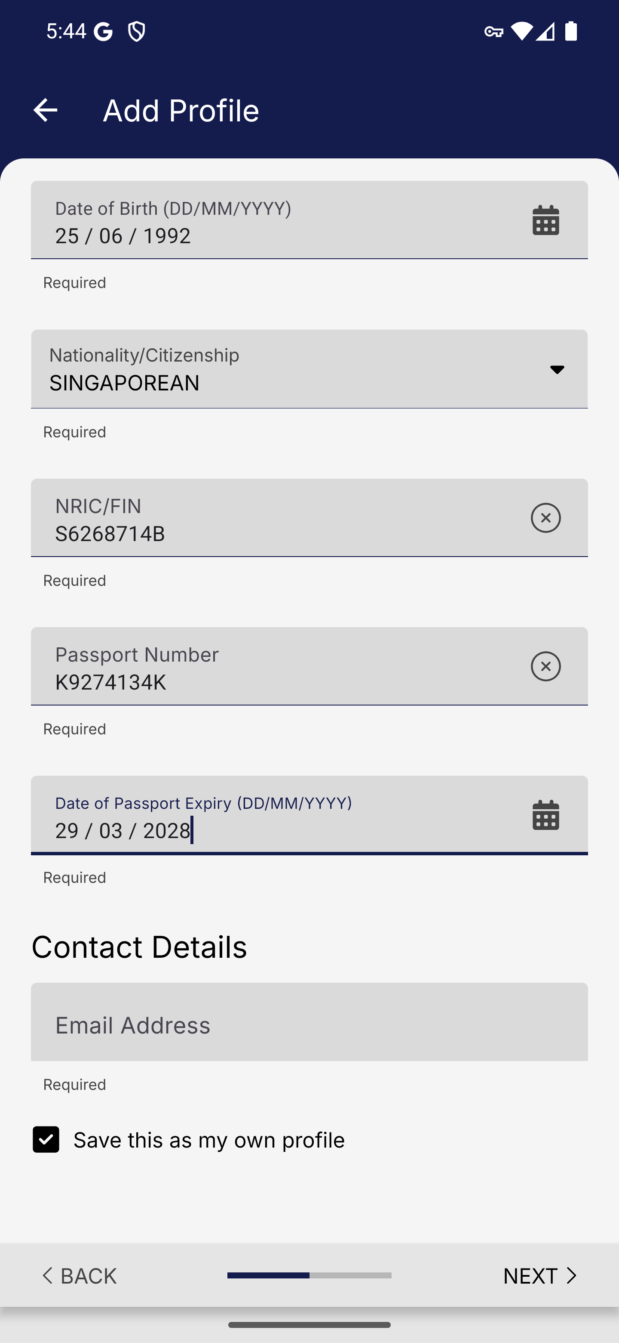
Screen 013 • 2026-09-07 17:44:07 • Captured

014 QR profile email validation
Review the QR profile details before saving.
Next remains on the profile form and displays email-format feedback while the email is empty.
Outcome: Validation observed
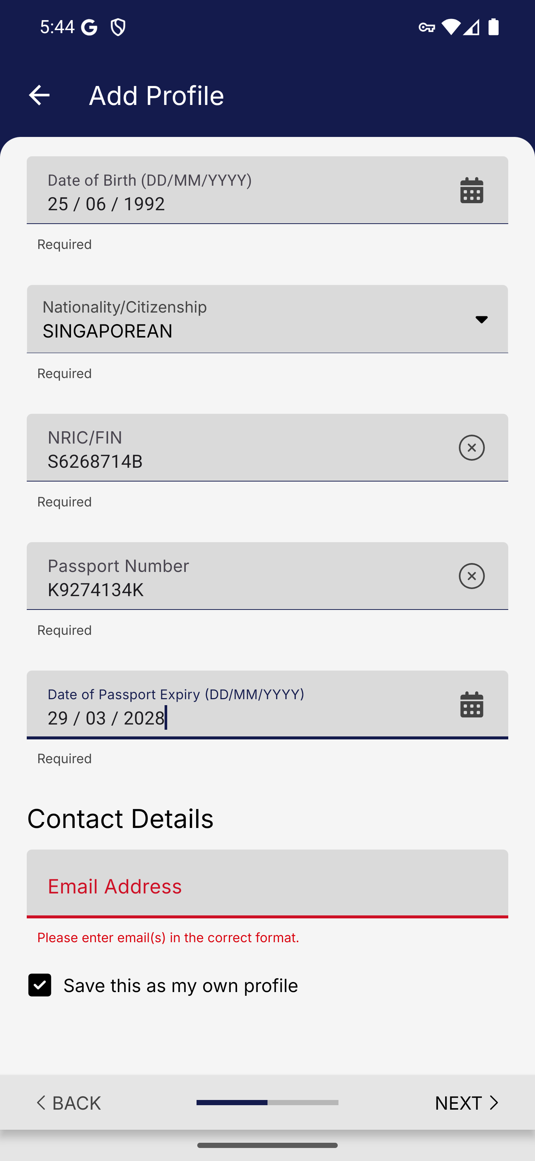
Screen 014 • 2026-09-07 17:44:08 • Validation observed

015 QR profile contact and own-profile option
Enter the synthetic email address and retain Save this as my own profile.
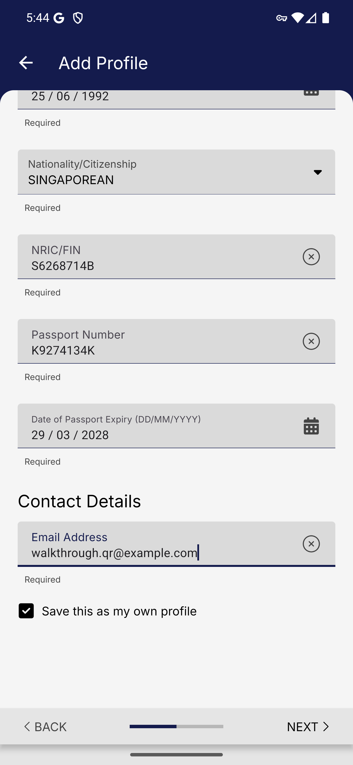
Screen 015 • 2026-09-07 17:44:26 • Captured

016 QR resident summary before save
Review the full QR profile summary.
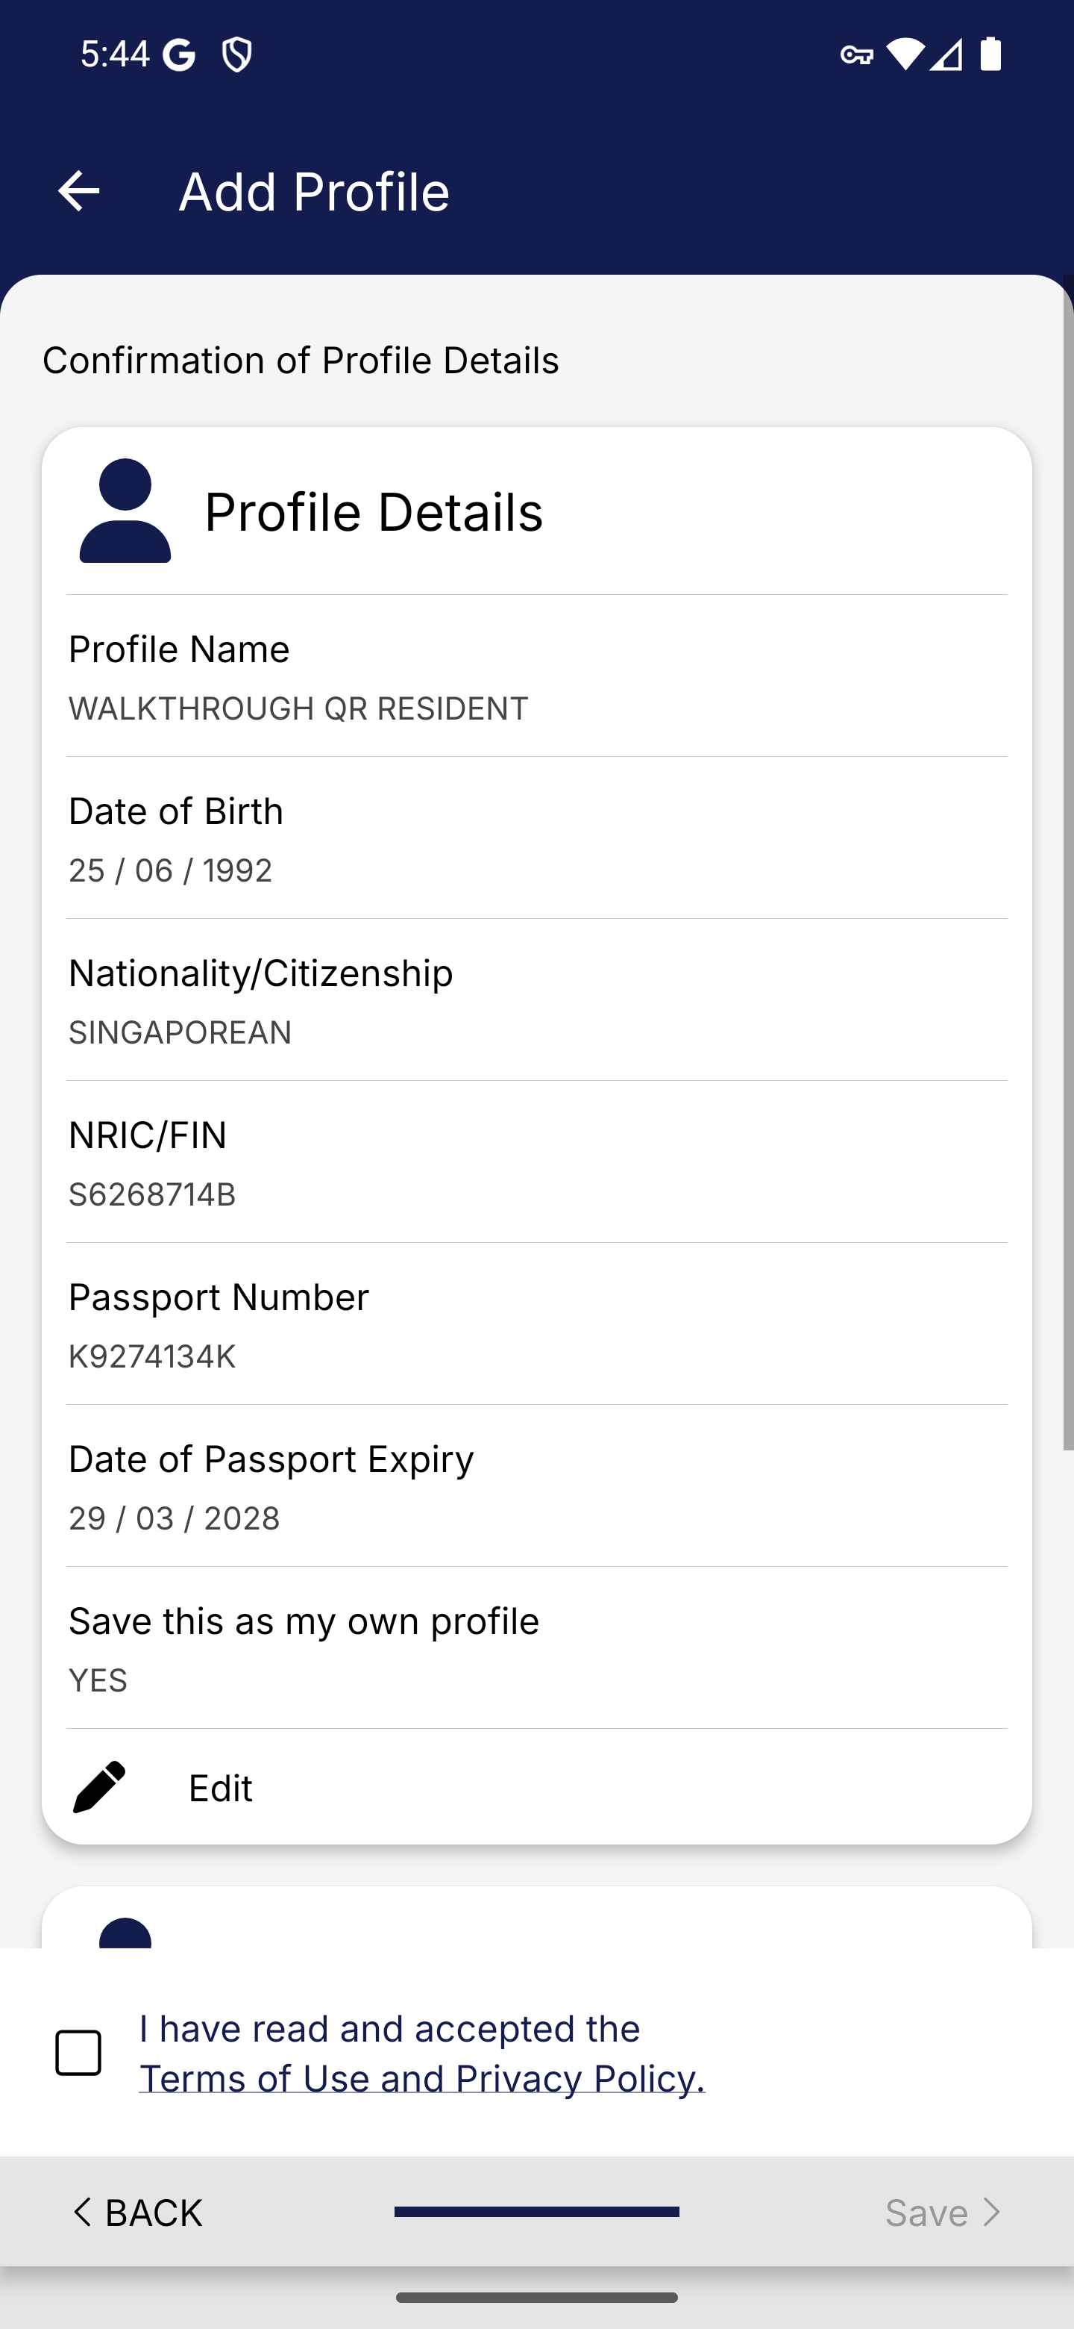
Screen 016 • 2026-09-07 17:44:27 • Captured

017 QR confirmation contact details
Scroll through the QR profile confirmation.
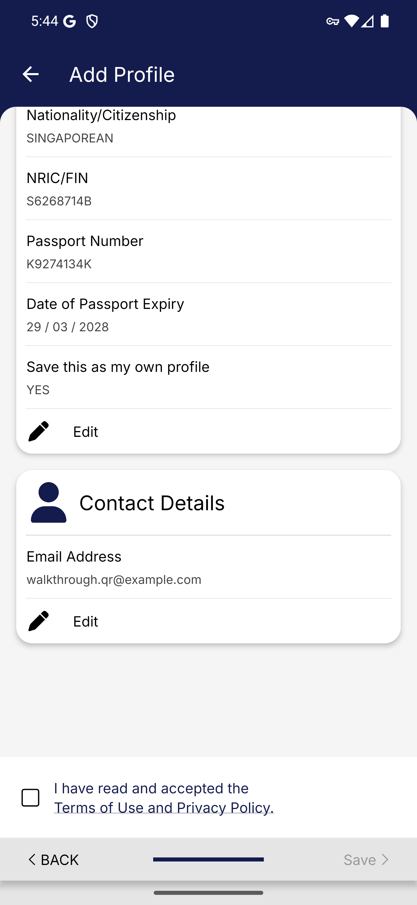
Screen 017 • 2026-09-07 17:44:44 • Captured

018 Access your QR after profile creation
Accept the terms and save the QR profile.
After saving, Confirm opens the QR; Add More Profiles returns to profile creation.
Outcome: Profile saved
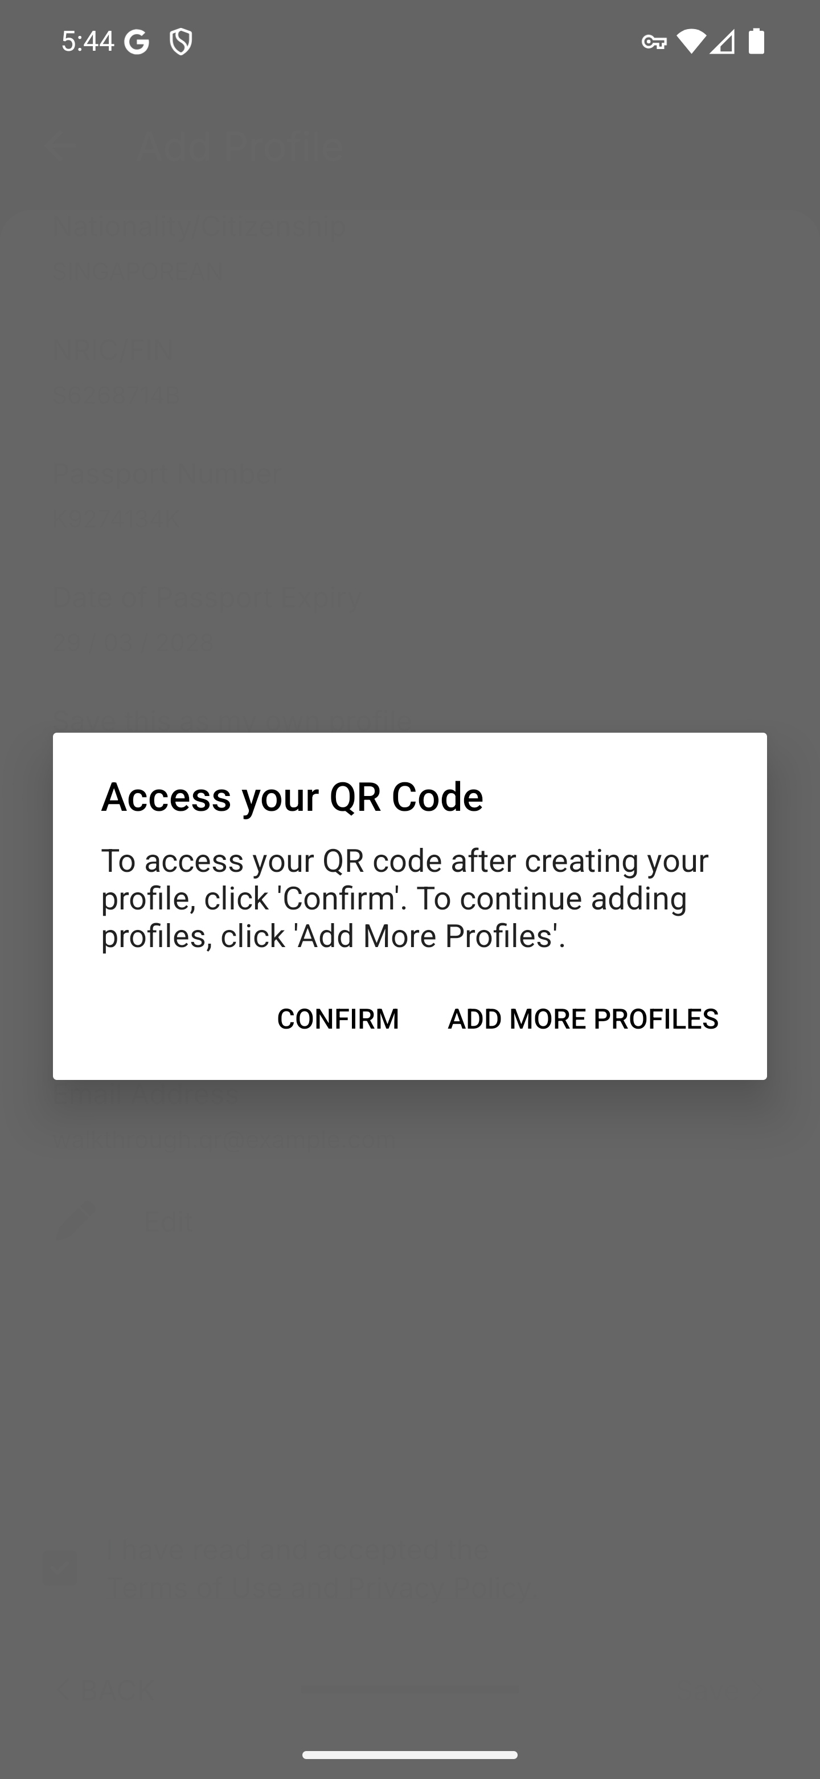
Screen 018 • 2026-09-07 17:44:47 • Profile saved

019 Individual resident QR code
Confirm to display the generated personal QR code.
The individual QR was generated for WALKTHROUGH QR RESIDENT. Physical checkpoint scanning was not performed.
Outcome: QR generated
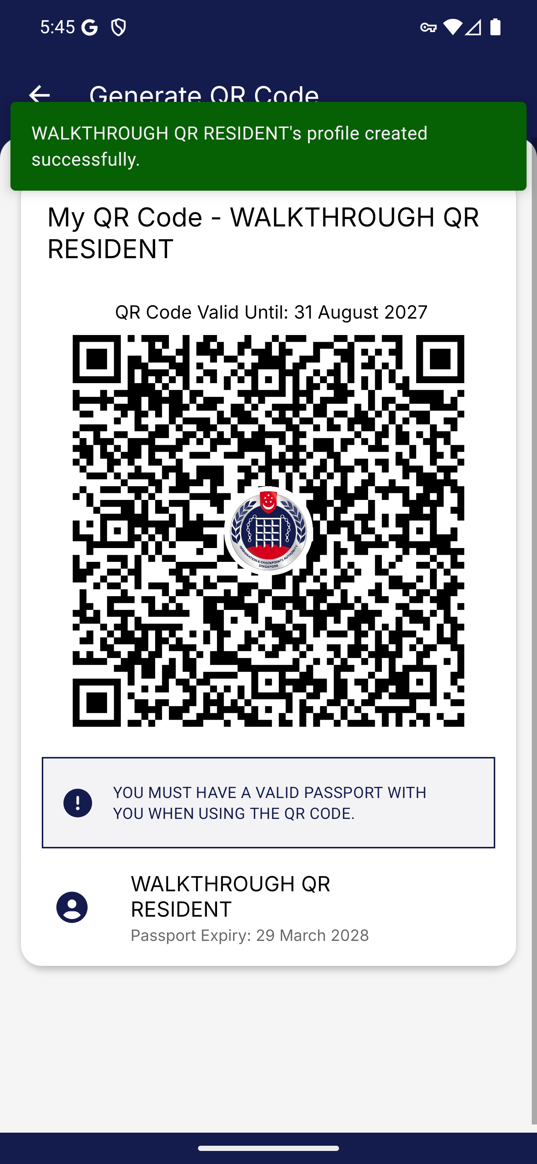
Screen 019 • 2026-09-07 17:45:05 • QR generated

020 Group QR creation form
Return to QR Home and choose Group QR Code.
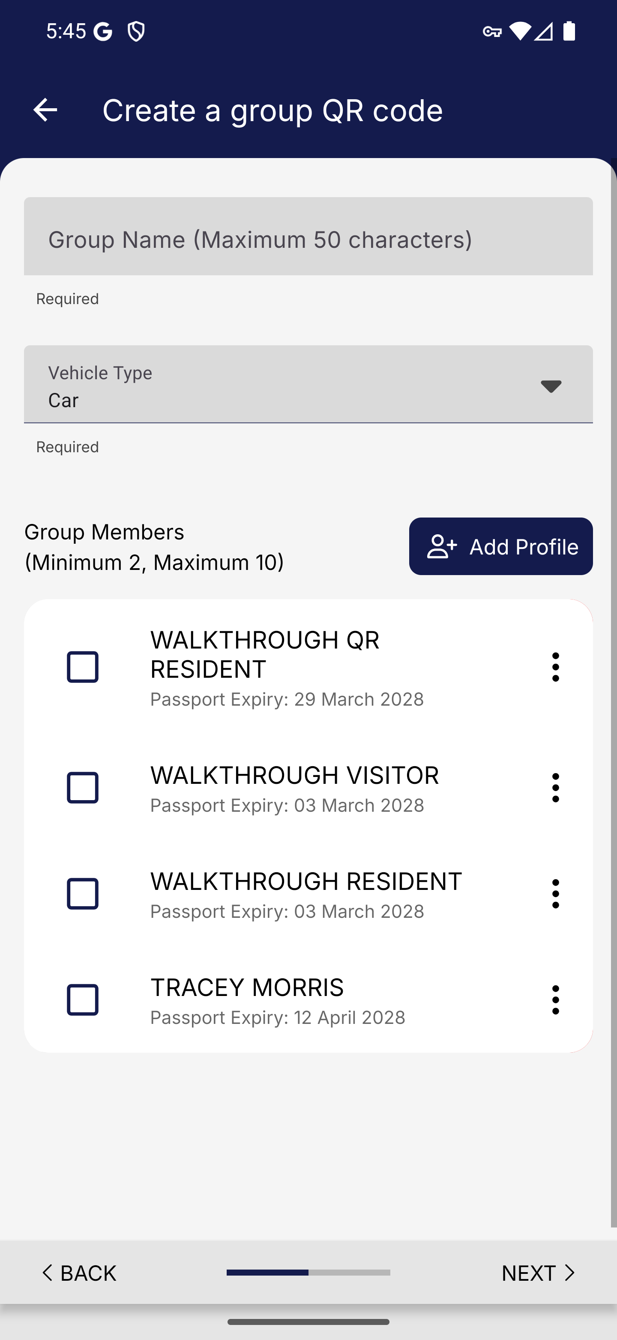
Screen 020 • 2026-09-07 17:45:28 • Captured

021 Group QR vehicle types
Open the vehicle type dropdown.
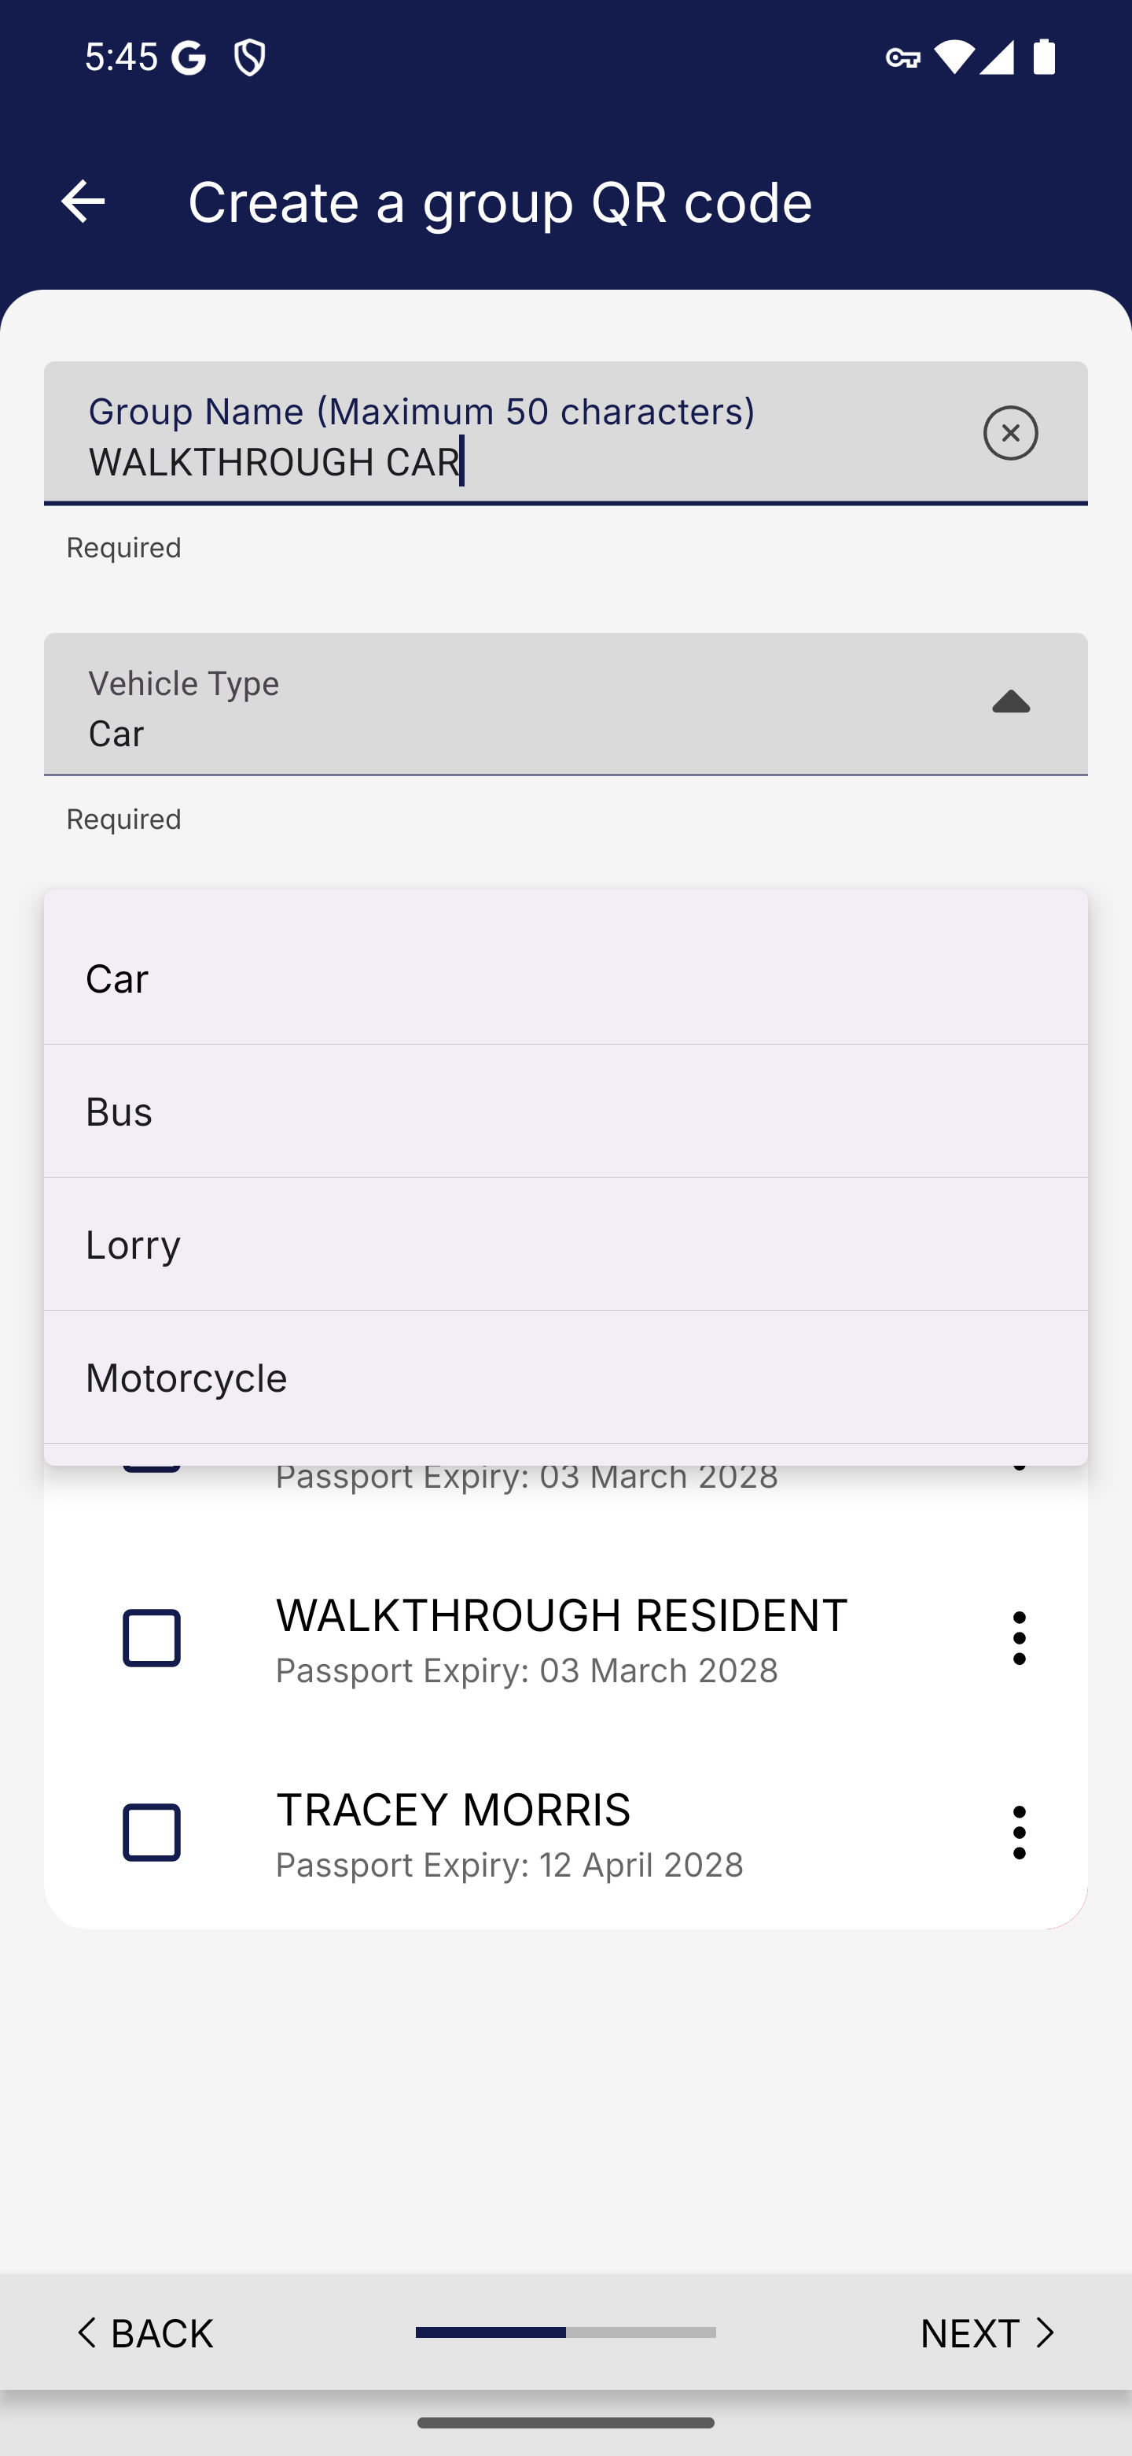
Screen 021 • 2026-09-07 17:45:31 • Captured

022 Car group members selected
Select the resident QR profile and the saved visitor for a car group.
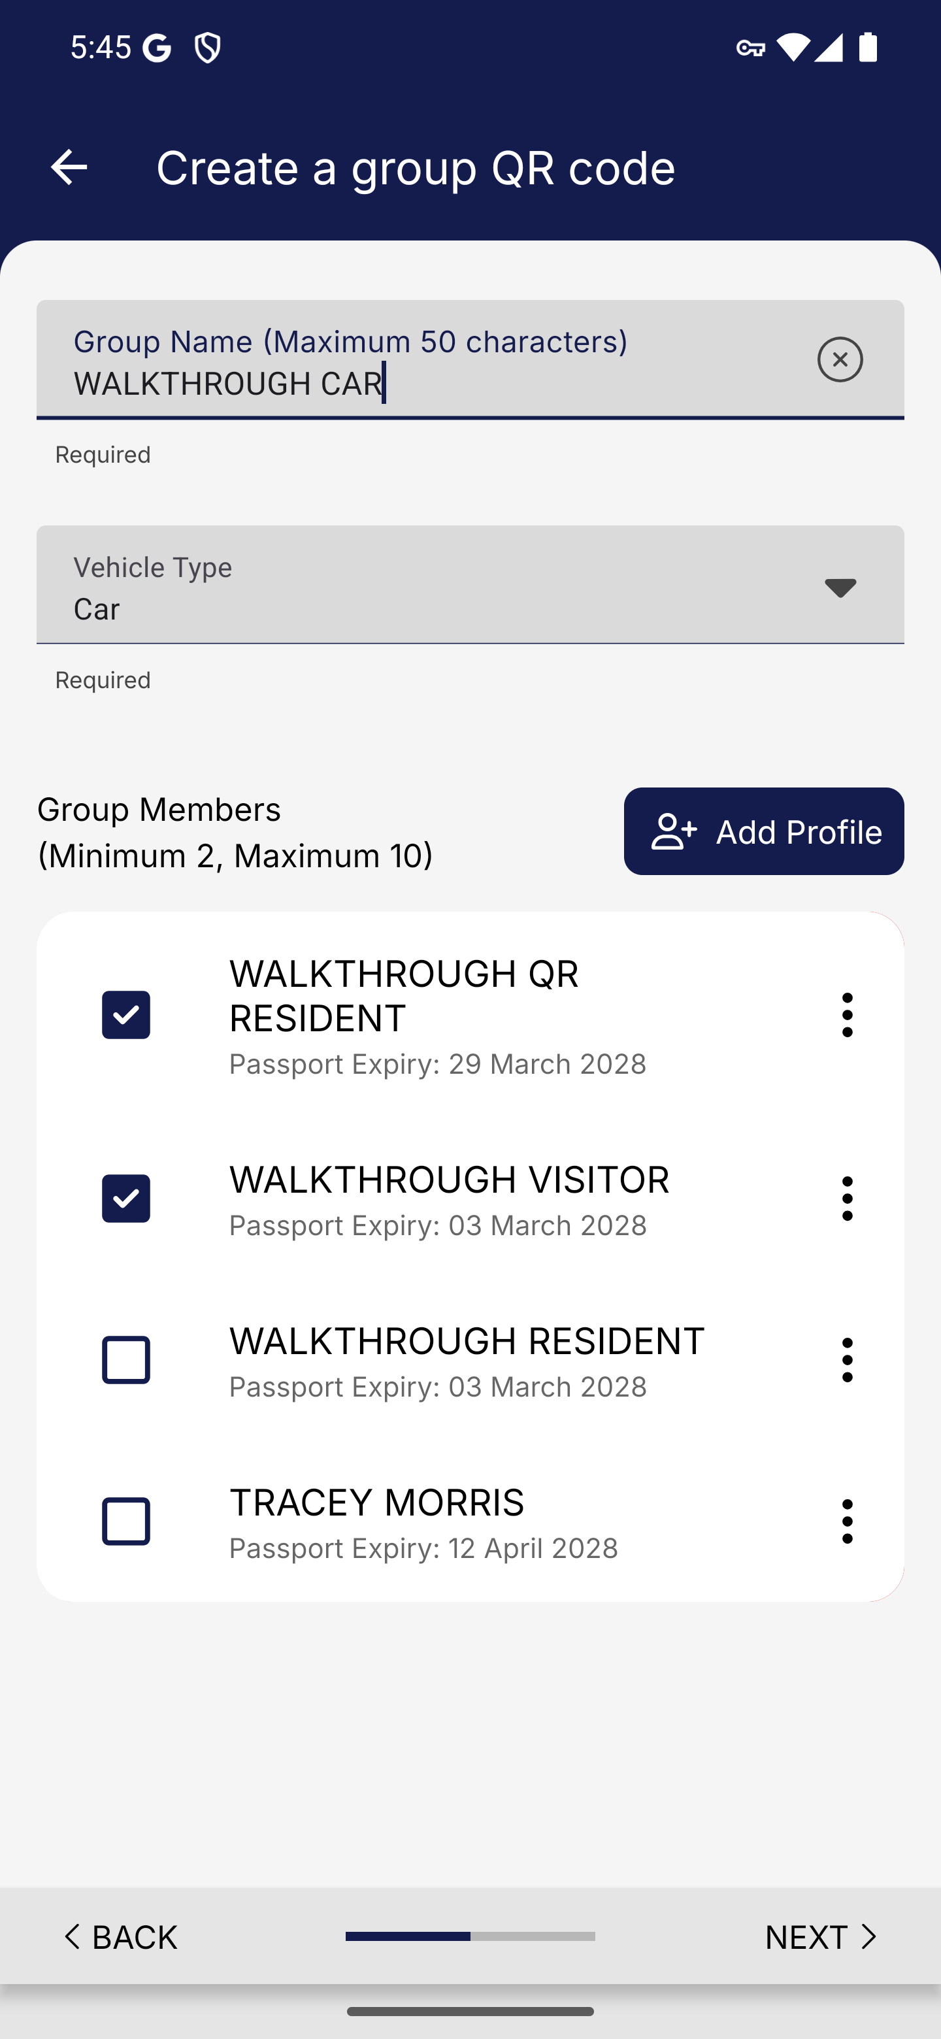
Screen 022 • 2026-09-07 17:45:54 • Captured

023 Car group QR confirmation
Review the two-member car group.
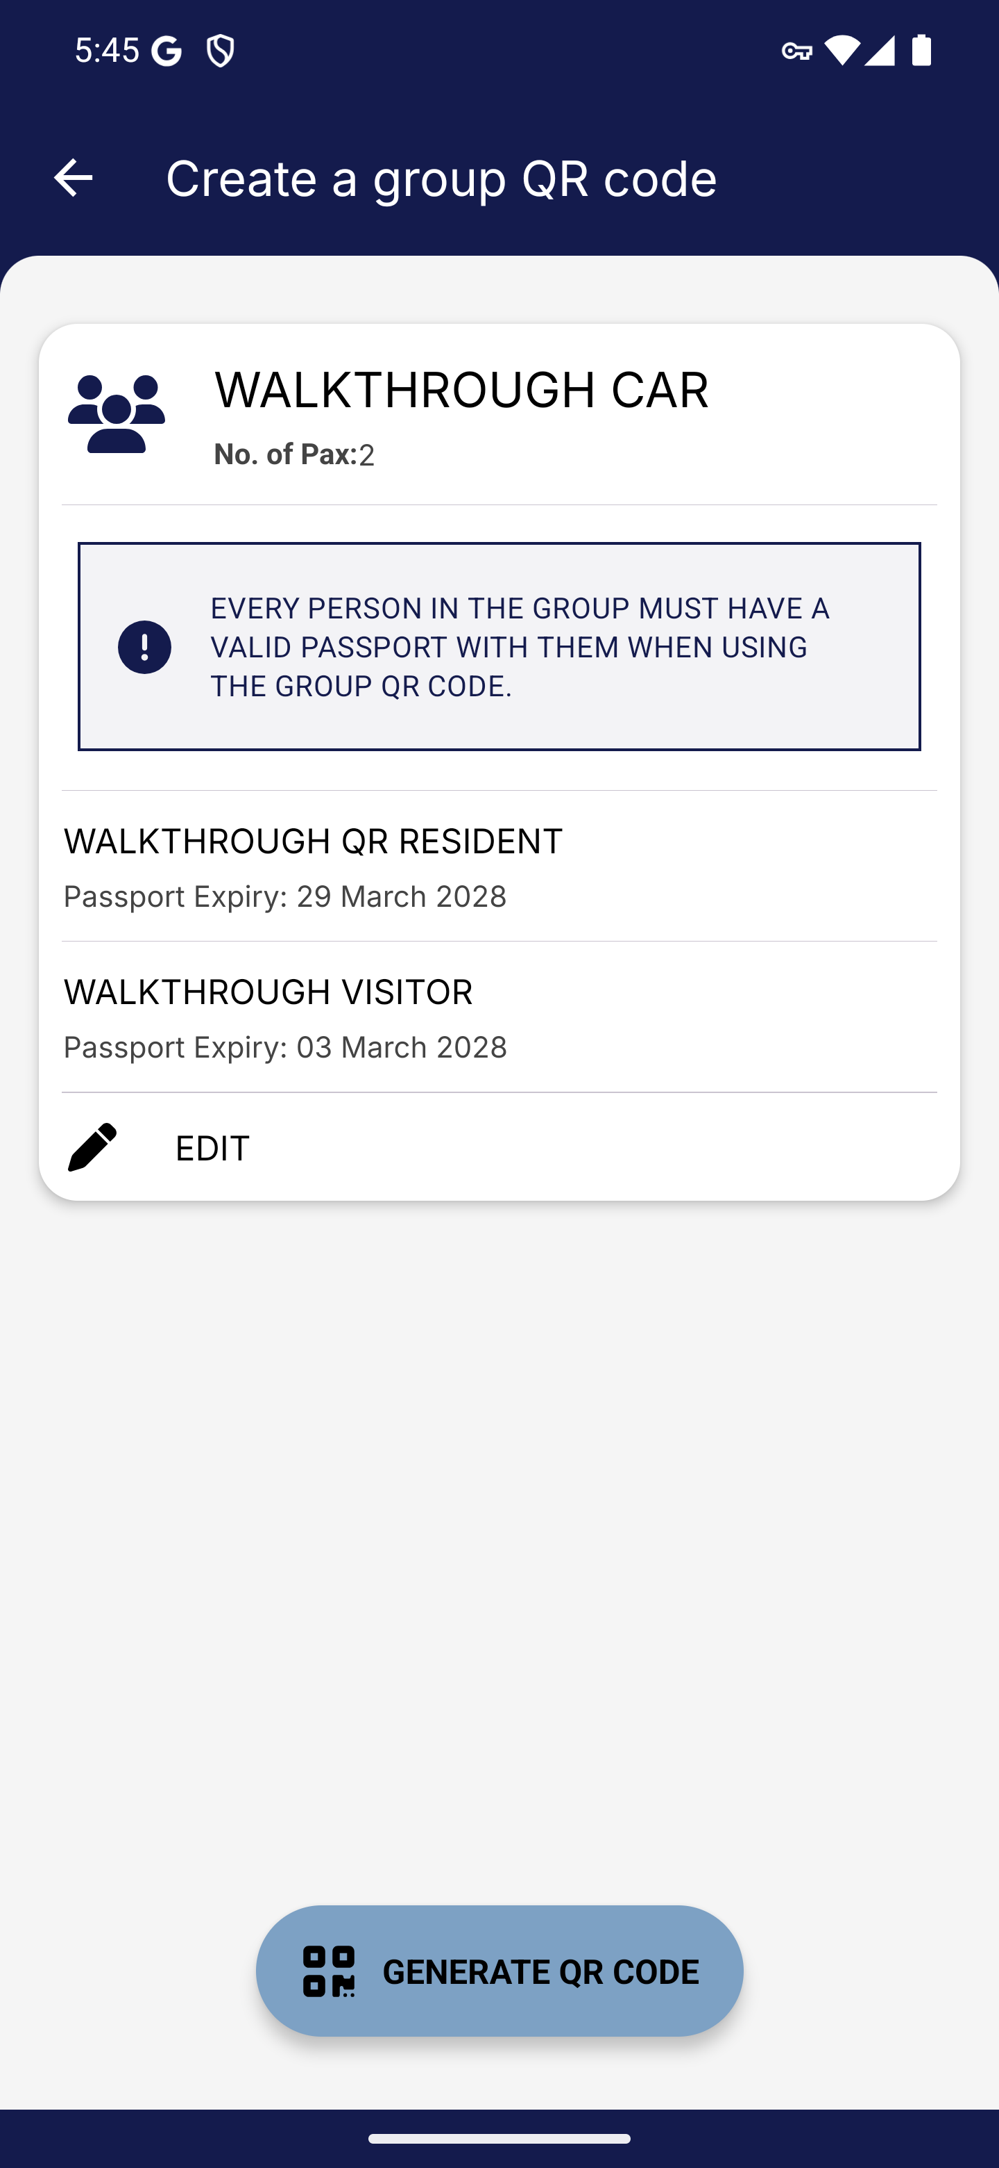
Screen 023 • 2026-09-07 17:45:55 • Captured

024 Car QR and foreign visitor SGAC reminder
Generate the car group QR code.
A generated car QR is behind the reminder that foreign visitors need an SG Arrival Card. The next step follows PROCEED TO CREATE SGAC.
Outcome: QR generated; reminder shown
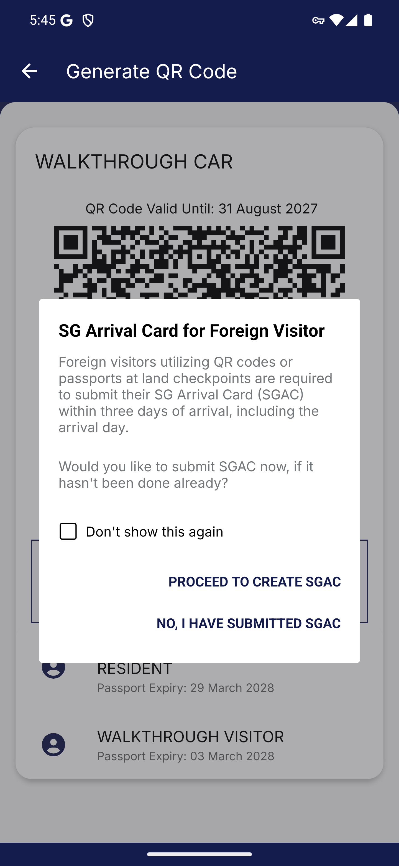
Screen 024 • 2026-09-07 17:45:57 • QR generated; reminder shown

025 Group QR handoff to SG Arrival Card
Follow the foreign-visitor reminder to create SGAC.
The reminder opens the foreign visitor SGAC dashboard. Selecting the saved visitor encounters the update loop documented in the visitor category.
Outcome: Handoff reached
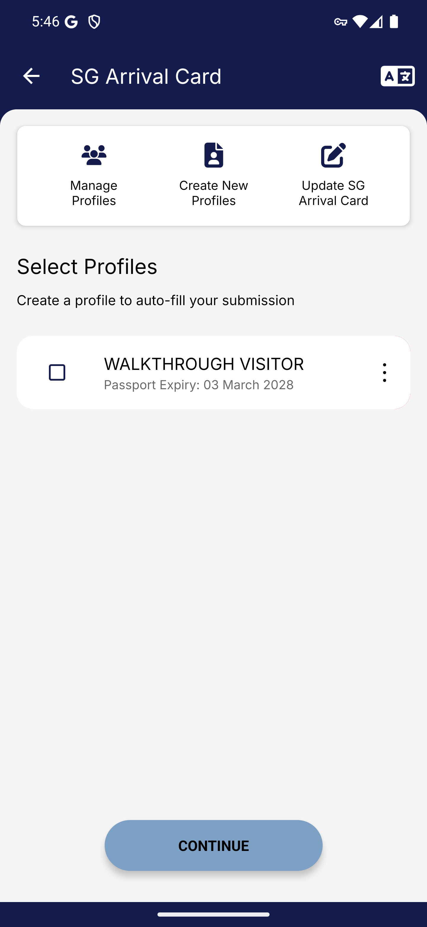
Screen 025 • 2026-09-07 17:46:21 • Handoff reached

026 Saved group QR list
Open Group QR Code after saving the first group.
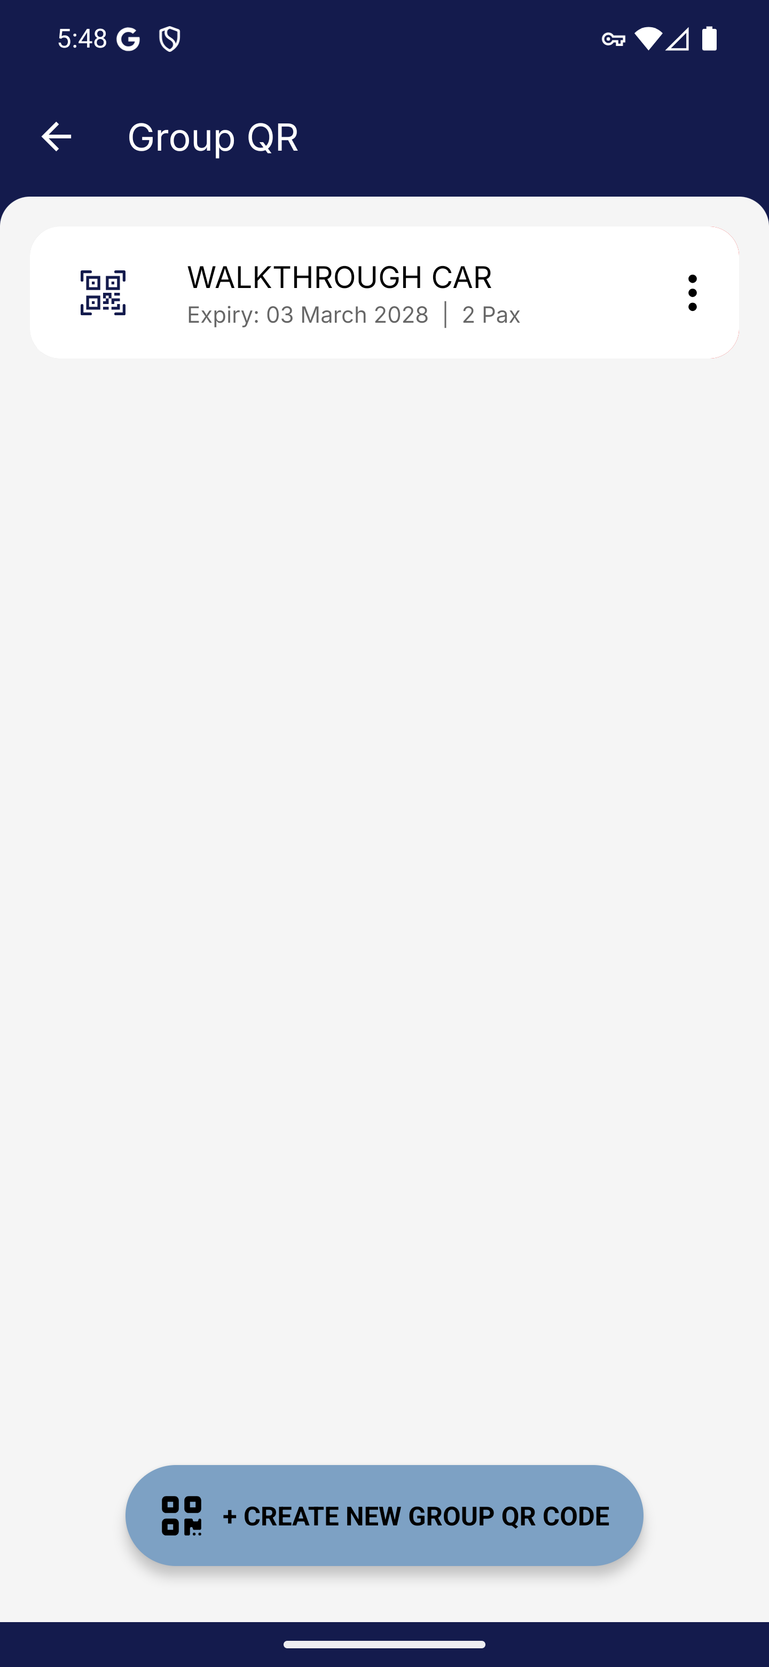
Screen 026 • 2026-09-07 17:48:41 • Captured

027 Motorcycle group limits and selected members
Select Motorcycle and two synthetic resident profiles.
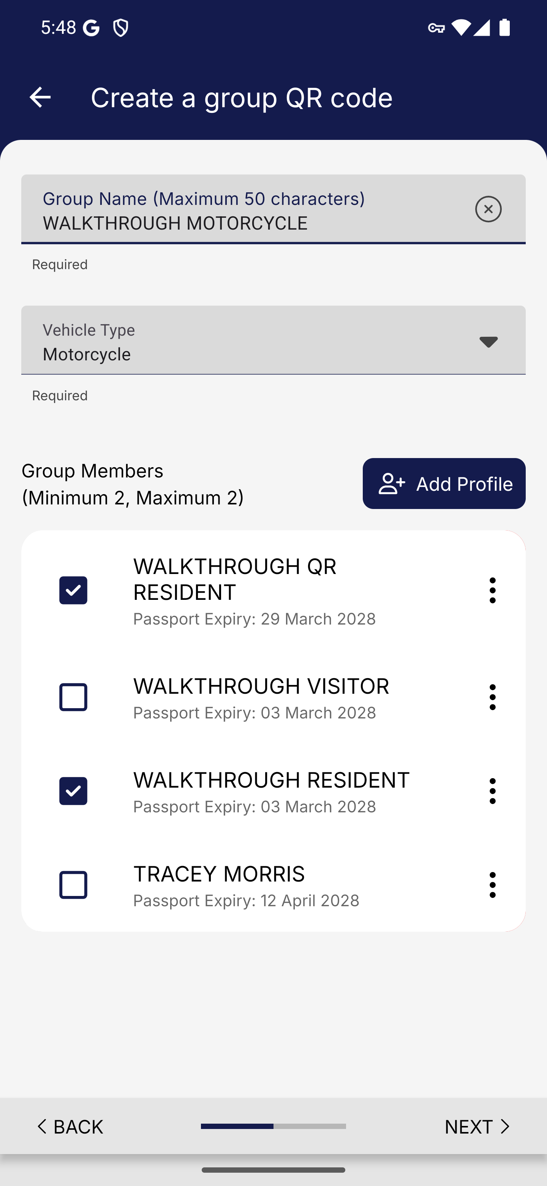
Screen 027 • 2026-09-07 17:49:05 • Captured

028 Motorcycle group confirmation
Review the two-passenger group.
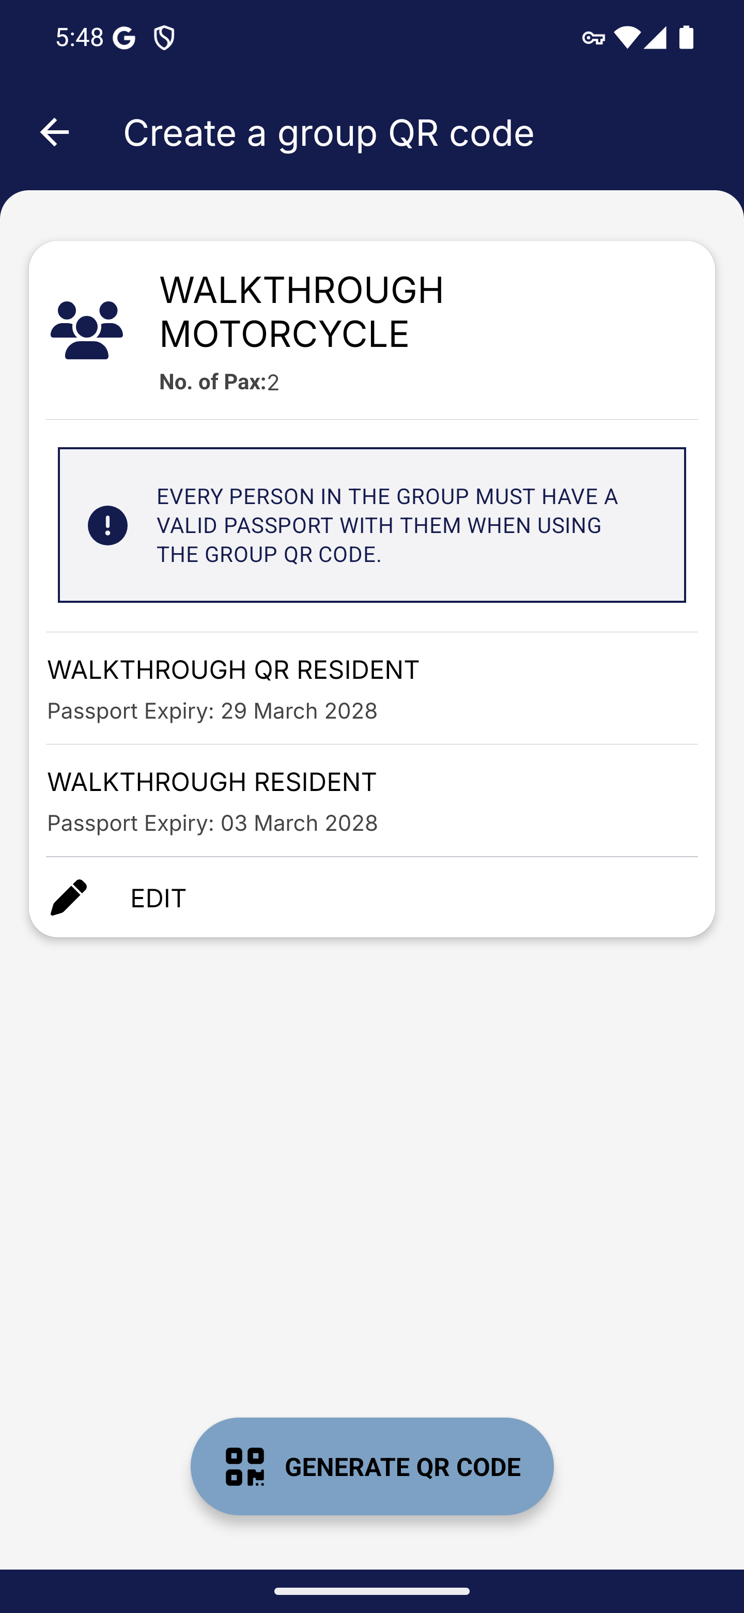
Screen 028 • 2026-09-07 17:49:06 • Captured

029 Motorcycle group QR code
Generate the group QR code.
A QR was generated for the two selected members.
Outcome: QR generated
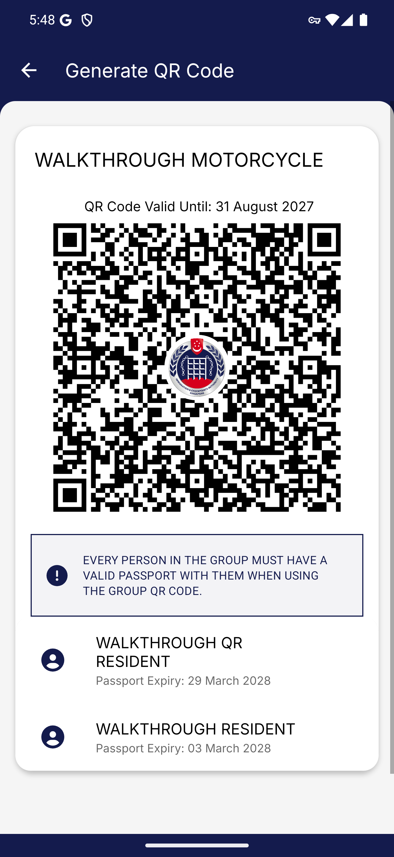
Screen 029 • 2026-09-07 17:49:08 • QR generated

030 Lorry group limits and selected members
Select Lorry and two synthetic resident profiles.
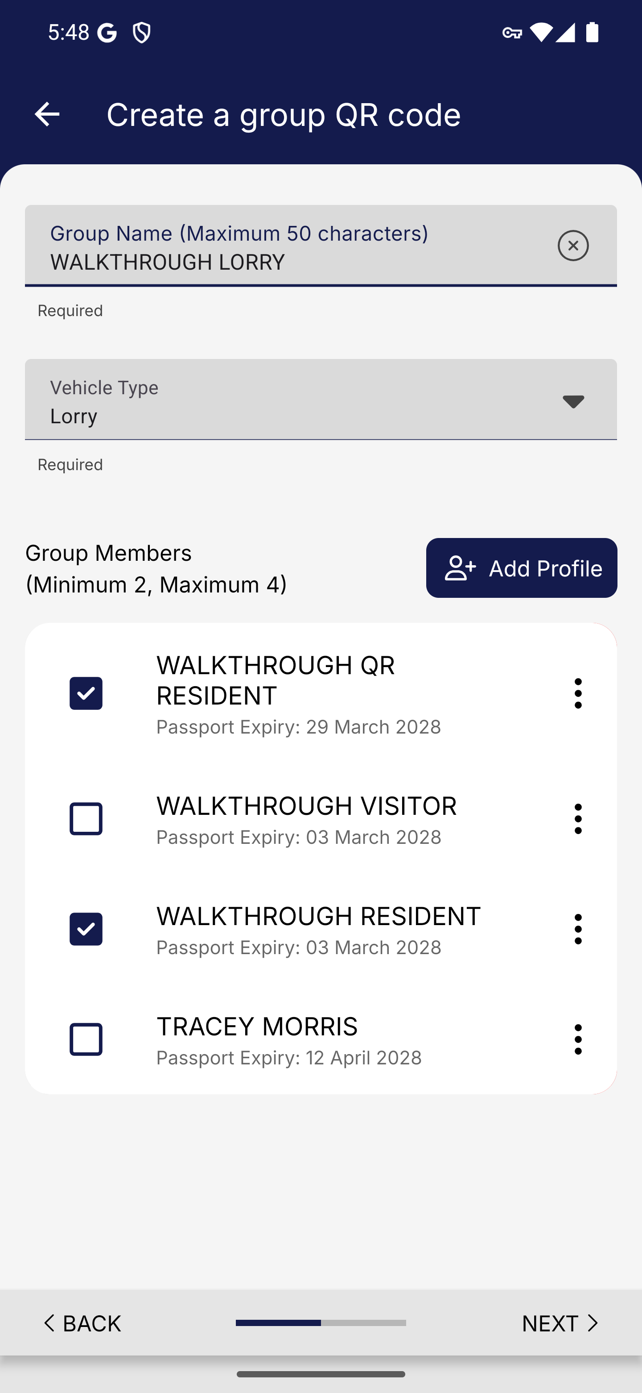
Screen 030 • 2026-09-07 17:49:31 • Captured

031 Lorry group confirmation
Review the two-passenger group.
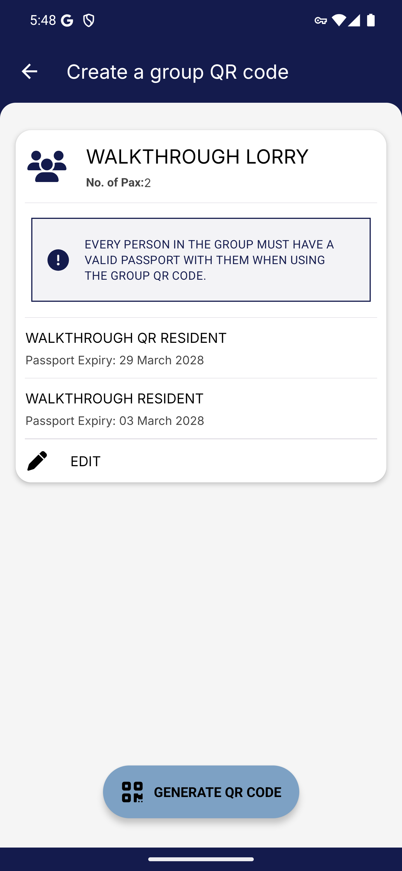
Screen 031 • 2026-09-07 17:49:32 • Captured

032 Lorry group QR code
Generate the group QR code.
A QR was generated for the two selected members.
Outcome: QR generated
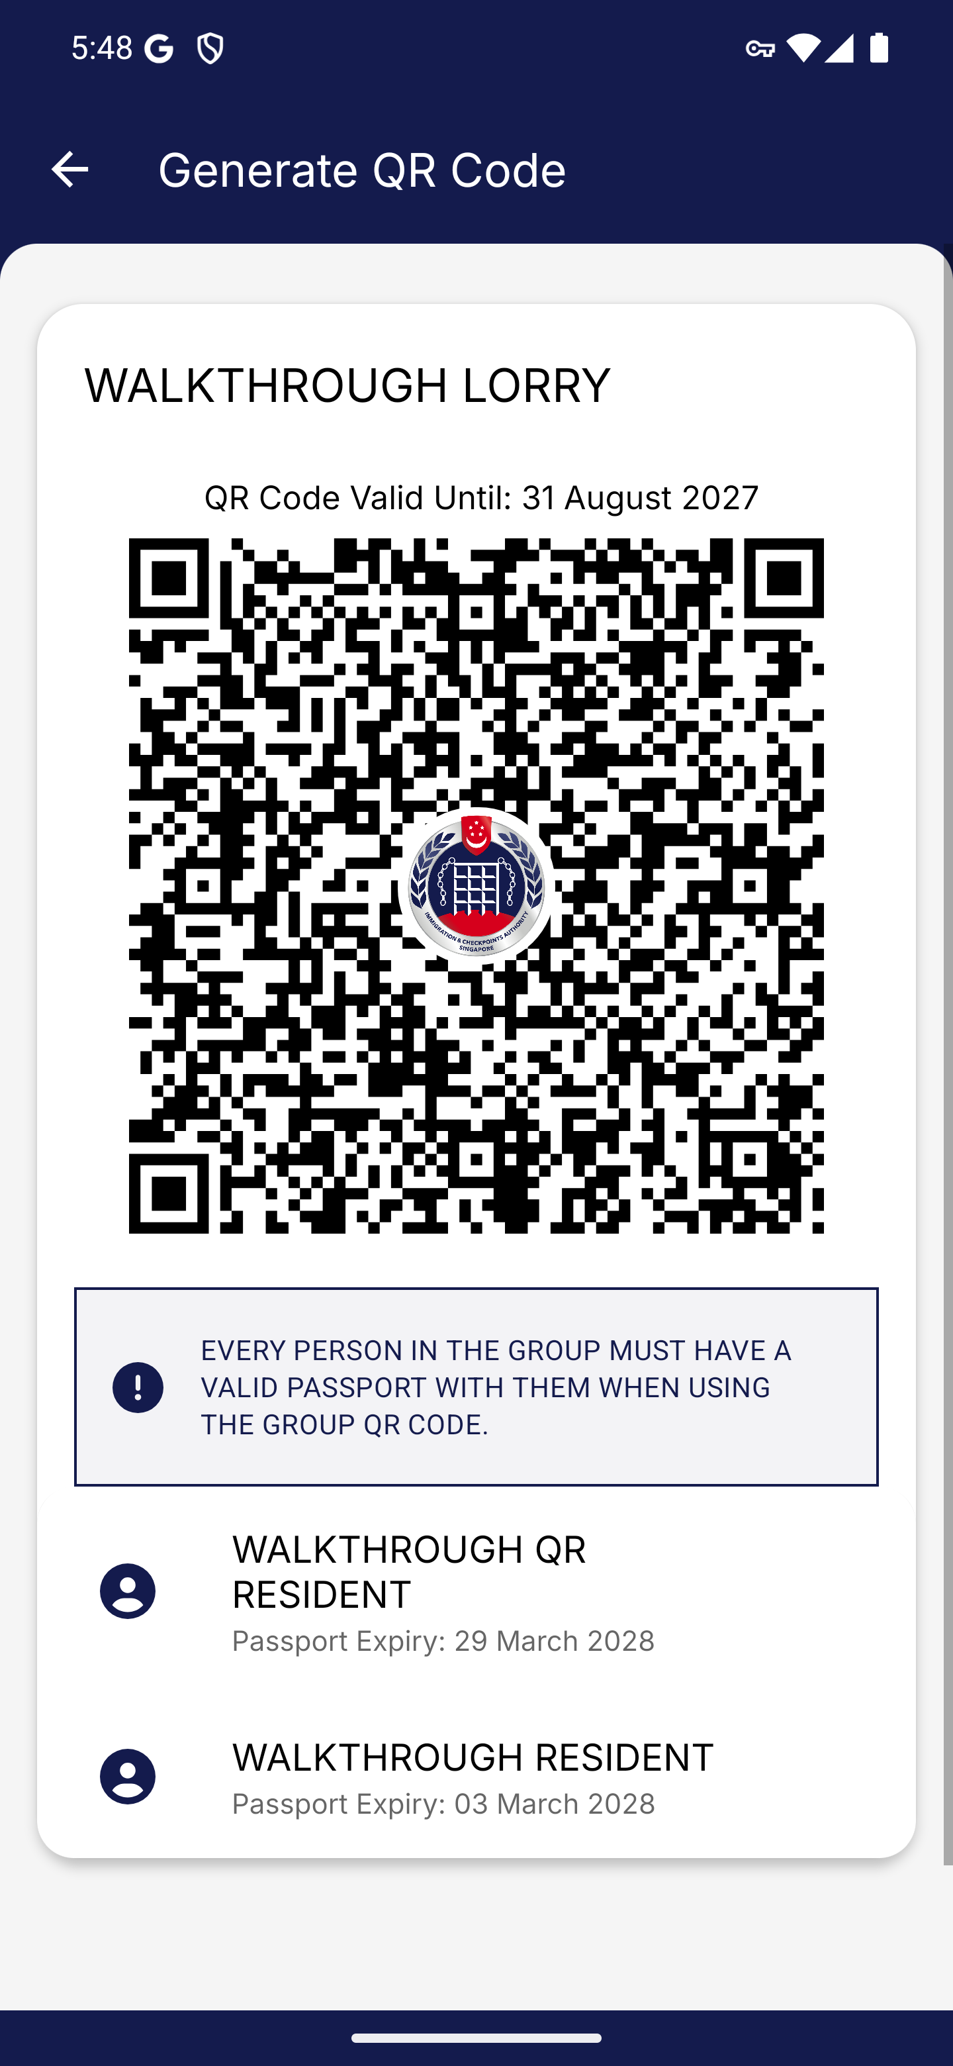
Screen 032 • 2026-09-07 17:49:33 • QR generated

033 Bus group limits and selected members
Select Bus and two synthetic resident profiles.
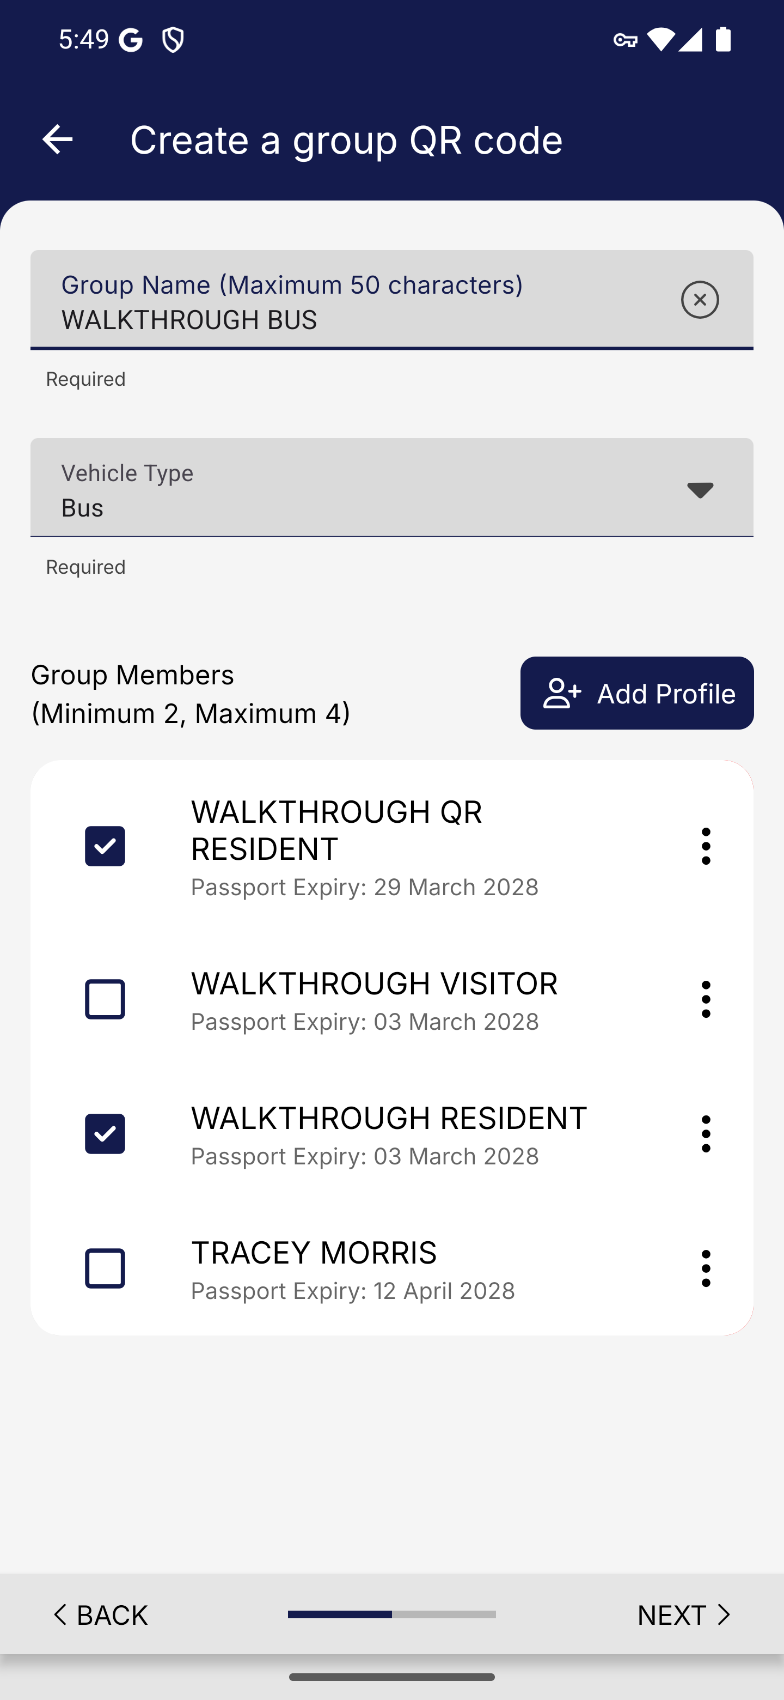
Screen 033 • 2026-09-07 17:49:41 • Captured

034 Bus group confirmation
Review the two-passenger group.
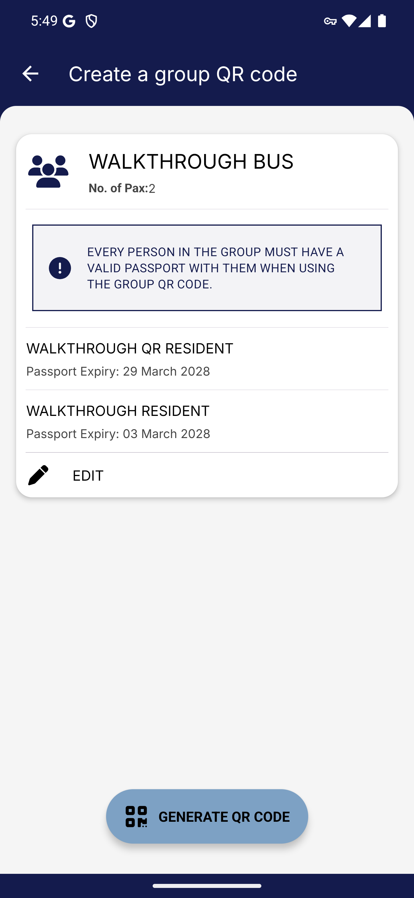
Screen 034 • 2026-09-07 17:49:43 • Captured

035 Bus group QR code
Generate the group QR code.
A QR was generated for the two selected members.
Outcome: QR generated
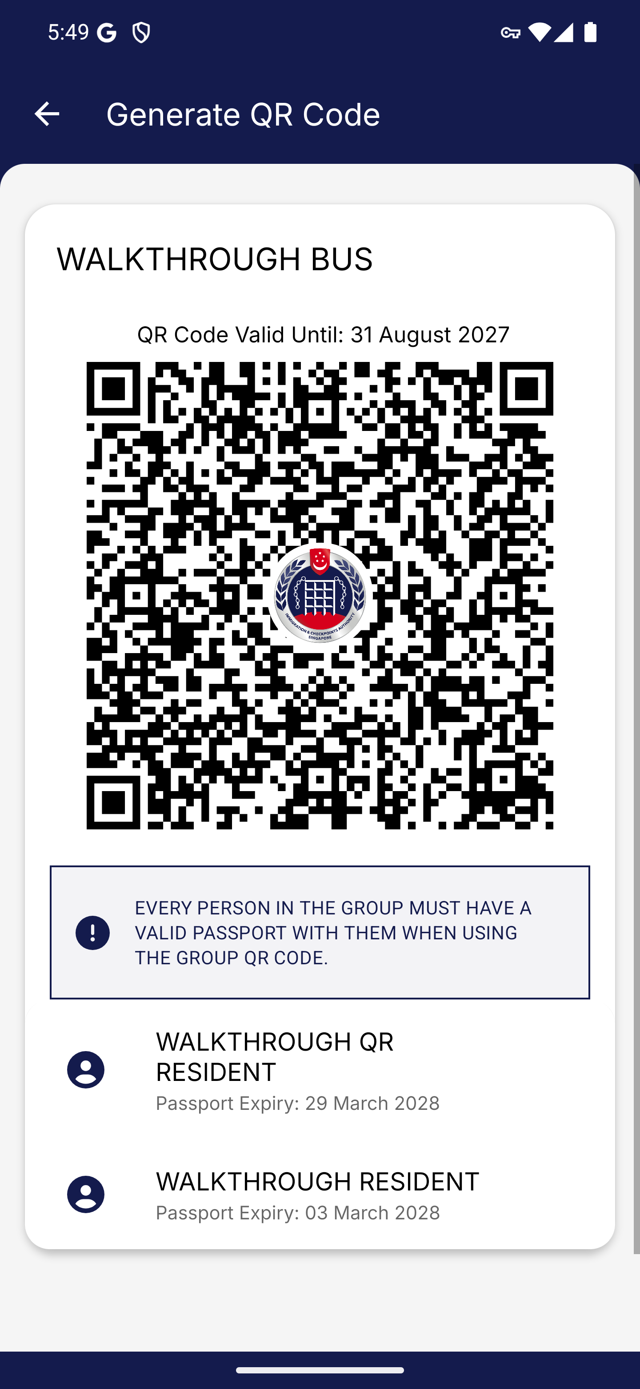
Screen 035 • 2026-09-07 17:49:44 • QR generated

036 All four group types saved
Return to the group list after generating car, motorcycle, lorry and bus codes.
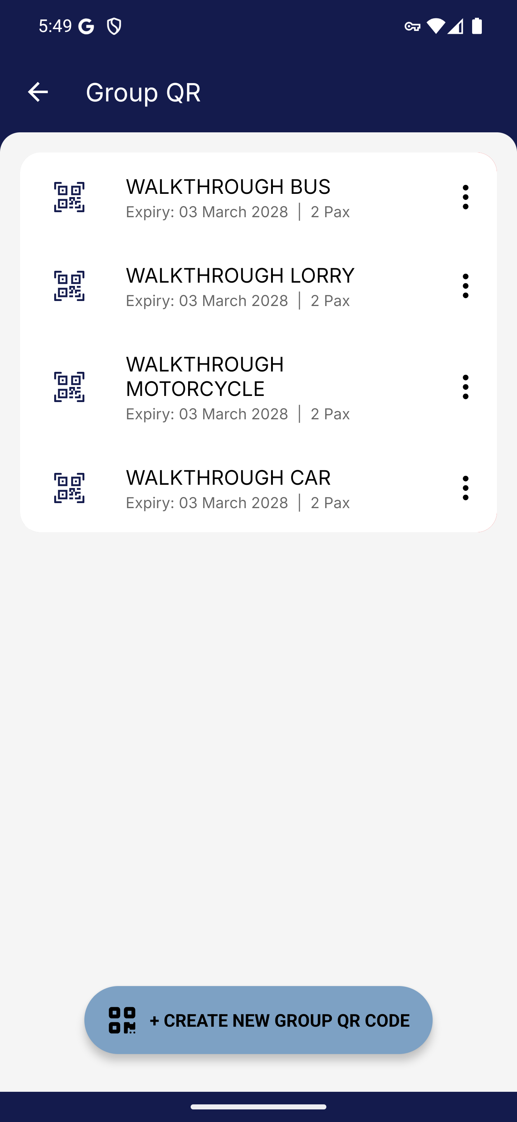
Screen 036 • 2026-09-07 17:49:57 • Captured

037 Group QR management menu
Open the menu for the walkthrough bus group.
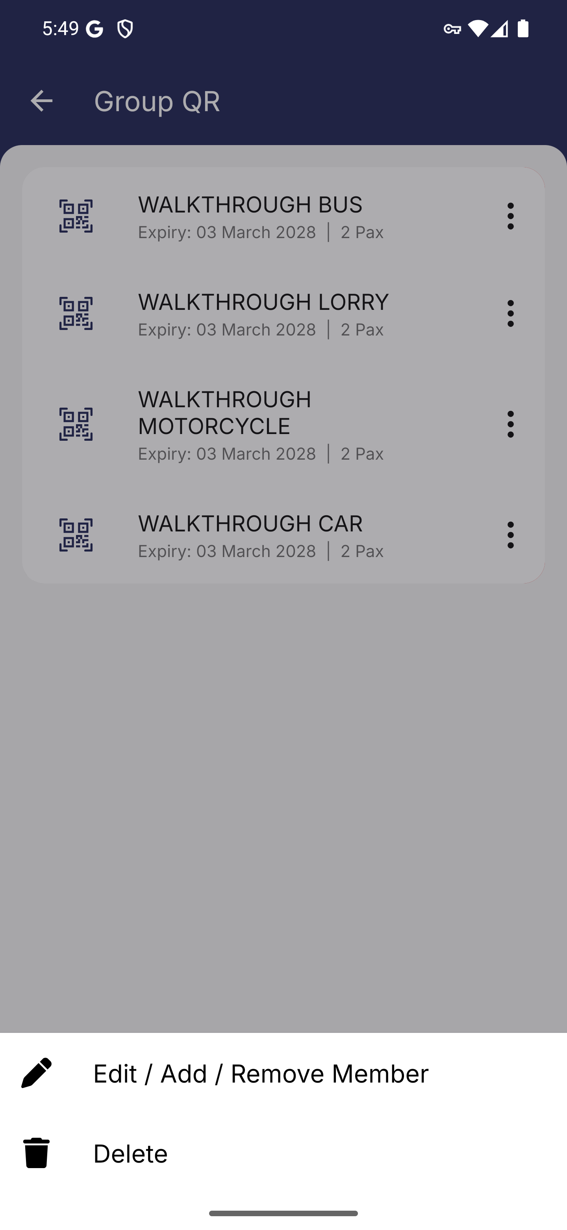
Screen 037 • 2026-09-07 17:49:58 • Captured

038 Edit a saved group QR
Choose Edit / Add / Remove Member.
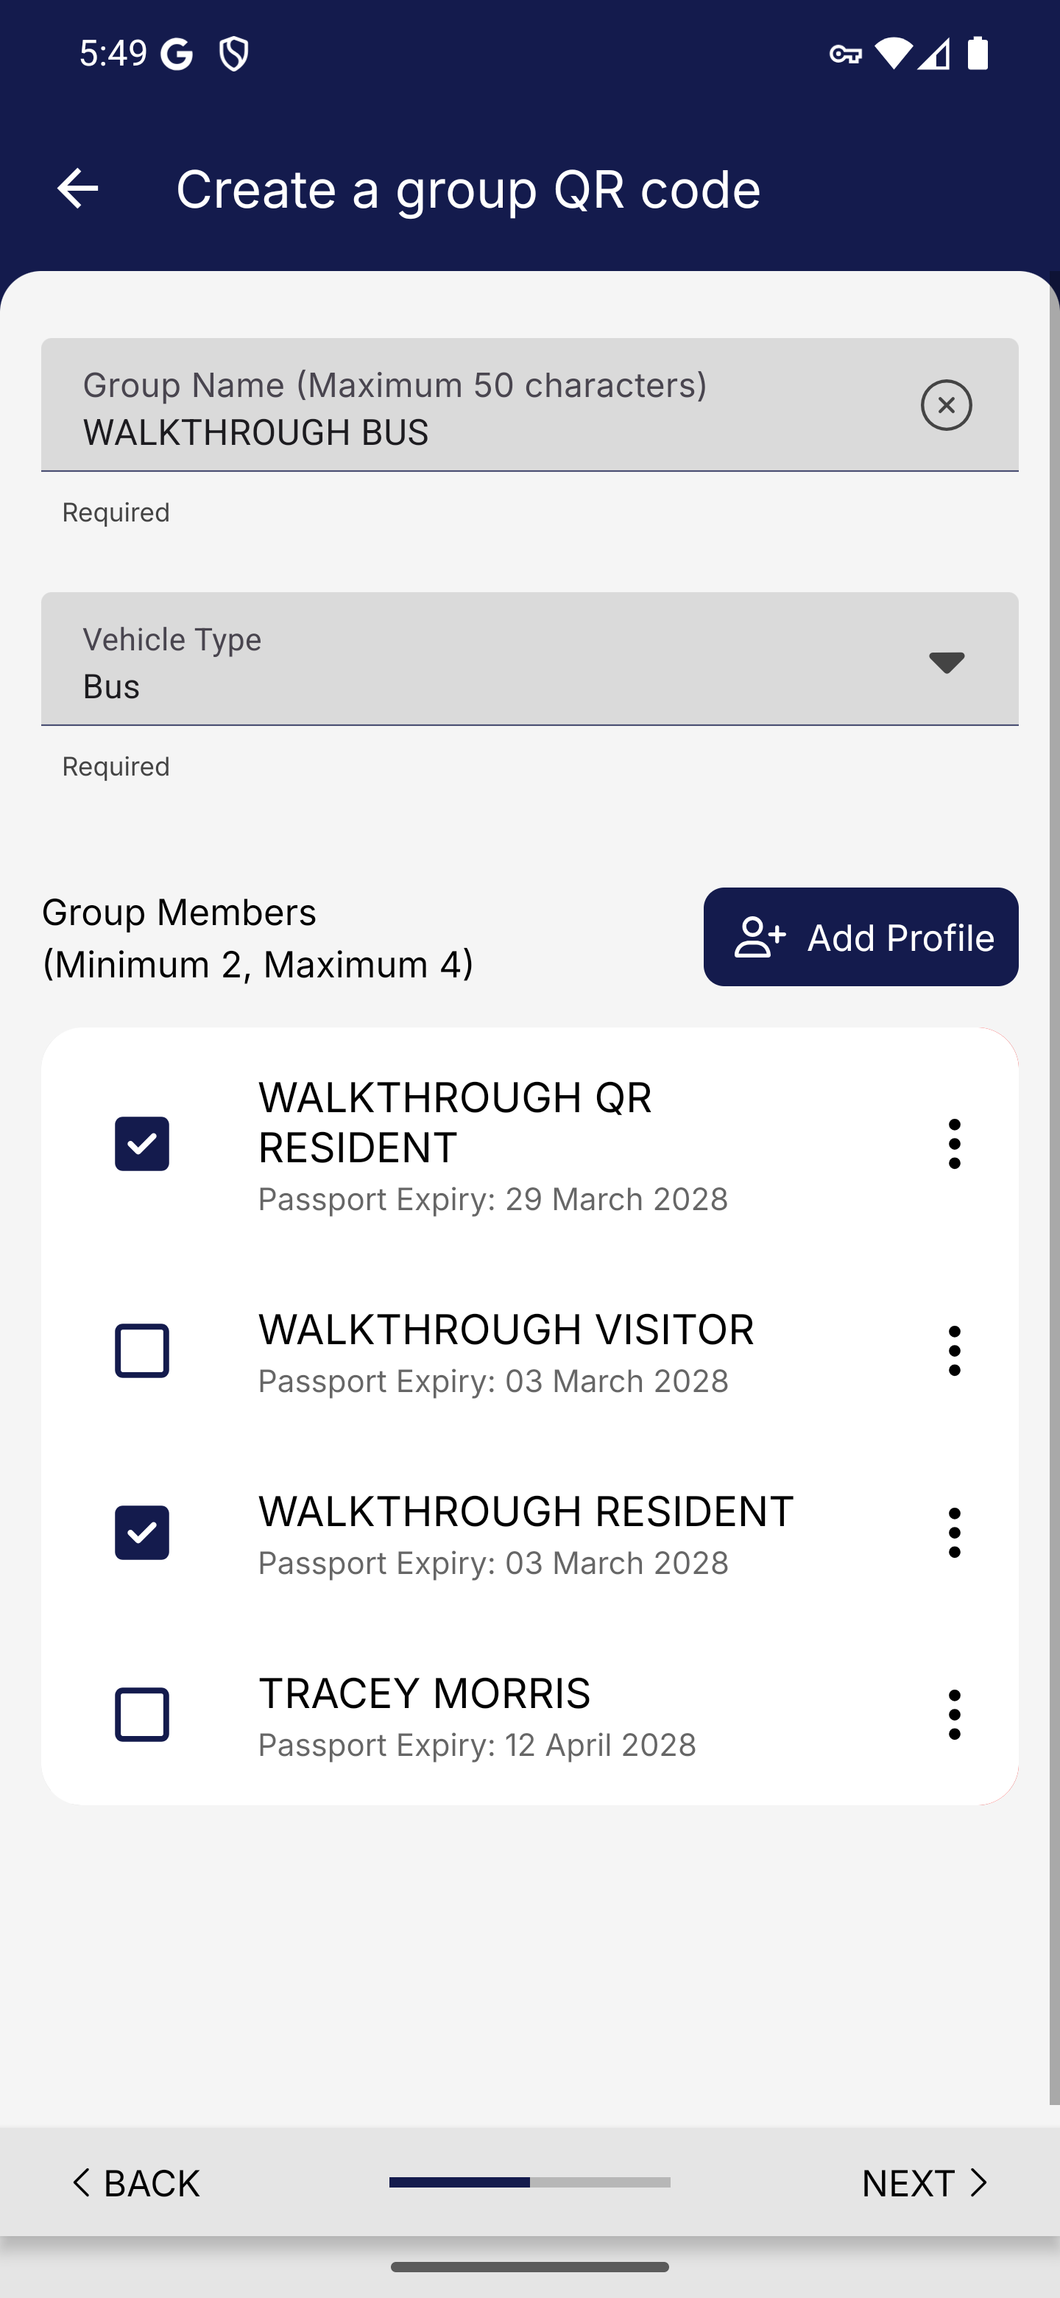
Screen 038 • 2026-09-07 17:50:30 • Captured

039 Updated bus group QR
Save the renamed bus group and regenerate its QR.
The saved group name changed to WALKTHROUGH BUS EDITED and its QR was displayed.
Outcome: Completed
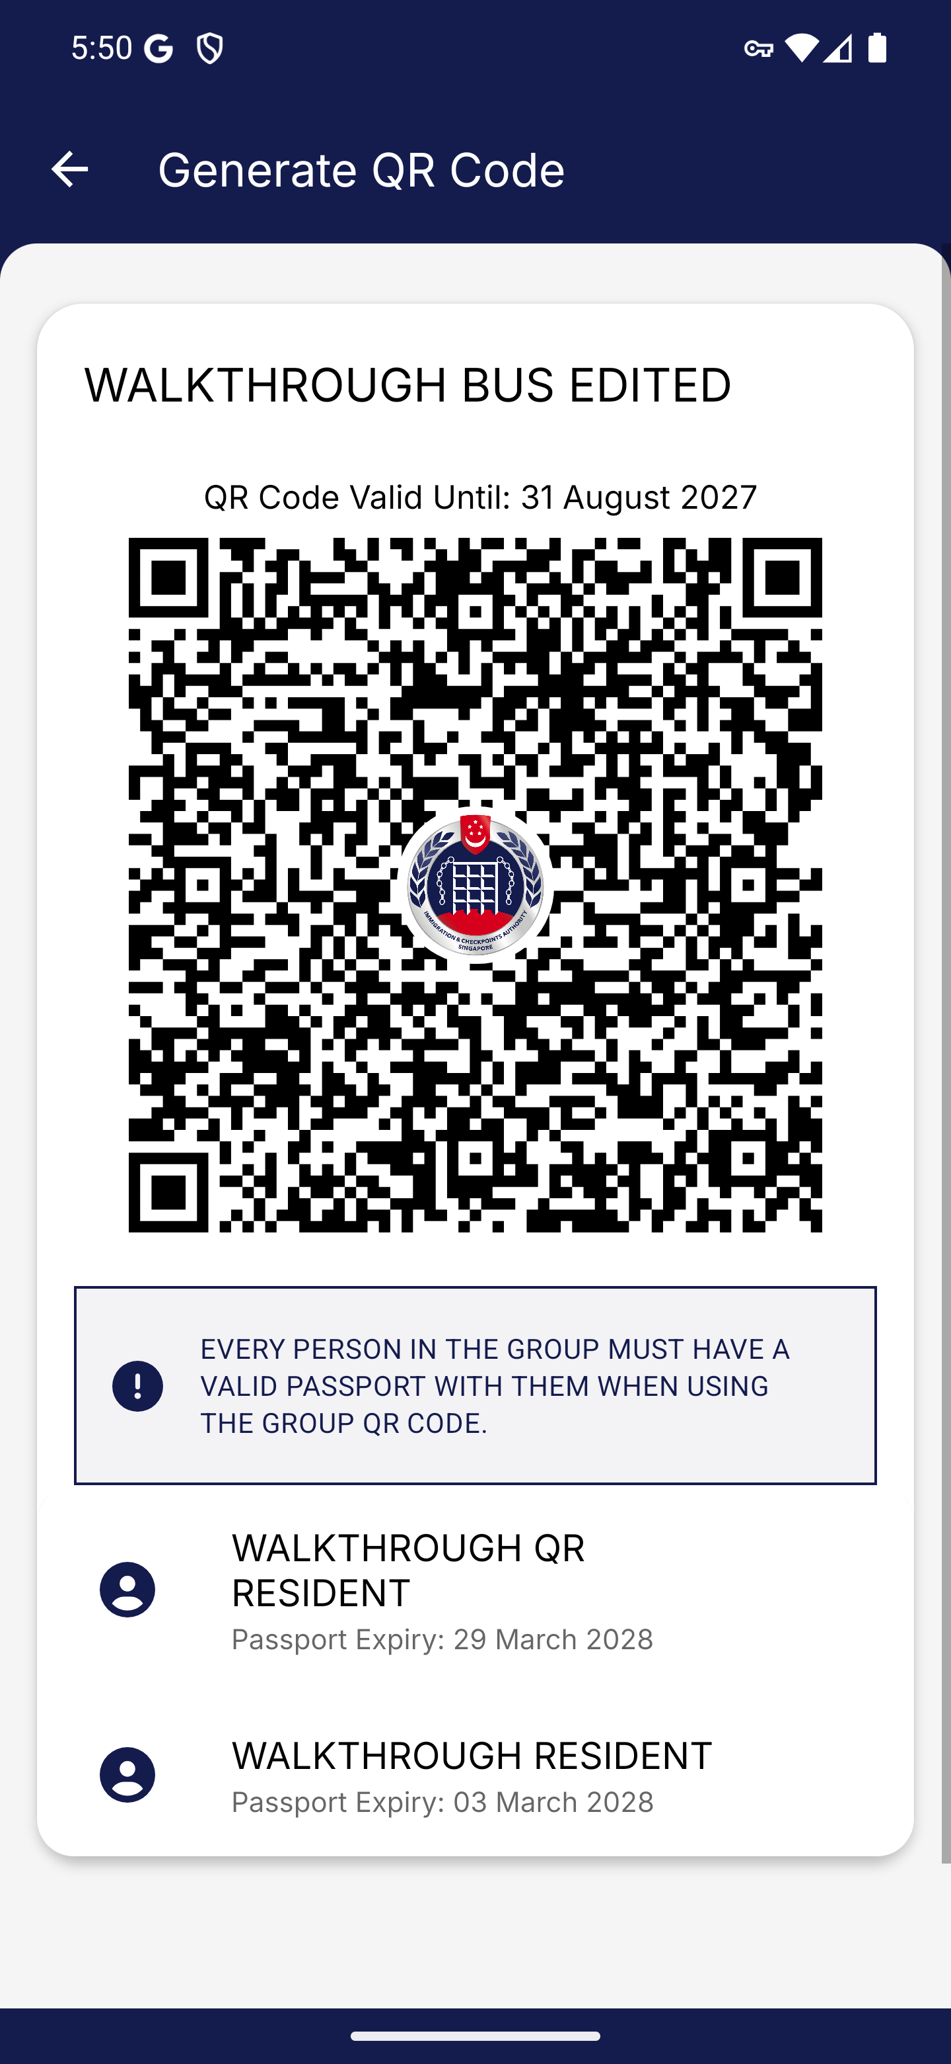
Screen 039 • 2026-09-07 17:50:35 • Completed

040 Delete walkthrough group confirmation
Choose Delete for the bus group created in this walkthrough.
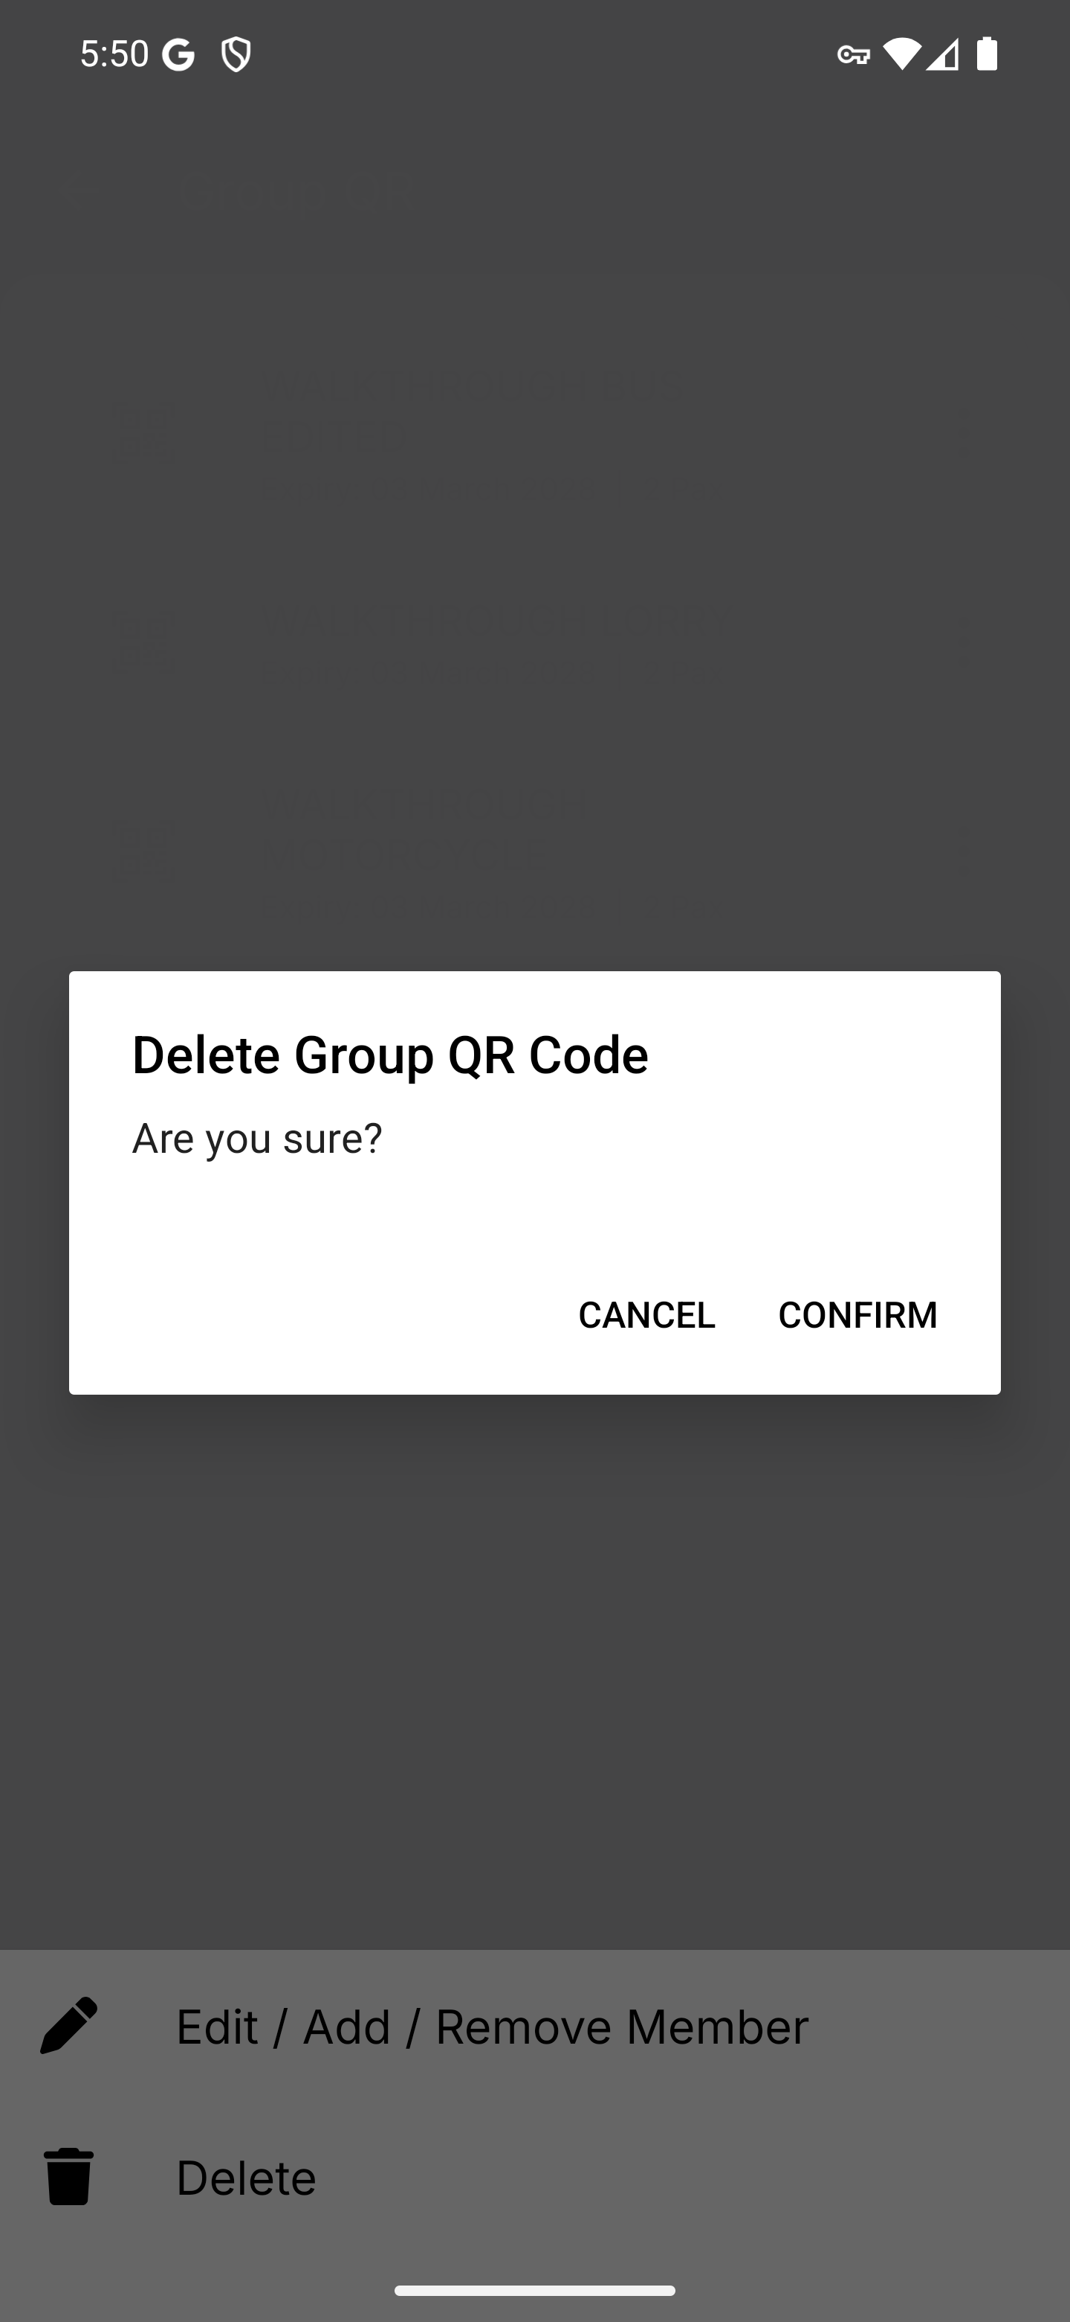
Screen 040 • 2026-09-07 17:50:38 • Captured

041 Walkthrough bus group deleted
Confirm deletion of the bus group created for this walkthrough.
The bus group disappeared after confirmation. The car, motorcycle and lorry walkthrough groups remain.
Outcome: Completed
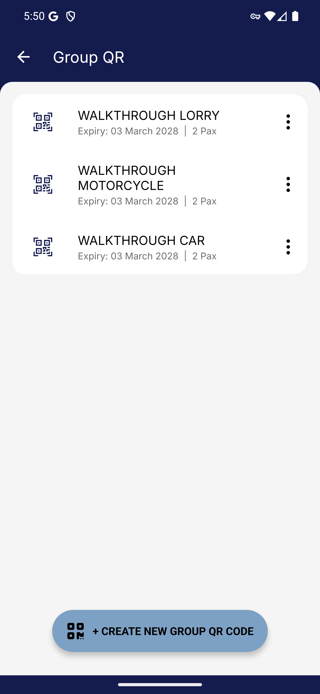
Screen 041 • 2026-09-07 17:50:52 • Completed

