  - PROJECT DOCUMENTATION

Cargo and convoy clearance
Vehicle-profile creation and editing, full and partial clearance permits, cargo review, existing-submission retrieval, and a two-vehicle convoy through review.
33 screen captures • Pixel 7 Pro emulator • Android 16 • English
Captured from the installed staging app on 7 September 2026. Screenshots are original device PNGs. This is a screen walkthrough; it does not certify every test case or every input combination.

Coverage and outcomes
Flow / branch | Observed outcome
Create vehicle profile | Completed: SBA1234G saved with synthetic contact details after required-field validation.
Edit vehicle profile | Completed: email updated and the new value carried into the cargo submission form.
Cargo with full clearance | Synthetic permit IG2BB990001 saved and displayed in review.
Cargo with partial clearance | Synthetic permit IG2BB990002 with quantity 10 saved alongside the full-clearance permit and displayed in review.
Cargo submission | Review and Submit control reached. No declaration was sent and no application reference was generated.
Manage existing submission | ARN and vehicle-number retrieval form opened. A matching submitted reference is needed to continue.
Two-vehicle convoy | Two synthetic vehicles, contact details and permit IG2BB990003 accepted through review. No convoy declaration was sent.
Convoy low value goods | YES selected. Attempting Next without a permit showed Please fill in the field above; saving a permit allowed review.
Language | Cargo language selector opened. English retained.
The convoy page displays a 15-vehicle limit and the cargo permit page displays a 100-permit limit; these maxima were not exercised.
Native screens belong to the staging app. In-app web endpoints may use a different environment. Only draft form navigation was performed; real-world declarations were not submitted.
No barcode fixture, existing ARN or physical cargo-checkpoint equipment was supplied. Permit scanning, amendment of a submitted declaration and physical clearance remain outside the completed walkthrough.

How to use this document
Each following page records one screen, the action used to reach it, and any relevant observation. Screen numbers match the category manifest and PNG filenames. Source XML and SHA-256 hashes are retained beside the screenshots for traceability. Open the original PNG when you need to zoom into small text.

001 Cargo clearance dashboard
Choose Cargo Clearance from Home.
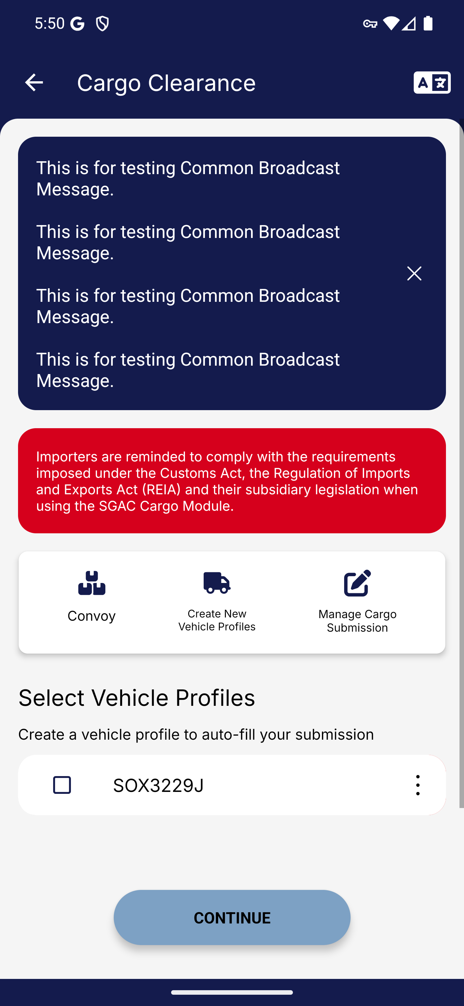
Screen 001 • 2026-09-07 17:50:57 • Captured

002 Cargo dashboard actions
Close the staging broadcast banner to view cargo actions.
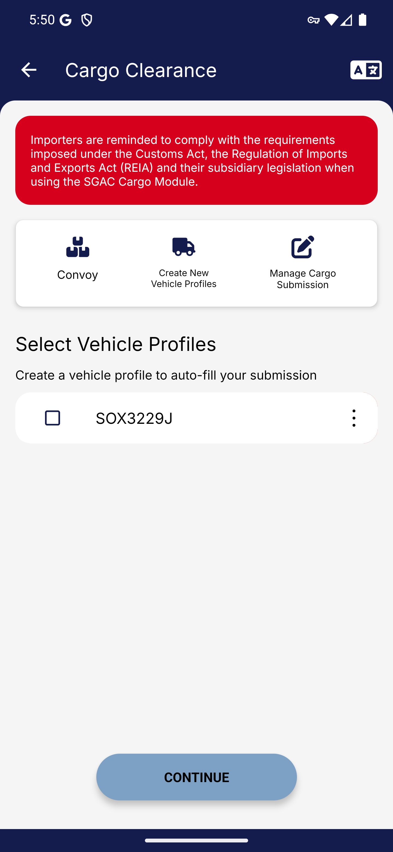
Screen 002 • 2026-09-07 17:51:17 • Captured

003 Vehicle profiles list
Choose Create New Vehicle Profiles.
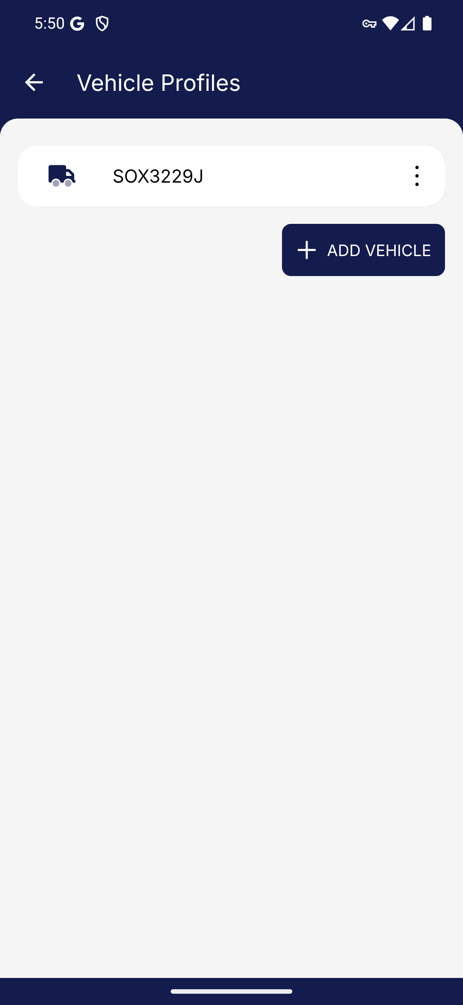
Screen 003 • 2026-09-07 17:51:19 • Captured

004 Add vehicle profile form
Choose Add Vehicle.
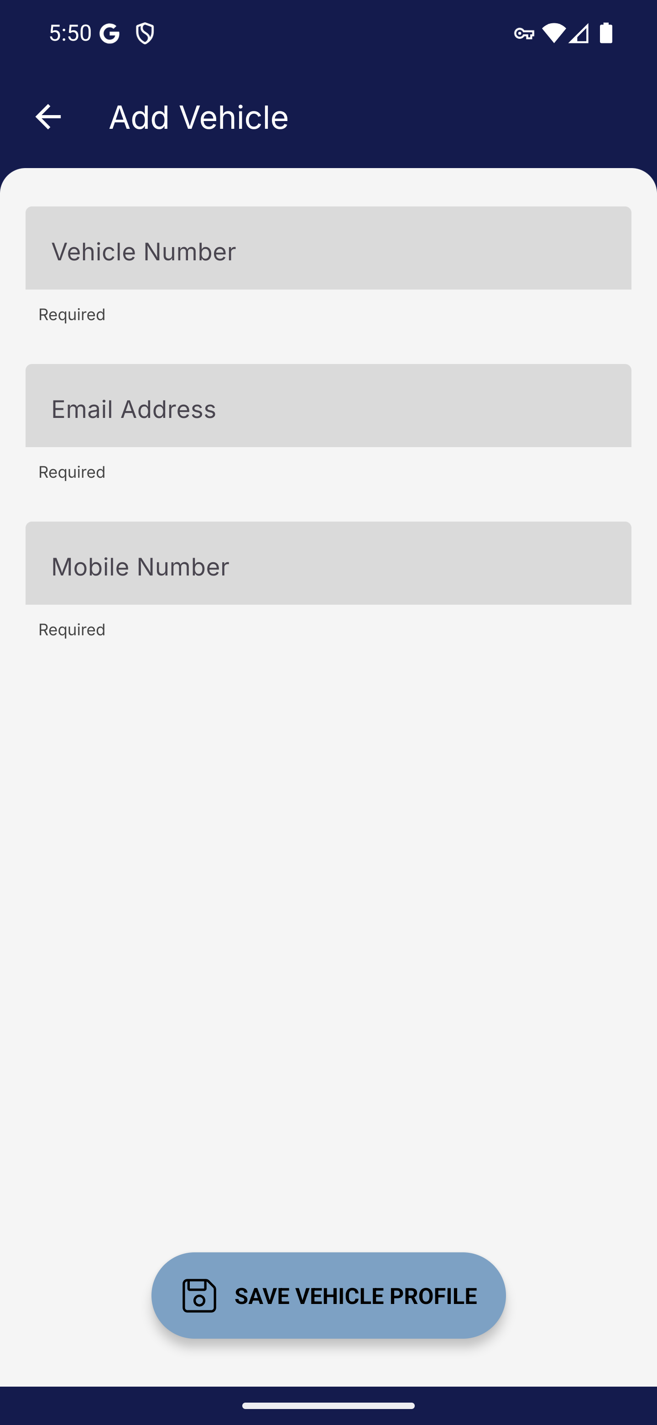
Screen 004 • 2026-09-07 17:51:20 • Captured

005 Vehicle profile required field validation
Attempt to save an empty vehicle profile.
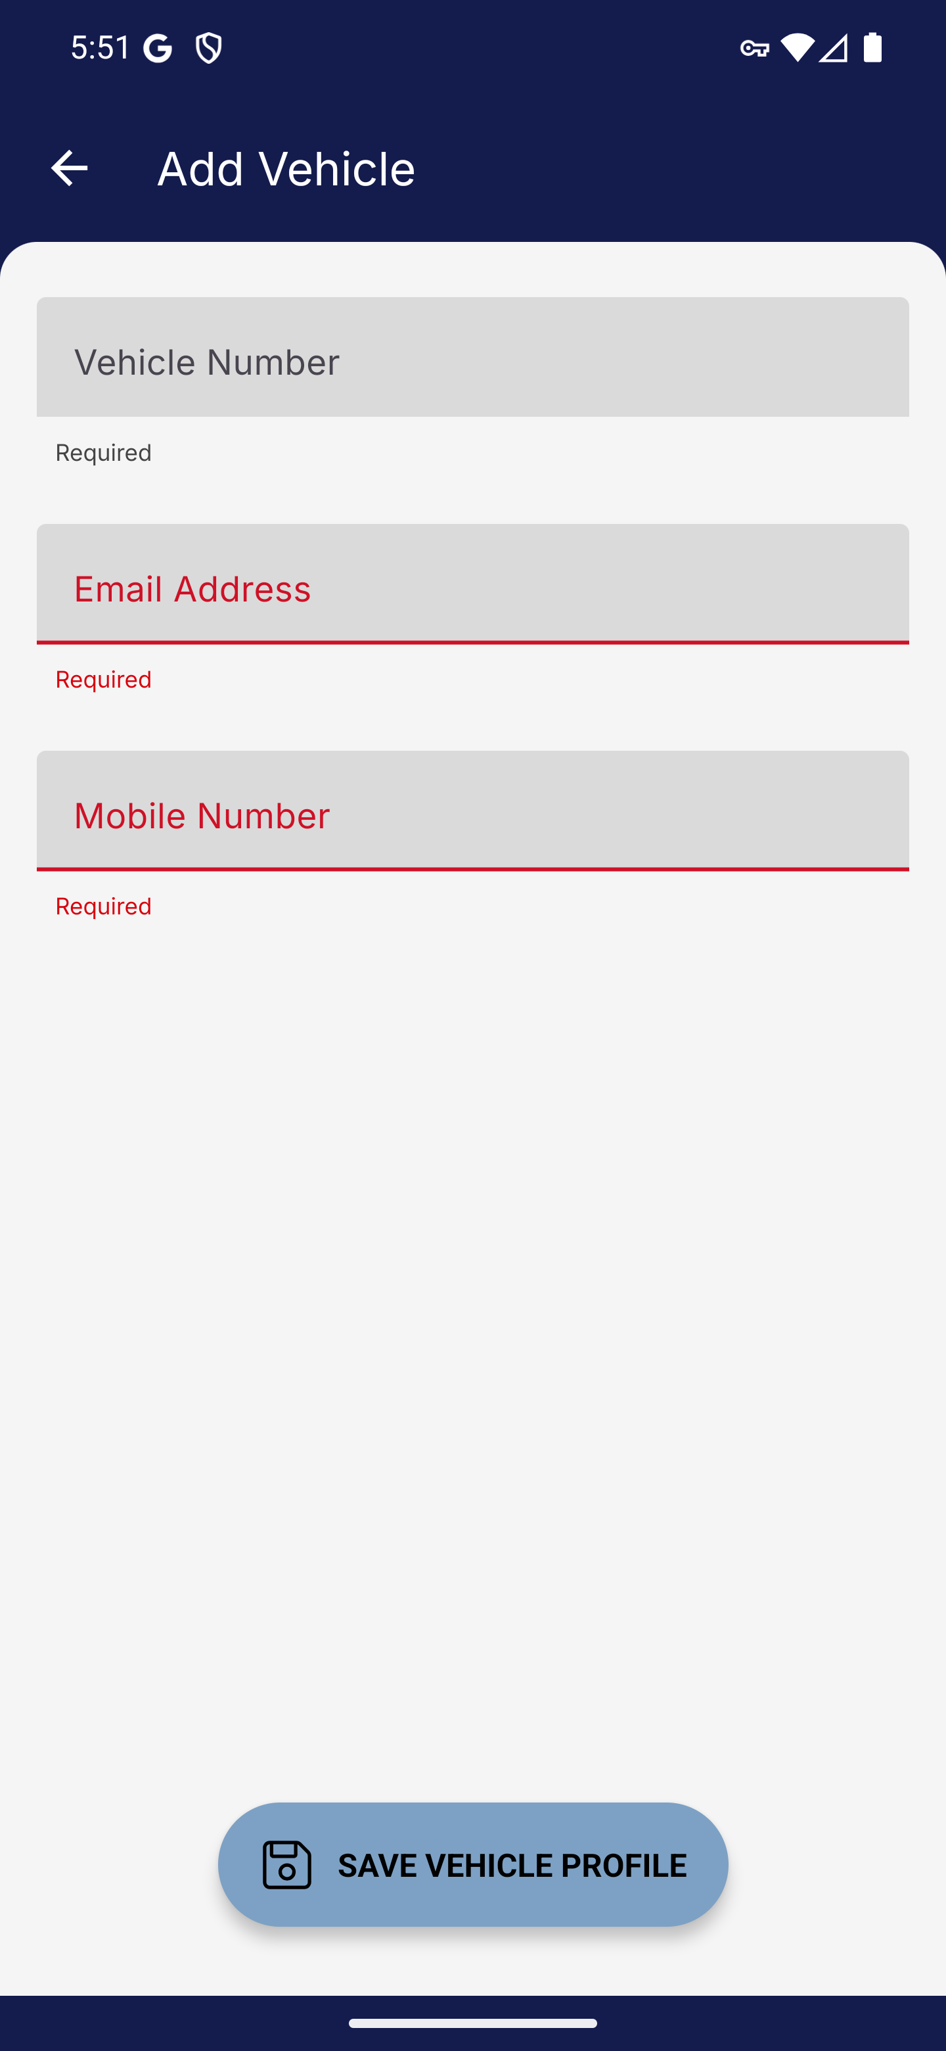
Screen 005 • 2026-09-07 17:51:43 • Captured

006 Completed walkthrough vehicle profile
Enter the synthetic walkthrough vehicle and contact details.
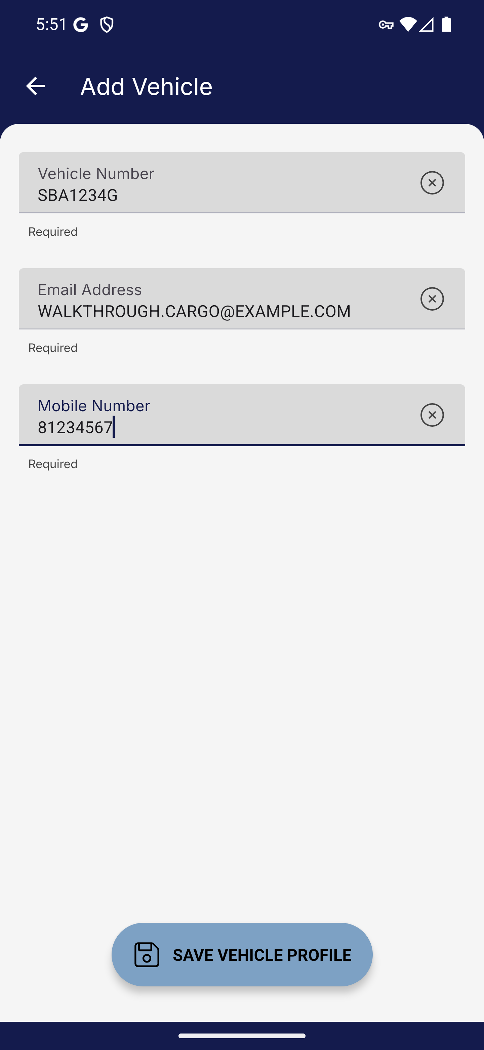
Screen 006 • 2026-09-07 17:51:49 • Captured

007 Vehicle profile saved
Save the new vehicle profile.
SBA1234G appears in the saved vehicle list.
Outcome: Completed
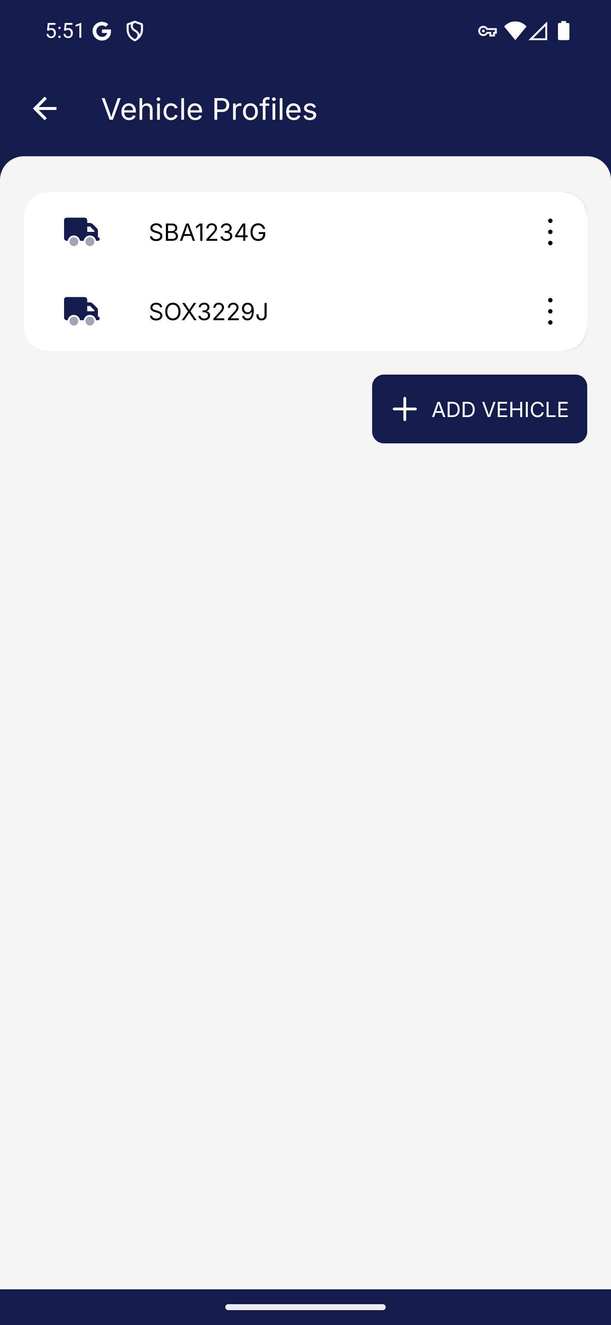
Screen 007 • 2026-09-07 17:51:50 • Completed

008 Vehicle profile management menu
Open the saved walkthrough vehicle profile.
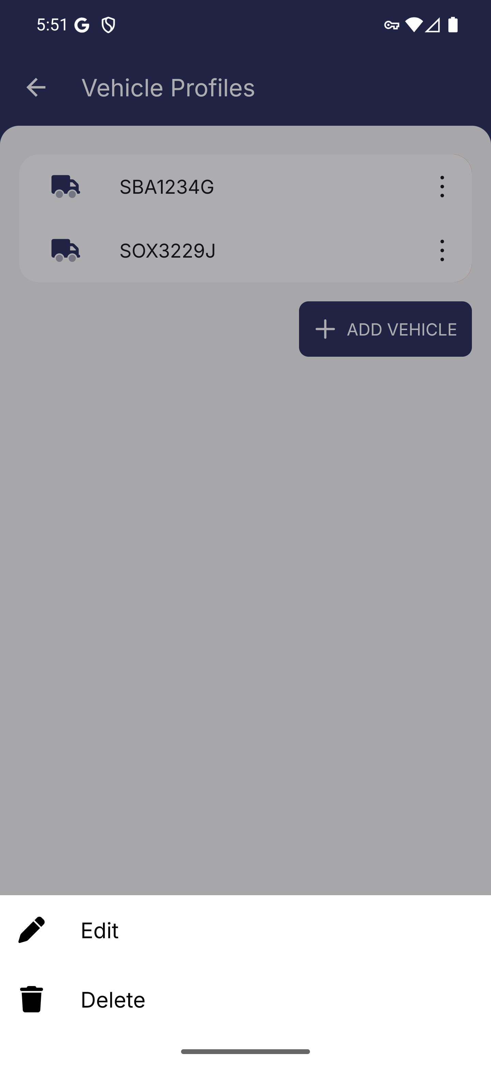
Screen 008 • 2026-09-07 17:51:52 • Captured

009 Edit vehicle profile
Choose Edit for the walkthrough vehicle.
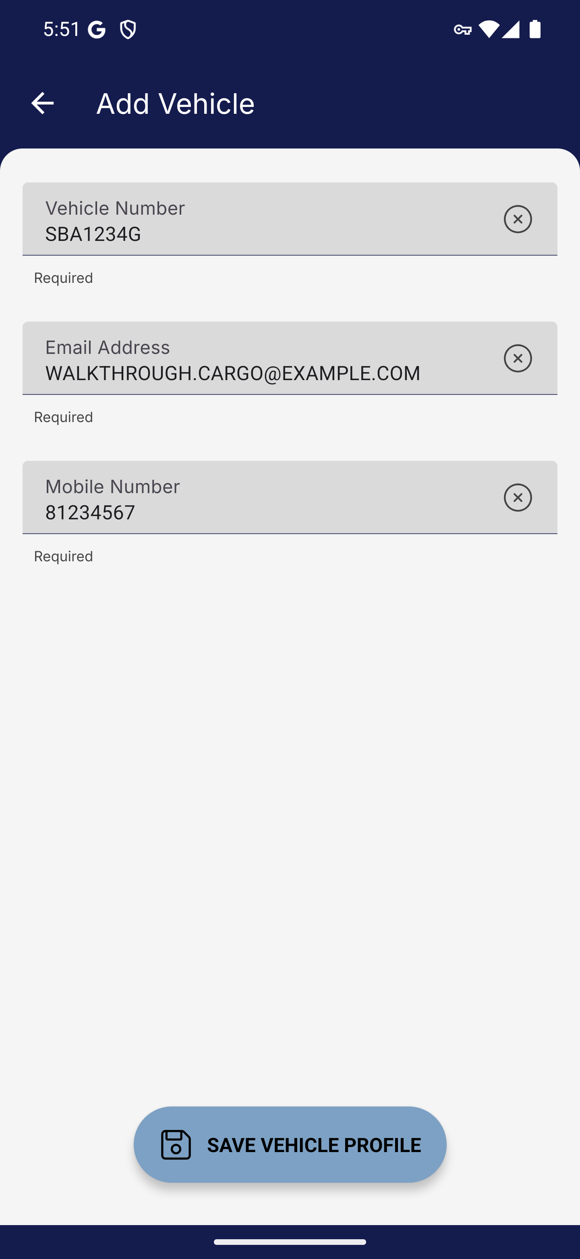
Screen 009 • 2026-09-07 17:52:10 • Captured

010 Vehicle profile update saved
Save the updated synthetic email address.
The edited vehicle profile was saved; the updated email appears in the subsequent cargo form.
Outcome: Completed
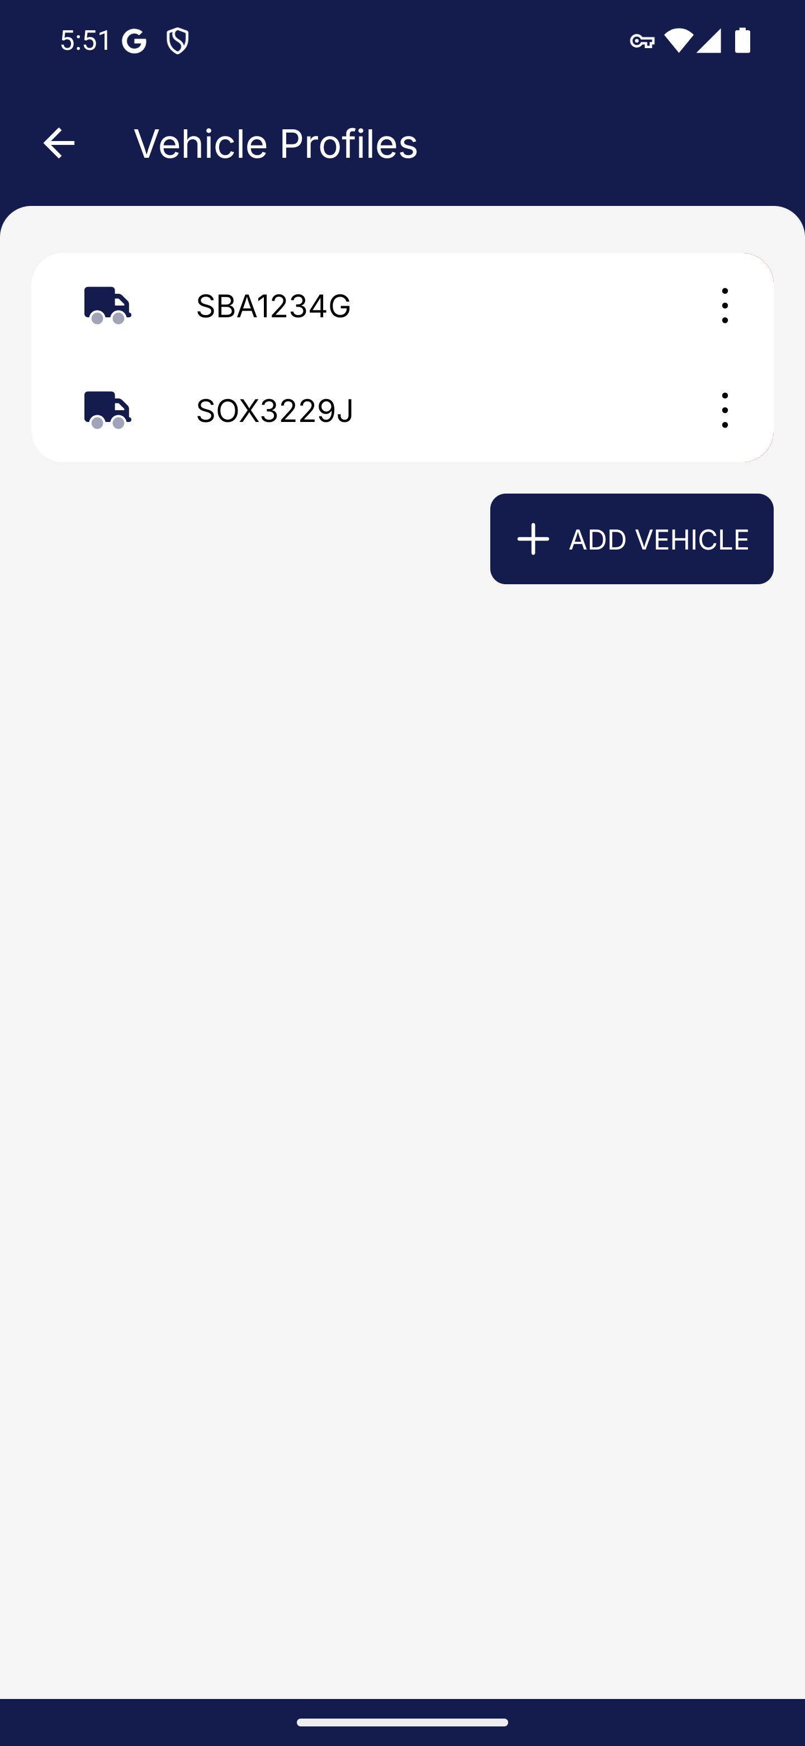
Screen 010 • 2026-09-07 17:52:15 • Completed

011 Vehicle selected for cargo submission
Select the walkthrough vehicle on the cargo dashboard.
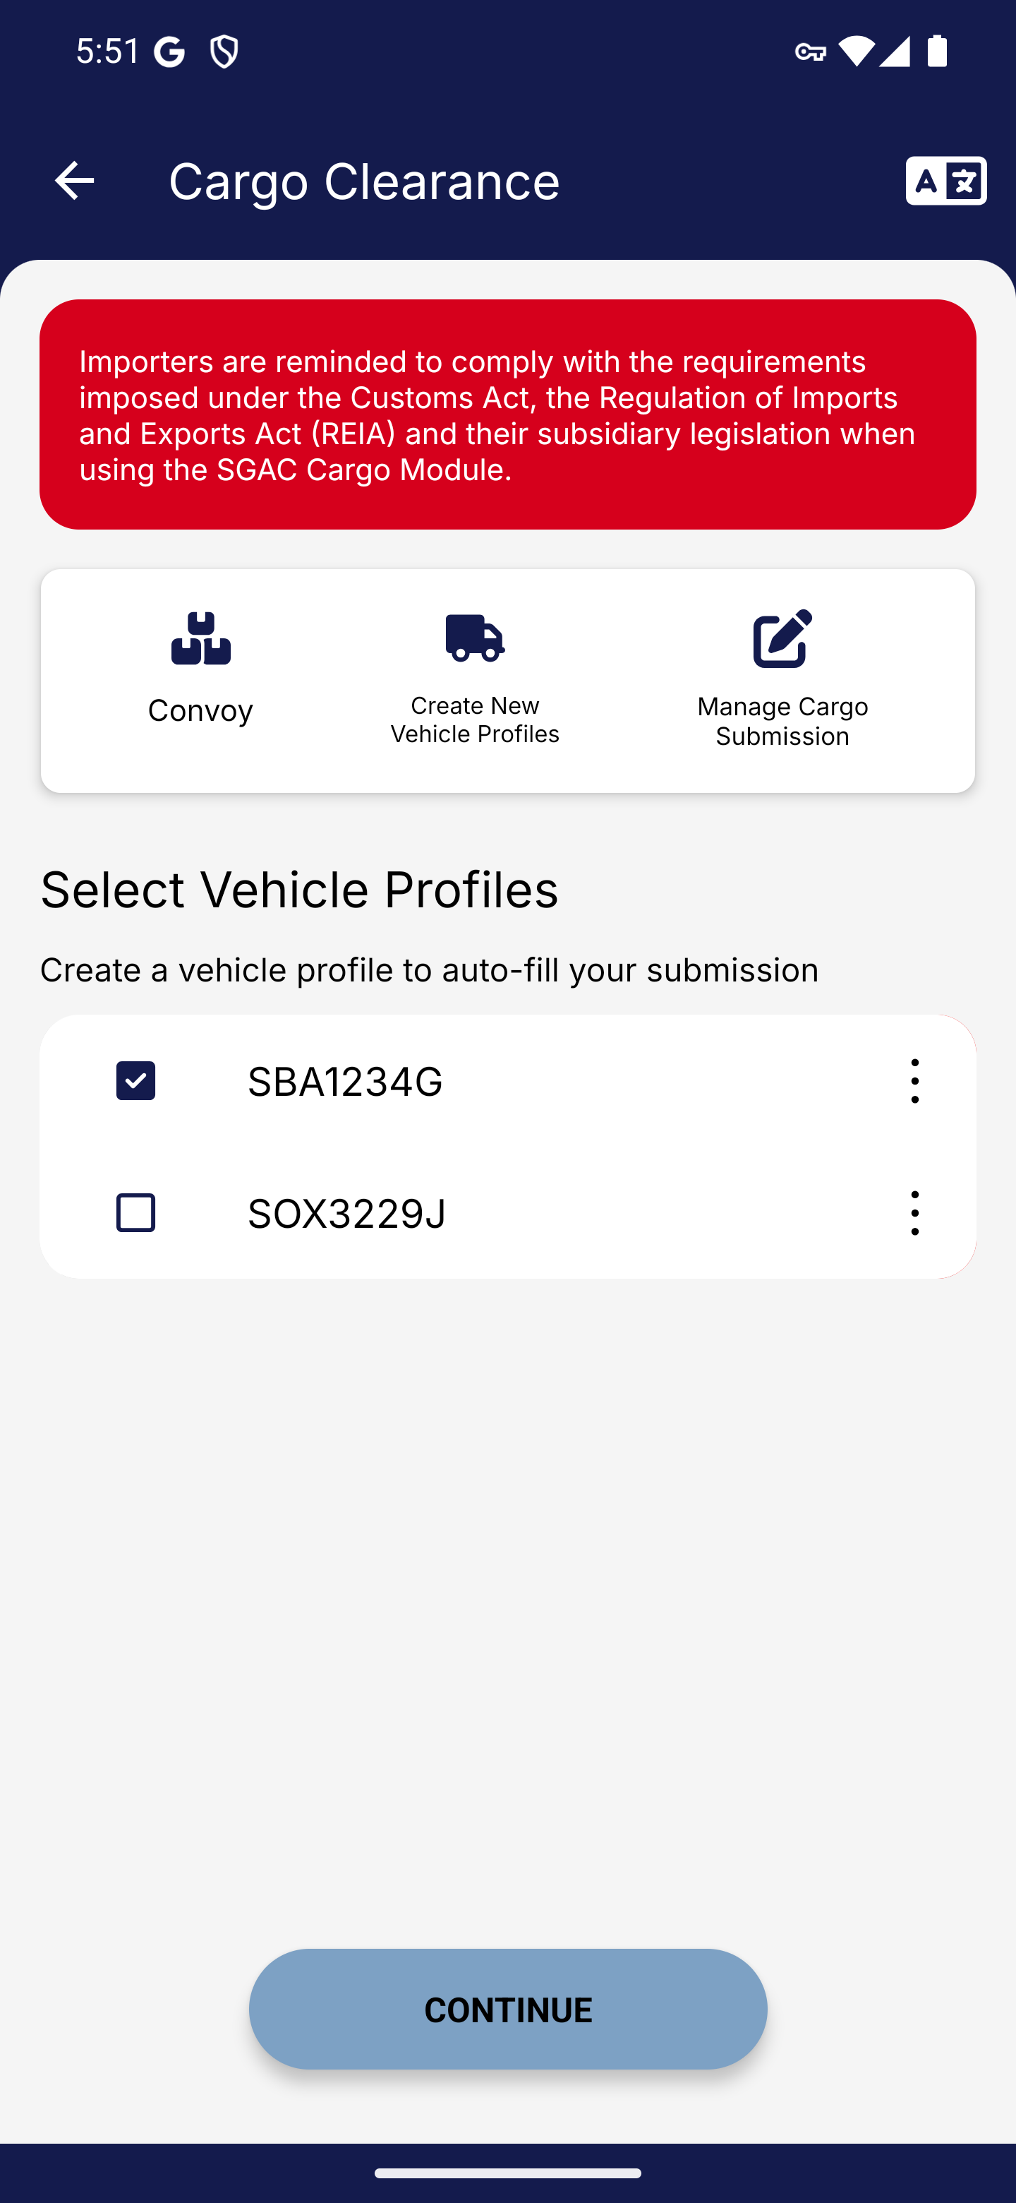
Screen 011 • 2026-09-07 17:52:17 • Captured

012 Cargo submission details loaded
Wait for the cargo submission web form.
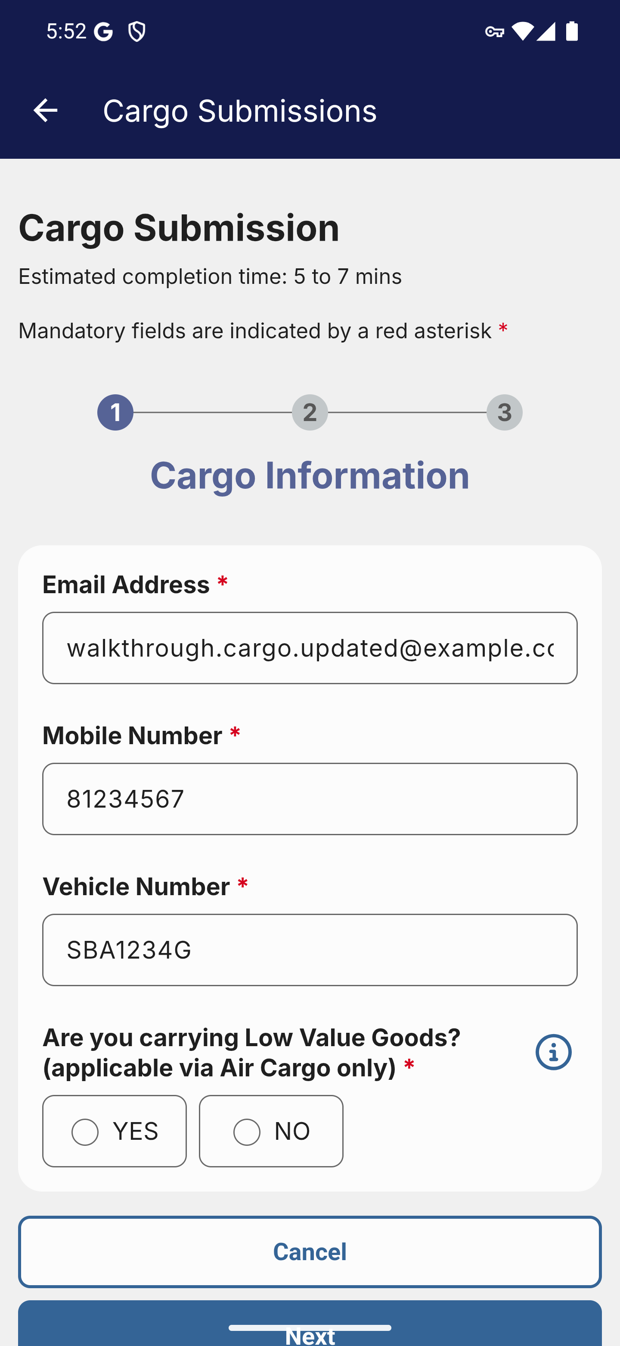
Screen 012 • 2026-09-07 17:52:41 • Captured

013 Cargo submission additional fields
Scroll through the cargo submission form.
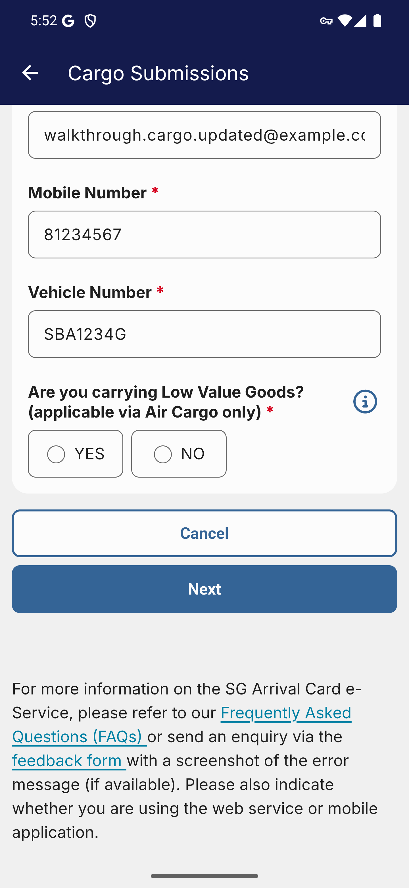
Screen 013 • 2026-09-07 17:52:42 • Captured

014 Cargo permit entry step
Choose No for Low Value Goods and continue.
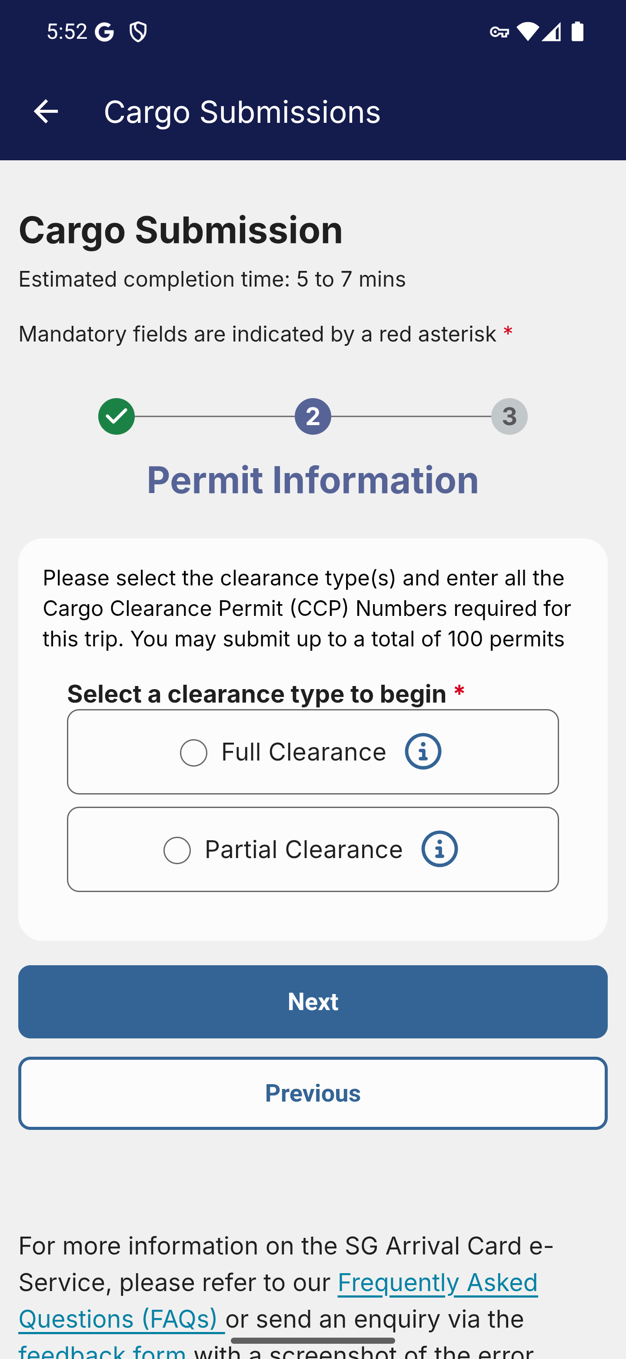
Screen 014 • 2026-09-07 17:53:15 • Captured

015 Full-clearance permit fields
Choose Full Clearance.
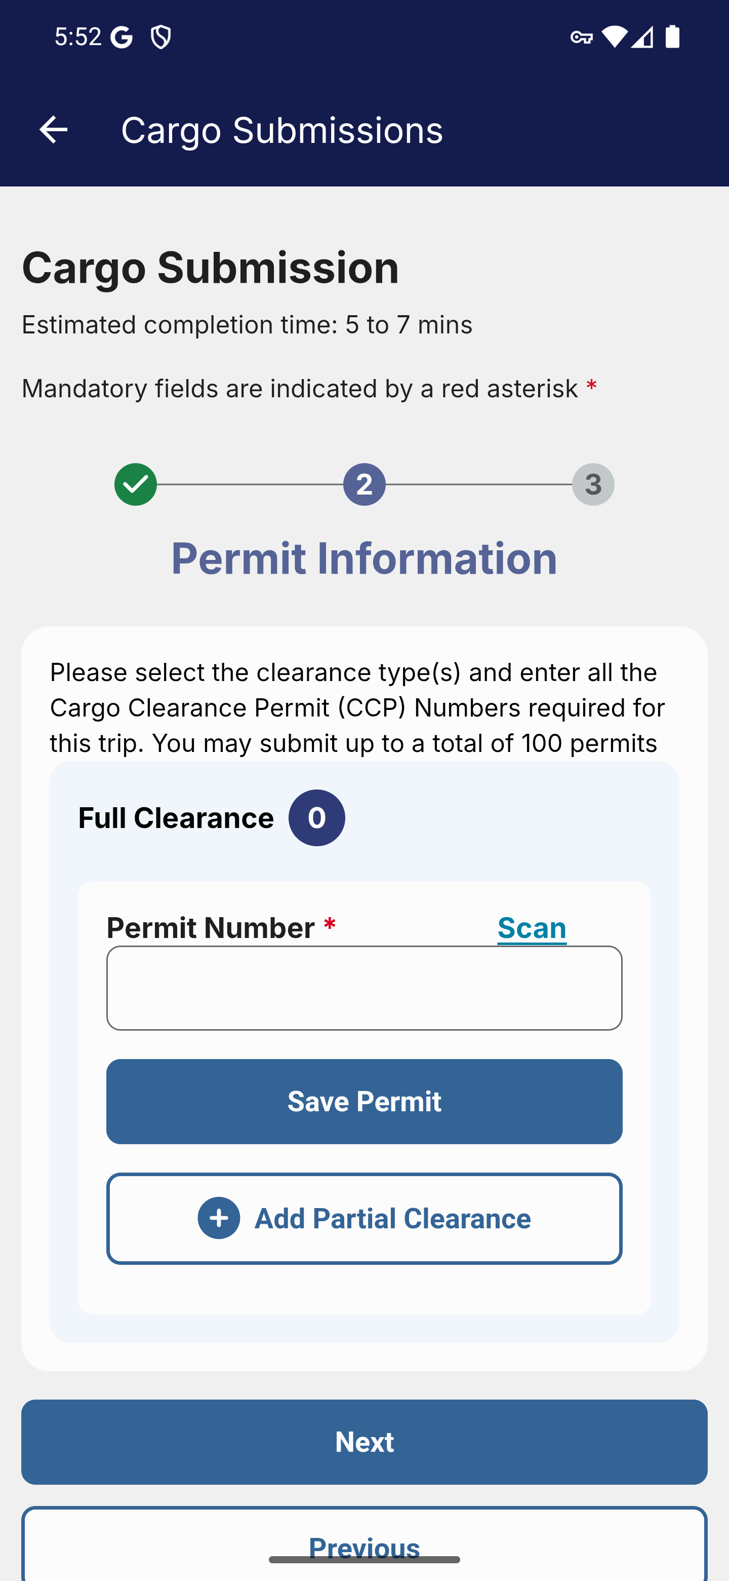
Screen 015 • 2026-09-07 17:53:30 • Captured

016 Full-clearance permit saved
Add permit IG2BB990001 from the repository test fixture.
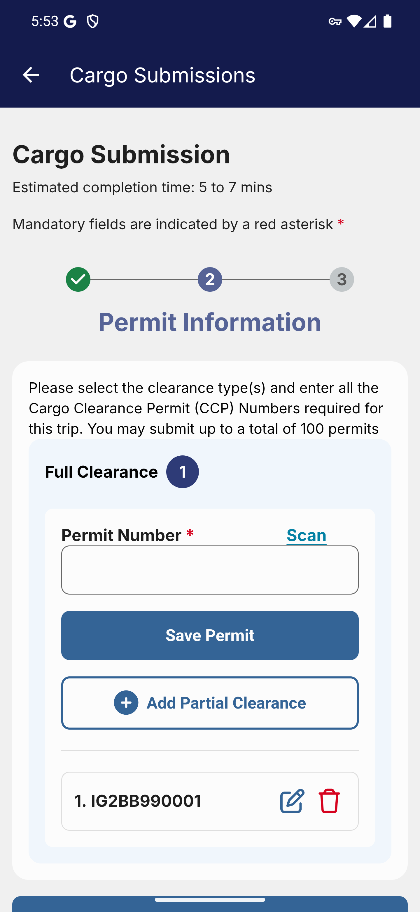
Screen 016 • 2026-09-07 17:53:56 • Captured

017 Partial-clearance permit fields
Add a Partial Clearance section.
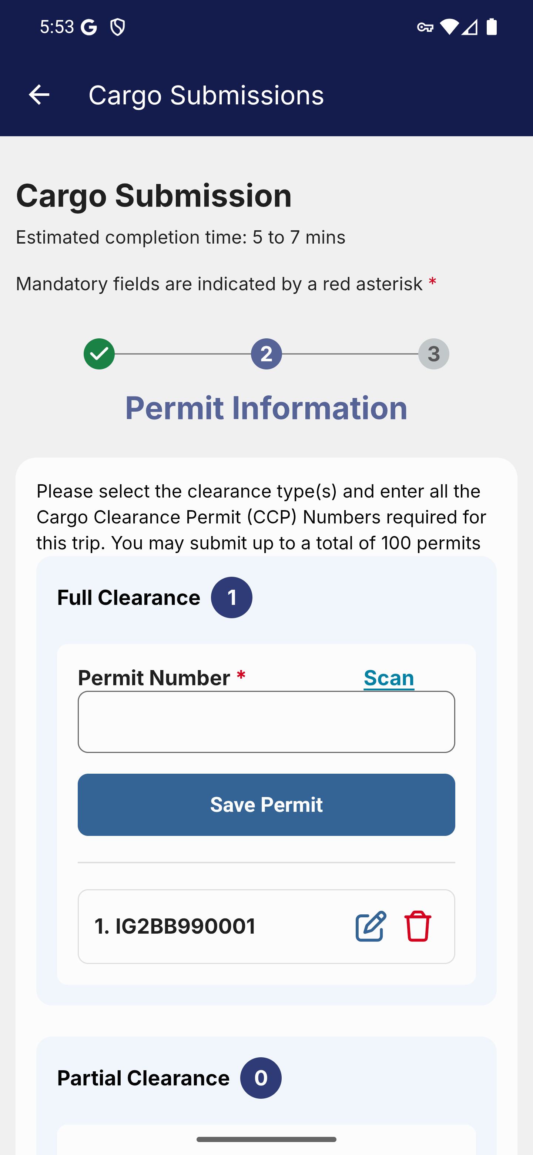
Screen 017 • 2026-09-07 17:53:58 • Captured

018 Partial-clearance permit and quantity
Scroll to the partial-clearance entry fields.
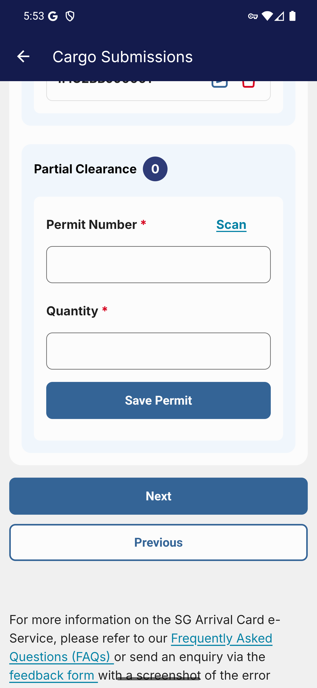
Screen 018 • 2026-09-07 17:54:18 • Captured

019 Partial-clearance permit saved
Add test permit IG2BB990002 with quantity 10.
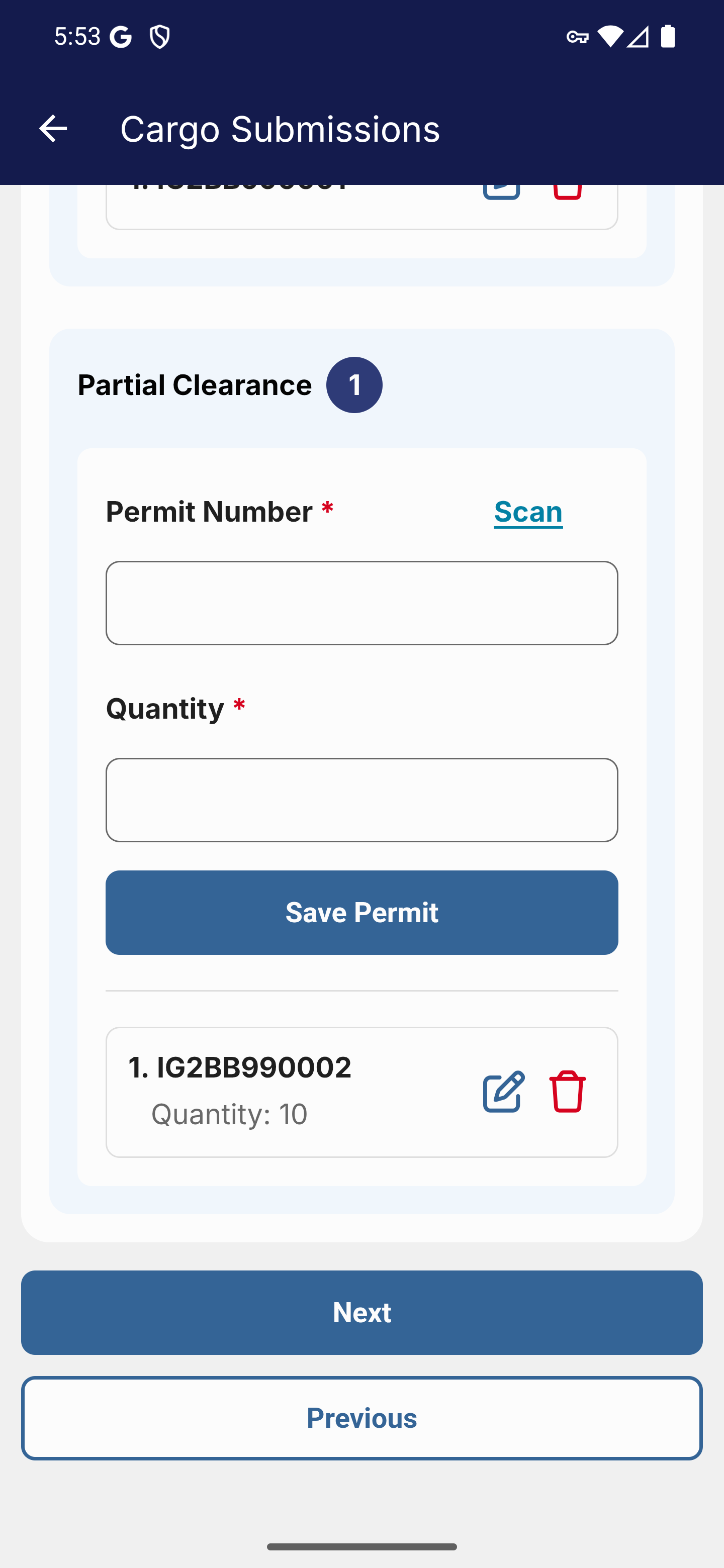
Screen 019 • 2026-09-07 17:54:25 • Captured

020 Cargo review contact details
Continue after adding full and partial clearance permits.
The review page shows the contact details copied from the selected vehicle profile.
Outcome: Review reached
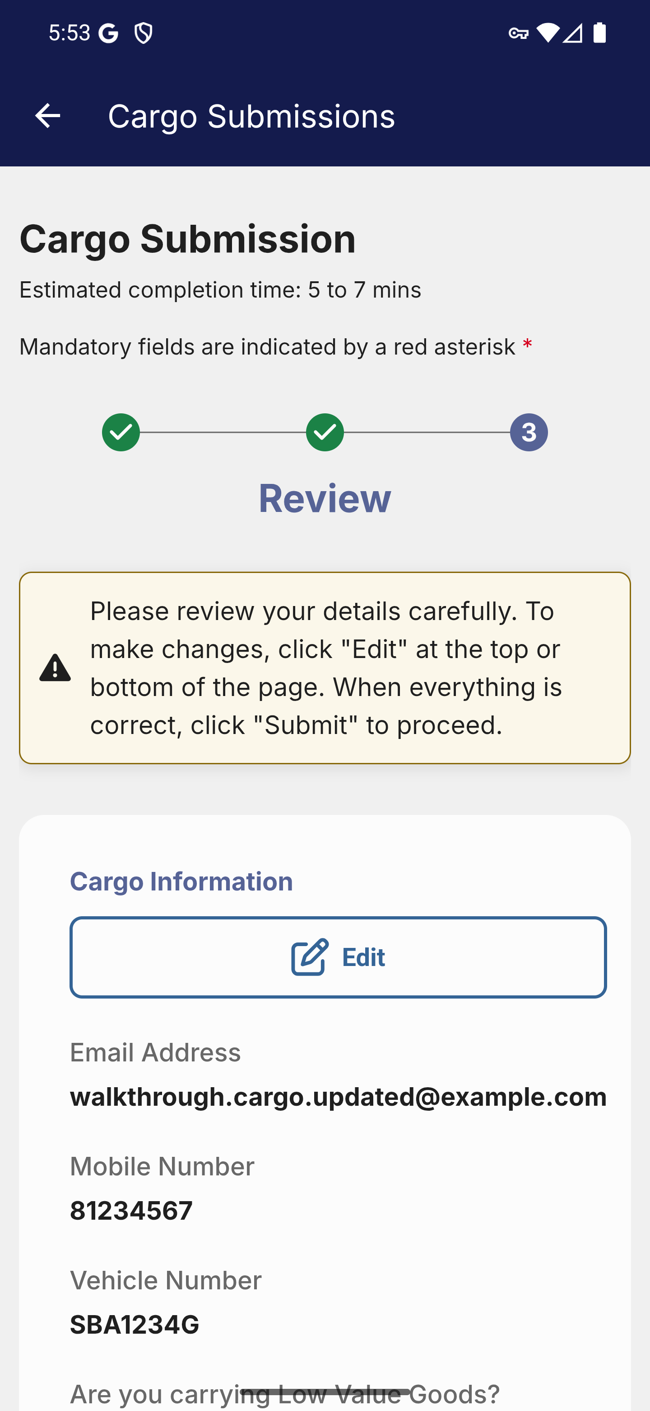
Screen 020 • 2026-09-07 17:54:28 • Review reached

021 Cargo review permit details
Scroll through the review page.
Review the entered synthetic vehicle, contact and permit details before any submission.
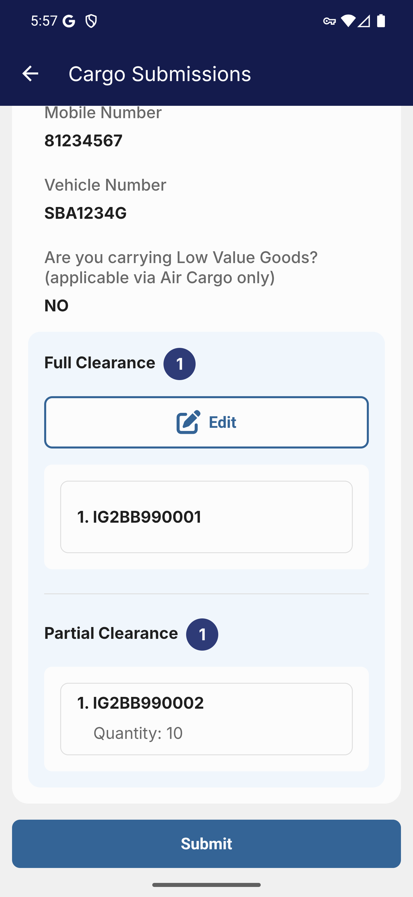
Screen 021 • 2026-09-07 17:57:54 • Captured

022 Cargo submission boundary
Scroll to the bottom of the review page.
The walkthrough stops before sending a cargo declaration; no cargo submission was made.
Outcome: Review reached; not submitted
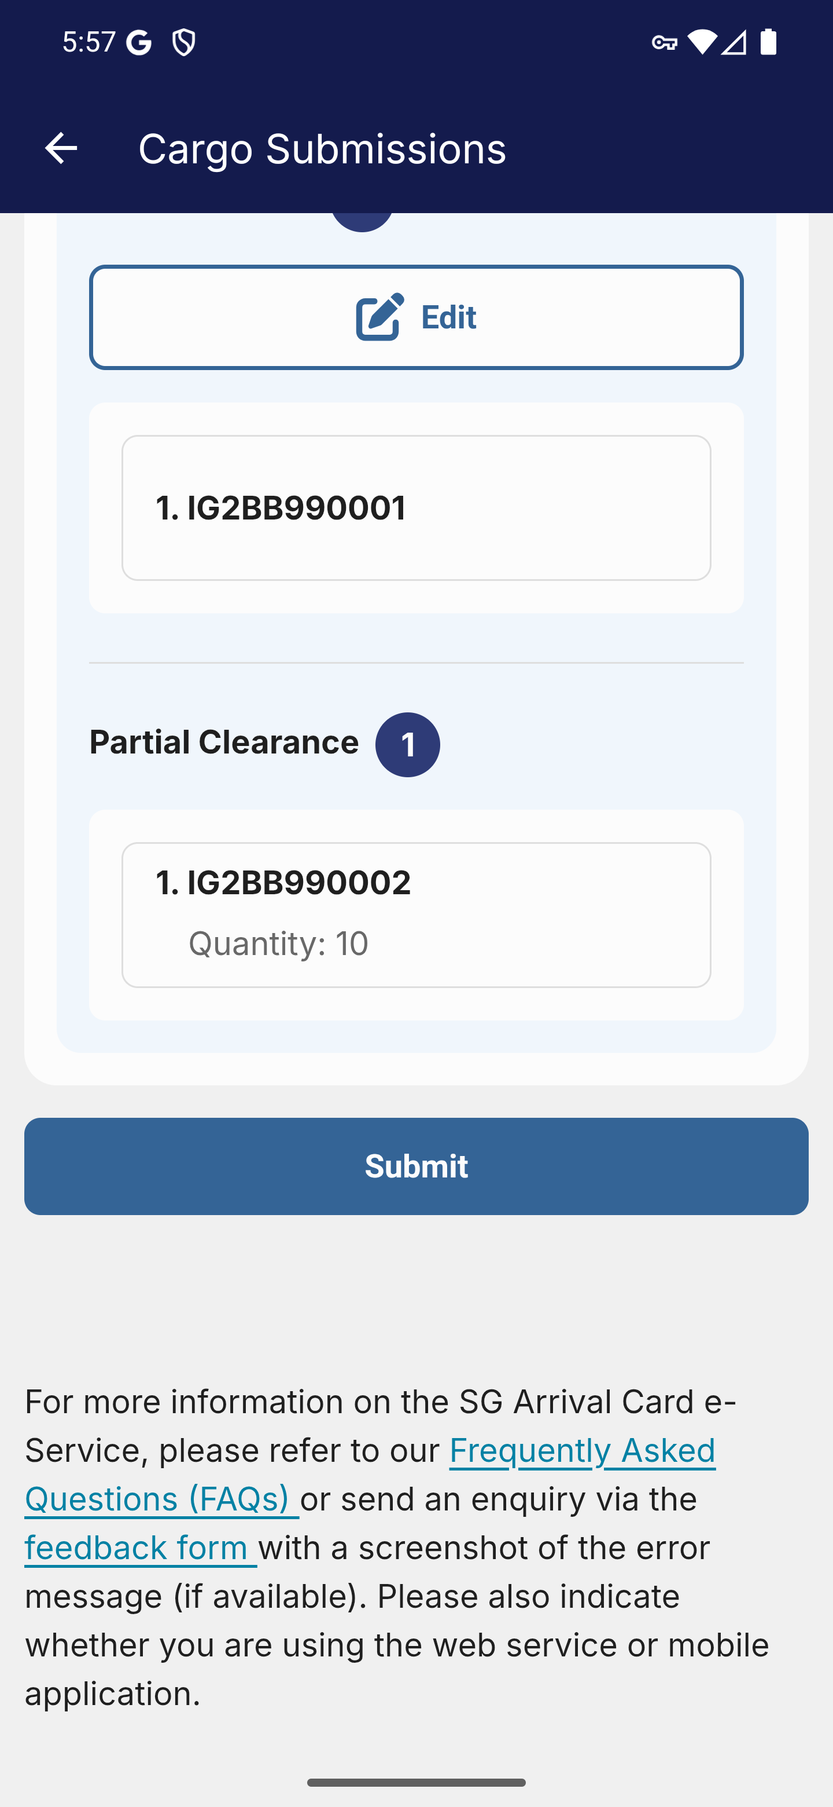
Screen 022 • 2026-09-07 17:57:56 • Review reached; not submitted

023 Retrieve an existing cargo submission
Cargo Clearance → Manage Cargo Submission.
Retrieval needs an existing cargo submission reference and matching vehicle details. No submitted reference was available.
Outcome: Existing submission required
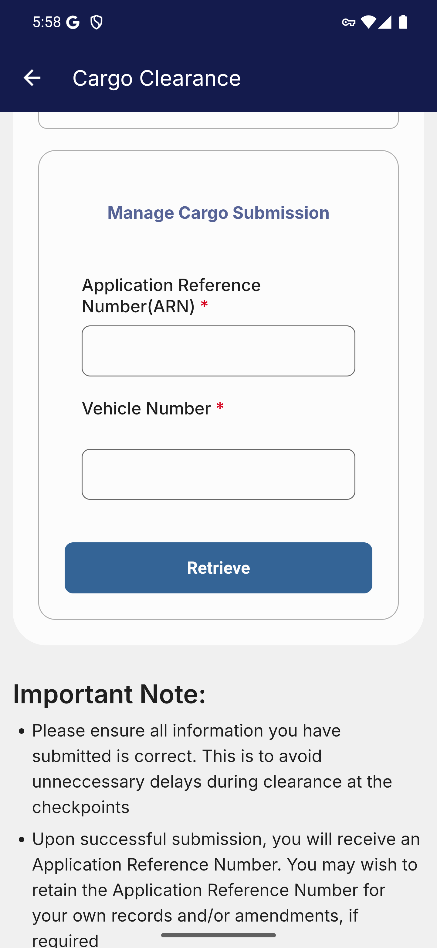
Screen 023 • 2026-09-07 17:58:40 • Existing submission required

024 Convoy contact information
Cargo Clearance → Convoy.
The convoy portal opens inside the app and starts with contact information.
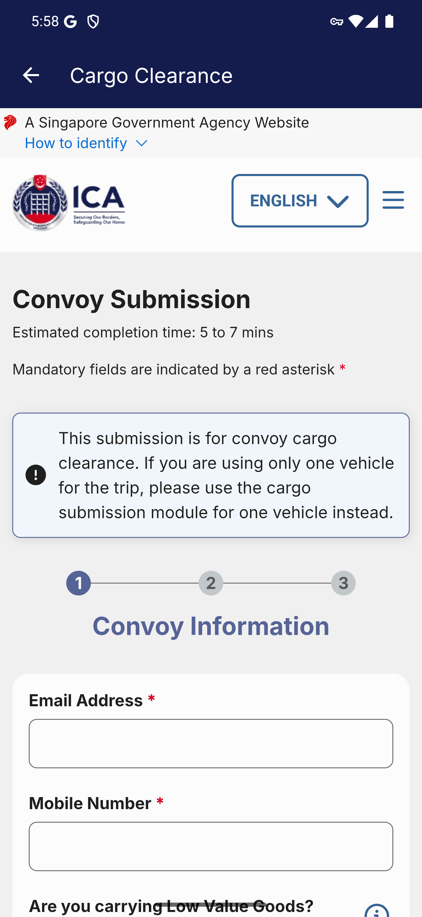
Screen 024 • 2026-09-07 17:58:45 • Captured

025 Convoy goods and vehicle options
Enter synthetic contact details and scroll.
Convoy submission requires more than one vehicle.
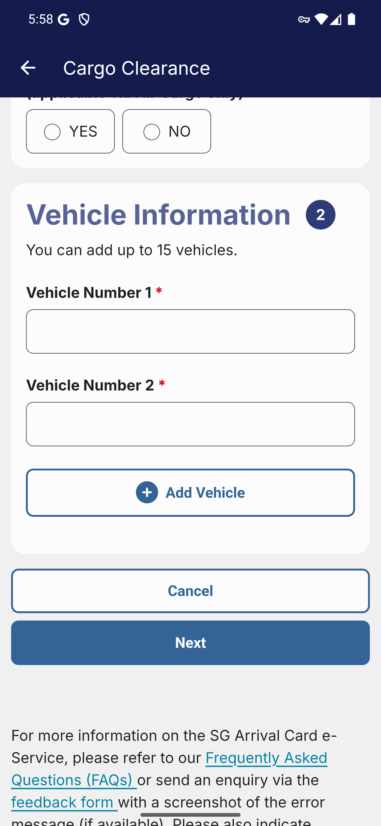
Screen 025 • 2026-09-07 17:59:04 • Captured

026 Convoy with two vehicles and low value goods
Select YES for low value goods and enter two synthetic vehicle numbers.
The page offers Add Vehicle and displays a maximum of 15 vehicles. Only the two-vehicle case was exercised.
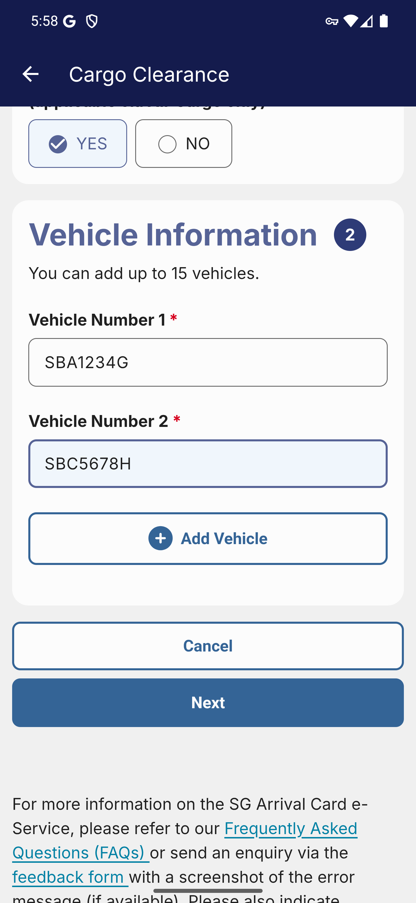
Screen 026 • 2026-09-07 17:59:35 • Captured

027 Convoy full-clearance permit form
Continue the two-vehicle low value goods scenario.
Despite selecting YES for low value goods, the next step displays a full-clearance permit form.
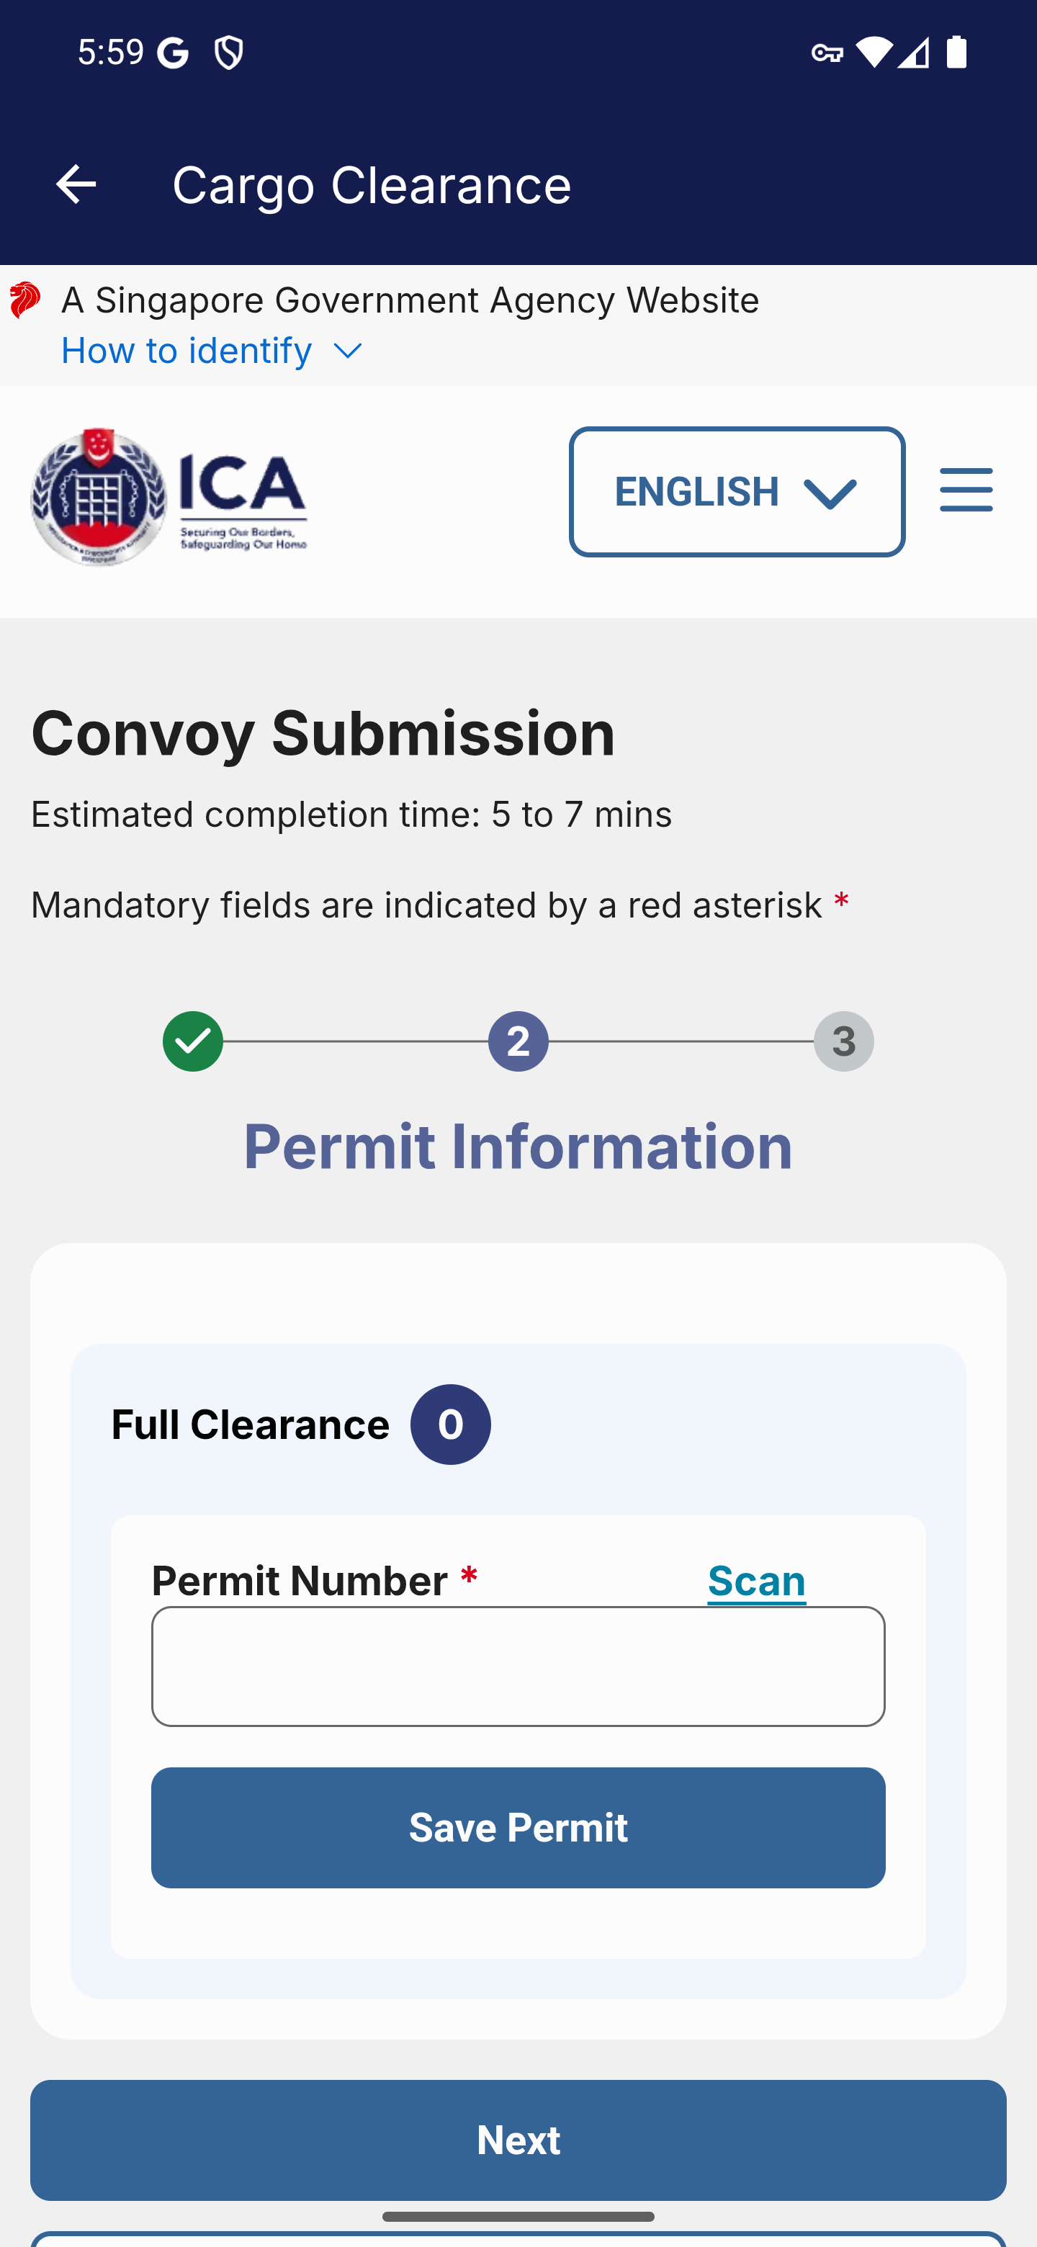
Screen 027 • 2026-09-07 17:59:38 • Captured

028 Convoy permit required validation
Attempt to continue without a permit.
Trying Next without a permit displays Please fill in the field above.
Outcome: Validation observed
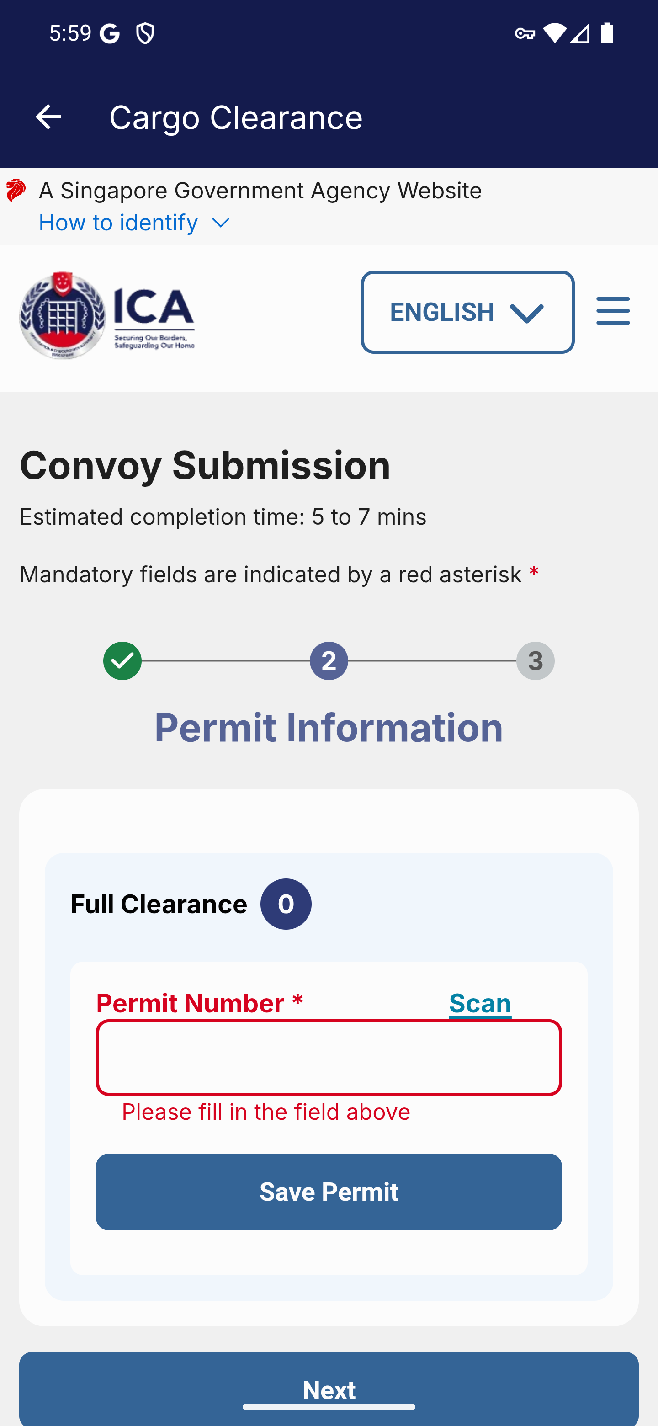
Screen 028 • 2026-09-07 17:59:58 • Validation observed

029 Convoy permit saved
Save synthetic permit IG2BB990003.
The convoy required a permit even with low value goods set to YES.
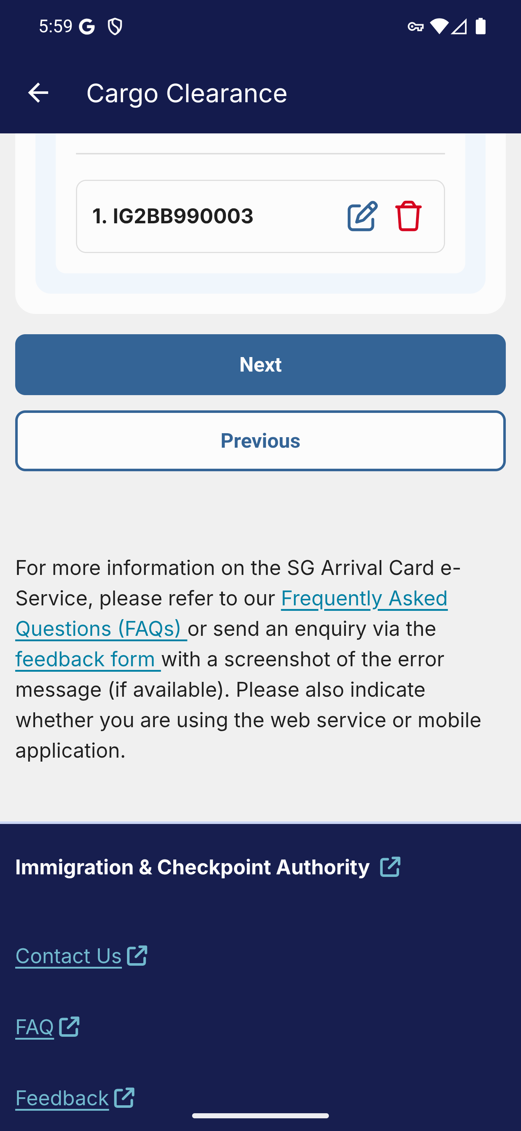
Screen 029 • 2026-09-07 18:00:27 • Captured

030 Convoy review
Continue after saving the convoy permit.
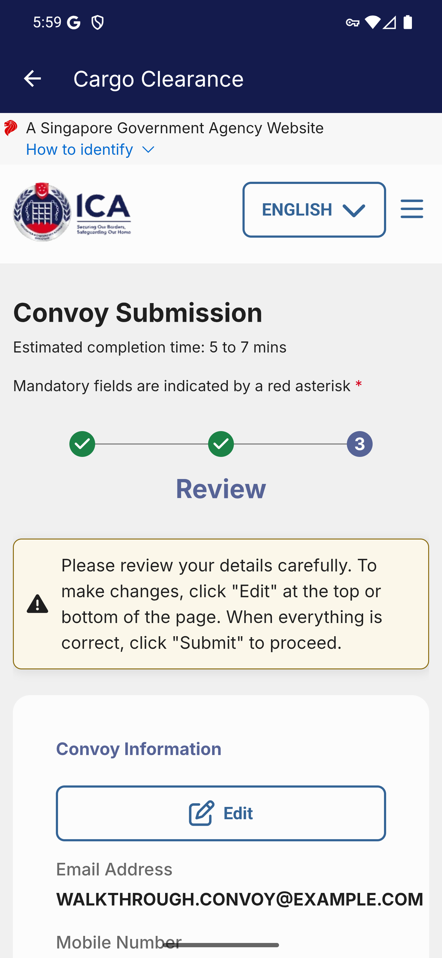
Screen 030 • 2026-09-07 18:00:30 • Captured

031 Convoy review vehicles and permit
Scroll through the convoy review.
The review includes the two synthetic vehicle numbers and saved permit.
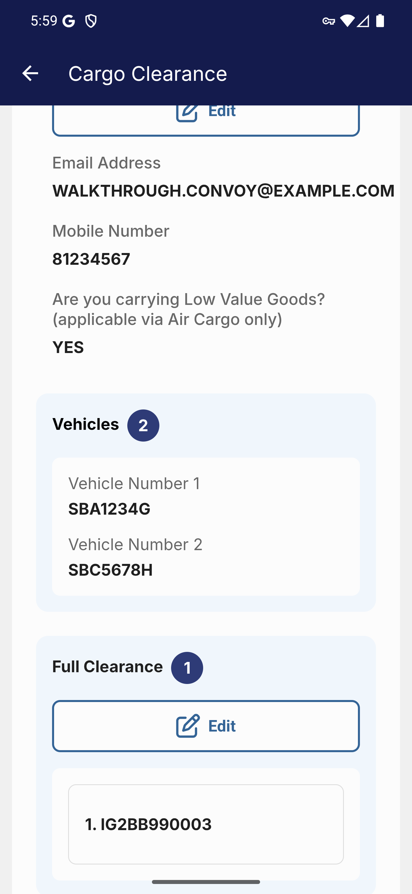
Screen 031 • 2026-09-07 18:00:31 • Captured

032 Convoy submission boundary
Scroll to the end of the convoy review.
No convoy declaration was submitted.
Outcome: Review reached; not submitted
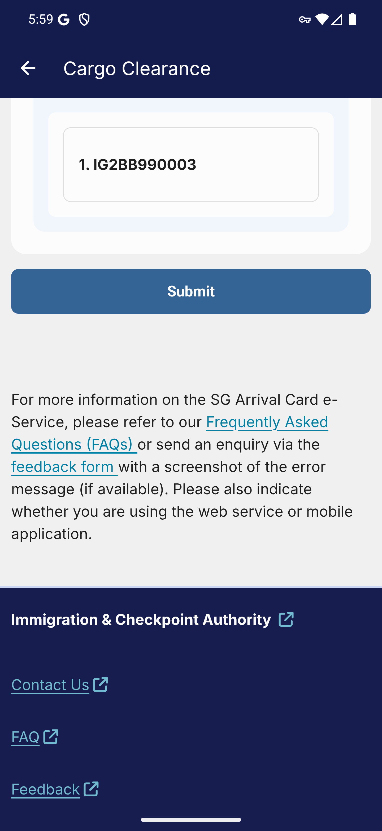
Screen 032 • 2026-09-07 18:00:33 • Review reached; not submitted

033 Cargo language selection
Open the cargo language control.
Language options are documented without changing the English walkthrough setting.
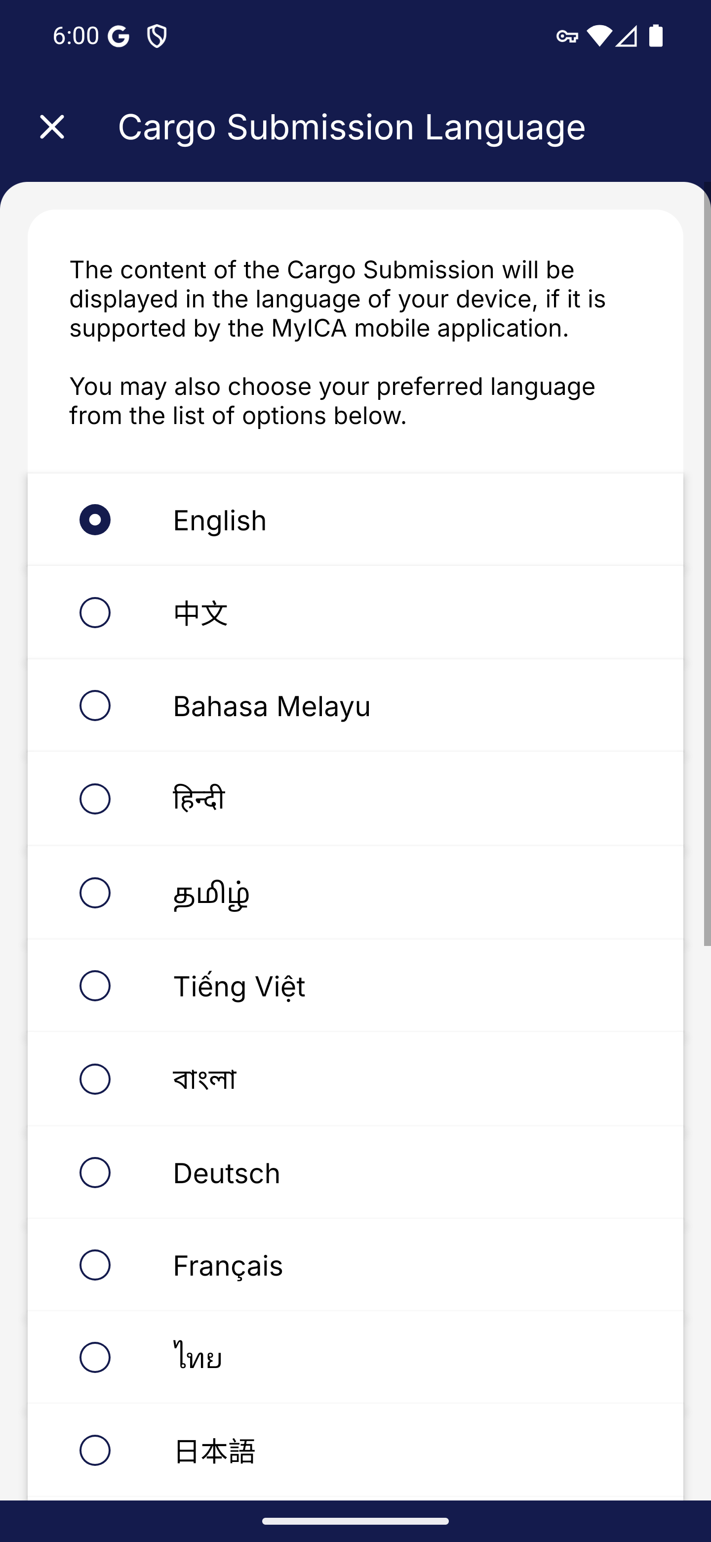
Screen 033 • 2026-09-07 18:00:57 • Captured

