  - PROJECT DOCUMENTATION

Other e-Services
All ten catalogue categories and 32 service entry links were walked. The screenshots include loaded destinations, the unavailable Trusted Traveller Programme page, authentication/reference boundaries, and service search with matching, no-match and cleared queries.
49 screen captures • Pixel 7 Pro emulator • Android 16 • English
Captured from the installed staging app on 7 September 2026. Screenshots are original device PNGs. This is a screen walkthrough; it does not certify every test case or every input combination.

Coverage and outcomes
Flow / branch | Observed outcome
Service catalogue | All ten categories and all 32 entry links opened across the two walkthrough sessions.
Passport and Identity Card | All four service entry links captured.
SG Arrival Card, Entry Visa, e-Pass and Visit Pass | All four entry links captured. Applications and retrieval results were not submitted or authenticated.
Check Validity/Verify | All eight entry links captured. Certificate/access-code fixtures and any CAPTCHA are still needed for verification results.
Residential address | Both links opened the Change of Residential Address landing page. The second native label displays FOR_LTVP_STP_HOLDER.
Citizenship and Permanent Residence | All three entries loaded: Singapore Citizenship, Permanent Residence and Re-entry Permit.
Long-Term Visit Pass and Student's Pass | All four entries loaded: LTVP, PMLA, SOLAR for IHLs and SOLAR+ for other schools.
Birth and Death | The Birth or Death Extract entry loaded.
Others | APEC entry loaded. Trusted Traveller Programme reached an ICA 404 page. Race/Dialect redirected to FormSG with Singpass login requirements.
Appointment | Both links loaded on eservices-stg.ica.gov.sg. Check-in requests an identity/application reference; no appointment was booked, changed, cancelled or checked in.
Customs Declaration | Customs@SG information page loaded; no declaration or payment performed.
Search | Report returned two matching services and one result was opened. test returned zero cards; clearing restored the list. Result labels/time estimates display raw translation keys.
These are observed entry-page and navigation outcomes, not completed government transactions or automated suite passes.
Destinations include public ICA services, staging Appointment services, FormSG and Singapore Customs. The native staging label does not identify every external environment.
The Digital Stillbirth Extract link opened the general eRECEIVE portal. The Trusted Traveller Programme link displayed the ICA page-not-found destination.
Search results expose untranslated keys, including REPORT_LOST_PASSPORT and MINUTES_5_TO_10. The existing YAML search locators were not changed or validated by this walkthrough.

How to use this document
Each following page records one screen, the action used to reach it, and any relevant observation. Screen numbers match the category manifest and PNG filenames. Source XML and SHA-256 hashes are retained beside the screenshots for traceability. Open the original PNG when you need to zoom into small text.

001 Other e-Services categories
Home → Other e-Services.
The service catalogue contains ten categories and a search function.
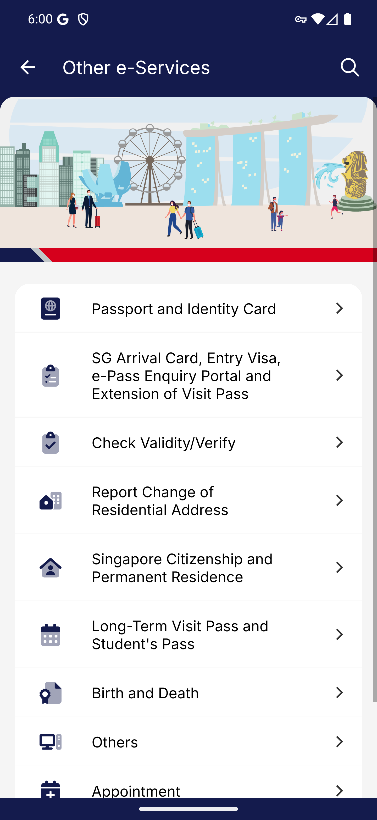
Screen 001 • 2026-09-07 18:01:02 • Captured

002 Other e-Services lower categories
Scroll the service catalogue.
Appointment and Customs Declaration are available at the bottom of the catalogue.
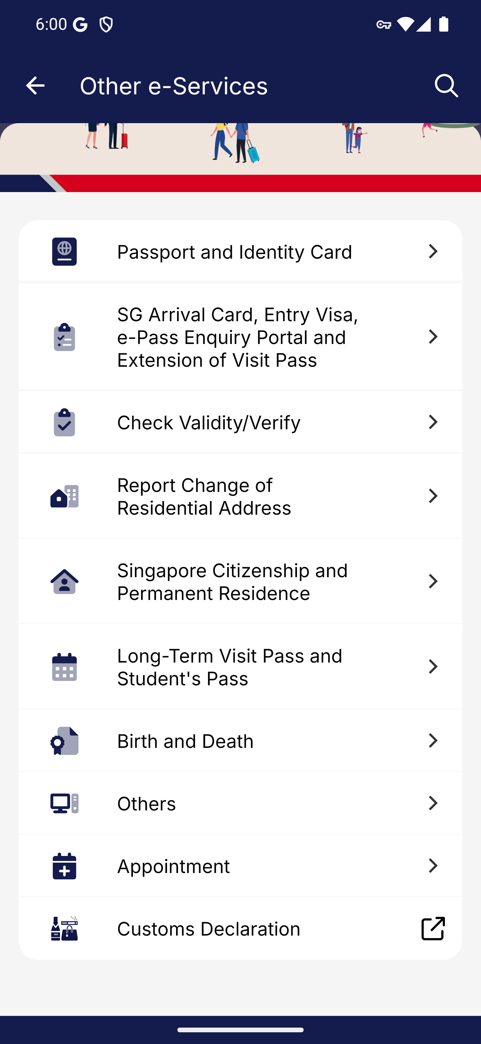
Screen 002 • 2026-09-07 18:01:18 • Captured

003 Passport and Identity Card services
Open Passport and Identity Card.
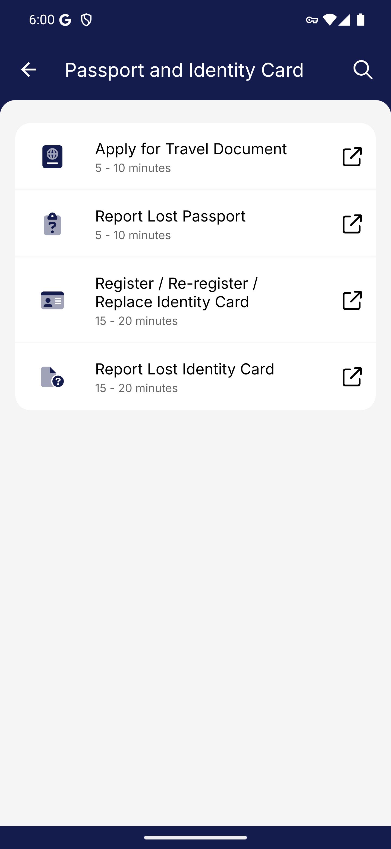
Screen 003 • 2026-09-07 18:01:20 • Captured

004 Apply for Travel Document entry
Passport and Identity Card → Apply for Travel Document.
Opened in Chrome: eservices.ica.gov.sg/esvclandingpage/apples. Downstream authenticated transactions were not performed.
Outcome: External service entry
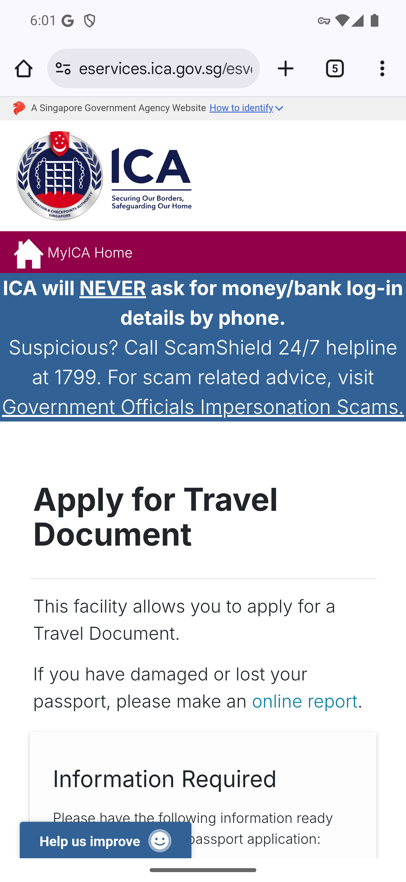
Screen 004 • 2026-09-07 18:01:41 • External service entry

005 Report Lost Passport entry
Passport and Identity Card → Report Lost Passport.
Opened in Chrome: eservices.ica.gov.sg/esvclandingpage/applesOnlineReport. Downstream authenticated transactions were not performed.
Outcome: External service entry
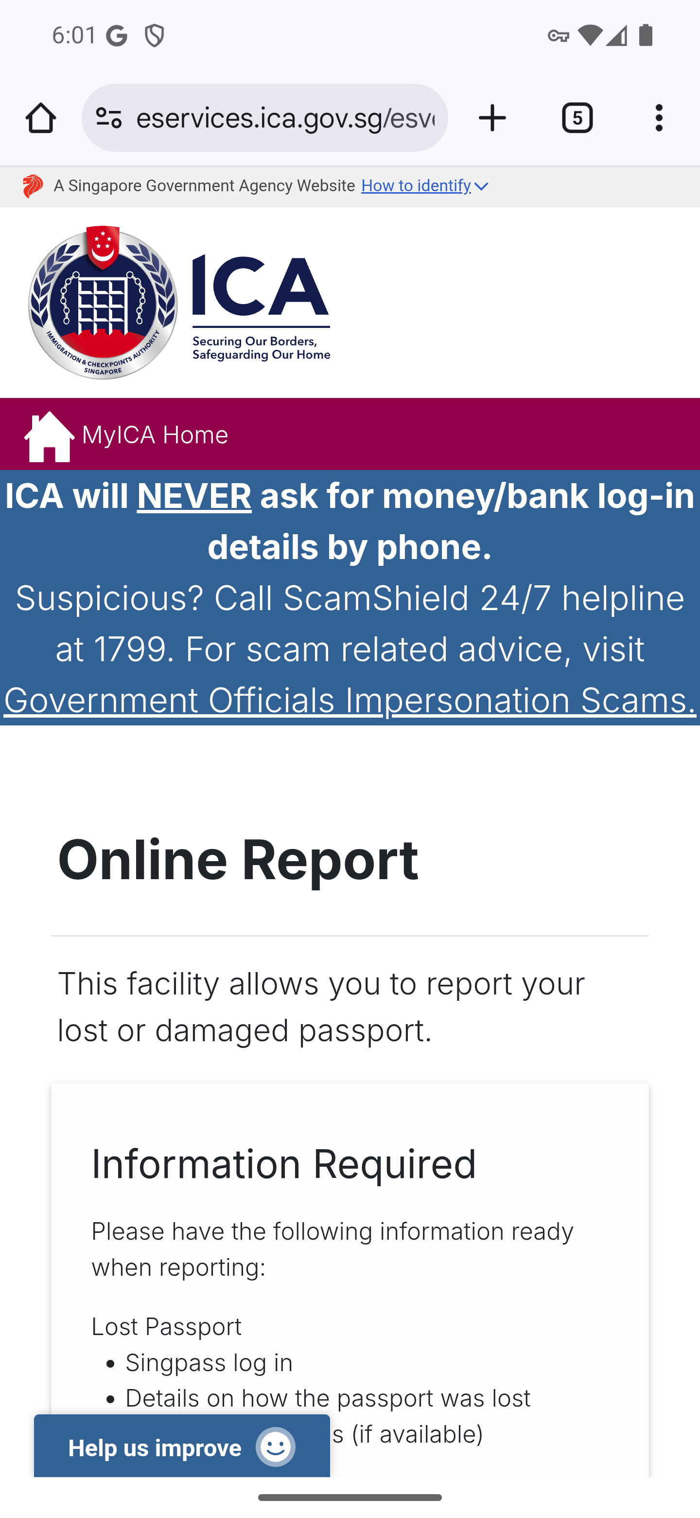
Screen 005 • 2026-09-07 18:02:12 • External service entry

006 Register / Re-register / Replace Identity Card entry
Passport and Identity Card → Register / Re-register / Replace Identity Card.
Opened in Chrome: eservices.ica.gov.sg/esvclandingpage/iconline. Downstream authenticated transactions were not performed.
Outcome: External service entry
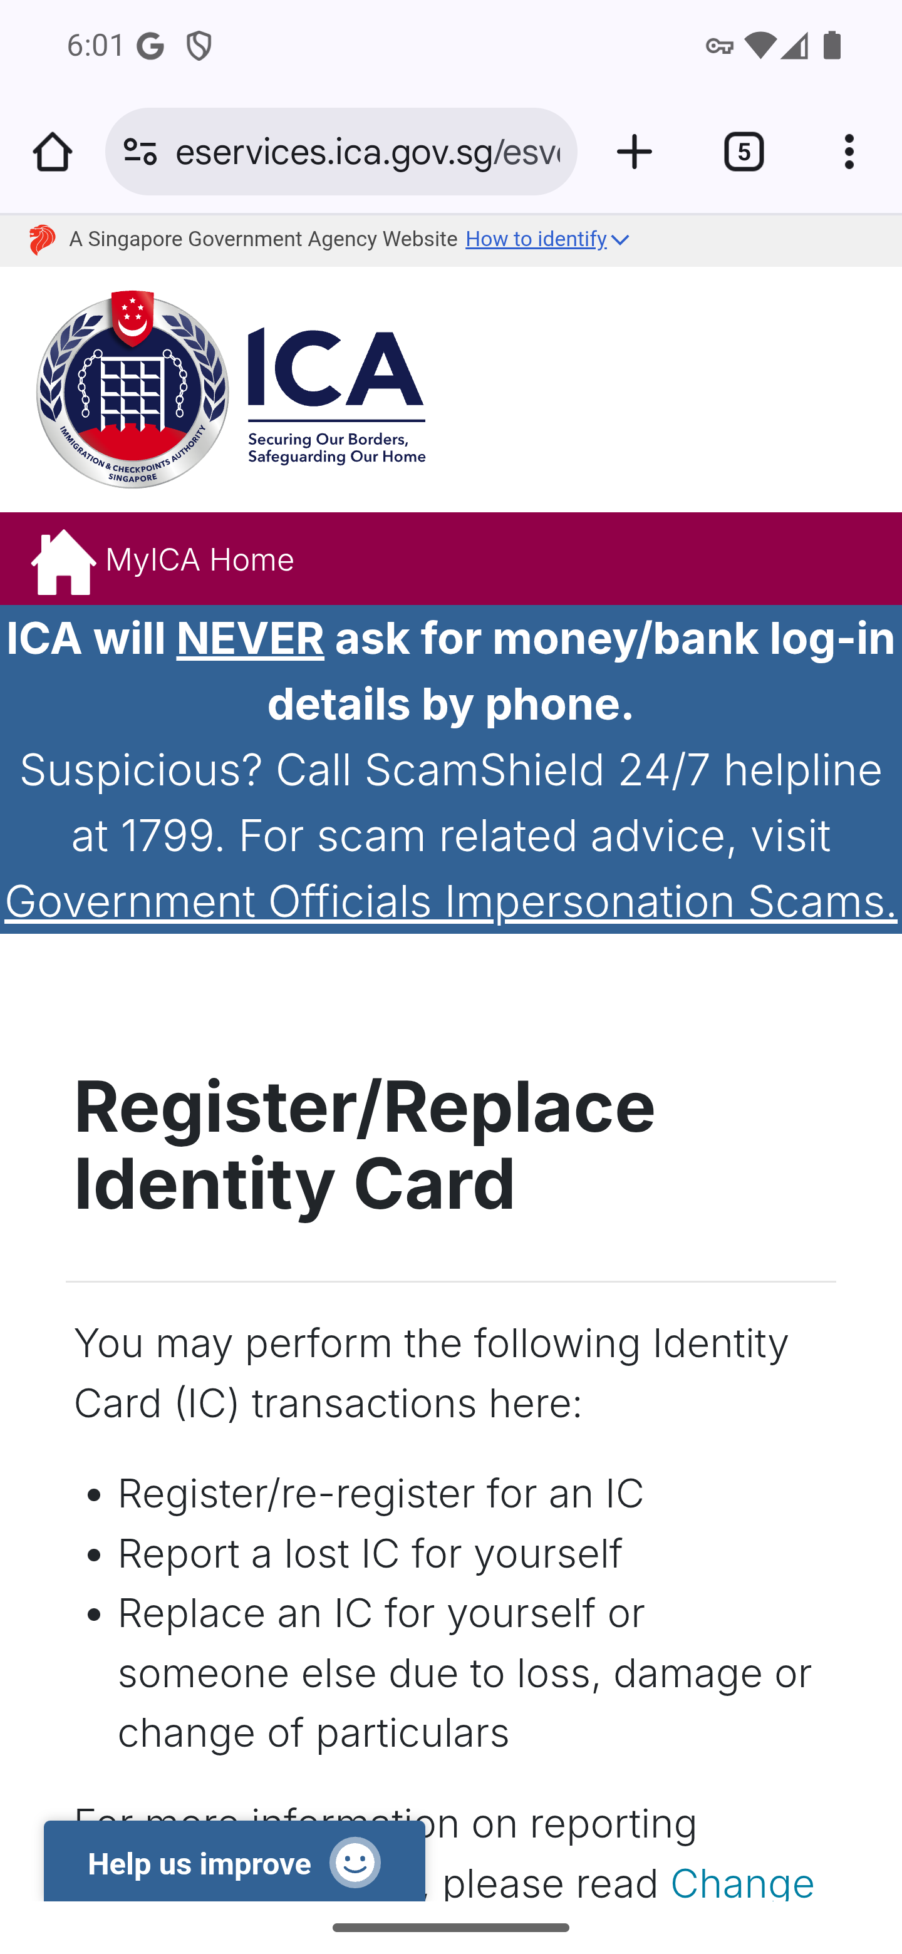
Screen 006 • 2026-09-07 18:02:17 • External service entry

007 Report Lost Identity Card entry
Passport and Identity Card → Report Lost Identity Card.
Opened in Chrome: eservices.ica.gov.sg/esvclandingpage/iconline. Downstream authenticated transactions were not performed.
Outcome: External service entry

Screen 007 • 2026-09-07 18:02:21 • External service entry

008 Arrival card visa and visit pass services
Open the SG Arrival Card, Entry Visa, e-Pass and Extension category.
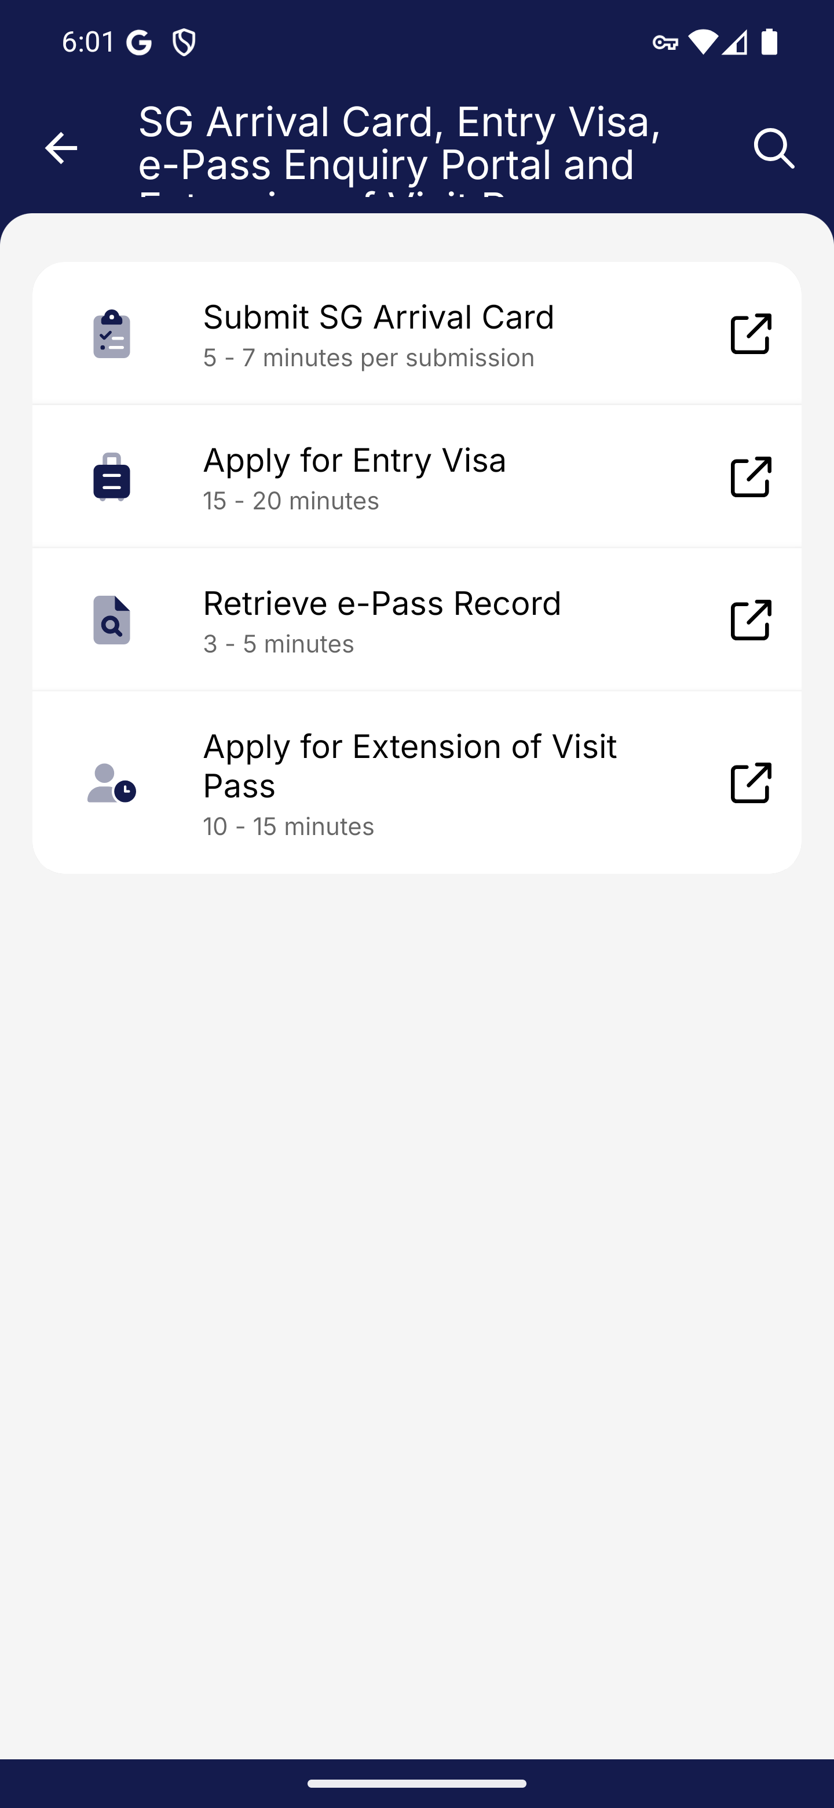
Screen 008 • 2026-09-07 18:02:25 • Captured

009 Submit SG Arrival Card entry
Arrival card services → Submit SG Arrival Card.
Opened in Chrome: eservices.ica.gov.sg/sgarrivalcard/. Downstream authenticated transactions were not performed.
Outcome: External service entry
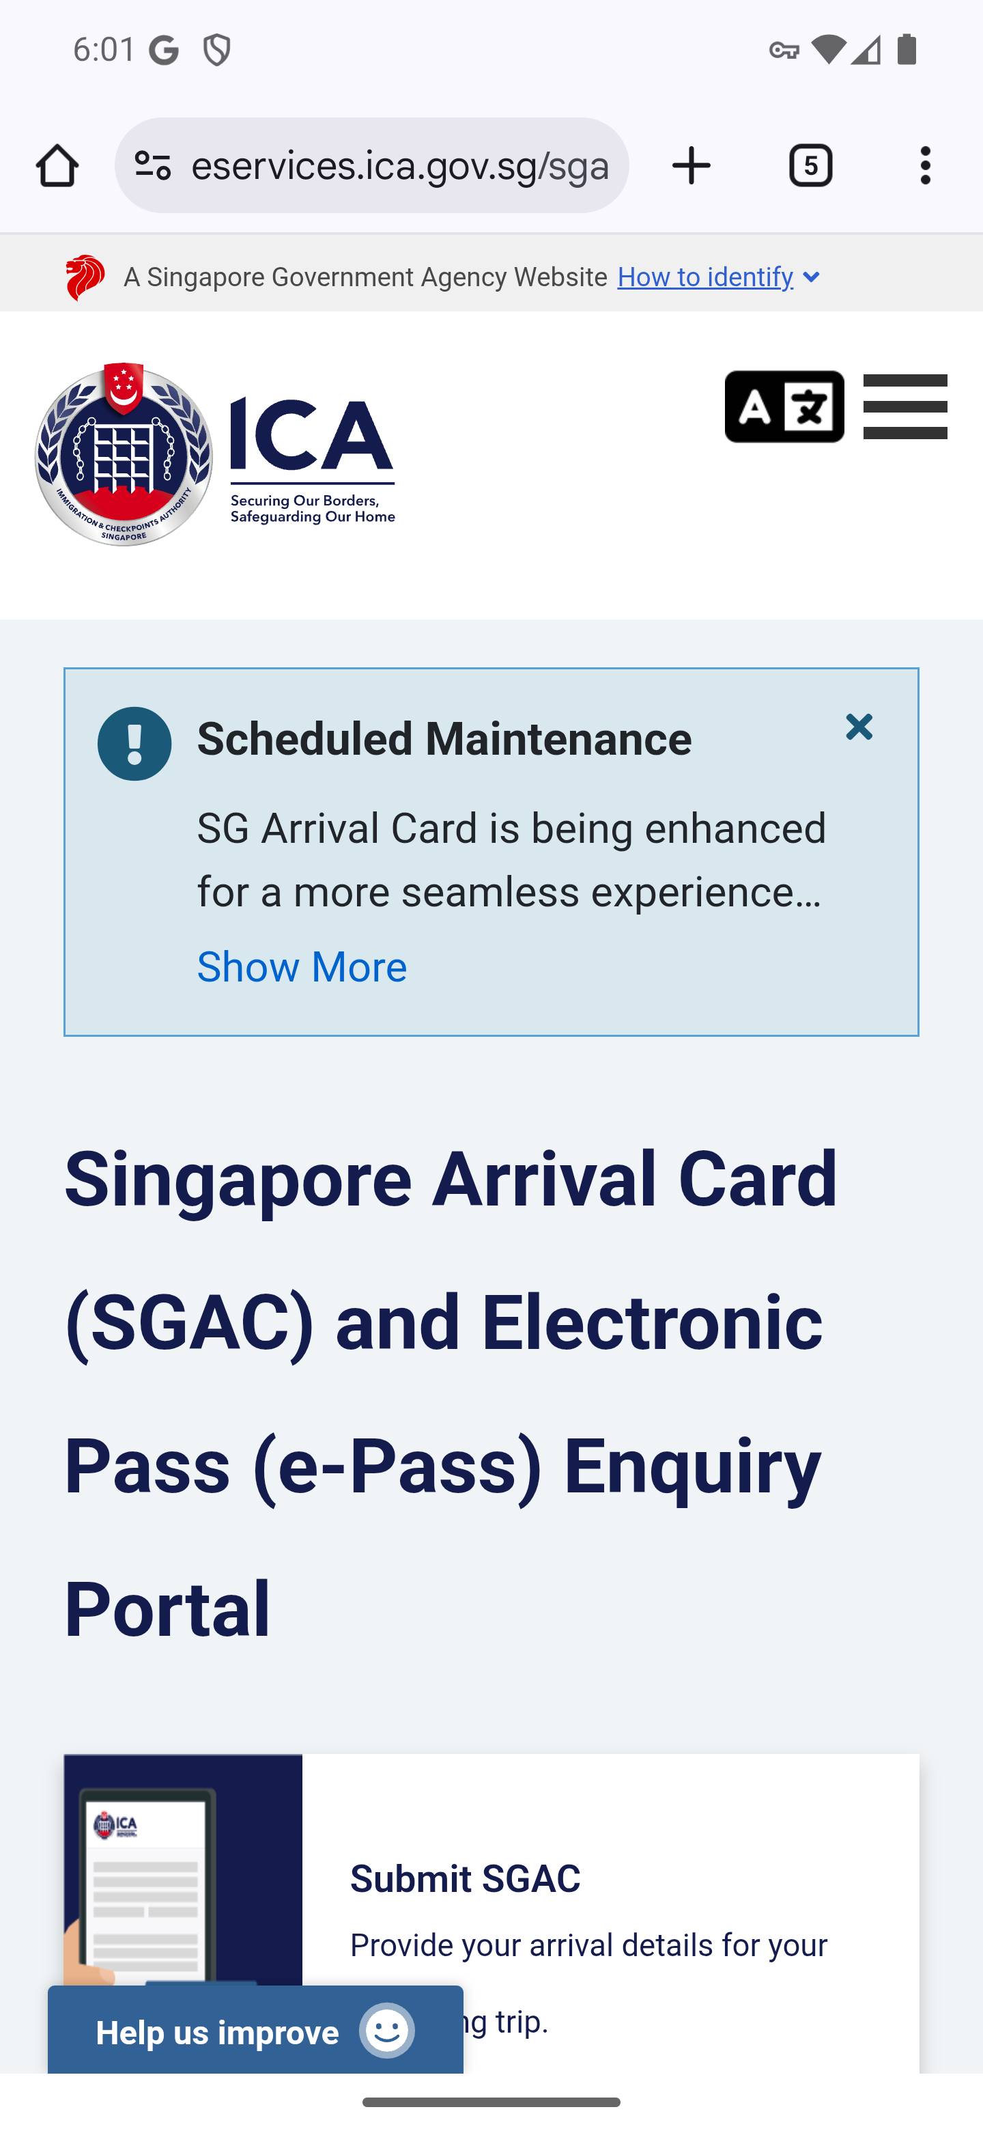
Screen 009 • 2026-09-07 18:02:35 • External service entry

010 Apply for Entry Visa entry
Arrival card and visit pass services → Apply for Entry Visa.
Opened in Chrome: eservices.ica.gov.sg/esvclandingpage/save. Downstream authenticated transactions were not performed.
Outcome: External service entry
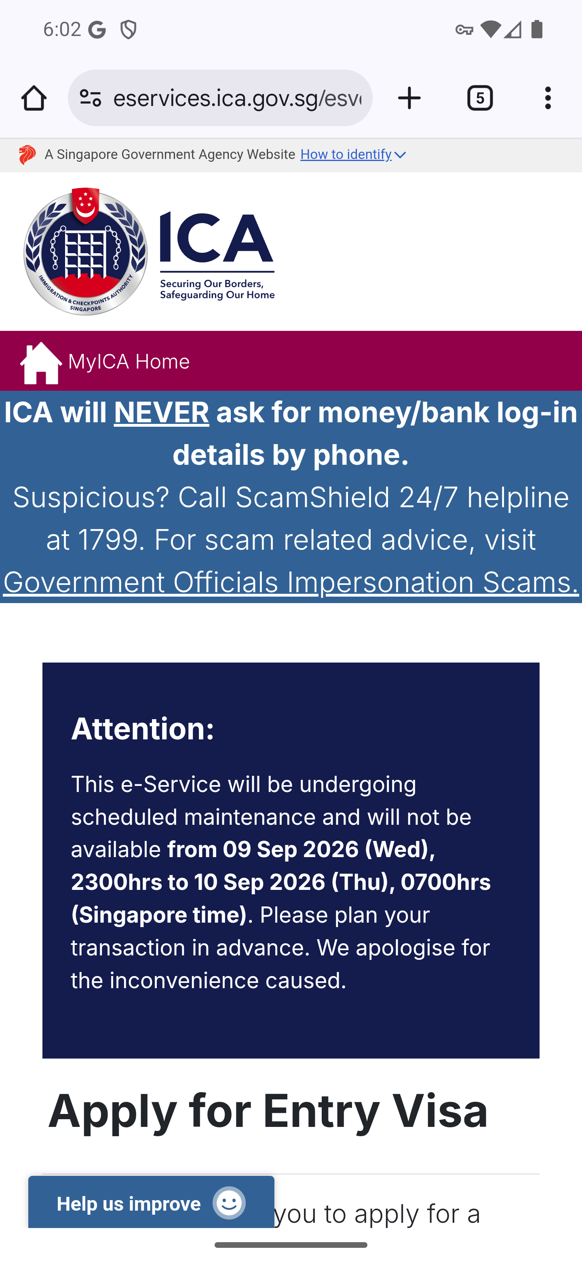
Screen 010 • 2026-09-07 18:03:01 • External service entry

011 Retrieve e-Pass Record entry
Arrival card and visit pass services → Retrieve e-Pass Record.
Opened in Chrome: eservices.ica.gov.sg/sgarrivalcard/epassenquiry. Downstream authenticated transactions were not performed.
Outcome: External service entry
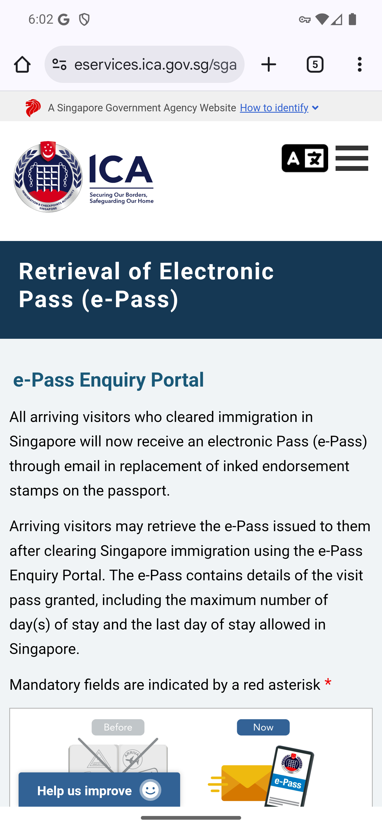
Screen 011 • 2026-09-07 18:03:05 • External service entry

012 Apply for Extension of Visit Pass entry
Arrival card and visit pass services → Apply for Extension of Visit Pass.
Opened in Chrome: eservices.ica.gov.sg/esvclandingpage/extend. Downstream authenticated transactions were not performed.
Outcome: External service entry
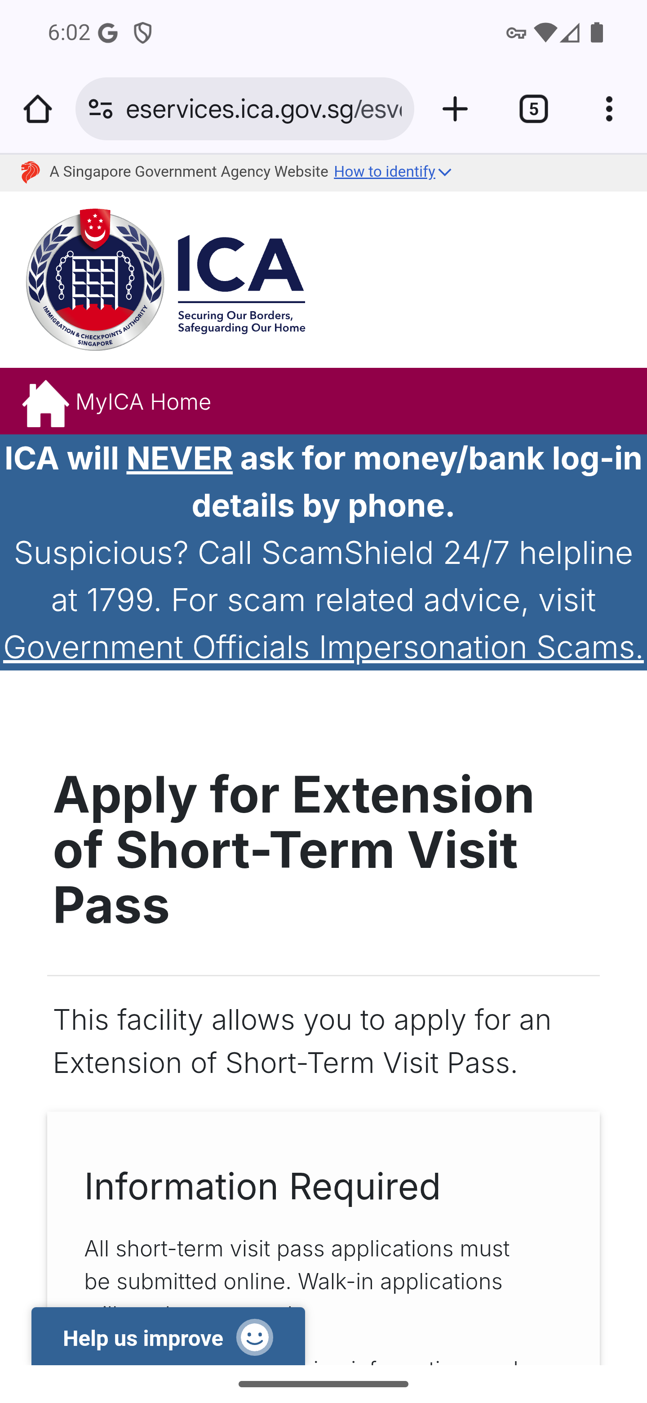
Screen 012 • 2026-09-07 18:03:10 • External service entry

013 Check Validity and Verify services
Open Check Validity/Verify.
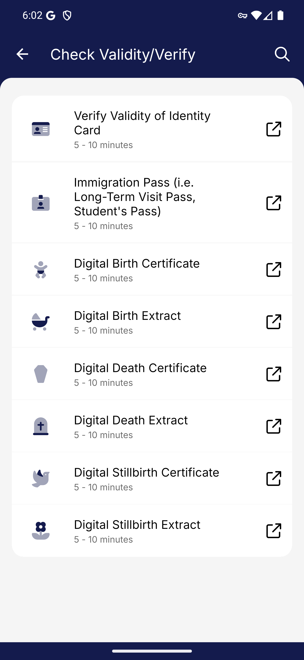
Screen 013 • 2026-09-07 18:03:13 • Captured

014 Verify Validity of Identity Card entry
Check Validity/Verify → Verify Validity of Identity Card.
Opened in Chrome: eservices.ica.gov.sg/ipienquiry/web/icheck/landing. Downstream authenticated transactions were not performed.
Outcome: External service entry
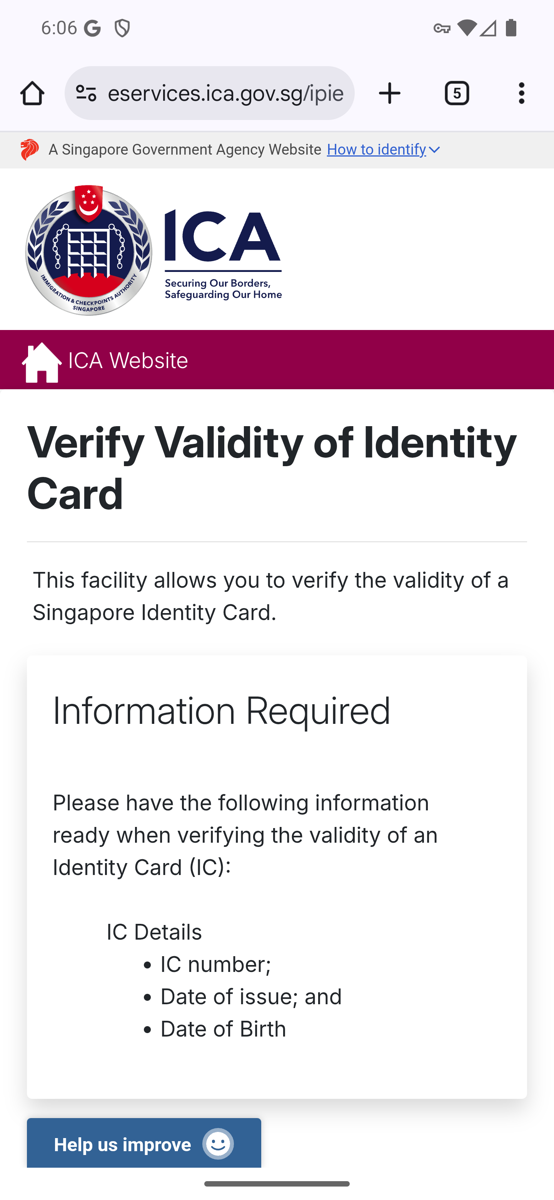
Screen 014 • 2026-09-07 18:06:39 • External service entry

015 Immigration pass validity entry
Check Validity/Verify → Immigration Pass (i.e. Long-Term Visit Pass, Student's Pass).
Opened the ICA immigration-pass validity landing page. Verification requires matching pass details.
Outcome: External service entry
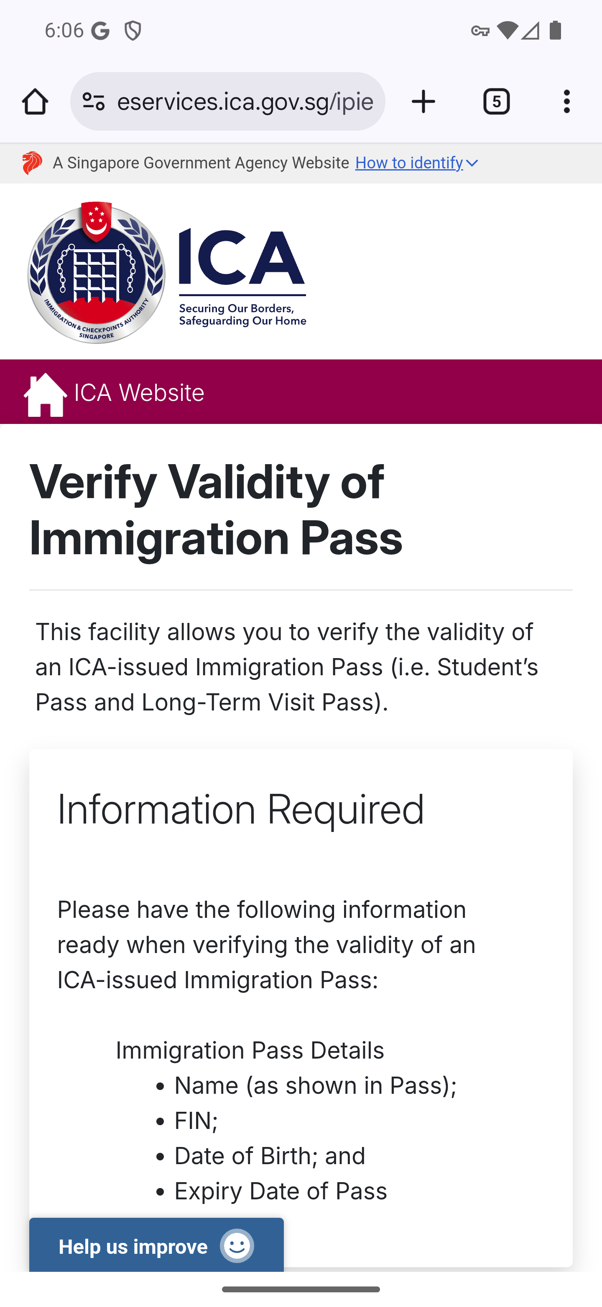
Screen 015 • 2026-09-07 18:06:43 • External service entry

016 Digital Birth Certificate entry
Check Validity/Verify → Digital Birth Certificate.
The verification form requests a certificate number and access code. No certificate fixture was supplied.
Outcome: Certificate and access code required
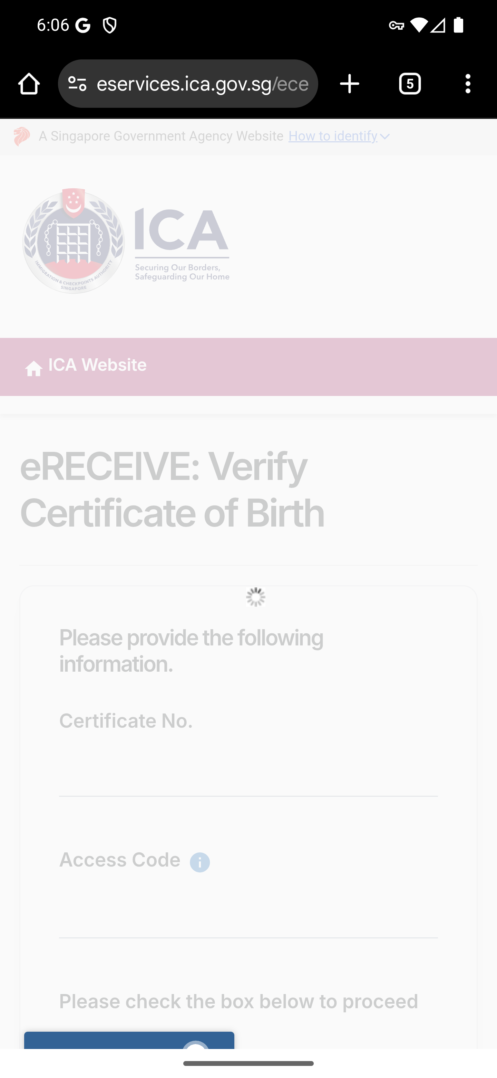
Screen 016 • 2026-09-07 18:06:50 • Certificate and access code required

017 Digital Birth Extract entry
Check Validity/Verify → Digital Birth Extract.
The verification form requests a certificate number and access code and shows a CAPTCHA. No verification was performed.
Outcome: Certificate and access code required
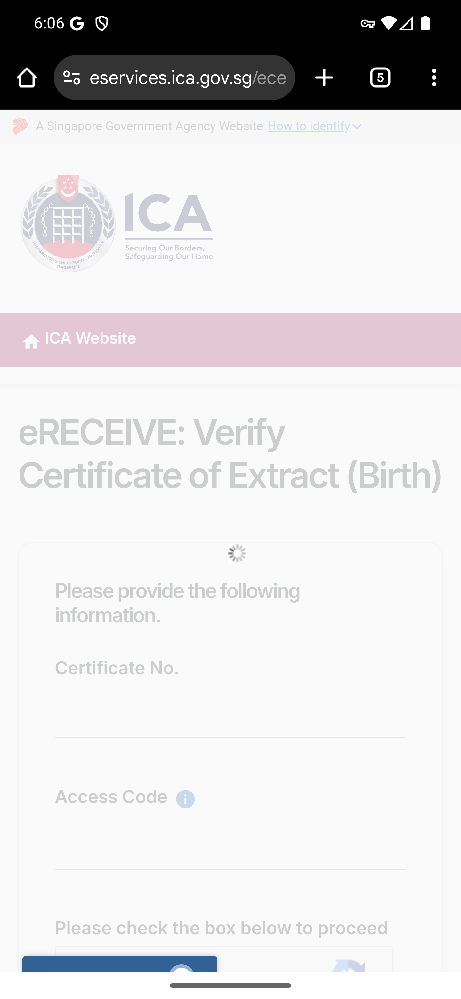
Screen 017 • 2026-09-07 18:06:56 • Certificate and access code required

018 Digital Death Certificate entry
Check Validity/Verify → Digital Death Certificate.
Opened in Chrome: eservices.ica.gov.sg/ecert/request/verify/death. Downstream authenticated transactions were not performed.
Outcome: Certificate and access code required
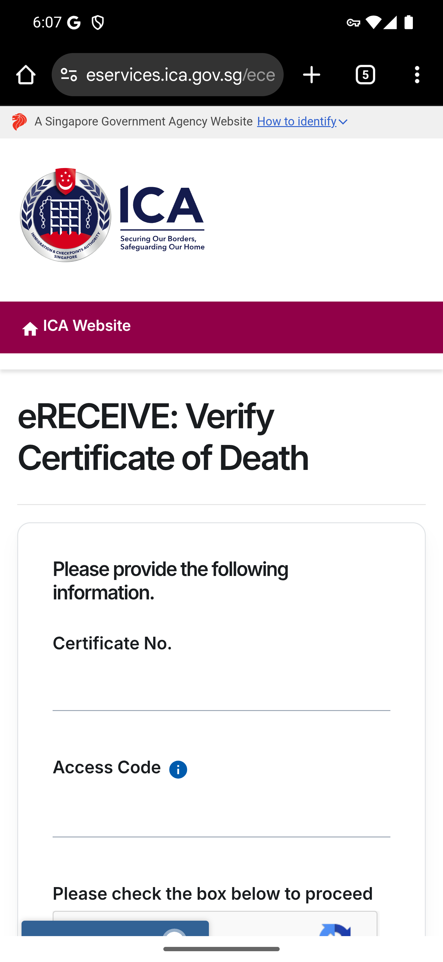
Screen 018 • 2026-09-07 18:07:42 • Certificate and access code required

019 Digital Death Extract entry
Check Validity/Verify → Digital Death Extract.
Opened in Chrome: eservices.ica.gov.sg/ecert/request/verify/deathx. Downstream authenticated transactions were not performed.
Outcome: Certificate and access code required
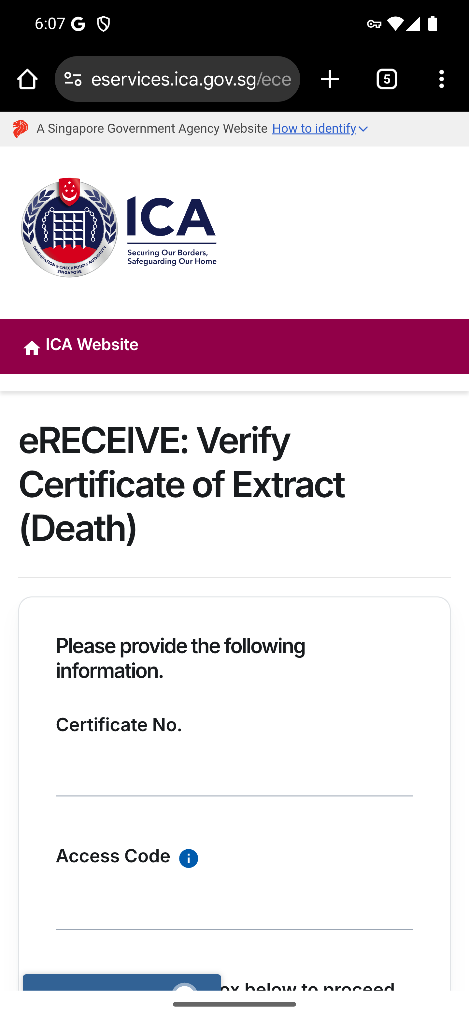
Screen 019 • 2026-09-07 18:07:52 • Certificate and access code required

020 Digital Stillbirth Certificate entry
Check Validity/Verify → Digital Stillbirth Certificate.
Opened in Chrome: eservices.ica.gov.sg/ecert/request/verify/stillbirth. Downstream authenticated transactions were not performed.
Outcome: Certificate and access code required
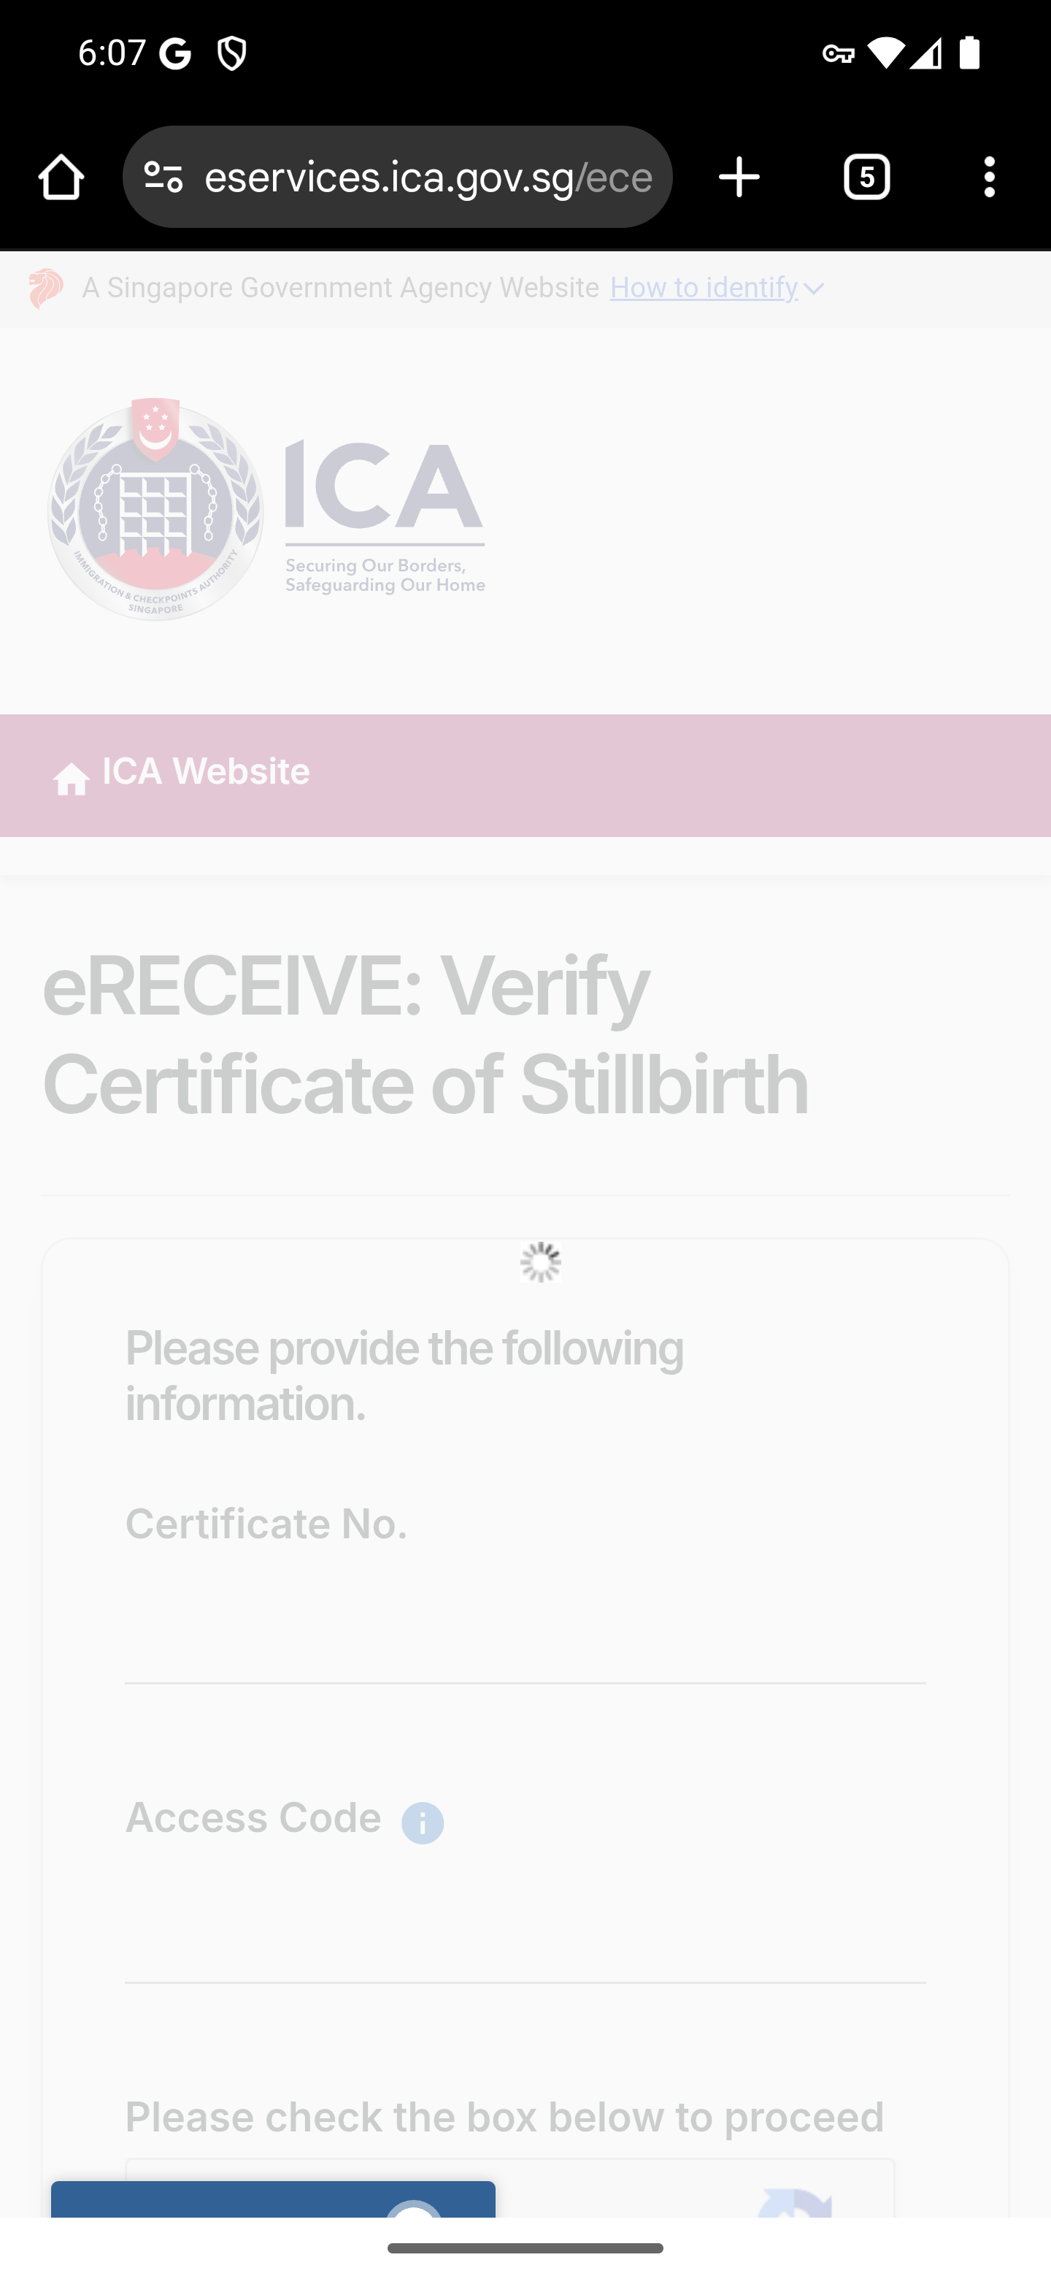
Screen 020 • 2026-09-07 18:08:00 • Certificate and access code required

021 Digital Stillbirth Extract portal entry
Check Validity/Verify → Digital Stillbirth Extract.
This link opens the general eRECEIVE Download/Verify Certificate portal, rather than a preselected stillbirth-extract verification form.
Outcome: External service entry
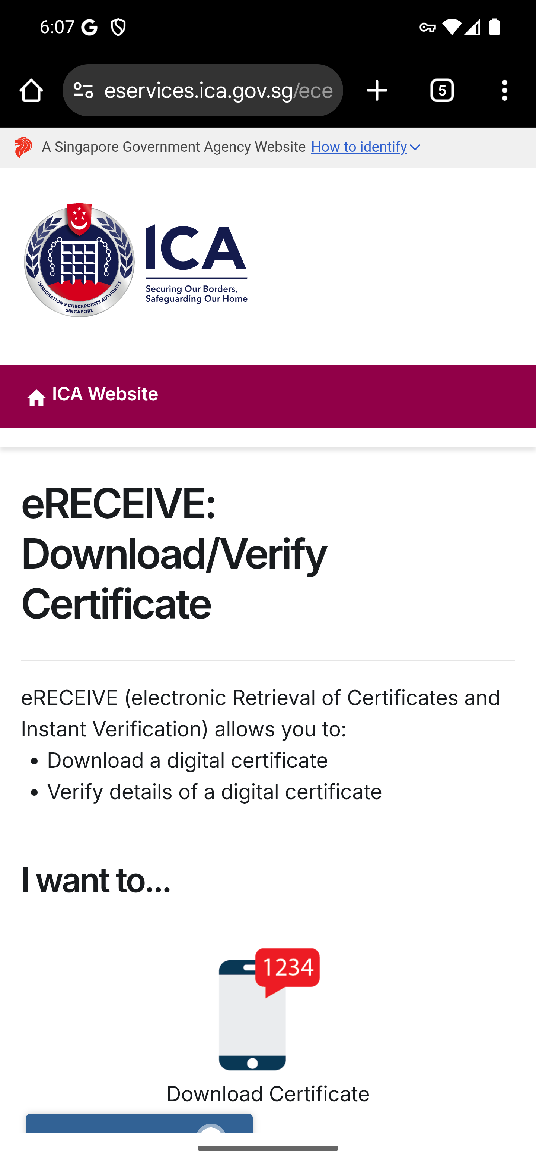
Screen 021 • 2026-09-07 18:08:07 • External service entry

022 Residential address services
Open Report Change of Residential Address.
The second service is visibly labelled FOR_LTVP_STP_HOLDER. Both address links opened the same Change of Residential Address landing page.
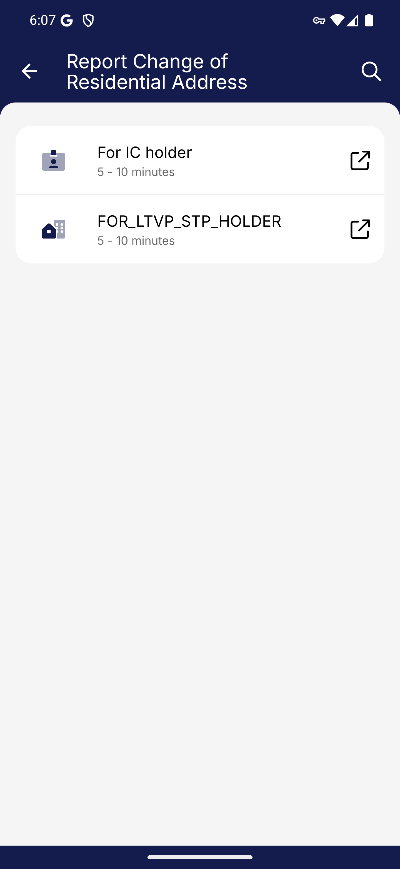
Screen 022 • 2026-09-07 18:08:11 • Captured

023 IC holder address change entry
Residential address → For IC holder.
Opened in Chrome: eservices.ica.gov.sg/esvclandingpage/ecoa. Downstream authenticated transactions were not performed.
Outcome: External service entry
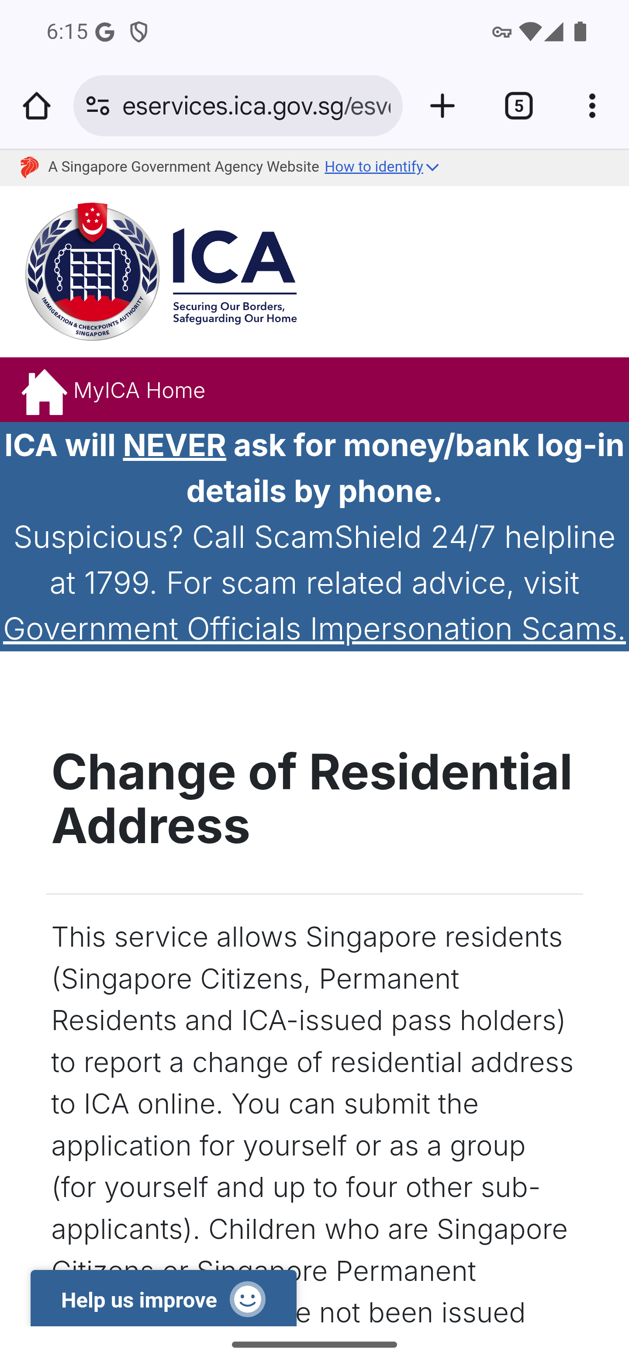
Screen 023 • 2026-09-07 18:16:10 • External service entry

024 LTVP and student pass address change entry
Residential address → FOR_LTVP_STP_HOLDER.
Opened in Chrome: eservices.ica.gov.sg/esvclandingpage/ecoa. Downstream authenticated transactions were not performed.
Outcome: External service entry

Screen 024 • 2026-09-07 18:16:15 • External service entry

025 Citizenship and permanent residence resume point
Open Singapore Citizenship and Permanent Residence.
The earlier session paused here. All three links were opened when the walkthrough resumed.
Outcome: Historical pause point
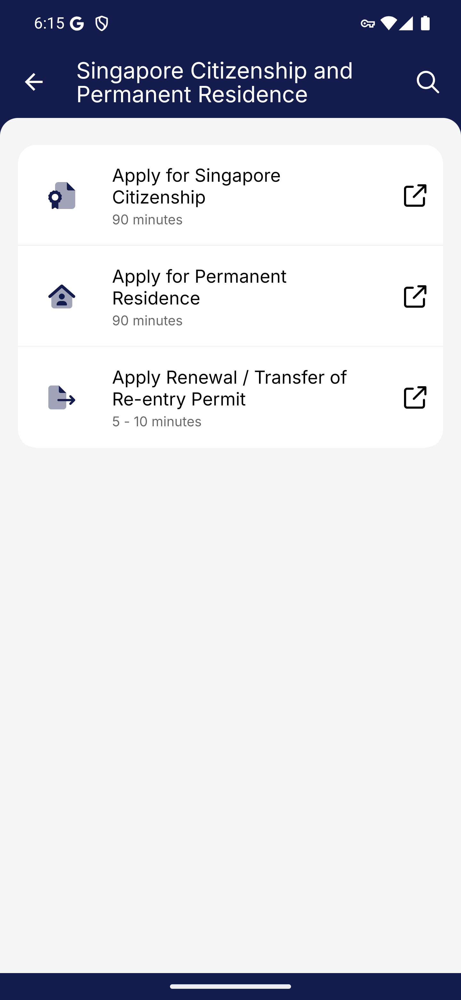
Screen 025 • 2026-09-07 18:16:18 • Historical pause point

026 Apply for Singapore Citizenship entry
Citizenship and Permanent Residence → Apply for Singapore Citizenship.
Browser page: ICA - Singapore Citizenship. Address: eservices.ica.gov.sg/esvclandingpage/esc.
Outcome: External service entry
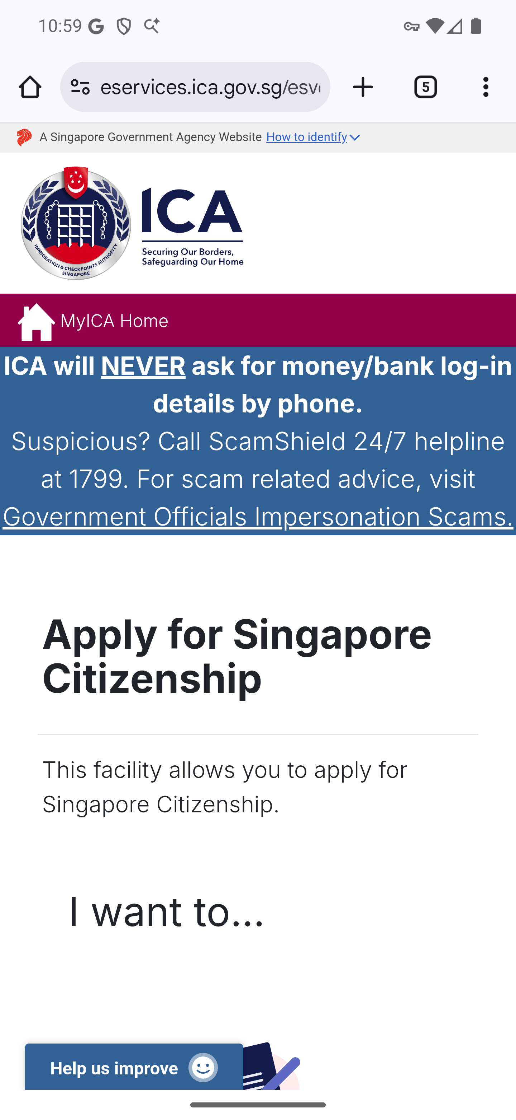
Screen 026 • 2026-09-07 22:59:21 • External service entry

027 Apply for Permanent Residence entry
Citizenship and Permanent Residence → Apply for Permanent Residence.
Browser page: ICA - Electronic Permanent Residence. Address: eservices.ica.gov.sg/esvclandingpage/epr.
Outcome: External service entry
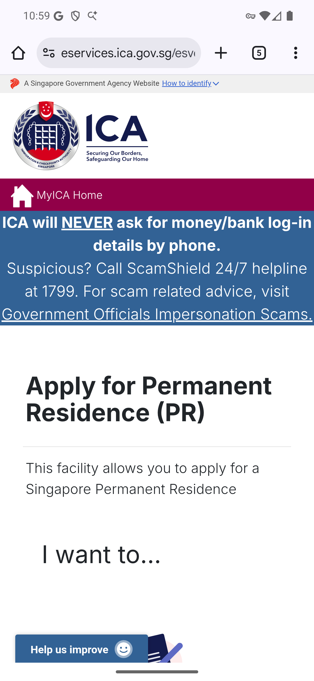
Screen 027 • 2026-09-07 22:59:25 • External service entry

028 Renewal or transfer of Re-entry Permit entry
Citizenship and Permanent Residence → Apply Renewal / Transfer of Re-entry Permit.
Browser page: ICA - Re-Entry Permit. Address: eservices.ica.gov.sg/esvclandingpage/erep.
Outcome: External service entry
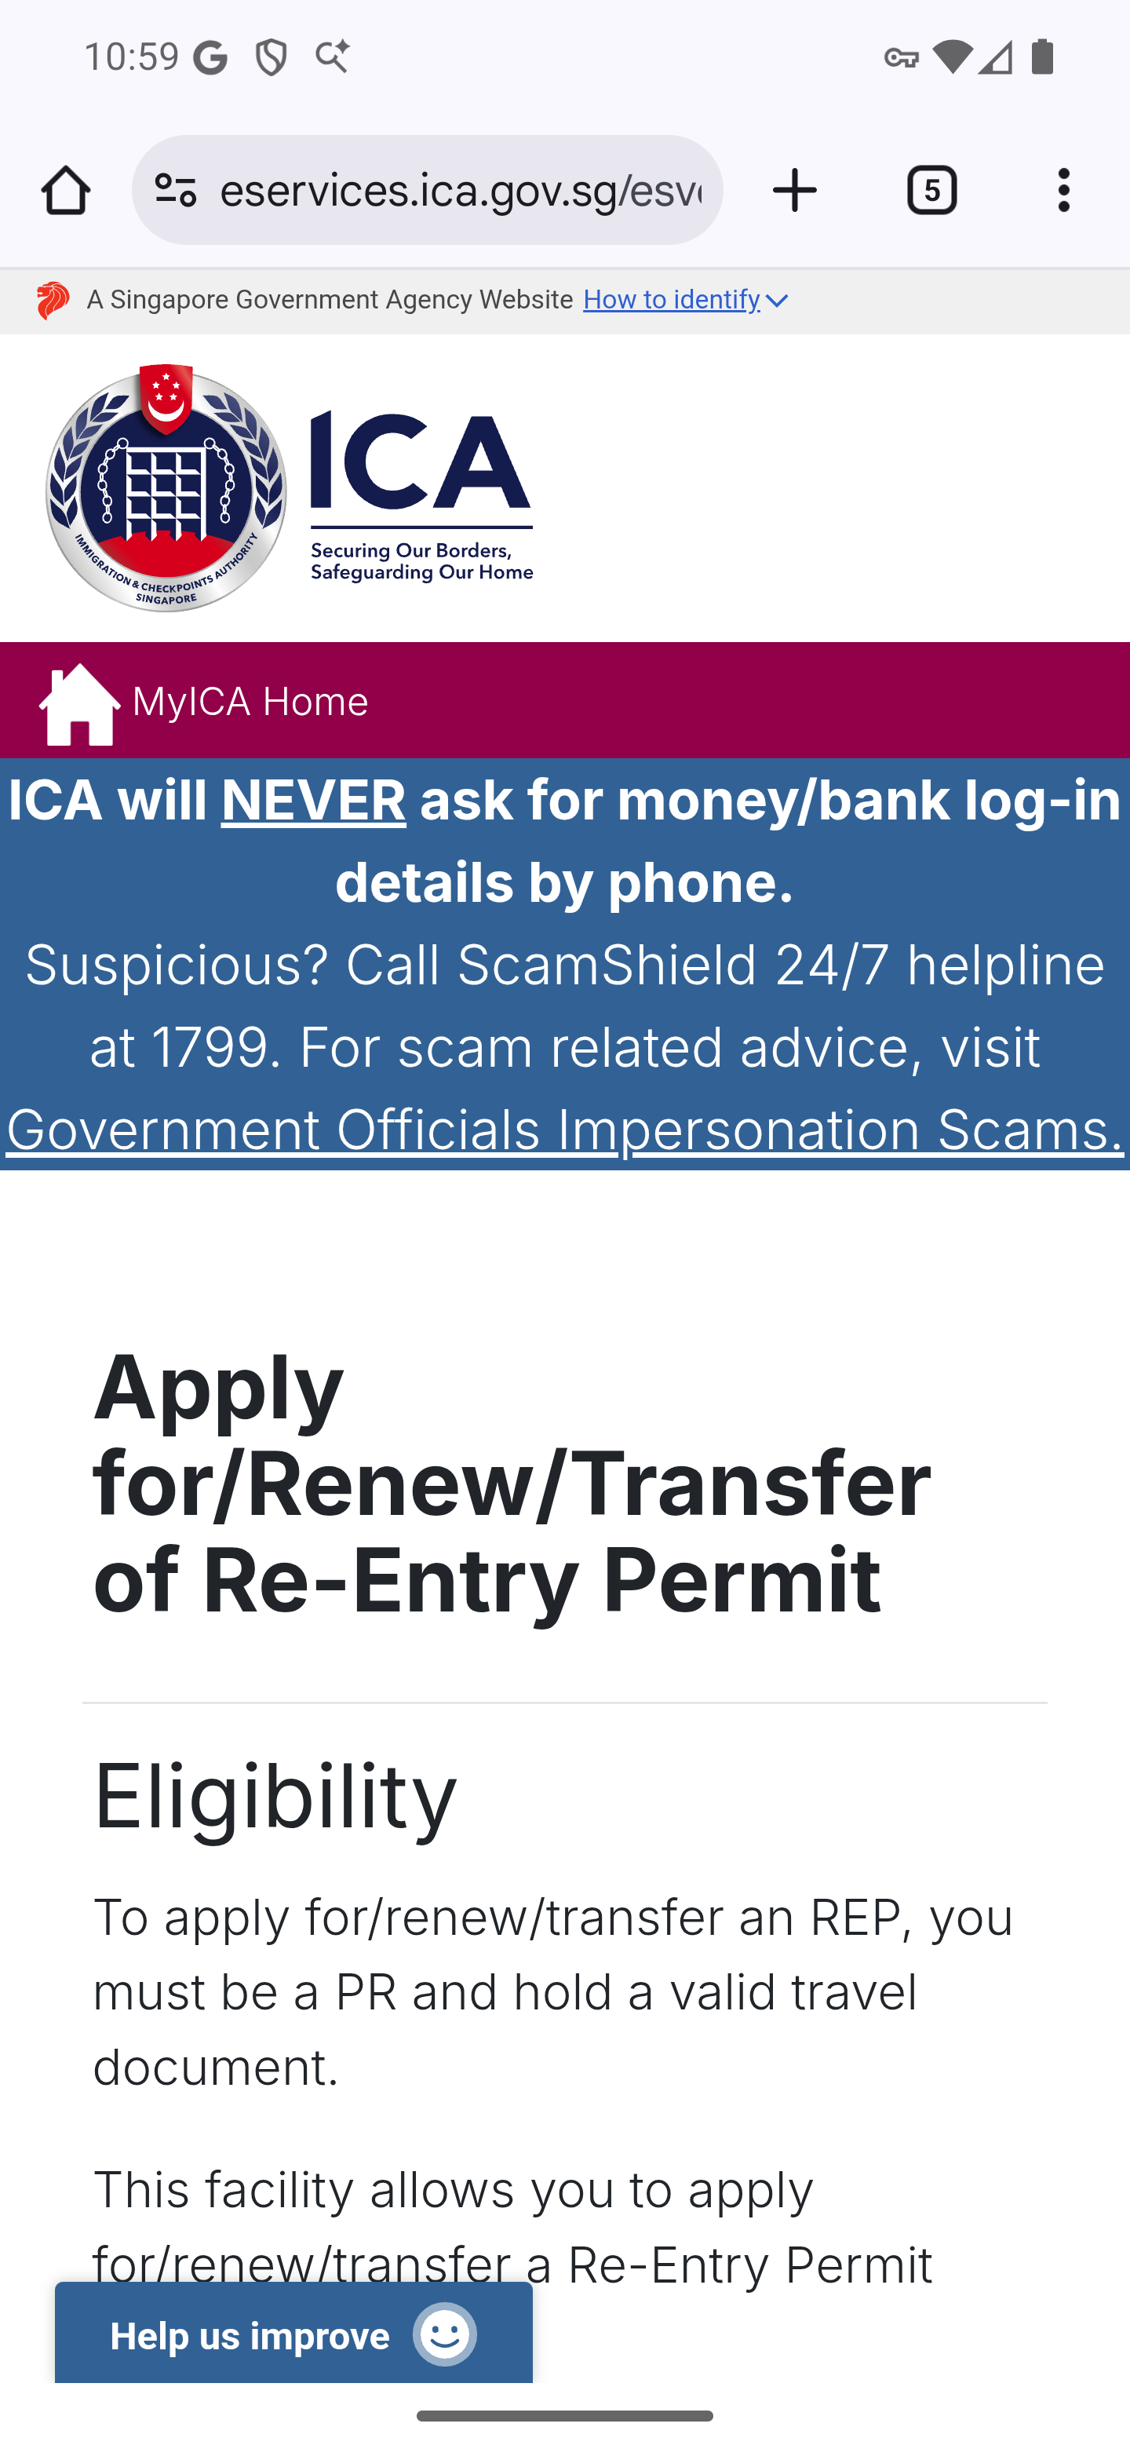
Screen 028 • 2026-09-07 22:59:30 • External service entry

029 Long-Term Visit Pass and Student's Pass services
Other e-Services → Long-Term Visit Pass and Student's Pass.
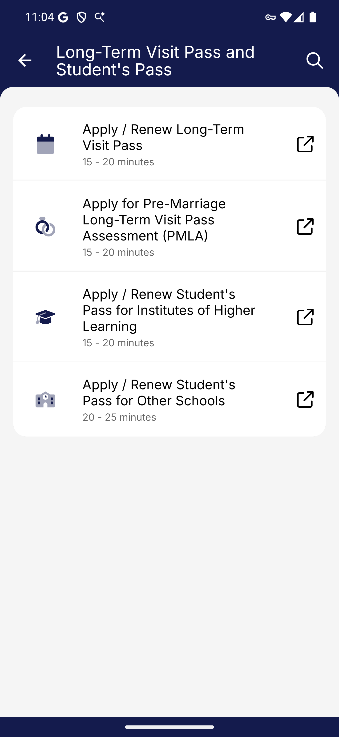
Screen 029 • 2026-09-07 23:04:24 • Captured

030 Apply / Renew Long-Term Visit Pass entry
Long-Term Visit Pass and Student's Pass → Apply / Renew Long-Term Visit Pass.
Browser page: ICA - Visit Pass Application. Address: eservices.ica.gov.sg/esvclandingpage/evp.
Outcome: External service entry
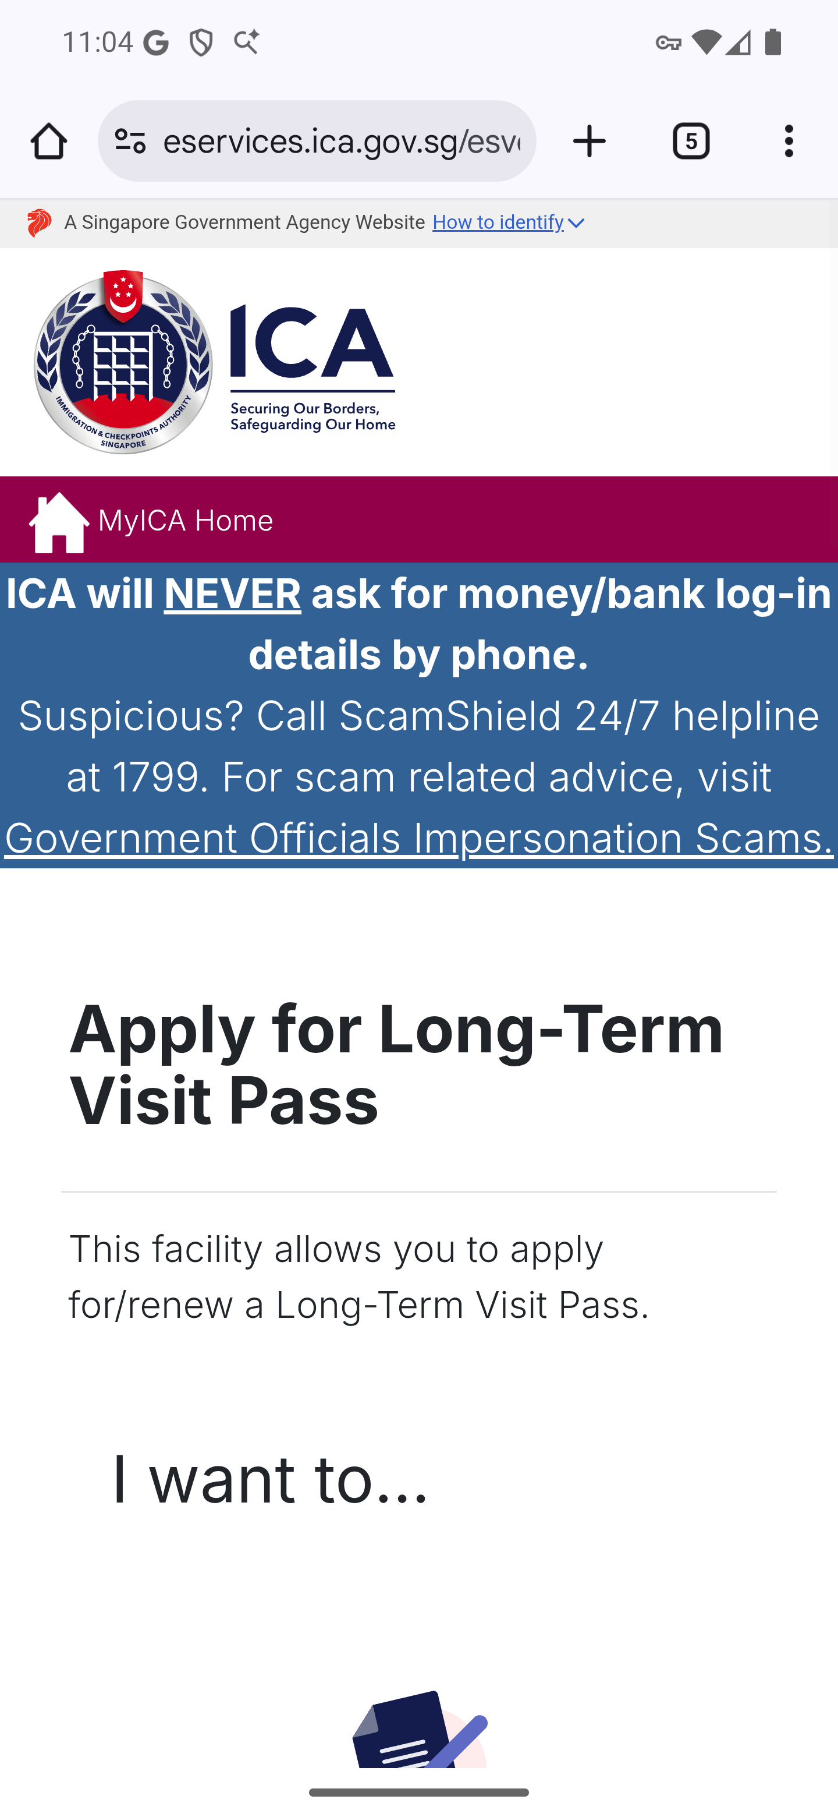
Screen 030 • 2026-09-07 23:04:55 • External service entry

031 Apply for Pre-Marriage Long-Term Visit Pass Assessment (PMLA) entry
Long-Term Visit Pass and Student's Pass → Apply for Pre-Marriage Long-Term Visit Pass Assessment (PMLA).
Browser page: ICA - Visit Pass Assessment and Application. Address: eservices.ica.gov.sg/esvclandingpage/evpaa.
Outcome: External service entry
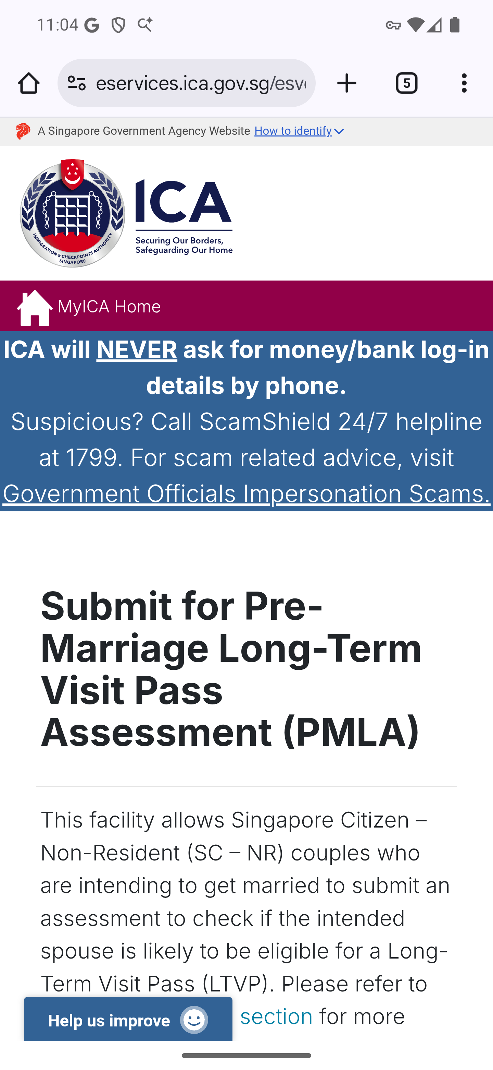
Screen 031 • 2026-09-07 23:04:59 • External service entry

032 Apply / Renew Student's Pass for Institutes of Higher Learning entry
Long-Term Visit Pass and Student's Pass → Apply / Renew Student's Pass for Institutes of Higher Learning.
Browser page: Immigration & Checkpoints Authority - SOLAR. Address: eservices.ica.gov.sg/solar/index.xhtml.
Outcome: External service entry
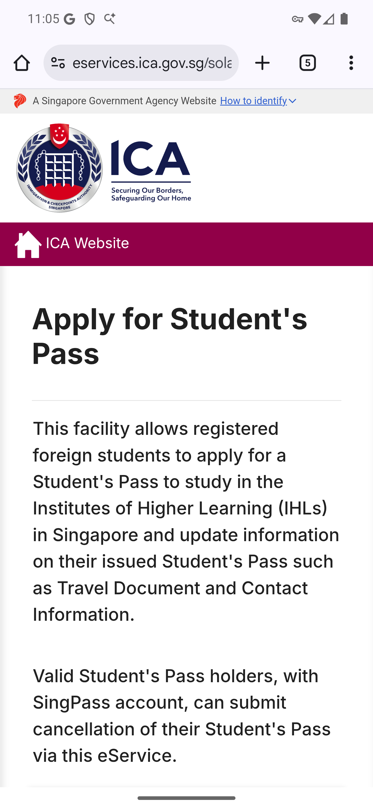
Screen 032 • 2026-09-07 23:05:04 • External service entry

033 Apply / Renew Student's Pass for Other Schools entry
Long-Term Visit Pass and Student's Pass → Apply / Renew Student's Pass for Other Schools.
Browser page: ICA - Student's Pass OnLine Application and Registration+. Address: eservices.ica.gov.sg/esvclandingpage/solarplus.
Outcome: External service entry
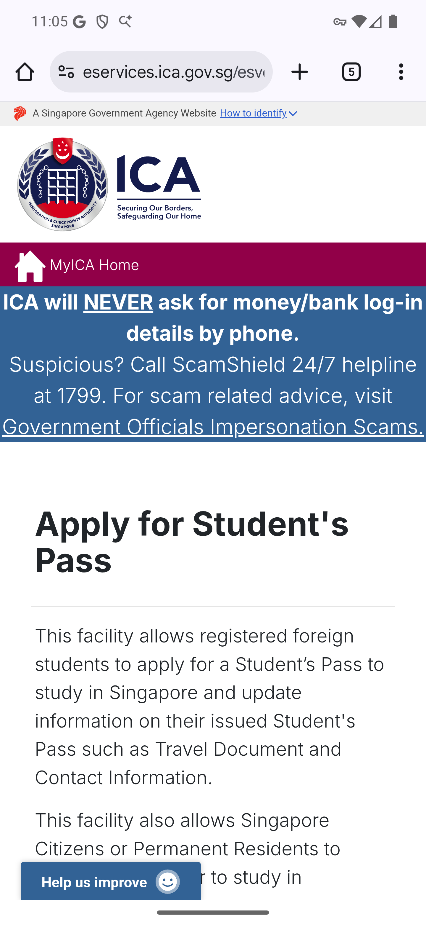
Screen 033 • 2026-09-07 23:05:09 • External service entry

034 Birth and Death services
Other e-Services → Birth and Death.
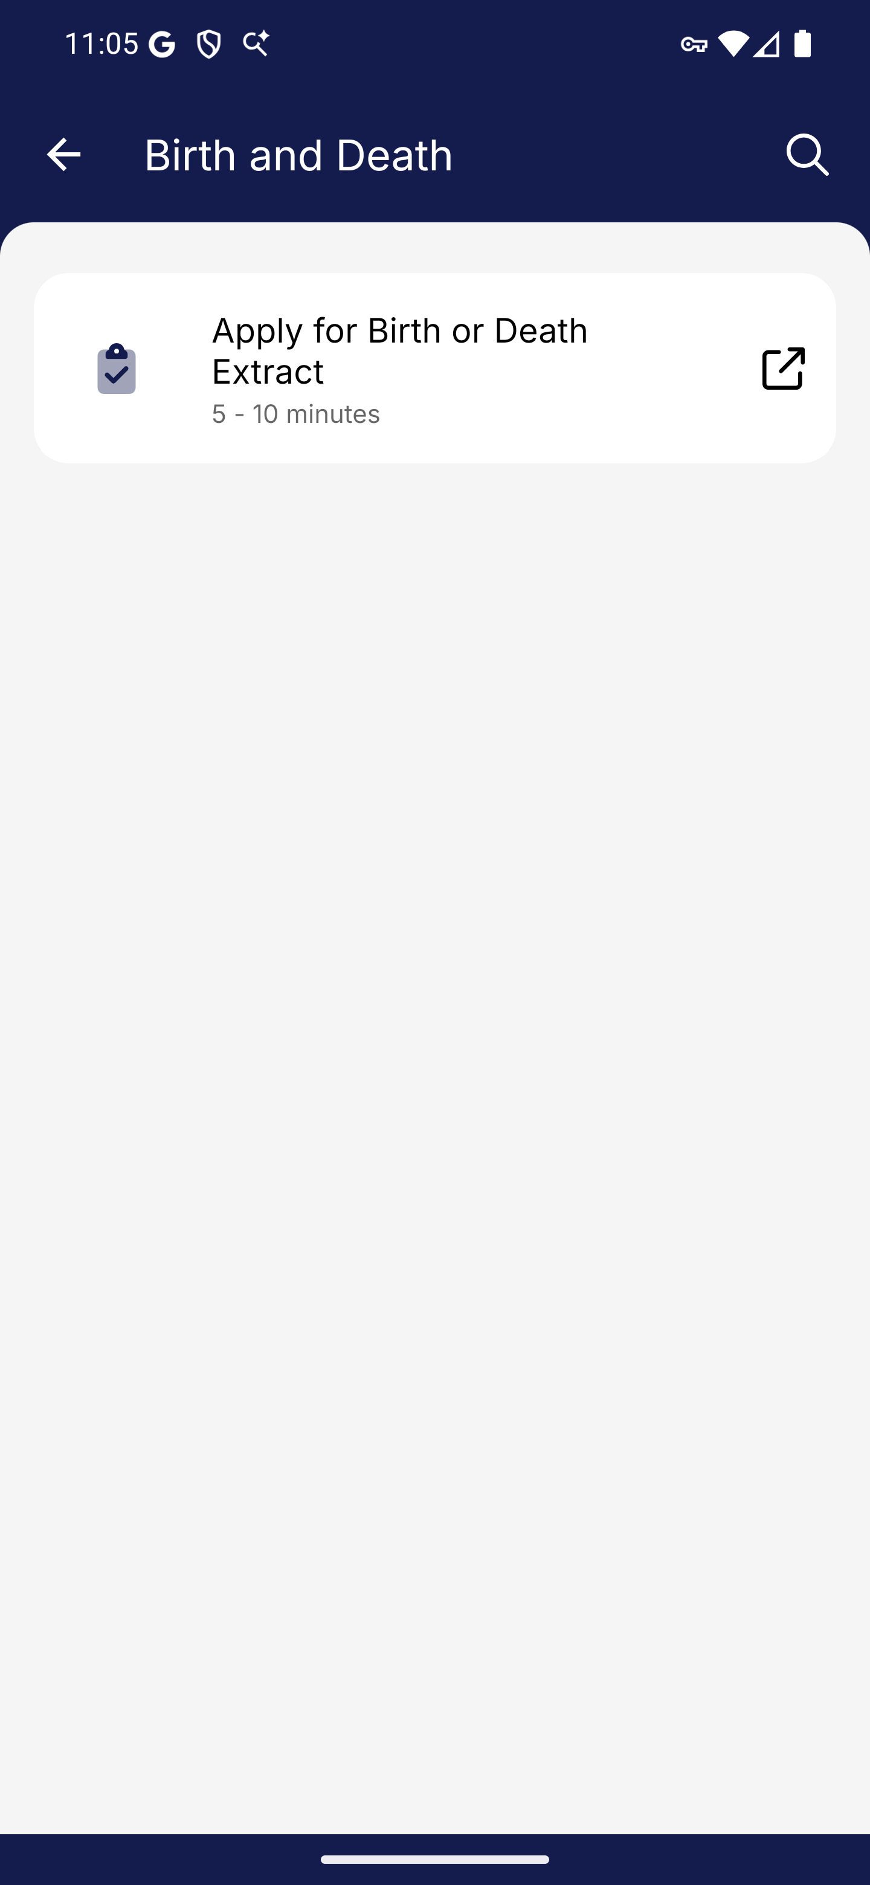
Screen 034 • 2026-09-07 23:05:12 • Captured

035 Apply for Birth or Death Extract entry
Birth and Death → Apply for Birth or Death Extract.
Browser page: ICA - Birth and Death Extracts. Address: eservices.ica.gov.sg/esvclandingpage/extracts.
Outcome: External service entry
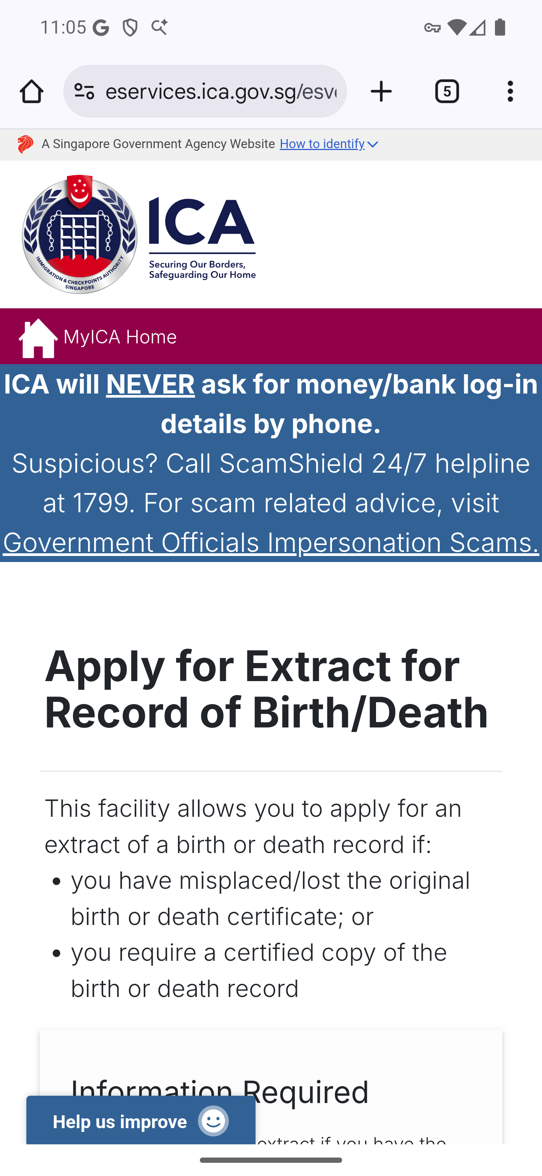
Screen 035 • 2026-09-07 23:05:27 • External service entry

036 Other services menu
Other e-Services → Others.
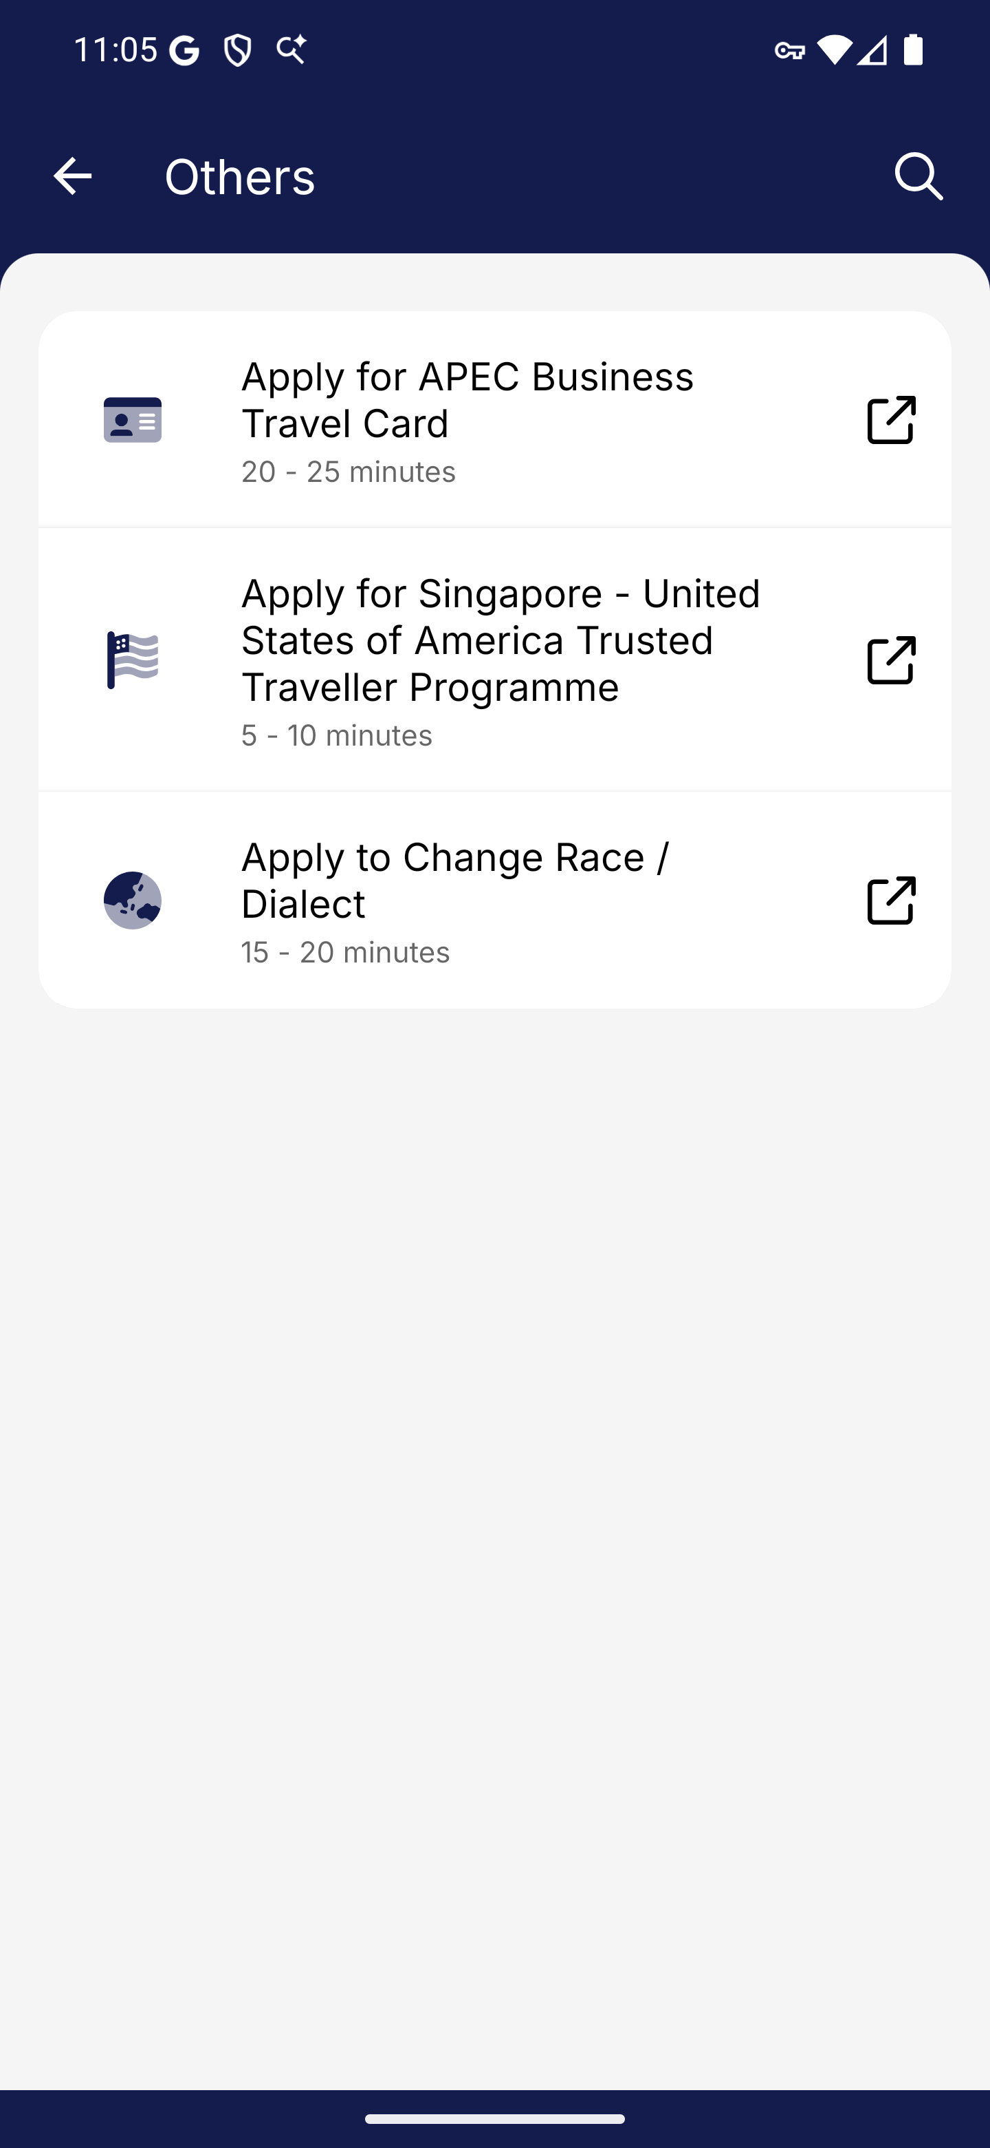
Screen 036 • 2026-09-07 23:05:31 • Captured

037 Apply for APEC Business Travel Card entry
Others → Apply for APEC Business Travel Card.
Browser page: ICA - APEC Business Travel Card. Address: eservices.ica.gov.sg/esvclandingpage/eabtc.
Outcome: External service entry
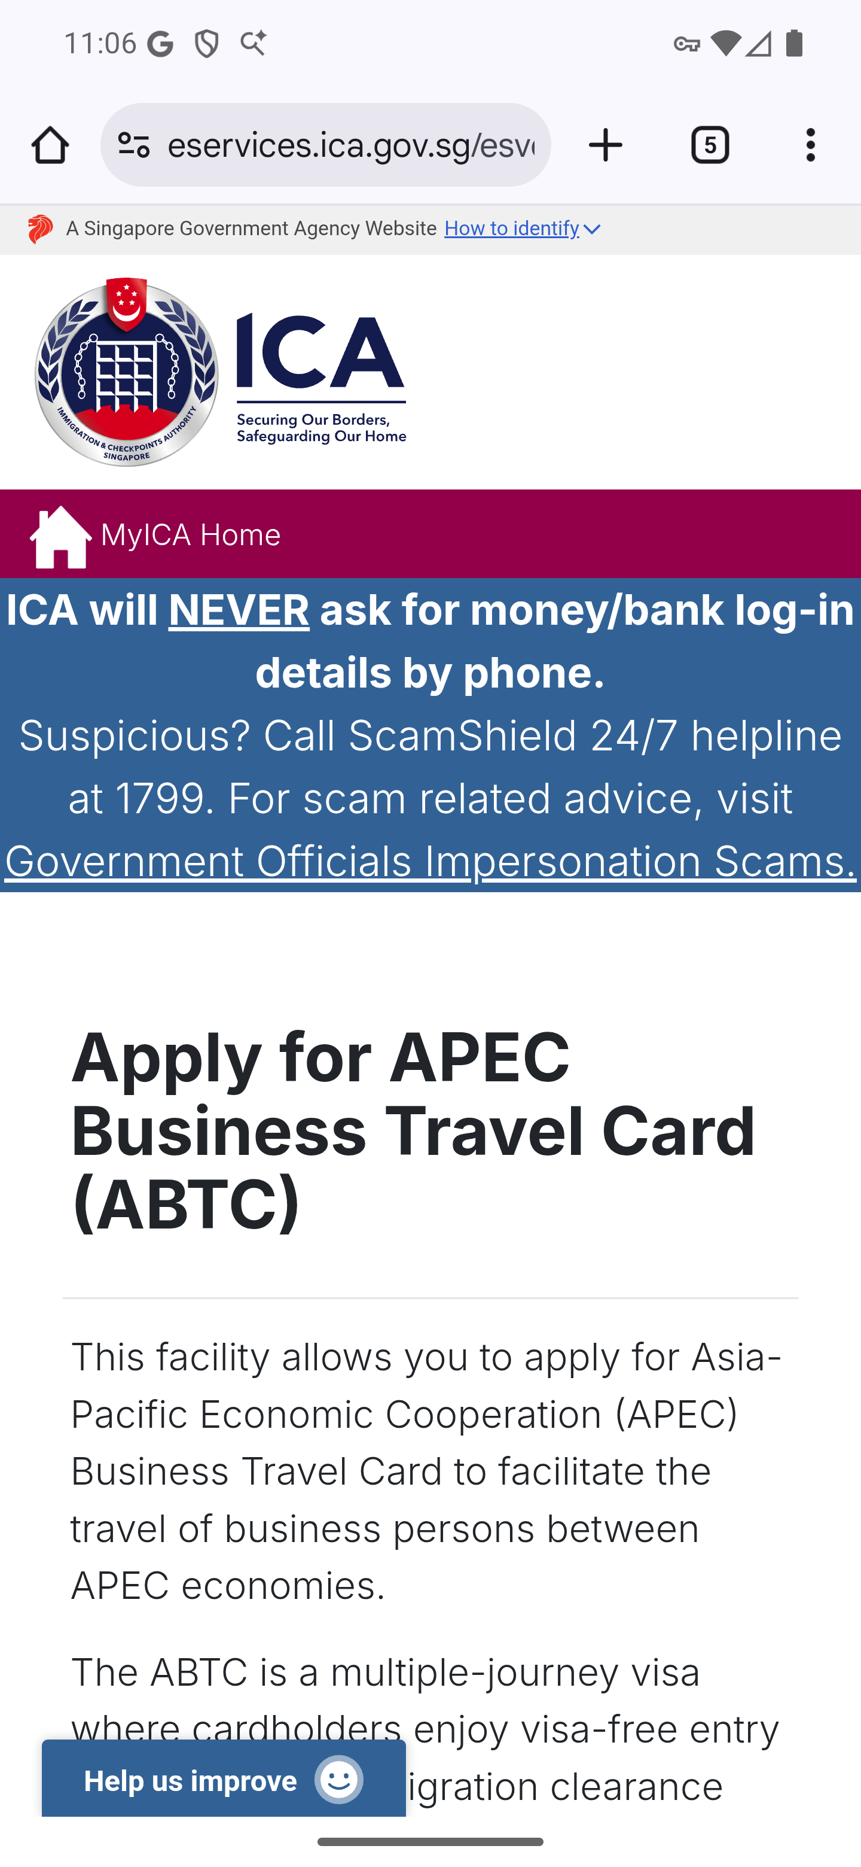
Screen 037 • 2026-09-07 23:06:02 • External service entry

038 Apply for Singapore - United States of America Trusted Traveller Programme entry
Others → Apply for Singapore - United States of America Trusted Traveller Programme.
The Trusted Traveller Programme link reached eservices.ica.gov.sg/404.html and displayed that the requested page cannot be found.
Outcome: Destination unavailable
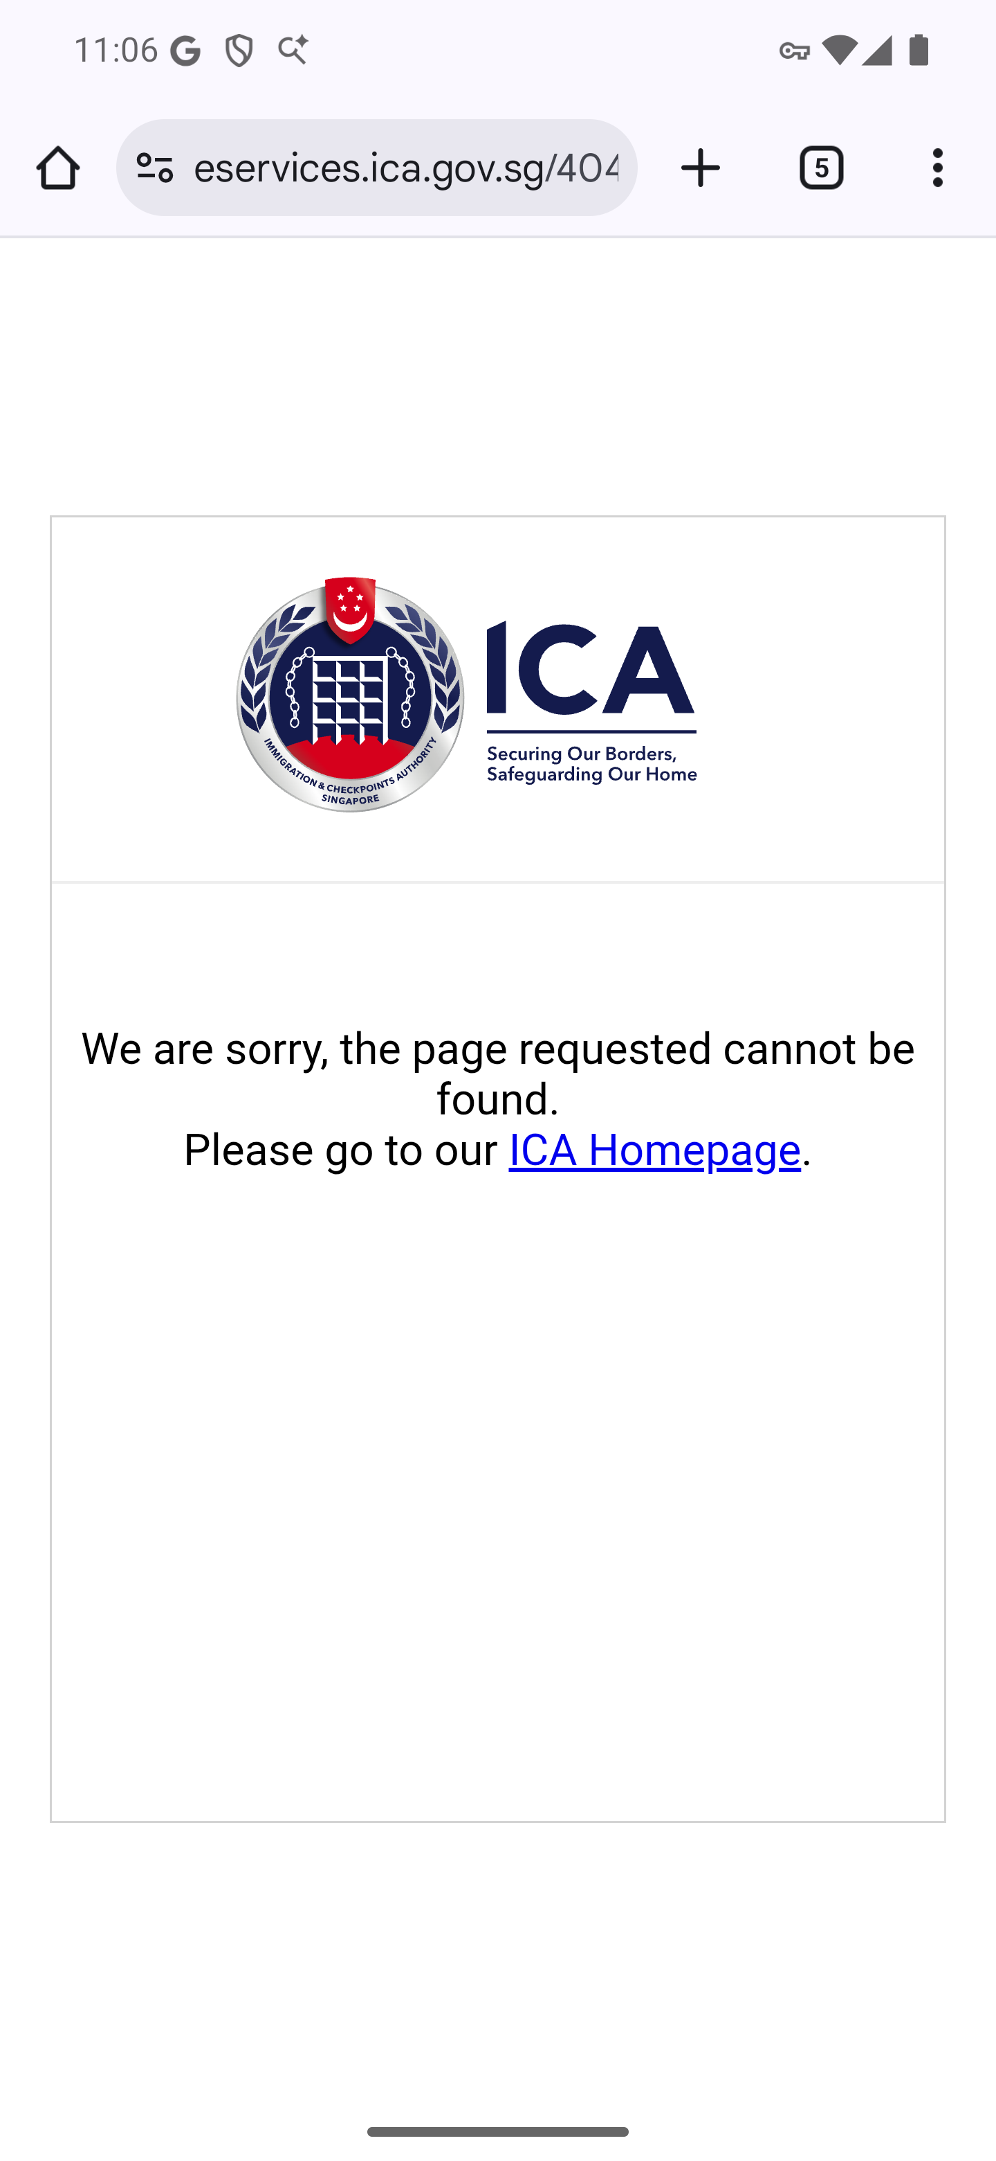
Screen 038 • 2026-09-07 23:06:24 • Destination unavailable

039 Apply to Change Race / Dialect entry
Others → Apply to Change Race / Dialect.
The government-link interstitial displayed a countdown at go.gov.sg/ica-race-dialect. Screen 043 records the loaded destination.
Outcome: Redirect interstitial
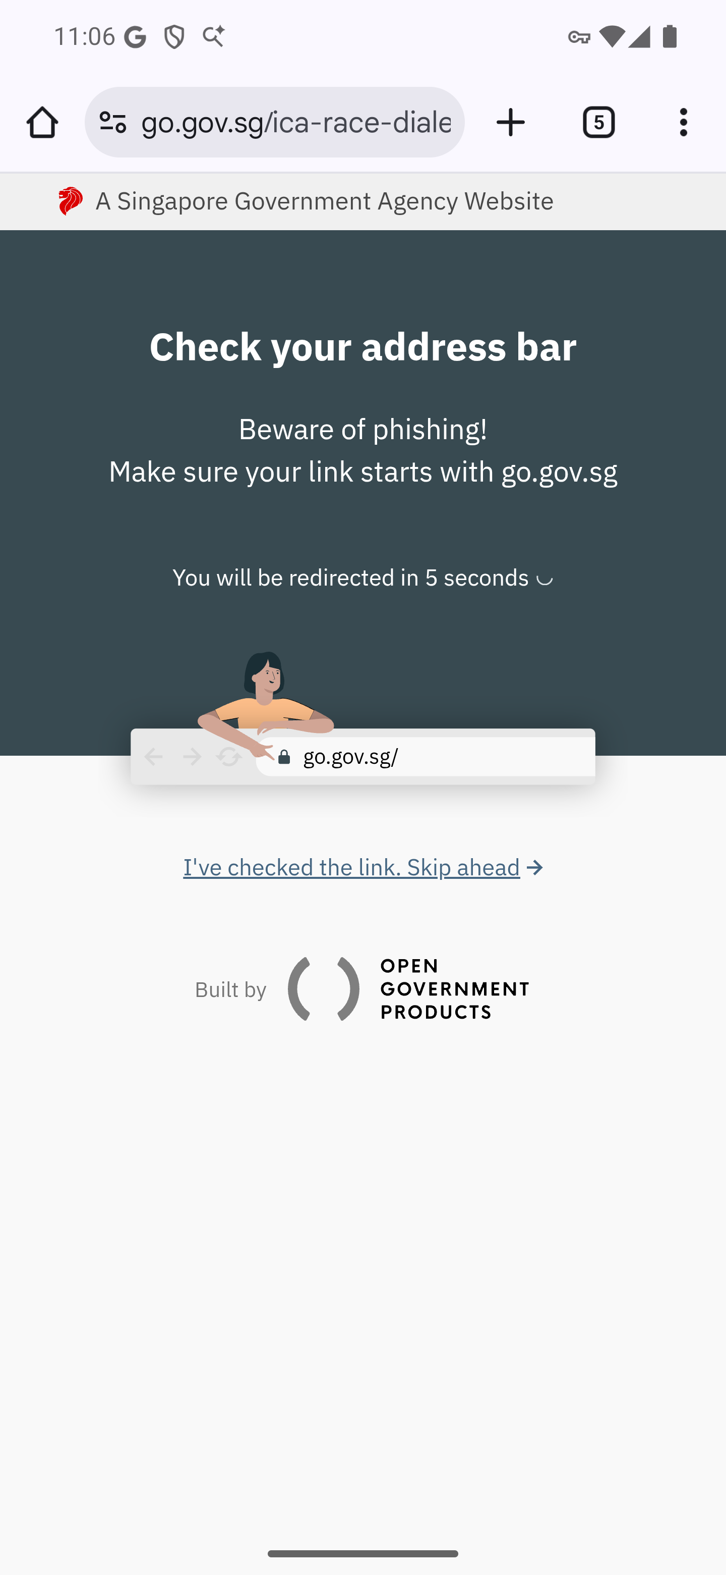
Screen 039 • 2026-09-07 23:06:29 • Redirect interstitial

040 Appointment services
Other e-Services → Appointment.
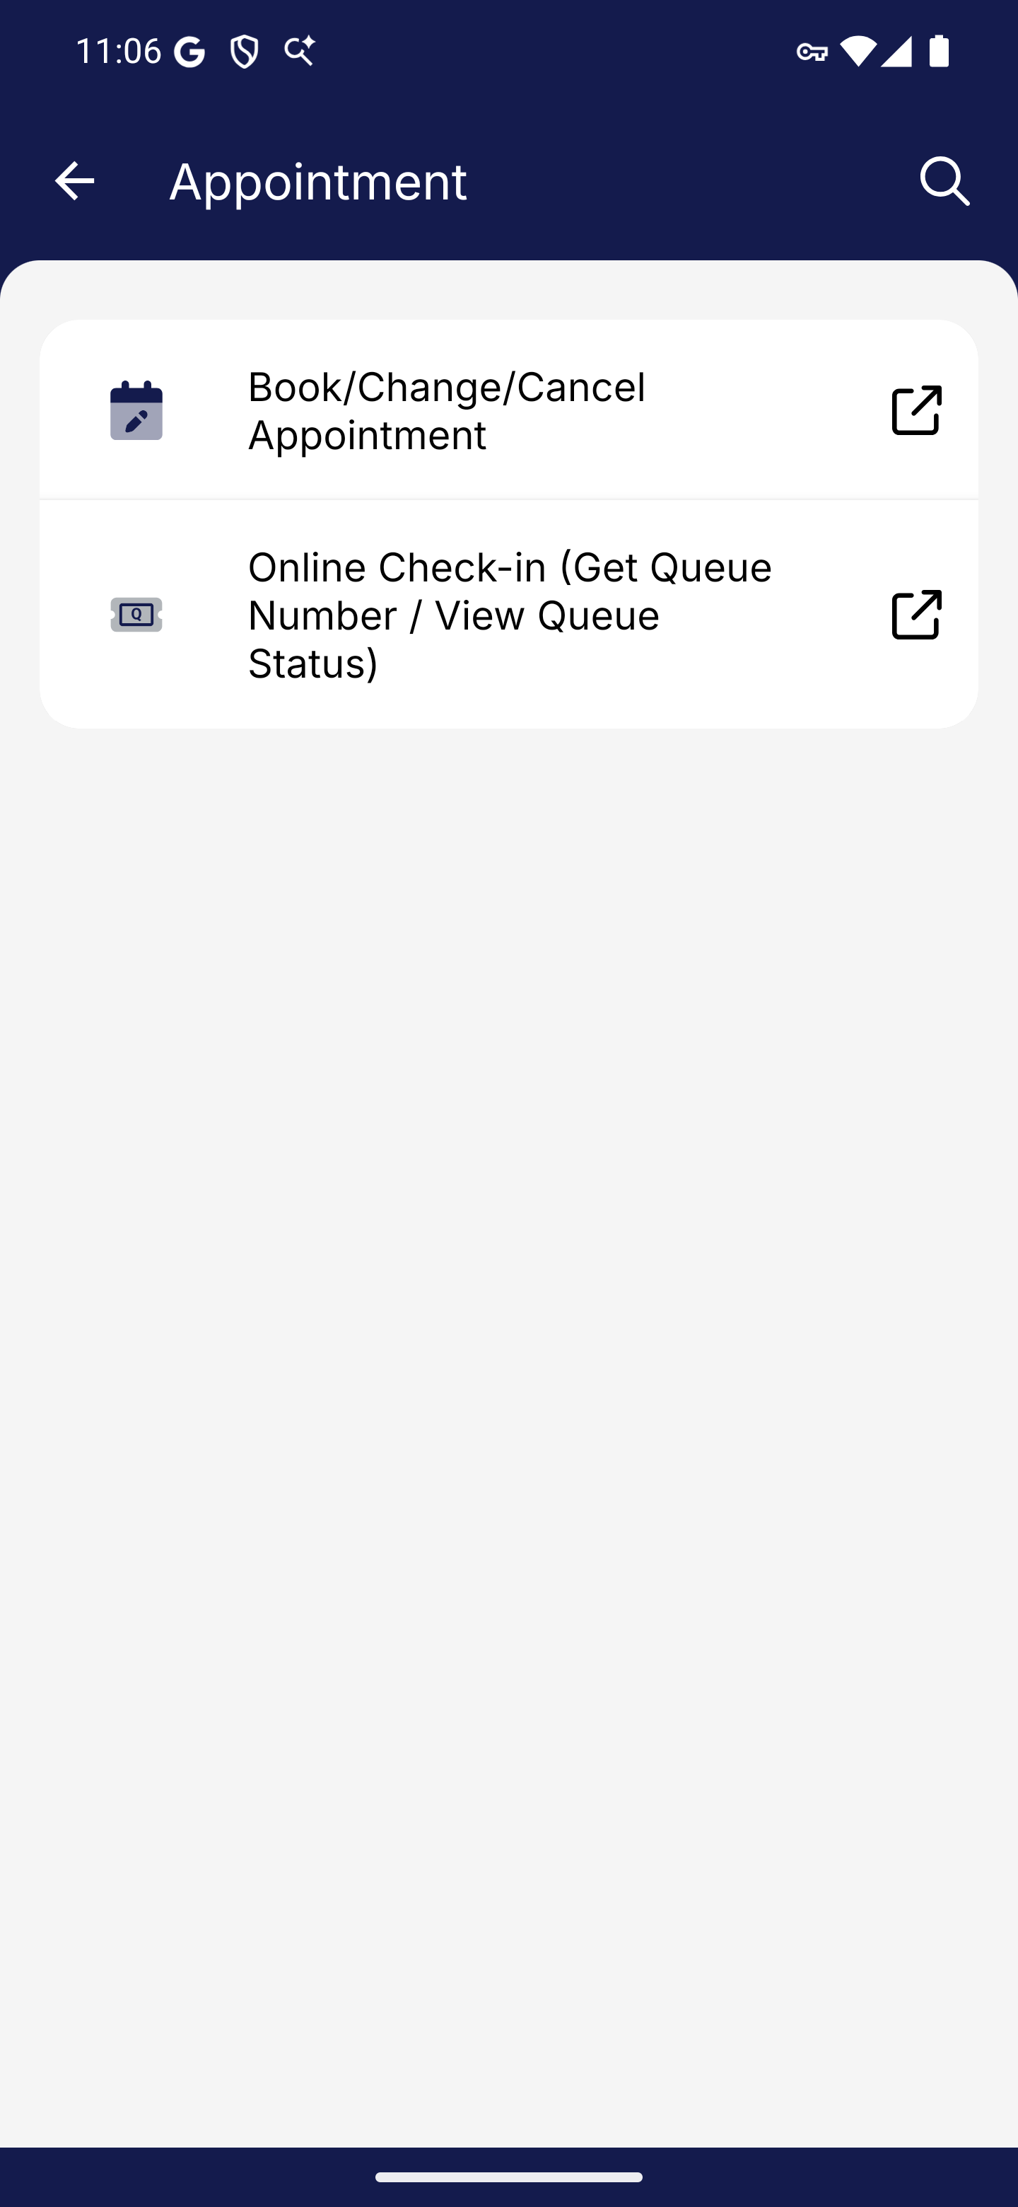
Screen 040 • 2026-09-07 23:06:32 • Captured

041 Book/Change/Cancel Appointment entry
Appointment → Book/Change/Cancel Appointment.
The appointment landing page loaded at eservices-stg.ica.gov.sg/eappt/, offering appointment management and check-in.
Outcome: External service entry
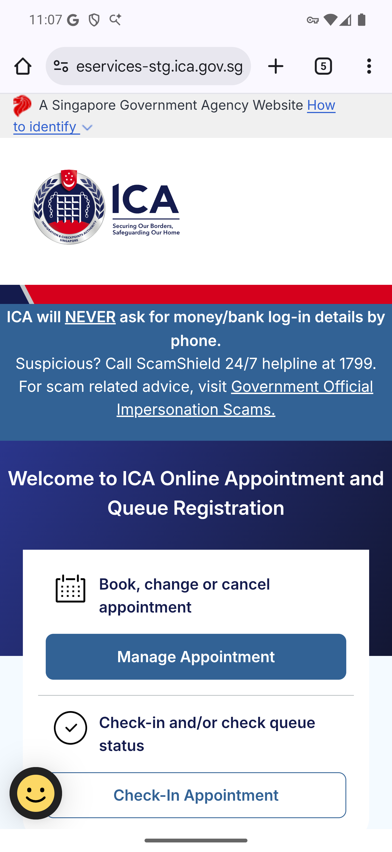
Screen 041 • 2026-09-07 23:07:11 • External service entry

042 Online Check-in (Get Queue Number / View Queue Status) entry
Appointment → Online Check-in (Get Queue Number / View Queue Status).
Online Check-in loaded at eservices-stg.ica.gov.sg/eappt/queue and requests an identity or application reference before Proceed. No check-in was submitted.
Outcome: Reference required
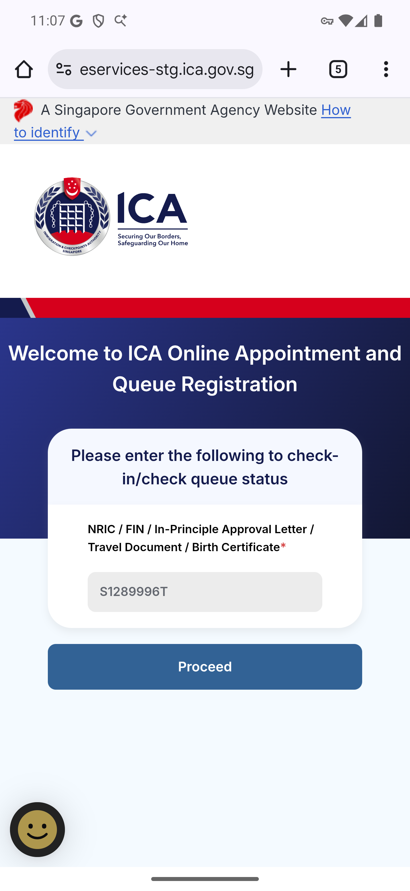
Screen 042 • 2026-09-07 23:07:23 • Reference required

043 Change Race or Dialect destination after redirect
Others → Apply to Change Race / Dialect; wait for the timed government-link redirect.
The redirect reached a FormSG Change of Race / Dialect form at form.gov.sg/682afae22dea99e8708b8868. Its instructions require Singpass app login; no form was submitted.
Outcome: Authentication required
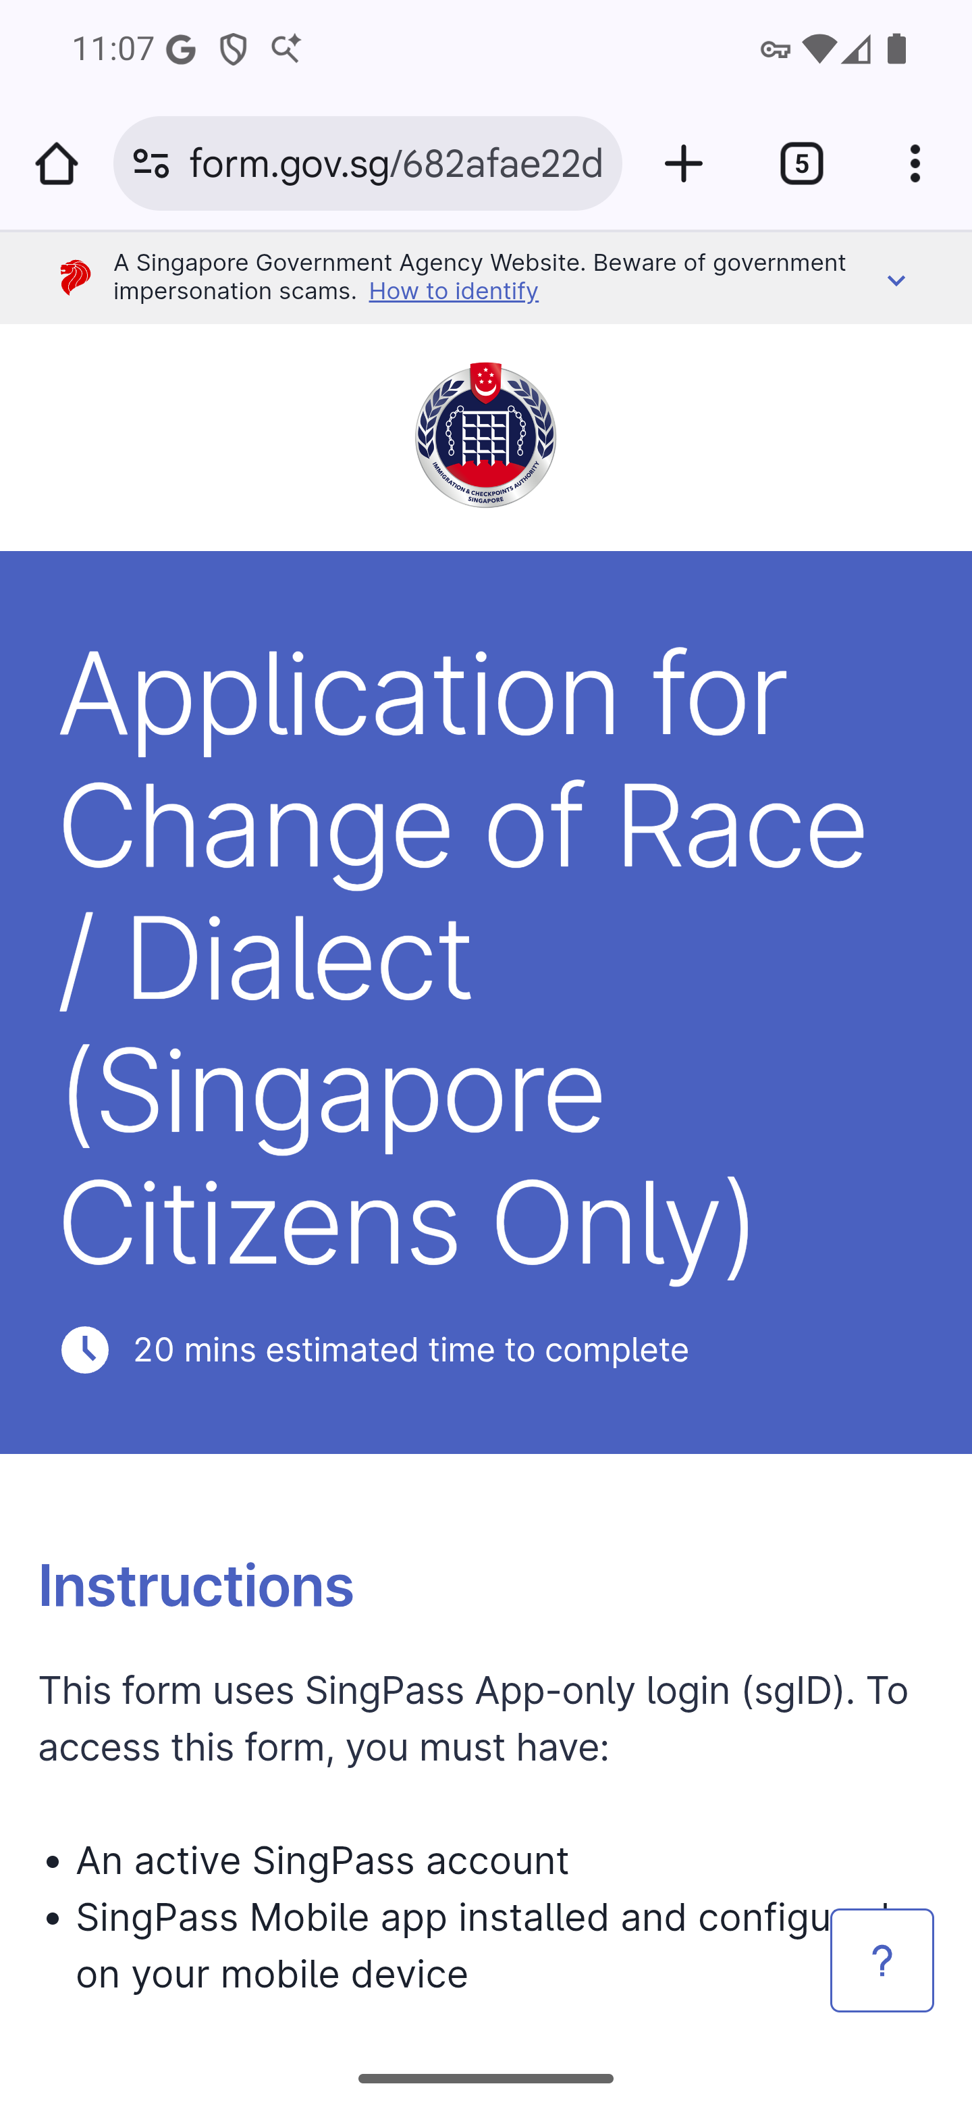
Screen 043 • 2026-09-07 23:07:40 • Authentication required

044 Customs Declaration entry
Other e-Services → Customs Declaration.
The link opened the Customs@SG Web Application information page on customs.gov.sg. No customs declaration or payment was made.
Outcome: External information entry
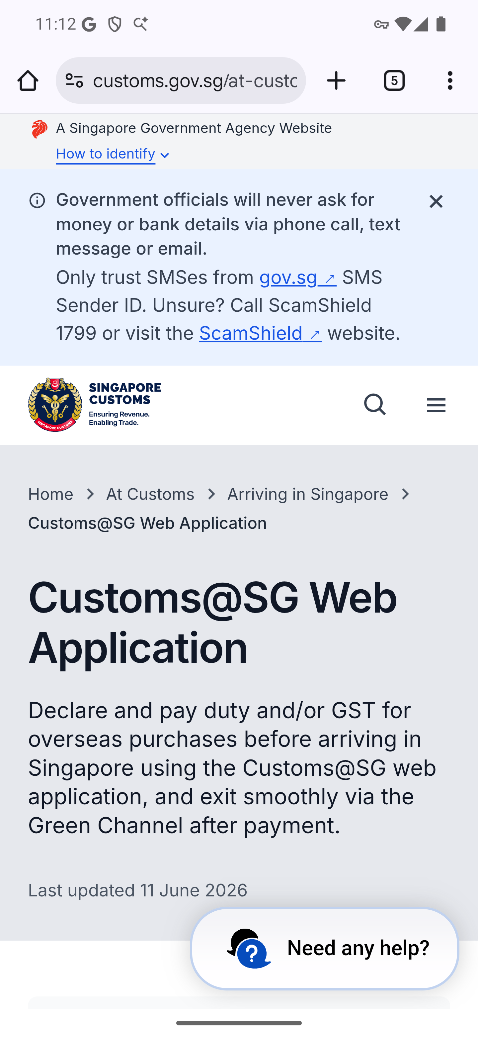
Screen 044 • 2026-09-07 23:12:41 • External information entry

045 Service search empty query
Tap the magnifying-glass icon in the catalogue header.
The empty search lists services, but many names and time estimates display raw translation keys.
Outcome: Display issue observed
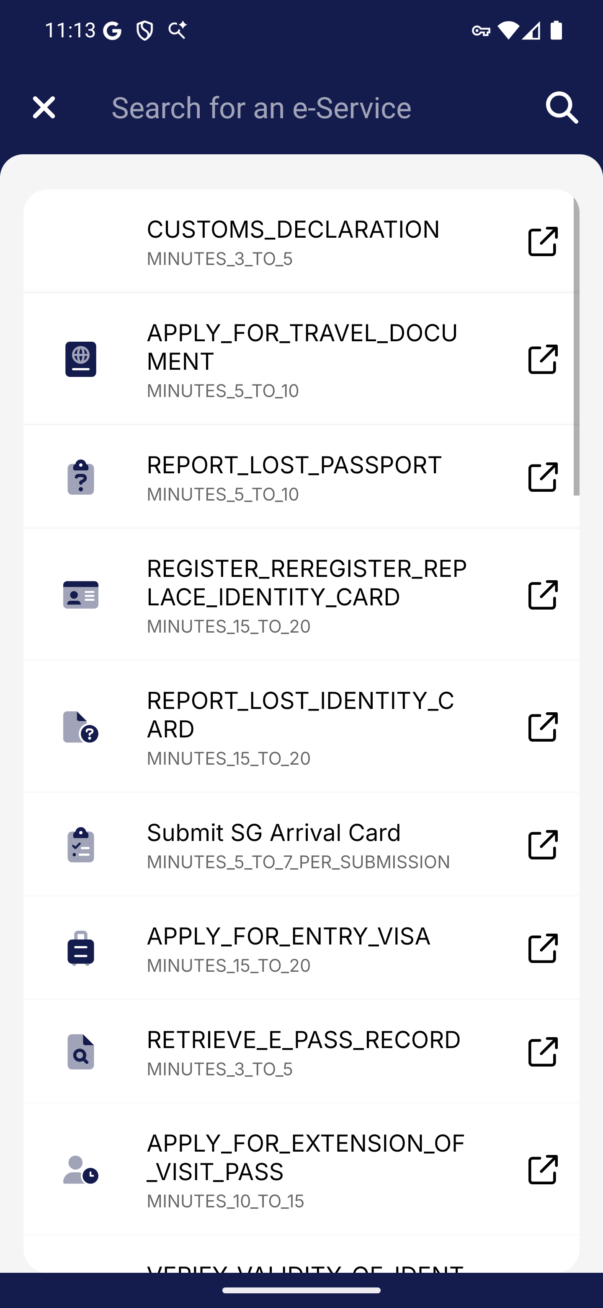
Screen 045 • 2026-09-07 23:13:56 • Display issue observed

046 Service search Report matches
Search for Report, matching the repository's positive-search fixture.
Report returns exactly two cards: REPORT_LOST_PASSPORT and REPORT_LOST_IDENTITY_CARD. Labels and time estimates are untranslated keys.
Outcome: Two matches; display issue
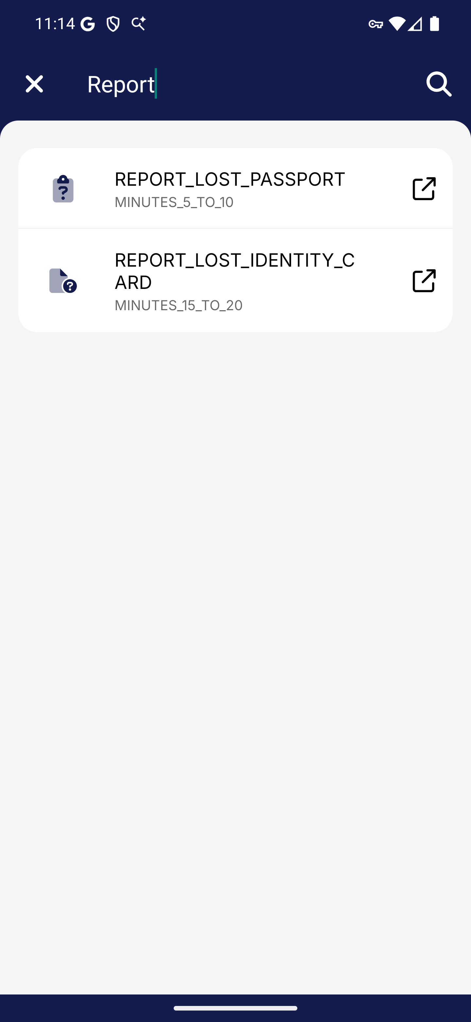
Screen 046 • 2026-09-07 23:14:26 • Two matches; display issue

047 Open a matched service search result
Search Report → REPORT_LOST_PASSPORT.
Selecting REPORT_LOST_PASSPORT from search opened the Passport Online Report entry page. No report was submitted.
Outcome: Search-result navigation reached
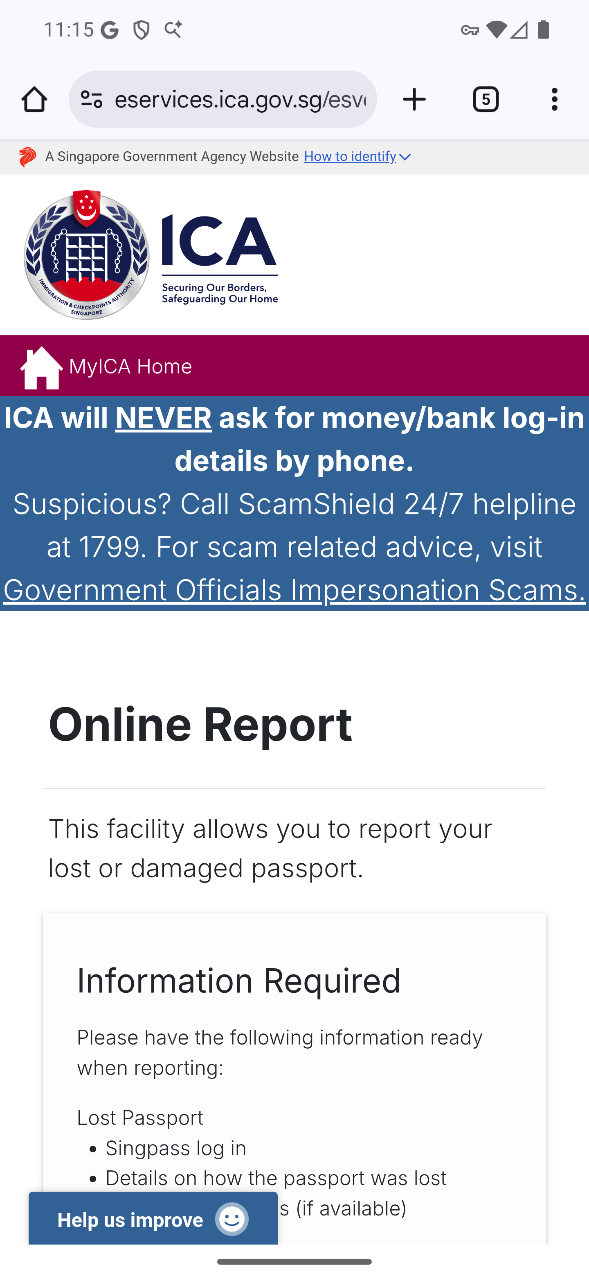
Screen 047 • 2026-09-07 23:15:02 • Search-result navigation reached

048 Service search with no matches
Replace Report with test, the repository's negative-search fixture.
The query test leaves no service cards visible. No no-results message is displayed.
Outcome: No matches
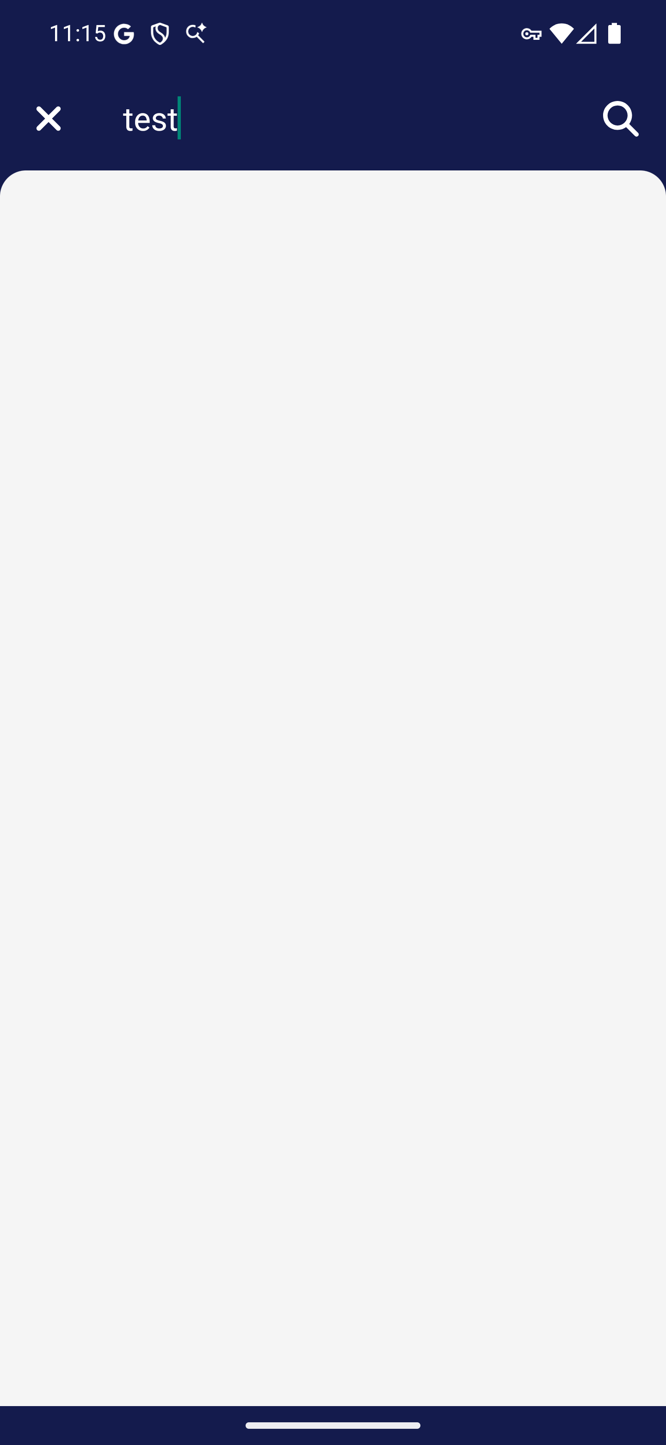
Screen 048 • 2026-09-07 23:15:07 • No matches

049 Clearing service search restores the list
Clear the no-match query.
Clearing test restores the unfiltered service list. Raw translation keys remain visible.
Outcome: List restored; display issue
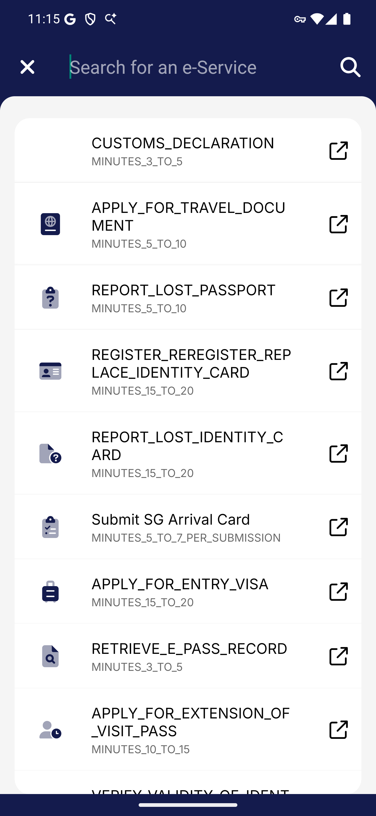
Screen 049 • 2026-09-07 23:15:26 • List restored; display issue

