  - REGRESSION ISSUE REVIEW

MyICA iOS
Possible issues
  - SGAC2.0 • Version 2.0.0(15) • Evidence from 9–10 September 2026
Eight findings for triage, covering confirmed visible defects, suspected functional issues and earlier observations that need retesting. Screenshots are embedded in this document.
Environment Physical iPad Air 11-inch (M3), iOS 26.6.1, portrait, English unless stated. Installed build 2.0.0(15), STAGING.
Evidence scope 10 September continuation plus the earlier 9 September run on the same build. The separate 1.19.1(1) / SGAC1.0 run is excluded.
Priority Suggested triage order, not an agreed severity classification. “Confirmed” describes the observed behavior; it does not establish its root cause.
Reference | Finding | Disposition
IOS-03 | Cargo Important Note text is clipped | Confirmed; 10 Sep
IOS-04 (copy) | Cargo empty state spells vehicle as “vechicle” | Confirmed; 10 Sep
IOS-07 | QR residence list contains literal test markup | Confirmed; 10 Sep
MAIL-01 | Visitor update email was not observed | Suspected; 10 Sep
IOS-06 | Staging cargo receipt opens production retrieval | Earlier; retest
IOS-05 | Resident submission returned to review without receipt | Suspected; retest
IOS-01 | Partial cargo quantity 0 reaches review | Rule check; retest
IOS-02 | Foreigner form intermittently shows translation keys | Intermittent; retest
Each finding starts with reproduction context and actual/expected behavior, followed by the full screenshot. Detail views use Word cropping; the original PNG bytes remain embedded. Synthetic test identifiers are retained where they establish the evidence.

IOS-03 | Cargo Important Note text is clipped
Confirmed visual defect • reproduced 10 Sep
Observed 9 and 10 September 2026
Suggested priority Medium
Prerequisites iPad in portrait; English; cargo webpage available.

Steps to reproduce / observed path
1. From MyICA Home, open Cargo Clearance.
2. Tap Manage Cargo Submission.
3. Scroll below the ARN / Vehicle Number retrieval form to Important Note.
Actual result The Important Note heading begins off-screen on the left. Its body extends beyond both viewport edges, cutting off words.
Expected result The heading and body should remain within the viewport and wrap into readable lines.
Impact Users cannot read the complete cargo instructions at the normal portrait layout.
Follow-up / limits Inspect the cargo web page container width, margins and wrapping at the iPad portrait viewport. Retest after a layout fix.

Evidence detail
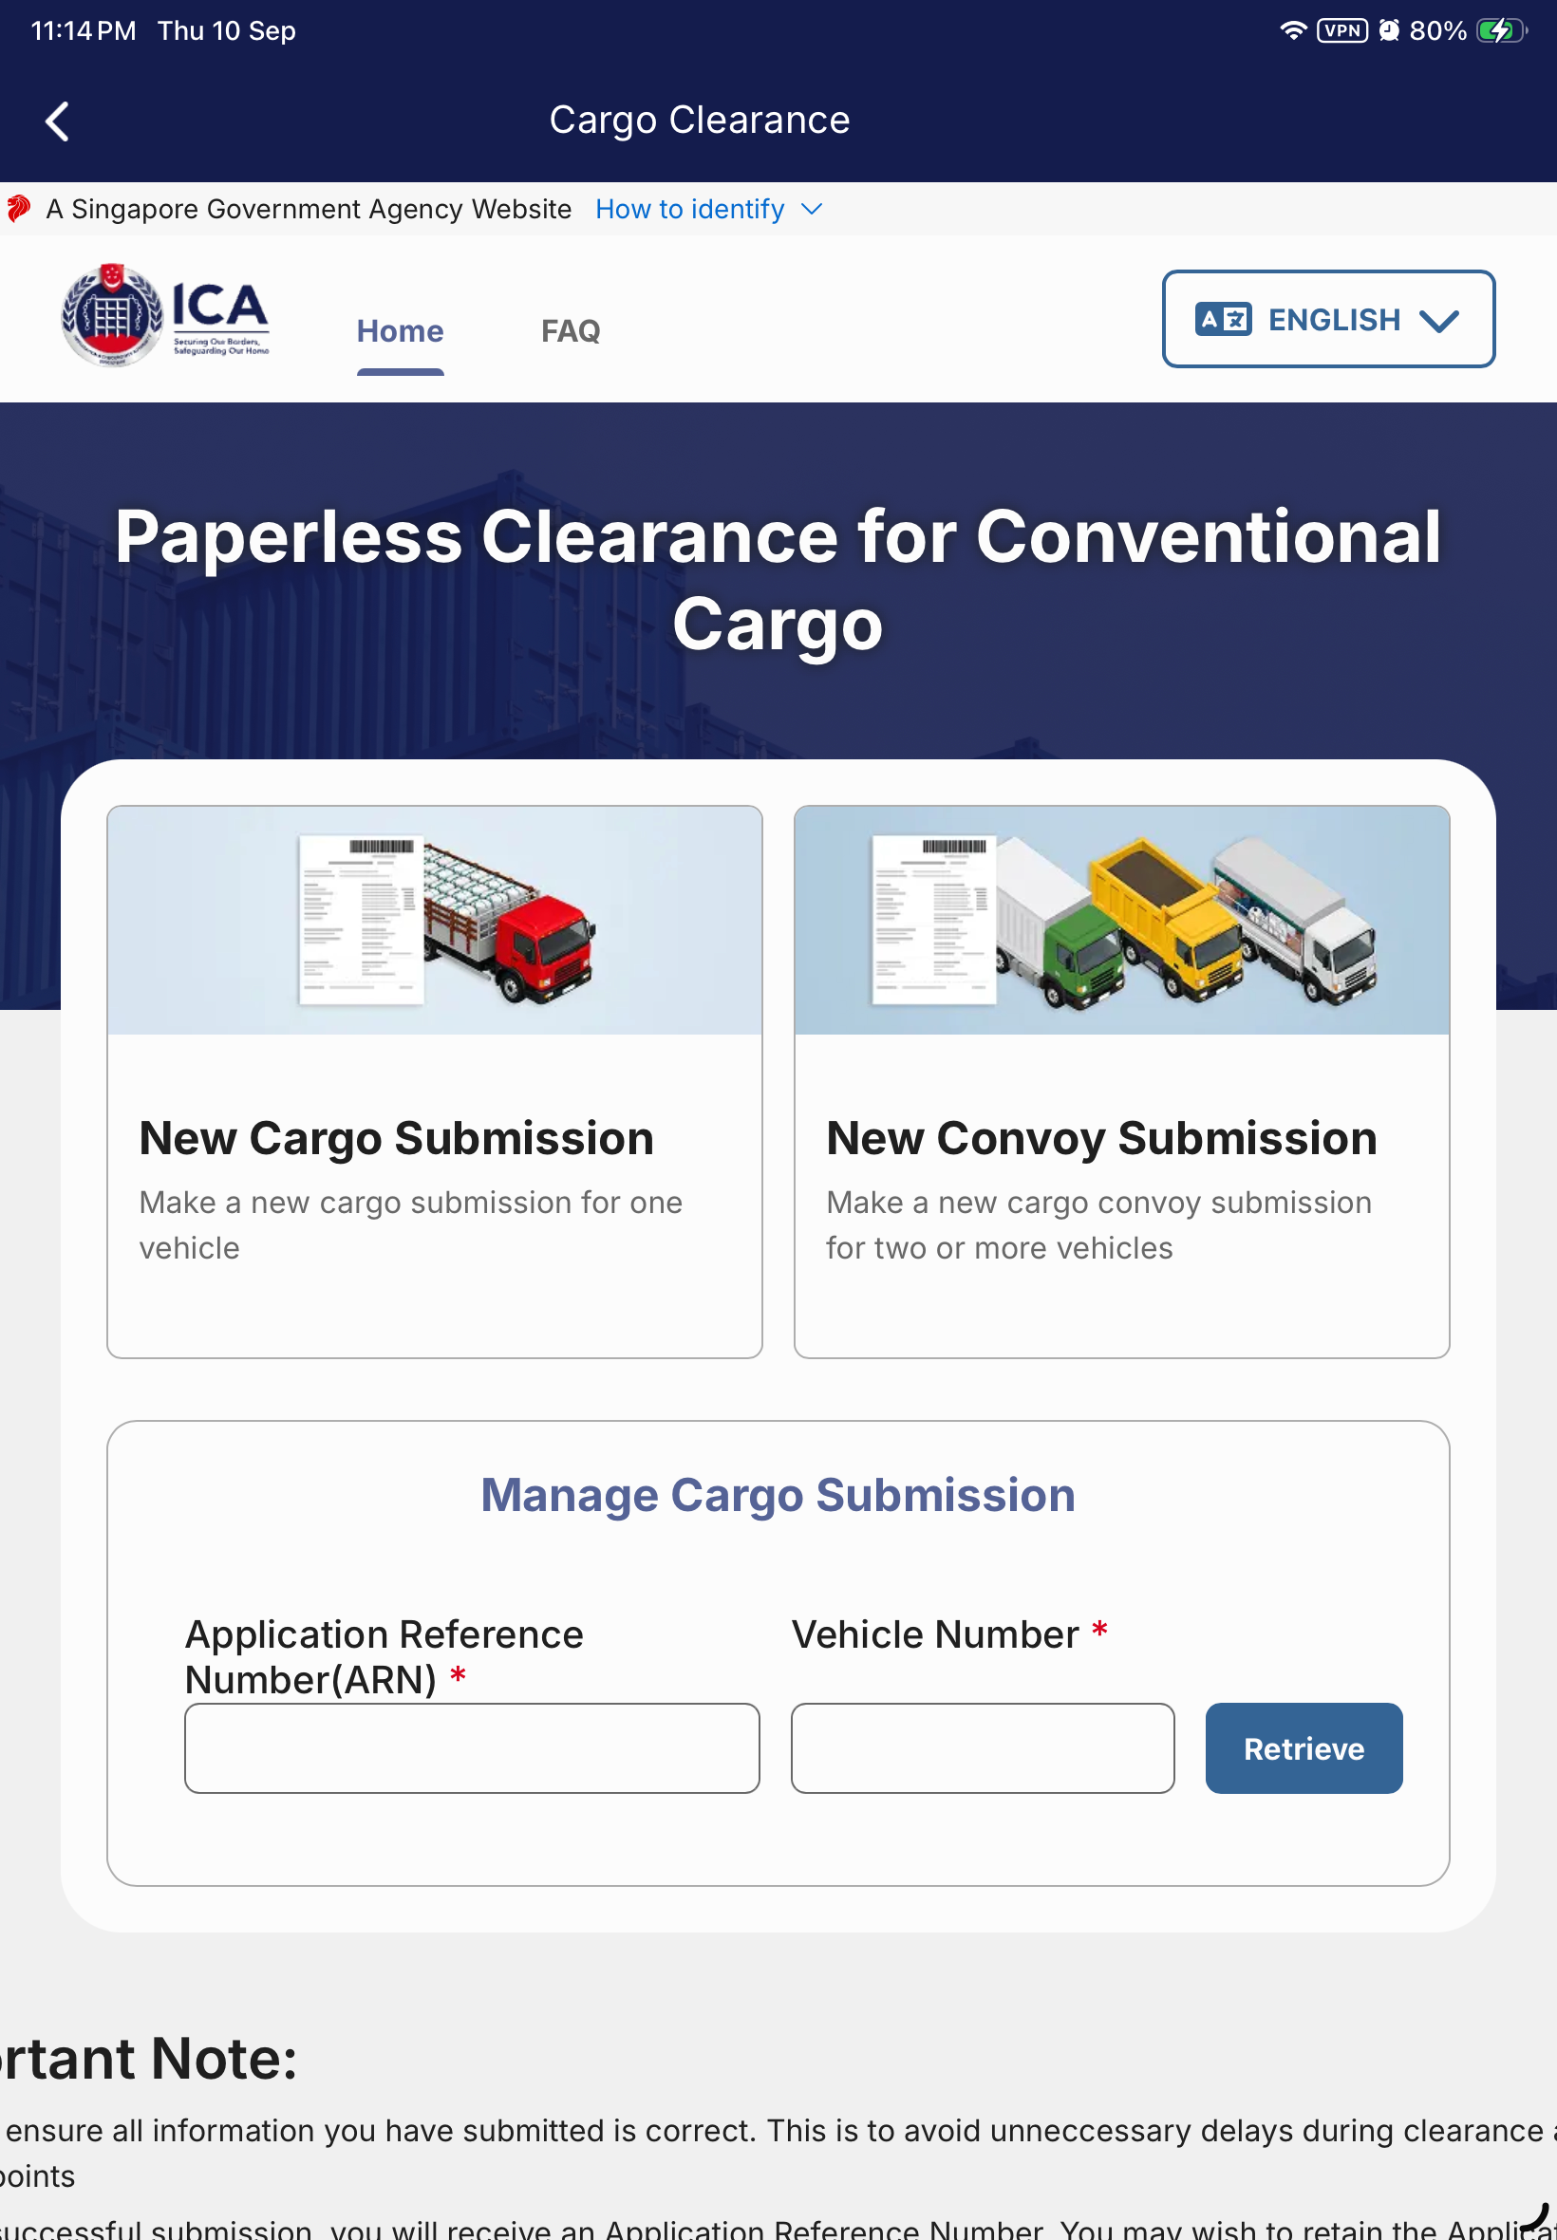
Detail view from 050-cargo-retrieval-form.png; full screenshot follows.

IOS-03 | Screenshot
10 Sep • 050. The clipped Important Note is below the retrieval form.
Output/ios-sgac2-build15-regression-2026-09-10/050-cargo-retrieval-form.png

IOS-04 (copy) | Cargo empty state spells vehicle as “vechicle”
Confirmed copy defect • reproduced 10 Sep
Observed 9 and 10 September 2026
Suggested priority Low
Prerequisites English; no saved cargo vehicle profiles, so the empty state is visible.

Steps to reproduce / observed path
1. From MyICA Home, open Cargo Clearance.
2. Find Select Vehicle Profiles.
3. Read the sentence beneath the large + icon.
Actual result The sentence reads: “Save your details as a vechicle profile to auto-fill future submission”.
Expected result Replace “vechicle” with “vehicle”.
Impact A visible spelling error appears in the instruction for creating a vehicle profile.
Follow-up / limits Correct the English resource string and check the empty state after rebuilding. Existing profiles do not need to be deleted to review this captured evidence.

Evidence detail
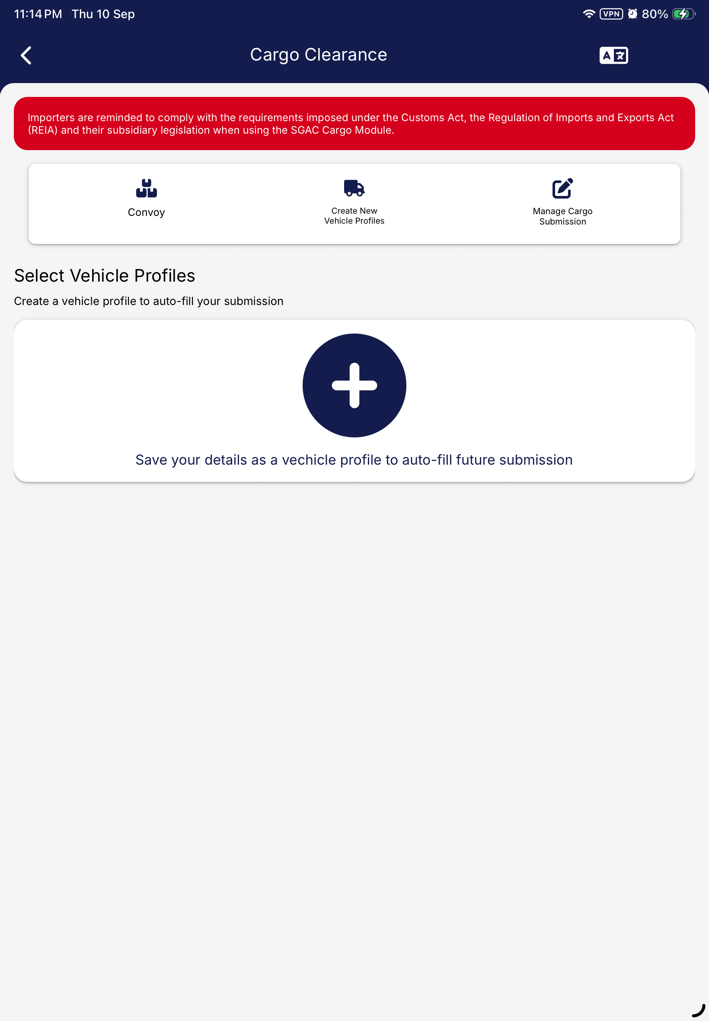
Detail view from 049-cargo-baseline.png; full screenshot follows.

IOS-04 (copy) | Screenshot
10 Sep • 049. The typo appears beneath the large + icon.
Output/ios-sgac2-build15-regression-2026-09-10/049-cargo-baseline.png

IOS-07 | QR residence list contains literal test markup
Confirmed visible content issue • 10 Sep
Observed 10 September 2026
Suggested priority Medium
Prerequisites English; manual foreigner QR profile flow with Place of Residence available.

Steps to reproduce / observed path
1. Open QR Code at Land Checkpoints from MyICA Home.
2. Open profile management and add a foreigner profile manually.
3. Complete the required identity fields and continue to contact details.
4. Open Place of Residence; inspect the Albania entries in the unfiltered list.
Actual result A selectable row contains “ALBANIA<h1>test</h1>, OTHERS IN ALBANIA<h1>test</h1>, …”. The markup is visibly rendered as text.
Expected result Location choices should contain clean country / region / city labels.
Impact Malformed reference content is exposed to users and could be selected as a residence.
Follow-up / limits Trace the location reference data and confirm the intended UAT dataset. Staging data contamination is a likely explanation; the source is unverified. This observation does not establish script execution.

Evidence detail
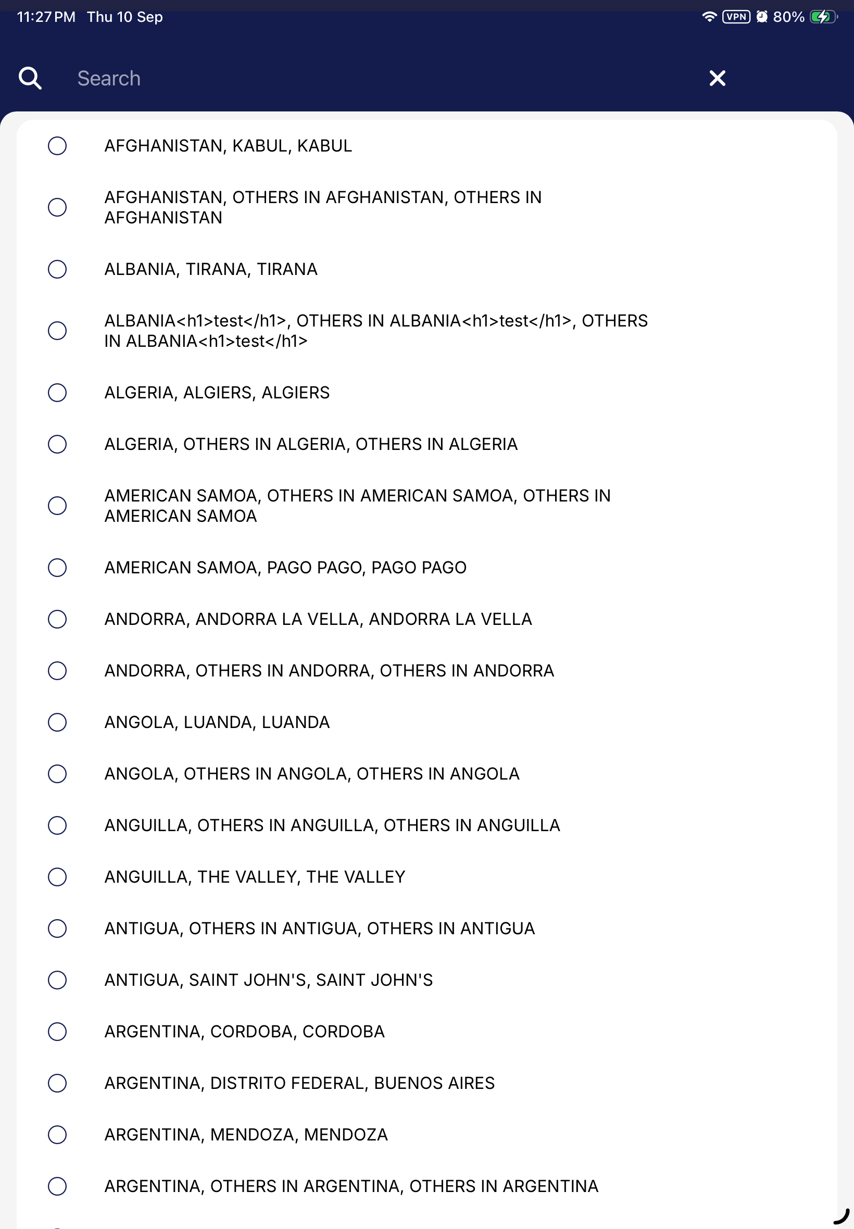
Detail view from 079-qr-residence-picker.png; full screenshot follows.

IOS-07 | Screenshot
10 Sep • 079. The fourth residence option contains literal <h1>test</h1> text.
Output/ios-sgac2-build15-regression-2026-09-10/079-qr-residence-picker.png

MAIL-01 | Visitor update email was not observed
Suspected notification issue • unverified cause
Observed 10 September 2026; last inbox check 23:39 SGT
Suggested priority Medium — provisional
Prerequisites Existing synthetic staging visitor record and an accessible UAT mailbox. The captured update was already accepted; do not repeat it merely to obtain mail.

Steps to reproduce / observed path
1. Recorded path: Home → Foreign Visitor SG Arrival Card → Update SG Arrival Card.
2. Retrieve the existing visitor using its DE and matching identity details.
3. In the approved run, set health answers to No / No, accept the declaration and submit once.
4. Compare the success screen with the pre-update mailbox baseline and subsequent inbox checks.
Actual result At 23:13 SGT the page showed Submission updated and said an acknowledgement email had been sent. At 23:39 the inbox still contained the same five messages as baseline, with no new acknowledgement.
Expected result The intended recipient should receive the matching acknowledgement. A dispatch / delivery expectation or SLA still needs confirmation.
Impact The user lacks the promised email confirmation. The observed delay was approximately 26 minutes.
Follow-up / limits Recheck the approved inbox and inspect mail dispatch / delivery logs. The UI update succeeded; fresh retrieval remained available but masked health answers. Email absence does not prove update failure.
Mailbox evidence: baseline 5 messages; final 5 messages; new messages 0. Last checked 10 Sep 2026, 23:39 SGT. Source: visitor-email-final-status.json in the 10 September evidence directory.

Evidence detail
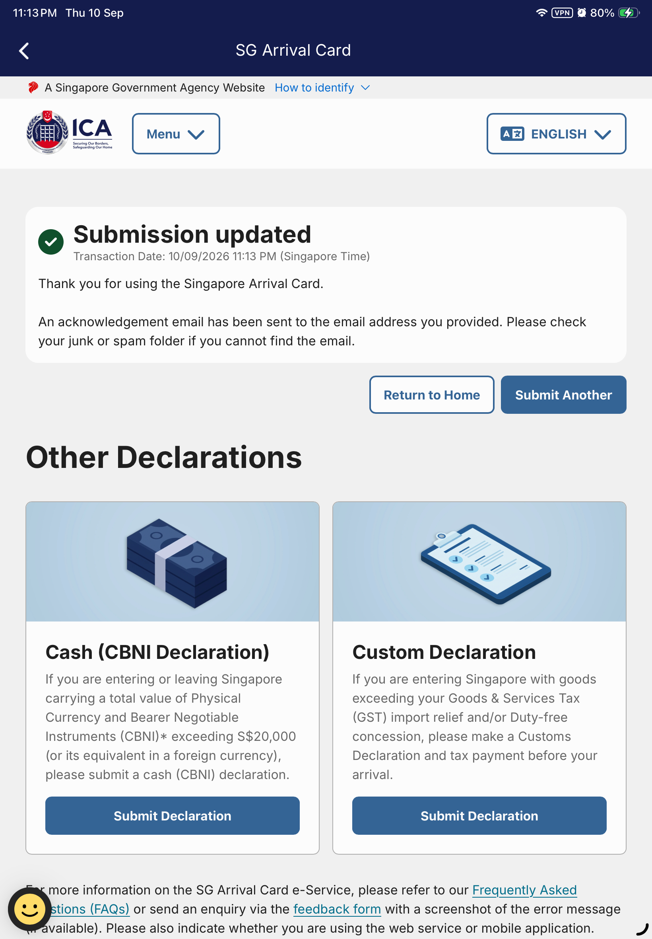
Detail view from 048-approved-update-settled.png; full screenshot follows.

MAIL-01 | Screenshot
10 Sep • 048. Success acknowledgement explicitly says an email has been sent.
Output/ios-sgac2-build15-regression-2026-09-10/048-approved-update-settled.png

IOS-06 | Staging cargo receipt opens production retrieval
Observed 9 Sep • not rerun in continuation
Observed 9 September 2026
Suggested priority High — proposed triage priority
Prerequisites An existing successful staging cargo receipt. The native dashboard retrieval route is separate and remained on staging.

Steps to reproduce / observed path
1. From the successful staging Cargo Submission receipt, tap Manage Cargo Submission.
2. Observe the newly opened Safari page.
3. Inspect the address bar before entering any data.
Actual result Safari opens eservices.ica.gov.sg, the production host, from the staging receipt link.
Expected result The staging receipt should route to the corresponding staging retrieval service at eservices-stg.ica.gov.sg, subject to the intended environment configuration.
Impact Users can be taken into the wrong environment when managing a staging submission.
Follow-up / limits Review the receipt link / redirect configuration and retest from a staging receipt. Only navigation was observed; no test data was entered on production.

Evidence detail
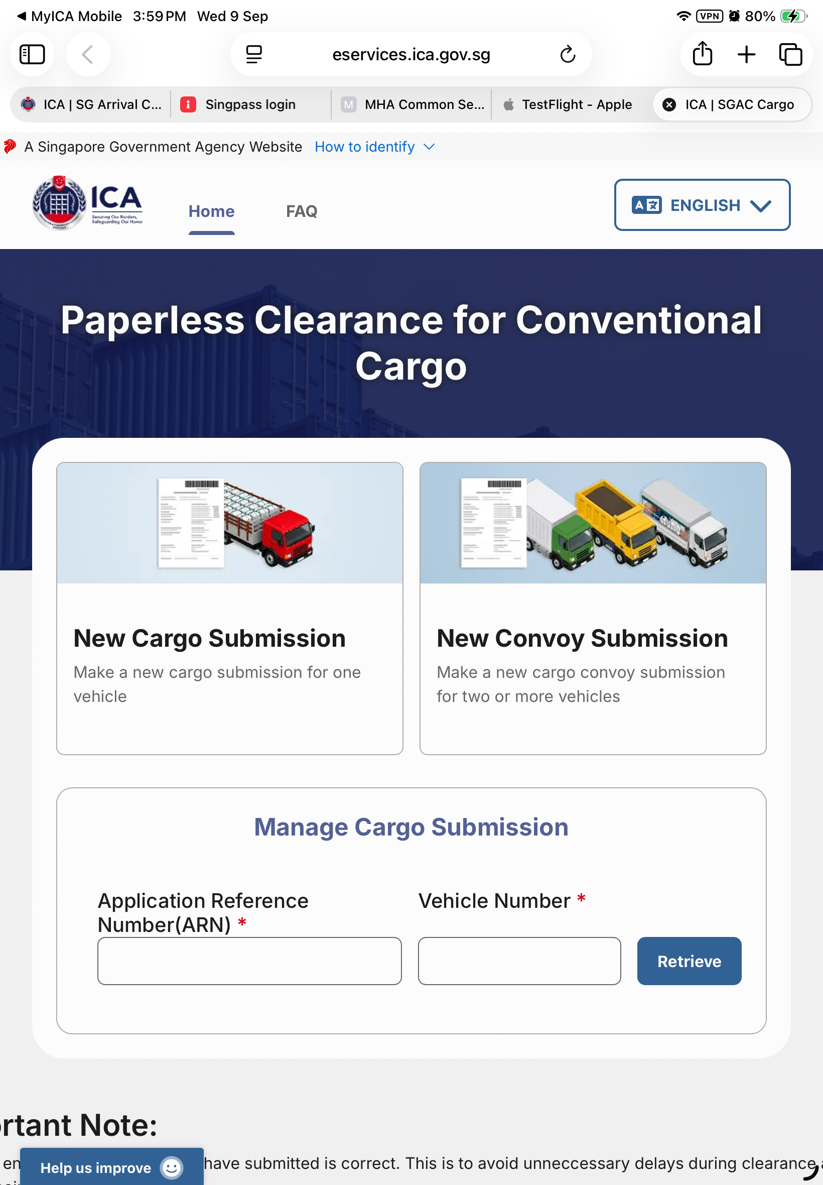
Detail view from 335-cargo-receipt-link-external-host.png; full screenshot follows.

IOS-06 | Screenshot
9 Sep • 335. Safari address bar shows eservices.ica.gov.sg after opening the receipt link.
Output/ios-regression-2026-09-09/335-cargo-receipt-link-external-host.png

IOS-05 | Resident submission returned to review without receipt
Suspected receipt / navigation issue • 9 Sep
Observed 9 September 2026; not rerun in continuation
Suggested priority High — provisional
Prerequisites Valid synthetic resident profile and an authorized staging submission with a supported arrival date.

Steps to reproduce / observed path
1. Open the Citizen and Resident SG Arrival Card flow and select a valid profile.
2. Complete the arrival and health fields, reach review and accept the declaration.
3. Submit once and wait for the response.
4. If review returns without an acknowledgement, retrieve using the same NRIC and arrival date before considering another submission.
Actual result After a loading state, the app returned to the same review with no observed acknowledgement or error (264–265). The matching record was retrieved afterwards (268), confirming it had persisted.
Expected result An accepted submission should show a clear acknowledgement or receipt. A failed submission should show an actionable error.
Impact An ambiguous result may cause users to attempt duplicate submissions.
Follow-up / limits Trace the submit response and receipt navigation. A later health update acknowledged normally. Reproduction is not established as consistent; the evidence does not show that the initial submission failed.

Evidence detail
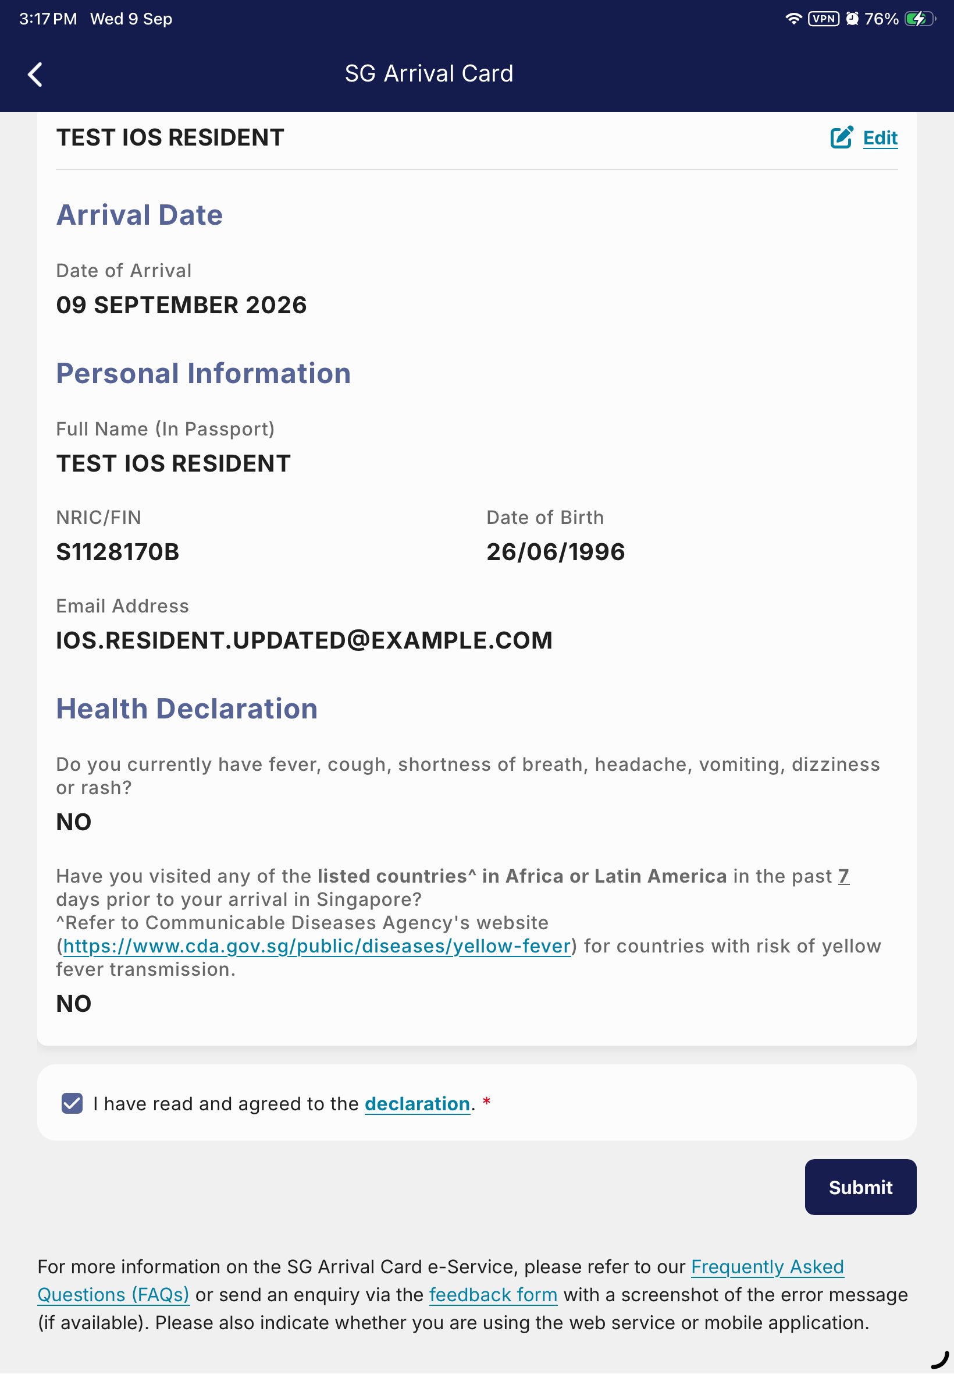
Detail view from 264-resident-submission-settled.png; full screenshot follows.

IOS-05 | Screenshot 1
9 Sep • 264. Settled screen remains on review after the submission attempt.
Output/ios-regression-2026-09-09/264-resident-submission-settled.png

IOS-05 | Screenshot 2
9 Sep • 268. Fresh retrieval returns the same resident and arrival date.
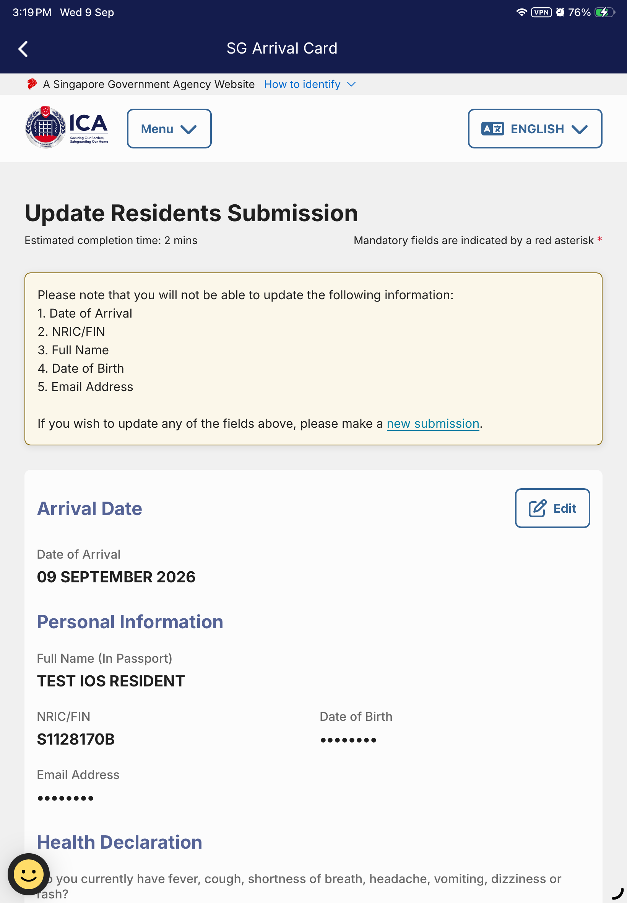
Output/ios-regression-2026-09-09/268-resident-retrieval-result.png

IOS-01 | Partial cargo quantity 0 reaches review
Validation concern • rule / backend unverified
Observed 9 September 2026; not rerun in continuation
Suggested priority Medium — provisional
Prerequisites Cargo submission form with a partial-clearance permit. Captured permits were format-valid fixtures; a later submission with these fixtures was rejected as invalid permits.

Steps to reproduce / observed path
1. Open Cargo Clearance and continue with a valid synthetic vehicle profile.
2. Complete cargo details, then add a partial-clearance permit.
3. Enter quantity 0, save the permit and continue to review.
Actual result The partial-clearance permit is listed on review with Quantity: 0.
Expected result If the business rule requires a positive quantity, 0 should be rejected before review. Confirm the required lower bound before accepting this as a defect.
Impact Potentially invalid clearance quantities can reach the submission review.
Follow-up / limits Confirm the quantity specification and retest with a currently valid UAT permit. Backend acceptance of zero was not tested. Successful later cargo submission used quantity 10.

Evidence detail
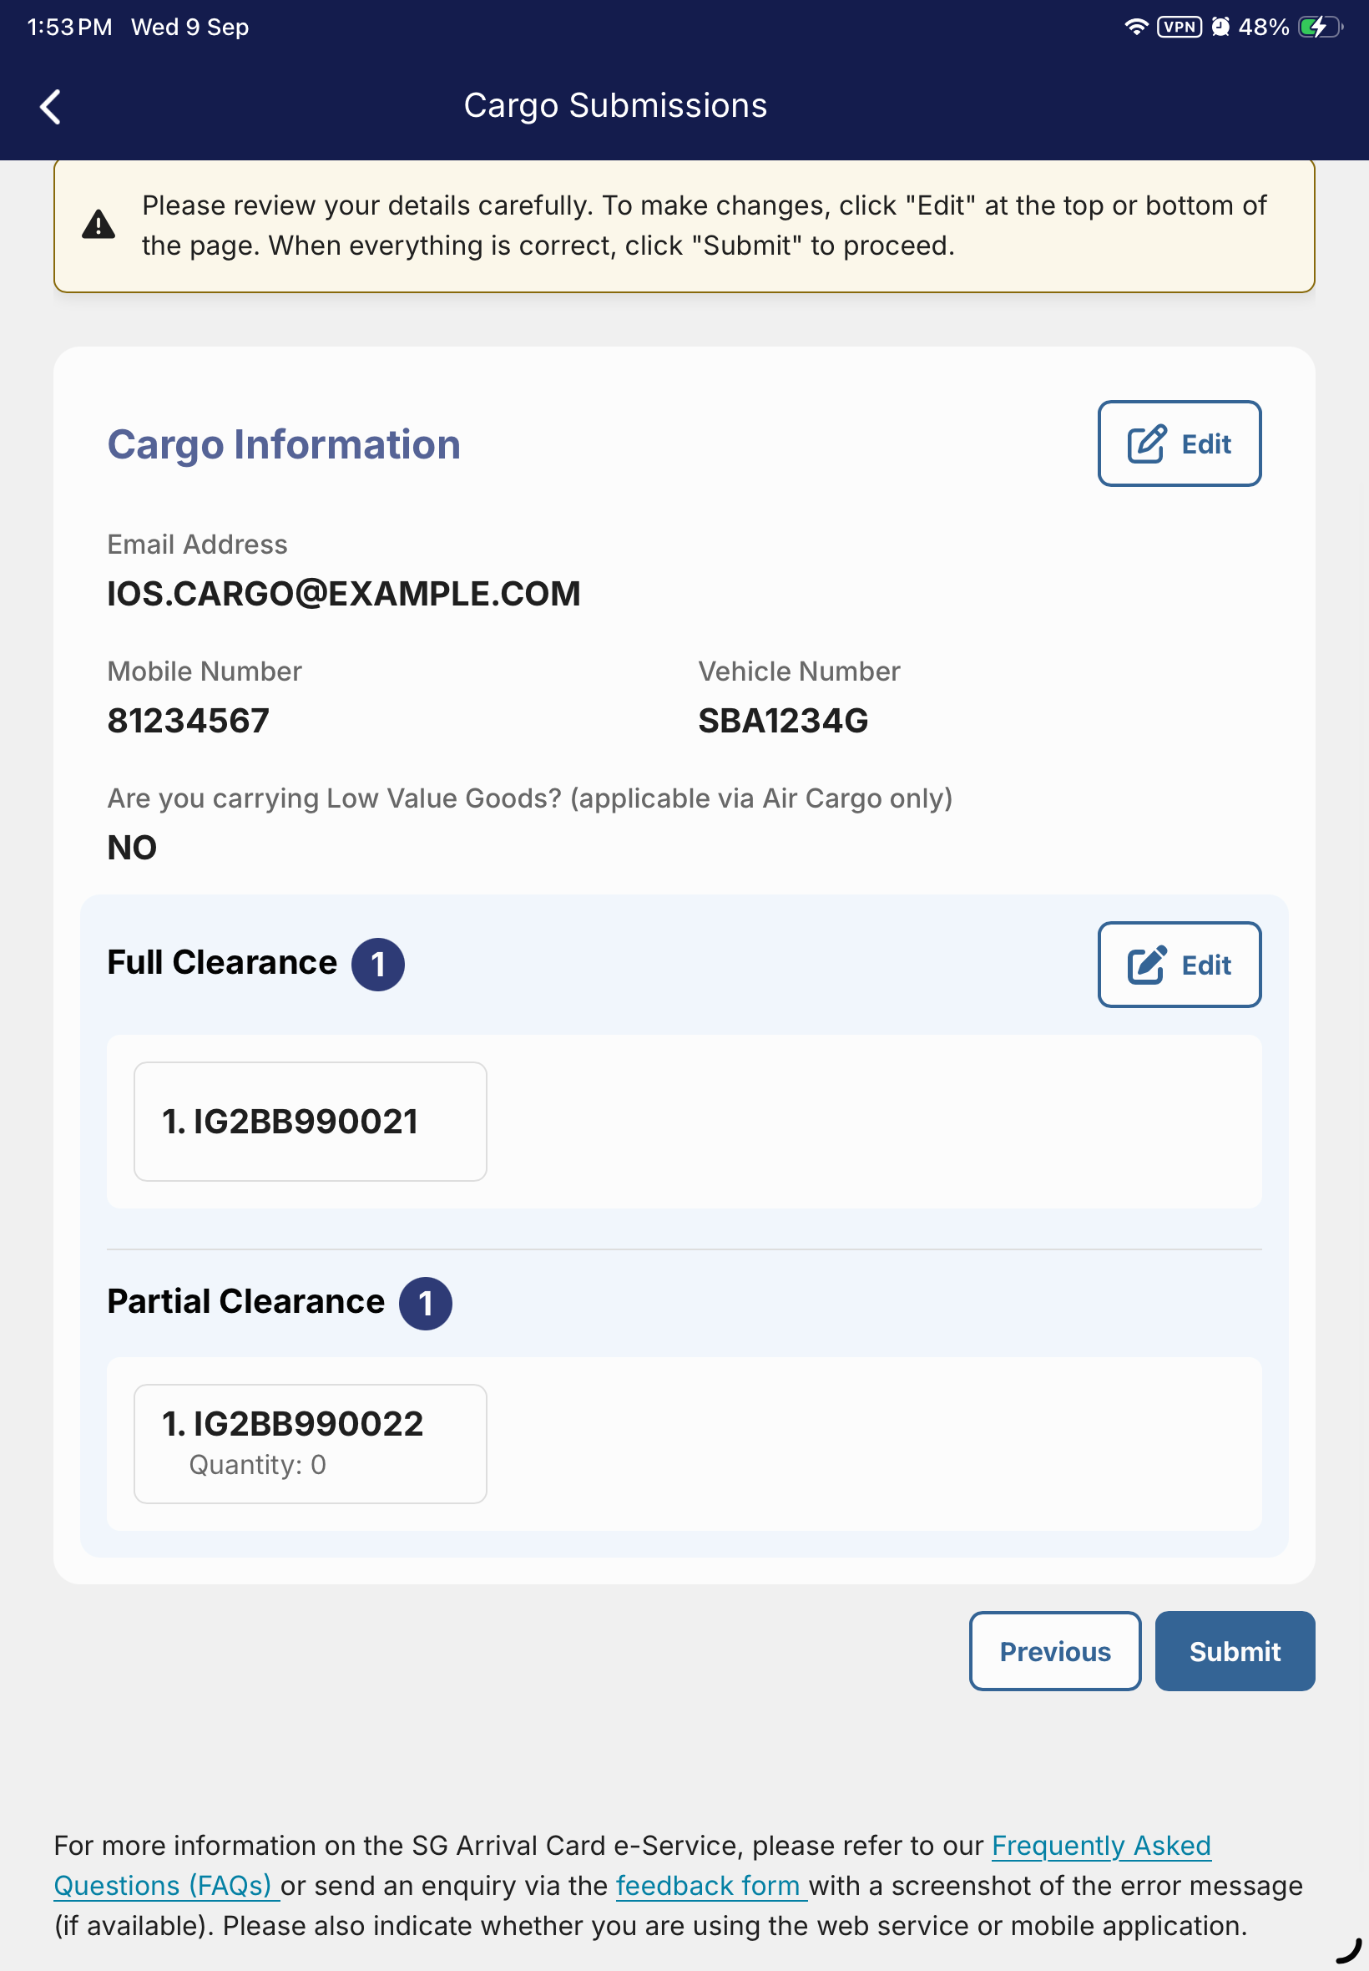
Detail view from 122-cargo-review-permits.png; full screenshot follows.

IOS-01 | Screenshot
9 Sep • 122. Partial Clearance shows Quantity: 0 on the review page.
Output/ios-regression-2026-09-09/122-cargo-review-permits.png

IOS-02 | Foreigner form intermittently shows translation keys
Observed visual defect • intermittent on 9 Sep
Observed 9 September 2026; readable prompts on a later load
Suggested priority Medium
Prerequisites English foreigner SG Arrival Card form. The affected capture used previous-name Yes and positive health Yes.

Steps to reproduce / observed path
1. Open the Foreign Visitor SG Arrival Card submission flow.
2. On the traveller step, select Yes for previous passport name and Yes for the first health question.
3. Scroll to the panel directly above Add Traveller and the Next button.
4. Repeat with a fresh form load to compare the prompt text.
Actual result The panel displays TRAVELLING_AS_A_GROUP_QUERY and CAN_SUBMIT_MULTIPLE_TRAVELLERS_TOGETHER instead of English prompts.
Expected result Show the intended readable English group-travel prompt and explanation.
Impact Internal translation identifiers replace instructions needed by users.
Follow-up / limits Inspect localization loading and the affected form branch. A later fresh load showed readable prompts, so these steps record the observed path but do not guarantee reproduction. The same capture contains “X country**” health copy, which needs UAT-content confirmation.

Evidence detail
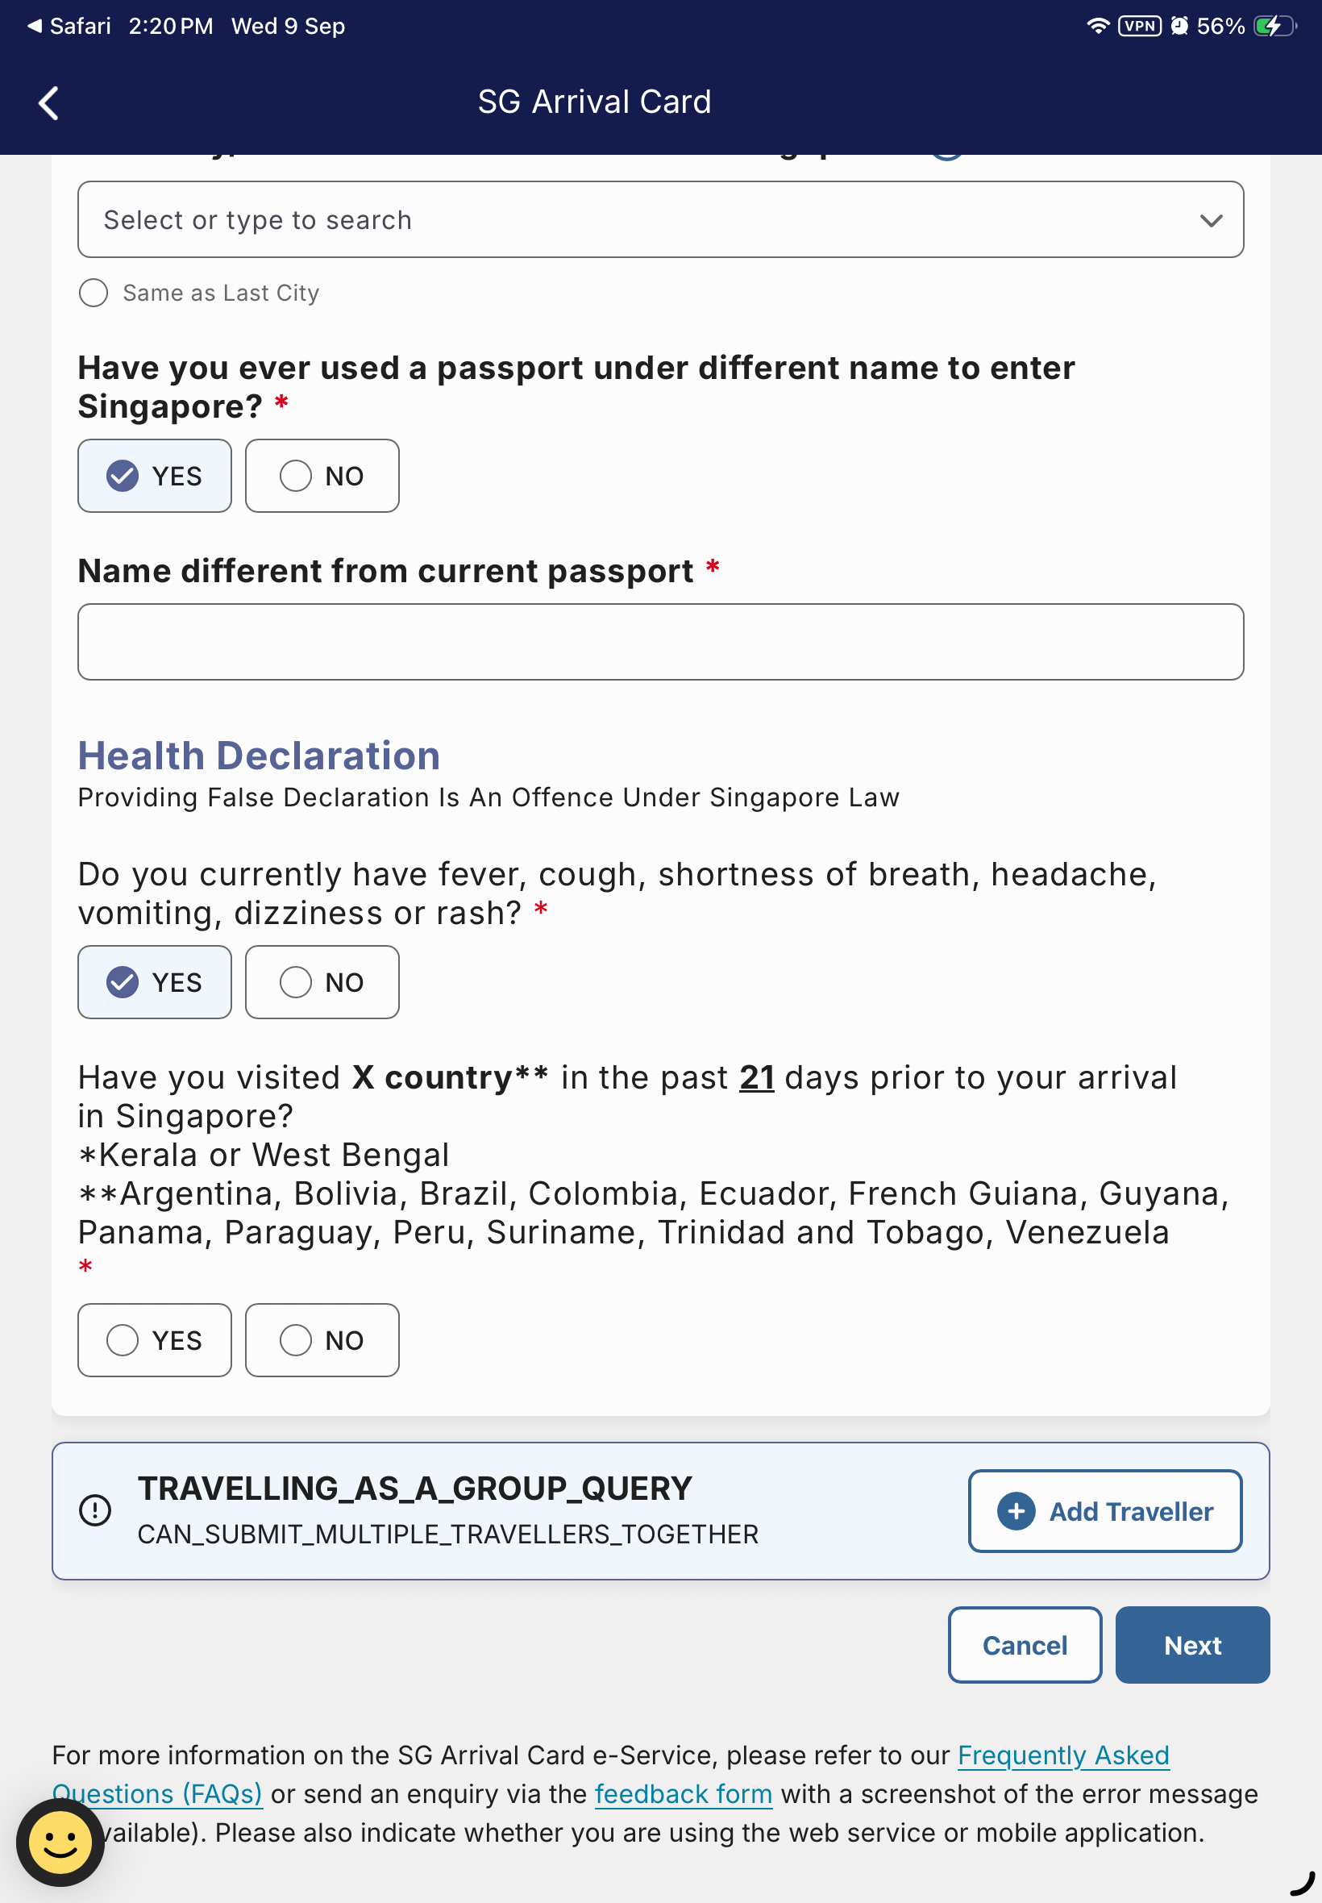
Detail view from 230-visitor-health-positive-followup.png; full screenshot follows.

IOS-02 | Screenshot
9 Sep • 230. Raw group-travel keys appear above Add Traveller; health copy also shows X country**.
Output/ios-regression-2026-09-09/230-visitor-health-positive-followup.png

Source reports and evidence limits
Current report: docs/testing/ios-sgac2-build15-regression-2026-09-10.md
Earlier same-build report: docs/testing/ios-build15-regression-2026-09-09.md
Current evidence directory: Output/ios-sgac2-build15-regression-2026-09-10/
Earlier evidence directory: Output/ios-regression-2026-09-09/
The numbered PNGs have matching page-source XML files in those directories. The Word document embeds the screenshots and can be reviewed without access to Output/.
This export is based on existing evidence; it does not represent a new device test or a live Robot-suite pass. The confirmed visual findings are distinct from notification delivery, receipt navigation and business-rule concerns.
Masked health values are an evidence boundary, not an observed persistence defect. Automation input/focus problems were excluded from the issue list.
Earlier copy/localization notes also include repeated UAT broadcasts, an English cargo-language header under Chinese, and an English expiry month under Malay. Their product expectations require confirmation; they are not promoted to additional confirmed defects in this export.
Observation dates remain attached to each issue. Later backend content changes may affect reproduction even when the installed app build is unchanged.
Compiled 11 September 2026, 00:02 SGT

