CPE301 – SPRING 2019

Design Assignment X

Student Name: Moriah Wingrove

Student #: 5000156247

Student Email: Wingrove@unlv.nevada.edu

Primary Github address: <https://github.com/windew/Tiny_Dragons.git>

Directory:

Submit the following for all Labs:

1. In the document, for each task submit the modified or included code (only) with highlights and justifications of the modifications. Also, include the comments.
2. Use the previously create a Github repository with a random name (no CPE/301, Lastname, Firstname). Place all labs under the root folder ESD301/DA, sub-folder named LABXX, with one document and one video link file for each lab, place modified asm/c files named as LabXX-TYY.asm/c.
3. If multiple asm/c files or other libraries are used, create a folder LabXX-TYY and place these files inside the folder.
4. The folder should have a) Word document (see template), b) source code file(s) and other include files, c) text file with youtube video links (see template).

1. **COMPONENTS LIST AND CONNECTION BLOCK DIAGRAM w/ PINS**

No components were used for design assignment 2A due to not having the microcontroller and necessary parts from the mail or put together.

1. **INITIAL/MODIFIED/DEVELOPED CODE OF TASK 2/A TASK 1**

**Asm code**

;

; design_assignment_2A.asm

;

; Created: 9/27/2019 2:14:43 PM

; Author :Moriah Wingrove

; Replace with your application code

.include<m328pbdef.inc>

;Task One

;Design delay subroutine to generate waveform on portb.3 with 40% duty cycle and 0.625 sec per period

sbi DDRB, 3 ; set Port b to output

blink:

sbi portb, 3 ; turn on LED on Portb bit 3

rcall delay_250ms ; delay will be 250ms

cbi portb, 3 ; turn off LED on portb bit 3

rcall delay_375ms ; delay will be 375 ms

rjmp blink ; loop back to the start

; Delay 4 000 000 cycles

; 250ms at 16 MHz

delay_250ms:

ldi r18, 21 ;r18 = 21

ldi r19, 75 ;r19 = 75

ldi r20, 191 ;r20 = 191

L1: dec r20 ;decremenet r20

brne L1 ;if r20 != 0 go again

dec r19 ;decrement r19

brne L1 ;if r19 != 0 go again

dec r18 ;decrement r18

brne L1 ;if r18 != 0 go again

nop

ret

; Delay 6 000 000 cycles

; 375ms at 16 MHz

delay_375ms:

ldi r18, 31 ;r18 = 31

ldi r19, 113 ;r19 = 113

ldi r20, 31 ;r20 = 31

L2: dec r20 ;decremenet r20

brne L2 ;if r20 != 0 go again

dec r19 ;decrement r19

brne L2 ;if r19 != 0 go again

dec r18 ;decrement r18

brne L2 ;if r18 != 0 go again

nop

ret

**C code**

#define *F_CPU* 16000000UL

#include <avr/io.h>

#include <util/delay.h>

int main(void)

{

    DDRB |= 0b1000;        // set PORTB.3 for output

    while (1)

    {

*_delay_ms*(250);       // delay for 250ms

PORTB |= 0b1000;    // set LED on

*_delay_ms*(375);      // delay for remaining 375ms

PORTB &= ~0b1000;    // set LED off

    }

}

1. **DEVELOPED MODIFIED CODE OF TASK 2/A from TASK 2**

**Asm code**

;

; Design_Assignment_2A_task2.asm

;

; Created: 9/30/2019 9:20:31 PM

; Author : Moriah Wingrove

;

; Replace with your application code

;Task Two

;Connect a switch to portc.3(active high -turn on and pull up transistor) to poll for and event to turn on led at portb.2 for 1.33 sec after the event

.org 0

cbi DDRC, 3 ;sets port c as input

sbi portc, 3 ; sets port c bit 2 high to enable pull up

sbi ddrb, 2 ;sets port b as output

cbi portb, 2 ;LED is off

poll_loop:

sbic pinc, 3 ;if pinc is low (0) skip next instruction

jmp LED ;jumps to label led

sbi portb, 2 ;turn on led

; 1s 333ms at 16 MHz

ldi r18, 109 ;r18 = 109

ldi r19, 51 ;r19 = 51

ldi r20, 106 ;r20 = 106

L1: dec r20 ;decrement r20

brne L1 ;if r20 != 0 go to label l1

dec r19 ;decrement r19

brne L1 ;if r20 != 0 go to label l1

dec r18 ;decrement r19

brne L1 ;if r18 != 0 go to label l1

LED:

cbi portb, 2 ;turns led off

jmp poll_loop ;go to label poll_loop

**C code**

#define *F_CPU* 16000000UL

#include <avr/io.h>

#include <util/delay.h>

 int main(void)

{

       DDRC &= 0b1000;            // connect PORTC.2 to switch as input

       PORTC |= 0b1000;     // enable pull-up on port c

       DDRB |= 0b0100;            // set PORTB.2 for output

       while(1){

              if(!(PINC & (1<<PINC2))){  // check if pin is low

                     PORTB &= ~0b0100;          // set LED on

*_delay_ms*(1333);           // delay of 1.33 sec

              }

              else{                                    // otherwise (pin is high)

                     PORTB |= 0b0100;           // LED off

              }

       }

       return 0;

}

1. **SCHEMATICS**

No schematics due to lack of microcontroller

1. **SCREENSHOTS OF EACH TASK OUTPUT (ATMEL STUDIO OUTPUT)**

TASK ONE:

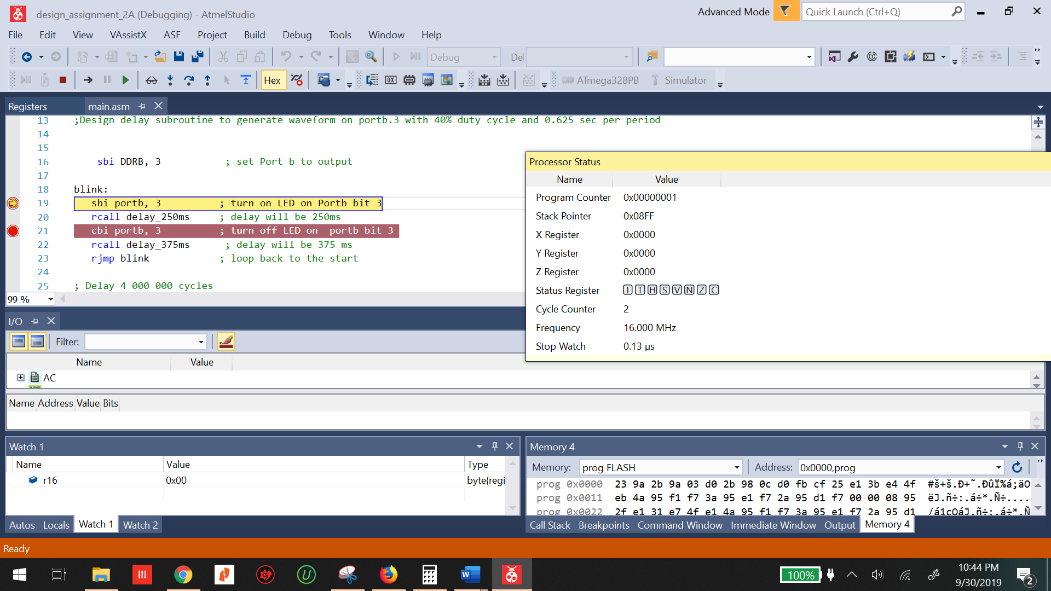

Figure : before portb.3 is set watch is at 0.13us

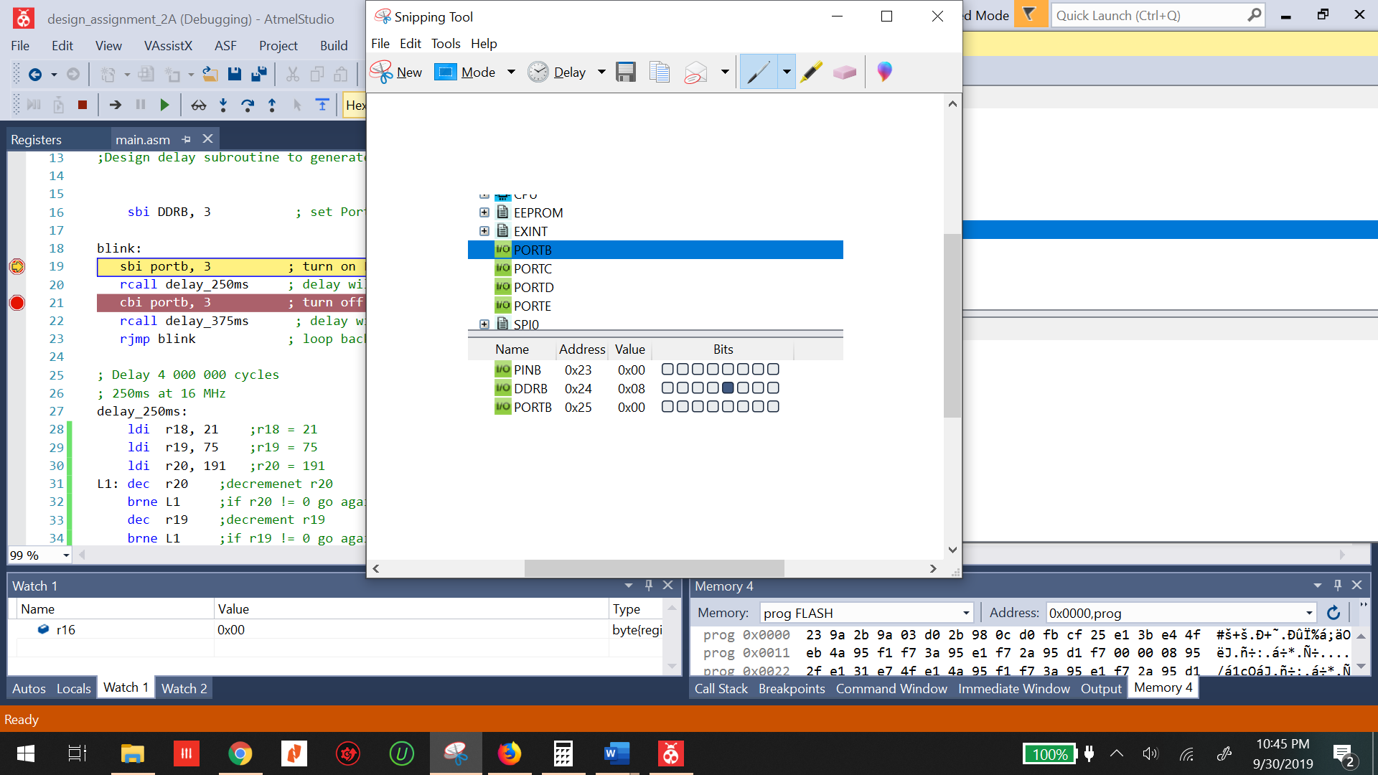

Figure : DDRB set to output

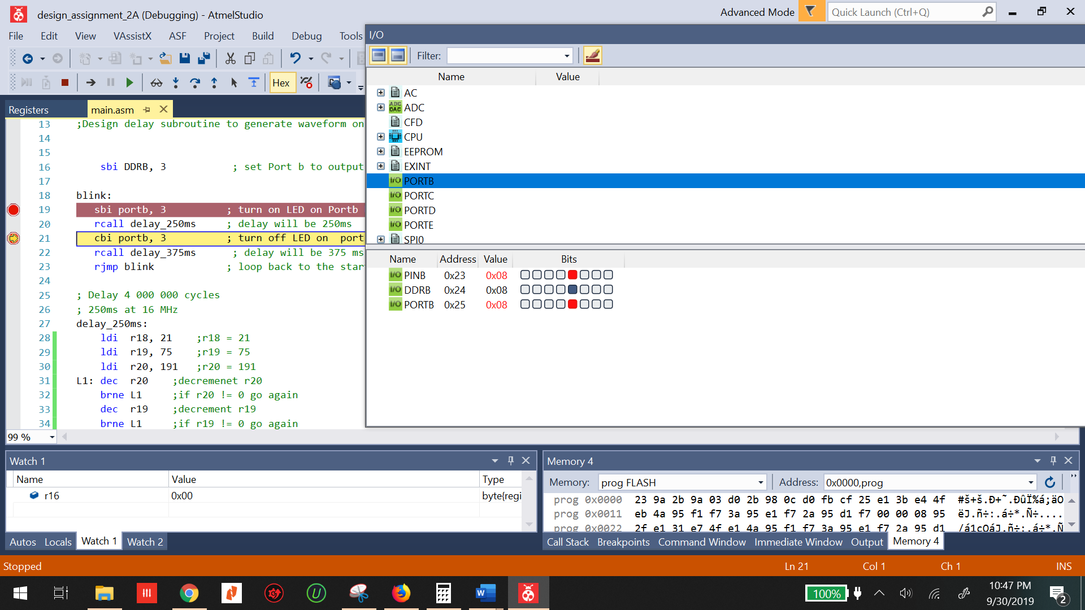

Figure : Pinb and portb.3 are set meaning the LED has been turned on

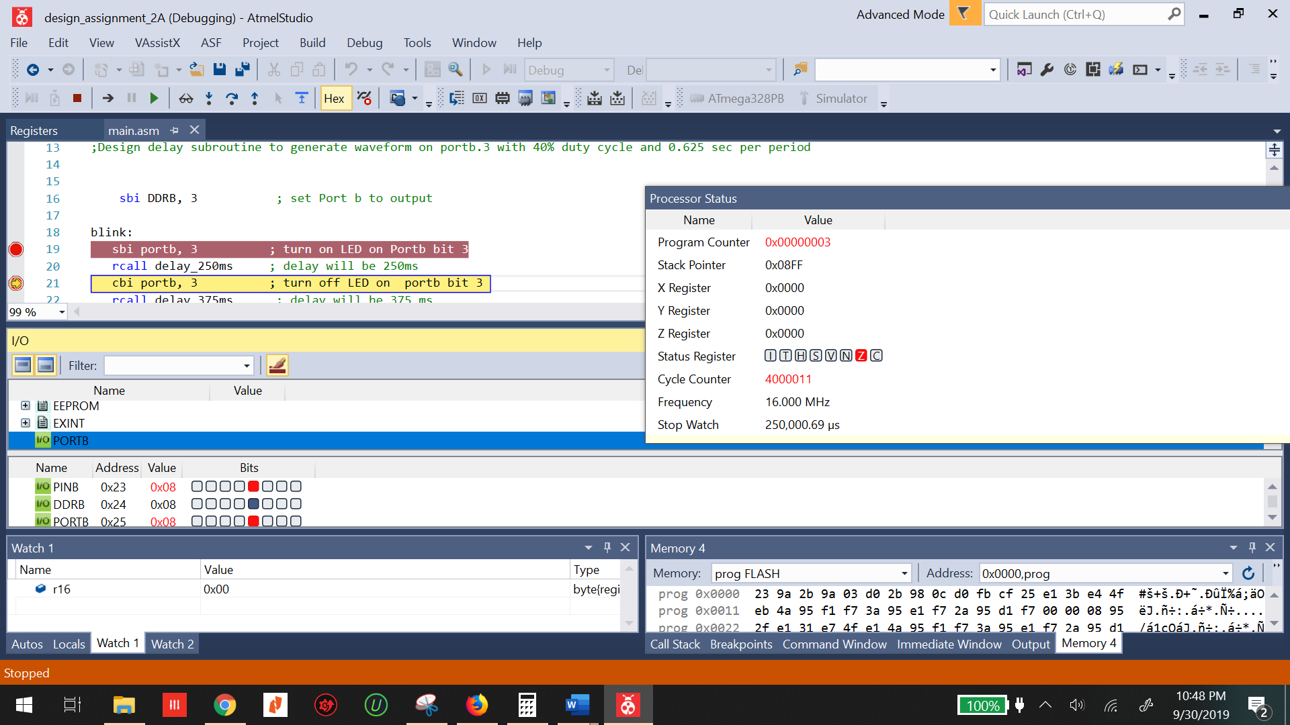

Figure : The time on the stopwatch is 250,000us or 250 ms

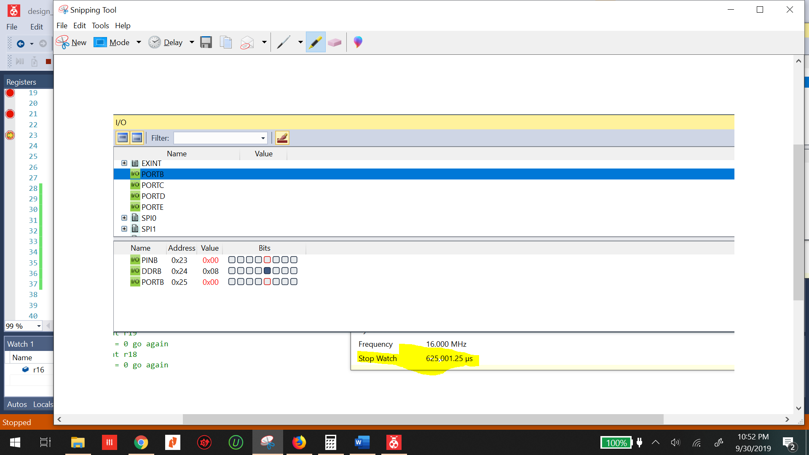

Figure : The led has been turned off and one period has been completed. The time on the watch is 625,000us or 625 ms

TASK TWO:

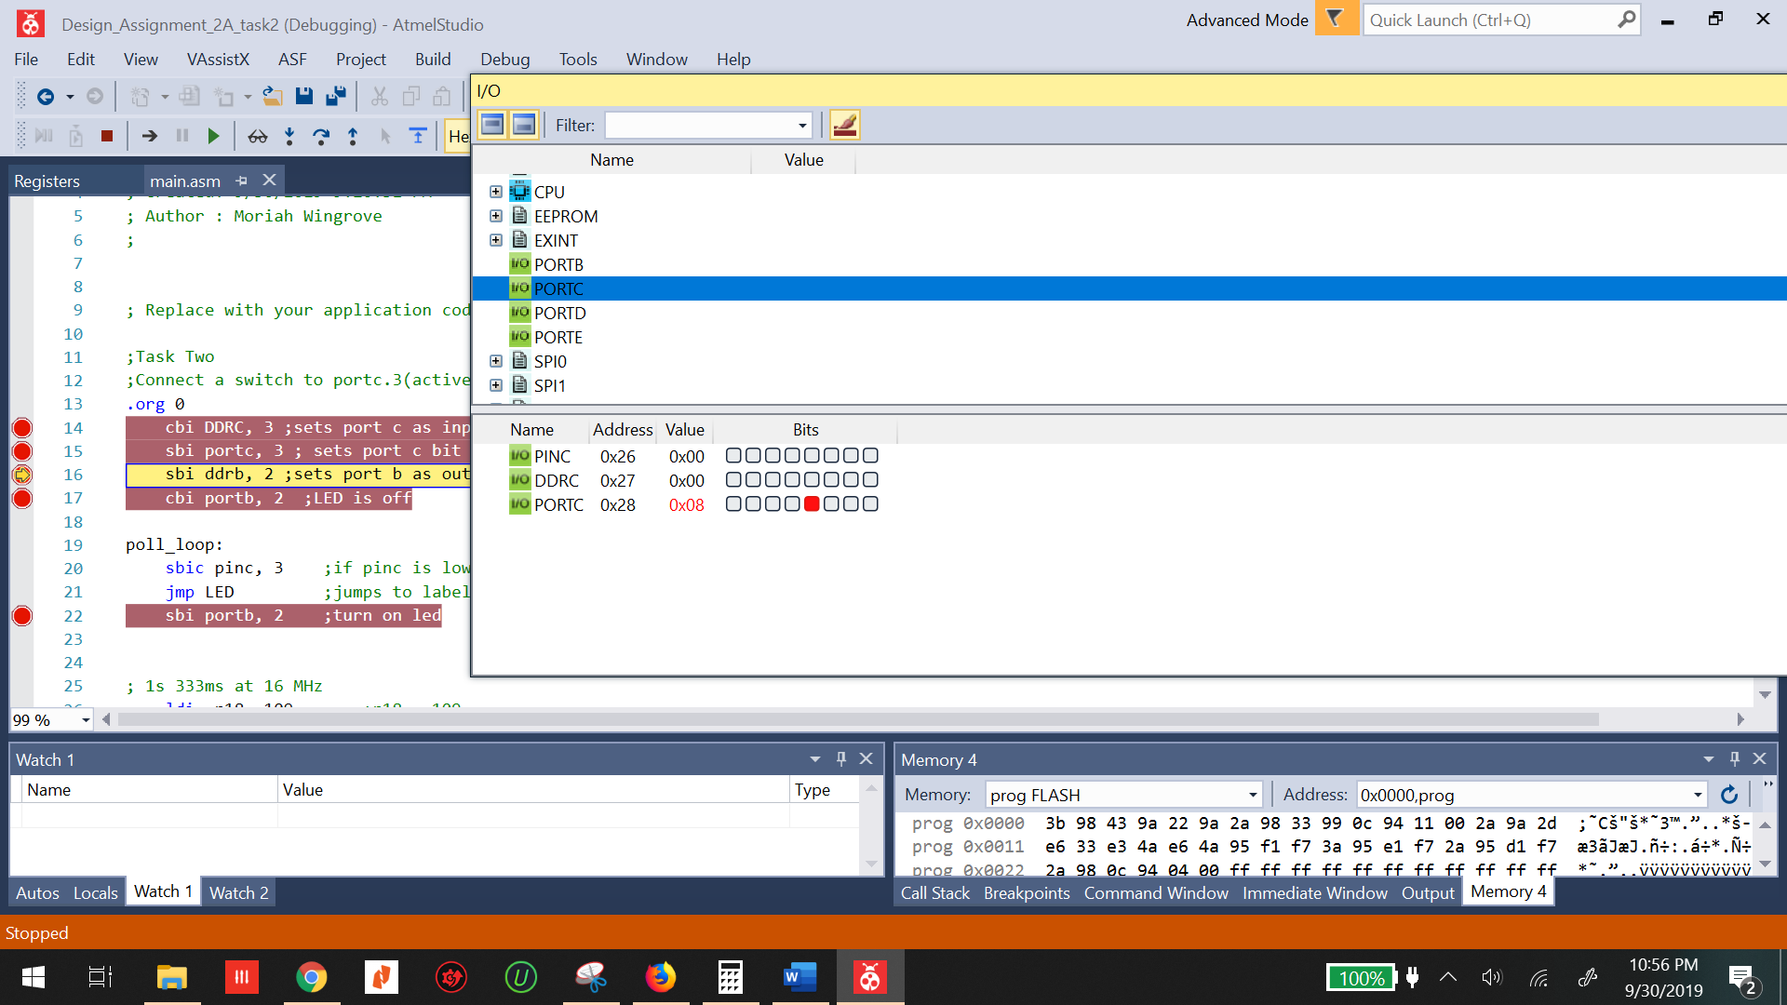

Figure : DDRC is set as an input and portc is set high

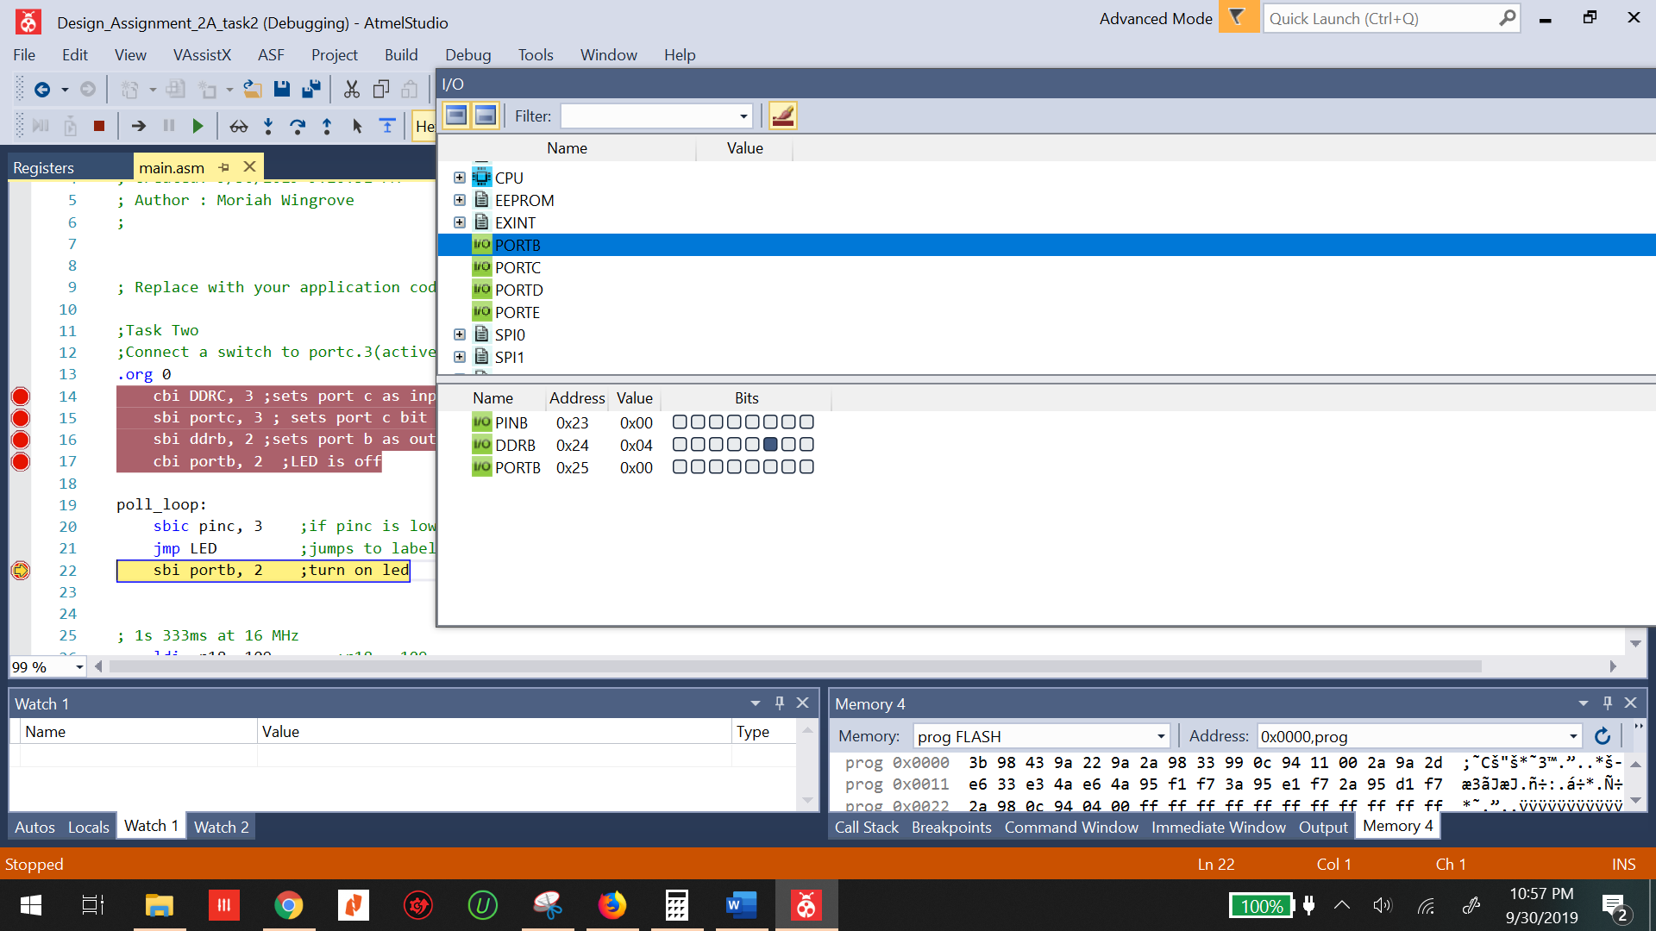

Figure : DDRB is set as an output and portb is cleared

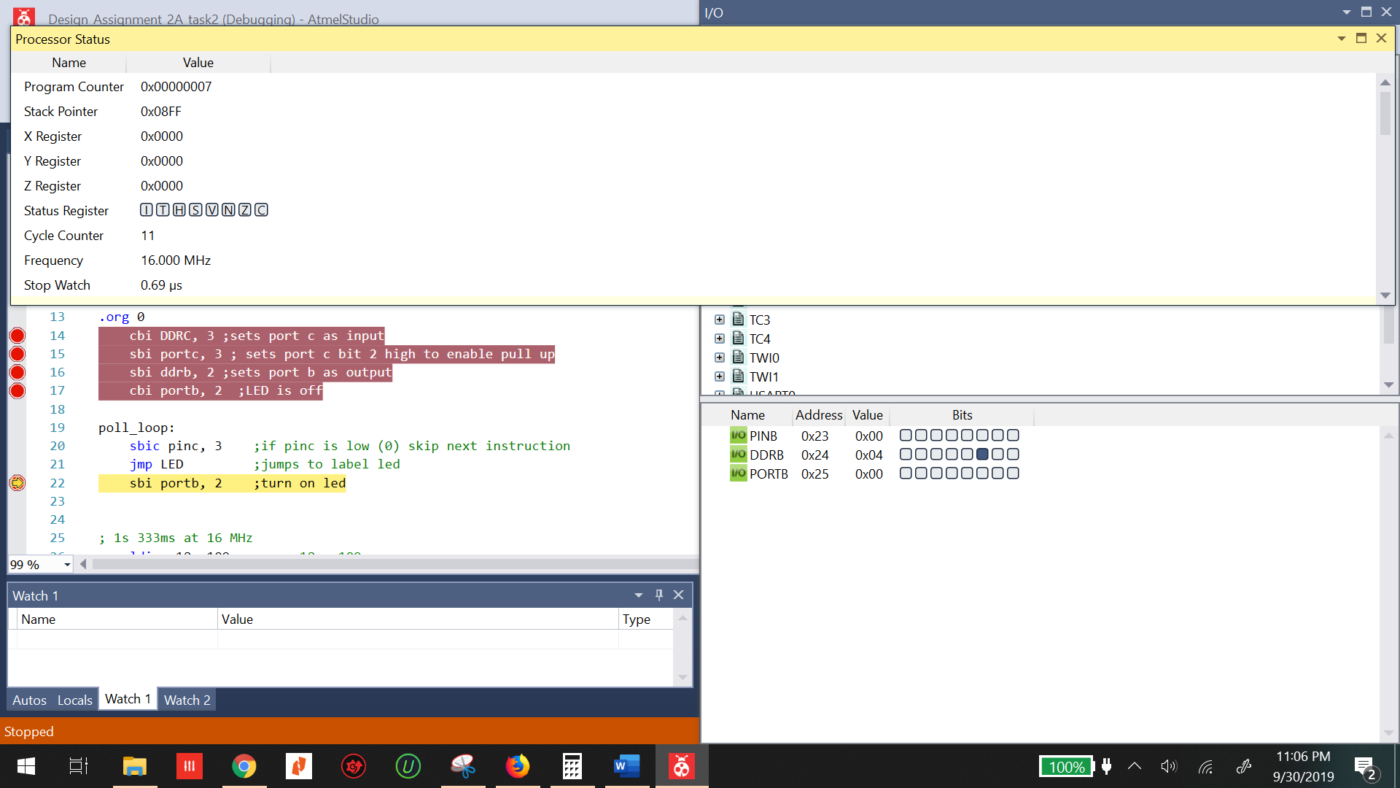

Figure : Initial stopwatch before the led is turned on time is 0.69us

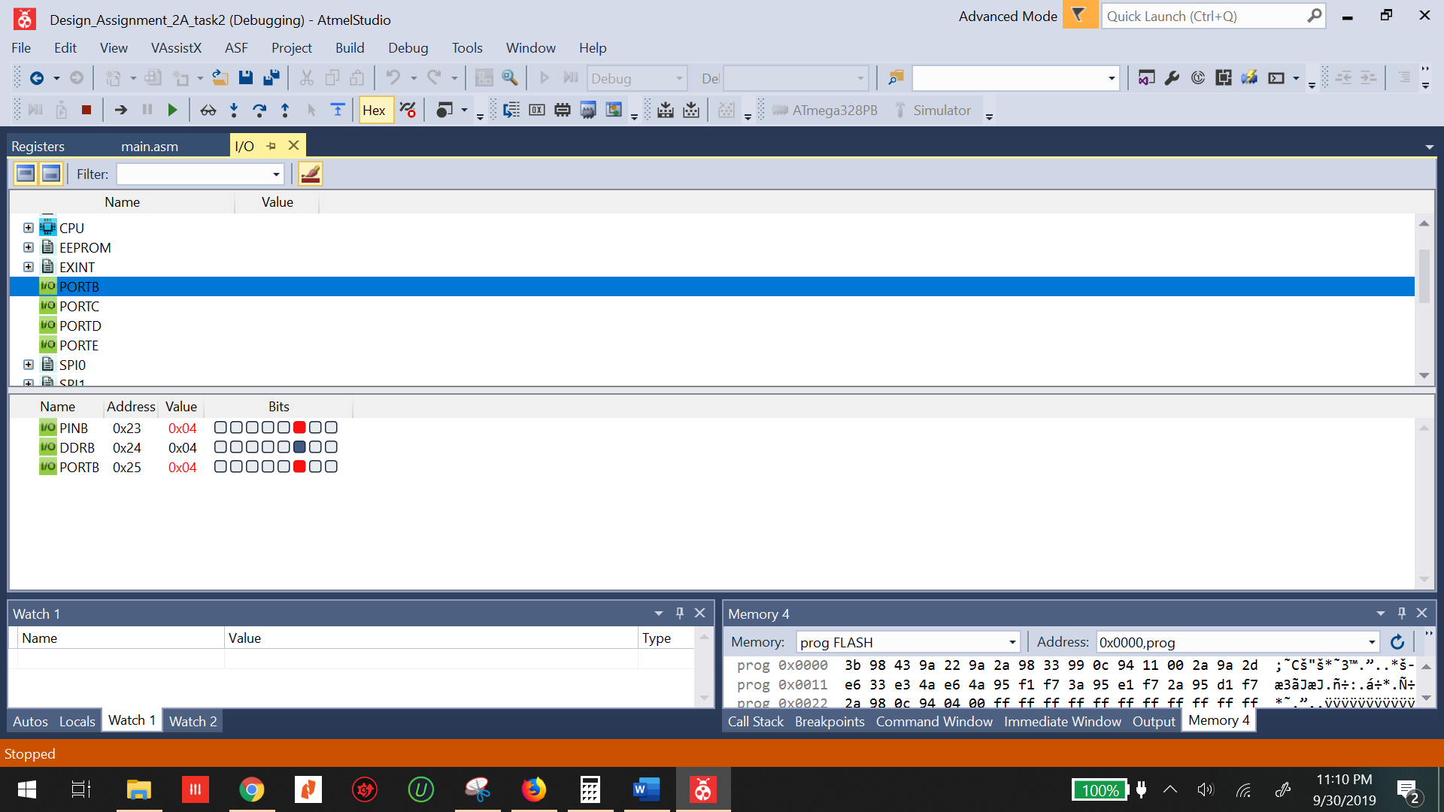

Figure : the poll event has occurred and the led is turned on portb.2 is set

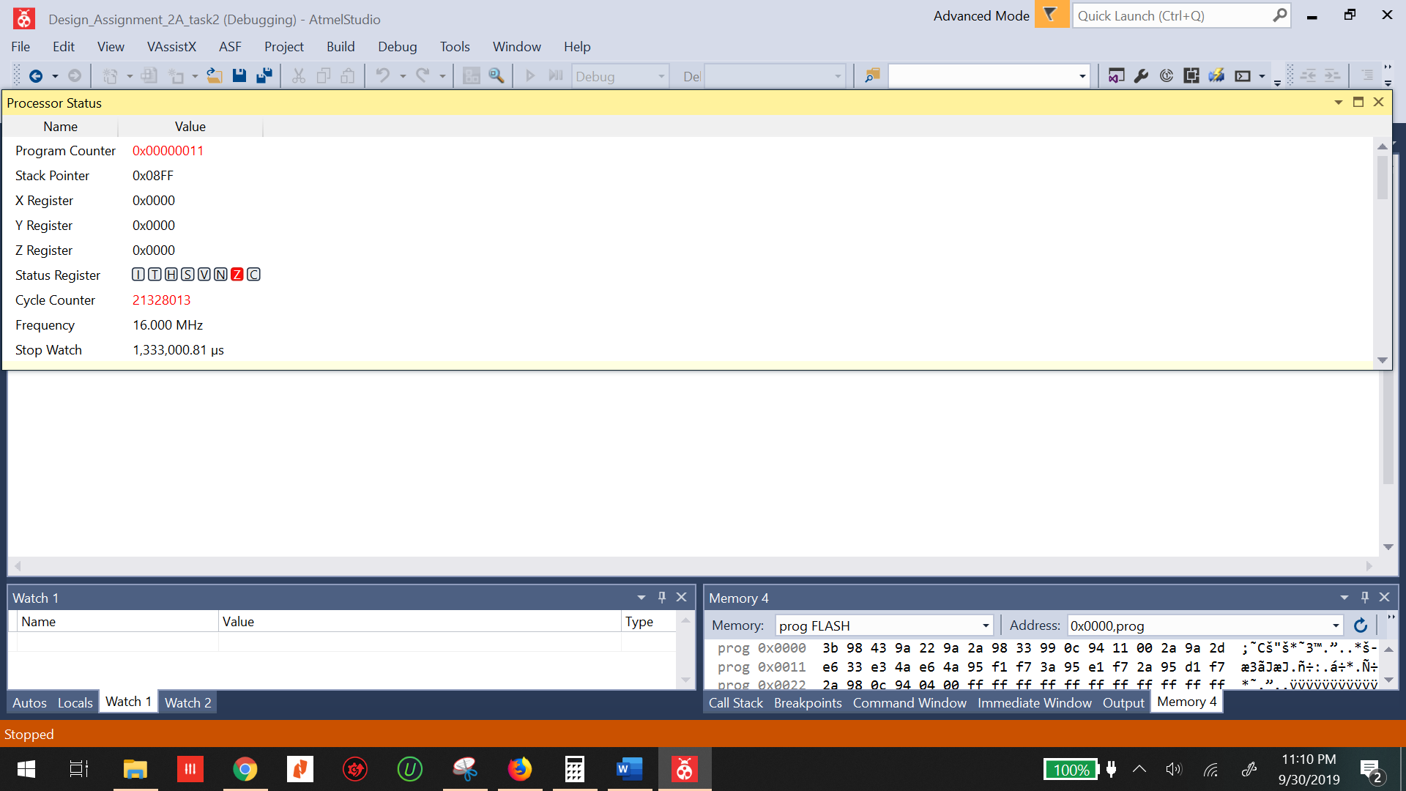

Figure : The time in which the led is on is 1,333,000.81 us or 1.333s

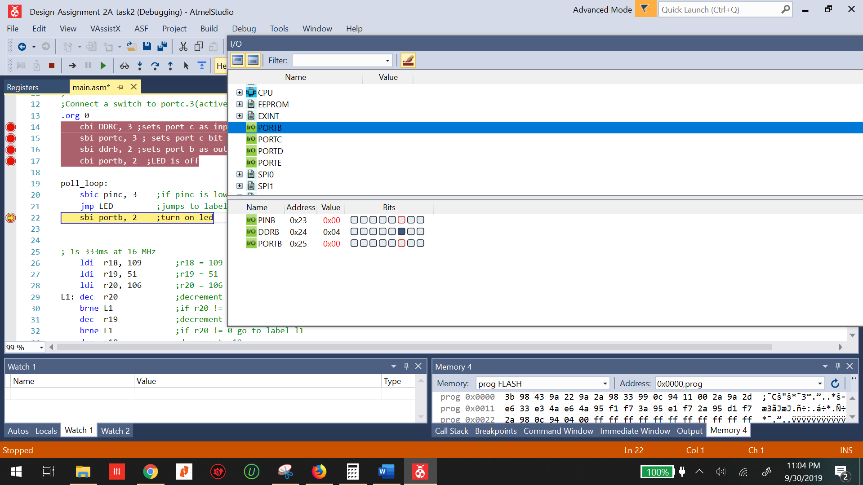

Figure : LED has been turned off portb2 is cleared

1. **SCREENSHOT OF EACH DEMO (BOARD SETUP)**

Board was not set up due to lack of microcontroller

1. **VIDEO LINKS OF EACH DEMO**

There are no videos due to the lack of working microcontroller

1. **GITHUB LINK OF THIS DA**

**Student Academic Misconduct Policy**

<http://studentconduct.unlv.edu/misconduct/policy.html>

“This assignment submission is my own, original work”.

NAME OF THE STUDENT