CPE301 – SPRING 2019

Design Assignment X

Student Name:

Student #:

Student Email:

Primary Github address:

Directory:

Submit the following for all Labs:

1. In the document, for each task submit the modified or included code (only) with highlights and justifications of the modifications. Also, include the comments.
2. Use the previously create a Github repository with a random name (no CPE/301, Lastname, Firstname). Place all labs under the root folder ESD301/DA, sub-folder named LABXX, with one document and one video link file for each lab, place modified asm/c files named as LabXX-TYY.asm/c.
3. If multiple asm/c files or other libraries are used, create a folder LabXX-TYY and place these files inside the folder.
4. The folder should have a) Word document (see template), b) source code file(s) and other include files, c) text file with youtube video links (see template).

1. **COMPONENTS LIST AND CONNECTION BLOCK DIAGRAM w/ PINS**

List of Components used

Block diagram with pins used in the Atmega328P

1. **INITIAL/MODIFIED/DEVELOPED CODE OF TASK 2/A**

; Design_Assignment_2A_task2.asm

;

; Created: 9/30/2019 9:20:31 PM

; Author : Moriah Wingrove

;

; Replace with your application code

;Task Two

;Connect a switch to portc.3(active high -turn on and pull up transistor) to poll for and event to turn on led at portb.2 for 1.33 sec after the event

.org 0

cbi DDRC, 3 ;sets port c as input

sbi portc, 3 ; sets port c bit 2 high to enable pull up

sbi ddrb, 2 ;sets port b as output

cbi portb, 2 ;LED is off

poll_loop:

sbic pinc, 3 ;if pinc is low (0) skip next instruction

jmp LED ;jumps to label led

sbi portb, 2 ;turn on led

; 1s 333ms at 16 MHz

ldi r18, 109 ;r18 = 109

ldi r19, 51 ;r19 = 51

ldi r20, 106 ;r20 = 106

L1: dec r20 ;decrement r20

brne L1 ;if r20 != 0 go to label l1

dec r19 ;decrement r19

brne L1 ;if r20 != 0 go to label l1

dec r18 ;decrement r19

brne L1 ;if r18 != 0 go to label l1

LED:

cbi portb, 2 ;turns led off

jmp poll_loop ;go to label poll_loop

1. **DEVELOPED MODIFIED CODE OF TASK 2/B from TASK 2/A**

;

; Design_Assignment_2B.asm

;

; Created: 10/5/2019 10:02:00 AM

; Author : Moriah Wingrove

;

; TASK ONE: Implement design assignment 2A.2 using INTO (PD2 pin) interrupt mechanism

; 2A.2: connect switch to PORTC.3(active high - turn on to pull up transistor) to poll for even to turn on

; LED at PORTB.2 for 1.333 seconds after event

.include <m328pbdef.inc> ;include file for atmega328PB

.org 0x00 ;location for reset

jmp main ;begin main program

.org 0X02 ;location of interupt PD2

jmp EXO_ISR ;external interrupt program

main:

ldi r20, high(RAMEND) ;initialize stack

out sph, r20 ;initialize stack

ldi r20, low(RAMEND) ;initialize stack

out spl, r20 ;initialize stack

ldi r20, 0x2 ;make INTO falling edge triggered

sts EICRA, r20

sbi portd, 2 ;pull up activated

cbi DDRC, 3 ;sets port c as input for switch

sbi portc, 3 ; sets port c bit 2 low switch not connected

sbi ddrb, 2 ;sets port b as output

cbi portb, 2 ;LED is off

ldi r20, 1<<INT0 ;enable INT0

out EIMSK, r20

SEI ;enable interrupts

wait:

jmp wait ;wait for interrupt

EXO_ISR:

in r21, portc

sbic pinc, 3 ;if pinc is low (0) skip next instruction

jmp LED ;jumps to label led

sbi portb, 2 ;turn on led

out portc, r21

; 1s 333ms at 16 MHz

ldi r18, 109 ;r18 = 109

ldi r19, 51 ;r19 = 51

ldi r20, 106 ;r20 = 106

L1: dec r20 ;decrement r20

brne L1 ;if r20 != 0 go to label l1

dec r19 ;decrement r19

brne L1 ;if r20 != 0 go to label l1

dec r18 ;decrement r19

brne L1 ;if r18 != 0 go to label l1

LED: cbi portb, 2 ;turns led off

RETI

C CODE

/*

* Design_Assignment_2B_C.c

*

* Created: 10/6/2019 12:00:49 AM

* Author : Moriah

*/

#include <avr/io.h>

#define *F_CPU* 16000000UL

#include <avr/io.h>

#include <util/delay.h>

int main(void)

{

DDRC &= 0b1000; // connect PORTC.2 to switch as input

PORTC |= 0b1000; // enable pull-up on port c

DDRB |= 0b0100; // set PORTB.2 for output

PORTD = 1<<2; // pull up activated

EICRA = 0x2; //make INT0 falling edge

EIMSK = (1<<INT0); //enable external interrupt 0

sei (); //enable interrupts

while(1); //wait here for interrupt

}

ISR (INT0_vect) //isr for external interrup 0

if(!(PINC & (1<<PINC2))){ // check if pin is low

PORTB &= ~0b0100; // set LED on

*_delay_ms*(1333); // delay of 1.33 sec

}

else{ // otherwise (pin is high)

PORTB |= 0b0100; // LED off

return

1. **SCHEMATICS**

Use fritzing.org

1. **SCREENSHOTS OF EACH TASK OUTPUT (ATMEL STUDIO OUTPUT)**

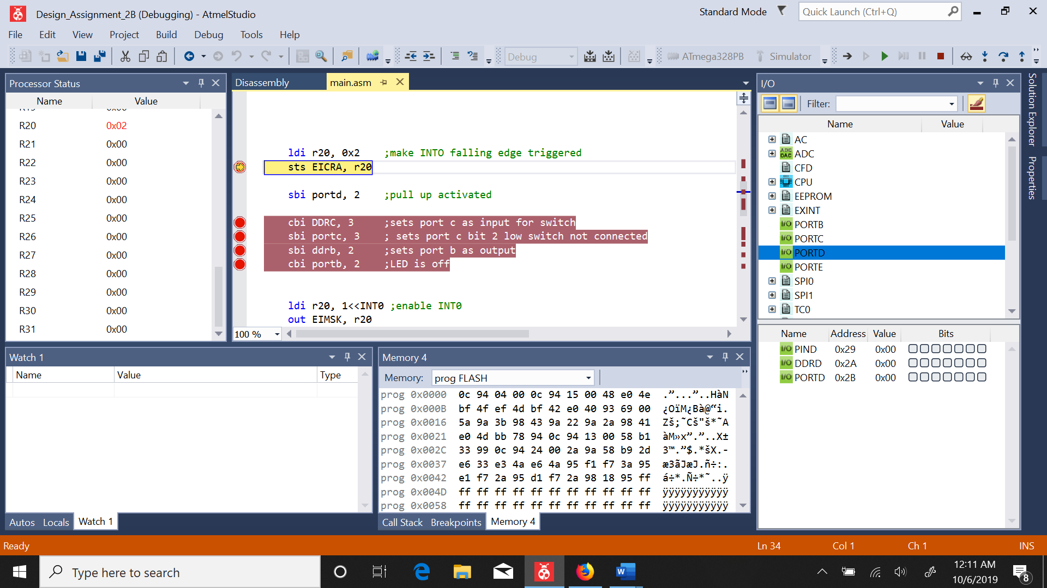

Figure : debugging code

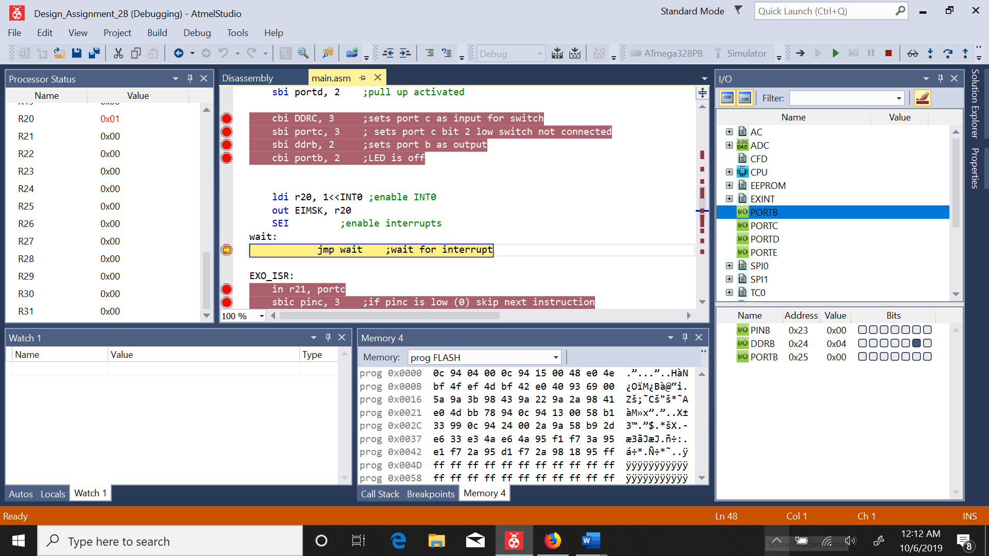

Figure : portb2 is set as output

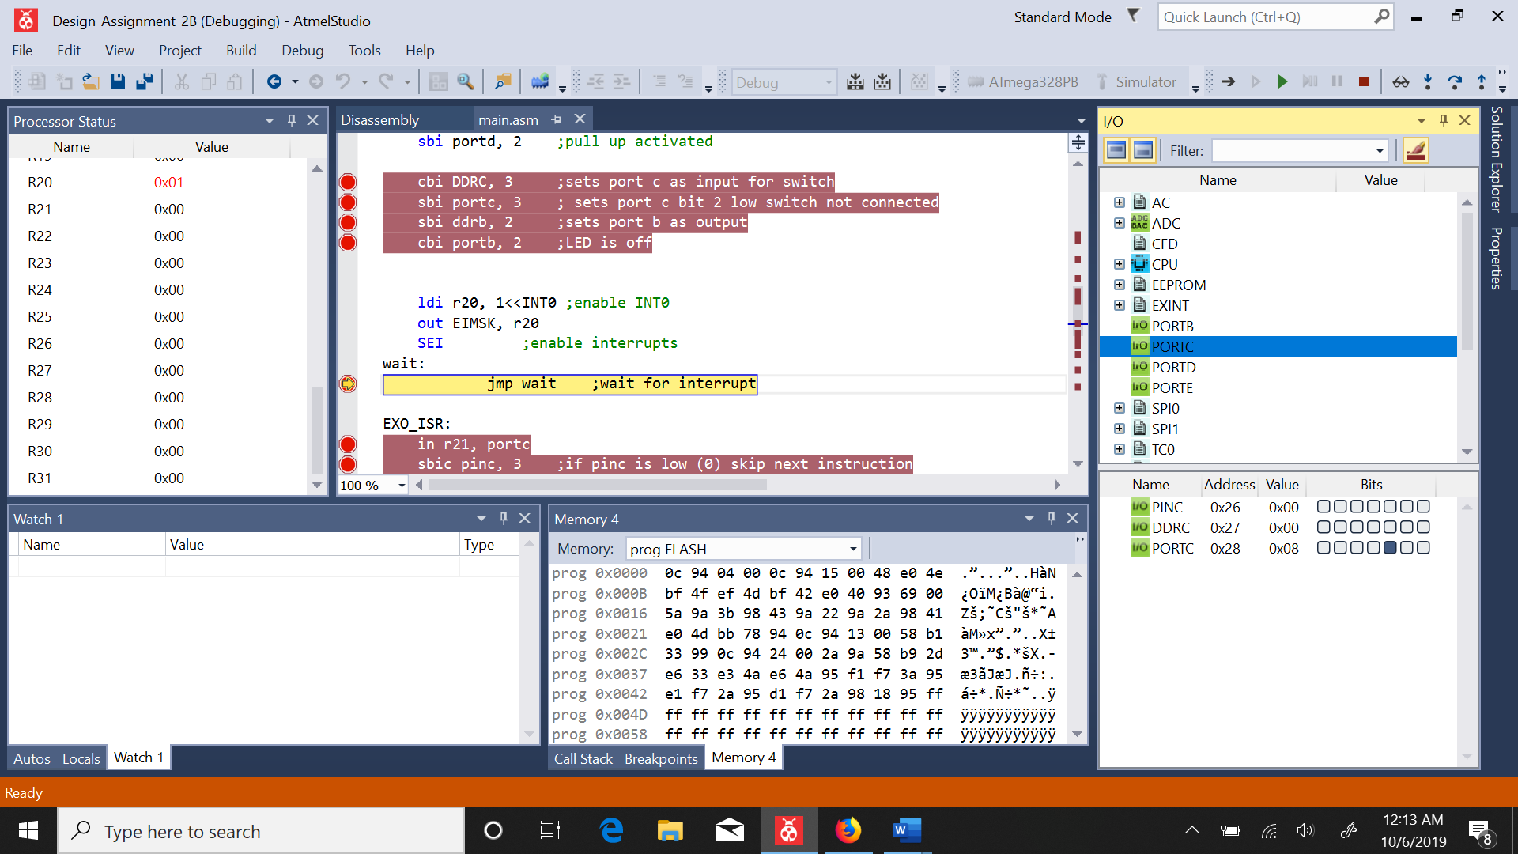

Figure : portc is an input portc.3 active high

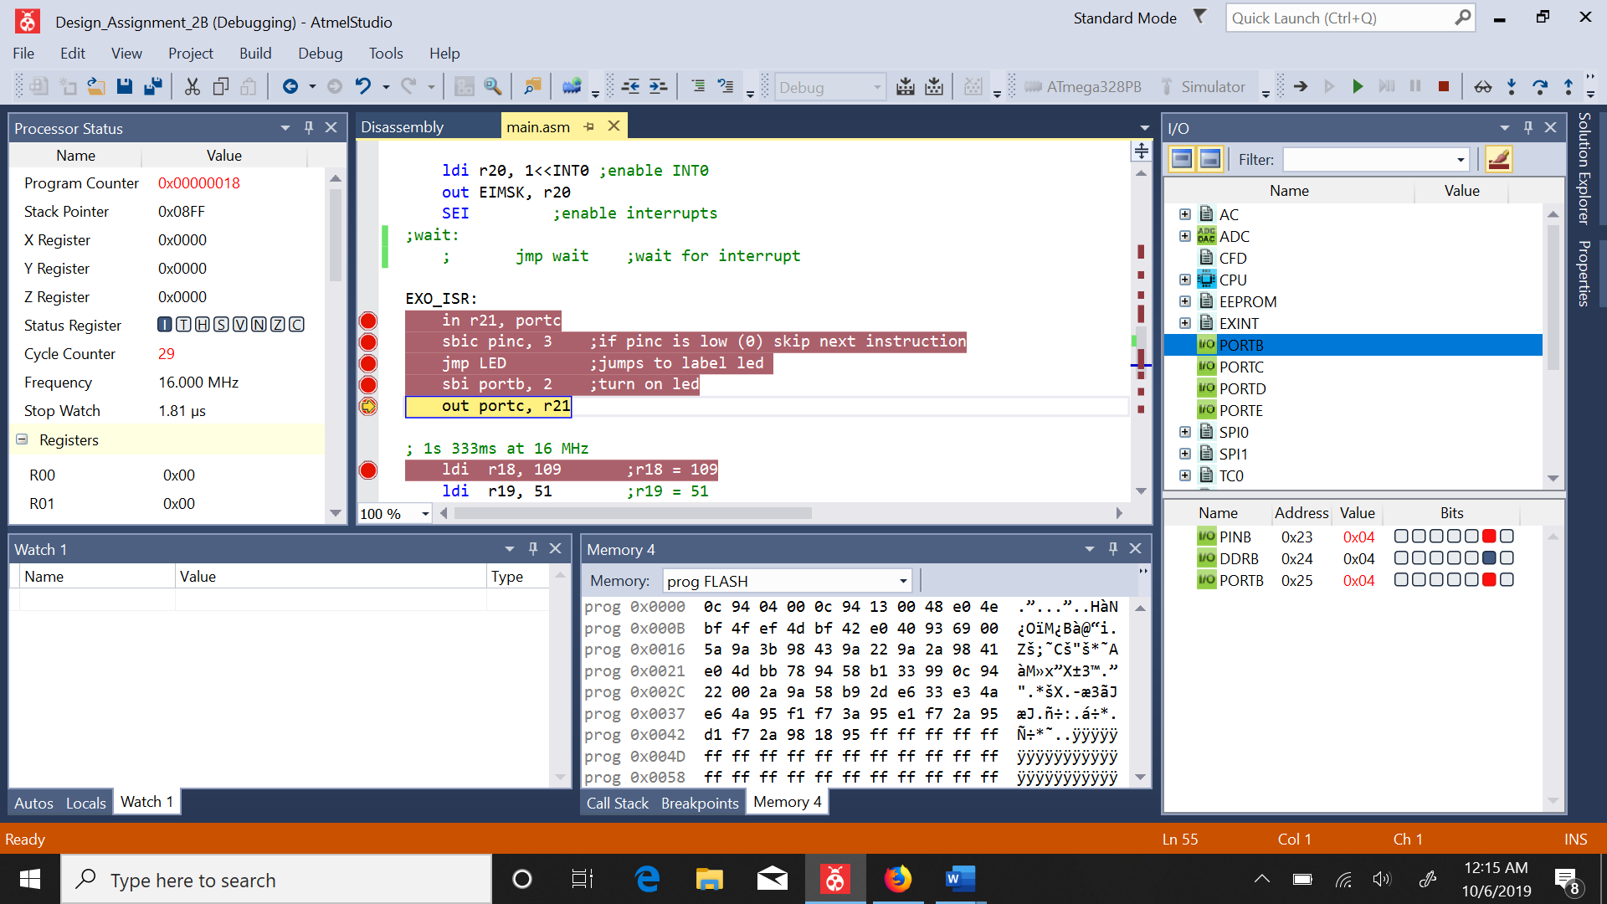

Figure : led on portb.2 is on time is 1.81us

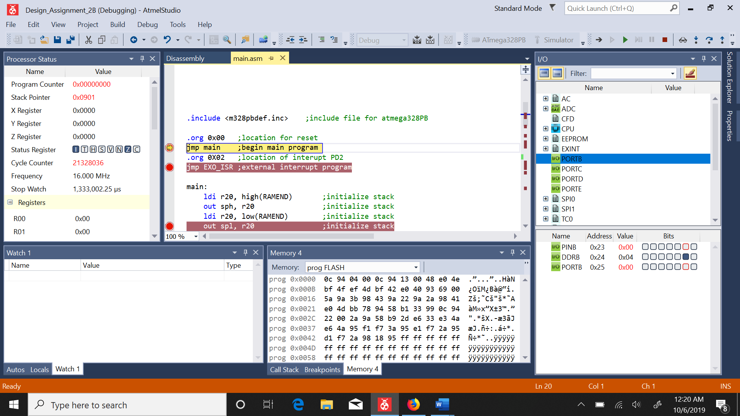

Figure : LED has been turned of 1.333 seconds after interrupt

1. **SCREENSHOT OF EACH DEMO (BOARD SETUP)**
2. **VIDEO LINKS OF EACH DEMO**
3. **GITHUB LINK OF THIS DA**