1. 下载smarty模板：[www.smarty.net](http://www.smarty.net);
2. Smarty模板的引入和实例化配置：

header("content-type:text/html; charset=utf-8");

require('../smarty/Smarty.class.php');

$smarty = new Smarty();

//smarty"五配置和两方法"

$smarty->left_delimiter = "{"; //左定界符

$smarty->right_delimiter = "}"; //右定界符

$smarty->template_dir = "tpl"; //定义html模板存放的位置

$smarty->compile_dir = "template_c"; //模板编译生成的文件

$smarty->cache_dir = "cache"; //缓存

//开启缓存的两个配置，应为不常用smarty的缓存机制，只作为了解

$smarty->caching = true; //开启缓存

$smarty->cache_lifetime = 120; //缓存时间

//对smarty模板变量的赋值

$smarty->assign("articletitle","文章标题");

$smarty->display("tpl/test.tpl");

1. smarty的注释：{*这里是注释和说明*}
2. 数组的输出方法：

$arr=array('title'=>'smarty的学习','author'=>'廖东');

$smarty->assign('arr',$arr);

$smarty->display("tpl/test.tpl");

{$arr.title} {$arr.author} {$arr['title']} {$arr['author']}

1. 变量调节器

Capitalize:将变量调节为首字母大写 示例：{$articletitle | capitalize}

Cat:字符串连接 示例：{$articletitle | cat:”yesterday.”}

Date_format:日期格式化

示例：{$yesterday|date_format}

{$yesterday | date_format:”:” %A, %B %e, %Y %H:%M:%S”}

Default:为未赋值或为空的变量指定默认值default 示例：{$titlecontent|default:”no title”}

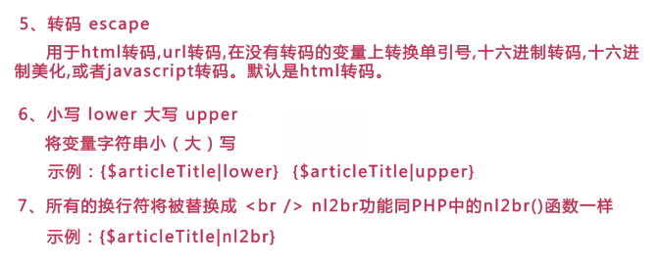

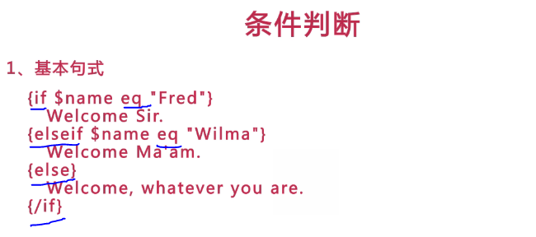



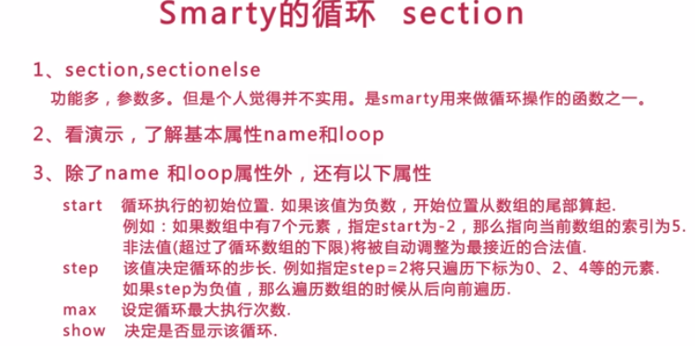

{section name=articlelist loop=$articlelist show=1}

{$articlelist[articlelist].title}

{$articlelist[articlelist].author}

{$articlelist[articlelist].content}

<br/>

{/section}

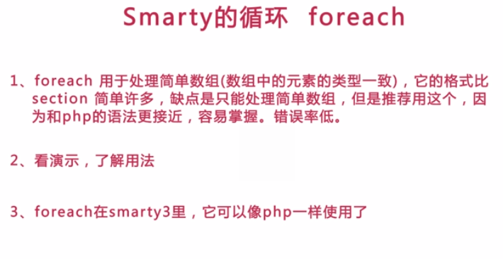

{foreach item=article from=$articlelist}

{$article.title}

{$article.author}

{$article.content}

<br/>

{foreachelse}

当前没有文章

{/foreach}

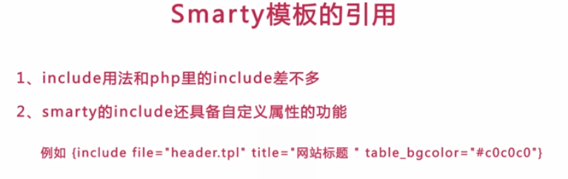

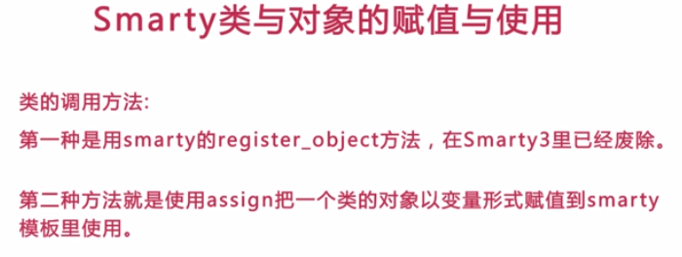

class My_Object{

function meth1($params){

return $params[0].'已经'.$params[1];

}

}

$myobj= new My_Object();

$smarty->assign('myobj',$myobj);

$smarty->display('tpl/test.tpl');

{$myobj->meth1(array('小明','回来了'))}

<br/>

{$myobj->meth1(array('苹果','熟了'))

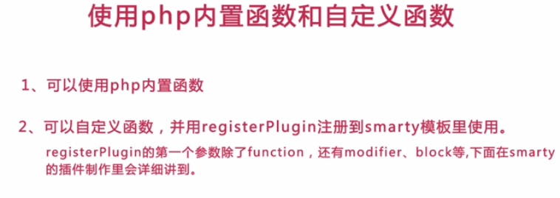

时间demo

$time=time();

$smarty->assign('time',$time);

$smarty->display('tpl/test.tpl');

{$time|date_formate} //smaty变量调节器写法

{"Y-m-d H:m:s"|date:$time} //PHP内置函数时间写法

字符串替换demo

{'y'|str_replace:'Z':$str}

在smarty模板里使用PHP内置函数的基本格式

