Project 6: Indicator Evaluation

Five trading indicators and Theoretically Optimal Trading Strategy

Ted Pham

Tpham328@gatech.edu

***Abstract—***This report introduced five common trading indicators that is popular among the traders. Based on them, there are variety of trading strategy that can be applied. The report also discussed a theoretically optimal strategy which is used to compare. Since we peaked into the future to build this optimal strategy there is no way we can beat that result but our goal is building a strategy that is good enough to compare with the benchmark. Good indicators and strategy are the ones that produced results as close as possible to the Theoretically Optimal Strategy and beat the benchmark. It will be tested using machine learning in future projects.

# Introduction

For our trading study, we started out with $100,00 cash. Assumed we only traded symbol JPM (JPMorgan Chase, one of the largest bank in the United States). We used in-sample data of JPM from period January 1, 2008 to December 31, 2009. (In sample means we used historically known data, including adjusted closing price, closing price, high and low price of the day).

We used daily data, no intraday trading. So, for Theoretically Optimal Strategy (TOS), we assumed we buy and sell at the adjusted closing price. For simplicity of testing, we also assumed there is no commission and we can fill the order at adjusted closing price. In addition, our position are limited to 1000 shares, which means we can only hold at most 1000 shares long or 1000 shares short position (also we may only trade up to 2,000 shares at a time).

We created a Theoretically Optimal Strategy (TOS) to trade JPM and compared it with the benchmark. The benchmark is that we buy 1,000 shares of JPM at the beginning of the period and hold that position. Our benchmark balanced at the end of the period is the value of 1000 shares and our remaining cash.

Finally, we discussed five good common trading indicators that are popular within the trading world and develop trading strategy around them, which can be used for our trading study. We will discuss about how the indicators is developed, how to use them and what strategy based on them. The result of indicator strategy will be reported in future projects.

# Indicator 1: CROSSING OF EMA9 and EMA21

The EMA9 cross EMA21 is a popular technical analysis tool used in stock trading that I personally have been using in the past. EMA stands for Exponential Moving Average. It is used to identify the trend direction of stocks’ price. Number 9 and 21 refer to the numbers of lookback period used to calculate the moving average, since our data is daily data. 9 is 9-day lookback data. And 21 is 21-day lookback data.

Compared to SMA, which is calculated by average closing prices, EMA gives more weighted to the recent price data. The formula for calculating EMA is as follows:

EMA = (Closing Price[1] - EMA previous period) * (k/(N+1)) + EMA previous period, where:

Closing price is adjusted closing price at the end of day

K is smoothing factor and one of the most common is 2, so we will use k = 2 here.

N is the number of lookback period, here we used N = 9 and 21 for EMA9 and EMA21 respectively.

EMA of the first lookback days is not available and is calculated based on the data available at the time. Which mean first EMA9 equal share price at starting period, second EMA9 is actually EMA2 since only 2 closing prices available at that time, and so on.

Here is our graph of EMA9 cross EMA21 signal in comparison with Price of JPM:

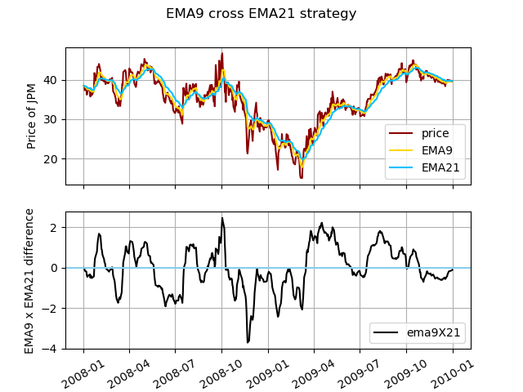

The first char is price of JPM and EMA9 and EMA21. One way to convert EMA9 cross EMA21 signal is to use the difference EMA9 minus EMA21. When it is above 0, it means EMA9 crossover 21; when it is below 0, EMA9 cross below EMA21.

A quick look, when EMA9 cross over EMA21, this is bullish signal and we can see price of JPM is going up. EMA9 cross down EMA21, this is bearish signal and JPM price fall. A strategy developed from this indicator is when EMA9 crossover EMA21, go long; and when EMA9 cross below EMA21 go short or sell all your long position.

This indicator should not be relied upon sorely, should be combined with other technical analysis tools. For example, when EMA9 crossover EMA21, check if stock is oversold by using RSI or stochastic, check if current price is above EMA200 before going long and vice versa. Those are other indicators that indicate bullish signal.

# Indicator2: Bollinger BAND PERCENTAGE (BBP)

Bollinger bands is used to measure the volatility of a stock price within a period. They consisted of 3 lines: The first line is a simple moving average (SMA), the top and bottom band is 2 standard deviation lines plotted from the middle line. To convert the Bollinger band into 1 simple Bollinger band percentage(BBP), when low BBP means stock price is closer to the bottom band and high BBP means stock price is closer to the top band.

Bollinger Bands is calculated as follows. The middle band is the 20-day simple moving average or average of 20 previous closing price (including current one). Then calculate the standard deviation of the same 20-day period. The calculate top band and bottom band by adding and subtracting respectively the middle band value with 2 times the standard deviation.

BBP = (current closing price – bottom_band) / (top_band – bottom_band) *100

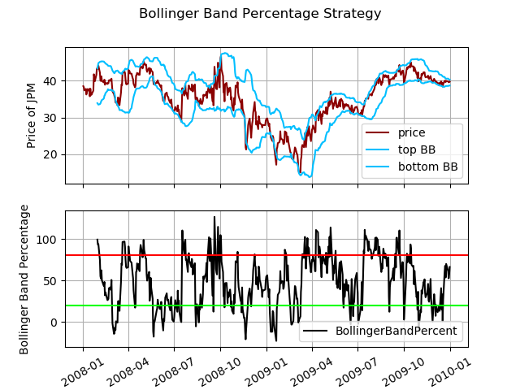Here is BBP chart, Bollinger Bands and JPM prices:

I crossed 2 lines value of 20% in green and 80% in red in the BBP chart. A simple trading strategy is when BBP is below 20% line, we can go long, and above 80% we can go short. This is based on a theory that when prices move out of the bands, it is either overbought or oversold and may indicate a potential trend reversal. The strategy is good to used alone for stocks price that move in range. But it should not be relied alone as any indicators. It should be used with other reversal signal like RSI and price divergence/convergence or trade with the long term trend using SMA200.

# INDICATOR3 : Moving average convergence divergence (MACD)

MACD is used to identify trend changes, momentum and potential buy or sell signal when 2 lines cut. MACD is consists of 2 lines: The MACD line and the signal line. MACD line is the difference of the EMA 12 and EMA 26 [2]. The signal line is then calculated from the MACD line, it is the EMA9 of the MACD line. So signal line tend to move “slower” compared to MACD line, indicating longer trend. When MACD line crosses above the signal line, it indicates a bullish signal, and vice versa. MACD chart sometime shows a histogram which is the difference between MACD line and signal line.

A good strategy for MACD is go long when MACD line crosses over signal line and go short when MACD line crosses below signal line. For ease of use, go long when histogram is positive (color is green in chart below) and go short when histogram is negative (color is red in chart below)

Like any other indicators, MACD should not be relied sorely upon. It can be used with other indicators like RSI or EMA crossover. A safer strategy is only go long when price is above EMA/SMA200 and MACD histogram is green and vice versa.

Here is the chart of MACD compared to price of JPM:

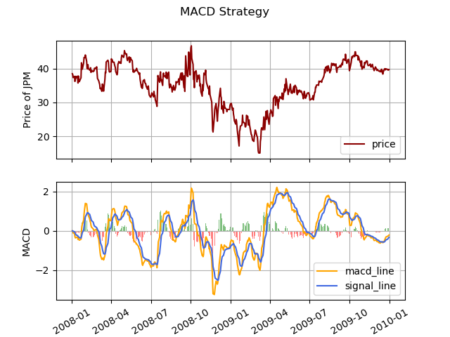

# INDICATORS 4: STOCHASTIC OSCILLATOR

Stochastic Oscillator is a momentum indicators that compares the closing price it its price range over a specified period (here we used 14-day lookback). Stochastic Oscillator consists of 2 lines: K-line of 14 period and D-line of 3 periods.

K = (Current Closing Price – Lowest Low) / (Highest High – Lowest Low) * 100

D = SMA3 of K

Lowest Low is the lowest price of 14-day lookback period

Highest High is the highest price of 14-day lookback period

Stochastic is used to identify potential overbought and oversold. Because Stochastic is calculated in a range (highest high, highest low) it is best used to trade stock price that run within a range. It can even be used for intra-day trading for this reason. A common stand alone trading for Stochastic Oscillator is buy low when K line cross over D line while under low value and sell high when K line cross below D line while over high value in the chart.

Here is chart of Stochastic Oscillator compared with price of JPM

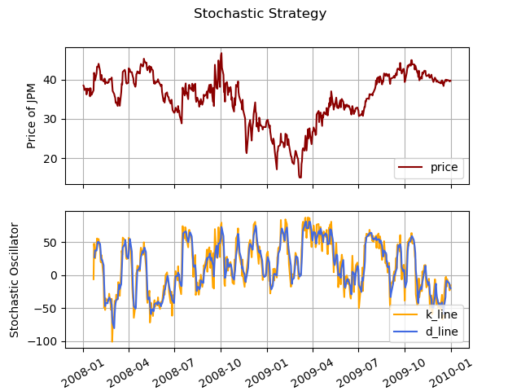

# INDICATOR 5: RATE OF CHANGE

Rate of Change (ROC) measures the percentage change in price of stock over a specific period/window. In this project, we used window = 5 because we used daily data and there are 5 trading days in a week.

ROC = [(Current closing price / Closing price 5 days ago) – 1] * 100

One strategy to trade using ROC is compared ROC of current stock with ROC of an index like SP500 to see if it is outperform or underperform the market. However, it should not be used alone. In bull market, buy stock with high ROC but never short in bull market even if stocks have low ROC. In bear market, short stock with low ROC compared to market.

Another strategy is momentum of ROC, we can long a stock with when there is a high increase in ROC of a stock, and stop-loss or sell when ROC dip below certain threshold. Here is chart of ROC compared with price of JPM:

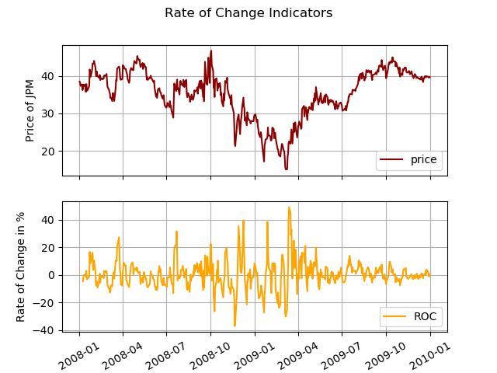

# THEORETICALLY OPTIMAL STRATEGY

Since we “know” the future, the best way to trade is buy low, sell high and short high and buy back low. We will only trade share of JPM during 1/1/2008 and 12/31/2009 period. Our constraint is that we cannot hold more than 1000 shares or short more than 1000 shares at anytime. Our starting cash value is $100,000.

Because we trade daily, we assume we can fill the order with adjusted closing price. We need to compare the closing price of tomorrow with current closing price. For the first order, when our current position is 0 share, if tomorrow price is higher, we buy 1000 share now otherwise short 1000 share. If the day after tomorrow is continue to be higher, we hold. If the day after tomorrow price is lower, we will sell 2000 shares instead of 1000 to take advantage of the “known” price. Our net position is still -1000 and stays within limit. We will need to buy 2000 shares when we know next day price is higher and so on.

For the benchmark, assume we buy 1000 shares of JPM at the beginning of the period and calculate the value of those shares plus remaining cash at the end of the period.

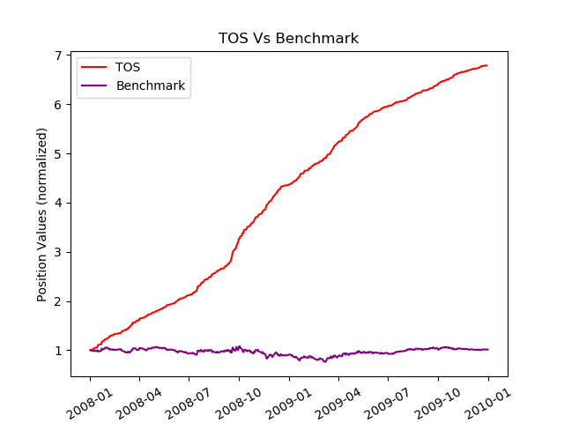Here is the chart to compare the value of our TOS vs. the benchmark:

Overall our TOS is pretty good compared to benchmark. Benchmark result is also 0% gain while our TOS value is almost 700% netting us 600% return on investment. Here is the performance metrics from 1/1/2008 to 12/31/2009

|  |  |  |
| --- | --- | --- |
| 1/1/2008-12/31/2009 | TOS | Benchmark |
| Cumulative Return | 5.784400 | 0.012299 |
| Mean of Daily Return | 0.003831 | 0.000168 |
| Standard Deviation of daily return | 0.004551 | 0.017004 |
| Sharpe Ratio | 13.365085 | 0.156918 |

# CONCLUSION

Our TOS strategy outperform the benchmark by a mile. Theoretically we can gain 578% return on investment if we follow with the strategy but it is not possible in real life because future is unknown. We cannot know the price as accurate as our assumption. We didn’t consider commission price as well so TOS is not realistic. We also discussed 5 very good indicators that are commonly used, but no indicator is holy grail of trading. We should never rely sorely based on 1 indicator for our trading. A combination of indicator is a good start. For indicators that good for range trading we should use stochastic. For momentum trading, we should use EMA and other combinations. And last but not least, risk management is still the most important factor in trading regardless of what indicators we used.

# References:

<https://school.stockcharts.com/doku.php?id=trading_strategies>

https://school.stockcharts.com/doku.php?id=technical_indicators:stochastic_oscillator_fast_slow_and_full

1. We are using adjusted closing price of JPM as illustration.
2. See Indicator 1 for description of EMA and how to calculate EMA