No.ORDER : FKKT0109
CODE AGEN : GGE
Customer : FKKT
Bank : OCBC NISP
Grade: B ( Garansi 10jt )
KCP : Bandengan
NIK : 3172-0126-0605-1005
Nama : Rendi Pirmansah
Tgl Lahir : Kuningan, 26-06-2005
Nama ibu kandung : Dewi Marwiyah
No.rek : 6938-1910-7485
No.atm : 5379-4080-2291-0159
Valid Thru : 07/30
No.hp : 0859-4680-4459
PIN ATM : 145145
User Id Nyala: RENDIPIR2606
User M-Bank: RENDIPIR2606
Pin Login: 145145
Pass Login: Dwiyans145
I-Banking : RENDIPIR2606
Pass I-Banking Dwiyans145
Email: rendicoy819@gmail.com
Password email : @dwiyans145
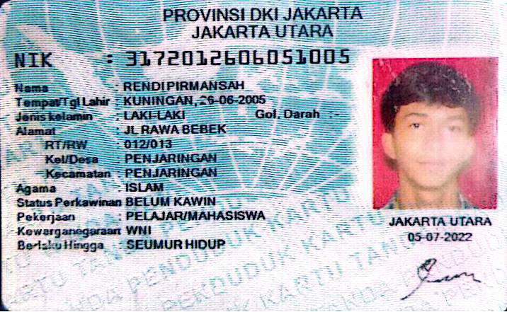
Expired Garansi: September 2005

