National University of Singapore
Institute of Systems Science
Master of Technology in Software Engineering
Team 4 (Part-Time)

One# Billing System for Telephony Services
Project Report v0.1

Course Assignment Contributor

Name | Matriculation No. | Phone | E-mail
Aman Sharma | A0092639U | 96756375 | sharma.amam82@gmail.com
Chen Changfeng | A0006573J | 90051315 | windiecct@gmail.com
Kenny Hartono | A0092674W | 81081794 | kenny1har@yahoo.com
Mansoor M I | A0092661A | 81269194 | mansoor.mi08@gmail.com
Robin Foe | A0092657U | 91157054 | robin.foe@gmail.com
Song Lei | A0092601N | 81009708 | tristone.song@gmail.com
Srinivas Appalla | A0092705E | 98219874 | asris@rediffmail.com
Yue Yang | A0092607A | 84480020 | xiaoyue311@gmail.com

Table of Contents
1 Background 4
2 Overview 4
3 Scope 4
4 Targeted Audience 4
5 Class Diagrams 6
6 Basic Functionalities 7
6.1 User Authentication 7
6.2 Customer Maintenance 8
6.3 Complaint Maintenance 9
6.4 View Bill 10
6.5 Generating Monthly Report 11
6.6 Make Payment 11
7 Assumptions 13
8 Available User Account 13

Contents
- Background
To build a prototype for One# telephone operator for computerizing their billing system. The purpose of this document is to provide simple user guidance on how to go about and navigate within the billing system prototype. There are two types of users going to access the system namely Administrators and Call Centre Agents. The Call Centre agents appointed to receive and log complaints from its customers and to generate monthly bills. Administrators can perform the functionalities provided by Call Centre Agents and also assume the additional duties of the maintenance of other critical functionalities provided by the system.
- Overview
Customers of One# can register for one or more services that are offered. Various kinds of services are digital voice, mobile voice and cable television subscriptions. Authorized administrators of the system will be able to create customer accounts. At the end of each month, the administrator will be able to print a consolidated bill for each customer.
- Scope
The scope of the One# billing system as follows:
- Customer maintenance
- The maintenance of Mobile, Voice & Cable TV Subscription Plans
- To maintain Subscription Rates
- To offer various subscription plans for Customers
- To capture complaints lodged by customers
- Generation of monthly bills at a specified date
The scope doesn’t include the transactional data for the subscriptions and assumed that it’s provisioned by another system. Only raw data is captured e.g. for each mobile voice subscription, call details for every single call made are stored.
- Targeted Audience
The system aimed at two groups of users namely Call Centre Agents and Administrators. The below use-case diagram describes the user responsibilities as follows:
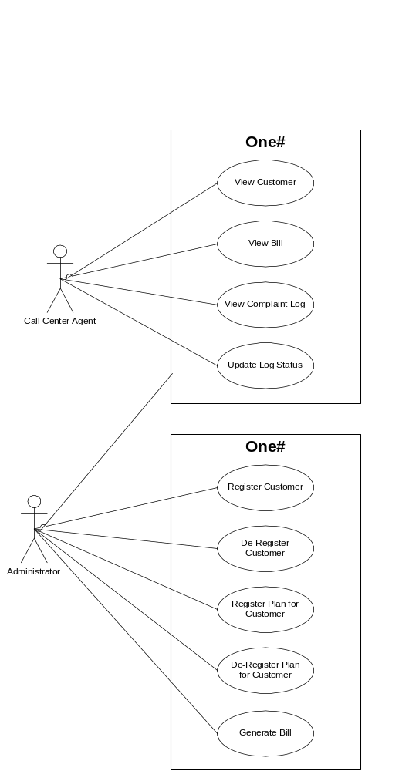
Figure 1 One# Use Case diagram
- Class Diagrams
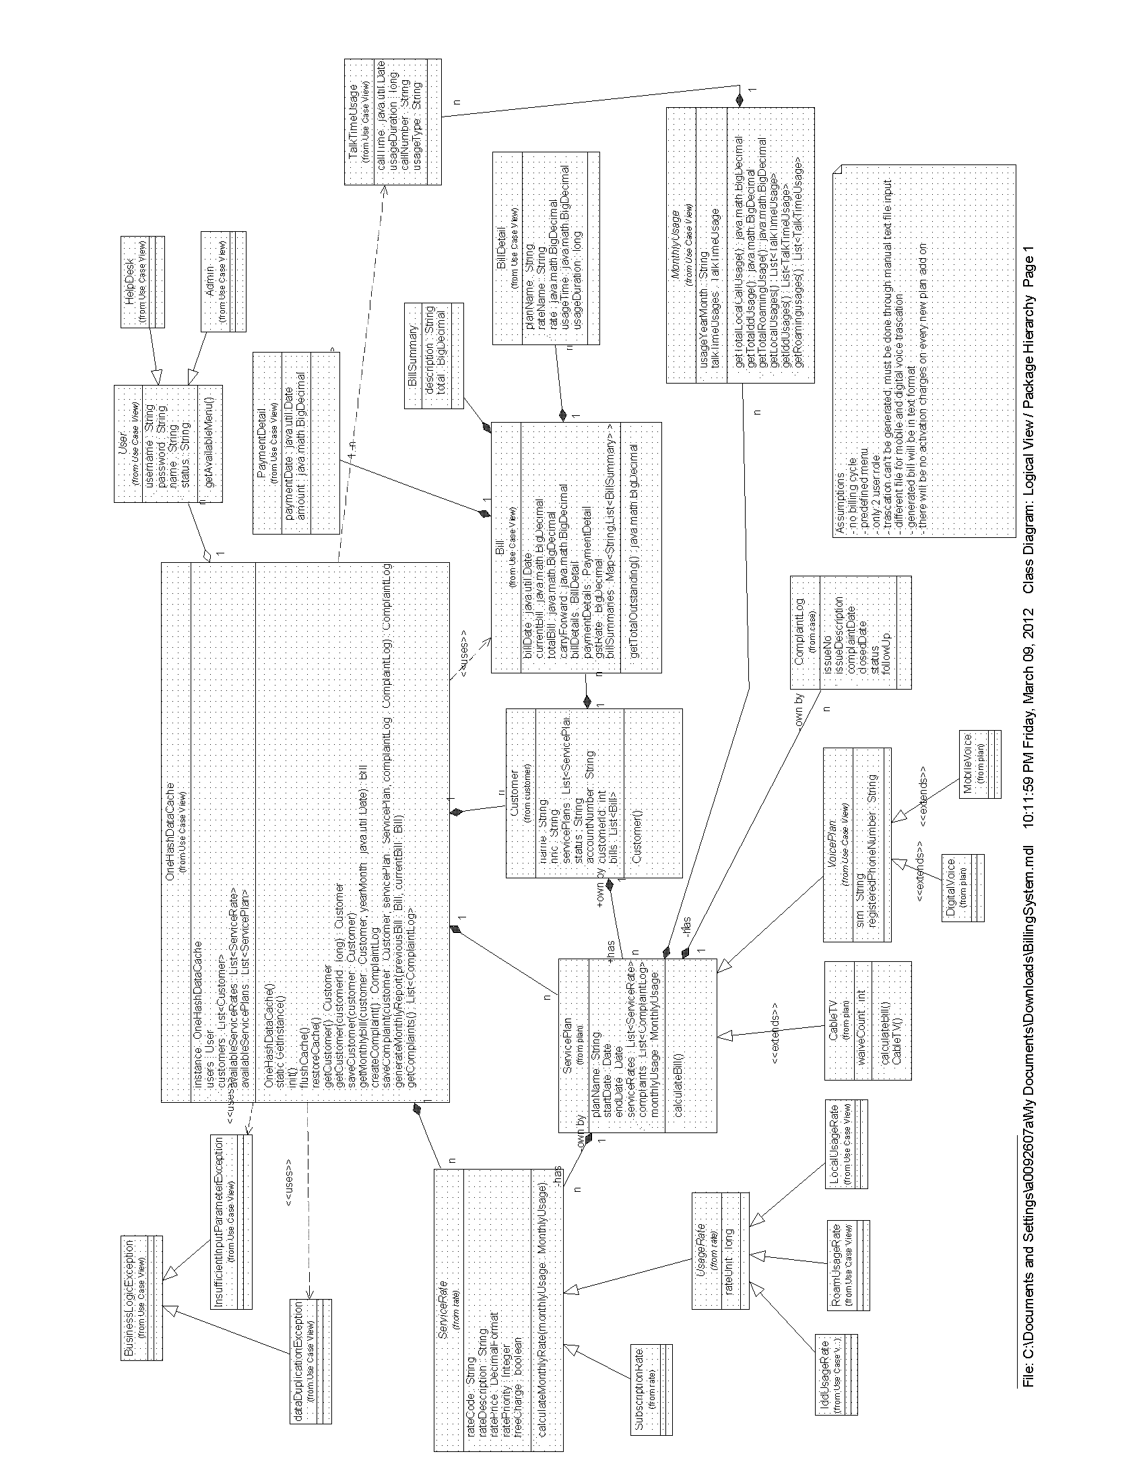
Figure 2 One# Class Diagram
(Attached PDF version for reference: )
- Basic Functionalities
  - User Authentication
Only authorized administrators and authorized call-center agents are allowed to use the system
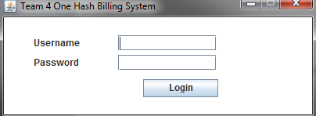
Call-center Agent
- May view a specific Customer’s bill for a specific month
- May view a specific customer’s details
- May view or log customer complaints
- May change the status of customer complaints (pending/completed)
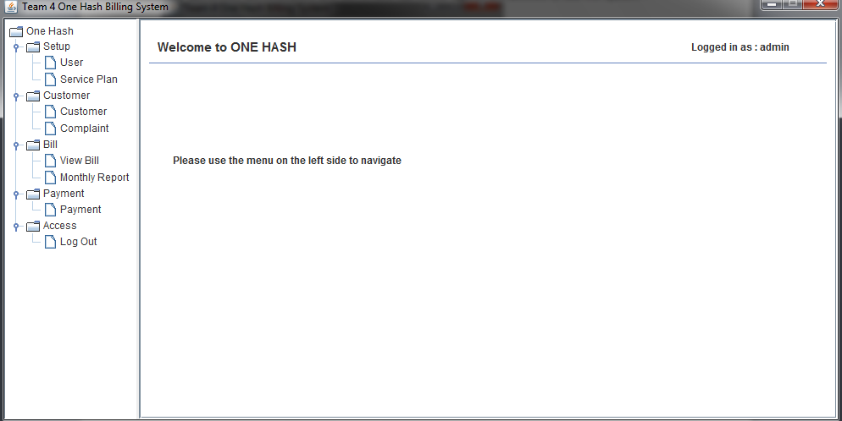

Administrator
- May register new customers. Information collected from the user includes name, NRIC, billing address, telephone number, interests (eg: specific TV programs, playing games, shopping etc)
- May de-register a customer (the customer record is only marked as deleted and is not physically removed from the store)
- May register new subscriptions for customers. Information includes the name of the subscription, date of commencement of the service, specific details of the service (eg: home/mobile telephone number, options etc)
- May de-register an existing customer subscription (the subscription record is only marked as deleted and is not physically removed from the store. The date of termination of the subscription is also stored)
- May generate monthly bills for all customers. The generated bills are stored in a file with a filename that indicates the month and year (eg: bills_201202 for the month of February).
- May perform all call-center agent functionality
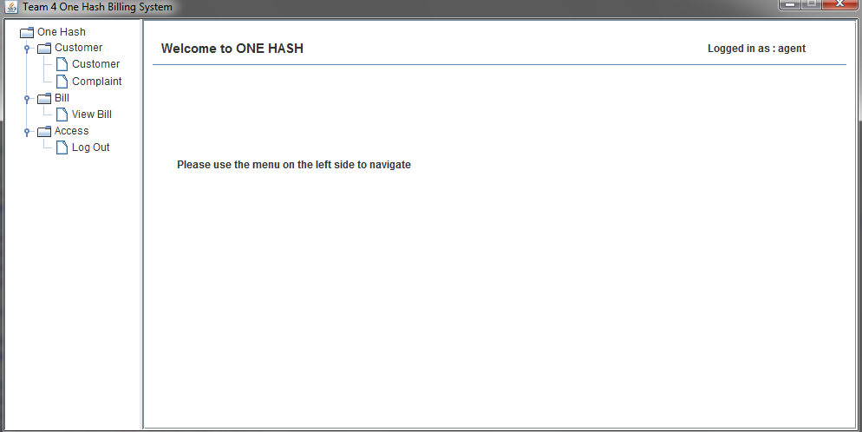
  - Customer Maintenance
- Register new customers. Information collected from the user includes name, NRIC, billing address, telephone number, interests.
- De-register a customer.
- Register new subscriptions for customers. Information includes the name of the subscription, date of commencement of the service, specific details of the service.
- De-register an existing customer subscription.
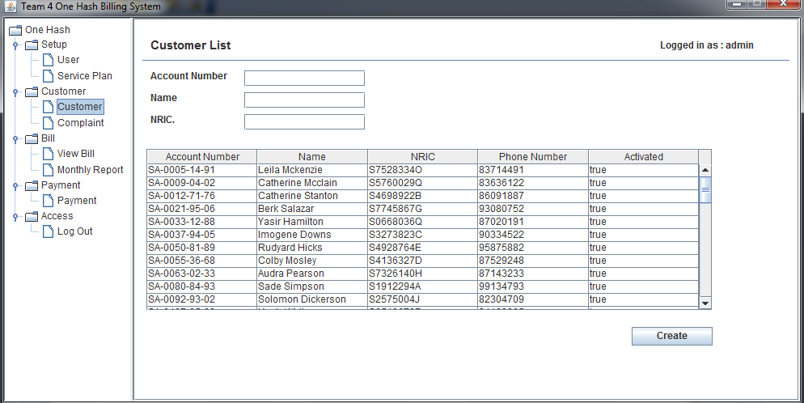
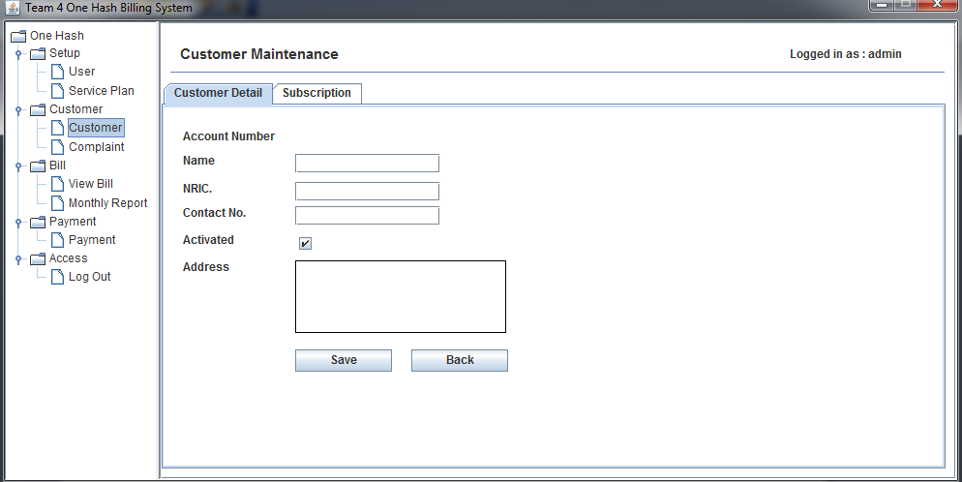
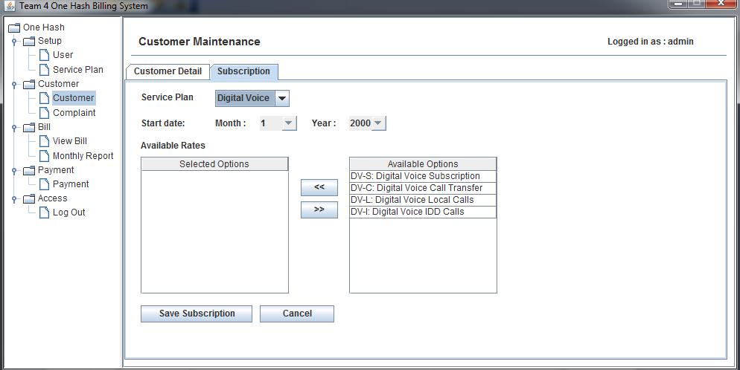
  - Complaint Maintenance
- View or log customer complaints.
- Change the status of customer complaints (pending/completed).
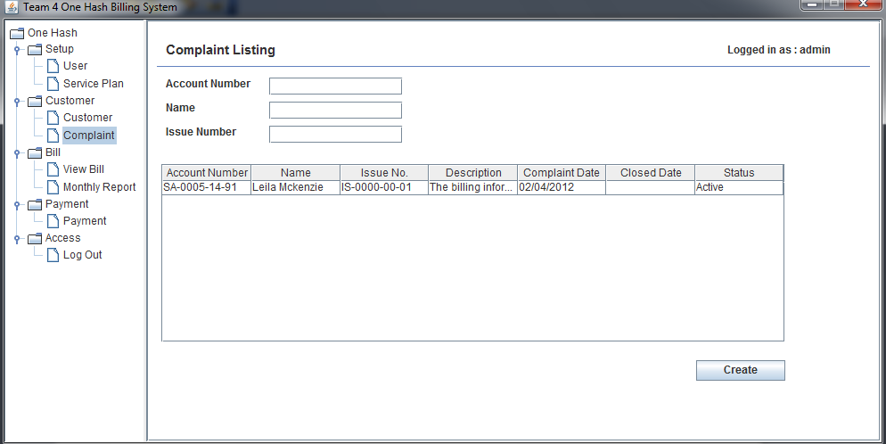
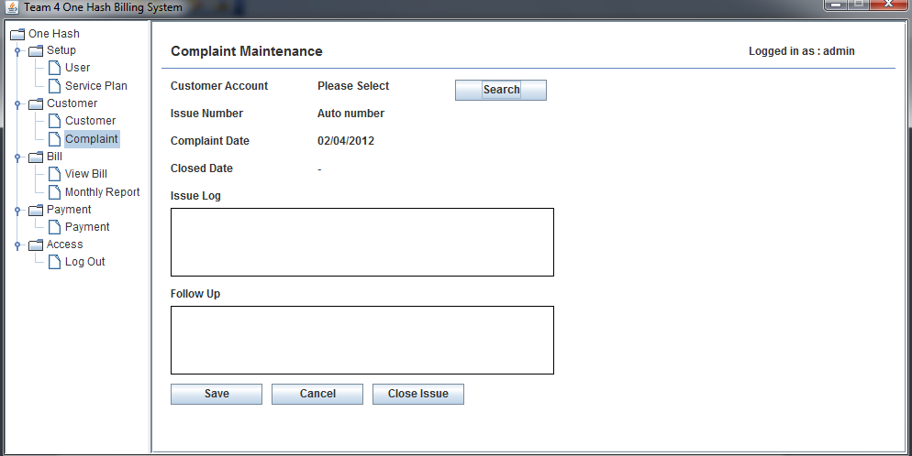
  - View Bill
- View a specific Customer’s bill for a specific month.

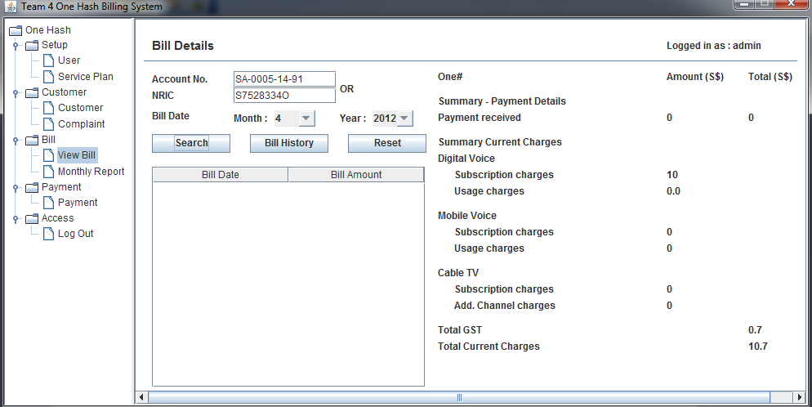
  - Generating Monthly Report
- Generate monthly bills for all customers.

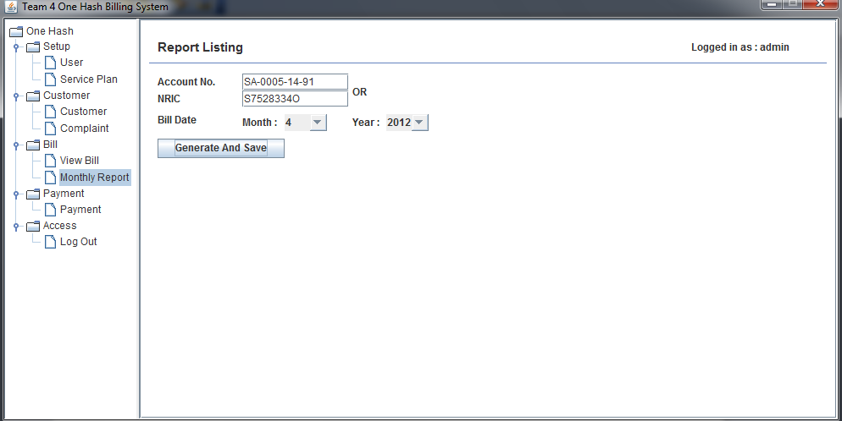
  - Make Payment
- Make payment for all customers
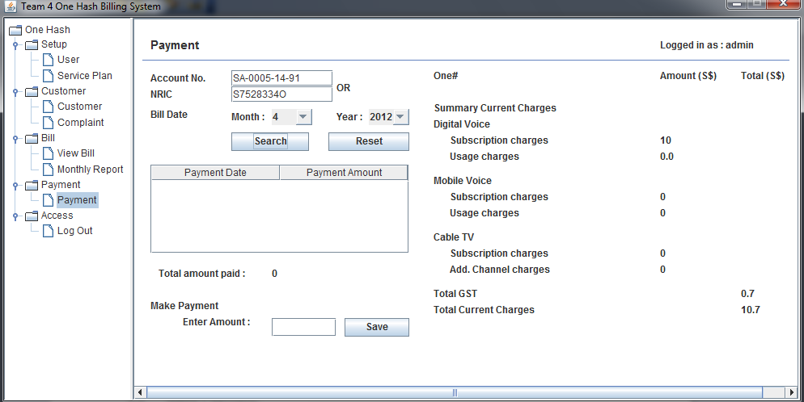
- Assumptions
- No billing cycle
- Menu will be predefined
- Only 2 user roles (administrators and authorized call-center agents)
- Transaction cannot be generated, it must be done through manual text file input
- Different file for mobile and digital voice transaction
- Generated bill will be in text format
- Available User Account

