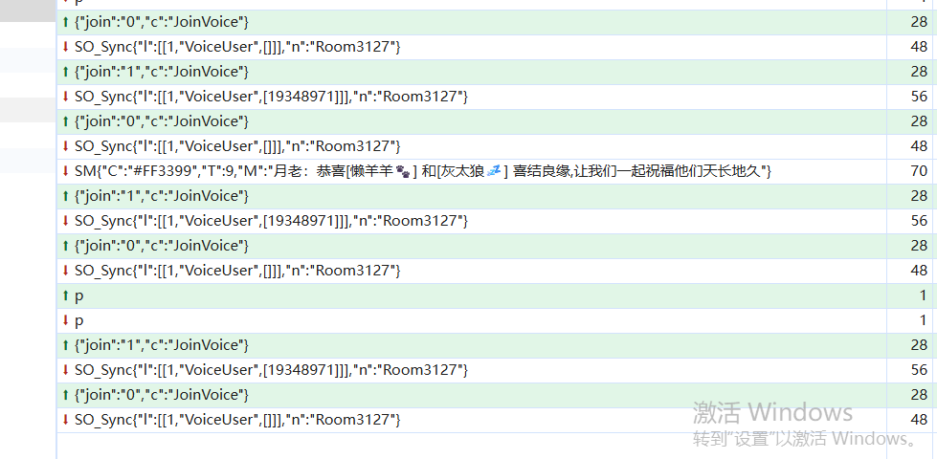
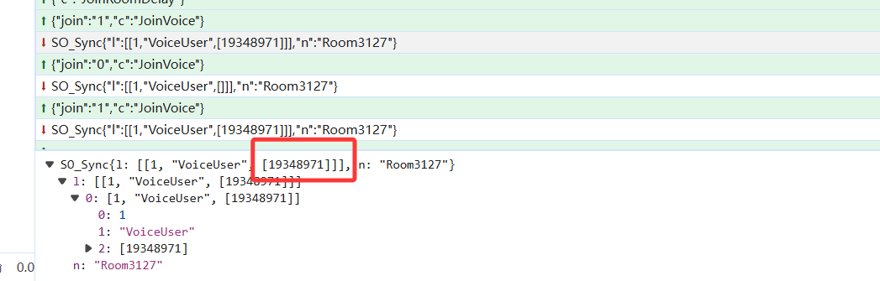
app_id
:
"14afb711d60047e899beaca69932a16a"

https://t1.ss911.cn/Conn/VoiceKey.ss?channel=3089&uid=19348971&device=html5%3A1459&u=GS9Ae5cHpliJW%2FbHTxQV%2F3g0uLn50iRK4CcMsh8Pww0%3D
{"key":"005AQAoAEY0NThDRDRDODJDMTY3RTI0NDc1N0RDNjYwNUZBQzRGNzRCMkVENjEQABSvtxHWAEfomb6s\r\nppkyoWrjqwZqlgC8uAAAAAAAAA==\r\n","msg":"OK"}

https://webrtc2-ap-web-1.agora.io/api/v2/transpond/webrtc?v=2
{"appid":"14afb711d60047e899beaca69932a16a","client_ts":1778822610442,"opid":475941622605,"sid":"065C010D12864CE9A911F73907AEF9EE","request_bodies":[{"uri":22,"buffer":{"cname":"3089","detail":{"11":"CN,GLOBAL","17":"1","22":"CN,GLOBAL"},"key":"005AQAoADAzMEQzMjM2QkU3NTdBRkY2MDk4OUYzMzhCQTU4RDY4NjI1ODMxMEEQABSvtxHWAEfomb6s\r\nppkyoWrSrQZqd4/WYQAAAAAAAA==\r\n","service_ids":[11,26],"uid":19348971}}]}
{
"detail": {
"502": "106.75.133.43"
},
"enter_ts": 1778822610449,
"leave_ts": 1778822610457,
"opid": 475941622605,
"response_body": [
{
"buffer": {
"cert": "S0FBQUFBVUFxWFFDQU9zOUp3RURBTml4NkZaUUcrQXJCd09YRXRLdEJtb0FBQUFBQkFBek1EZzVGQUIxeHJmY1ZWRW1uWXA4NjhOLzV1ZHpVc2ZwU3c9PQ==",
"cid": 2282400059,
"cname": "3089",
"code": 0,
"detail": {
"1": "202.104.160.172",
"10": "005AQAoADAzMEQzMjM2QkU3NTdBRkY2MDk4OUYzMzhCQTU4RDY4NjI1ODMxMEEQABSvtxHWAEfomb6s\r\nppkyoWrSrQZqd4/WYQAAAAAAAA==\r\n",
"2": "CTEL",
"23": "",
"3": "CN",
"4": "B6rkQ/YEqnV/H/BLmTa1n/laLXnzWoN4Y03WPY4FQcCfpC3TUfdZdtbebQeIWQbUU4He6vnsuhqTk+b/Yu9TSg==",
"8": "160937",
"9": ""
},
"edges_services": [
{
"ip": "14.29.94.153",
"port": 443
},
{
"ip": "14.29.38.150",
"port": 443
},
{
"ip": "115.238.206.10",
"port": 443
}
],
"flag": 4194310,
"uid": 19348971
},
"uri": 23
},
{
"buffer": {
"cert": "S0FBQUFBVUFxWFFDQU9zOUp3RURBTGtXMEVpZGNOQklHNlROU05LdEJtb0FBQUFBQkFBek1EZzVGQURjZloxRGppVi9PQXk1NHB1a08vNjB5TDJCeGc9PQ==",
"cid": 2282400059,
"cname": "3089",
"code": 0,
"detail": {
"1": "202.104.160.172",
"10": "005AQAoADAzMEQzMjM2QkU3NTdBRkY2MDk4OUYzMzhCQTU4RDY4NjI1ODMxMEEQABSvtxHWAEfomb6s\r\nppkyoWrSrQZqd4/WYQAAAAAAAA==\r\n",
"19": "EF:1F:D8:6E:55:32:9F:80:42:A1:C2:66:91:F6:D0:9E:93:87:1A:FB:62:4F:11:CE:0D:CB:A6:40:91:0E:6B:B0;1C:C6:D1:23:E4:70:21:38:DC:0E:C6:CA:B1:EF:BD:B6:82:E7:93:AB:BD:70:FC:00:18:97:C9:67:21:DD:DB:F7;A3:35:A0:64:7B:36:81:3C:64:55:2C:74:15:FB:A5:B6:7E:FE:BC:45:56:84:0D:30:F6:DD:28:66:98:FB:6C:76;",
"2": "CTEL",
"23": "",
"3": "CN",
"4": "YKNHRxkY85Jmh0owuicpoflaLXnzWoN4Y03WPY4FQcCfpC3TUfdZdtbebQeIWQbUU4He6vnsuhqTk+b/Yu9TSg==",
"8": "160937",
"9": ""
},
"edges_services": [
{
"ip": "171.43.252.19",
"port": 4709
},
{
"ip": "119.84.246.242",
"port": 4700
},
{
"ip": "117.68.10.8",
"port": 4705
}
],
"flag": 4096,
"uid": 19348971
},
"uri": 23
}
],
"wan_ip": "202.104.160.172"
}
https://webrtc2-2.ap.sd-rtn.com/api/v2/transpond/webrtc?v=2
{"appid":"14afb711d60047e899beaca69932a16a","client_ts":1778822610444,"opid":145332422964,"sid":"065C010D12864CE9A911F73907AEF9EE","request_bodies":[{"uri":22,"buffer":{"cname":"3089","detail":{"11":"CN,GLOBAL","17":"1","22":"CN,GLOBAL"},"key":"005AQAoADAzMEQzMjM2QkU3NTdBRkY2MDk4OUYzMzhCQTU4RDY4NjI1ODMxMEEQABSvtxHWAEfomb6s\r\nppkyoWrSrQZqd4/WYQAAAAAAAA==\r\n","service_ids":[11,26],"uid":19348971}}]}
{
"detail": {
"502": "103.228.162.58"
},
"enter_ts": 1778822610487,
"leave_ts": 1778822610491,
"opid": 145332422964,
"response_body": [
{
"buffer": {
"cert": "S0FBQUFBVUFxWFFDQU9zOUp3RURBTU1XMEVqRGJkQklOWi9OU05LdEJtb0FBQUFBQkFBek1EZzVGQURnaDI2bmJnL2NMa3BHbWxpYmJkUEFyQXUzRlE9PQ==",
"cid": 2282400059,
"cname": "3089",
"code": 0,
"detail": {
"1": "202.104.160.172",
"10": "005AQAoADAzMEQzMjM2QkU3NTdBRkY2MDk4OUYzMzhCQTU4RDY4NjI1ODMxMEEQABSvtxHWAEfomb6s\r\nppkyoWrSrQZqd4/WYQAAAAAAAA==\r\n",
"19": "92:63:F6:A6:3E:B0:2F:0D:AD:55:F0:DF:0C:69:74:4E:77:B3:66:5C:81:10:2C:C0:D7:8E:FE:B1:F3:08:84:05;B8:37:FC:42:7B:F9:A0:C2:E2:C6:C4:AD:FA:E4:12:B8:D9:A8:7D:02:86:2B:06:00:85:6E:6D:38:53:8F:FE:02;B1:B3:61:E4:43:14:97:F8:5B:08:26:80:28:08:49:B6:4D:12:11:EE:A0:E7:14:04:70:E3:77:7F:03:01:48:41;",
"2": "CTEL",
"23": "",
"3": "CN",
"4": "bSrjvv2c2h634dtZOJAVlPlaLXnzWoN4Y03WPY4FQcCfpC3TUfdZdtbebQeIWQbUU4He6vnsuhqTk+b/Yu9TSg==",
"8": "160937",
"9": ""
},
"edges_services": [
{
"ip": "171.43.252.19",
"port": 4712
},
{
"ip": "119.84.246.224",
"port": 4708
},
{
"ip": "117.68.10.101",
"port": 4710
}
],
"flag": 4096,
"uid": 19348971
},
"uri": 23
},
{
"buffer": {
"cert": "S0FBQUFBVUFxWFFDQU9zOUp3RURBTml4NkZaRDF0Z3JCd09YRXRLdEJtb0FBQUFBQkFBek1EZzVGQURwMFhNOXRvTU5jWFI4bHpOdWxtQzZZQVpoSEE9PQ==",
"cid": 2282400059,
"cname": "3089",
"code": 0,
"detail": {
"1": "202.104.160.172",
"10": "005AQAoADAzMEQzMjM2QkU3NTdBRkY2MDk4OUYzMzhCQTU4RDY4NjI1ODMxMEEQABSvtxHWAEfomb6s\r\nppkyoWrSrQZqd4/WYQAAAAAAAA==\r\n",
"2": "CTEL",
"23": "",
"3": "CN",
"4": "MkFGn06AU2yTzFdZh5BWu/laLXnzWoN4Y03WPY4FQcCfpC3TUfdZdtbebQeIWQbUU4He6vnsuhqTk+b/Yu9TSg==",
"8": "160937",
"9": ""
},
"edges_services": [
{
"ip": "14.29.94.153",
"port": 443
},
{
"ip": "14.29.38.157",
"port": 443
},
{
"ip": "115.238.206.10",
"port": 443
}
],
"flag": 4194310,
"uid": 19348971
},
"uri": 23
}
],
"wan_ip": "202.104.160.172"
}
https://statscollector-1.agora.io/events/messages
{"msgType":"EventMessages","sentTs":1778822611,"payloads":["{\"type\":\"io.agora.pb.Wrtc.JoinChooseServer\",\"data\":{\"sid\":\"065C010D12864CE9A911F73907AEF9EE\",\"lts\":1778822610510,\"success\":true,\"cname\":\"3089\",\"uid\":19348971,\"peer\":null,\"cid\":2282400059,\"elapse\":71,\"vid\":\"160937\",\"role\":\"host\",\"eventType\":\"join_choose_server\",\"eventElapse\":68,\"chooseServerAddr\":\"https://webrtc2-ap-web-1.agora.io/api/v2/transpond/webrtc?v=2\",\"errorCode\":null,\"chooseServerAddrList\":\"[\\\"171-43-252-19.edge.agora.io:4709\\\",\\\"119-84-246-242.edge.sd-rtn.com:4700\\\",\\\"117-68-10-8.edge.agora.io:4705\\\"]\",\"chooseServerIp\":\"106.75.133.43\",\"opid\":475941622605,\"unilbsServerIds\":\"11,26\",\"isHttp3\":-1,\"ua\":\"Mozilla/5.0 (Windows NT 10.0; Win64; x64) AppleWebKit/537.36 (KHTML, like Gecko) Chrome/147.0.0.0 Safari/537.36 Edg/147.0.0.0\"}}"],"vid":160937}
{"succ" : true}
https://cds-ap-web-1.agora.io/api/v1?action=config
{"flag":64,"cipher_method":0,"features":{"install_id":"7E03B64D7F994CC3887AE2D08562AEB3","device":"Chrome","system":"Windows 10","system_general":"Mozilla/5.0 (Windows NT 10.0; Win64; x64) AppleWebKit/537.36 (KHTML, like Gecko) Chrome/147.0.0.0 Safari/537.36 Edg/147.0.0.0","vendor":"14afb711d60047e899beaca69932a16a","version":"4.24.2","cname":"3089","session_id":"065C010D12864CE9A911F73907AEF9EE","sdk_type":"web_rtc","browser_name":"Chrome","browser_version":"147","user_agent":"Mozilla/5.0 (Windows NT 10.0; Win64; x64) AppleWebKit/537.36 (KHTML, like Gecko) Chrome/147.0.0.0 Safari/537.36 Edg/147.0.0.0","channel_name":"3089","uid":"19348971","os_name":"Windows 10","os_version":"10","detail":""}}
{
"code": 0,
"test_tags": {
"_web webrtc_ng_global_parameter_prepc_4_24_20260422 #762594": "[\"A\",{\"ENABLE_PREALLOC_PC\":false}]",
"_web webrtc_ng_global_parameter_new_video_freeze_rate #695228": "[\"A\",{\"USE_NEW_RENDER_FREEZE_TIME\":true}]"
}
- }
wss://171-43-252-19.edge.agora.io:4705/
wss://171-43-252-19.edge.sd-rtn.com:4705/
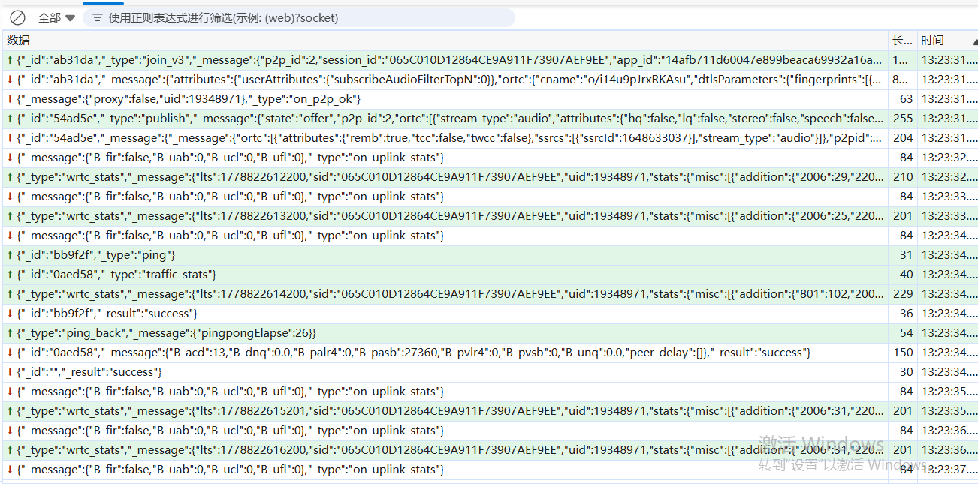
{_id: "ab31da", _type: "join_v3",…}
  - _id: "ab31da"
  - _message: {p2p_id: 2, session_id: "065C010D12864CE9A911F73907AEF9EE", app_id: "14afb711d60047e899beaca69932a16a",…}
    - ap_response: {code: 0, server_ts: 1778822611000, uid: 19348971, cid: 2282400059, cname: "3089",…}
    - app_id: "14afb711d60047e899beaca69932a16a"
    - attributes: {,…}
    - browser: "Mozilla/5.0 (Windows NT 10.0; Win64; x64) AppleWebKit/537.36 (KHTML, like Gecko) Chrome/147.0.0.0 Safari/537.36 Edg/147.0.0.0"
    - channel_key: "005AQAoADAzMEQzMjM2QkU3NTdBRkY2MDk4OUYzMzhCQTU4RDY4NjI1ODMxMEEQABSvtxHWAEfomb6s\r\nppkyoWrSrQZqd4/WYQAAAAAAAA==\r\n"
    - channel_name: "3089"
    - codec: "vp8"
    - details: {}
    - extend: ""
    - features: {rejoin: true}
    - has_changed_gateway: true
    - join_ts: 1778822611020
    - mode: "rtc"
    - ortc: {iceParameters: {iceUfrag: "c35y", icePwd: "4XycMCC+BmavUX+tC+I5AFgF"},…}
    - p2p_id: 2
    - process_id: "process-1a2c469c-0793-afca-45a2-995839fefd46"
    - role: "host"
    - sdk_version: "4.24.2"
    - session_id: "065C010D12864CE9A911F73907AEF9EE"
  - _type: "join_v3"
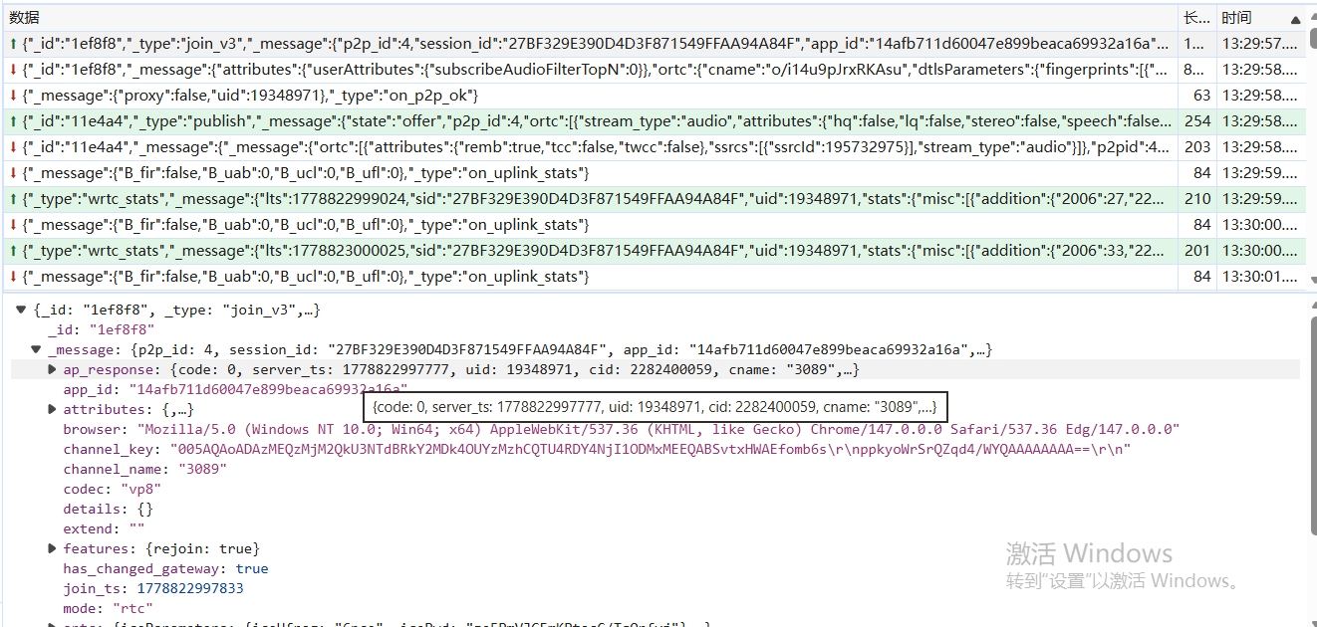
- {_id: "1ef8f8", _type: "join_v3",…}
  - _id: "1ef8f8"
  - _message: {p2p_id: 4, session_id: "27BF329E390D4D3F871549FFAA94A84F", app_id: "14afb711d60047e899beaca69932a16a",…}
    - ap_response: {code: 0, server_ts: 1778822997777, uid: 19348971, cid: 2282400059, cname: "3089",…}
      - cert: "S0FBQUFBVUFxWFFDQU9zOUp3RURBRENpelVqV2U4OUlHSmpPU0ZXdkJtb0FBQUFBQkFBek1EZzVGQUNiNkJGMzVmQ0kxanVsS083TUZoLzcxVVJhd3c9PQ=="
      - cid: 2282400059
      - cname: "3089"
      - code: 0
      - detail: {1: "202.104.160.172", 2: "CTEL", 3: "CN",…}
        - 1: "202.104.160.172"
        - 2: "CTEL"
        - 3: "CN"
        - 4: "IdggR0LLrdD82ibw8JZX0/laLXnzWoN4Y03WPY4FQcCfpC3TUfdZdtbebQeIWQbUU4He6vnsuhqTk+b/Yu9TSg=="
        - 5: "multi-ip"
        - 8: "160937"
        - 9: ""
        - 10: "005AQAoADAzMEQzMjM2QkU3NTdBRkY2MDk4OUYzMzhCQTU4RDY4NjI1ODMxMEEQABSvtxHWAEfomb6s\r\nppkyoWrSrQZqd4/WYQAAAAAAAA==\r\n"
        - 19: "07:BF:62:4E:CF:DC:E4:0D:32:64:4B:5F:52:3C:9C:66:7F:18:2C:FA:3B:42:2C:57:24:61:08:9B:0B:F2:7C:5B;13:0B:1F:67:0F:E9:5C:D6:B7:02:36:50:1A:E3:48:A1:A3:82:D9:76:42:FF:FE:0A:54:96:82:C4:AB:2C:0C:1E;BA:0E:B3:C4:F7:70:79:E2:4B:80:86:41:B7:5C:92:32:87:98:EB:A3:87:2E:BB:14:E7:87:8B:17:2A:4A:5D:A9;"
        - 23: ""
        - 502: "106.75.133.43"
      - flag: 4096
      - opid: 721279210575
      - server_ts: 1778822997777
      - ticket: "S0FBQUFBVUFxWFFDQU9zOUp3RURBRENpelVqV2U4OUlHSmpPU0ZXdkJtb0FBQUFBQkFBek1EZzVGQUNiNkJGMzVmQ0kxanVsS083TUZoLzcxVVJhd3c9PQ=="
      - uid: 19348971
    - app_id: "14afb711d60047e899beaca69932a16a"
    - attributes: {,…}
      - userAttributes: {enableAudioMetadata: false, enableAudioPts: false, enableNetworkQualityProbe: false,…}
        - enableAudioMetadata: false
        - enableAudioPts: false
        - enableAutCC: true
        - enableAutFeedback: true
        - enableDataStream2: false
        - enableDualStreamFlag: false
        - enableInstantVideo: false
        - enableLossbasedBwe: true
        - enableNetworkQualityProbe: false
        - enablePreallocPC: false
        - enablePubRTX: true
        - enablePubTWCC: false
        - enablePublishedUserList: true
        - enableQualityFallback: false
        - enableRTX: true
        - enableSubRTX: true
        - enableSubTWCC: true
        - enableUserAutoRebalanceCheck: true
        - enableUserLicenseCheck: true
        - enableVosFallback: false
        - enableXR: true
        - maxSubscription: 50
    - browser: "Mozilla/5.0 (Windows NT 10.0; Win64; x64) AppleWebKit/537.36 (KHTML, like Gecko) Chrome/147.0.0.0 Safari/537.36 Edg/147.0.0.0"
    - channel_key: "005AQAoADAzMEQzMjM2QkU3NTdBRkY2MDk4OUYzMzhCQTU4RDY4NjI1ODMxMEEQABSvtxHWAEfomb6s\r\nppkyoWrSrQZqd4/WYQAAAAAAAA==\r\n"
    - channel_name: "3089"
    - codec: "vp8"
    - details: {}
    - extend: ""
    - features: {rejoin: true}
      - rejoin: true
    - has_changed_gateway: true
    - join_ts: 1778822997833
    - mode: "rtc"
    - ortc: {iceParameters: {iceUfrag: "6nce", icePwd: "ze5PmVJGFmKPtocC/TqQrfvj"},…}
      - dtlsParameters: {fingerprints: [{hashFunction: "sha-256",…}]}
        - fingerprints: [{hashFunction: "sha-256",…}]
      - iceParameters: {iceUfrag: "6nce", icePwd: "ze5PmVJGFmKPtocC/TqQrfvj"}
      - rtpCapabilities: {send: {audioCodecs: [], audioExtensions: [], videoCodecs: [], videoExtensions: []},…}
      - version: "2"
    - p2p_id: 4
    - process_id: "process-1a2c469c-0793-afca-45a2-995839fefd46"
    - role: "host"
    - sdk_version: "4.24.2"
    - session_id: "27BF329E390D4D3F871549FFAA94A84F"
  - _type: "join_v3"

