参考链接：[https://blog.csdn.net/Peng___Peng/article/details/51510668?ops_request_misc=%257B%2522request%255Fid%2522%253A%2522172239110816800184161981%2522%252C%2522scm%2522%253A%252220140713.130102334.pc%255Fall.%2522%257D&request_id=172239110816800184161981&biz_id=0&utm_medium=distribute.pc_search_result.none-task-blog-2~all~first_rank_ecpm_v1~hot_rank-2-51510668-null-null.142^v100^pc_search_result_base1&utm_term=%E4%B8%89%E7%BB%B4%E5%9D%90%E6%A0%87%E5%8F%98%E6%8D%A2&spm=1018.2226.3001.4187](https://blog.csdn.net/Peng___Peng/article/details/51510668?ops_request_misc=%257B%2522request%255Fid%2522%253A%2522172239110816800184161981%2522%252C%2522scm%2522%253A%252220140713.130102334.pc%255Fall.%2522%257D&request_id=172239110816800184161981&biz_id=0&utm_medium=distribute.pc_search_result.none-task-blog-2~all~first_rank_ecpm_v1~hot_rank-2-51510668-null-null.142%5ev100%5epc_search_result_base1&utm_term=%E4%B8%89%E7%BB%B4%E5%9D%90%E6%A0%87%E5%8F%98%E6%8D%A2&spm=1018.2226.3001.4187)

任何维的旋转可以表述为向量与合适尺寸的方阵的乘积，并且坐标系旋转可以等价为目标点绕坐标原点反方向旋转同样的角度。

同时，任何旋转应当可以分解为绕X，Y，Z轴旋转的部分

以向量OP绕Z轴旋转为例，相当于OP在XY平面的投影OM绕原点旋转，如图

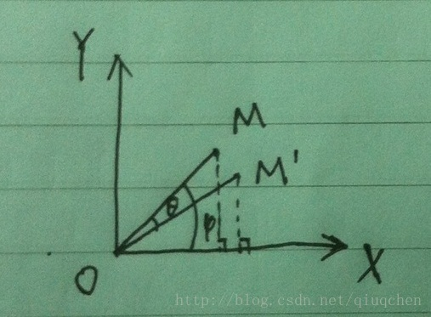

此时我们可以得到

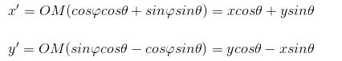

故旋转矩阵为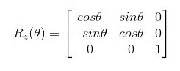

绕Y轴和Z轴旋转也同理，旋转矩阵如下

