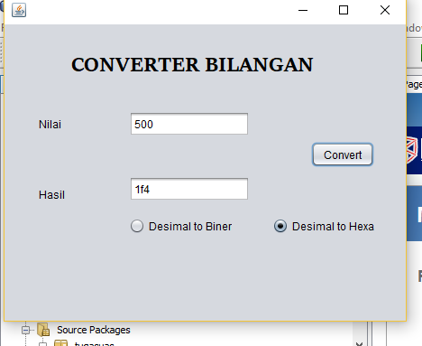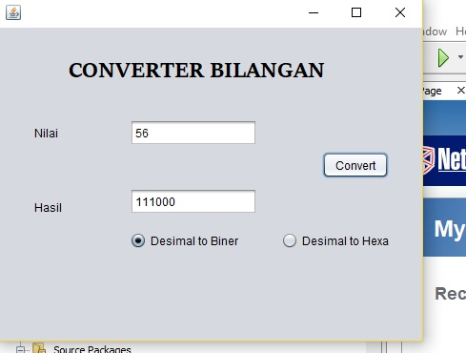

/*

* To change this license header, choose License Headers in Project Properties.

* To change this template file, choose Tools | Templates

* and open the template in the editor.

*/

package convertform;

import javax.swing.JOptionPane;

import rumus.Rumus;

/**

*

* @author User

*/

public class convertform extends javax.swing.JFrame {

Rumus convert;

/**

* Creates new form convertform

*/

public convertform() {

initComponents();

convert = new Rumus();

txthasil.setEditable(false);

}

/**

* This method is called from within the constructor to initialize the form.

* WARNING: Do NOT modify this code. The content of this method is always

* regenerated by the Form Editor.

*/

@SuppressWarnings("unchecked")

// <editor-fold defaultstate="collapsed" desc="Generated Code">

private void initComponents() {

buttonGroup1 = new javax.swing.ButtonGroup();

jLabel1 = new javax.swing.JLabel();

jLabel2 = new javax.swing.JLabel();

jLabel3 = new javax.swing.JLabel();

txtnilai = new javax.swing.JTextField();

txthasil = new javax.swing.JTextField();

btnbiner = new javax.swing.JRadioButton();

btnhexa = new javax.swing.JRadioButton();

jButton1 = new javax.swing.JButton();

setDefaultCloseOperation(javax.swing.WindowConstants.EXIT_ON_CLOSE);

setBackground(new java.awt.Color(153, 153, 255));

jLabel1.setFont(new java.awt.Font("Sitka Subheading", 1, 24)); // NOI18N

jLabel1.setText("CONVERTER BILANGAN");

jLabel2.setText("Nilai");

jLabel3.setText("Hasil");

txtnilai.addActionListener(new java.awt.event.ActionListener() {

public void actionPerformed(java.awt.event.ActionEvent evt) {

txtnilaiActionPerformed(evt);

}

});

buttonGroup1.add(btnbiner);

btnbiner.setText("Desimal to Biner");

btnbiner.addActionListener(new java.awt.event.ActionListener() {

public void actionPerformed(java.awt.event.ActionEvent evt) {

btnbinerActionPerformed(evt);

}

});

buttonGroup1.add(btnhexa);

btnhexa.setText("Desimal to Hexa");

btnhexa.addActionListener(new java.awt.event.ActionListener() {

public void actionPerformed(java.awt.event.ActionEvent evt) {

btnhexaActionPerformed(evt);

}

});

jButton1.setText("Convert");

jButton1.addActionListener(new java.awt.event.ActionListener() {

public void actionPerformed(java.awt.event.ActionEvent evt) {

jButton1ActionPerformed(evt);

}

});

javax.swing.GroupLayout layout = new javax.swing.GroupLayout(getContentPane());

getContentPane().setLayout(layout);

layout.setHorizontalGroup(

layout.createParallelGroup(javax.swing.GroupLayout.Alignment.LEADING)

.addGroup(javax.swing.GroupLayout.Alignment.TRAILING, layout.createSequentialGroup()

.addGroup(layout.createParallelGroup(javax.swing.GroupLayout.Alignment.TRAILING)

.addGroup(layout.createSequentialGroup()

.addGap(38, 38, 38)

.addGroup(layout.createParallelGroup(javax.swing.GroupLayout.Alignment.LEADING)

.addGroup(layout.createSequentialGroup()

.addGap(36, 36, 36)

.addGroup(layout.createParallelGroup(javax.swing.GroupLayout.Alignment.LEADING)

.addComponent(jLabel1)

.addGroup(layout.createSequentialGroup()

.addGap(0, 223, Short.MAX_VALUE)

.addComponent(btnhexa))))

.addGroup(layout.createSequentialGroup()

.addGroup(layout.createParallelGroup(javax.swing.GroupLayout.Alignment.LEADING)

.addComponent(jLabel2)

.addComponent(jLabel3))

.addGap(71, 71, 71)

.addGroup(layout.createParallelGroup(javax.swing.GroupLayout.Alignment.LEADING)

.addGroup(layout.createSequentialGroup()

.addComponent(btnbiner)

.addGap(0, 0, Short.MAX_VALUE))

.addGroup(layout.createSequentialGroup()

.addGroup(layout.createParallelGroup(javax.swing.GroupLayout.Alignment.LEADING, false)

.addComponent(txtnilai)

.addComponent(txthasil, javax.swing.GroupLayout.DEFAULT_SIZE, 134, Short.MAX_VALUE))

.addPreferredGap(javax.swing.LayoutStyle.ComponentPlacement.RELATED, 135, Short.MAX_VALUE))))))

.addGroup(layout.createSequentialGroup()

.addGap(0, 0, Short.MAX_VALUE)

.addComponent(jButton1)))

.addGap(35, 35, 35))

);

layout.setVerticalGroup(

layout.createParallelGroup(javax.swing.GroupLayout.Alignment.LEADING)

.addGroup(layout.createSequentialGroup()

.addGap(30, 30, 30)

.addComponent(jLabel1)

.addGap(35, 35, 35)

.addGroup(layout.createParallelGroup(javax.swing.GroupLayout.Alignment.BASELINE)

.addComponent(jLabel2)

.addComponent(txtnilai, javax.swing.GroupLayout.PREFERRED_SIZE, javax.swing.GroupLayout.DEFAULT_SIZE, javax.swing.GroupLayout.PREFERRED_SIZE))

.addPreferredGap(javax.swing.LayoutStyle.ComponentPlacement.RELATED)

.addComponent(jButton1)

.addGap(10, 10, 10)

.addGroup(layout.createParallelGroup(javax.swing.GroupLayout.Alignment.TRAILING)

.addComponent(jLabel3)

.addComponent(txthasil, javax.swing.GroupLayout.PREFERRED_SIZE, javax.swing.GroupLayout.DEFAULT_SIZE, javax.swing.GroupLayout.PREFERRED_SIZE))

.addGap(18, 18, 18)

.addGroup(layout.createParallelGroup(javax.swing.GroupLayout.Alignment.BASELINE)

.addComponent(btnbiner)

.addComponent(btnhexa))

.addContainerGap(96, Short.MAX_VALUE))

);

pack();

}// </editor-fold>

private void btnbinerActionPerformed(java.awt.event.ActionEvent evt) {

// TODO add your handling code here:

}

private void jButton1ActionPerformed(java.awt.event.ActionEvent evt) {

// TODO add your handling code here:

Convertbilangan();

}

private void txtnilaiActionPerformed(java.awt.event.ActionEvent evt) {

// TODO add your handling code here:

}

private void btnhexaActionPerformed(java.awt.event.ActionEvent evt) {

// TODO add your handling code here:

}

/**

* @param args the command line arguments

*/

public static void main(String args[]) {

/* Set the Nimbus look and feel */

//<editor-fold defaultstate="collapsed" desc=" Look and feel setting code (optional) ">

/* If Nimbus (introduced in Java SE 6) is not available, stay with the default look and feel.

* For details see http://download.oracle.com/javase/tutorial/uiswing/lookandfeel/plaf.html

*/

try {

for (javax.swing.UIManager.LookAndFeelInfo info : javax.swing.UIManager.getInstalledLookAndFeels()) {

if ("Nimbus".equals(info.getName())) {

javax.swing.UIManager.setLookAndFeel(info.getClassName());

break;

}

}

} catch (ClassNotFoundException ex) {

java.util.logging.Logger.getLogger(convertform.class.getName()).log(java.util.logging.Level.SEVERE, null, ex);

} catch (InstantiationException ex) {

java.util.logging.Logger.getLogger(convertform.class.getName()).log(java.util.logging.Level.SEVERE, null, ex);

} catch (IllegalAccessException ex) {

java.util.logging.Logger.getLogger(convertform.class.getName()).log(java.util.logging.Level.SEVERE, null, ex);

} catch (javax.swing.UnsupportedLookAndFeelException ex) {

java.util.logging.Logger.getLogger(convertform.class.getName()).log(java.util.logging.Level.SEVERE, null, ex);

}

//</editor-fold>

/* Create and display the form */

java.awt.EventQueue.invokeLater(new Runnable() {

public void run() {

new convertform().setVisible(true);

}

});

}

// Variables declaration - do not modify

private javax.swing.JRadioButton btnbiner;

private javax.swing.JRadioButton btnhexa;

private javax.swing.ButtonGroup buttonGroup1;

private javax.swing.JButton jButton1;

private javax.swing.JLabel jLabel1;

private javax.swing.JLabel jLabel2;

private javax.swing.JLabel jLabel3;

private javax.swing.JTextField txthasil;

private javax.swing.JTextField txtnilai;

// End of variables declaration

private void Convertbilangan(){

String n1;

String x = txtnilai.getText();

n1 = txtnilai.getText();

//String Hasil;

if (btnbiner.isSelected()){

int hasil = 0;

if (x !=null && x.trim().isEmpty()){

JOptionPane.showMessageDialog(null, "Masukan Angka");

} else {

//int hasil=0;

int des= Integer.parseInt(n1);

hasil = convert.Rumus(des);

txthasil.setEditable(false);

txthasil.setText(String.valueOf(hasil));

}

} else if (btnhexa.isSelected()){

String hasil =null;

if (x !=null && x.trim().isEmpty()){

JOptionPane.showMessageDialog(null, "Masukan Angka");

}else{

hasil = convert.Rumus(n1);

txthasil.setEditable(false);

txthasil.setText(String.valueOf(hasil));

}

}

}

}