ESales Portal Development Cookbook

Shan Gopalakrishnan
Jun Yang
Emad Benjamin

1 Overview 4
2 Architecture 5
3 Development Environment 6
3.1 Developing on Command Line 6
3.2 Developing with Eclipse 7
3.3 Updating Framework Source from CVS 13
4 Tutorial 13
4.1 Building a Service 13
4.1.1 Creating a Service 13
4.1.2 Creating the Service Registry Entry 15
4.1.3 Deploying the Service 15
4.1.4 Using the Service 16
4.2 Building a Portlet 16
4.2.1 Creating the Portlet Registry File 16
4.2.2 Creating the JSP Template 17
4.2.3 Deploying the Portlet 17
4.2.4 Using the Portlet 17
5 Advanced Topics 17
5.1 Using SequentialServiceController 17
5.2 Caching Service Results 18
5.3 Customizing Portlets 18
5.3.1 Out-of-Box Portlet Preferences 18
5.3.2 Custom Portlet Preferences 19
5.4 Using HttpService 19
invokeDirect 19
How to Use the Cookies 20
5.5 Using Actions 20
5.5.1 Actions Explained 20
5.5.2 Using Actions to Process Form Submission from a Portlet 21
5.5.3 Using Actions to Implement Custom Portlet Customization 22
5.5.4 The Complete Flow 23
5.5.5 Files for Reference 24
5.6 Using Session Variables 25
5.7 Using the ROOT Servlet Context 25
6 FAQ 26
6.1.1 I have installed the MySQL JDBC driver. But when Tomcat is started, I see the error “com.mysql.jdbc.Driver is not recognized”. What’s wrong? 26
6.1.2 How do use logging in my code? 26
7 Appendix 26
7.1 Framework Coding Standard 26
7.1.1 Source File Revisioning 27
7.1.2 Class Revisioning 27
7.1.3 Naming of Data Members 27
7.1.4 Visibility of Data Members: protected vs. private 27
7.2 Patterns 27
7.2.1 Singleton 28
7.2.2 Factory 29
7.2.3 Configurable Class 29
7.2.4 Interface-Implementation-Factory 29
7.3 Advanced Caching 30
7.3.1 Example of a Cacheable Service 30
7.3.2 Configuring Your Service in JCSConfig.xml 31
7.3.3 Configure the CacheRegion in your Service Registry File 33
7.3.4 Configuring the JCS 33
7.3.5 Final CheckList before you Do Ant 33
7.3.6 Ready to Ant 34
7.3.7 Some commonly encountered problems 34
7.3.8 Do’s & Dont’s 34
7.4 Invoking a Service Programmatically 35

Overview
This document describes how to develop services and portlets in the new ESales Portal Framework.

Architecture
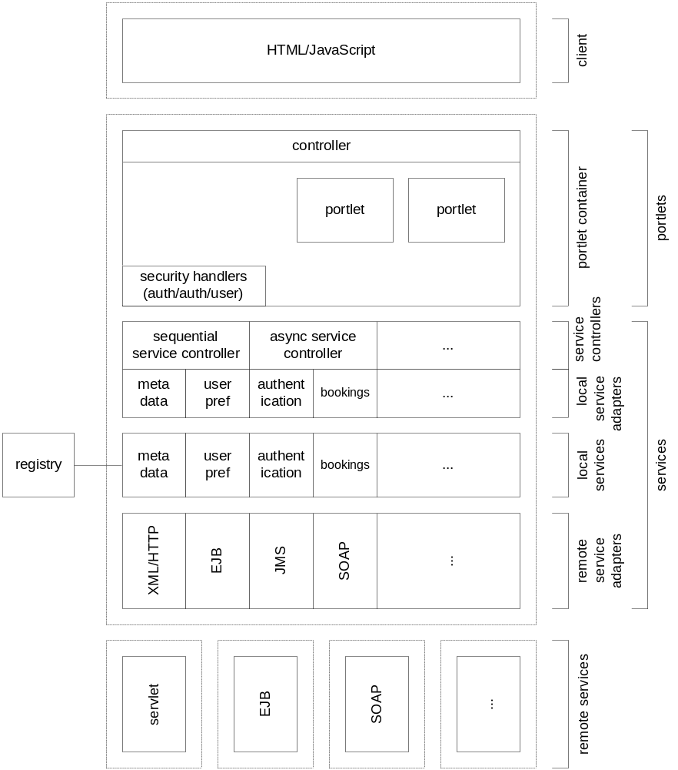
Figure: Portal Architecture
In essence the ESales Portal Framework is quite simple:
- Portlets run inside and are managed by a portlet container (Jetspeed today and JSR 168 compliant product tomorrow).
- Every portlet calls one and only one local service (although this service can call other local or remote services manually or automatically using SequencialServiceController). Results are rendered using a JSP template.
- Services are specified in a Service Registry and can be used outside the context of a portal.
Please refer to the document Design of ESales Portal Architecture for details.

Development Environment

Developing on Command Line
Here are the steps to set up the recommended development environment using JDK 1.4 on Windows.
- Add recognition of host junyang-redhat-3.
  - Add an entry to your machine's hosts file so that host junyang-redhat-3 is resolved to 171.71.97.174 (by adding a line "171.71.97.174 junyang-redhat-3" to file c:\winnt\system32\drivers\etc\hosts).
- Install Tomcat.
  - Unzip Tomcat into a directory of your choice. As of this writing the current release of Tomcat is 4.1.24. Any 4.1.x release should work.
- Install MySQL JDBC driver.
  - Download it here and extract mysql-connector-java-3.0.7-stable-bin.jar (or whatever version that is current) into your JRE's lib/ext (not lib) directory. Make sure this is the JRE in the JDK that Tomcat uses. We only tested with JDK 1.4.
Note: Make sure the jar file is directly under your JDK’s jre/lib/ext, not with the mysql directory.
- Build from source.
  - Check out the projects into your source directory.
Note: WinCVS checks out files and directories read-only by default. You want to change this before you check out so that files and directories are writable.
cvs co CEC/Applications/SalesIT/architecture/framework
cvs co infrastructure/framework/jetspeed
  - Search for “junyang” in the following configuration files under framework and update them to your own values:
./portal/cpp-1.0/build.properties
./common/src/com/cisco/salesit/framework/common/registry/RegistryPropertiesFactory.properties
  - CD into CEC/Applications/SalesIT/architecture/framework and do "ant clean", if this is NOT the first time you build, and then "ant".
- Mount webapp /esales
  - Create the configuration file for the esales context webapps/esales.xml to contain the following content:
<Context
path="/esales"
docBase="???"
debug="0"
reloadable="true"
crossContext="true"
/>
??? is the absolute path to CCP's webapps/ROOT directory, for example, d:/src2/CEC/Applications/SalesIT/architecture/framework/portal/cpp-1.0/ROOT.
- Make sure log directory exists
  - If you don’t have d:\logs already then create it. The log files framework.log, jetspeed.log and portlet-access.log will all appear there.
- Add yourself to list of valid users.
  - Modify jakarta-tomcat-4.1.24-LE-jdk14/conf/tomcat-users.xml to add yourself.
- Test.
  - Start up Tomcat by executing jakarta-tomcat-4.1.24-LE-jdk14\bin\startup.bat
  - Access http://localhost:8080 to see the home page of Tomcat to make sure Tomcat runs.
  - Access http://localhost:8080/esales to see the home page of Cisco Portal Pack. Use the user name and password you added at step 6 to login.
  - You can then add TimePortlet, DatePortlet and/or DateAndTimePortlet to this page if they are not there already.

Developing with Eclipse
Here are the steps to set up Eclipse to debug.
- Download Eclipse.
  - As of this writing, the production release is 2.1. Download it here.
- Install Eclipse.
  - Unzip Eclipse into the directory of your choice. Suppose that is d:\eclipse.
- Install Sysdeo plugin so that we start and stop Tomcat from within Eclipse easily.
  - Download the latest Sysdeo plugin from here.
  - Unzip into the Eclipse plugins directory, for example, d:\eclipse\plugins.
  - Start Eclipse.
  - Select menu item Windows/Customize Perspective. Open Other. Make sure Tomcat is checked.
  - Select menu item Windows/Preferences and set up set up Sysdeo like the 2 shots below.
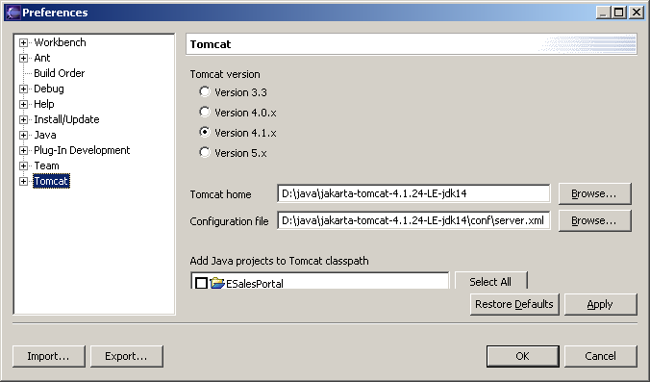
Use your own Tomcat installation directory. Make sure all projects under Add Java projects to Tomcat classpath are NOT checked.
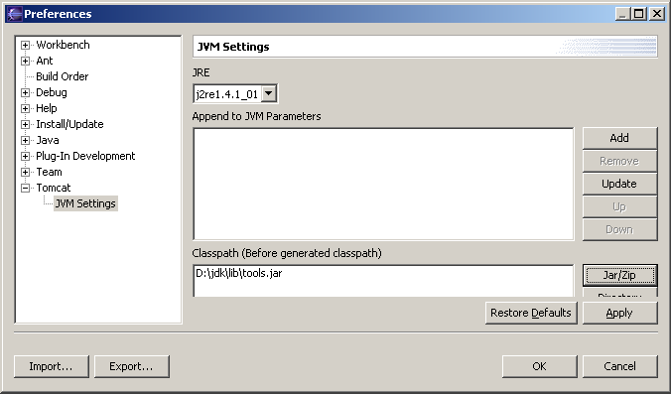
Use your own location of JDK. Leave Boot Classpath box empty.
- Create the ESalesPortal project in Eclipse.
  - Select from menu File/New/Project. Select Java Project. Press Next button. Enter ESalesPortal for Project name. Uncheck Use default. Press Browse button and select the cpp-1.0 directiory from your CVS source tree. Then the screen looks like this:
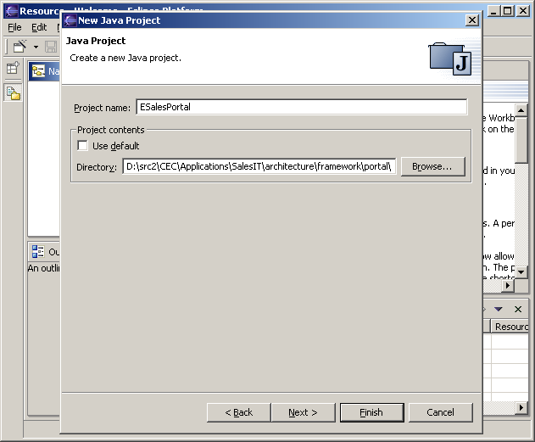
Press Next button. After some crunching, the screen looks like this:
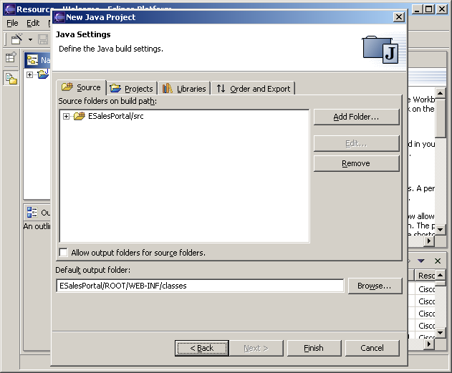
Make sure the Default output folder is the same as that in the screen shot. The press Finish button. Answer Yes if you get prompted with the question "This kind of project is associated with ...".
- Make sure the log files are pointing to the right place.
  - Modify cpp-1.0/ROOT/WEB-INF/conf/TurbineResource.properties so that the entries defined for jetspeed.log and portlet-access.log are like the following:
services.LoggingService.logforj.log4j.appender.logforj.file = d:/java/jakarta-tomcat-4.1.24-LE-jdk14/logs/jetspeed.log
services.LoggingService.access.log4j.appender.access.file = d:/java/jakarta-tomcat-4.1.24-LE-jdk14/logs/portlet-access.log
Use your own absolute path to Tomcat's logs directory.
- Test.
  - Press the Tomcat button to start Tomcat. Check Eclipse's Console window to make sure there are no critical error messages.
  - Access http://localhost:8080 and you should see the Tomcat home page.
  - Access http://localhost:8080/esales and you should see the Cisco Portal Pack home page. Use your own user name and password to login if you have created a new user in TOM_HOME/conf/tomcat-users.xml or use tomcat/tomcat otherwise.
- Hit a CPP break point.
  - In the ESalesPortal project, browse to src/com.cisco.it.psf.modules.actions.sessionvalidator and double-click on CiscoSessionValidator.java to open it.
  - Double-click on the left margin of the editor window on line "String myLoginName = " right below "doPerform(RunData ...)" to set a break point.
  - Reload CPP home page and you should hit the break point in Eclipse.
  - Press the resume button in the Debug window to resume execution.
- Hit an ESales break point.
  - In the project locate esales-services.jar.
  - Right click it and select Properties.
  - Select Java Source Attachment, press External Folder button and select CEC/Applications/SalesIt/architecture/framework/service/src from your CVS source tree.
  - Open esales-services.jar to com.cisco.salesit.framework.service.test and DateService.java.
  - Set a break point in method invoke().
  - Reload CPP home page and Eclipse should hit it.
Next we also set up Eclipse to compile.
- Add source for services framework.
  - Right click project ESalesPortal and select Properties.
  - Select Java Build Path and click on the Source tab.
  - Press Add Folder and then Create New Folder.
  - Enter esales-services-src to Folder name field.
  - Press Advanced button.
  - Check Link to folder in the file system.
  - Press Browse button and browse to CEC/Applications/SalesIT/architecture/framework/service/src.
  - Press OK and then OK.
- Add source for portlets framework.
  - Similar to above and use esales-portlets-src as the folder name and browse to CEC/Applications/SalesIT/architecture/framework/portal/cppext/src.
- Add source for your own code likewise.
Now if you set any break point in the source code added above, Eclipse should hit it.

When you modify any of the source code, Eclipse will build it automatically and the class file will be in CPP's ROOT/WEB-INF/classes directory, which is Eclipse's output directory. The jar file are not created and updated. But since Tomcat looks in that classses directory before the jars in the lib directory, everything is fine. You can build the jars outside of Eclipse using ant.

Updating Framework Source from CVS
When you update framework source code from CVS, follow these steps:
- Quit Eclipse.
- Update CEC/Applications/SalesIT/architecture/framework and do “ant clean” and then “ant” there.
- Start Eclipse, right click on project ESalesPortal and select Refresh.
Now your Eclipse environment should be in sync with the updated source code.

Tutorial
In this tutorial, we will build a DateService and a DatePortlet to call it.

Building a Service
We use an example DateService to illustrate how to build a service.

Creating a Service
package com.cisco.salesit.framework.service.test;  import java.util.*;  import java.text.*;  import org.apache.log4j.*;  import com.cisco.salesit.framework.service.core.*;  public class DateService extends BaseService  { | Subclass BaseService, if result of your service is never going to be cached. Or subclass CacheableService otherwise (caching can be turned on or off with easy configuration).
public static final String REVISION = "$Revision: 1.9 $";  public static final String TIME_ZONE = "timeZone";  public static final String DATE_STYLE = "dateStyle";  public static final String DATE = "date";  public static final String SHORT = “SHORT”;  /**  * Service metadata  */  public static final String INVOKE_DIRECT_INPUTS = TIME_ZONE + "," + DATE_STYLE;  public static final String INVOKE_DIRECT_OUTPUT = DATE; | Define service metadata in INVOKE_DIRECT_INPUTS (comma separated names of input parameters) and INVOKE_DIRECT_OUTPUT (name of output parameter), all of which are properties names of the context object. In this example, notice “timeZone” matches the first parameter to invokeDirect() and “dateStyle” second. At initialization time, the framework checks all services in the service registry and makes sure their metadata is specified.
/**  * Gets current date in time zone  * @param timeZone String E.g. "GMT-0800"  * @param date placeholder for output parameter name  * @return Current date in time zone.  */  public String invokeDirect(String timeZone, String dateStyle)  throws ServiceException  { | Define method invokeDirect() with the following general signature:  public <returnType> invokeDirect(<inputParameters>) throws ServiceException  Fill the parts between angle brackets according to your needs. Primitive types can also be used. Most likely the types will be just String because the parameters passed over from portlets are in the form of Strings.
int dateStyleInt = DateFormat.FULL;  If (SHORT.equals(dateStyle))  dateStyleInt = DateFormat.SHORT;  DateFormat df = DateFormat.getDateInstance(dateStyleInt);  df.setTimeZone(TimeZone.getTimeZone(timeZone));  Date date = new Date();  String dateString = df.format(date);  if (_Logger.isInfoEnabled())  {  _Logger.info(DATE + "('" + timeZone + "')=" + dateString);  }  return dateString;  } | Implement invokeDirect(). When invoke(IContext ctx) is called on your service instance, the framework will use reflection to call your invokeDirect() by passing the properties of ctx with names specified in INVOKE_DIRECT_INPUTS and will set the result on ctx using name specified by INVOKE_DIRECT_OUTPUT.
private static Logger _Logger = Logger.getLogger(DateService.class);  } | Optionally define a local logger. Log content will appear in framework.log under eclipse directory if you use Eclipse.

Creating the Service Registry Entry
// file name: DateService.reg.properties  _.factoryClassName=  com.cisco.salesit.framework.service.test.DateServiceFactory  myProperty1=value1  myProperty2=value2 | Create a service registry entry file <registryEntryName>.reg.properties and put in a line to specify how the service is created: _.{className,factoryClassName}=<className or factoryClassName>  If you use _.className, then the service is created by calling the default constructor of the specified class. If you use _.factoryClassName, then the service created by calling the factory class. You can have other custom properties that can be obtained from your service by calling String getConfigProperty(String propertyName).

Deploying the Service
We follow the steps below to deploy a new service:
- Build a jar file that contains the class files, e.g. mysvc.jar.
- Build a jar file that contains the configuration files, if any, e.g. mysvc-config.jar.
- Copy the jar files into CEC/Applications/SalesIT/architecture/framework/portal/cpp-1.0/ROOT/WEB-INF/lib.
- Copy the registry entry files into CEC/Applications/SalesIT/architecture/framework/portal/cpp-1.0/ROOT/WEB-INF/conf/registry/service.
Refer to CEC/Applications/SalesIT/architecture/framework/service/build.xml for an example of how to do this.

Using the Service
Just specify the name of the service in the registry entry of the portlet that uses it. See below for details.

Building a Portlet
There is no code to write to build a new portlet. You just need to create a Jetspeed portlet registry file and a JSP template file.

Creating the Portlet Registry File
DatePortlet.xreg:
<?xml version="1.0" encoding="UTF-8"?>  <registry> | You put in those highlighted items.
<portlet-entry name="DatePortlet" hidden="false" type="ref"  parent="GenericMVCPortlet" application="false">  <meta-info>  <title>Date Portlet</title>  <description>portlet shows current date</description>  </meta-info> | Portlet’s name, title and description.
<classname>com.cisco.salesit.framework.portal.portlets.BasePortlet</classname>  <parameter name="template" value="DatePortlet" hidden="true"  cachedOnName="true" cachedOnValue="true"/>  <parameter name="viewtype" value="JSP" hidden="true"  cachedOnName="true" cachedOnValue="true"/> | Specify the name of JSP template. In this example, DatePortlet.jsp will be used when this Portlet is rendered.
<parameter name="timeZone" value="GMT-0800" hidden="false" type="style"  cachedOnName="true" cachedOnValue="true"/>  <parameter name="timeZone.style" value="ListBox" hidden="true"/>  <parameter name="timeZone.style.items" value="GMT-0800,GMT,GMT+0800" hidden="true"/> | Portlet user preferences. These parameters will be populated into the context object passed to the service of this portlet..
<parameter name="service.name"  value="DateService"  hidden="true" cachedOnName="true" cachedOnValue="true"/>  <url cachedOnURL="true"/>  </portlet-entry>  </registry> | Name of service in the service registry for this portlet.

Creating the JSP Template
DatePortlet.jsp:
<%@ page language="java" session="false" %>  <%@ page import = "org.apache.velocity.context.Context" %>  <%@ page import = "com.cisco.salesit.framework.service.test.*" %>  <%  Context context = (Context) request.getAttribute("context");  Sting date = (String) context.get(DateService.DATE);  %>  Current date is <i><%= date %></i>. | Those in italic bold are different from template to template.

Deploying the Portlet
Follow these steps:
- Copy the xreg file into CEC/Applications/SalesIT/architecture/framework/portal/cpp-1.0/ROOT/WEB-INF/conf/, the standard location for all Jetspeed registry files.
- Copy the JSP template into CEC/Applications/SalesIT/architecture/framework/portal/cpp-1.0/ROOT/WEB-INF/templates/jsp/portlets/html, the standard location for all Jetspeed JSP templates.
Refer to CEC/Applications/SalesIT/architecture/framework/portal/cppext/build.xml for an example of how to do this.

Using the Portlet
Now you can use the Jetspeed customization page to add DatePortlet to your page.

Advanced Topics

Using SequentialServiceController
SequentialServiceController is a service that calls a sequence of other services. To use it, you just need create a service registry entry following this example in DateAndTimeService.reg.properties:
_.className=  com.cisco.salesit.framework.service.core.SequentialServiceController  sequence=dateService,timeService  sequence.dateService.name=DateService  sequence.timeService.name=TimeService | Those in italic bold are provided by you. The value of sequence is comma separated name so f services to call in sequence. You can specify the class name, factory class name or registry name (by using className, factoryClassName, or name, respective) of the services.
To call this sequence, you can do:
IService dateAndTime = ServiceManager.getSingleton().  createServiceByName(“DateAndTimeService”);  IContext ctx = new BaseContext();  ctx.setValue(..., ...);  ctx.setValue(..., ...);  Object result = dateAndTime.invoke(ctx);  Object date = ctx.getValue(DateService.INVOKE_DIRECT_OUTPUT);  Object time = ctx.getValue(TimeService.INVOKE_DIRECT_OUTPUT); | When dateAndTime’s invoke() is called, the same context object is passed to each service in sequence. The result of dateAndTime is the result of the last service.

Caching Service Results
It is very simple to make the result of a service cacheable. You only need to:
- Make the service class extend CacheableService.
- Make sure the parameters of invokeDirect() are serializable.
The rest is done by the framework. To optimize caching for your service, please refer to Appendix C for advanced cache configurations.

Customizing Portlets

Out-of-Box Portlet Preferences
User preferences are implemented as parameters to portlet instances in Jetspeed and stored in PSML files. All sample portlets DatePortlet , TimePortlet and and DateAndTimePortlet show how to use user preferences. Here is the example of DatePortlet.xreg.
<parameter name="timeZone" value="GMT-0800" hidden="false" type="style"  cachedOnName="true" cachedOnValue="true"/>  <parameter name="timeZone.style" value="ListBox" hidden="true"/>  <parameter name="timeZone.style.items" value="GMT-0800,GMT,GMT+0800" hidden="true"/> | For every user preference, we define a parameter tag. In this example, we define a parameter called timeZone that is not hidden (i.e. visible in customization page) and is customized using a list box of items GMT-0800, GMT and GMT+0800
For the complete documentation of all supported styles, please refer to Parameter Styles Demo in cpp-1.0/ROOT/WEB-INF/conf/demo-portlets.xreg.
When the service of this portlet is called, all the parameters are populated into the context object and passed to the service. In the above example, the context object will contain a property called timeZone with the current value set by the user.

Custom Portlet Preferences
See section 5.5

Using HttpService
com.cisco.salesit.framework.service.util.HttpService is used to make an HTTP call to a remote service (that is implemented as a servlet for example). Right now it handles text formats (plain text, HTML and XML) and serialized objects automatically. Handlers of new content types can be added easily.

invokeDirect
public java.lang.Object invokeDirect(boolean isMethodGet,
java.lang.String urlString,
INameValueList parameters,
INameValueList headers,
INameValueList cookies)
throws ServiceException
Calls remote URL.
Parameters:
isMethodGet - true if HTTP method to use is GET; otherwise POST will be used.
urlString - URL.
parameters - name value pairs used as HTTP parameters.
headers - name value pairs used as HTTP headers.
cookies - name value pairs used as HTTP cookies.
Returns: content of URL. If returned content type is text/plain, text/html or text/xml, the string of the text is returned. If the returned content type is application/octet-stream, it is assumed the content is an serialized object and the unserialized object is returned (in this case make sure the class for the object is available on the caller side).
Throws: ServiceException
Here is an example of how to call it directly:
public static final String QUOTE_URL = "http://wwwin-tools-dev.cisco.com/GSM/mygsm/RequestDispatcher";
public static final String HTTP_SERVICE_NAME = "HttpService";
public static final INameValueList EMPTY_NAME_VALUE_LIST = new PropertiesNameValueList();

public CscoStock getQuote() throws ServiceException
{
INameValueList parameters = new PropertiesNameValueList();
parameters.setValue("modulename", "mgsmCscoStub");
parameters.setValue("username", "smoura");

HttpService httpService = (HttpService) ServiceManager.getSingleton().
createServiceByName(HTTP_SERVICE_NAME);
// server returns a serialized instance of CscoStock

CscoStock stockQuote = (CscoStock) httpService.invokeDirect(
true, // use method GET
QUOTE_URL, // URL to call
parameters, // request parameters
EMPTY_NAME_VALUE_LIST, // request headers
EMPTY_NAME_VALUE_LIST // cookies
);

return stockQuote;
}

How to Use the Cookies
Suppose your service is:
public static final String INVOKE_DIRECT_INPUTS = "myParam";
public Object invokeDirect(String myParam) throws ServiceException
{
...
}
Change that to:
public static final String INVOKE_DIRECT_INPUTS = "myParam" + "," + BaseService.COOKIES;
public Object invokeDirect(String myParam, INameValueList cookies) throws ServiceException
{
...
}
Then you can pass cookies directly into HttpService.

Using Actions

Actions Explained
In Jetspeed, actions are used for 2 purposes:
- Process user actions on the user interface (e.g. respond to user pressing on an Refresh button).
- Build up data in context to populate into presentation templates (whether Velocity or JSP).
Usually the same class serves both purposes with different methods (e.g doRefresh(), doUpdate(), etc. for the first purpose and buildNormalContext() and buildMaximizedContext() for the second purpose).
A portlet can have zero or one action, which is specified in its xreg file. For example, WeatherPortlet.xreg:
<portlet-entry name="WeatherPortlet" hidden="false" type="ref" parent="GenericMVCPortlet" application="false">
<meta-info>
<title>Weather Portlet</title>
<description>portlet shows current weather</description>
</meta-info>
<classname>com.cisco.salesit.framework.portal.portlets.BasePortlet</classname>
<parameter name="template" value="WeatherPortlet" hidden="true"
cachedOnName="true" cachedOnValue="true"/>
<parameter name="viewtype" value="JSP" hidden="true"
cachedOnName="true" cachedOnValue="true"/>
<parameter name="_customizer" value="WeatherPortletCustomizer"
hidden="true" cachedOnName="true" cachedOnValue="true"/>
<parameter name="action" value="portlets.WeatherPortletAction"
hidden="true" cachedOnName="true" cachedOnValue="true"/>
<parameter name="service.name" value="weatherService"
hidden="true" cachedOnName="true" cachedOnValue="true"/>
<parameter name="rendering.delayed" value="true" hidden="false"
cachedOnName="true" cachedOnValue="true"/>
<url cachedOnURL="true"/>
<category group="Jetspeed">Portal Framework Sample</category>
</portlet-entry>
In the example above, WeatherPortlet’s action is class org.apache.jetspeed.modules.actions.portlets.WeatherPortletAction (org.apache.jetspeed.modules.actions. is always prepended to the value of action and thus actions have to have be in package org.apache.jetspeed.modules.actions.portlets). When a portlet is rendered, if it has an action, the action’s buildNormalContext() is called to prepare data in the context before template is called. When a portlet is rendered maximized, if it has an action, the action’s buildMaximizedContext() is called to prepare data in the context before template is called.

Using Actions to Process Form Submission from a Portlet
WeatherPortlet.jsp shows an example of how to render a form in a portlet:
<% String jspeid = (String) request.getAttribute("js_peid"); %>
<form action="<jetspeed:portletlink jspeid="<%= jspeid %>"/>" method="get">
City: <input type="text" size="12" name="city" value="San Jose, CA">
<input type="submit" name="eventSubmit_doRefresh" value="Refresh">
</form>
Just follow this example to build your own form. The bold part is the name of the action’s method that’s called when the form is submitted. So when this form is submitted, WeatherPortletAction.doRefresh() will be called where you can get all the parameters of the form.

Using Actions to Implement Custom Portlet Customization
The out-of-box customizer doesn’t satisfy our UI requirements for portlet customization (when you press the edit button). To use a custom customizer, look at the example of WeatherPortlet.xreg:
<portlet-entry name="WeatherPortlet" hidden="false" type="ref" parent="GenericMVCPortlet" application="false">
<meta-info>
<title>Weather Portlet</title>
<description>portlet shows current weather</description>
</meta-info>
<classname>com.cisco.salesit.framework.portal.portlets.BasePortlet</classname>
<parameter name="template" value="WeatherPortlet" hidden="true"
cachedOnName="true" cachedOnValue="true"/>
<parameter name="viewtype" value="JSP" hidden="true"
cachedOnName="true" cachedOnValue="true"/>
<parameter name="_customizer" value="WeatherPortletCustomizer"
hidden="true" cachedOnName="true" cachedOnValue="true"/>
<parameter name="action" value="portlets.WeatherPortletAction"
hidden="true" cachedOnName="true" cachedOnValue="true"/>
<parameter name="service.name" value="weatherService"
hidden="true" cachedOnName="true" cachedOnValue="true"/>
<parameter name="rendering.delayed" value="true" hidden="false"
cachedOnName="true" cachedOnValue="true"/>
<url cachedOnURL="true"/>
<category group="Jetspeed">Portal Framework Sample</category>
</portlet-entry>
We specify the customizer of WeatherPortlet to be another portlet called WeatherPortletCustomizer, which defined to be:
<portlet-entry name="WeatherPortletCustomizer" hidden="false"
type="ref" parent="GenericMVCPortlet" application="false">
<meta-info>
<title>Weather Portlet Customizer Portlet</title>
<description>portlet that customizes WeatherPortlet</description>
</meta-info>
<classname>com.cisco.salesit.framework.portal.portlets.BasePortlet</classname>
<parameter name="template" value="WeatherPortletCustomizer"
hidden="true" cachedOnName="true" cachedOnValue="true"/>
<parameter name="viewtype" value="JSP" hidden="true"
cachedOnName="true" cachedOnValue="true"/>
<parameter name="action" value="portlets.WeatherPortletCustomizerAction"
hidden="true" cachedOnName="true" cachedOnValue="true"/>
<url cachedOnURL="true"/>
<category group="Jetspeed">Portal Framework Sample</category>
</portlet-entry>
As you can see, WeatherPortletCustomizer is nothing more than a regular portlet with an action. When the customizer is rendered, WeatherPortletCustomizerAction.buildNormalContext() is called to build data in context for display in the customizer. Its template also has a form:
<%
Context context = (Context) request.getAttribute("context");
Properties customizableProperties = (Properties) context.get(WeatherPortletCustomizerAction.CUSTOMIZABLE_PROPERTIES);
Object jslink = context.get("jslink");
%>

<form action="<%= jslink %>" method="post">

<table border="0">
<%
for (Enumeration e = customizableProperties.propertyNames(); e.hasMoreElements();)
{
String name = (String) e.nextElement();
String value = customizableProperties.getProperty(name);
%>
<tr>
<td align="right"><%= name %>:</td>
<td><input type="text" size="10" name="<%= name %>" value="<%= value %>">
</tr>
<%
}
%>
</table>

<input type="submit" name="eventSubmit_doUpdate" value="Update">
</form>
When user presses on button Update, notice WeatherPortletAction (not WeatherPortletCustomizerAction)’s doUpdate() method will be called to process the form.

The Complete Flow
Here is the complete flow of user doing form submission and customization of WeatherPortlet:
User’s Action | Code Executed
User accesses a page that has a WeatherPortlet | - WeatherPortletAction.buildNormalContext() is called to prepare data for the normal view of WeatherPortlet.  - WeatherService.invokeDirect() is called to prepare data for the normal view of WeatherPortlet.  - WeatherPortlet is rendered by evaluating its template WeatherPortlet.jsp.
User presses the Refresh button in WeatherPortlet | - WeatherPortletAction.doRefresh() is called to process form submission.  - WeatherPortletAction.buildNormalContext() is called to prepare data for the normal view of WeatherPortlet.  - WeatherService.invokeDirect() is called to prepare data for the normal view of WeatherPortlet.  - WeatherPortlet is re-rendered by evaluating its template WeatherPortlet.jsp.
User presses the customize (edit) button in WeatherPortlet | - WeatherPortletCustomizerAction.buildNormalContext() is called to prepare data for the normal view of WeatherPortletCustomizer.  - WeatherPortletCustomizer is rendered by evaluating its template WeatherPortletCustomizer.jsp.
User presses the Update button in WeatherPortletCustomizer | - WeatherPortletAction.doUpdate() is called to process form submission.  - WeatherPortletAction.buildNormalContext() is called to prepare data for the normal view of WeatherPortlet.  - WeatherService.invokeDirect() is called to prepare data for the normal view of WeatherPortlet.  - WeatherPortlet is re-rendered by evaluating its template WeatherPortlet.jsp.
Although action and service are both optional for a portlet, they can exist at the same time for it. What does it mean when you have both an action and a service for a portlet? The difference between action and service is actions are used for presentation logic and service business logic. For a portlet, its action is called before its service. They both share the same context object.

Files for Reference
The complete list of files for reference:
CEC\Applications\SalesIT\Architecture\framework\portal\cppext\registry\WeatherPortlet.xreg
CEC\Applications\SalesIT\Architecture\framework\portal\cppext\registry\WeatherPortletCustomizer.xreg
CEC\Applications\SalesIT\Architecture\framework\portal\cppext\template\jsp\portlets\html\WeatherPortlet.jsp
CEC\Applications\SalesIT\Architecture\framework\portal\cppext\template\jsp\portlets\html\WeatherPortletCustomizer.jsp
CEC\Applications\SalesIT\Architecture\framework\portal\cppext\src\org\apache\jetspeed\modules\actions\portlets\WeatherPortletAction.java
CEC\Applications\SalesIT\Architecture\framework\portal\cppext\src\org\apache\jetspeed\modules\actions\portlets\WeatherPortletCustomizerAction.java

Using Session Variables
Sometimes you want to save some of the values in context to the session so that you can reuse them in another request (notice this is a little different than caching). The framework supports this. To use it, just defined a “sessionVariables” parameter in your portlet’s xreg file:
<portlet-entry name="WeatherPortletCustomizer" hidden="false"
type="ref" parent="GenericMVCPortlet" application="false">
<meta-info>
<title>Weather Portlet Customizer Portlet</title>
<description>portlet that customizes WeatherPortlet</description>
</meta-info>
<classname>com.cisco.salesit.framework.portal.portlets.BasePortlet</classname>
<parameter name="template" value="WeatherPortletCustomizer"
hidden="true" cachedOnName="true" cachedOnValue="true"/>
<parameter name="viewtype" value="JSP" hidden="true"
cachedOnName="true" cachedOnValue="true"/>
<parameter name="action" value="portlets.WeatherPortletCustomizerAction"
hidden="true" cachedOnName="true" cachedOnValue="true"/>
<parameter name="sessionVariables" value="a,b,c"
hidden="true" cachedOnName="true" cachedOnValue="true"/>
<url cachedOnURL="true"/>
<category group="Jetspeed">Portal Framework Sample</category>
</portlet-entry>
Then before your service is called, the context will already have a, b and c populated from session. After your service is called, a, b and c will be copied back into the session.

Using the ROOT Servlet Context
We have been using /esales context for the ESales portal for a while. For the production environment, we will move to the ROOT context. Also only when we move to the ROOT context will the images start to appear correctly. To do so, modify your definition for context esales in TOMCAT/conf/server.xml to (i.e. change “esales” to “”):
<Context
path=""
docBase="d:/eclipse/workspace/ESalesPortalFramework/portal/cpp-1.0/ROOT"
debug="0"
reloadable="true"
crossContext="true"
/>
Make sure you comment out the existing context definition for path “” if you already have one in your server.xml. Make sure the bold italic portion points to your own path to cpp-1.0/ROOT directory.

FAQ

I have installed the MySQL JDBC driver. But when Tomcat is started, I see the error “com.mysql.jdbc.Driver is not recognized”. What’s wrong?
First make sure file mysql-connector-java-<version>-stable-bin.jar itself, not any directory that contains it, is in your JRE’s lib\ext directory.
Second, if you have multiple JREs on your machine, you may have copied that jar file into the JRE other than the one Eclipse uses to start Tomcat. Copy the jar file into the lib\ext directory of the JRE Eclipse uses. If you are not sure which JRE it is, just copy the jar file to the lib\ext directory of all of them. The most likely JRE is under c:\Program Files\Java\j2re<version>.

How do use logging in my code?
The best practice of Log4J logging is for each class to have its own logger. This way we can easily tell which class the log message is coming from. To use logging, add the following to your class:
import org.apache.log4j.*;
public class MyClass
{
...
private static Logger _Logger = Logger.getLogger(MyClass.class);
...
}
Then you can use:
if (_Logger.isDebugEnabled())
{
_Logger.debug(“...”);
}

Appendix

Framework Coding Standard
To maintain a consistent style in the framework source code, here is the proposed coding standard.

Source File Revisioning
At the begining of every source file, we include the following CVS keywords:
/*
$Log: $
*/
which will cause revision history to be included in the source file. By referring to the top of the file, you can also easily tell which revision it is.

Class Revisioning
To assist run-time debugging, each class is also revisioned in the following way:
public class MyObject
{
public static final String REVISION = "$Revision: $";
...
}
which will cause the revision number to appear as MyObject.REVISION for every class.

Naming of Data Members
All data members (except constants) start with an underscore. First letter of non-static data members is lower case. First letter of static data members is uppercase. Constants are all uppercase without a leading underscore. For example:
public class MyObject
{
public static final String REVISION = "$Revision: 1.1 $";
private static Logger _Logger = Logger.getLogger(MyObject.class);
protected Map _dataMap = new HashMap();
...
}

Visibility of Data Members: protected vs. private
Most of the time, a non-public data member or method should be declared protected as opposed to private to allow subclasses an opportunity to overwrite, which is the cornerstone of OOP. Unless you are really sure it's private to the class, for example, a per class logger, you should use protected.

Patterns
The Services Framework uses some basic patterns, Singleton, Factory and Configurable Class.

Singleton
Suppose class SomeFactory has only a singleton instance. To get the singleton, do SomeFactory.getSingleton() and you will get an instance of SomeFactory.

To implement SomeFactory, do the following:
- Provide a private static data member to save the singleton instance:
private static SomeFactory _Singleton = ...;
and provide an accessor method for it:
public static SomeFactory getSingleton()
{
return _Singleton;
}
- Initialize it to an instance of your class:
private static SomeFactory _Singleton = new SomeFactory();
This way the constructor is called only once to create the singleton at class load time.
- In your protected constructor, register the singleton with SingletonManager:
protected SomeFactory()
{
SingletonManager.addSingleton(this);
}
Note: The above method is NOT necessary if your class (SomeFactory) extends Singleton.
SingletonManager helps with locating a singleton given its class:
public class SingletonManager
{
public static Object getSingleton(String className);
public static void addSingleton(Object singleton);
}

Factory
All factories implement interface IFactory, which has a method public Object createInstance(). To create a factory class, do the following:
- Extend BaseFactory, which implements IFactory and provides a protected constructor that registers this instance with SingletonManager because all factories and singletons.
- Complete the singleton pattern by doing step 1 and 2 in the singleton pattern.
- Complete the factory pattern by implementing your own createInstance() method.

Configurable Class
The intent is for any class, say MyObject, to be configurable through MyObject.properties. MyObject can use getConfigProperty(configPropertyName) to get the value of any configuration property. There are 2 ways to achieve this:
- If you can subclass BaseObject, do so. Then you will get the implementation of getConfigProperty() methods automatically. There are several signatures. If you have "a=x" in MyObject.properties, use getConfigProperty("a") to get it. If you have "a.b=y", use getConfigProperty("a", "b"). So on and so forth up to four segments in the key.
- If you cannot subclass BaseObject, use Properties Util.loadClassConfig(Class) to load the properties file. Util is in package com.cisco.salesit.framework.common.util.

Interface-Implementation-Factory
Always use interfaces. Prefix interface name with 'I'. The base implementation of an interface should be prefixed Base and don't use Abstract for that purpose because not all base implementations are abstract. (Almost) always use a factory class for creating instances rather than using a class' constructor. So for a class Car, here is the typical set:
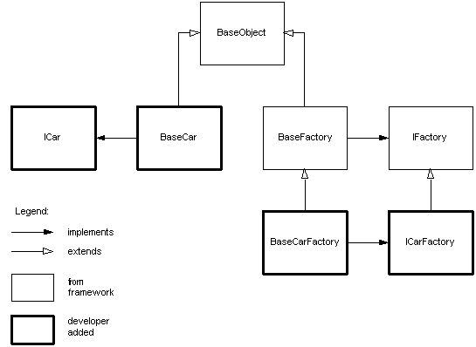

Advanced Caching

Example of a Cacheable Service
Here is an example called ExampleCacheableService:
package com.cisco.salesit.framework.service.test;

import java.util.*;

import org.apache.log4j.*;
import com.cisco.salesit.framework.service.cache.*;
import com.cisco.salesit.framework.service.core.ServiceException;

public class ExampleCacheableService extends CacheableService {

public static final String REVISION = "$Revision: 1.10 $";

private static Logger _Logger = Logger.getLogger(ExampleCacheableService.class);

/**
* Service metadata
*/
public static final String INVOKE_DIRECT_INPUTS = "newsProvider";
public static final String INVOKE_DIRECT_OUTPUT = "news";

public Object invokeDirect(String newsProvider) throws ServiceException
{
// handle default
if (newsProvider == null) newsProvider = "ABC News";

// handle error condition
if (newsProvider.equalsIgnoreCase("CNN"))
{
String errorMessage = this.getClass().getName() +
": invalid news provider '" + newsProvider + "'";
throw new ServiceException(errorMessage);
}

// proceed to normal processing
Calendar calendarNow = Calendar.getInstance();
int month = calendarNow.get(Calendar.MONTH) + 1;
int date = calendarNow.get(Calendar.DATE);
return "news provided by [" + newsProvider + "] on " + month + "/" + date;
}
}

Configuring Your Service in JCSConfig.xml
In this step you must specify a Cache Object Region (e.g. NewsRegion1* block) block. For example, for News related objects you may have all very long living cache objects in a region that has long timing cache parameters, or you may have a second region for very short lived cached object. There is no limit on the number of Cache Object Regions you can configure; this is really up to the tuning of your application capacity.
For the above example we use the NewsRegions1*, this means our cache objects will get the following cache parameters.
The JCSConfig.xml file is located in /CEC/Applications/SalesIT/architecture/framework/service/src.

<cache-object>
<pattern>NewsRegion1*</pattern>
<element-attributes>
<idle-time>-1</idle-time>
<is-distribute>false</is-distribute>
<is-eternal>false</is-eternal>
<is-lateral>false</is-lateral>
<is-remote>false</is-remote>
<is-spool>false</is-spool>
<max-life-seconds>180</max-life-seconds>
<event-handler-class>
<name>com.cisco.salesit.framework.service.cache.DefaultCacheEventHandler</name>
</event-handler-class>
</element-attributes>
</cache-object>

<cache-object>
<pattern>NewsRegion2*</pattern>
<element-attributes>
<idle-time>-1</idle-time>
<is-distribute>false</is-distribute>
<is-eternal>false</is-eternal>
<is-lateral>false</is-lateral>
<is-remote>false</is-remote>
<is-spool>false</is-spool>
<max-life-seconds>3180</max-life-seconds>
<event-handler-class>
<name>com.cisco.salesit.framework.service.cache.DefaultCacheEventHandler</name>
</event-handler-class>
</element-attributes>
</cache-object>

<cache-object>
<pattern>DefaultCacheRegion*</pattern>
<element-attributes>
<idle-time>-1</idle-time>
<is-distribute>false</is-distribute>
<is-eternal>false</is-eternal>
<is-lateral>false</is-lateral>
<is-remote>false</is-remote>
<is-spool>false</is-spool>
<max-life-seconds>180</max-life-seconds>
<event-handler-class>
<name>com.cisco.salesit.framework.service.cache.DefaultCacheEventHandler</name>
</event-handler-class>
</element-attributes>
</cache-object>

Configure the CacheRegion in your Service Registry File
In your service/registry/ExampleCacheableService.reg.properties, configure the following:

_.factoryClassName=com.Cisco.salesit.framework.service.test.ExampleCacheableServiceFactory
cache.region=NewsRegion1

Note:
  - The first entry is the factory class name, and the second entry specified which cach object region this service’s objects will be cached in.
  - If you don’t have a Factory built for your service, then you can simply put the classname. For example, _.className=com.Cisco.salesit.framework.test.ExampleCacheableService
cache.region=NewsRegion1

Configuring the JCS
This step is optional – also a very delicate one.
WARNING: When you perform this configuration in your own local environment it will only affect the cache in your jvm. Therefore the cache.ccf can be updated by you but shouldn’t be checked into the team wide cvs tree.
The Deployment Manager of the application is responsible to manage one copy of this in the integrated application environment, since this tunes the one and only Cache System for the entire application.
In your services source directory, ie /CEC/Applications/SalesIT/architecture/framework/service/src, you will find the cache.ccf file. This is the JCS cache configuration file.

ONLY in your own environment you can set your desired value of the following:

jcs.region.ApplicationRegion.cacheattributes.MaxObjects=25
jcs.region.ApplicationRegion.cacheattributes.MaxMemoryIdleTimeSeconds=3600
jcs.region.ApplicationRegion.cacheattributes.ShrinkerIntervalSeconds=300
jcs.region.ApplicationRegion.elementattributes.MaxLifeSeconds=86400
jcs.region.ApplicationRegion.elementattributes.IdleTime=1800

NOTE:
Should you determine that your process has need for above parameters to be increased in the System Wide Copy of the cache.ccf, then you must obtain approval from the rest of the team, or teams dependent on this caching system.

Final CheckList before you Do Ant
- You must have configured a CacheObject Region in your JCSConfig.xml
- You must have had ExampleCacheableService extend from the CacheableService
- Implement your invokeDirect method and make sure all elements beinf passed intot he methods are Serializable
- You must have created an ExampleCacheableServiceFactory (optional but good practice)
- You must have specified your Cache Region in your Service Registry file

Ready to Ant
If you have followed all of the above steps then you are ready to CD into the
/CEC/Applications/SalesIT/architecture/framework/service directory and perform Ant, this well compile everything and then deploy it.

Now you can polucg this cacheable service into your Portlet, if you don’t have a portlet build, please refer to the Cookbook section on building a Portlet.

Some commonly encountered problems

Potentially a jar is missing
Make sure all of the jars below are in the WEB-IN/lib directory
- DataCaching-1.0.jar.
- Java Caching Service (JCS) v 1.0-dev
- Jakarta Regexp v 1.2
- Log4J v 1.1.3
- Jakarta Commons Lang v 1.0.1
- Jakarta Commons Logging v 1.0.1

Cache.ccf and JCSConfig.xml missing from classpath
The file JCSConfig.xml and cache.ccf must exist on your class path. Essentially as long as these files are at /CEC/Applications/SalesIT/architecture/framework/service/src, the when you do Ant, they will get deployed to your classpath, and you don’t have to do anything.

Two regions Conflicting names or similar Names
Make sure when you configure a Cache Object Region in the JCSConfig.xml file you don’t conflict with another name, always add your business unit name as a prefix, like for Bookings, use BookingsRegion1*, BookingsRegion2*, etc. and similarly for News, newsRegion1*, etc.

Do’s & Dont’s
- DO NOT use the value “true” for any of the following attributes: is-distribute, is-lateral, is-spool, is-remote.
DO use only the value “false” for the above-mentioned attributes.
- DO NOT configure any Auxilliary Caches in cache.ccf.
- DO place configuration files on the classpath.
- DO always provide cache.ccf. Refrain from configuring this unless you have absolutely a need for doing so. Proper team lead approval required here.
- Only one instance of a cache event handler is instantiated per cache object pattern. DO follow thread safe coding practices in implementing the event handler.
- DO be aware of the type of objects to be cached and take into consideration object size while setting administrative options. This can be tricky especially if one caches objects such as Vectors and ArrayLists, which can be of varying sizes.
- Make Sure your object being passed into invokeDirect are Serilaizable
- Generally one cache region (ApplicationRegion) should be sufficient for caching needs of an application. DO modify the ApplicationRegion properties in cache.ccf AS NEEDED by your application.

Invoking a Service Programmatically
In addition to letting the framework invoke your service in a portlet automatically, you can also invoke a service programmatically. A service can be obtained by:
IService service = ServiceManager.getSingleton().createServiceByName(“DateService”);
and called by:
// [1] calling “indirectly”
IContext ctx = new BaseContext();
ctx.setValue(DateService.TIME_ZONE, “GMT-0800”);
ctx.setValue(DateService.DATE_STYLE, new Integer(DateFormat.SHORT));
String date = service.invoke(ctx);
String date2 = ctx.getValue(DateService.DATE); // same as date
String date3 = ctx.getValue(DateService.INVOKE_DIRECT_OUTPUT); // same as date
or by:
// [2] calling “directly”
String date = service.invokeDirect(“GMT-0800”, DateFormat.SHORT);
Notice when calling directly, you can use the primitive types declared in invokeDirect(). When calling indirectly, you need to convert the primitive types to their corresponding object wrapper types (e.g. Integer for int) because property values of context can only be objects.

