FLUTTER: 17th Feb ‘21

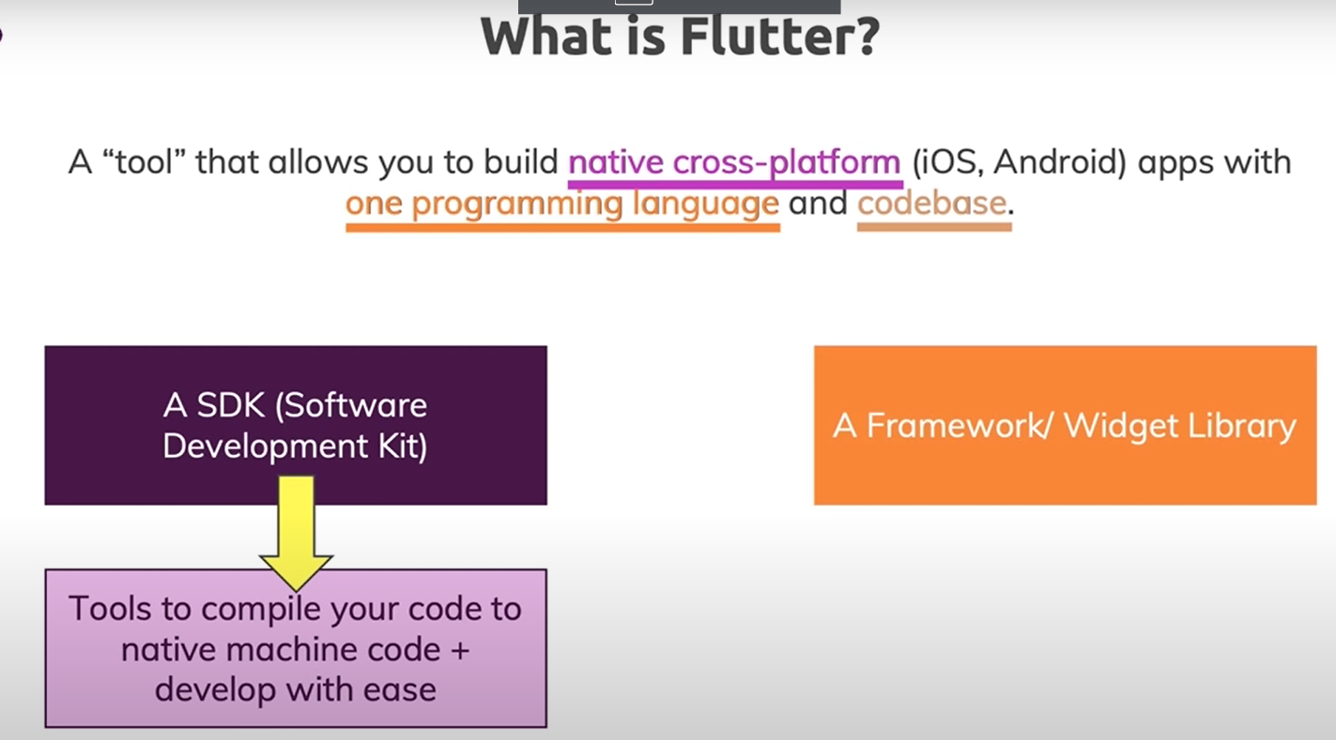

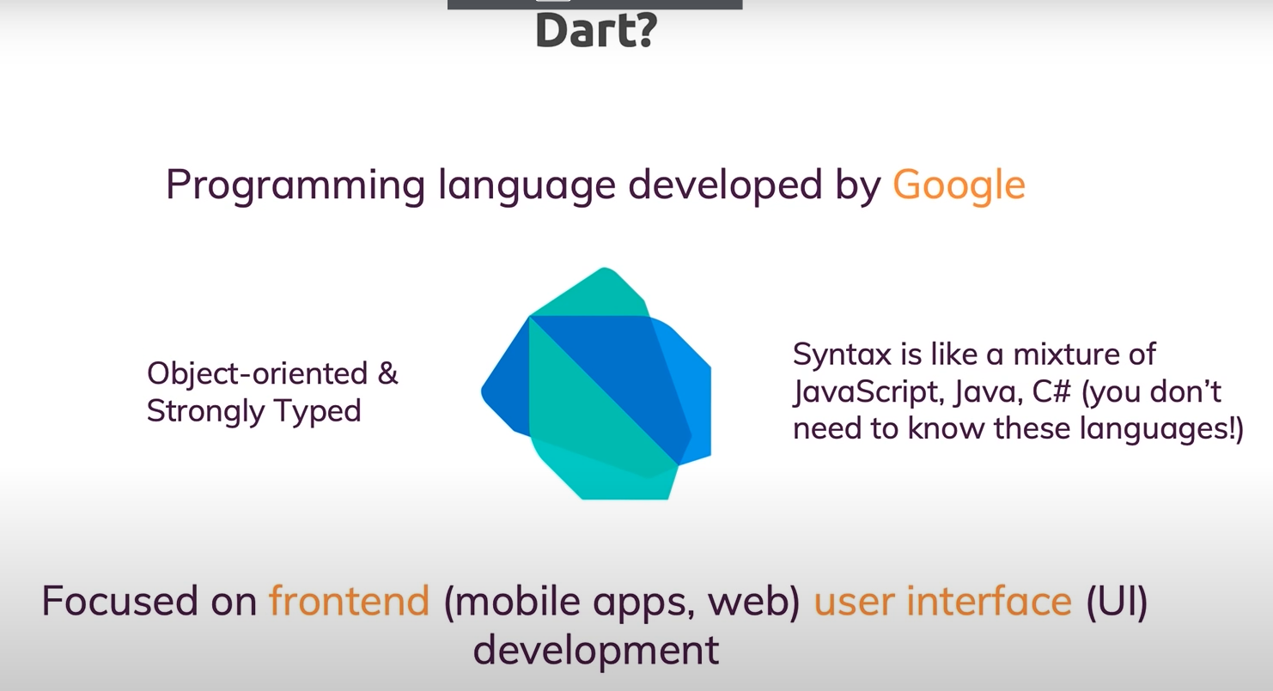

Android studio – code editor for flutter

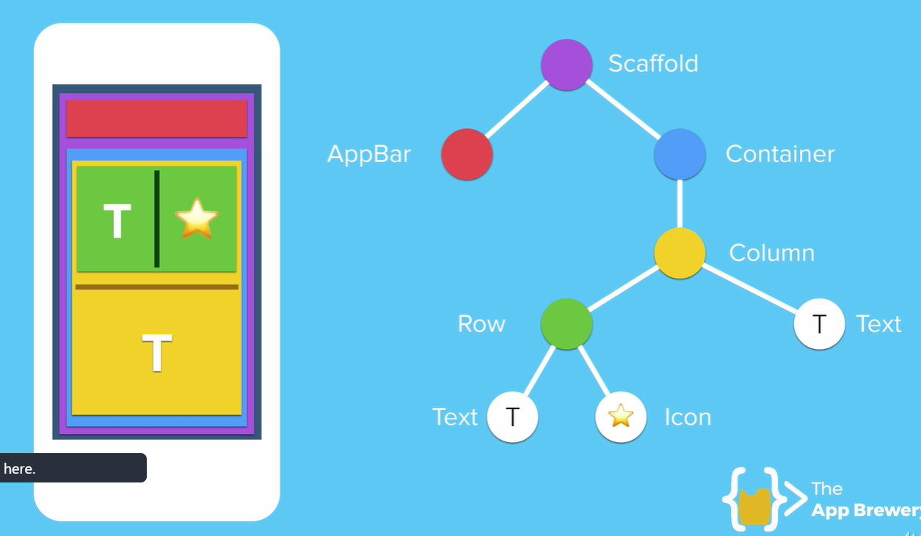

Widget tree

Flutter.dev

1. Install fultter, set it to the path variable
2. Install android studio, configure flutter with dart
3. Install android emulator from the android studio – AVD manager, choose device and os, choose hardware for graphics

In the cmd, accept flutter licenses by running – flutter doctor –android-licenses

First code:

import 'package:flutter/material.dart';  
  
void main() { // => fat arrow can be used here, then curly braces not required  
 runApp(  
 MaterialApp(  
 home: Center(  
 child: Text("Hello world, I arrived"),  
 ),  
 ),  
 );  
}

docs.flutter.io

‘dart’ language uses single quotes.

Draw.io – to create flowcharts and diagrams

Inside pubspec.yaml, we need to specify what are the sections we have in the application.

Each indentation level in ‘YAML’ is 2 spaces.

Appicon.co -- to create a custm icon from an image

To deploy the app in to android device, get build number from settings-about taptaptap.., then settings – developer options usb-debugging, -- now phone will be able to communicate with the computer, -- connect mobile with usb cable which can transfer data. Trust the computer if prompted

Select the mobile on the devices in the android studio.

Cons8.com, vecteezy.com, canva.com for icos.

In orer for the hot reload to work in android studio, the property we modified should be inside the stateless or statefull widget.

Container is normally put inside a SafeArea in the Scaffold inorder to avoid screen notches.

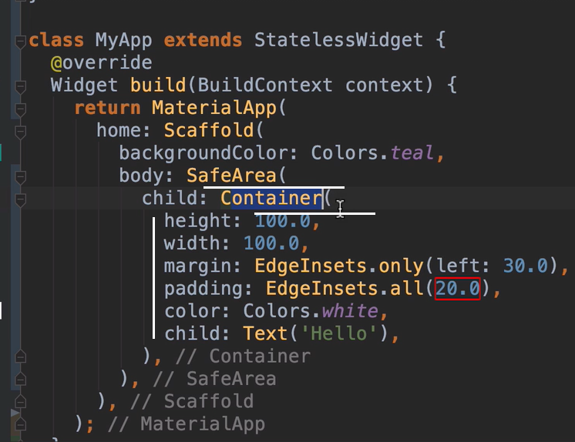

Multicolumn widgets are row, column and stack.

Containers inside a column:

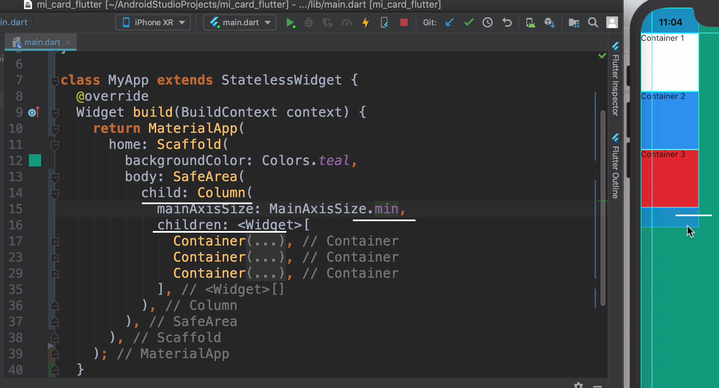

Column direction:

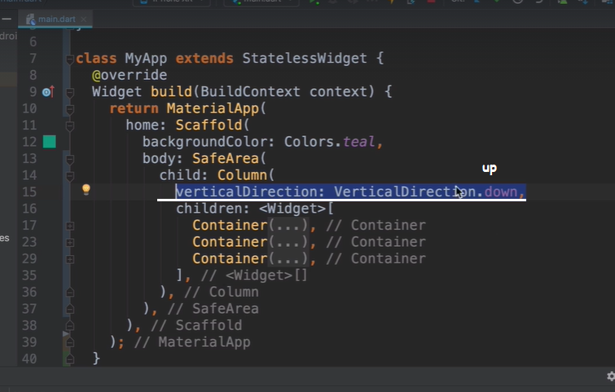

Mainaxis:

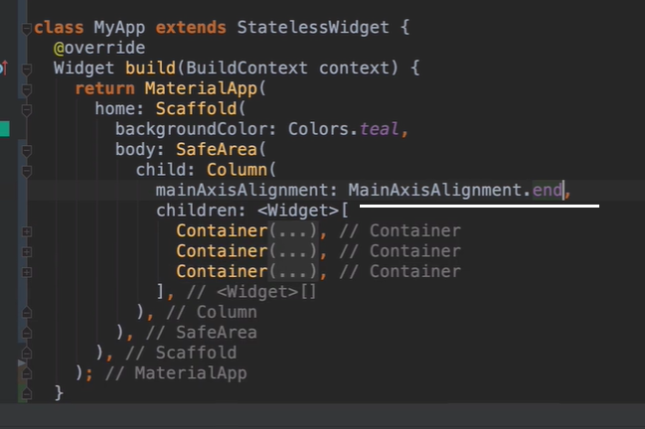

Container width infinity to the end of the screen horizontally:

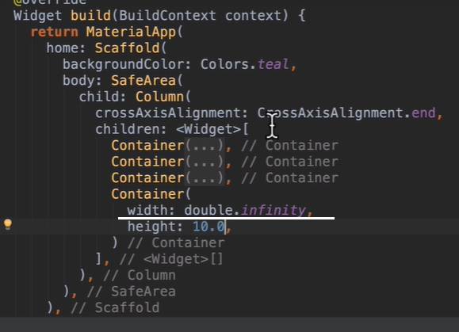

Container stretch also does the infinity:

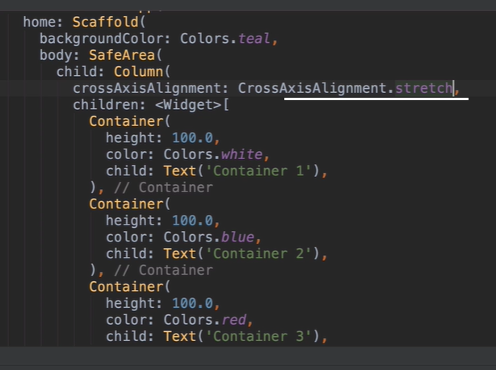

Sizedbox takes only height to give space between the containers:

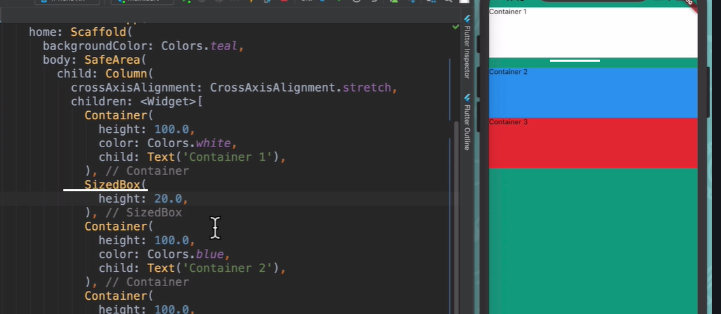

<https://medium.com/flutter-community/flutter-layout-cheat-sheet-5363348d037e>

IntrinsicWidth and IntrinsicHeight

Want all the widgets inside Row or Column to be as tall/wide as the tallest/widest widget

Widget build(BuildContext context) {  
return Scaffold(  
appBar: AppBar(title: Text('IntrinsicWidth')),  
body: Center(  
child: **IntrinsicWidth**(  
child: Column(  
crossAxisAlignment: CrossAxisAlignment.stretch,  
children: <Widget>[  
RaisedButton(  
onPressed: () {},  
child: Text('Short'),  
),  
RaisedButton(  
onPressed: () {},  
child: Text('A bit Longer'),  
),  
RaisedButton(  
onPressed: () {},  
child: Text('The Longest text button'),  
),  
],  
),  
),  
),  
);  
}

# Stack

Perfect for overlaying Widgets on top of each other

For quickdocs, use ctrl+q

In order to use fonts inside the project, download it and add to a folder in the project. Then add it to the pubspec.yaml

Yaml setup of image and font:

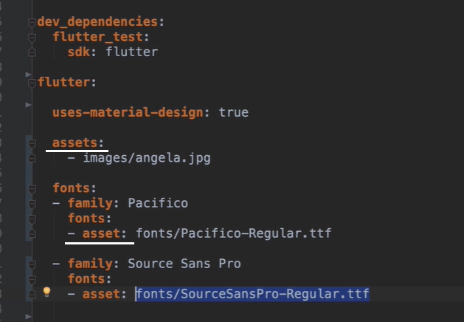

*starend