<https://www.youtube.com/watch?v=WMy3OzvBWc0>

UEFI puts all the boot code into one partition.

BIOS first stage GRUB looks in the partition table for location of the 2nd stage GRUB where it has the instructions to find an load the Kernel name and its location.

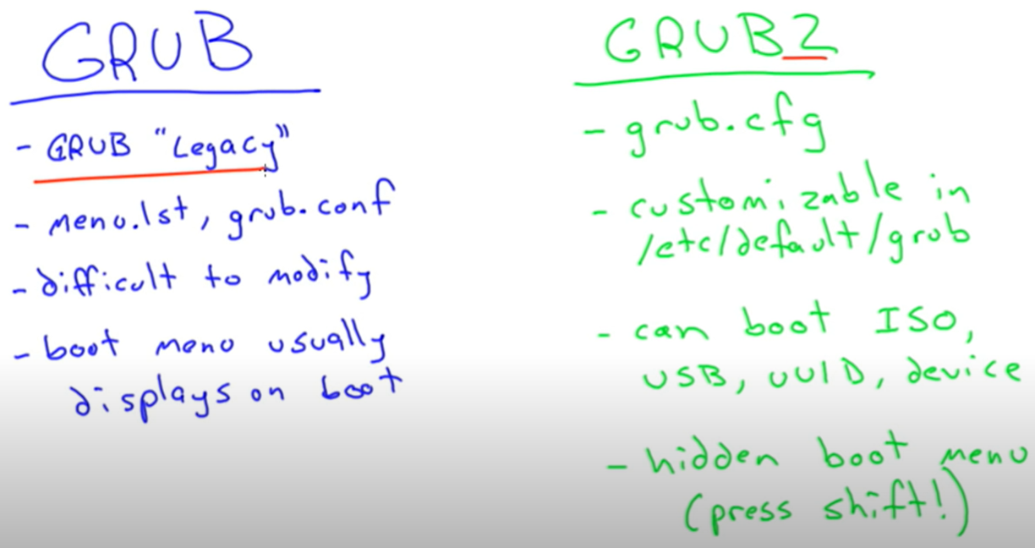

Slackware still uses GRUB legacy

Grub2 allows to do more configuration.

After making changes to /etc/default/grub, run update-grub. This will update the /boot/grub2/grub.cfg

In Grub2, to find the boot menu we need to hold the ‘Shift key’ to view the boot menu.

PXE = preboot execution environment.

TFTP is a server where we can store files remotely.

iPXE uses HTTP to download the boot file.

Windows also can boot from USB or CD

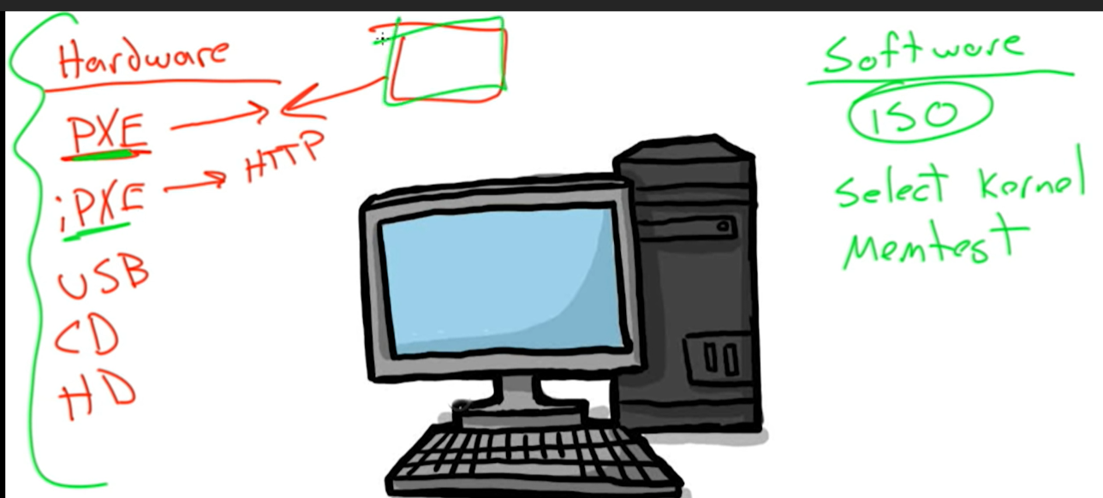

Initrd is initRAM disk, which provides information about the modules to the vmliux. It’s used only in the boot stage.

InitramFS lives in the vmlinux. Vmlinux is a very small kernel. Vmlinuz is compressed.

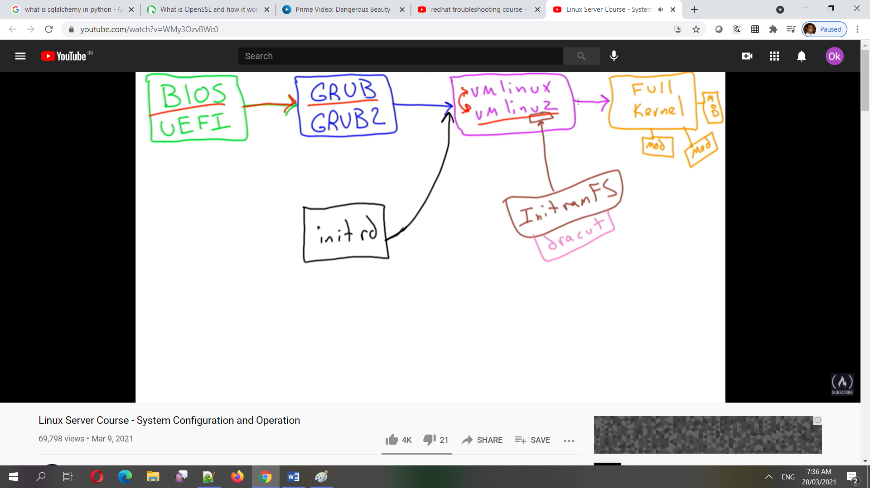

Inside /boot, the system.map tells where the file system and modules live, config gives the configuration files when the kernel compiles

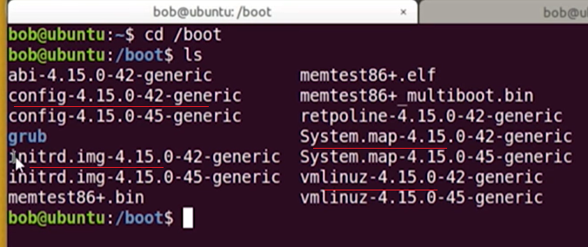

When the system fails to boot after a kernel update, reboot the system, press shift key to show the different kernels, then choose the older version which is used before the update. Then remove/reinstall the newest kernel. In another way, boot from cd or usb and access the system disks to save the date to another computer.

Manually we can enter the modules to be loaded at boot time into /etc/modules

When a module should be prohibited from loading, we can put it into /etc/modprobe.d/blacklist.conf

Linux kernel is modular – means only the required modules has to be loaded into memory.

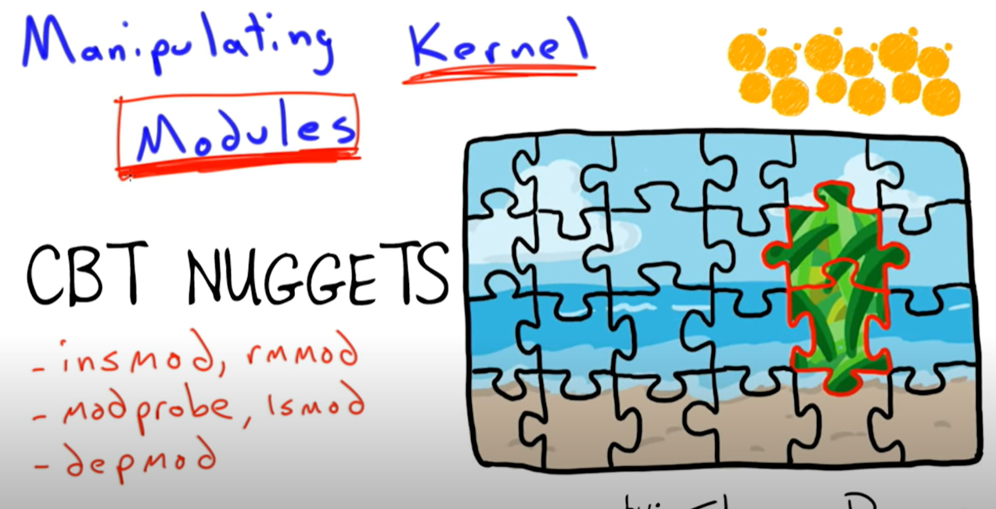

Modprobe uses insprobe internally to insert the modules.

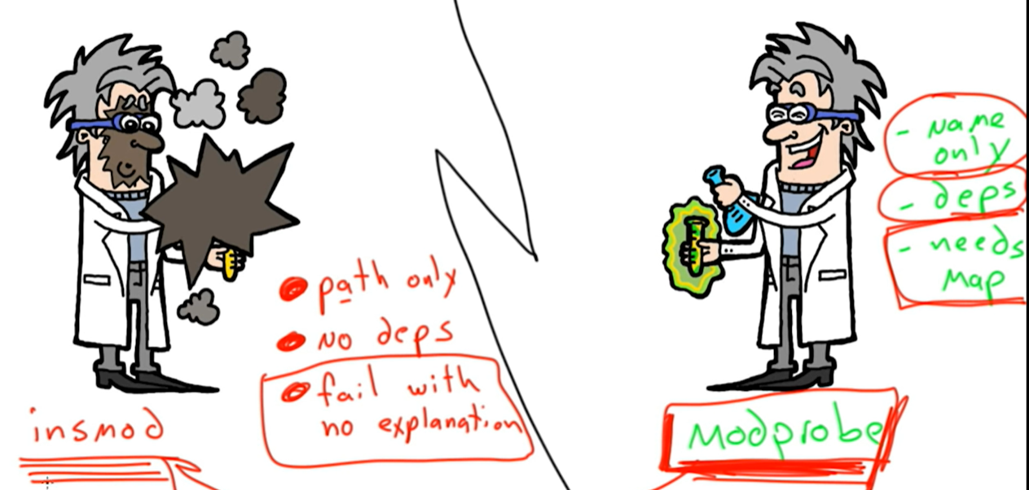

Lsmod = gives a list of installed modules.

When removing a modules, first remove its dependency, then the module itself. Use ‘rmmod’

After installing a new hardware, run ‘depmod’ to update the system.map file, so that the modprobe can find the module for that hardware.

Ping, ip add, ip route (for routing information). Think like a packet for things that are required to find the addresses.

Dig, host, nslookup:

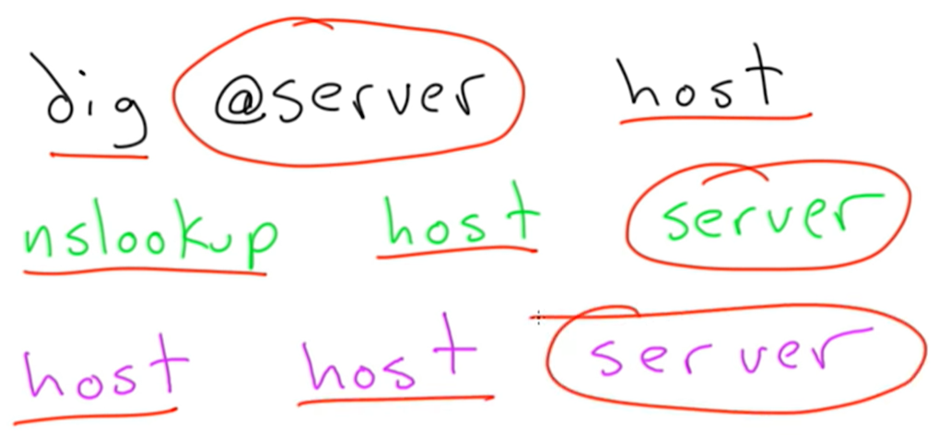

After editing the etc/hosts, run dnsmasq restart

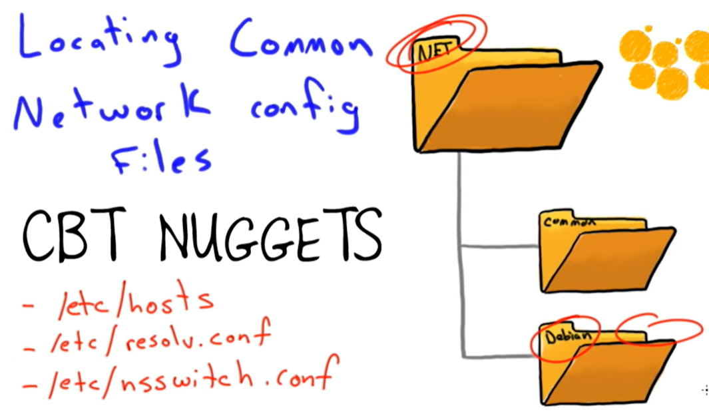

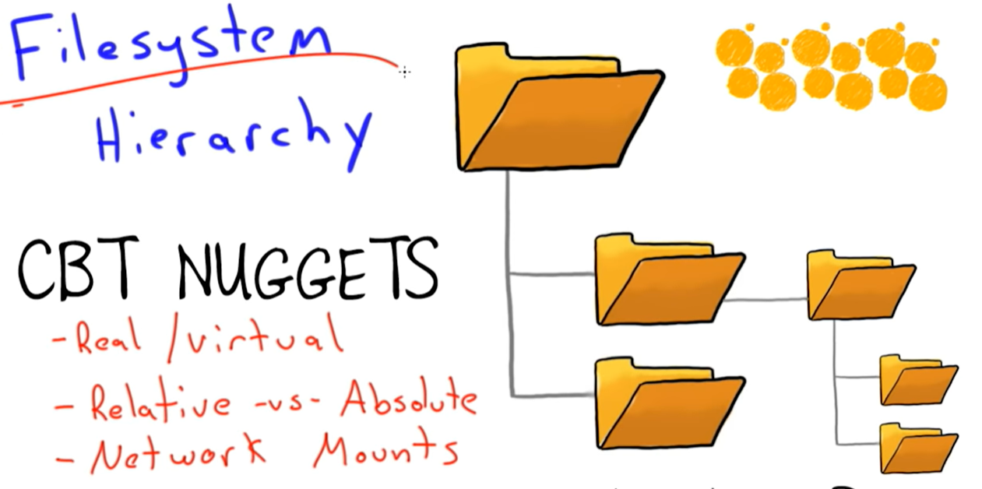

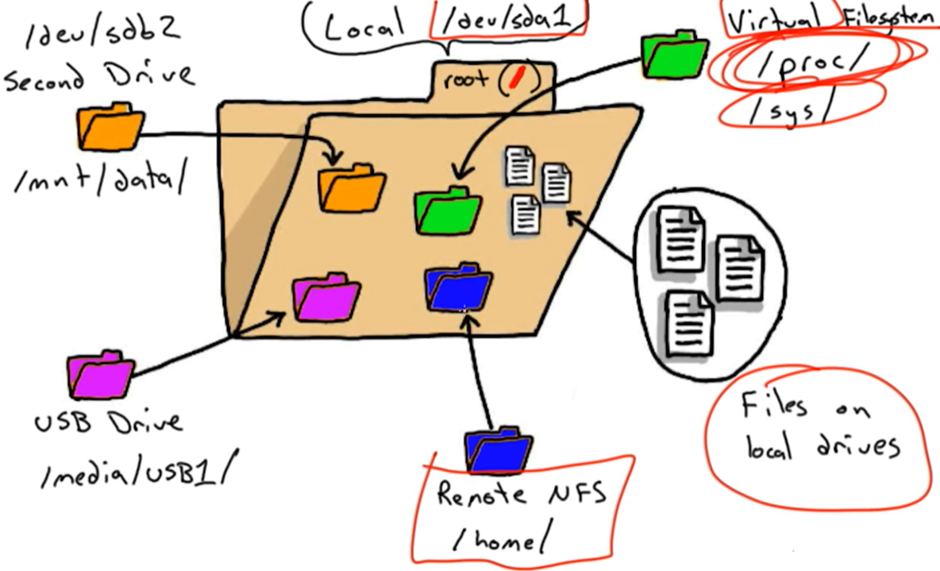

\*starend