Solaris ZFS: <https://www.youtube.com/watch?v=n3kjqaVdZ-E>

ZFS is the root file system of Solaris 11

Echo | format = to display the hard disks installed

In order to use the zfs file system first create a pool of devices.

In solaris 11 zfs, with one command can create and mount the file system.

Zpool create mypool disk1 disk2

The devcices may consist of disks, large files etc. means, not only disk

Df –j or df –h = command to find the file systems currently mounted

Rpool is the default pool name // zpool list

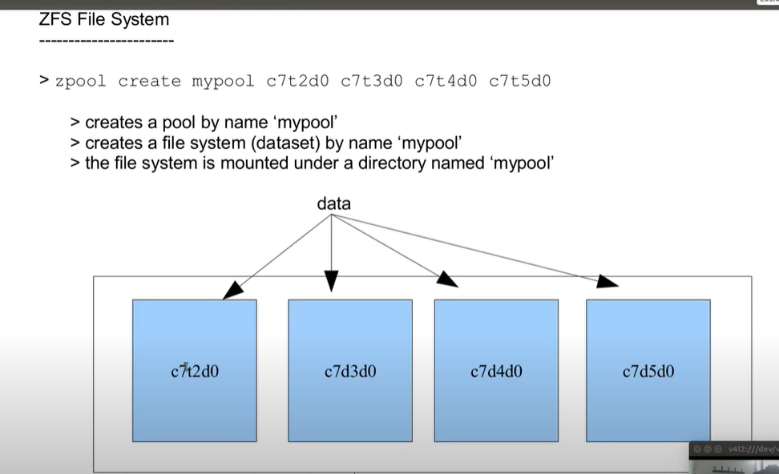

The data is striped across each disks, so a loss of 1 disk causes data loss. No redundancy.

Zfs create mypool/fs1

Zfs list = to list the file system.

Zfs is a property centric file-system. Manage it by setting and getting properties.

Zfs get all mypool

Zfs set mountpoint=/eng mypool/fs1 = to set the mountpoint for the mypool/fs1



Zpool add mypool disk3 = adding another disk to ‘mypool’

Zfs set quota=500m mypool/fs1 = setting quota on the filesystem/dataset of ‘fs1’

Setting a quota is not a guarantee, but it is only an upper limit.

Zfs set reservation=500m mypool/fs1 = is now a guarantee

Zpool status mypool = shows devices in the pool

Zpool destroy mypool

Mirror pool:



Data will be striped across virtual devices.

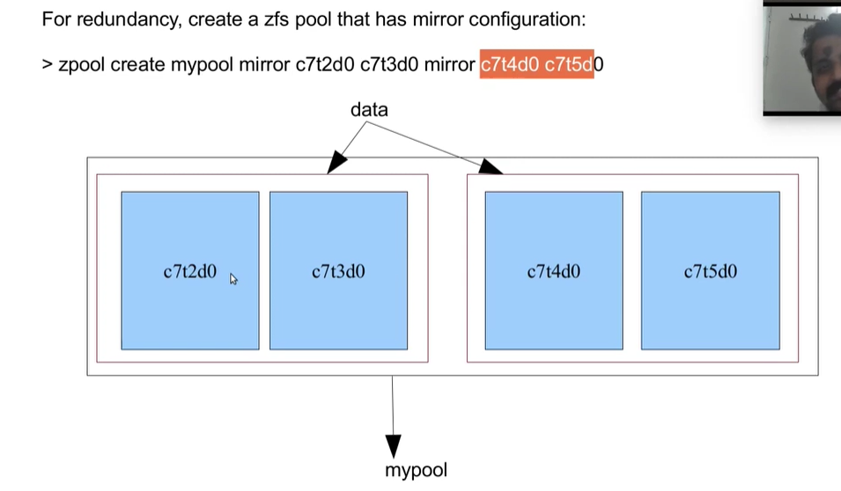

Create a pool with parity 1 disk:



Create large file: mkfile



Snapshot can be taken on zfs file system.

Du –sh <filename> = to find the file size



List the snapshot taken:



When the original files are removed from the file system, it is added to the snapshot. Not when it exists on the file system.

Restore/rollback the snapshot:



Snapshot is hidden under a hidden directory:



Showing a hidden directory in the zfs:

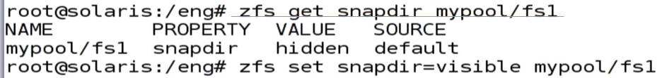

Share a file system: dfshares



No etc/dfstab entry required

A clone of a filesystem can be created only from its snapshot.



A clone is a writable copy.

Promoting a clone to a file system as original:

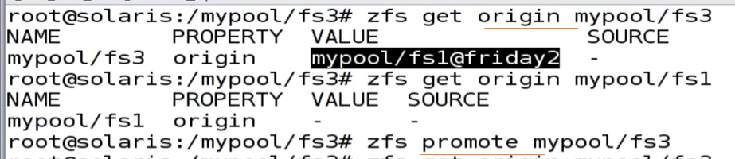

Sending a snapshot to an nfs share or some other place as a backup

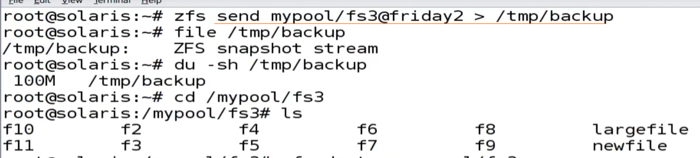

Restoring the file from backup:



Sending a snapshot from one machine to another using ssh:



A destroyed pool can be recovered:

