The following document describes the development of style files for the Sidebar project in the Whistler (Windows Modern) project (in this document, “Sidebar” refers to both the project and its program); for this project, such style files are called “themes”.

Contents
Contents 1
About This Document 2
File Layout 2
About the Libraries That Can Be Used 2
Theme Information and Configuration 2
Resources Common to All Themes and Utility Resources 3
Sidebar Section 9
Tile Control Section 14
Flyout Section 18
Drag Window Section 19
Notification Window Section 20
Exception Window Section 24
Tiles Section 26
Clock Tile 27
Search Tile 38
Feed Tile 43
Quick Launch Tile 47
Tray Icon Tile 49
Power Tile 50
Slideshow Tile 58
User Tile 60
Notification History Tile 62
Flexible Customization 67
Packaging and Sharing, Potential Risk Statement 67

About This Document
This document was rewritten after the new architecture was implemented (the new architecture was implemented in beta version 0.7.5.0, and the documentation was not fully completed). Documentation for the old architecture can still be used for reference.

File Layout
A complete theme requires the following files in the root directory of the theme folder. These file names are fixed and mandatory:
- Theme.xaml – a WPF resource dictionary file, referred to here as the theme file.
The following files are also located in the root directory of the theme folder. Their names are fixed, but whether to include them depends on actual needs (they are optional):
- Locale.xml – the resource file used for localization; used only for theme information.
- Path.xml – the resource file that records file paths for high DPI; used only for theme information.

About the Libraries That Can Be Used
Officially, two libraries are used for themes: Native.dll and Win32ThemeStyle.WPF. Both provide nine-slice image handling; choose the most suitable approach for your situation.
Support for third-party libraries (usually class libraries you write yourself to achieve more complex effects, typically located in the theme folder) will be considered later.
Using other WPF resource dictionary files is supported, as this is a native WPF feature. Note, however, the file path issue.
For details about Win32ThemeStyle.WPF, see the documentation:
Simplified Chinese: https://github.com/windowsmodern/win32-style-in-wpf/blob/master/docs/hack-components.zh-CN.md
English: https://github.com/windowsmodern/win32-style-in-wpf/blob/master/docs/hack-components.md

Theme Information and Configuration
Themes are distinguished by the folder name in which they reside (for example, the folder for the Slate theme is “Slate”), so the folder name should be both distinctive and not too long. To better present theme-related information, in the new architecture a theme file needs the following resource keys; these resource keys are not mandatory. Example (namespace xmlns:s="clr-namespace:System;assembly=mscorlib"):
<!-- Infomation -->
<s:String x:Key="ThemeDisplayName">Slate</s:String>
<s:String x:Key="ThemePublisherDisplayName">Windows Modern</s:String>
<s:String x:Key="ThemeDescription">Slate style in Windows Longhorn.</s:String>
<s:String x:Key="ThemeLogo">Logo.jpg</s:String>
ThemeDisplayName: the display name of the theme; this property can use localized resources. If this resource key is absent or the text is null or blank, the name of the folder containing the theme file is displayed instead.
ThemePublisherDisplayName: the publisher display name of the theme. This is not the Identity Publisher used for identity (the “CN=...” kind), but a display name. This property can use localized resources.
ThemeDescription: the theme description; this property can use localized resources.
ThemeLogo: the theme icon, a square image (a side length of 50–100 px is recommended). File resources can be used.
To achieve better results with a theme, the following items can be configured through resource keys. Example (which also shows the default values):
<s:Boolean x:Key="EnableBlur">true</s:Boolean>
<s:Boolean x:Key="EnableBlurForFlyout">false</s:Boolean>
<s:Boolean x:Key="EnableBlurForDrag">false</s:Boolean>
<s:Boolean x:Key="EnableNotificationBlur">true</s:Boolean>
<s:Boolean x:Key="EnableNotificationClipRound">true</s:Boolean>
EnableBlur: enables a semi-transparent blurred window background via Aero or the Windows 10 and later APIs. If enabled, this directly affects Sidebar, flyouts, and drag windows.
EnableBlurForFlyout: takes effect when EnableBlur is not enabled. It specifies whether the semi-transparent blur effect is also enabled for flyouts when EnableBlur is disabled.
EnableBlurForDrag: similar in meaning to the previous setting, but for drag windows.
EnableNotificationBlur: not affected by EnableBlur; specifies whether the semi-transparent blur effect is enabled for notification windows.
EnableNotificationClipRound: because notification windows are relatively complex to implement and Windows XP has extremely poor support for AllowsTransparency, this option makes it convenient to create rounded rectangles for the window and clip at the window level.

Resources Common to All Themes and Utility Resources
To make tiles fit the theme better and to prevent content from becoming hard to read under the theme, resource keys are provided here to unify some styles. In practice, however, these are not mandatory.
<!-- Global Fonts -->
<FontFamily x:Key="GlobalFontFamily">
Microsoft YaHei, Segoe UI, Ebrima, Nirmala, Gadugi, Segoe UI Emoji, Segoe UI Symbol,
Meiryo, Leelawadee, Microsoft JhengHei, Malgun Gothic, Estrangelo Edessa, Microsoft Himalaya,
Microsoft New Tai Lue, Microsoft PhagsPa, Microsoft Tai Le, Microsoft Yi Baiti, Mongolian Baiti,
MV Boli, Myanmar Text, Javanese Text, Cambria Math
</FontFamily>
<!-- Global -->
<SolidColorBrush x:Key="GlobalForegroundBrush" Color="{Binding ForegroundColor, Source={x:Static pst:DwmThemeProvider.Instance}}" />
<SolidColorBrush x:Key="GlobalFlyoutForegroundBrush" Color="{Binding ForegroundColor, Source={x:Static pst:DwmThemeProvider.Instance}}" />
<s:Double x:Key="GlobalFontSize">10</s:Double>
<s:Double x:Key="GlobalNormalFontSize">10</s:Double>
<s:Double x:Key="GlobalNormalFontSizeSmall">9</s:Double>
<Style x:Key="GlobalControlTextDisplay" TargetType="Control">
<Setter Property="FontFamily" Value="{DynamicResource GlobalFontFamily}" />
<Setter Property="Foreground" Value="{DynamicResource GlobalForegroundBrush}" />
<Setter Property="FontSize" Value="{DynamicResource GlobalFontSize}" />
</Style>
<Style x:Key="GlobalTextBlockTextDisplay" TargetType="TextBlock">
<Setter Property="FontFamily" Value="{DynamicResource GlobalFontFamily}" />
<Setter Property="Foreground" Value="{DynamicResource GlobalForegroundBrush}" />
<Setter Property="FontSize" Value="{DynamicResource GlobalFontSize}" />
</Style>
<Style x:Key="GlobalFlyoutControlTextDisplay" TargetType="Control">
<Setter Property="FontFamily" Value="{DynamicResource GlobalFontFamily}" />
<Setter Property="Foreground" Value="{DynamicResource GlobalFlyoutForegroundBrush}" />
<Setter Property="FontSize" Value="{DynamicResource GlobalFontSize}" />
</Style>
<Style x:Key="GlobalFlyoutTextBlockTextDisplay" TargetType="TextBlock">
<Setter Property="FontFamily" Value="{DynamicResource GlobalFontFamily}" />
<Setter Property="Foreground" Value="{DynamicResource GlobalFlyoutForegroundBrush}" />
<Setter Property="FontSize" Value="{DynamicResource GlobalFontSize}" />
</Style>
<Style x:Key="AutoHideScrollViewer" TargetType="ScrollViewer">
<Setter Property="VerticalScrollBarVisibility" Value="Auto" />
<Setter Property="HorizontalScrollBarVisibility" Value="Auto" />
<Setter Property="local:AutoHideScrollBar.IsEnabled" Value="True"></Setter>
<Setter Property="Template" Value="(Ignore)"></Setter>
</Style>
Resource Key | Type | Purpose | Usage | Notes
GlobalFontFamily | FontFamily | Defines the font families used globally. When these font families are unavailable, the WPF default font family is used. | Dynamic reference | These are fonts commonly used since Windows 8, also intended to make the sidebar look better.
GlobalForegroundBrush | SolidColorBrush | Defines the globally used text color brush. This brush is used in the Sidebar and tile parts. | Dynamic reference | Distinct from GlobalFlyoutForegroundBrush
GlobalFlyoutForegroundBrush | SolidColorBrush | Defines the globally used text color brush. This brush is used in the flyout part. | Dynamic reference | Distinct from GlobalFlyoutForegroundBrush
GlobalFontSize | Double | Defines the global text font size, often used in tiles and flyouts. | Dynamic reference | This is generally kept at the default; little adjustment is needed.
GlobalNormalFontSize | Double | Defines the global normal text font size, often used in tiles and flyouts. | Dynamic reference | Rarely used
GlobalNormalFontSizeSmall | Double | Defines the global small text font size, often used in tiles and flyouts. | Dynamic reference | Rarely used
GlobalControlTextDisplay | Style[Control] | Recommended global control style, often used in tiles. | Dynamic reference | Only used when the default text style is in use; if you want to customize on top of it, do not use it in BasedOn form
GlobalTextBlockTextDisplay | Style[TextBlock] | Recommended global text block style, often used in tiles. | Dynamic reference | Only used when the default text style is in use; if you want to customize on top of it, do not use it in BasedOn form
GlobalFlyoutControlTextDisplay | Style[Control] | Recommended global control style, often used in flyouts. | Dynamic reference | Only used when the default text style is in use; if you want to customize on top of it, do not use it in BasedOn form
GlobalFlyoutTextBlockTextDisplay | Style[TextBlock] | Recommended global text block style, often used in flyouts. | Dynamic reference | Only used when the default text style is in use; if you want to customize on top of it, do not use it in BasedOn form
In addition, there are utility resource keys for themes, which relate to system and Sidebar settings.
<!-- DWM Themes -->
<SolidColorBrush x:Key="UtilDwmThemeBrush" Color="{Binding ThemeColor, Source={x:Static pst:DwmThemeProvider.Instance}}" />
<SolidColorBrush x:Key="UtilDwmOpaqueThemeBrush" Color="{Binding ThemeColorOpaque, Source={x:Static pst:DwmThemeProvider.Instance}}" />
<SolidColorBrush x:Key="UtilDwmForegroundBrush" Color="{Binding ForegroundColor, Source={x:Static pst:DwmThemeProvider.Instance}}" />
<Binding x:Key="UtilSystemIsTaskbarTopBinding" Path="IsTaskbarTop" Source="{x:Static pst:SystemExplorerShell.Instance}" />
<Binding x:Key="UtilSystemIsAppDarkModeBinding" Path="IsAppDarkMode" Source="{x:Static pst:SystemExplorerShell.Instance}" />
<Binding x:Key="UtilSystemIsShellDarkModeBinding" Path="IsShellDarkMode" Source="{x:Static pst:SystemExplorerShell.Instance}" />
<Binding x:Key="UtilSidebarIsReversedBinding" Path="IsReversed" Source="{x:Static pst:SidebarUIConfig.Instance}" />
<x:Static x:Key="UtilObjectToVisibilityConverter" Member="pst:ObjectToVisibilityConverter.Instance" />
<x:Static x:Key="UtilStringResourceConverter" Member="pst:StringResourceConverter.Instance" />
<x:Static x:Key="UtilCalendarModeToBooleanConverter" Member="pst:CalendarModeToBooleanConverter.Instance" />
<pst:StringResourceExtension x:Key="UtilStringSidebarOptions" Key="SIDEBAR_OPTIONS" Fallback="Options" />
Resource Key | Type | Purpose | Usage | Notes
UtilDwmThemeBrush | SolidColorBrush | The Aero theme color on Windows Vista and later; this color has transparency. | Static/dynamic reference | The theme color changes automatically in response to the theme.
UtilDwmOpaqueThemeBrush | SolidColorBrush | The Aero theme color on Windows Vista and later; this color is opaque. | Static/dynamic reference | The theme color changes automatically in response to the theme.
UtilDwmForegroundBrush | SolidColorBrush | The Aero theme color on Windows Vista and later; a readable text color calculated from this color by an algorithm. | Static/dynamic reference | It changes automatically in response to theme color changes. If possible, it could use black text + white glow like Windows Vista/7, but unfortunately there is no globally used resource key for this effect. (Consider adding it later.)
UtilSystemIsTaskbarTopBinding | Binding | A binding whose value type is Boolean, indicating whether the taskbar is at the top. | Static reference | Commonly used for the window background in TaskbarView. Changes automatically in response; usually used with triggers.
UtilSystemIsAppDarkModeBinding | Binding | A binding whose value type is Boolean, indicating whether dark mode is for the application (not the theme). (Supported only on Windows 10 1809 and later; default false.) | Static reference | Changes automatically in response; usually used with triggers.
UtilSystemIsShellDarkModeBinding | Binding | A binding whose value type is Boolean, indicating whether dark mode is for the theme. (Supported only on Windows 10 1809 and later; default false.) | Static reference | Changes automatically in response; usually used with triggers.
UtilSidebarIsReversedBinding | Binding | A binding whose value type is Boolean, indicating whether Sidebar is on the left. (The design with Sidebar on the right is the normal design; to adapt to the left side, modify the right-side design or redesign it completely.) | Static reference | Changes automatically in response; usually used with triggers.
UtilObjectToVisibilityConverter | StaticExtension[IValueConverter] | A converter that returns Visible when the passed object is non-null and Collapsed otherwise. | Static reference | This was designed earlier for the ItemsControl style of the Overflow area. I am not sure whether it was used afterwards. It was probably eventually solved through dynamic code. I forget anyway.
UtilStringResourceConverter | StaticExtension[IValueConverter] | A converter that converts text into the string resources used by Sidebar (unrelated to tiles). | Static reference | Almost never used in theme design.
UtilCalendarModeToBooleanConverter | StaticExtension[IValueConverter] | Recommended global text block style, often used in flyouts. | Static reference | Only used when the default text style is in use; if you want to customize on top of it, do not use it in BasedOn form
UtilStringSidebarOptions | Sidebar.Presentation. StringResourceExtension | The “Options” string for the options part at the top of the sidebar and flyout. | Dynamic reference | A dynamic reference is sufficient, for example: Text="{DynamicResource UtilStringSidebarOptions}"

Sidebar Section
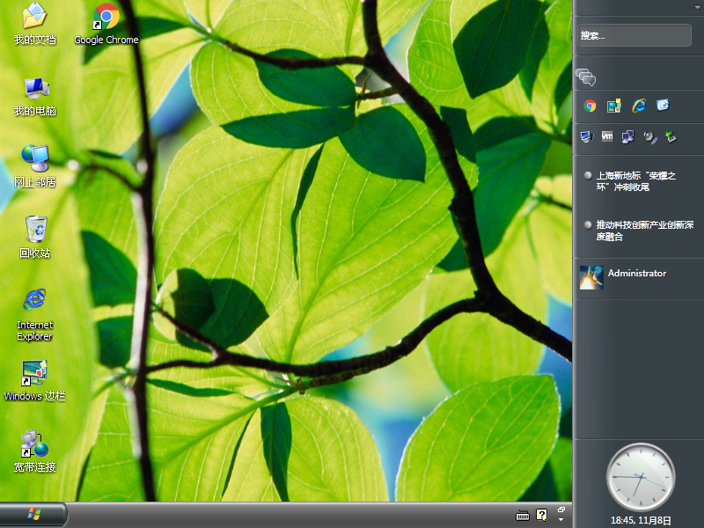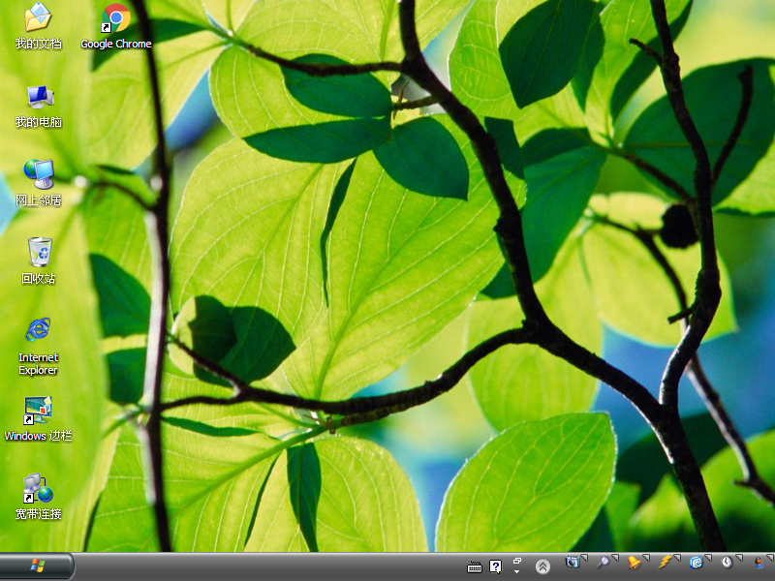
The old architecture was modeled on LongBar and also reflected habits from when I built web pages with HTML. The new architecture is one that I gradually came to understand during development, then overturned and redesigned.
To make theme design more flexible, and also more complex and detailed, some parts of the new architecture use Control and then override them through Template.
(There are some spelling mistakes from when I designed it, but they are harmless; as long as it works.)
Layout:
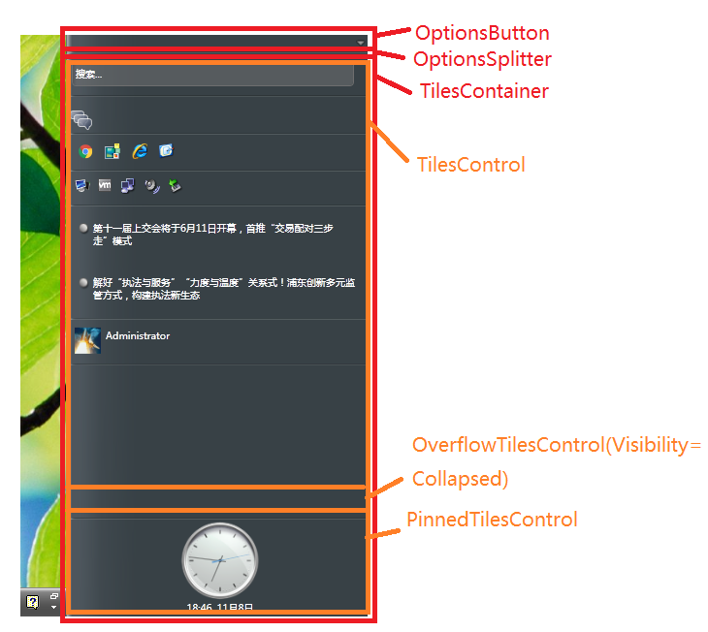
Sidebar (sidebar view)
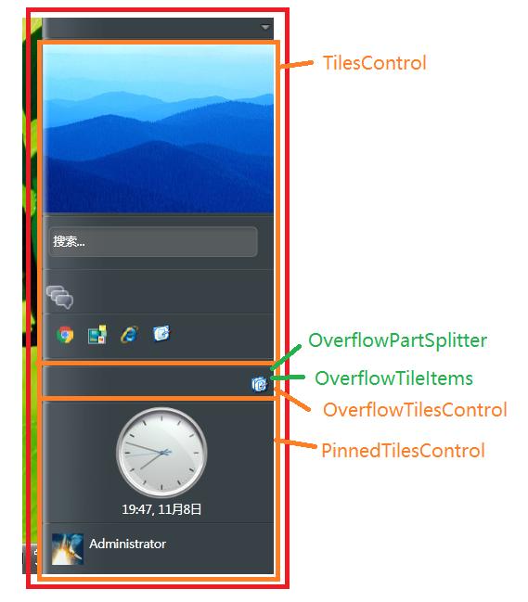
Sidebar (sidebar view, with tile overflow)
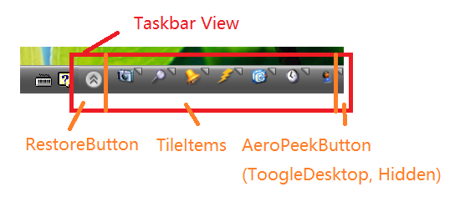
Sidebar (taskbar view)
<Grid>
<Grid Name="SidebarView" Visibility="Visible" Loaded="SidebarView_Loaded" Style="{DynamicResource SidebarSidebarView}">
<Control Name="SidebarBackground" Style="{DynamicResource SidebarBackground}" />
<Grid>
<Button Name="TopOptionsButton" Click="TopOptionsButton_Click" Style="{DynamicResource SidebarOptionsTop}" Focusable="False"/>
<Control Name="TopOptionsSplitter" Style="{DynamicResource SidebarOptionsSplliter}" />
<DockPanel Name="TilesContainer" Style="{DynamicResource SidebarTilesRegion}">
<ScrollViewer Name="ScrollPinnedTilesControl" Style="{DynamicResource SidebarPinnedTilesScrollControl}" />
<StackPanel Name="PinnedTilesControl" Style="{DynamicResource SidebarPinnedTilesControl}" />
<ItemsControl Name="OverflowTilesControl" Style="{DynamicResource SidebarOverflowTilesControl}" pst:ItemsControlAutoCollapseHelper.AutoCollapseWhenEmpty="True"/>
<ScrollViewer Name="ScrollTilesControl" Style="{DynamicResource SidebarTilesScrollControl}" />
<StackPanel Name="TilesControl" Style="{DynamicResource SidebarTilesControl}" />
</DockPanel>
</Grid>
<Control Name="SidebarHighlight" IsHitTestVisible="False" Style="{DynamicResource SidebarHighlightSide}" />
</Grid>
<Grid Name="TaskbarView" Visibility="Collapsed" Style="{DynamicResource SidebarTaskbarView}">
<Control Name="TaskbarBackground" Style="{DynamicResource SidebarTaskbarTrayBackground}"></Control>
<DockPanel Name="TaskbarContent">
<Button Name="RestoreButton" Style="{DynamicResource SidebarMinRestoreButton}" Click="RestoreButton_Click">↑</Button>
<Button Name="AeroPeekButton" Style="{DynamicResource SidebarMinAeroPeekButton}" Click="AeroPeekButton_Click"></Button>
<ItemsControl Name="TaskbarTiles" Style="{DynamicResource SidebarMinTaskbarTilesControl}"></ItemsControl>
</DockPanel>
<Control Name="TaskbarHighlight" Style="{DynamicResource SidebarTaskbarTrayHighlight}" IsHitTestVisible="False"></Control>
</Grid>
</Grid>
Style notes (for the actual default styles, see the source code in the project repository):
Resource Key | Type | Purpose | Notes
SidebarWindow | Style[Window] | Window-level style; generally keep the default unless designing a more complex effect. | Generally not used; keep the default.
SidebarWindowLoaded | Storyboard | Called when the window loads; the window loading animation. The default has no effect.
SidebarBackground | Style[Control] | Sidebar background area, implemented by overriding Template. | When the sidebar is on the left, use the utility resource keys mentioned above together with triggers.
SidebarOptionsTop | Style[Button] | The panel for the top options part. | When the sidebar is on the left, use the utility resource keys mentioned above together with triggers.
SidebarOptionsSplliter | Style[Control] | The separator between the options panel and the tile area. | This kind of separator is decorative. Do not worry about the spelling mistake; many themes use it and it is hard to change...
SidebarTilesRegion | Style[DockPanel] | The tile area. | If you change the height of the options part, this needs to be adjusted.
SidebarPinnedTilesScrollControl | Style[ScrollViewer] | The container for tiles pinned to the bottom when the “use scroll bar on overflow” option is enabled (located at the bottom). | Generally keep the default
SidebarPinnedTilesControl | Style[StackPanel] | The area for tiles pinned to the bottom. | Generally keep the default
SidebarOverflowTilesControl | Style[ItemsControl] | The icon area for overflow tiles, located between the two tile areas.
GlobalFlyoutTextBlockTextDisplay | Style[TextBlock] | Recommended global text block style, often used in flyouts. | Only used when the default text style is in use; if you want to customize on top of it, do not use it in BasedOn form
SidebarTilesScrollControl | Style[ScrollViewer] | The container for tiles pinned to the top when the “use scroll bar on overflow” option is enabled (located at the bottom). | Generally keep the default
SidebarTilesControl | Style[StackPanel] | The area for tiles pinned to the top. | Generally keep the default
SidebarHighlightSide | Style[Control] | The highlight part in the sidebar section, used as needed. | Cannot receive any mouse events, to prevent interference with interaction with the sidebar and tiles.
(Before this, note that TaskbarView can be displayed when the sidebar's cover-taskbar option is enabled. See your own experience. Also note that when switching to TaskbarView, the window width is affected by the content.)
SidebarTaskbarTrayBackground | Style[Control] | The background area in the taskbar section. | When the taskbar is at the top, use the utility resource keys mentioned above together with triggers.
SidebarMinRestoreButton | Style[Button] | The taskbar minimize/restore button.
SidebarMinAeroPeekButton | Style[Button] | A button imitating Aero Peek and the show-desktop-on-click effect in the lower-right corner of Windows 7 and later. (Although Aero Peek did not seem to work in my tests.) | If not used, it can be handled by setting Visibility to Collapsed.
SidebarMinTaskbarTilesControl | Style[ItemsControl] | The tile icon area in the taskbar section.
SidebarTaskbarTrayHighlight | Style[Control] | The highlight part in the taskbar section, used as needed. | Cannot receive any mouse events, to prevent interference with interaction with the sidebar and tiles.
SidebarSidebarView | Style[Grid] | The container for the sidebar section. | Generally keep the default and do not touch it, unless implementing more complex functionality (such as triggers).
SidebarTaskbarView | Style[Grid] | The container for the taskbar section. | Generally keep the default and do not touch it, unless implementing more complex functionality (such as triggers).

Tile Control Section
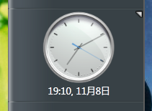
Tiles have pinned and unpinned states. To adapt to the pinned state, you can imitate the following approach (using bindings and triggers):
<Style x:Key="TileSplliter" TargetType="Thumb">
<Setter Property="DockPanel.Dock" Value="Bottom"></Setter>
<Setter Property="Height" Value="4"></Setter>
<Setter Property="Cursor" Value="SizeNS" />
<Setter Property="Background" Value="Transparent"></Setter>
<Setter Property="Template" Value="{DynamicResource TileSplliterTemplate}"></Setter>
<Style.Triggers>
<DataTrigger Binding="{Binding IsPinned, ElementName=RootTileElement}" Value="True">
<Setter Property="DockPanel.Dock" Value="Top"/>
</DataTrigger>
</Style.Triggers>
</Style>
Layout:
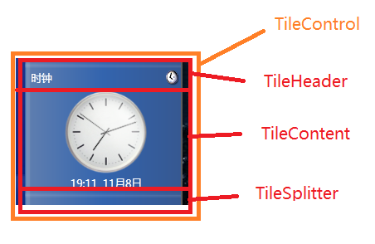
Tile (unpinned)
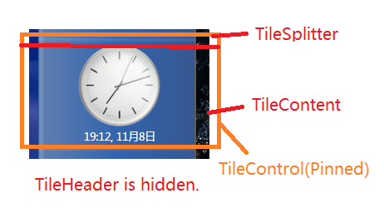
Tile (pinned)
<Grid>
<DockPanel>
<Thumb Name="TileSplitterThumb" Style="{DynamicResource TileSplliter}" DragStarted="TileSplitterThumb_DragStarted" DragDelta="TileSplitterThumb_DragDelta" DragCompleted="TileSplitterThumb_DragCompleted" PreviewMouseLeftButtonDown="TileSplitterThumb_PreviewMouseLeftButtonDown"></Thumb>
<Grid Name="TileMainPanel" Opacity="0" ClipToBounds="True">
<Control Style="{DynamicResource TileBackground}"></Control>
<DockPanel>
<Grid Style="{DynamicResource TileHeaderContainer}">
<Control Style="{DynamicResource TileHeaderBackground}"></Control>
<DockPanel>
<Image Name="TileDisplayImageControl" Style="{DynamicResource TileHeaderIcon}"></Image>
<TextBlock Name="TileDisplayNameControl" Style="{DynamicResource TileHeaderDisplayName}"></TextBlock>
</DockPanel>
<Control Style="{DynamicResource TileHeaderHighlight}" IsHitTestVisible="False"></Control>
</Grid>
<Grid Name="TileContentControlContainer">
<Control Style="{DynamicResource TileContentBackground}"></Control>
<Grid Name="TileContentContainerControl" Style="{DynamicResource TileContentContainer}" SizeChanged="TileContentContainerControl_SizeChanged">
<Grid Name="TileContentContainer" SizeChanged="TileContentContainer_SizeChanged"></Grid>
</Grid>
<Control Style="{DynamicResource TileContentHighlight}" IsHitTestVisible="False"></Control>
</Grid>
</DockPanel>
<Control Style="{DynamicResource TileHighlight}" IsHitTestVisible="False"></Control>
</Grid>
</DockPanel>
<Control Name="FlyoutIcon" Style="{DynamicResource TileFlyoutIcon}"></Control>
</Grid>
Style notes (for the actual default styles, see the source code in the project repository):
Resource Key | Type | Purpose | Notes
TileControlElement | Style[UserControl] | The tile control element. | Generally not set.
TileSplliter | Style[Thumb] | The separator used to adjust tile height. | It is recommended to have a corresponding trigger effect on mouse hover to make it more obvious. Also, the separator is disabled when the tile's Overflow is Auto, so it is recommended not to adapt the disabled-state effect.
TileBackground | Style[Control] | Tile background. | Generally not needed, and used only for areas other than the separator. The overflow part is clipped.
TileHeaderContainer | Style[Grid] | Tile title bar container. | For themes that do not display the title bar, simply set Visibility to Collapsed.
TileHeaderBackground | Style[Control] | Tile title bar background. | Generally not needed
TileHeaderIcon | Style[Image] | The tile icon in the tile title bar. | This may involve the position of Sidebar; use triggers as before.
TileHeaderDisplayName | Style[TextBlock] | The tile display name in the tile title bar.
TileHeaderHighlight | Style[Control] | The highlight part of the tile title bar. | Forces IsHitTestVisible="False", so it cannot capture mouse events. And it is generally not needed.
TileContentBackground | Style[Control] | The background part of the tile content area. | Generally not needed
TileContentContainer | Style[Grid] | The content container of the tile content area. | Generally no adjustment is needed.
TileContentHighlight | Style[Control] | The highlight part of the tile content area. | Forces IsHitTestVisible="False", so it cannot capture mouse events. And it is generally not needed.
TileHighlight | Style[Control] | The highlight part of the tile. | Forces IsHitTestVisible="False", so it cannot capture mouse events. And it is generally not needed.
TileFlyoutIcon | Style[Control] | The effect triggered when the mouse is over the tile area. | The pinned state of the tile and the position of Sidebar need to be considered.
TileShowFlyoutIconWhenEnter | Storyboard | The animation triggered when the mouse/touch enters.
TileShowFlyoutIconWhenLeave | Storyboard | The animation triggered when the mouse/touch leaves.

Flyout Section
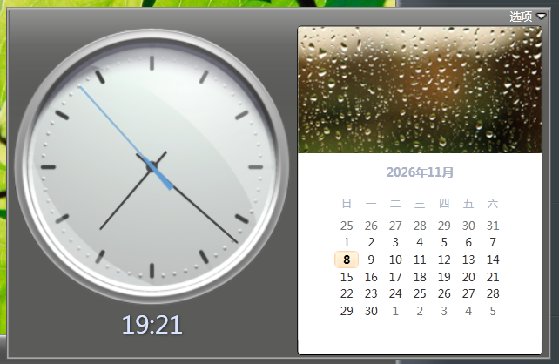
I feel that the flyout should really be called a “fly-out window”, since it is called “Flyout”. But this is really hard to translate.
No need to consider the position of the sidebar.
Layout:
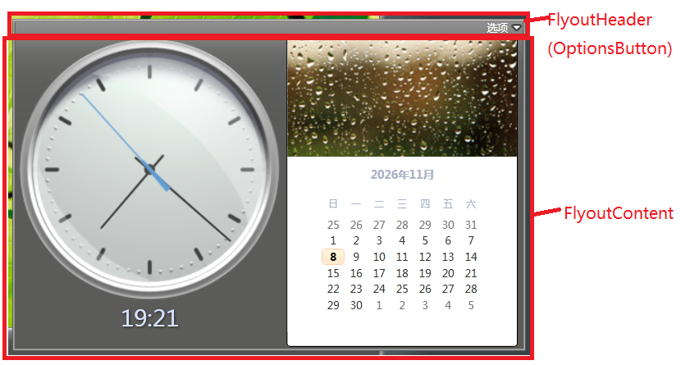
<Grid>
<Control Name="FlyoutBackground" Style="{DynamicResource FlyoutBackground}"></Control>
<Button Name="FlyoutHeader" Style="{DynamicResource FlyoutHeader}"></Button>
<Grid Name="FlyoutContentContainer" Style="{DynamicResource FlyoutContentContainer}" SizeChanged="FlyoutContentContainer_SizeChanged"></Grid>
<Control Name="FlyoutHighlight" Style="{DynamicResource FlyoutHighlight}" IsHitTestVisible="False"></Control>
</Grid>
Style notes (for the actual default styles, see the source code in the project repository):
Resource Key | Type | Purpose | Notes
FlyoutWindow | Style[Window] | Flyout window style. | Generally not used.
FlyoutBackground | Style[Control] | Flyout window background.
FlyoutHeader | Style[Button] | Flyout header part. | The content area must be a component whose background is set to Transparent (as needed, but it must not be null) and that fills the area, to prevent mouse click-through.
FlyoutContentContainer | Style[Grid] | Flyout window content area. | Margin must be set.
FlyoutHighlight | Style[Control] | The tile icon in the tile title bar. | Forces IsHitTestVisible="False", so it cannot capture mouse events. And it is generally not needed.

Drag Window Section
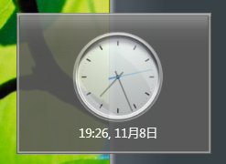
The tile drag window is created when a tile triggers drag reordering, to better show the drag effect; it looks like a tile lifted out. This window hosts the tile control.
No need to consider the position of the sidebar.
Layout:
<Grid Style="{DynamicResource DragWindowClientArea}">
<Control Style="{DynamicResource DragWindowBackground}"></Control>
<Grid Name="TileTemplateContainer" Style="{DynamicResource DragWindowContentContainer}"></Grid>
<Control Style="{DynamicResource DragWindowHighlight}"></Control>
</Grid>
Style notes (for the actual default styles, see the source code in the project repository):
Resource Key | Type | Purpose | Notes
DragWindowWindow | Style[Window] | Drag window style.
DragWindowClientArea | Style[Grid] | Drag window content container.
DragWindowBackground | Style[Control] | Drag window background.
DragWindowContentContainer | Style[Grid] | The part of the drag window that hosts the tile. | Margin must be set.
DragWindowHighlight | Style[Control] | The highlight part of the drag window.

Notification Window Section
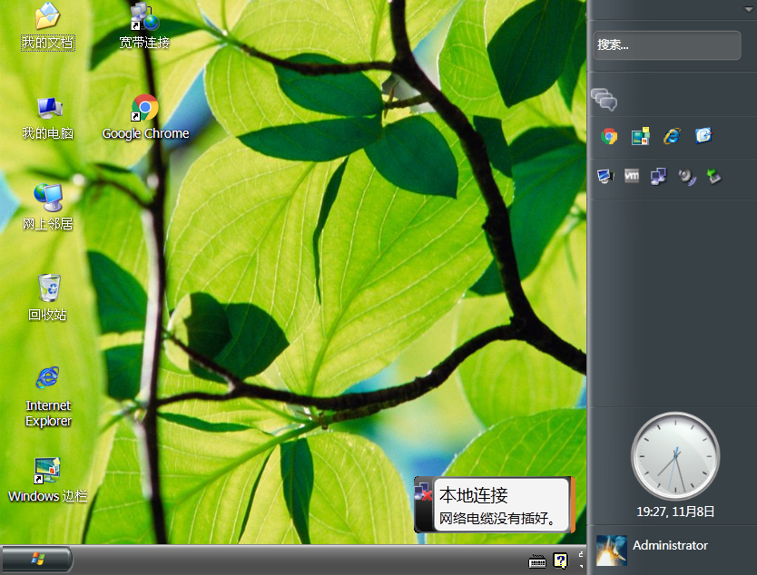
The notification window imitates the Windows Longhorn notification window (and is also similar to the Toast Notification that appeared starting with Windows 8). This style is rather complex, because it was created just before the new architecture was about to change, and I was too lazy to change it.
The notification window theme is not easy to create; the bundled theme creation tool is very limited. It is recommended to clone the project from GitHub, install Visual Studio (2015 or later), and use the IDE to create it.
No need to consider the position of the sidebar.
Layout:
Notification window (Header hidden)Header
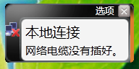
Notification window (Header shown)Header
<Grid>
<Border Name="NotificationUI" Style="{DynamicResource NotificationRegionBorder}">
<Grid>
<Grid Name="BackgroundContainer" SizeChanged="BackgroundContainer_SizeChanged" Style="{DynamicResource NotificationBackgroundContainer}">
<Grid Name="BackgroundHeightChange" SizeChanged="BackgroundContainer_SizeChanged" Visibility="Hidden" Style="{DynamicResource NotificationHeightClipContainer}"></Grid>
<Grid>
<Border Name="BackgroundBase" Style="{DynamicResource NotificationBaseBackground}"></Border>
<Border Name="BackgroundHighlight" Style="{DynamicResource NotificationBackgroundHighlight}"></Border>
<ptswc:HackBorder Name="BackgroundHighlightImage" Style="{DynamicResource NotificationBackgroundImageSlice9}"></ptswc:HackBorder>
<Control Name="BackgroundAdvanceCustom" Style="{DynamicResource NotificationBackgroundCustomControl}"></Control>
<Border Name="BackgroundBorder" Style="{DynamicResource NotificationBorder}"></Border>
<StackPanel Name="HeaderBar" Style="{DynamicResource NotificationHeader}" Opacity="0">
<Button Name="OptionsButton" Style="{DynamicResource NotificationOptionsButton}" Content="{pres:StringResource SIDEBAR_NOTIFY_OPTIONS}" Click="OptionsButton_Click" ContextMenu="{DynamicResource NotificationOptionsMenu}"></Button>
<Button Name="CloseButton" Click="CloseButton_Click" Style="{DynamicResource NotificationCloseButton}"></Button>
</StackPanel>
<Control Name="TimeoutBar" Style="{DynamicResource NotificationTimeout}"></Control>
</Grid>
<Grid Name="IconPart" Style="{DynamicResource NotificationIconPart}">
<Image Name="Icon" Source="Images\default.ico" Style="{DynamicResource NotificationIcon}">
<Image.RenderTransform>
<TranslateTransform x:Name="IconTranslate" Y="0" />
</Image.RenderTransform>
</Image>
<Image Name="IconRef" Source="Images\default.ico" Style="{DynamicResource NotificationIconReflection}">
<Image.RenderTransform>
<TransformGroup>
<ScaleTransform ScaleY="-1"/>
<TranslateTransform x:Name="IconRefTranslate" Y="0" />
</TransformGroup>
</Image.RenderTransform>
</Image>
</Grid>
</Grid>
<ptswc:HackBorder Name="TextAreaBackgroundImage" Style="{DynamicResource NotificationTextAreaBackgroundImageSlice9}"></ptswc:HackBorder>
<Control Name="TextAreaBackgroundAdvanceCustom" Style="{DynamicResource NotificationTextAreaCustomControl}"></Control>
<Border Name="TextAreaBorderOuter" Style="{DynamicResource NotificationTextAreaOuterBorder}">
<Border Name="TextAreaBorderInner" Style="{DynamicResource NotificationTextAreaInnerBorder}">
<Border Name="TextAreaTextArea" Style="{DynamicResource NotificationTextAreaTextPart}">
<ScrollViewer HorizontalContentAlignment="Stretch" HorizontalScrollBarVisibility="Disabled" VerticalScrollBarVisibility="Auto" Style="{DynamicResource AutoHideScrollViewer}">
<StackPanel MouseDown="ScrollViewer_MouseDown" MouseUp="ScrollViewer_MouseUp" TouchDown="ScrollViewer_TouchDown" TouchUp="ScrollViewer_TouchUp" Background="Transparent">
<TextBlock Name="MessageTitle" TextWrapping="Wrap" Style="{DynamicResource NotificationTitle}" HorizontalAlignment="Left">Stay current with automatic updates</TextBlock>
<TextBlock Name="MessageContent" TextWrapping="Wrap" Style="{DynamicResource NotificationContent}">Click here to learn how to keep your computer up to date automatically with important downloads from Windows Update.</TextBlock>
</StackPanel>
</ScrollViewer>
</Border>
</Border>
</Border>
</Grid>
</Border>
</Grid>
Style notes (for the actual default styles, see the source code in the project repository):
Resource Key | Type | Purpose | Notes
NotificationWindow | Style[Window] | Notification window style.
NotificationRegionBorder | Style[Border] | The container that hosts the notification window content.
NotificationBackgroundContainer | Style[Grid] | The container that hosts the notification window background.
NotificationBaseBackground | Style[Border] | Notification window background base color.
NotificationBackgroundHighlight | Style[Border] | Notification window background highlight.
NotificationBackgroundImageSlice9 | Style[ptswc: HackBorder] | Notification window background nine-slice image.
NotificationBackgroundCustomControl | Style[Control] | Notification window background, usable for more complex background shaping.
NotificationBorder | Style[Border] | Notification window border.
NotificationHeader | Style[StackPanel] | Notification window header.
NotificationOptionsButton | Style[Button] | Notification window options button. | For the text used by the button, the Content property can be used.
NotificationCloseButton | Style[Button] | Notification window close button.
NotificationTimeout | Style[Control] | The notification window close timer is visible and must participate in layout; when the timer ends, the window closes automatically. | The component's height must keep the default value (keep the component's default behavior); the width depends on needs; if you do not want to display it, simply set Width=0.
NotificationIconPart | Style[Grid] | The icon area of the notification window.
NotificationIcon | Style[Image] | Notification window icon.
NotificationIconReflection | Style[Image] | Notification window icon reflection. | Display as needed.
NotificationTextAreaBackgroundImageSlice9 | Style[ptswc: HackBorder] | The background nine-slice image of the notification window's text display part.
NotificationTextAreaCustomControl | Style[Control] | The background of the notification window's text part, usable for more complex background shaping.
NotificationTextAreaOuterBorder | Style[Border] | The outer border of the notification window's text part.
NotificationTextAreaInnerBorder | Style[Border] | The middle border of the notification window's text part.
NotificationTextAreaTextPart | Style[Border] | The inner border of the notification window's text part, also the part that hosts the text area.
NotificationTitle | Style[TextBlock] | The notification title in the notification window's text part.
NotificationContent | Style[TextBlock] | The notification content in the notification window's text part.

Exception Window Section
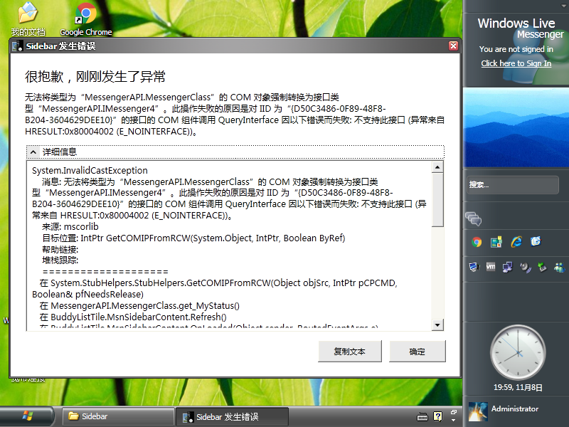
The exception window is used to catch unhandled global exceptions and display them with more detailed exception information for easy diagnosis.
It is generally not used; keep the default. If you create a theme for it, be sure to avoid exceptions in this window; otherwise it may be invoked repeatedly and cause the program to freeze.
Layout:
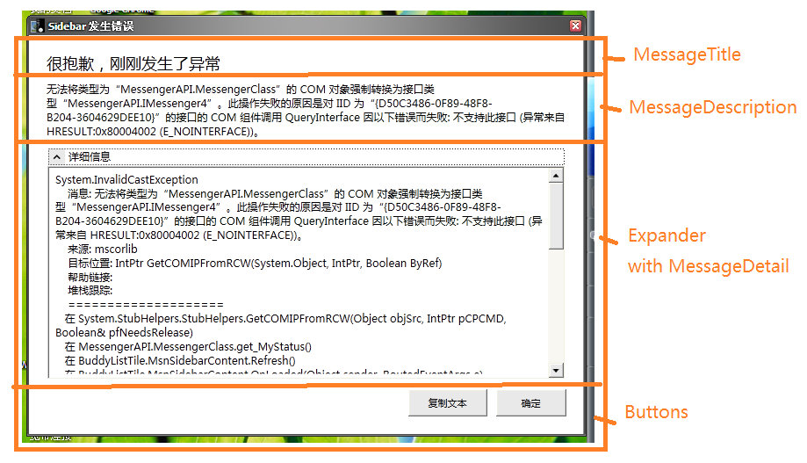
<Grid Background="Transparent">
<Control Style="{DynamicResource MessageWindowBackground}"></Control>
<DockPanel>
<TextBlock Name="MessageTitle" Style="{DynamicResource MessageWindowTitle}"></TextBlock>
<TextBlock Name="MessageDescription" Style="{DynamicResource MessageWindowText}"></TextBlock>
<Grid Style="{DynamicResource MessageWindowButtonAera}">
<Control Style="{DynamicResource MessageWindowControlsBackground}"></Control>
<StackPanel Style="{DynamicResource MessageWindowButtonsContainer}">
<Button Name="CopyInfoButton" Click="CopyInfoButton_Click" Style="{DynamicResource MessageWindowControlButton}" Content="{pst:StringResource SIDEBAR_MESSAGE_ERROR_COPYTEXT}"></Button>
<Button Name="OkButton" Focusable="True" Click="OkButton_Click" Style="{DynamicResource MessageWindowControlButton}" Content="{pst:StringResource SIDEBAR_MESSAGE_ERROR_OK}"></Button>
</StackPanel>
</Grid>
<Expander Name="DetailExpander" Style="{DynamicResource MessageWindowDetailExpander}" Header="{pst:StringResource SIDEBAR_MESSAGE_ERROR_DETAIL}">
<TextBox Name="MessageDetail" Style="{DynamicResource MessageWindowDetailMessage}"></TextBox>
</Expander>
</DockPanel>
</Grid>
Style notes (for the actual default styles, see the source code in the project repository):
Resource Key | Type | Purpose | Notes
MessageWindowWindow | Style[Window] | Exception window style.
MessageWindowBackground | Style[Control] | Exception window background.
MessageWindowTitle | Style[TextBlock] | Information title.
MessageWindowText | Style[TextBlock] | Information content.
MessageWindowButtonAera | Style[Grid] | The container for the control button area at the bottom of the window.
MessageWindowControlsBackground | Style[Control] | The background of the control button area at the bottom of the window.
MessageWindowButtonsContainer | Style[StackPanel] | The button row in the control button area at the bottom of the window.
MessageWindowControlButton | Style[Button] | The generic button style for the control buttons at the bottom of the window.
MessageWindowDetailExpander | Style[Expander] | The collapsible area for detailed content in the window.
MessageWindowDetailMessage | Style[TextBox] | The detailed content of the window; read-only.

Tiles Section
In the Sidebar project, if you look at the source code, you can see some tile projects. These projects imitate the tiles of Windows Longhorn (mainly based on the Slate-era style) and appear as tiles preinstalled with Sidebar.
Some tiles were created under the old architecture, so the degree of customization freedom is not that high. But there is still some.
If you write your own tiles, you can learn from them (do not learn from the specific implementation code, because it is a bit messy with AI assistance; DeepSeek was not as capable then as it is now), but the references to libraries, etc. are slightly different.

Clock Tile
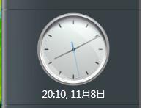
The clock tile is a very classic tile; it existed from build 3683 until the reset. In addition to displaying the time and date, the clock tile also has simple functions for changing the display time zone and setting an alarm.
Of course, it is not a complete reproduction; after enabling the alarm, adjusting the alarm time with buttons in the flyout was not implemented.
Because I was not yet very familiar with WPF at the time, some parts of the design are not quite reasonable. I am too lazy to redo it now; as long as it runs. (

Components

Clock
A panel component that simulates a clock face.
Layout:
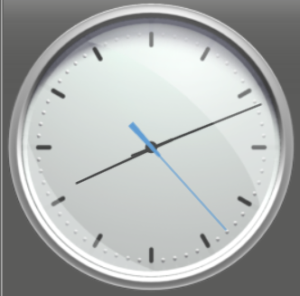
<Grid>
<Viewbox>
<Grid Name="ClockContainer" Style="{DynamicResource TileClockClockContainer}">
<Image Name="ClockFaceBack" RenderOptions.BitmapScalingMode="HighQuality" Style="{DynamicResource TileClockFace}"></Image>
<Image Name="HourHand" RenderOptions.BitmapScalingMode="HighQuality" Style="{DynamicResource TileClockHourHand}">
<Image.RenderTransform>
<RotateTransform />
</Image.RenderTransform>
</Image>
<Image Name="MinuteHand" RenderOptions.BitmapScalingMode="HighQuality" Style="{DynamicResource TileClockMinuteHand}">
<Image.RenderTransform>
<RotateTransform />
</Image.RenderTransform>
</Image>
<Image Name="ClockHub" RenderOptions.BitmapScalingMode="HighQuality" Style="{DynamicResource TileClockHub}"></Image>
<Image Name="SecondHand" RenderOptions.BitmapScalingMode="HighQuality" Style="{DynamicResource TileClockSecondHand}">
<Image.RenderTransform>
<RotateTransform />
</Image.RenderTransform>
</Image>
<Image Name="ClockCrystal" RenderOptions.BitmapScalingMode="HighQuality" Style="{DynamicResource TileClockCrystal}"></Image>
</Grid>
</Viewbox>
</Grid>
Style notes (for the actual default styles, see the source code in the project repository):
Resource Key | Type | Purpose | Notes
TileClockClockContainer | Style[Grid] | The panel that hosts the clock's components.
TileClockFace | Style[Image] | The image representing the clock face.
TileClockHourHand | Style[Image] | The image representing the hour hand.
TileClockMinuteHand | Style[Image] | The image representing the minute hand.
TileClockHub | Style[Image] | The image representing the center point that fixes the hands.
TileClockSecondHand | Style[Image] | The image representing the second hand.
TileClockCrystal | Style[Image] | The image representing the clock's cover glass.

Short Time
Displays a short time such as “2:35 PM”, with the two parts in different colors.
Layout:
<Grid Width="Auto" Height="Auto">
<DockPanel LastChildFill="False" HorizontalAlignment="{Binding HorizontalContentAlignment, RelativeSource={RelativeSource AncestorType=local:ShortTimeText}}">
<TextBlock Name="TimeText" Style="{DynamicResource TileClockShortTimeTimePart}">
<TextBlock.Effect>
<DropShadowEffect ShadowDepth="1" BlurRadius="4" Color="Black" Opacity="0.6"/>
</TextBlock.Effect>
</TextBlock>
<TextBlock Name="BlankSpace" Text="&#x00A0;" Style="{DynamicResource TileClockShortTimeBlankPart}" />
<TextBlock Name="MeridiemText" Style="{DynamicResource TileClockShortTimeMeridiemPart}">
<TextBlock.Effect>
<DropShadowEffect ShadowDepth="1" BlurRadius="4" Color="Black" Opacity="0.6"/>
</TextBlock.Effect>
</TextBlock>
</DockPanel>
</Grid>
Style notes (for the actual default styles, see the source code in the project repository):
Resource Key | Type | Purpose | Notes
TileClockShortTimeTimePart | Style[TextBlock] | The time part, such as “2:35”.
TileClockShortTimeBlankPart | Style[TextBlock] | The gap between the time part and the AM/PM part.
TileClockShortTimeMeridiemPart | Style[TextBlock] | The AM/PM part, such as “AM”.
TileClockShortTimeTimePartLarge | Style[TextBlock] | The time part, such as “2:35”. The style used when the flyout displays large text.
TileClockShortTimeMeridiemPartLarge | Style[TextBlock] | The AM/PM part, such as “AM”. The style used when the flyout displays large text.
TileClockShortTimeBlankPartLarge | Style[TextBlock] | The gap between the time part and the AM/PM part. The style used when the flyout displays large text.

Small Calendar
A small widget that displays only the date and the day of the week.
Layout:
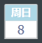
<Grid>
<Viewbox>
<Border Style="{DynamicResource TileClockSmallCalendarBorder}">
<DockPanel Style="{DynamicResource TileClockSmallCalendarContainer}">
<Grid Style="{DynamicResource TileClockSmallCalendarDayInWeek}">
<TextBlock Name="SCDayInWeek" FontSize="10" Style="{DynamicResource TileClockSmallCalendarDayInWeekText}">SUN</TextBlock>
</Grid>
<Line Style="{DynamicResource TileClockSmallCalendarDivideLine}"></Line>
<Grid Style="{DynamicResource TileClockSmallCalendarDay}">
<TextBlock Name="SCDay" FontSize="13" Style="{DynamicResource TileClockSmallCalendarDayText}">10</TextBlock>
</Grid>
</DockPanel>
</Border>
</Viewbox>
</Grid>
Style notes (for the actual default styles, see the source code in the project repository):
Resource Key | Type | Purpose | Notes
TileClockSmallCalendarBorder | Style[Border] | Container; also the border part
TileClockSmallCalendarContainer | Style[DockPanel] | Container part
TileClockSmallCalendarDayInWeek | Style[Grid] | The part representing the day of the week.
TileClockSmallCalendarDayInWeekText | Style[TextBlock] | The text representing the day of the week.
TileClockSmallCalendarDivideLine | Style[Line] | The separator between the upper and lower parts.
TileClockSmallCalendarDay | Style[Grid] | The part representing the x-th day of the current month.
TileClockSmallCalendarDayText | Style[TextBlock] | The text representing the x-th day of the current month.

Calendar for the Flyout
Includes switching the image at the top of the calendar.
Layout:
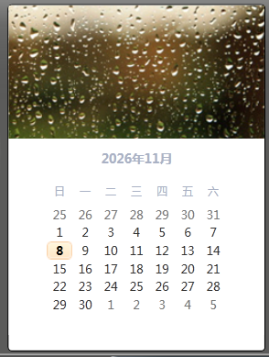
<Grid>
<Viewbox>
<Border Style="{DynamicResource TileClockCalendarBorder}">
<DockPanel Style="{DynamicResource TileClockCalendarContainer}">
<Image Name="MonthImage" RenderOptions.BitmapScalingMode="HighQuality" Style="{DynamicResource TileClockCalendarMonthImage}"></Image>
<Grid>
<Calendar Name="MonthCalendar" Style="{DynamicResource TileClockCalendarItem}" DisplayDateChanged="MonthCalendar_DisplayDateChanged">
</Calendar>
</Grid>
</DockPanel>
</Border>
</Viewbox>
</Grid>
Style notes (for the actual default styles, see the source code in the project repository):
Resource Key | Type | Purpose | Notes
TileClockCalendarBorder | Style[Border] | Container; also the border part
TileClockCalendarContainer | Style[DockPanel] | Container part
TileClockCalendarMonthImage | Style[Image] | The monthly image above the calendar.
TileClockCalendarItem | Style[Calendar] | Calendar. | Rewriting this template was very painful; if you do not want major changes, you do not need to override this style.

Flyout
Why is the flyout placed before the tile section? Because the tile section is quite large.
Layout:
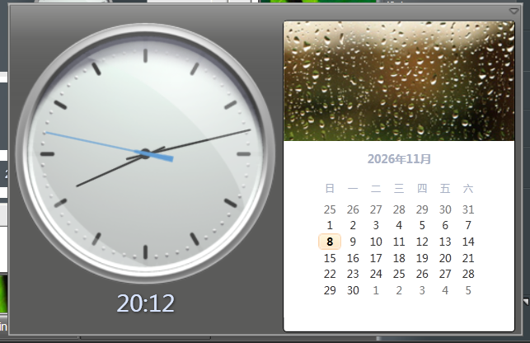
<Grid Style="{DynamicResource TileClockFlyoutPanel}">
<DockPanel LastChildFill="True">
<local:Calendar x:Name="DisplayCalendar" DockPanel.Dock="Right"></local:Calendar>
<StackPanel DockPanel.Dock="Left" Orientation="Vertical" VerticalAlignment="Top" HorizontalAlignment="Left">
<local:ClockControl x:Name="DisplayClock" Style="{DynamicResource TileClockFlyoutClock}"></local:ClockControl>
<local:ShortTimeText x:Name="DisplayShortTime" IsLarge="True" Style="{DynamicResource TileClockPanelShortTimeText}"></local:ShortTimeText>
<TextBlock Name="DisplayAlarm" Style="{DynamicResource TileClockPanelCommonTextFlyout}">
<Run Text="♫" />
<Run Text=" " />
<Run Name="DisplayAlarmTip" Text="" />
</TextBlock>
</StackPanel>
</DockPanel>
</Grid>
Style notes (for the actual default styles, see the source code in the project repository):
Resource Key | Type | Purpose | Notes
TileClockFlyoutPanel | Style[Grid] | Container.
TileClockFlyoutClock | Style[local:ClockControl] | The clock displayed in the flyout.
TileClockPanelShortTimeText | Style[local:ShortTimeText] | The short time text displayed in the flyout.
TileClockPanelCommonTextFlyout | Style[TextBlock] | The time text displayed in the flyout after the alarm is enabled.

Tile Panel
The tile panel is the style in which the tile is displayed. The clock has multiple tile panels (or “layouts”).
Style notes (for the actual default styles, see the source code in the project repository; parts that reuse this style are not described again below):
Resource Key | Type | Purpose | Notes
TileClockPanelCommonText | Style[TextBlock] | The style for non-special text on the tile.

Clock + Hours/Minutes + Month/Day
Layout:
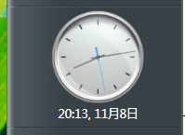
<Grid Style="{DynamicResource TileClockPanelFace1}">
<DockPanel>
<Grid Height="2" DockPanel.Dock="Top"></Grid>
<TextBlock Name="ClockDateTime" DockPanel.Dock="Bottom" Style="{DynamicResource TileClockPanelCommonText}">18 Jan., 2015.</TextBlock>
<p:ClockControl x:Name="ClockCtrl"></p:ClockControl>
</DockPanel>
</Grid>
Style notes (for the actual default styles, see the source code in the project repository):
Resource Key | Type | Purpose | Notes
TileClockPanelFace1 | Style[Grid] | Current panel style.

Clock + Short Time + Small Calendar
Layout:
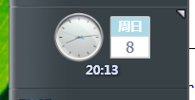
<Grid Style="{DynamicResource TileClockPanelFace2}">
<StackPanel Orientation="Vertical" VerticalAlignment="Center" HorizontalAlignment="Center">
<StackPanel Orientation="Horizontal" VerticalAlignment="Center" HorizontalAlignment="Center">
<p:ClockControl x:Name="ClockCtrl" Style="{DynamicResource TileClockPanel2Clock}"></p:ClockControl>
<Grid Height="1" Width="5"></Grid>
<p:SmallCalendar x:Name="ClockSmallCalendar" Style="{DynamicResource TileClockPanelSmallCalendar}"></p:SmallCalendar>
</StackPanel>
<p:ShortTimeText x:Name="ClockShortTime" HorizontalAlignment="Center" DockPanel.Dock="Bottom" Style="{DynamicResource TileClockPanelShortTimeText2}"></p:ShortTimeText>
</StackPanel>
</Grid>
Style notes (for the actual default styles, see the source code in the project repository):
Resource Key | Type | Purpose | Notes
TileClockPanelFace2 | Style[Grid] | Current panel style.
TileClockPanel2Clock | Style[p:ClockControl] | The clock style in the current panel.
TileClockPanelSmallCalendar | Style[p:SmallCalendar] | The small calendar style in the current panel.
TileClockPanelShortTimeText2 | Style[p:ShortTimeText] | The short time style in the current panel.

Short Time
Layout:
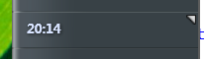
<Grid Style="{DynamicResource TileClockPanelFace3}">
<StackPanel Orientation="Horizontal" VerticalAlignment="Center">
<p:ShortTimeText x:Name="ClockShortTime" HorizontalContentAlignment="Left"></p:ShortTimeText>
</StackPanel>
</Grid>
Style notes (for the actual default styles, see the source code in the project repository):
Resource Key | Type | Purpose | Notes
TileClockPanelFace3 | Style[Grid] | Current panel style.

Short Time + Day of Week + Date
Layout:
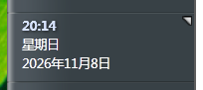
<Grid Style="{DynamicResource TileClockPanelFace4}">
<StackPanel Orientation="Horizontal" VerticalAlignment="Center">
<StackPanel>
<p:ShortTimeText x:Name="ClockShortTime" HorizontalContentAlignment="Left" Style="{DynamicResource TileClockPanelShortTimeText4}"></p:ShortTimeText>
<TextBlock Name="ClockDayInWeek" Style="{DynamicResource TileClockPanelCommonText4}">Sunday</TextBlock>
<TextBlock Name="ClockDate" Style="{DynamicResource TileClockPanelCommonText4}">May 11, 2026</TextBlock>
</StackPanel>
</StackPanel>
</Grid>
Style notes (for the actual default styles, see the source code in the project repository):
Resource Key | Type | Purpose | Notes
TileClockPanelFace4 | Style[Grid] | Current panel style.
TileClockPanelShortTimeText4 | Style[p:ShortTimeText] | The short time style of the current panel style.
TileClockPanelCommonText4 | Style[TextBlock] | The normal text style of the current panel style.

Clock + Short Time
Layout:
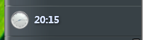
<Grid Style="{DynamicResource TileClockPanelFace5}">
<DockPanel LastChildFill="True">
<p:ClockControl x:Name="ClockPart" Style="{DynamicResource TileClockPanelClock5}"></p:ClockControl>
<StackPanel Style="{DynamicResource TileClockPanelTextPart5}">
<p:ShortTimeText x:Name="ShortTime" HorizontalContentAlignment="Left"></p:ShortTimeText>
</StackPanel>
</DockPanel>
</Grid>
Style notes (for the actual default styles, see the source code in the project repository):
Resource Key | Type | Purpose | Notes
TileClockPanelFace5 | Style[Grid] | Current panel style.
TileClockPanelClock5 | Style[p:ClockControl] | The clock style of the current panel style.
TileClockPanelTextPart5 | Style[StackPanel] | The text part of the current panel style.

Clock + Short Time + Month/Day
Layout:
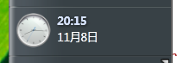
<Grid Style="{DynamicResource TileClockPanelFace6}">
<DockPanel LastChildFill="True">
<p:ClockControl x:Name="ClockPart" Style="{DynamicResource TileClockPanelClock6}"></p:ClockControl>
<StackPanel Style="{DynamicResource TileClockPanelTextPart5}">
<p:ShortTimeText x:Name="ShortTime" Style="{DynamicResource TileClockPanelShortTimeText6}"></p:ShortTimeText>
<TextBlock Name="Date" Style="{DynamicResource TileClockPanelCommonTextLeft}">May 11</TextBlock>
</StackPanel>
</DockPanel>
</Grid>
Style notes (for the actual default styles, see the source code in the project repository):
Resource Key | Type | Purpose | Notes
TileClockPanelFace6 | Style[Grid] | Current panel style.
TileClockPanelClock6 | Style[p:ClockControl] | The clock style of the current panel style.
TileClockPanelShortTimeText6 | Style[p:ShortTimeText] | The short time style of the current panel style.
TileClockPanelCommonTextLeft | Style[TextBlock] | The left-aligned normal text style of the current panel style.

Clock (larger) + Short Time + Month/Day
Layout:
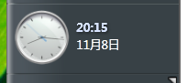
<Grid Style="{DynamicResource TileClockPanelFace7}">
<DockPanel LastChildFill="True">
<p:ClockControl x:Name="ClockPart" Style="{DynamicResource TileClockPanelClock7}"></p:ClockControl>
<StackPanel Style="{DynamicResource TileClockPanelTextPart5}">
<p:ShortTimeText x:Name="ShortTime" Style="{DynamicResource TileClockPanelShortTimeText6}"></p:ShortTimeText>
<TextBlock Name="Date" Style="{DynamicResource TileClockPanelCommonTextLeft}">May 11</TextBlock>
</StackPanel>
</DockPanel>
</Grid>
Style notes (for the actual default styles, see the source code in the project repository):
Resource Key | Type | Purpose | Notes
TileClockPanelFace7 | Style[Grid] | Current panel style.
TileClockPanelClock7 | Style[p:ClockControl] | The clock style of the current panel style.

Clock + Short Time + Day of Week + Date
Layout:
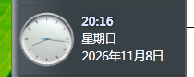
<Grid Style="{DynamicResource TileClockPanelFace7}">
<DockPanel LastChildFill="True">
<p:ClockControl x:Name="ClockPart" Style="{DynamicResource TileClockPanelClock7}"></p:ClockControl>
<StackPanel Style="{DynamicResource TileClockPanelTextPart5}">
<p:ShortTimeText x:Name="ClockShortTime" Style="{DynamicResource TileClockPanelShortTimeText6}"></p:ShortTimeText>
<TextBlock Name="ClockDayInWeek" Style="{DynamicResource TileClockPanelCommonTextLeft}">Sunday</TextBlock>
<TextBlock Name="ClockDate" Style="{DynamicResource TileClockPanelCommonTextLeft}">May 11, 2026</TextBlock>
</StackPanel>
</DockPanel>
</Grid>

Search Tile
The search tile existed in both the Plex and Slate eras of Windows Longhorn; it is tied to WinFS. The current default style follows the Slate era.
On Windows XP it displays a search results window (without automatically filling in the search content). On Windows Vista and later, because Windows Search is built into the system, it builds a search link instead. MSN Search builds a Bing search results page. To put it plainly, this cannot reproduce the exact Windows Longhorn effect; you could call it decorative. But it does still work.

Tile Panel
This was completed under the old architecture. Following the new architecture approach, the styles would most likely be written with Template.
Layout:
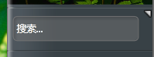
<Grid>
<Grid Style="{DynamicResource TileSearchTilePanel}">
<Border Style="{DynamicResource TileSearchTextboxBorder}">
<Border Style="{DynamicResource TileSearchTextboxBorderInner}">
<Grid Name="ClipGrid" ClipToBounds="True" Style="{DynamicResource TileSearchTextboxInnerClip}" SizeChanged="UserControl_SizeChanged">
<Grid>
<Rectangle Style="{DynamicResource TileSearchTextboxBackground}" ClipToBounds="True"></Rectangle>
</Grid>
<Grid>
<TextBox Name="SearchBox" Style="{DynamicResource TileSearchTextboxTextInput}" KeyDown="SearchBox_KeyDown">
<TextBox.Template>
<ControlTemplate TargetType="{x:Type TextBox}">
<Border x:Name="border" Background="{TemplateBinding Background}" BorderBrush="{TemplateBinding BorderBrush}" BorderThickness="{TemplateBinding BorderThickness}">
<Grid>
<TextBlock x:Name="Placeholder" Text="{TemplateBinding Tag}" Style="{DynamicResource TileSearchTextboxPlaceholder}" IsHitTestVisible="False" Visibility="{Binding Text, RelativeSource={RelativeSource TemplatedParent}, Converter={StaticResource TextEmptyToVisibility}}" />
<ScrollViewer x:Name="PART_ContentHost" Margin="{TemplateBinding Padding}" />
</Grid>
</Border>
<ControlTemplate.Triggers>
<Trigger Property="Text" Value="">
<Setter TargetName="Placeholder" Property="Visibility" Value="Visible" />
</Trigger>
<Trigger Property="Text" Value="{x:Null}">
<Setter TargetName="Placeholder" Property="Visibility" Value="Visible" />
</Trigger>
<DataTrigger Binding="{Binding Text.Length, RelativeSource={RelativeSource Self}}" Value="0">
<Setter TargetName="Placeholder" Property="Visibility" Value="Visible" />
</DataTrigger>
<Trigger Property="IsFocused" Value="True">
<Setter TargetName="Placeholder" Property="Visibility" Value="Collapsed" />
</Trigger>
<Trigger Property="IsMouseOver" Value="True">
<Setter TargetName="border" Property="Background" Value="#7BFFFFFF" />
</Trigger>
<Trigger Property="IsFocused" Value="True">
<Setter TargetName="border" Property="Background" Value="White" />
<Setter Property="Foreground" Value="Black" />
<Setter TargetName="Placeholder" Property="Visibility" Value="Collapsed" />
</Trigger>
</ControlTemplate.Triggers>
</ControlTemplate>
</TextBox.Template>
</TextBox>
</Grid>
<Grid IsHitTestVisible="False" Style="{DynamicResource TileSearchTextboxInnerShadowRegion}">
<Rectangle Style="{DynamicResource TileSearchTextboxInnerShadowTop}" />
<Rectangle Style="{DynamicResource TileSearchTextboxInnerShadowLeft}" />
</Grid>
</Grid>
</Border>
</Border>
</Grid>
</Grid>
Style notes (for the actual default styles, see the source code in the project repository):
Resource Key | Type | Purpose | Notes
TileSearchTilePanel | Style[Grid] | The root container style of the search tile panel.
TileSearchTextboxBorder | Style[Border] | The outer border style of the search box.
TileSearchTextboxBorderInner | Style[Border] | The inner border style of the search box.
TileSearchTextboxInnerClip | Style[Grid] | The inner clip/content container style of the search box.
TileSearchTextboxBackground | Style[Rectangle] | The search box background rectangle style.
TileSearchTextboxTextInput | Style[TextBox] | The search input box style.
TileSearchTextboxPlaceholder | Style[TextBlock] | The search box placeholder text style. | Corresponds to Placeholder in the template; the TextEmptyToVisibility converter and triggers control show/hide.
TileSearchTextboxInnerShadowRegion | Style[Grid] | The container style for the inner shadow area of the search box. | Corresponds to the inner shadow Grid; sets IsHitTestVisible="False" so it does not participate in mouse hit testing.
TileSearchTextboxInnerShadowTop | Style[Rectangle] | The top inner shadow style of the search box. | The upper rectangle in the inner shadow layer.
TileSearchTextboxInnerShadowLeft | Style[Rectangle] | The left inner shadow style of the search box. | The left rectangle in the inner shadow layer.

Flyout
Layout:
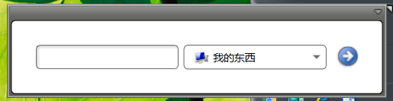
<Grid>
<Border Style="{DynamicResource TileSearchFlyoutContainerBorder}">
<Grid>
<StackPanel Orientation="Horizontal" HorizontalAlignment="Center" VerticalAlignment="Center">
<TextBox Name="SearchText" Style="{DynamicResource TileSearchFlyoutCustomTextboxStyle}" TextChanged="SearchText_TextChanged" KeyDown="SearchText_KeyDown"></TextBox>
<ComboBox Name="SearchProviderSelect" Style="{DynamicResource TileSearchFlyoutCustomComboBoxStyle}" SelectionChanged="SearchProviderSelect_SelectionChanged">
<ComboBox.ItemTemplate>
<DataTemplate>
<StackPanel Orientation="Horizontal">
<Image Source="{Binding Key, Converter={StaticResource ProviderToIconConverter}}" Width="16" Height="16" Margin="3,3,5,3" />
<TextBlock Margin="0,0,3,0" Text="{Binding Value}" VerticalAlignment="Center" />
</StackPanel>
</DataTemplate>
</ComboBox.ItemTemplate>
</ComboBox>
<Button Style="{DynamicResource TileSearchFlyoutCustomNextButtonStyle}" Click="Button_Click"></Button>
</StackPanel>
</Grid>
</Border>
</Grid>
Style notes (for the actual default styles, see the source code in the project repository):
Resource Key | Type | Purpose | Notes
TileSearchFlyoutContainerBorder | Style[Border] | The container border style of the search tile flyout.
TileSearchFlyoutCustomTextboxStyle | Style[TextBox] | The search input box style in the search flyout.
TileSearchFlyoutCustomComboBoxStyle | Style[ComboBox] | The search provider selection drop-down style.
TileSearchFlyoutCustomNextButtonStyle | Style[Button] | The “Next/Search” button style in the search flyout.

Feed Tile
The feed tile is also a tile from the old architecture. To be honest, I really want to refactor it; mainly because I did not understand templates at the time.
The feed sources of the feed tile come from the “Microsoft Feeds 2.0 Object Library”, just like Windows desktop gadgets. Opening Internet Explorer actually lets you subscribe to and manage these feeds. But background updates probably depend on system support.
It uses a fair amount of memory because it involves COM components. There is currently no good solution. Maybe let AI handle it? (laughs)

Components

Feed Title Item
Used in the tile to represent a feed title item. In Windows Longhorn it was not clickable; this one is clickable and displays detailed content.
Layout:
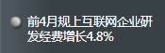
<Grid Margin="0,15,0,15">
<StackPanel Orientation="Horizontal" VerticalAlignment="Top" Background="Transparent">
<DockPanel Margin="5,1,0,0">
<Image DockPanel.Dock="Top" Name="ItemPoint" Style="{DynamicResource TileFeedsTileItemPoint}"></Image>
<Grid></Grid>
</DockPanel>
<TextBlock Name="FeedTitle" Margin="4,0,0,0" TextWrapping="Wrap" Style="{DynamicResource TileFeedTitleNormal}"></TextBlock>
</StackPanel>
<Button Name="ClickContainer" Background="Transparent" BorderBrush="Transparent" BorderThickness="0" MouseEnter="StackPanel_MouseEnter" MouseLeave="StackPanel_MouseLeave" Click="ClickContainer_Click">
<Button.Template>
<ControlTemplate TargetType="Button">
<Border Background="{TemplateBinding Background}" BorderBrush="{TemplateBinding BorderBrush}" BorderThickness="{TemplateBinding BorderThickness}"></Border>
</ControlTemplate>
</Button.Template>
</Button>
</Grid>
Style notes (for the actual default styles, see the source code in the project repository):
Resource Key | Type | Purpose | Notes
TileFeedsTileItemPoint | Style[Image] | The indicator dot image style of a feed item.
TileFeedTitleNormal | Style[TextBlock] | The feed item title text style.
TileFeedTitleHover | Style[TextBlock] | The feed item title text style when hovered.

Flyout Feed Item
The feed title item used in the flyout. In Windows Longhorn it was not clickable; this one is clickable and displays detailed content.
Layout:
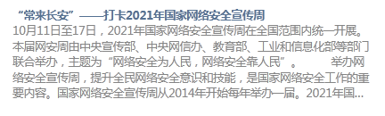
<Grid Margin="0,10,0,10">
<WrapPanel Orientation="Vertical" Name="FeedItemContainer">
<TextBlock Name="Title" Style="{DynamicResource TileFeedItemTitle}">Feed Item Title</TextBlock>
<TextBlock Name="Desc" Style="{DynamicResource TileFeedItemDescription}">Feed Item Content</TextBlock>
</WrapPanel>
<Button Name="ClickContainer" Click="ClickContainer_Click" Background="Transparent" BorderBrush="Transparent" BorderThickness="0"
MouseEnter="FeedItemContainer_MouseEnter" MouseLeave="FeedItemContainer_MouseLeave">
<Button.Template>
<ControlTemplate TargetType="Button">
<Border Background="{TemplateBinding Background}" BorderBrush="{TemplateBinding BorderBrush}" BorderThickness="{TemplateBinding BorderThickness}"></Border>
</ControlTemplate>
</Button.Template>
</Button>
</Grid>
Style notes (for the actual default styles, see the source code in the project repository):
Resource Key | Type | Purpose | Notes
TileFeedItemTitle | Style[TextBlock] | The feed item title text style.
TileFeedItemDescription | Style[TextBlock] | The feed item content/description text style.
TileFeedItemTitleHover | Style[TextBlock] | The feed item title text style when hovered.
TileFeedItemDescriptionHover | Style[TextBlock] | The feed item content/description text style when hovered.

Tile Panel
Layout:
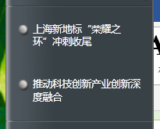
<Grid Margin="7,0,7,0" Height="Auto">
<Grid>
<Grid>
<WrapPanel Name="LoadingPanel" Orientation="Horizontal" Margin="3,10,3,10" VerticalAlignment="Center" HorizontalAlignment="Center">
<Image Name="LoadingImage" Width="16"></Image>
<TextBlock Margin="10,0,0,0" Name="LoadingText" Style="{DynamicResource GlobalTextBlockTextDisplay}">Loading...</TextBlock>
</WrapPanel>
</Grid>
<Grid>
<WrapPanel Name="NoItemsPanel" Orientation="Horizontal" Margin="3,10,3,10" VerticalAlignment="Center" HorizontalAlignment="Center">
<TextBlock Name="NoItemsText" Style="{DynamicResource GlobalTextBlockTextDisplay}">There is no items.</TextBlock>
</WrapPanel>
</Grid>
<StackPanel Orientation="Vertical" Name="FeedItemsContainerBehind" VerticalAlignment="Top">

</StackPanel>
<StackPanel Orientation="Vertical" Name="FeedItemsContainerFront" VerticalAlignment="Top">

</StackPanel>
</Grid>
</Grid>

Flyout
Layout:
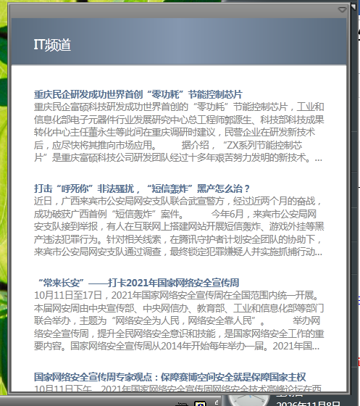
<Grid>
<DockPanel Width="370">
<Grid DockPanel.Dock="Top" Height="52">
<Rectangle Style="{DynamicResource TileFeedFlyoutHeaderBackground}"></Rectangle>
<TextBlock Name="FeedTitle" TextTrimming="CharacterEllipsis" Style="{DynamicResource TileFeedFlyoutHeaderTitle}"></TextBlock>
<Button Name="ButtonBack" Focusable="False" HorizontalAlignment="Left" Style="{DynamicResource TileFeedFlyoutSwitchButton}" Click="ButtonBack_Click">3</Button>
<Button Name="ButtonNext" Focusable="False" HorizontalAlignment="Right" Style="{DynamicResource TileFeedFlyoutSwitchButton}" Click="ButtonNext_Click">4</Button>
</Grid>
<Line DockPanel.Dock="Top" Style="{DynamicResource TileFeedFlyoutLine}"></Line>
<ScrollViewer Style="{DynamicResource TileFeedFlyoutContentPart}" VerticalScrollBarVisibility="Auto">
<WrapPanel Style="{DynamicResource TileFeedFlyoutContentContainer}" Name="FeedItemList">
</WrapPanel>
</ScrollViewer>
</DockPanel>
</Grid>
Style notes (for the actual default styles, see the source code in the project repository):
Resource Key | Type | Purpose | Notes
TileFeedFlyoutHeaderBackground | Style[Rectangle] | The flyout header background rectangle style.
TileFeedFlyoutHeaderTitle | Style[TextBlock] | The flyout header title text style.
TileFeedFlyoutSwitchButton | Style[Button] | The flyout previous/next button style.
TileFeedFlyoutLine | Style[Line] | The flyout header separator line style.
TileFeedFlyoutContentPart | Style[ScrollViewer] | The flyout content scroll area style.
TileFeedFlyoutContentContainer | Style[WrapPanel] | The flyout feed item container style.

Quick Launch Tile
Quick Launch refers to the Quick Launch toolbar that could optionally be shown on the taskbar in Windows XP – Vista (in Windows 7 and later it was replaced by pinned taskbar icons, but the original Quick Launch folder remains); taskbar icons are all placed in one location. The Quick Launch tile displays the lnk and scf files in that location.

Tile Panel
This was completed under the old architecture. Following the new architecture approach, the styles would most likely be written with Template.
Layout:
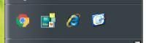
<Grid Height="Auto">
<ItemsControl Style="{DynamicResource TileIconItemTileContainerForQuickLaunchTile}"
Name="ItemContainer"
ItemsSource="{Binding TrayIcons}"
ItemTemplate="{DynamicResource ItemTemplate}"
ItemsPanel="{DynamicResource TileIconItemWrapPanelForQuickLaunchTile}"
PreviewMouseRightButtonDown="ItemContainer_PreviewMouseRightButtonDown"/>
</Grid>
Style notes (for the actual default styles, see the source code in the project repository):
Resource Key | Type | Purpose | Notes
TileIconItemForQuickLaunchTile | Style[Button] | The Quick Launch icon button style.
TileIconItemTileContainerForQuickLaunchTile | Style[ItemsControl] | The Quick Launch icon item container style.
TileIconItemWrapPanelForQuickLaunchTile | ItemsPanelTemplate | The Quick Launch icon item arrangement panel template.

Flyout
Layout:
。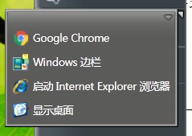
<Grid Width="Auto" Height="Auto" MaxHeight="400" MaxWidth="500">
<ScrollViewer VerticalScrollBarVisibility="Auto">
<ItemsControl
Name="ItemContainer"
ItemsSource="{Binding TrayIcons}"
ItemTemplate="{DynamicResource ItemTemplate}"
ItemsPanel="{DynamicResource TileIconItemWithTextWrapPanel}"
PreviewMouseRightButtonDown="ItemContainer_PreviewMouseRightButtonDown"/>
</ScrollViewer>
</Grid>
Style notes (for the actual default styles, see the source code in the project repository):
Resource Key | Type | Purpose | Notes
TileIconItemWithTextForQuickLaunchTile | Style[Button] | The Quick Launch flyout icon button style with text.
TileIconItemWithTextItemTextPart | Style[TextBlock] | The Quick Launch flyout icon item text style.
TileIconItemWithTextWrapPanel | ItemsPanelTemplate | The Quick Launch flyout icon item arrangement panel template.

Tray Icon Tile
This was really troublesome to implement; fortunately, AI read the historical documents and related code before it could be done. One problem is that it does not fully reproduce the tray icon functionality, and its level of support is limited. It does not support the new Windows 11 taskbar.

Tile Panel
Layout:
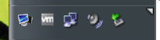
<Grid Height="Auto">
<ItemsControl Margin="4,3,1,3"
Name="SystemTrayContainer"
ItemsSource="{Binding TrayIcons}"
ItemTemplate="{DynamicResource TrayIconTemplate}"
ItemsPanel="{DynamicResource TileIconItemWrapPanelForTrayTile}"
PreviewMouseRightButtonDown="SystemTrayContainer_PreviewMouseRightButtonDown"/>
</Grid>
Style notes (for the actual default styles, see the source code in the project repository):
Resource Key | Type | Purpose | Notes
TileIconItemForTrayTile | Style[Button] | The tray icon button style.
TileIconItemWrapPanelForTrayTile | ItemsPanelTemplate | The tray icon item arrangement panel template.

Flyout
Layout:
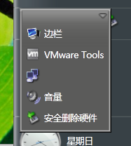
<Grid Width="Auto" Height="Auto" MaxHeight="400" MaxWidth="500">
<ScrollViewer VerticalScrollBarVisibility="Auto">
<ItemsControl
Name="ItemContainer"
ItemsSource="{Binding TrayIcons}"
ItemTemplate="{DynamicResource ItemTemplate}"
ItemsPanel="{DynamicResource TileIconItemWithTextWrapPanel}"
PreviewMouseRightButtonDown="ItemContainer_PreviewMouseRightButtonDown"/>
</ScrollViewer>
</Grid>
Style notes (for the actual default styles, see the source code in the project repository):
Resource Key | Type | Purpose | Notes
TileIconItemWithTextForTrayTile | Style[Button] | The tray flyout icon button style with text.
TileIconItemWithTextItemTextPart | Style[TextBlock] | The tray flyout icon item text style.
TileIconItemWithTextWrapPanel | ItemsPanelTemplate | The tray flyout icon item arrangement panel template.

Power Tile
The earliest version was actually very simple, with only an icon and text. Later, after exploring how Windows Longhorn implemented it (I also made BamlLonghorn for parsing and decompiling BAML from the Windows Longhorn era, completed with AI; link: https://github.com/windowsmodern/baml-longhorn ), it was made to imitate the Windows Longhorn look.
This one was also quite troublesome to make.

Tile Panel
Old Layout:
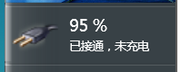
<Grid Margin="6,4,6,4">
<StackPanel Orientation="Horizontal">
<Image Name="PowerIcon" Width="40" Height="40" RenderOptions.BitmapScalingMode="HighQuality"/>
<Grid Width="10" Height="10" />
<StackPanel Name="TextPart" VerticalAlignment="Center" Orientation="Vertical">
<TextBlock FontSize="14" Name="VolumeDisplay" TextWrapping="Wrap">
<Run Name="BatteryVolume" Text="0"/>
<Run Text="%" />
</TextBlock>
<TextBlock Name="ACDisplay" Visibility="Collapsed" TextWrapping="Wrap">
</TextBlock>
<TextBlock Name="StatusText" Margin="0,3,0,0" TextWrapping="Wrap"></TextBlock>
</StackPanel>
</StackPanel>
</Grid>
The old layout has been abandoned; only the code is retained, but it is no longer used.
New Layout:
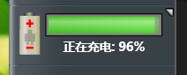
<Grid>
<Grid Margin="0,4">
<Canvas x:Name="TilePowerTile_BatteryCanvas" Style="{DynamicResource TilePowerTileBatteryCanvas}">
<Canvas x:Name="TilePowerTile_Power" Style="{DynamicResource TilePowerTilePower}">
<Canvas x:Name="TilePowerTile_battery_body" Style="{DynamicResource TilePowerTileBatteryBody}">
<Rectangle x:Name="TilePowerTile_coppertop" Style="{DynamicResource TilePowerTileCoppertop}"/>
<Rectangle x:Name="TilePowerTile_copper" Style="{DynamicResource TilePowerTileCopper}"/>
<Rectangle x:Name="TilePowerTile_border" Style="{DynamicResource TilePowerTileBorder}"/>
<Rectangle x:Name="TilePowerTile_minus" Style="{DynamicResource TilePowerTileMinus}"/>
<Rectangle x:Name="TilePowerTile_plus_h" Style="{DynamicResource TilePowerTilePlusH}"/>
<Rectangle x:Name="TilePowerTile_plus_v" Style="{DynamicResource TilePowerTilePlusV}"/>
</Canvas>
<Rectangle x:Name="TilePowerTile_nub" Style="{DynamicResource TilePowerTileNub}"/>
<Canvas x:Name="TilePowerTile_ACLogo" Style="{DynamicResource TilePowerTileACLogo}">
<Rectangle Style="{DynamicResource TilePowerTileACLogoRectSmallTop}"/>
<Rectangle Style="{DynamicResource TilePowerTileACLogoRectSmallBottom}"/>
<Rectangle Style="{DynamicResource TilePowerTileACLogoRectTall}"/>
<Rectangle Style="{DynamicResource TilePowerTileACLogoRectWide}"/>
</Canvas>
</Canvas>
</Canvas>
<DockPanel x:Name="TilePowerTile_StatusPanel" Style="{DynamicResource TilePowerTileStatusPanel}">
<DockPanel Style="{DynamicResource TilePowerTileStatusInnerPanel}">
<DockPanel Style="{DynamicResource TilePowerTileGaugeTopPanel}">
<Border Style="{DynamicResource TilePowerTileGaugeBackgroundBorder}">
<Border Style="{DynamicResource TilePowerTileGaugeOuterBorder}">
<DockPanel Style="{DynamicResource TilePowerTileGaugeInnerPanel}">
<Grid x:Name="TilePowerTile_GaugeGrid" Style="{DynamicResource TilePowerTileGaugeGrid}">
<Grid.ColumnDefinitions>
<ColumnDefinition x:Name="TilePowerTile_GaugeColumn" Style="{DynamicResource TilePowerTileGaugeColumn}"/>
<ColumnDefinition x:Name="TilePowerTile_GaugeRemainColumn" Style="{DynamicResource TilePowerTileGaugeRemainColumn}"/>
</Grid.ColumnDefinitions>
<Rectangle x:Name="TilePowerTile_gaugebkg" Style="{DynamicResource TilePowerTileGaugeBackground}"/>
<Rectangle x:Name="TilePowerTile_gauge" Style="{DynamicResource TilePowerTileGauge}"/>
<Rectangle x:Name="TilePowerTile_gaugesweep" Style="{DynamicResource TilePowerTileGaugeSweep}"/>
</Grid>
</DockPanel>
</Border>
</Border>
</DockPanel>
<DockPanel x:Name="TilePowerTile_TextPanel" Style="{DynamicResource TilePowerTileTextPanel}">
<TextBlock x:Name="TilePowerTile_Numbers" Style="{DynamicResource TilePowerTileNumbers}"/>
</DockPanel>
</DockPanel>
</DockPanel>
</Grid>
</Grid>
Style notes (for the actual default styles, see the source code in the project repository):
Resource Key | Type | Purpose | Notes
TilePowerTileBatteryCanvas | Style[Canvas] | The battery icon outer canvas style.
TilePowerTilePower | Style[Canvas] | The power icon body canvas style.
TilePowerTileBatteryBody | Style[Canvas] | The battery body canvas style.
TilePowerTileCoppertop | Style[Rectangle] | The battery top copper rectangle style.
TilePowerTileCopper | Style[Rectangle] | The battery copper rectangle style.
TilePowerTileBorder | Style[Rectangle] | The battery border rectangle style.
TilePowerTileMinus | Style[Rectangle] | The battery negative terminal mark style.
TilePowerTilePlusH | Style[Rectangle] | The battery positive terminal horizontal mark style.
TilePowerTilePlusV | Style[Rectangle] | The battery positive terminal vertical mark style.
TilePowerTileNub | Style[Rectangle] | The battery contact/bump style.
TilePowerTileACLogo | Style[Canvas] | The AC power symbol canvas style.
TilePowerTileACLogoRectSmallTop | Style[Rectangle] | The AC symbol upper small rectangle style.
TilePowerTileACLogoRectSmallBottom | Style[Rectangle] | The AC symbol lower small rectangle style.
TilePowerTileACLogoRectTall | Style[Rectangle] | The AC symbol vertical rectangle style.
TilePowerTileACLogoRectWide | Style[Rectangle] | The AC symbol horizontal rectangle style.
TilePowerTileStatusPanel | Style[DockPanel] | The battery status area container style.
TilePowerTileStatusInnerPanel | Style[DockPanel] | The battery status area inner container style.
TilePowerTileGaugeTopPanel | Style[DockPanel] | The battery bar top container style.
TilePowerTileGaugeBackgroundBorder | Style[Border] | The battery bar background border style.
TilePowerTileGaugeOuterBorder | Style[Border] | The battery bar outer border style.
TilePowerTileGaugeInnerPanel | Style[DockPanel] | The battery bar inner container style.
TilePowerTileGaugeGrid | Style[Grid] | The battery bar grid style.
TilePowerTileGaugeColumn | Style[ColumnDefinition] | The battery bar used-capacity column style.
TilePowerTileGaugeRemainColumn | Style[ColumnDefinition] | The battery bar remaining-capacity column style.
TilePowerTileGaugeBackground | Style[Rectangle] | The battery bar background rectangle style.
TilePowerTileGauge | Style[Rectangle] | The battery bar foreground rectangle style.
TilePowerTileGaugeSweep | Style[Rectangle] | The battery bar sweep/highlight rectangle style.
TilePowerTileTextPanel | Style[DockPanel] | The battery text area container style.
TilePowerTileNumbers | Style[TextBlock] | The battery percentage text style.
TilePowerTileNumbersForFlyout | Style[TextBlock] | The battery percentage text style, used in the flyout.

Flyout
Layout:
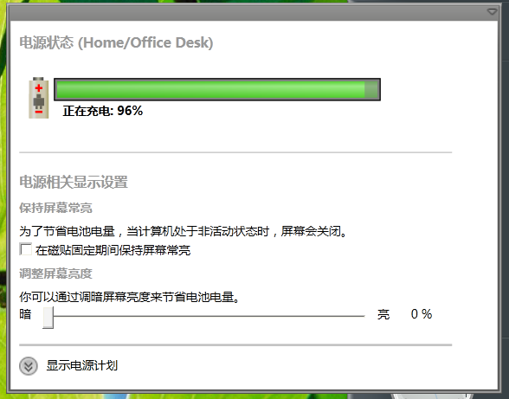
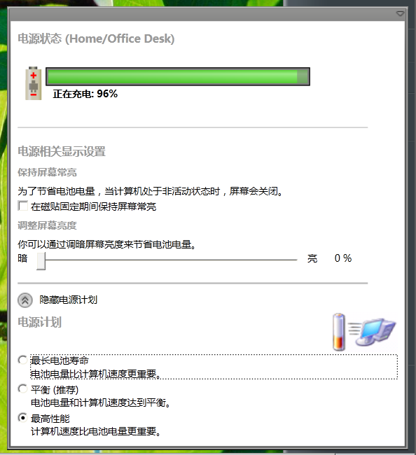
<Grid Margin="8,8,8,8">
<StackPanel>
<StackPanel>
<TextBlock Name="TitlePowerStatus" Style="{DynamicResource TilePowerFlyoutTitle1}">Power Status</TextBlock>
<StackPanel Name="TilePanelContainer" Margin="0,16,0,0">

</StackPanel>
</StackPanel>
<Line Margin="0,25,0,15" X1="0" Y1="0" X2="400" Y2="0" Style="{DynamicResource TilePowerFlyoutSpillter}"></Line>
<StackPanel>
<TextBlock Name="TitlePrds" Style="{DynamicResource TilePowerFlyoutTitle1}">Power-Related Display Settings</TextBlock>
<TextBlock Name="TitleKeepScreen" Style="{DynamicResource TilePowerFlyoutTitle2}">Keep my screen on</TextBlock>
<TextBlock Name="DescKeepScreen" Margin="0,2,0,2">To conserve ...</TextBlock>
<CheckBox Name="InputKeepScreen" Margin="0,2,0,2">Keep my screen on for the rest of this Windows session</CheckBox>
<TextBlock Name="TitleAsb" Style="{DynamicResource TilePowerFlyoutTitle2}">Adjust the screen brightness</TextBlock>
<TextBlock Name="DescAsb" Margin="0,2,0,2">You can conserve ...</TextBlock>
<StackPanel Orientation="Horizontal" VerticalAlignment="Center">
<TextBlock Name="TipDim">Dim</TextBlock>
<Slider Name="InputBrightness" AutoToolTipPlacement="TopLeft" AutoToolTipPrecision="0" Minimum="0" Maximum="100" TickFrequency="1" Width="300" Margin="10,0,10,0"></Slider>
<TextBlock Name="TipBright">Bright</TextBlock>
<TextBlock Name="LabelBrightnessTip" Margin="20,0,0,0">
<Run Name="LabelBrightnessTipPercent" Text="{Binding ElementName=InputBrightness, Path=Value, StringFormat={}{0:F0}}" />
<Run Text="%" />
</TextBlock>
</StackPanel>
</StackPanel>
<Line Margin="0,15,0,5" X1="0" Y1="0" X2="400" Y2="0" StrokeThickness="2" Style="{DynamicResource TilePowerFlyoutSpillter}"></Line>
<StackPanel Margin="0,5,0,5" Orientation="Horizontal" VerticalAlignment="Center">
<ToggleButton Name="FoldButton" Width="17" Height="17" Style="{DynamicResource TilePowerFoldToggleButton}" Checked="FoldButton_Checked" Unchecked="FoldButton_Unchecked"></ToggleButton>
<TextBlock Margin="8,0,0,0" Name="LabelFold">Show power plans</TextBlock>
</StackPanel>
<StackPanel Name="PowerPlansPart">
<DockPanel LastChildFill="False">
<Image Width="75" Name="ImagePowerPlan" DockPanel.Dock="Right"></Image>
<TextBlock Name="TitlePowerPlans" Style="{DynamicResource TilePowerFlyoutTitle1}">Power Plans</TextBlock>
</DockPanel>
<RadioButton Name="InputPlanLongest" Margin="0,2,0,2">
<TextBlock>
<Run Name="TitleLongest" Text="Longest Battery Life" />
<LineBreak />
<Run Name="DescLongest" Text="Barrery power is more important than computer speed." />
</TextBlock>
</RadioButton>
<RadioButton Name="InputPlanBalanced" Margin="0,2,0,2">
<TextBlock>
<Run Name="TitleBalanced" Text="Balanced (Recommended)" />
<LineBreak />
<Run Name="DescBalanced" Text="Barrery power is more important than computer speed." />
</TextBlock>
</RadioButton>
<RadioButton Name="InputPlanHighest" Margin="0,2,0,2">
<TextBlock>
<Run Name="TitleHighest" Text="Highest Performance" />
<LineBreak />
<Run Name="DescHighest" Text="Barrery power is more important than computer speed." />
</TextBlock>
</RadioButton>
</StackPanel>
</StackPanel>
</Grid>
Style notes (for the actual default styles, see the source code in the project repository):
Resource Key | Type | Purpose | Notes
TilePowerFlyoutTitle1 | Style[TextBlock] | The power flyout level-1 heading text style.
TilePowerFlyoutTitle2 | Style[TextBlock] | The power flyout level-2 heading text style.
TilePowerFlyoutSpillter | Style[Line] | The power flyout separator line style. | Spelled Spillter.
TilePowerFoldToggleButton | Style[ToggleButton] | The power flyout collapse/expand button style.

Slideshow Tile
It does not fully reproduce the Windows Longhorn effect, and it really consumes a lot of memory. (The memory issue is a hard problem.)

Tile Panel
There are no style keys available for customization here.
Layout:
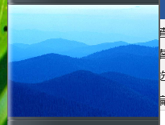
<Grid Background="Transparent" Height="Auto">
<Image Name="Image1"
VerticalAlignment="Center"
HorizontalAlignment="Stretch"
Stretch="Uniform"
RenderTransformOrigin="0.5,0.5">
<Image.RenderTransform>
<ScaleTransform ScaleX="1" ScaleY="1"/>
</Image.RenderTransform>
</Image>
<Image Name="Image2"
VerticalAlignment="Center"
HorizontalAlignment="Stretch"
Stretch="Uniform"
RenderTransformOrigin="0.5,0.5">
<Image.RenderTransform>
<ScaleTransform ScaleX="1" ScaleY="1"/>
</Image.RenderTransform>
</Image>
</Grid>

Flyout
Layout:
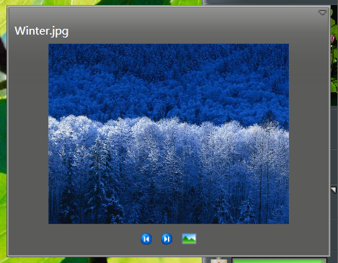
<Grid>
<DockPanel>
<TextBlock Name="FileName" DockPanel.Dock="Top" TextTrimming="CharacterEllipsis" Style="{DynamicResource TileSlideshowFlyoutFileName}"></TextBlock>
<StackPanel MinHeight="27" Margin="0,3,0,3" DockPanel.Dock="Bottom" Orientation="Horizontal" VerticalAlignment="Center" HorizontalAlignment="Center">
<Button Name="BtnBack" Click="BtnBack_Click" Style="{DynamicResource TileSlideshowBackButton}"></Button>
<Button Name="BtnNext" Click="BtnNext_Click" Margin="10,0,10,0" Style="{DynamicResource TileSlideshowNextButton}"></Button>
<Button Name="BtnOpenFile" Click="BtnOpenFile_Click" Style="{DynamicResource TileSlideshowOpenFileButton}"></Button>
</StackPanel>
<Viewbox>
<Image Name="Image"></Image>
</Viewbox>
</DockPanel>
</Grid>
Style notes (for the actual default styles, see the source code in the project repository):
Resource Key | Type | Purpose | Notes
TileSlideshowFlyoutFileName | Style[TextBlock] | The slideshow flyout file name text style.
TileSlideshowBackButton | Style[Button] | The slideshow flyout “Previous” button style.
TileSlideshowNextButton | Style[Button] | The slideshow flyout “Next” button style.
TileSlideshowOpenFileButton | Style[Button] | The slideshow flyout “Open File” button style.

User Tile
This tile existed in the Plex era, but disappeared in the Slate era.
The small icon used for the tile was originally used for the Plex People tile, but in the Slate era it became the Contact tile and the icon was changed, so it was used.
It borrows some elements from the User and Welcome tiles for Karl's Sidebar.

Tile Panel
Layout:
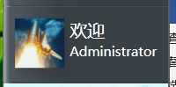
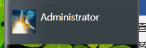
<Grid Margin="8,8,2,8">
<DockPanel Name="WelcomePart" Margin="2" Opacity="0" Visibility="Collapsed">
<Image Name="WelcomeUserImage" Style="{DynamicResource TileUserWelcomeUserImage}"></Image>
<StackPanel Orientation="Vertical">
<TextBlock Name="WelcomeText" Style="{DynamicResource TileUserWelcomeUserWelcomeText}">Welcome,</TextBlock>
<TextBlock Name="WelcomeUser" TextWrapping="Wrap" Style="{DynamicResource TileUserWelcomeUserUserText}">User</TextBlock>
</StackPanel>
</DockPanel>
<DockPanel VerticalAlignment="Center" Name="CommonPanel" Opacity="0" Visibility="Collapsed">
<Image Name="UserImage" Style="{DynamicResource TileUserCommonUserImage}"></Image>
<WrapPanel>
<TextBlock Name="UserName" HorizontalAlignment="Stretch" TextWrapping="Wrap" Style="{DynamicResource TileUserCommonUserText}">Administrator</TextBlock>
</WrapPanel>
</DockPanel>
</Grid>
Style notes (for the actual default styles, see the source code in the project repository):
Resource Key | Type | Purpose | Notes
TileUserWelcomeUserImage | Style[Image] | The welcome area user avatar image style.
TileUserWelcomeUserWelcomeText | Style[TextBlock] | The welcome area “Welcome,” text style.
TileUserWelcomeUserUserText | Style[TextBlock] | The welcome area user name text style.
TileUserCommonUserImage | Style[Image] | The regular area user avatar image style.
TileUserCommonUserText | Style[TextBlock] | The regular area user name text style.

Flyout
Layout:
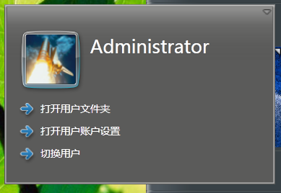
<Grid>
<DockPanel Margin="6">
<DockPanel DockPanel.Dock="Top" VerticalAlignment="Top">
<Viewbox Style="{DynamicResource TileUserFlyoutUserImageView}">
<Grid Width="Auto" Height="Auto">
<Image Name="UserImage" Style="{DynamicResource TileUserFlyoutUserImage}"></Image>
<Image Name="BorderImage" Style="{DynamicResource TileUserFlyoutUserImageBorder}"></Image>
</Grid>
</Viewbox>
<WrapPanel Margin="5,0,5,0">
<TextBlock Name="UserName" TextWrapping="Wrap" Style="{DynamicResource TileUserFlyoutUserName}">User</TextBlock>
</WrapPanel>
</DockPanel>
<StackPanel DockPanel.Dock="Bottom" Orientation="Horizontal">
<StackPanel Orientation="Vertical" Margin="5,5,0,0">
<Button Name="UserFolderButton" Click="UserFolderButton_Click" Style="{DynamicResource TileUserFlyoutButtonStyle}">User Folder</Button>
<Button Name="UserSettingsButton" Click="UserSettingsButton_Click" Style="{DynamicResource TileUserFlyoutButtonStyle}" Margin="0,5">User Settings</Button>
<Button Name="UserSwitchButton" Click="UserSwitchButton_Click" Style="{DynamicResource TileUserFlyoutButtonStyle}">Switch User</Button>
</StackPanel>
</StackPanel>
</DockPanel>
</Grid>
Style notes (for the actual default styles, see the source code in the project repository):
Resource Key | Type | Purpose | Notes
TileUserFlyoutUserImageView | Style[Viewbox] | The user flyout avatar view container style.
TileUserFlyoutUserImage | Style[Image] | The user flyout avatar image style.
TileUserFlyoutUserImageBorder | Style[Image] | The user flyout avatar border image style.
TileUserFlyoutUserName | Style[TextBlock] | The user flyout user name text style.
TileUserFlyoutButtonStyle | Style[Button] | The user flyout action button style.

Notification History Tile
This tile appeared in the Slate era, because Microsoft wanted to design a notification center at the time, along with a notification window similar to today's Toast notifications. But this design was not implemented well until Windows 10.
In fact, Windows Longhorn's Toast notifications supported adding buttons, which is also possible with Windows 10 Toast notifications.

Tile Panel
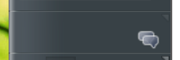
TilePanel is used rather than TilePanel2.
Layout:
<Grid>
<Border Visibility="Hidden" Name="NotificationPanelProp" Style="{DynamicResource TileNotificationTilePanelDetail}" SizeChanged="NotificationPanelProp_SizeChanged"></Border>
<Border Visibility="Hidden" Name="NotificationButtonProp" Style="{DynamicResource TileNotificationTileButtonDetail}" SizeChanged="NotificationButtonProp_SizeChanged"></Border>
<Button Visibility="Hidden" Name="NotificationStyleButton" Style="{DynamicResource TileNotificationButton}" HorizontalAlignment="Left" VerticalAlignment="Top" SizeChanged="NotificationStyleButton_SizeChanged"></Button>
<Canvas SizeChanged="Canvas_SizeChanged" Name="NoticePanel" Style="{DynamicResource TileNotificationTileArea}"></Canvas>
</Grid>
Style notes (for the actual default styles, see the source code in the project repository):
Resource Key | Type | Purpose | Notes
TileNotificationTilePanelDetail | Style[Border] | The notification history tile panel measurement container style. | A hidden element whose size is read in code to calculate the visible count and stacked count.
TileNotificationTileButtonDetail | Style[Border] | The notification history tile button measurement container style. | A hidden element whose size is read in code to calculate the stacking offset and merge distance.
TileNotificationButton | Style[Button] | The notification history tile notification button style. | Notification buttons are created dynamically in code via TryFindResource("TileNotificationButton").
TileNotificationTileArea | Style[Canvas] | The notification history tile notification icon layout canvas style. | Notification buttons are arranged on this Canvas according to time and stacking rules.

Flyout
Layout:
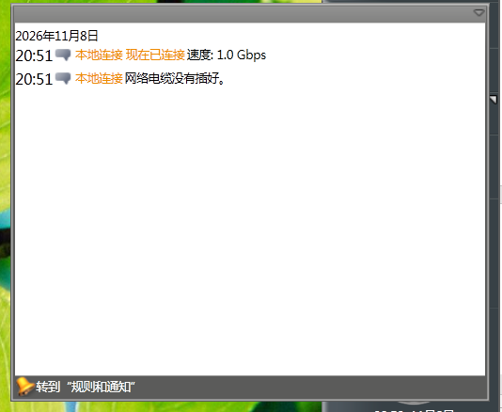
<Grid>
<DockPanel>
<Button Name="GotoRulesAlertButton" Content="Go to Rules and Alerts" Style="{DynamicResource TileNotificationRulesAndAlertsButton}" Click="GotoRulesAlertButton_Click">
<Button.Template>
<ControlTemplate TargetType="Button">
<StackPanel Orientation="Horizontal" DockPanel.Dock="Bottom">
<Image Style="{DynamicResource TileNotificationRulesAndAlertsImage}"></Image>
<TextBlock Style="{DynamicResource TileNotificationRulesAndAlerts}" Text="{TemplateBinding Content}"></TextBlock>
</StackPanel>
</ControlTemplate>
</Button.Template>
</Button>
<ScrollViewer Style="{DynamicResource TileNotificationFlyoutScrollViewer}">
<ItemsControl ItemsSource="{Binding Grouped}" Grid.IsSharedSizeScope="True">
<ItemsControl.ItemsPanel>
<ItemsPanelTemplate>
<StackPanel Orientation="Vertical"></StackPanel>
</ItemsPanelTemplate>
</ItemsControl.ItemsPanel>
<ItemsControl.ItemTemplate>
<DataTemplate>
<StackPanel>
<TextBlock Text="{Binding Date, Converter={x:Static local:LocalDateConverter.Instance}}" Style="{DynamicResource TileNotificationFlyoutDateTitle}"/>
<ItemsControl ItemsSource="{Binding}">
<ItemsControl.ItemsPanel>
<ItemsPanelTemplate>
<StackPanel Orientation="Vertical"></StackPanel>
</ItemsPanelTemplate>
</ItemsControl.ItemsPanel>
<ItemsControl.ItemTemplate>
<DataTemplate>
<Grid MinHeight="20">
<Grid.ColumnDefinitions>
<ColumnDefinition Width="Auto" SharedSizeGroup="FlyoutTime"></ColumnDefinition>
<ColumnDefinition Width="Auto" SharedSizeGroup="FlyoutIcon"></ColumnDefinition>
<ColumnDefinition Width="*"></ColumnDefinition>
</Grid.ColumnDefinitions>
<TextBlock Grid.Column="0" Text="{Binding TimeStampUtc, Converter={x:Static local:LocalTimeConverter.Instance}}" Style="{DynamicResource TileNotificationFlyoutItemTime}"/>
<Grid Grid.Column="1">
<Image x:Name="Icon" Style="{DynamicResource TileNotificationFlyoutItemImage}"/>
<Image x:Name="IconHover" Style="{DynamicResource TileNotificationFlyoutItemImageHover}" Opacity="0" />
</Grid>
<StackPanel Grid.Column="2" Style="{DynamicResource TileNotificationFlyoutItemTextPart}">
<TextBlock Text="{Binding InfoTitle}" Style="{DynamicResource TileNotificationFlyoutItemTitle}"></TextBlock>
<TextBlock Text="{Binding Info}" Style="{DynamicResource TileNotificationFlyoutItemText}"/>
</StackPanel>
<Button Grid.Column="0" Grid.ColumnSpan="3" Style="{DynamicResource TileNotificationFlyoutItemButton}" Click="Button_Click"/>
</Grid>
<DataTemplate.Triggers>
<Trigger Property="IsMouseOver" Value="True">
<Trigger.EnterActions>
<BeginStoryboard>
<Storyboard>
<DoubleAnimation Storyboard.TargetName="Icon" Storyboard.TargetProperty="Opacity" To="0" Duration="0:0:0.25"/>
<DoubleAnimation Storyboard.TargetName="IconHover" Storyboard.TargetProperty="Opacity" To="1" Duration="0:0:0.25"/>
</Storyboard>
</BeginStoryboard>
</Trigger.EnterActions>
<Trigger.ExitActions>
<BeginStoryboard>
<Storyboard>
<DoubleAnimation Storyboard.TargetName="Icon" Storyboard.TargetProperty="Opacity" To="1" Duration="0:0:0.25"/>
<DoubleAnimation Storyboard.TargetName="IconHover" Storyboard.TargetProperty="Opacity" To="0" Duration="0:0:0.25"/>
</Storyboard>
</BeginStoryboard>
</Trigger.ExitActions>
</Trigger>
</DataTemplate.Triggers>
</DataTemplate>
</ItemsControl.ItemTemplate>
</ItemsControl>
</StackPanel>
</DataTemplate>
</ItemsControl.ItemTemplate>
</ItemsControl>
</ScrollViewer>
</DockPanel>
</Grid>
Style notes (for the actual default styles, see the source code in the project repository):
Resource Key | Type | Purpose | Notes
TileNotificationRulesAndAlertsButton | Style[Button] | The notification history flyout “Go to rules and alerts” button style.
TileNotificationRulesAndAlertsImage | Style[Image] | The “rules and alerts” button icon image style.
TileNotificationRulesAndAlerts | Style[TextBlock] | The “rules and alerts” button text style.
TileNotificationFlyoutScrollViewer | Style[ScrollViewer] | The notification history flyout scroll area style.
TileNotificationFlyoutDateTitle | Style[TextBlock] | The notification history date header text style.
TileNotificationFlyoutItemTime | Style[TextBlock] | The notification item time text style.
TileNotificationFlyoutItemImage | Style[Image] | The notification item icon image style.
TileNotificationFlyoutItemImageHover | Style[Image] | The notification item hover icon image style.
TileNotificationFlyoutItemTextPart | Style[StackPanel] | The notification item text area container style.
TileNotificationFlyoutItemTitle | Style[TextBlock] | The notification item title text style.
TileNotificationFlyoutItemText | Style[TextBlock] | The notification item content text style.
TileNotificationFlyoutItemButton | Style[Button] | The notification item transparent click button style.

Flexible Customization
“Flexible” here means that you can combine C# code to design more complex themes. Starting with 0.8.6.0, you can write a class library to help implement some parts of a theme. The Snowfall theme bundled starting with 0.8.6.0 is a complete example of this new feature (although it was completed with AI).
Here, as with the earlier requirement for class libraries used by tiles, the assembly name of the library still needs a bit of uniqueness, for example “RickAstley.Theme.NeverGonnaGiveYouUp”. This reduces the risk of assembly import conflicts.
For final use, place it in the folder where the theme file is located.
Be sure to resolve assembly conflicts properly to avoid conflicts with others.
Although this kind of customization is more flexible, it also means more risk. Therefore, when using third-party themes, please be cautious and careful. For this reason, themes completed using only XAML are relatively safer by comparison.
(But if only XAML is used, performance and memory issues still need to be considered, especially whether to support Windows XP, because the hardware standard supported by Windows XP is lower than that of Windows Vista.)

Packaging and Sharing, Potential Risk Statement
For themes, there is currently no intention to add packaging and deployment mechanisms, and no online store will be established for the time being to collect third-party themes.
It is stated here that, except for themes bundled with the installer and produced by Whistler (Windows Modern), the security risks of other third-party themes cannot be guaranteed. Third-party themes are extension content independently produced and distributed by third-party developers or the community, who bear the relevant responsibilities themselves; they are unrelated to Whistler (Windows Modern) and its official team. Therefore, when downloading and using third-party themes, please identify and check their safety, integrity, and availability, and avoid using dangerous or destructive third-party themes. By using a third-party theme, you acknowledge and voluntarily accept the above risks.

November 10, 2026

