The following document describes the development of plug-ins for the Sidebar project in the Whistler (Windows Modern) project (in this document, “Sidebar” refers to both the project and its program); for this project, such plug-ins are called “tiles”.

Contents
Contents 1
About This Document 2
File Layout 2
SDK and Debugging Files 2
Tile Manifest 3
Identity Section 4
Properties Section 5
Prerequisites Section 5
Applications Section 6
Editing 7
Overview of the Tile Base Class 8
Properties 9
Methods 9
Events 10
Lifetime 11
Creating a Simple Tile 11
Adding Flyout Support 12
Adding Properties Window Support 13
Sharing Members with Other Classes via Static Members 16
Exception Handling 16
Using WinForms Components 17
Debugging 17
Packaging 17
Additional Topics 19
Using Resource Files 19
Communicating with Sidebar and Other Tiles 21
Using Third-Party Libraries 26
Adapting to Themes and Their Styles 26
Description of Other Public Classes 28
From TileClient.dll 28
From Native.dll 29
Potential Risk Statement 38

About This Document
This document supplements and completes the documentation produced after the new architecture was introduced (the new architecture was implemented in beta version 0.7.5.0, at which time the documentation was not fully completed). Documentation for the old architecture can still be used for reference.

File Layout
A complete tile must contain the following files in its root directory. These file names are fixed and mandatory:
- Manifest.xml – the tile manifest file.
- The tile class library file. Under the new architecture, the name of the tile class library file does not have to be fixed.
If these files are missing, the program will not recognize the folder as a tile.
The following files are also located in the tile root directory and have fixed names, but whether to include them depends on actual needs (they are optional):
- Locale.xml – the resource file used for localization.
- Path.xml – the resource file that records file paths for high-DPI scenarios.
- Config.ini – used to read and write configuration files in INI format; not recommended for use in the tile root directory.
- Config.xml – used to read and write configuration files in XML format; not recommended for use in the tile root directory.

SDK and Debugging Files
An official Debug build of the program is provided for debugging.
Official SDK files are provided separately for the Debug and Release builds. There are two files:
- Native.dll: provides common structures and utilities.
- TileClient.dll: the SDK file used to create a project.
In addition, there are the packaging tool SGPackaging.exe, the manifest editing tool TileManifestEditor.exe, and a copy of the program used for debugging.
Note: Native.dll depends on Newtonsoft.Json (version 13.0.4). This library is used for serializing array-type data in XmlConfig. It is used for XmlConfig's handling of arrays:
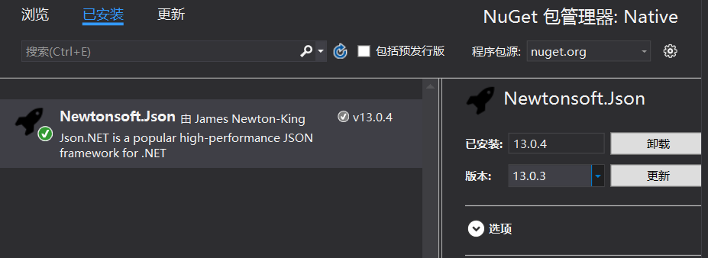
There is also the “Win32ThemeStyle.WPF” NuGet package. Although Native.dll and TileClient.dll do not use it, it can still be used in themes and tiles. When using it in a tile, simply obtain it from NuGet, but be sure to use the same version of the library as Sidebar; otherwise, Sidebar will crash. Win32ThemeStyle.WPF mainly provides components for handling nine-slice images (commonly used in theme file resources):
HackImage: a nine-slice image, but note that it may be enlarged to the maximum size when SizeToContent is used (similar to Image behavior).
HackImageTransition and HackImageTransitions: animation effects for switching nine-slice images, similar to a fade.
HackBorder: a container that uses a nine-slice image as its background. Compared with a nine-slice image, it is not enlarged to the maximum size when SizeToContent is used (it behaves more like Border or Grid than Image).
HackButton, HackRepeatButton, and HackToggleButton: simple, lightweight wrappers around HackBorder. For more customized effects, it is recommended to use a ControlTemplate for Button, RepeatButton, and ToggleButton.
For details, see the documentation:
Simplified Chinese: https://github.com/windowsmodern/win32-style-in-wpf/blob/master/docs/hack-components.zh-CN.md
English: https://github.com/windowsmodern/win32-style-in-wpf/blob/master/docs/hack-components.md

Tile Manifest
The tile manifest describes some information and behavior of the tile. After the main program creates the tile, this information constrains the tile, mainly in terms of visual effects. The idea of the tile manifest is borrowed from the WinRT app manifest, and some concepts are also shared.
The tile manifest is an XML file and can be edited with TileManifestEditor.
For some items in the manifest, the property names may differ from those in the XML, but the meanings are similar.
In the new architecture, the manifest version is marked as 2. The old version is uniformly 1, and the old version is no longer compatible (because the old version has no explicit support for declaring an entry point).
Example manifest structure
<?xml version="1.0" encoding="utf-8"?>
<Manifest Version="2">
<Identity Name="WindowsModern.NewsFeedTile" Publisher="CN=Windows Modern" Version="1.0.0.2" ProcessorArchitecture="Neutral" />
<Properties>
<DisplayName>TILE_PROP_DISPNAME</DisplayName>
<PublisherDisplayName>Windows Modern</PublisherDisplayName>
<Description>TILE_PROP_DESC</Description>
<Logo>gadgeticon.png</Logo>
</Properties>
<Prerequisites>
<OSMinVersion>5.1.2600.0</OSMinVersion>
</Prerequisites>
<Applications>
<Application Id="App" Executable="WindowsModern.NewsFeedTile.dll" EntryPoint="WindowsModern.FeedTile.Tile" HasFlyout="true" HasProperties="true">
<VisualElements DisplayName="TILE_PROP_DISPNAME" Logo="Icon-20.png">
<Tile MinHeight="28" MaxHeight="300" DefaultHeight="97" CanPinBottom="true" Overflow="Hidden" />
<Flyout FlyoutWidth="370" FlyoutHeight="700" FlyoutCanResize="false" />
</VisualElements>
</Application>
</Applications>
</Manifest>

Identity Section
Identity contains the basic information of the tile.
<Identity Name="WindowsModern.NewsFeedTile" Publisher="CN=Windows Modern" Version="1.0.0.2" ProcessorArchitecture="Neutral" />
Name identifies the unique name of the tile. The name must be no longer than 50 characters and no shorter than 3 characters, and is case-insensitive. (However, when writing tile files, it is still recommended to use consistent casing for this part.) Name is used as the storage directory of the tile file. The name may contain alphanumeric characters, periods, and hyphens. In addition, it cannot be any of the following string values: CON, PRN, AUX, NUL, COM1, COM2, COM3, COM4, COM5, COM6, COM7, COM8, COM9, LPT1, LPT2, LPT3, LPT4, LPT5, LPT6, LPT7, LPT8, or LPT9. It is recommended that the Name usually include author information, for example “RickAstley.NeverGonnaGiveYouUp”, to make it easier to distinguish. It is also recommended to use Name as the assembly name when writing the tile class library, to reduce the probability of collisions.
Publisher refers to the publisher. It is a string between 1 and 8192 characters long and conforms to the regular expression for a distinguished name. Although tile packaging and installation do not currently use signing, the Publisher part is still required to follow the format used for signing.
Version indicates the version information of the tile. Tile upgrade decisions are based on this version number, not on the version number of the tile class library file at compile time.
ProcessorArchitecture indicates the processor architectures supported by the tile. It is case-sensitive in the manifest; the allowed values are:
- X86
- ARM
- IA64
- X64
- ARM64
- Neutral
Neutral means all architectures are supported. For languages that support cross-architecture builds, such as C# and VB, use Neutral only when the target platform used at compile time is Any CPU. Otherwise, the manifest must be edited strictly according to the target platform used at compile time.
The encoded Publisher is combined with Name to form a FamilyName. This usually constitutes the unique identifier of a tile, and this identifier is used for storage.

Properties Section
The Properties section stores information used for display. If you want to use resources, you can use the resource name directly; the program uses it automatically when this information is used.
<Properties>
<DisplayName>TILE_PROP_DISPNAME</DisplayName>
<PublisherDisplayName>Windows Modern</PublisherDisplayName>
<Description>TILE_PROP_DESC</Description>
<Logo>gadgeticon.png</Logo>
</Properties>
DisplayName is the display name of the tile, used by Tile Manager and the tile installation tool.
PublisherDisplayName indicates the publisher name used for display.
Description indicates the tile description. The description can be as rich as needed, but only plain text is allowed.
Logo indicates the icon of the tile.

Prerequisites Section
The Prerequisites section restricts the system versions on which the tile can be used. It is currently used for tile installation. Version restrictions serve purposes such as using a newer version of the .NET runtime (which imposes requirements on system support) or using a Windows API that is not supported on older versions of Windows.
<Prerequisites>
<OSMinVersion>5.1.2600.0</OSMinVersion>
<OSMaxVersion>11.0.0.0</OSMaxVersion>
</Prerequisites>
OSMinVersion indicates the minimum supported system version.
OSMaxVersion indicates the maximum supported system version. If this item is absent, all future versions are supported.

Applications Section
<Applications>
<Application Id="App" Executable="WindowsModern.NewsFeedTile.dll" EntryPoint="WindowsModern.FeedTile.Tile" HasFlyout="true" HasProperties="true">
<VisualElements DisplayName="TILE_PROP_DISPNAME" Logo="Icon-20.png">
<Tile MinHeight="28" MaxHeight="300" DefaultHeight="97" CanPinBottom="true" Overflow="Hidden" />
<Flyout FlyoutWidth="370" FlyoutHeight="700" FlyoutCanResize="false" />
</VisualElements>
</Application>
</Applications>
Applications represents a collection of multiple tile instances, including at least one Application node. One Application node represents one tile instance.

Application Section
Properties:
Id: the unique identifier of a tile instance. This identifier must comply with Windows file name requirements (the same requirements as Identity Name, because it is also used for the folder name). The identifier must be unique among all Application nodes with the same property in Applications, is case-insensitive, and ignores leading spaces. If there is only one Application node, “App” is recommended. FamilyName and App are combined to form the UserModelId.
Executable: the executable file. This file is a tile class library file (dll) and uses a relative file name.
EntryPoint: the entry point. This string indicates the class in the class library that you want to use; this class must inherit from TileBase. The format is usually “<namespace>.<class>”, it is case-sensitive, and it must not begin with a space. This item cannot be empty.
HasFlyout: whether the tile has a flyout
HasProperties: whether the tile requires a properties window

VisualElements Section
The VisualElements section represents the default visual effect used when a tile instance is created or after creation until it is destroyed. This effect can be changed during the tile instance's lifetime.
Properties:
DisplayName: the display name of the tile instance. String resources can be used. The name should not be long, but it can be somewhat distinctive.
Logo: the icon of the tile instance. A 20×20 icon is usually sufficient. File resources can be used.
Tile node section:
MinHeight indicates the minimum height of the tile. It cannot be set to a value smaller than 20. Because some themes do not include a tile title bar, a minimum height needs to be set for easy adjustment.
MaxHeight indicates the maximum height of the tile.
DefaultHeight indicates the default height applied when the tile is created, if no height is specified in the settings.
MinHeight and MaxHeight limit the height of the tile content area, not the overall height of the tile. DefaultHeight also refers to the height of the tile content area.
The types of all these properties are double-precision floating point (double).
CanPinBottom indicates whether the tile can be pinned to the bottom, but this property is currently unused and is considered deprecated.
Overflow indicates how the tile handles overflow content. The allowed values are:
- Auto The tile automatically adjusts its height according to the content, with no MinHeight or MaxHeight limits; in this case, AutoMode is forcibly enabled and cannot be disabled.
- Hidden The overflowing part of the tile is hidden.
- Scroll The tile content area is wrapped in a ScrollView (the container is still a Grid) and can scroll (but a scroll bar may affect the experience; the scroll bar does not affect layout but does affect interaction, and it is an automatically hiding scroll bar).
- Scale The tile content area is wrapped in a Viewbox (the container is still a Grid), and the content is scaled automatically.
Flyout node section:
FlyoutWidth refers to the width of the flyout content area.
FlyoutHeight refers to the height of the flyout content area.
FlyoutWidth and FlyoutHeight are used only when the flyout is created, but the width and height of the flyout can still be set after creation. Note that the position then needs to be corrected. (If you adjust it yourself, you also need to set the e.ClientArea part; setting only the window is not enough.)
The types of all these properties are double-precision floating point (double).
FlyoutCanResize is deprecated.

Editing
It is more convenient to edit with SGPkgMgr, a tool included with the SDK.
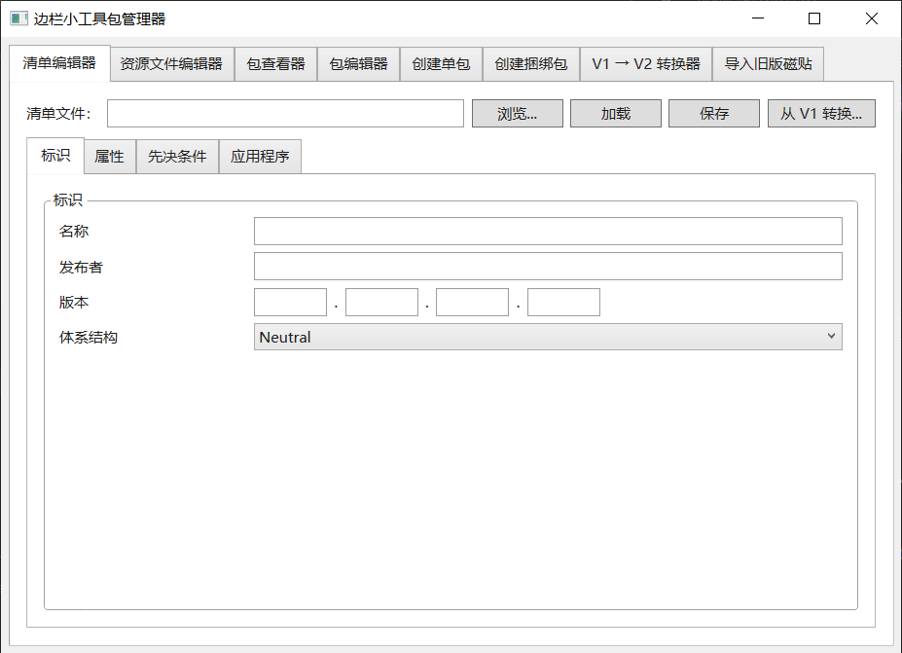

Overview of the Tile Base Class
The tile base class (TileBase) is an abstract class located in TileClient.dll (some of its types also require a reference to Native.dll). All custom tile classes must inherit from this class. When a tile is loaded, the program searches the assembly for the first non-abstract class that inherits from TileBase and creates an instance of it (the only one).
Prototype of the tile base class:
public abstract class TileBase: ITileBase
{
public TileBase () { }
public ITileManifest Manifest { get; }
public IProgramFolder Region { get; }
public IProgramFolder UserRegion { get; }
public UIElement TileUI { get; }
public ITileApplication Application { get; }
public string UserModelId { get; }
public virtual void OnInitialize () { }
public virtual void OnDestroy () { }
public virtual bool OnResponse (ITileResponse resp) { return false; }
public virtual bool OnRequest (ITileRequest req) { return false; }
public event EventHandler Load;
public event EventHandler Unload;
public event EventHandler<SizeChangedEventArgs> Resize;
public event EventHandler<SizeChangedEventArgs> FlyoutResize;
public event EventHandler<FlyoutAboutEventArgs> FlyoutInit;
public event EventHandler<FlyoutAboutEventArgs> FlyoutShow;
public event EventHandler<FlyoutAboutEventArgs> FlyoutClosing;
public event EventHandler FlyoutClosed;
public event EventHandler<SidebarDirectionChangedEventArgs> SidebarDirectionChanged;
public event EventHandler<ThemeChangedEventArgs> ThemeChanged;
public event EventHandler<PropertiesAboutEventArgs> PropertiesInit;
public event EventHandler<PropertiesAboutEventArgs> PropertiesShow;
public event EventHandler<PropertiesAboutEventArgs> PropertiesClosing;
public event EventHandler<PropertiesAboutEventArgs> PropertiesClickOK;
public event EventHandler<PropertiesAboutEventArgs> PropertiesClickCancel;
public event EventHandler PropertiesClosed;
public ITileConfig Config { get; }
public ISidebarFeatures Features { get; }
public virtual ContextMenu ContextMenu { get; set; } = null;
}
The members are described below.

Properties
Property Manifest: the tile can read the tile manifest; read-only.
Property Region: the folder where the tile file is located (that is, the root directory containing the manifest and the tile class library file). Some resource files, etc. can be used.
Property UserRegion: the folder where the tile's user-specific files are located (previously in “%LocalAppData%\Windows Modern\Sidebar\Tiles\<FamilyName>”, now in “%LocalAppData%\Windows Modern\Sidebar\Tiles\<FamilyName>\<AppId>”). This folder is provided for per-user settings, and each tile instance has its own folder. It is recommended to store configuration items that are closely related to user habits in this folder.
Property TileUI: TileUI is the host container for the tile content (of type UIElement, used as a Panel). Developers should add custom UI controls to this container. This property is assigned an existing element when the class is initialized and lasts for the entire lifetime of the tile. During initialization, you can use: Tile as Panel (Panel is a WPF component).
Property Config: represents the tile's user-specific configuration file, using InitConfig and XmlConfig of UserRegion. InitConfig is recommended because it is based on the Win32 API, but it is usually used for simple settings. XmlConfig supports JSON serialization of arbitrarily complex objects and is suitable for storing structured data, but note that the file may be modified externally.
Property Features: used to communicate with Sidebar and other tiles (provided that the tiles have been created). This makes extension convenient.
Property ContextMenu: the menu used when the tile is right-clicked. Users generally assign it during initialization, and then the program reads it when processing the tile's context menu. Note, however, that when the main program uses this property, it works like a “borrow and return” operation. When the tile's context menu opens, the get method is called once to read it, and then all items of the ContextMenu are extracted. When the tile's context menu closes, the get method is called once more to read it, and then the items originally belonging to the ContextMenu are returned. Therefore, for the tile's own ContextMenu, defining events such as Opened is useless, because this menu is never opened; it serves only as a container for menu items. To update the state of menu items, it is recommended to update them whenever the tile's settings or state change.

Methods
Some methods must be implemented by overriding.
Method OnInitialize: used to initialize the tile instance. This is the first function called.
Method OnDestroy: used for cleanup when destroying the tile instance, and is also the last function called in the complete lifetime.
Methods OnResponse and OnRequest: used to receive requests (OnRequest) or responses (OnResponse) from other tiles or Sidebar. The return value indicates whether the handling succeeded.

Events
Events are responses to events fed back by the tile.
Event Load: responds when the tile is loaded. Not commonly used; it is actually called when the element's Loaded event is triggered. Initialization is not recommended here, because the Loaded event may be triggered when the tile is dragged.
Event Unload: responds when the tile is unloaded. Not commonly used; it is actually called when the element's Unloaded event is triggered. Cleaning up tile UI elements is not recommended here, because the Unloaded event may be triggered when the tile is dragged.
Event Resize: triggered when the tile size changes, including the overall tile size and the size of the tile content area.
Event FlyoutInit: triggered when the user invokes the flyout and the flyout is initialized. The flyout can be initialized here.
Event FlyoutShow: actually the Loaded event of the flyout.
Event FlyoutResize: triggered when the flyout size changes.
Event FlyoutClosing: triggered when the flyout is about to close. The sender object passed by the window's Closing event is passed in.
Event FlyoutClosed: triggered when the flyout has closed. Cleanup can be done here.
Event PropertiesInit: triggered when the user invokes the tile properties window. Initialization can be done here.
Event PropertiesShow: actually the Loaded event of the properties window.
Event PropertiesClickOK: triggered when the OK button of the properties window is clicked. Modified configuration items can be checked and saved here. The window closes automatically after the button is pressed. To prevent this, an exception can be thrown. After receiving the exception, the program displays a message box with the exception information and does not close the window.
Event PropertiesClickCancel: triggered when the Cancel button of the properties window is clicked, although it is rarely used. The window closes automatically after the button is pressed. To prevent this, an exception can be thrown. After receiving the exception, the program displays a message box with the exception information and does not close the window.
Event PropertiesClosing: triggered when the properties window is about to close. The sender object passed by the window's Closing event is passed in.
Event PropertiesClosed: triggered when the properties window has closed. Cleanup can be done here.
Event SidebarDirectionChanged: triggered when the position of Sidebar changes. The tile display can be adjusted according to this event.
Event ThemeChanged: triggered when the theme of Sidebar changes. When triggered, it provides a theme name (not the theme display name). It is actually the name of a direct subfolder of the Themes folder in the program root directory. The main program includes the following themes by default:
- Slate: the sidebar style used by Windows Longhorn Build 4074 (default, with Aero disabled).
- Plex: a style designed with Windows Longhorn Build 4031 as reference.
- Aero: the sidebar style used by Windows Longhorn Build 4074 with Aero and similar features enabled.
- System: also the default sidebar theme; supports Aero and uses the theme color.
- Vista: the theme of the same name from the LongBar project.
- Experience: a theme applicable only to Windows XP. It is implemented by extracting the current system theme style and tries to match the system theme style as closely as possible.
Third-party themes shared by community members may appear later. These can be supported manually.
Other members not mentioned are not allowed to be called by tiles; they may only be called by the program.

Lifetime
A tile class that inherits from the tile base class must not use a constructor, nor is one needed. The tile's lifetime begins with OnInitialize and ends with OnDestroy. During this period the tile performs its work.

Creating a Simple Tile
First, use a language that supports the Common Language Runtime (CLR), such as C#, C++/CLI, or VB. Then set the target framework to .NET Framework 4.0 and use WPF and XAML. For C++/CLI projects, if you want to compile a class library supported by Windows XP, set the platform toolset to one that supports Windows XP.
Example:
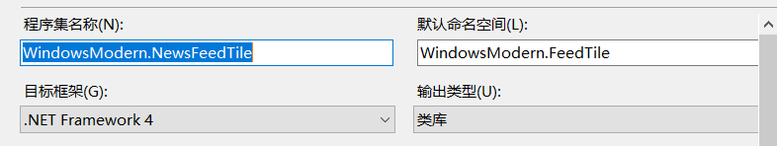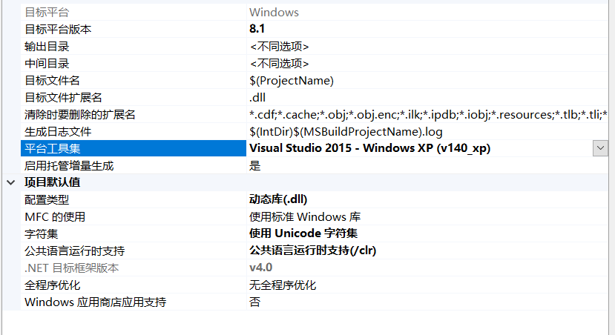
The assembly name is recommended to be consistent with Identity/Name in the manifest, or at least unique, for easy identification.
Then create a public class that inherits from the base class. You can create a WPF component (user control) to represent the tile panel (which makes it easy to use the designer). Use “override” uniformly; the rest of the document should also be consistent.
public class Tile: TileBase
{
public override void OnInitialize ()
{
var panel = TileUI as Panel;
panel.Children.Add (new TilePanel ());
}
}
This completes the most basic work.
Of course, for cleanup (memory must be managed well), the OnDestroy method must be overridden.
public class Tile: TileBase
{
private TilePanel tilePanel = null;
public override void OnInitialize ()
{
var panel = TileUI as Panel;
tilePanel = new TilePanel ();
panel.Children.Add (tilePanel);
}
public override void OnDestroy ()
{
(tilePanel?.Parent as Panel)?.Children?.Clear ();
tilePanel = null;
}
}
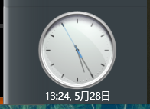
To prevent memory leaks, unsubscribe from all events in OnDestroy.

Adding Flyout Support
You can add a WPF component such as FlyoutPanel for easy design, and then add it in the flyout initialization event, which also makes it easy to reuse. Therefore, data in the flyout is not automatically retained; developers must manage state themselves (for example, through static members or configuration). Note, however, that the related events must be subscribed to and unsubscribed from. Only the code related to the flyout is shown here.
public class Tile: TileBase
{
private FlyoutPanel flyoutPanel = null;
public override void OnInitialize ()
{
FlyoutInit += OnFlyoutInit;
}
private void OnFlyoutInit (object sender, FlyoutAboutEventArgs e)
{
var flyoutContent = e.FlyoutUI as Panel;
if (flyoutContent == null) return;
(flyoutPanel?.Parent as Panel)?.Children?.Clear ();
flyoutContent.Children.Add (flyoutPanel = flyoutPanel ?? new FlyoutPanel ());
}
public override void OnDestroy ()
{
FlyoutInit -= OnFlyoutInit;
(flyoutPanel?.Parent as Panel)?.Children?.Clear ();
flyoutPanel = null;
}
}
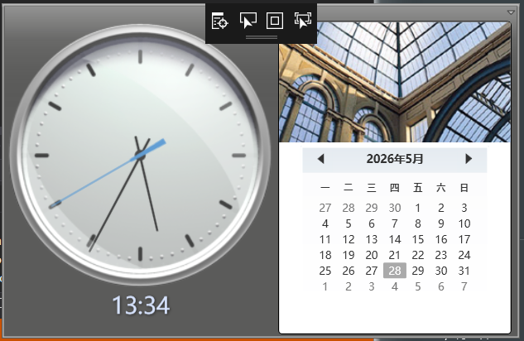

Adding Properties Window Support
You can add a WPF component such as PropertiesPanel for easy design. Usually the properties window does not need to be reused, but this depends on the specific requirements. Only the related code is shown here (Options is a self-encapsulated property class that inherits from INotifyPropertyChanged).
public class Tile: TileBase
{
public static TileOptions Options { get; private set; }
private OptionsPanel optionsPanel = null;
public override void OnInitialize ()
{
Options = new TileOptions (this.Config);
PropertiesInit += OnOptionsFormInit;
PropertiesClosed += OnPropertiesFormClosed;
Options.PropertyChanged += Options_PropertyChanged;
}
private void Options_PropertyChanged (object sender, System.ComponentModel.PropertyChangedEventArgs e)
{
// ...
}
private void OnPropertiesFormClosed (object sender, EventArgs e)
{
try
{
(optionsPanel?.Parent as Panel)?.Children?.Clear ();
PropertiesClickOK -= optionsPanel.OkButton_Click;
optionsPanel = null;
}
catch { }
}
private void OnOptionsFormInit (object sender, PropertiesAboutEventArgs e)
{
var propWnd = e.PropertiesWindow as Window;
if (propWnd != null)
{
const double clientWidth = 350;
const double clientHeight = 371.0;
bool isResizable = (propWnd.ResizeMode == ResizeMode.CanResize || propWnd.ResizeMode == ResizeMode.CanResizeWithGrip);
double borderWidth = isResizable
? SystemParameters.ResizeFrameVerticalBorderWidth // Resizable border width
: SystemParameters.BorderWidth; // Fixed border width
double topBorderHeight = isResizable
? SystemParameters.ResizeFrameHorizontalBorderHeight // Resizable top border height
: SystemParameters.BorderWidth; // Fixed top border height
double captionHeight = SystemParameters.WindowCaptionHeight;
double totalWidth = clientWidth + 2 * borderWidth;
double totalHeight = clientHeight + topBorderHeight + captionHeight;
propWnd.Width = totalWidth;
propWnd.Height = totalHeight;
}
var propContent = e.PropertiesContent as Panel;
if (propContent == null) return;
propContent?.Children?.Clear ();
(optionsPanel?.Parent as Panel)?.Children?.Clear ();
propContent.Children.Add (optionsPanel = optionsPanel ?? new OptionsPanel ());
PropertiesClickOK -= optionsPanel.OkButton_Click;
PropertiesClickOK += optionsPanel.OkButton_Click;
}
public override void OnDestroy ()
{
PropertiesInit -= OnOptionsFormInit;
PropertiesClosed -= OnPropertiesFormClosed;
Options.PropertyChanged -= Options_PropertyChanged;
optionsPanel = null;
Options = null;
}
}
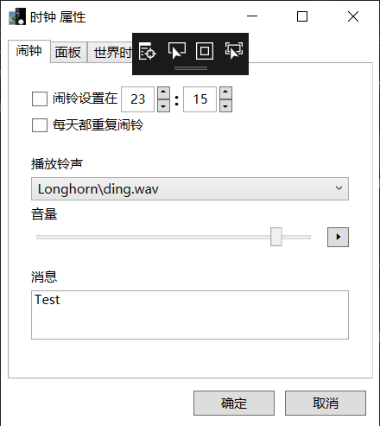
The interface IPropertiesToolMembers can be obtained in code with e.Window as IPropertiesToolMembers.
Prototype:
public interface IPropertiesToolMembers
{
Button OKButton { get; }
Button CancelButton { get; }
}
The purpose of this interface is to control these two buttons according to the actual situation, preventing user operations from saving unwanted settings or losing wanted settings.

Sharing Members with Other Classes via Static Members
The lifetime of a tile is strictly limited to between OnInitialize and OnDestroy, so you can use static members to share data. However, note that any class using these static members must also have its lifetime limited to the same period; otherwise it may access a released instance. For example:
public class TilePanel: UserControl
{
public TilePanel ()
{
Title.Text = Tile.StringResources?.SuitableValue ("TILE_TITLE", "Tile Title") || "Tile Title";
}
}
public class Tile: TileBase
{
public static ILocaleResources StringResources { get; private set; }
private TilePanel tilePanel = null;
public override void OnInitialize ()
{
StringResources = Region.StringResources;
var panel = TileUI as Panel;
panel.Children.Add (tilePanel);
}
public override void OnDestroy ()
{
(tilePanel?.Parent as Panel)?.Children?.Clear ();
StringResources = null;
}
}

Exception Handling
The program catches most exceptions, but after catching them it does not handle them, which also makes subsequent behavior unpredictable. Therefore, tile developers must handle all possible exceptions themselves to improve the robustness of the tile.

Using WinForms Components
This mainly depends on your own requirements, but note: for tiles and flyouts, AllowsTransparency is enabled (but on Windows XP, enabling this causes abnormal window rendering, so it is automatically disabled when Windows XP is detected; this also means that some themes that require translucency can only be displayed opaquely). Therefore, WinForms components may display abnormally. Of course, they can safely be displayed in the properties window, because the properties window does not enable AllowsTransparency. There are tutorials online that allow WinForms components to display correctly when AllowsTransparency is enabled; you can try them.

Debugging
Prepare the Sidebar program files for debugging. Change the output path to a direct subdirectory of the Gadgets folder in the root directory where the Sidebar program is located. As shown in the figure.
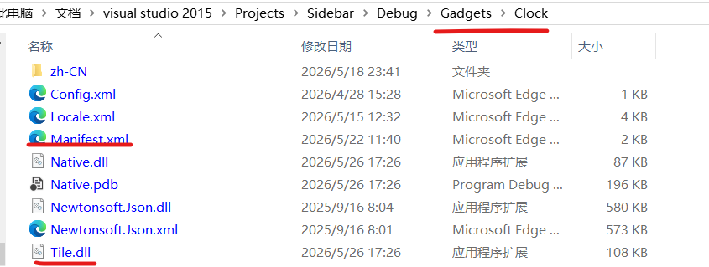
Manifest.xml is mandatory, and the file name of the generated tile class library must match the manifest (usually the tile assembly name or project name plus “.dll”).
Then set the debug start action in the project to point to the Sidebar program.
Note: during debugging, Sidebar reads and writes a fixed user configuration directory (%LocalAppData%\Windows Modern\Sidebar), which may affect data in the production environment. It is recommended to back up the existing configuration before debugging.

Packaging
First build the class library in Release mode (this is mandatory for class libraries written in C++/CLI, and compiling in Release mode is also recommended for other languages).
Before packaging, clean up some generated files, such as pdb symbol files, as well as the two class library files from the SDK: TileClient.dll and Native.dll.
Example:
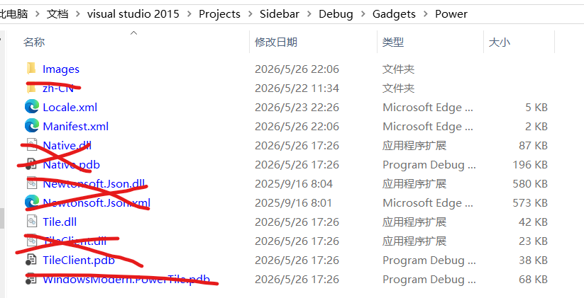
Note: the zh-CN folder contains a resource DLL generated because Native.dll uses resource files when it was written (used for IDE hints, although it is not very useful). Its content is Native.resources.dll. What mainly needs to be deleted is the Native.resources.dll file. Of course, unless the tile project uses resource files for localization, in which case clean up according to your own needs.
Once the files are ready, use SGPkgMgr.exe to package.
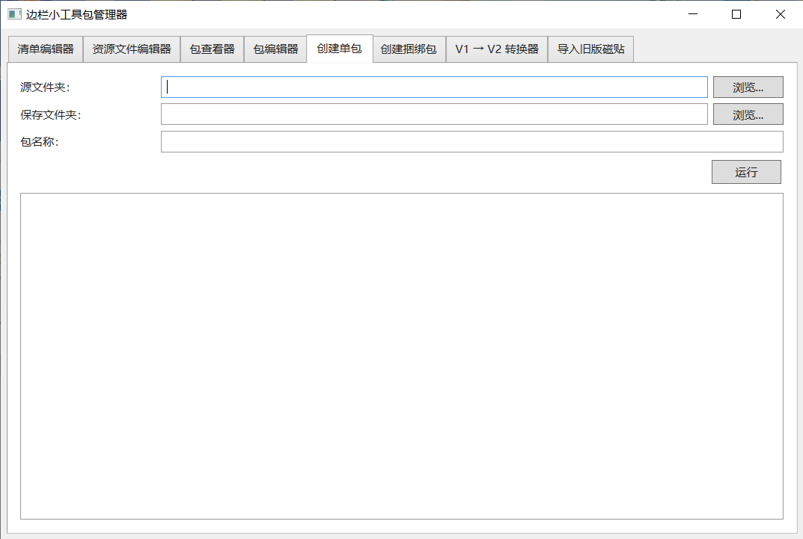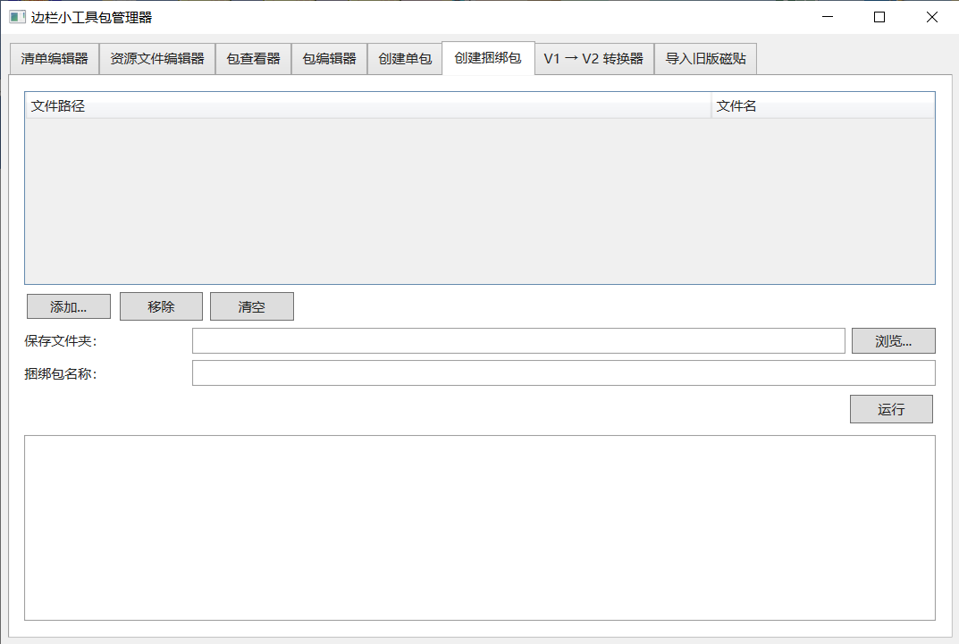
Depending on requirements, you can package into a bundle, but the files generated for each architecture must first be packaged into separate packages (this requires preparing matching manifest files). When packaging into a bundle, a manifest file is not required. Instead, you need to check that some content of the manifests of all packages to be included is consistent.

Additional Topics

Using Resource Files
Resource files are divided into string resource files and file resource files; both are essentially XML files (UTF-8 encoded). The string resource file is named Locale.xml, and the file resource file is named Path.xml. These two kinds of resources are external resources (as opposed to built-in resources compiled with RC or ResX in the project). For resources that make it easy for others to add localized languages, or that are used in the manifest file, use external resources.

Resource File Format
For localization resource files, the format is:
<?xml version="1.0" encoding="utf-8"?>
<resources>
<resource id=...">
<lang name="...">...</lang>
</resource>
</resources>
The name attribute of the lang node indicates the locale code, such as zh-CN. The id attribute of the resource node indicates the resource name. The resources node contains multiple resource nodes, and a resource node contains multiple lang nodes.
For string resource files, it is recommended to use the included ResqXmlEditor.exe editor.
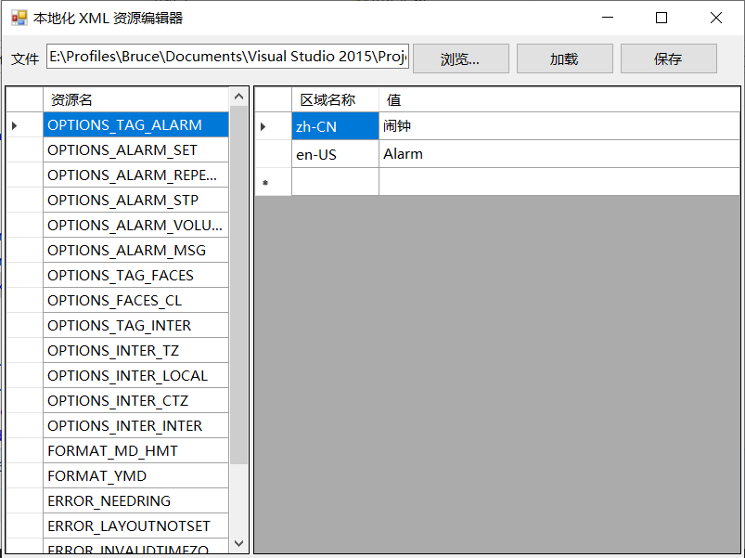
For file resources, an example (quoted from another project file):
<?xml version="1.0" encoding="utf-8"?>
<resources>
<resource id="splash">
<path scale="100">splash\AppPackageSplashScreen.scale-100.png</path>
<path scale="125">splash\AppPackageSplashScreen.scale-125.png</path>
<path scale="150">splash\AppPackageSplashScreen.scale-150.png</path>
<path scale="200">splash\AppPackageSplashScreen.scale-200.png</path>
<path scale="400">splash\AppPackageSplashScreen.scale-200.png</path>
</resource>
</resources>
The id attribute of the resource node indicates the resource name, which can be set to a path relative to the tile file as needed. The scale attribute indicates the DPI scaling percentage (for example, 100, 125, 150), not a specific DPI value (such as 96, 120). The value must be an integer; otherwise an exception is thrown. The resources node contains multiple resource nodes. A resource node contains multiple path nodes. File resource files are used relatively rarely, usually for high-DPI adaptation, and there is currently no editor for them.

Usage
TileBase.Region.StringResources and TileBase.Region.FileResources
Getting a matching resource:
string result = Region.StringResources.SuitableResource (string resourceName, string fallback = null, string localeName = null); // A null localeName means the program's current locale is used.
string path = Region.FileResources. SuitableResource (string resourceName, string fallback = null, int scale = -1); // A scale of -1 means the system's current DPI scaling is used.

Appropriate Cleanup After Loading Resources
The four interfaces ILocaleResource, ILocaleResources, IPathResource, and IPathResources all have an added method: CleanRedundantValues. Its purpose is to clean up unused resources to reduce memory usage. For example, for string resources:
zh-CN: 你好
en-US: Hello
ja: おはよう
When the current thread language is zh-CN, only the resources for zh-CN and en-US are retained.
Which resources are retained:
String resources:
The languages in the recommended language list (and additionally retained languages) and their variants that match the current resource key.
Matching rules (in order of priority):
- An exact match of the key with the recommended language.
- The key's LCID is the same as the LCID of the recommended language.
- The key's “restricted code” is the same as the restricted code of the recommended language.
- The LCID of the key's restricted code is the same as the LCID of the restricted code of the recommended language.
At least 2 resources are retained.
File resources:
The 100% scale, the DPI scaling of the current screen, and additionally retained scales.
At least 2 resources are retained.
This cleanup is irreversible; resources may not be restored until the program is closed and opened again.
Currently Sidebar does not proactively clean up resources, because there is no setting for manually selecting a language; it directly uses the language of the current user on the current computer, which does not change while the program is running.

Communicating with Sidebar and Other Tiles
Features is a feature added to facilitate extension. It can be used to communicate with the main program and with other tiles (which requires that those tiles have been created). Its usage is as follows:

Requests
Sends a request to the program, asking the program to perform an operation. Prototype:
bool Request (ISidebarRequest request)
Here request is the request body, which represents a unified way of handling request data. The return value indicates whether the request succeeded. Depending on the requirement, the request operation may be affected by the thread.
Create the request body with SidebarRequest; the RequestName and RequestDatas properties can be assigned. RequestName is mandatory.
Example:
this.Features.Request (new Sidebar.SidebarRequest (this) {
RequestName = "FlyoutUpdatePosition"
});

Communicate
Communicate is used to send a request to a specified target (which can be Sidebar or another tile). The Request method is actually a specialized version of Communicate (with the target fixed to “Sidebar”).
bool Communicate (ITileRequest request)
Its usage and return value are similar to those of Request. The difference is that communication requires you to specify the target yourself. Create the request body with TileRequest or SidebarRequest. For TileRequest, RequestName, RequestTarget, and RequestDatas can be assigned, and RequestName and RequestTarget are mandatory. The value of RequestTarget is “Sidebar” (for the program) or the UserModelId of another tile.

Responses
Replies according to the request content. The response can be synchronous or asynchronous, depending on the developer's implementation. A response is not mandatory.
bool Response (ITileResponse resp)
When replying, use TileResponse to construct the response body; ResponseName, Success, ResponseData, and ErrorMessage can be assigned. ResponseName and Success are mandatory properties.
Example:
var resp = new TileResponse (request);
resp.Success = true;
resp.ResponseName = "NotificationClick";
Response (resp);

Receiving and Handling Requests and Responses
In addition to using the Features member, you must override the OnRequest and OnResponse functions to receive and handle requests and responses. After handling, return a value as needed to indicate whether the request or response was handled successfully.

Requirements for Request and Response Data
Request data and response data must use primitive types, the official SDK from .NET Framework 4.0, and data types from Native.dll and TileClient.dll. No other types may be used.

Passing Auxiliary Data in Request and Response Data
A new property is added to both the ITileRequest and ITileResponse interfaces: TransferDatas: object. This property is used to pass data used by the tile itself. It can be assigned in TileRequest and SidebarRequest, but it is read-only in TileResponse (assignment is done during construction). TransferDatas can be a custom data type, because only the tile itself uses it.

Requests Supported by the Program
The program currently supports the following requests:
Request Name | Request Type | Description | Has Response
Notification | string or Sidebar.NotifyIconNotification | Makes the program's notification-area icon display a balloon notification. If the value is a string, only the notification body is set, the title is automatically set to the tile name, and the notification is displayed for 5 seconds. If the value is a NotifyIconNotification, it can be customized to the greatest extent. | Yes
Resize | double | Adjusts the tile height (content area). The change is not recorded (written to the configuration), however. | No
ResizeForever | double | Adjusts the tile height (content area) and records it in the configuration. | No
OpacityAnime | double or null | Performs a one-time opacity transition animation. If a value is assigned, the opacity transitions from 0 to the specified opacity (0–1; the larger the value, the more opaque). If no value is assigned, the opacity transitions from 0 to 1. | No
FlyoutSizeToContent | System.Windows. SizeToContent | Sets the strategy by which the flyout size adjusts to its content. Note: because the backgrounds of some themes affect the content, you still need to specify the maximum width and height yourself. Since passing the window object is now supported in flyout events, this request is of little use; it is mainly for compatibility. | No
FlyoutUpdatePosition | null | Adjusts the flyout position. If you have manually set the flyout's width and height, this request is required. | No
RequireExtraFlyout | null | Creates an extra flyout instance. This instance is configured by the user. | Yes
ResizeIgnoreAutoSize | double | After the AutoSize property is triggered and the AutoSize property is true, a fixed value can be set for the tile content area height. This keeps the height fixed in AutoSize mode and prevents it from changing with the content area. This value is not written to the configuration. | No
GetTitle |  | Gets the tile's current display name (some themes make tiles display a title bar). | Yes
SetTitle | string | Sets the tile's current display name.
GetIcon |  | Gets the tile's current icon (some themes make tiles display a title bar). | Yes
SetIcon | ImageSource | Sets the tile's current icon.
The program provides the following responses:
Response Name | Response Type | Description | From Request
NotificationClick | null | Responds when the balloon is clicked. | Notification
ExtraFlyoutWindow | Sidebar. FlyoutAboutEventArgs | Returns a created window instance, but the instance is not constrained by the program, so events in the tile instance cannot be captured; you need to customize it yourself. In addition, the window closes when it loses focus, just like a normal flyout. | RequireExtraFlyout
ReturnGetTitle | string | The response value obtained via GetTitle. | GetTitle
ReturnGetIcon | ImageSource | The response value obtained via GetIcon. | GetIcon

Using Third-Party Libraries
The main program uses:
- Newtonsoft.Json, version 13.0.4.
- ICSharpCode.SharpZipLib, version 0.86.0.
- WpfAnimatedGif, version 1.4.18.
- WindowsAPICodePack, version 1.1.0. (Authors: Microsoft Corporation, Jacob Slusser, Peter William Wagner (aka PWagner))
- Win32ThemeStyle.WPF, version 1.0.15 (although this is not a third-party library, it is used in the form of one).
These libraries can all be obtained via NuGet. When writing a tile, do not use versions other than those listed here, to prevent errors in the program.

Adapting to Themes and Their Styles
The theme style is switched dynamically by Sidebar (for example, Slate, Aero, etc.). Tiles need to actively adapt to the current theme to ensure content readability and visual consistency. In addition, when creating a theme, theme designers should ensure that flyouts and the Sidebar body use similar color schemes, so that text does not become hard to read.
The following global resources are provided by the current theme (the examples show default values). Tiles and their flyouts should reference them through dynamic resources (DynamicResource) so that they update automatically when the theme changes.
<FontFamily x:Key="GlobalFontFamily">
Microsoft YaHei, Segoe UI, Ebrima, Nirmala, Gadugi, Segoe UI Emoji, Segoe UI Symbol,
Meiryo, Leelawadee, Microsoft JhengHei, Malgun Gothic, Estrangelo Edessa, Microsoft Himalaya,
Microsoft New Tai Lue, Microsoft PhagsPa, Microsoft Tai Le, Microsoft Yi Baiti, Mongolian Baiti,
MV Boli, Myanmar Text, Javanese Text, Cambria Math
</FontFamily>
<SolidColorBrush x:Key="GlobalForegroundBrush" Color="{Binding ForegroundColor, Source={x:Static pst:DwmThemeProvider.Instance}}" />
<SolidColorBrush x:Key="GlobalFlyoutForegroundBrush" Color="{Binding ForegroundColor, Source={x:Static pst:DwmThemeProvider.Instance}}" />
<s:Double x:Key="GlobalFontSize">10</s:Double>
<s:Double x:Key="GlobalNormalFontSize">10</s:Double>
<s:Double x:Key="GlobalNormalFontSizeSmall">9</s:Double>
<Style x:Key="GlobalControlTextDisplay" TargetType="Control">
<Setter Property="FontFamily" Value="{DynamicResource GlobalFontFamily}" />
<Setter Property="Foreground" Value="{DynamicResource GlobalForegroundBrush}" />
<Setter Property="FontSize" Value="{DynamicResource GlobalFontSize}" />
</Style>
<Style x:Key="GlobalTextBlockTextDisplay" TargetType="TextBlock">
<Setter Property="FontFamily" Value="{DynamicResource GlobalFontFamily}" />
<Setter Property="Foreground" Value="{DynamicResource GlobalForegroundBrush}" />
<Setter Property="FontSize" Value="{DynamicResource GlobalFontSize}" />
</Style>
<Style x:Key="GlobalFlyoutControlTextDisplay" TargetType="Control">
<Setter Property="FontFamily" Value="{DynamicResource GlobalFontFamily}" />
<Setter Property="Foreground" Value="{DynamicResource GlobalFlyoutForegroundBrush}" />
<Setter Property="FontSize" Value="{DynamicResource GlobalFontSize}" />
</Style>
<Style x:Key="GlobalFlyoutTextBlockTextDisplay" TargetType="TextBlock">
<Setter Property="FontFamily" Value="{DynamicResource GlobalFontFamily}" />
<Setter Property="Foreground" Value="{DynamicResource GlobalFlyoutForegroundBrush}" />
<Setter Property="FontSize" Value="{DynamicResource GlobalFontSize}" />
</Style>
When designing a tile, you should also consider using global resources to adapt to the theme style. For example:
<Style x:Key="TileClockPanelCommonText" TargetType="TextBlock">
<Setter Property="Foreground" Value="{DynamicResource GlobalForegroundBrush}"/>
<Setter Property="FontSize" Value="{DynamicResource GlobalNormalFontSize}"/>
<Setter Property="TextAlignment" Value="Center"></Setter>
<Setter Property="Margin" Value="0,0,0,2"></Setter>
</Style>
Use these global resources according to your own needs.
GlobalForegroundBrush is intended for the tile panel, and GlobalFlyoutForegroundBrush is intended for the tile flyout; do not mix them.
For Style resources, reference them dynamically, rather than statically or with BasedOn.

Description of Other Public Classes

From TileClient.dll
Type Name | Kind | Brief Description
TileBase | Abstract class | The base class of tiles; all tiles must inherit from this class. For details of the members, see “Overview of the Tile Base Class” above.
TileRequest | Class | Implements ITileRequest; used to construct requests sent to other tiles or Sidebar. The request ID is generated automatically.
SidebarRequest | Class | Implements ISidebarRequest; used specifically to send requests to Sidebar, with RequestTarget fixed to "Sidebar".
TileResponse | Class | Implements ITileResponse; used to respond to requests. ResponseName and Success must be specified.
TileBaseEventRouter | Class | A helper class that automatically subscribes to all events of TileBase and provides overridable virtual methods, simplifying event-handling code.
FlyoutAboutEventArgs | Class | Event arguments for flyout-related events, containing FlyoutWindow (the window object) and FlyoutUI (the content panel).
PropertiesAboutEventArgs | Class | Event arguments for properties window-related events, containing PropertiesWindow and PropertiesContent.
SizeChangedEventArgs | Class | Event arguments for tile or flyout size change events; provides sizes in pixels and in WPF units.
SidebarDirectionChangedEventArgs | Class | Event arguments for the Sidebar direction change event, containing the new Direction.
ThemeChangedEventArgs | Class | Event arguments for the theme change event, containing ThemeName and an ITheme object.
TileOverflow | Enum | How tile content overflow is handled: Auto, Hidden, Scroll, Scale, Resize (deprecated).
TileHostEvent | Enum | Tile host event identifiers, used by the OnHostChanged method.
SidebarDirection | Enum | Sidebar docking direction: Left, Right.
Note: the main members of interfaces such as ITileRequest, ISidebarRequest, ITileResponse, ITileBase, ITileConfig, ISidebarFeatures, ISidebarConfig, ITileContext, ISidebarContext, and ITileRuntime have already been described in the relevant sections above and are not repeated here.

From Native.dll

Architecture and System Information
Type Name | Kind | Brief Description
ProcessorArchitecture | Enum | Processor architecture enumeration, consistent with Win32 PROCESSOR_ARCHITECTURE_*.
ProcessorDetector | Static class | Provides the GetCurrentArchitecture() method to get the native processor architecture of the current runtime environment.
Version | Struct | Version number structure (major, minor, build, revision); supports comparison, serialization, and conversion to and from ulong.

Configuration
Type Name | Kind | Brief Description
InitConfig / InitSection / InitKey | Class | Configuration reading and writing based on the Win32 INI API, supporting strongly typed access (ReadInt, ReadBool, etc.).
XmlConfig / ConfigSection | Class | Configuration management based on XML and JSON serialization, supporting global and per-user sections.

Windows and Screens
Type Name | Kind | Brief Description
HWND | Struct | A wrapper around a window handle, providing extension methods (Move, Resize, SetOpacity, Flash, etc.).
Win32 namespace | Struct/Enum | Contains common Win32 structures such as RECT, POINT, and WINDOWPLACEMENT, as well as enumerations such as WindowStyles and ShowWindowCommand.
ScreenHelper | Static class | Gets screen information, screen DPI, monitor friendly names, etc.
ScreenExtraMethods | Static class | Provides extension methods for Screen, such as GetSize() and GetDPIPercent().

Themes and Visual Effects
Type Name | Kind | Brief Description
UITheme | Static class | Detects system high-contrast mode, the DWM theme color, dark/light mode, system DPI, etc.
ITheme | Interface | Theme object interface, containing FolderPath, ThemeMainFile, and ResourceDictionary.

Resources and Localization
Type Name | Kind | Brief Description
Locale | Static class | Locale operations: conversion between LCID and locale names, getting the current input method language, the recommended language list, etc.
ILocaleResources / ILocaleResource | Interface | Containers for multilingual string resources and for a single resource.
IPathResources / IPathResource | Interface | Containers for multi-DPI file path resources and for a single resource.

Other
Type Name | Kind | Brief Description
StringNormalize | Static class | Provides extension methods for string null/empty checks, normalization (case conversion), equality comparison, etc.
HResult | Struct | Encapsulates HRESULT and provides Succeeded / Failed checks and error message formatting.
NotifyIconNotification | Class | The data model for a notification-area notification, used by the Notification request.

New WPF Components
In the Native library, components are added for nine-slicing. Nine-slicing means splitting an image into 9 parts (four corners, four edges, and the center), so that when the width or height is adjusted, the corners stay unchanged, the edges change in width or height, and the center is stretched. For example, in a rounded rectangle, the rounded corners are not affected by changes to the rectangle's width and height.
Here, the “Win32ThemeStyle.WPF” NuGet package mentioned earlier is recommended. When using it in a tile, simply obtain it from NuGet, but be sure to use the same version of the library as Sidebar; otherwise, Sidebar will crash. It is recommended because it is more lightweight. For details, see the documentation:
Simplified Chinese: https://github.com/windowsmodern/win32-style-in-wpf/blob/master/docs/hack-components.zh-CN.md
English: https://github.com/windowsmodern/win32-style-in-wpf/blob/master/docs/hack-components.md
Below is a classic nine-slice example.
Before slicing:
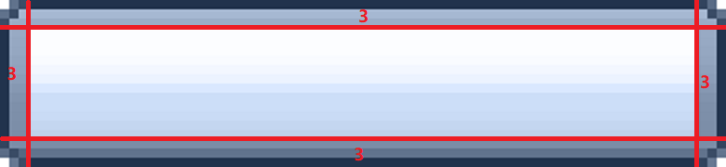
After stretching:
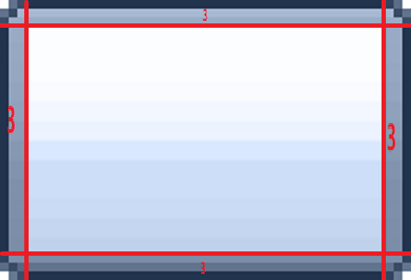
Native, in turn, provides two WPF components: Slice9Image and Slice9Button, designed specifically for nine-slice images.
In XAML, they can be used like this:
Namespace: xmlns:snt="clr-namespace:Sidebar;assembly=Native"
They can be used directly in XAML, for example:
<snt:Slice9Image Name="BackgroundImage1" Style="{DynamicResource BackgroundImageSlice9}"></snt:Slice9Image>

Slice9Image
Structure:
<UserControl x:Class="Sidebar.Slice9Image"
xmlns="http://schemas.microsoft.com/winfx/2006/xaml/presentation"
xmlns:x="http://schemas.microsoft.com/winfx/2006/xaml"
xmlns:mc="http://schemas.openxmlformats.org/markup-compatibility/2006"
xmlns:local="clr-namespace:Sidebar">
<Grid SnapsToDevicePixels="True" UseLayoutRounding="True" RenderOptions.BitmapScalingMode="NearestNeighbor">
<Grid.RowDefinitions>
<RowDefinition Name="SliceTop" Height="0"/>
<RowDefinition Height="*"/>
<RowDefinition Name="SliceBottom" Height="0"/>
</Grid.RowDefinitions>
<Grid.ColumnDefinitions>
<ColumnDefinition Name="SliceLeft" Width="0"/>
<ColumnDefinition Width="*"/>
<ColumnDefinition Name="SliceRight" Width="0"/>
</Grid.ColumnDefinitions>
<Image Name="ImageTopLeft" Grid.Row="0" Grid.Column="0" Stretch="None"/>
<Image Name="ImageTop" Grid.Row="0" Grid.Column="1" Stretch="Fill"/>
<Image Name="ImageTopRight" Grid.Row="0" Grid.Column="2" Stretch="None"/>
<Image Name="ImageLeft" Grid.Row="1" Grid.Column="0" Stretch="Fill"/>
<Image Name="ImageCenter" Grid.Row="1" Grid.Column="1" Stretch="Fill"/>
<Image Name="ImageRight" Grid.Row="1" Grid.Column="2" Stretch="Fill"/>
<Image Name="ImageBottomLeft" Grid.Row="2" Grid.Column="0" Stretch="None"/>
<Image Name="ImageBottom" Grid.Row="2" Grid.Column="1" Stretch="Fill"/>
<Image Name="ImageBottomRight" Grid.Row="2" Grid.Column="2" Stretch="None"/>
</Grid>
</UserControl>
Therefore, keep in mind that Slice9Image is a container that fills by default. Set its size according to your needs. Also, because it involves 9 Image elements, consider using the Visibility property to reduce rendering each time when Slice9Image has no image.
The following properties are custom properties of these components and can be used in both XAML and dynamic code.
Property Name | Type | Default Value | Purpose
Source | ImageSource | null | The image used for nine-slicing
SliceThickness | Thickness | Thickness (0) | Slicing margins, in the order left, top, right, bottom
ScalingMode | BitmapScalingMode |  | Sets the image scaling quality for each slice.
Example usage:
<Style x:Key="PreviewTileOrangeHoverImage" TargetType="snt:Slice9Image">
<Setter Property="Source" Value="{DynamicResource TileItemHoverImage}"></Setter>
<Setter Property="SliceThickness" Value="4"></Setter>
</Style>

Slice9Button
Slice9Button uses multiple Slice9Images and handles component states such as hover and pressed. Of course, it could also be implemented entirely with a Style + Slice9Image. Slice9Button supports animated fade transitions and image fallback (meaning that if there is no corresponding image, it falls back to the previous state; for example, if there is no pressed-state image, it falls back to the hover image, and failing that, to the focused image). However, only mouse and touch input events are supported.
Structure:
<UserControl x:Class="Sidebar.Slice9Button"
xmlns="http://schemas.microsoft.com/winfx/2006/xaml/presentation"
xmlns:x="http://schemas.microsoft.com/winfx/2006/xaml"
xmlns:mc="http://schemas.openxmlformats.org/markup-compatibility/2006"
xmlns:local="clr-namespace:Sidebar"
mc:Ignorable="d" Focusable="True" x:Name="RootElement" MouseEnter="UserControl_MouseEnter" MouseLeave="UserControl_MouseLeave" MouseLeftButtonDown="UserControl_MouseLeftButtonDown" MouseLeftButtonUp="UserControl_MouseLeftButtonUp" TouchEnter="UserControl_TouchEnter" TouchLeave="UserControl_TouchLeave" TouchUp="UserControl_TouchUp" TouchDown="UserControl_TouchDown" GotFocus="UserControl_GotFocus" LostFocus="UserControl_LostFocus">
<Border>
<Grid Background="Transparent">
<local:Slice9Image x:Name="ImageNormal"
Source="{Binding NormalSource, RelativeSource={RelativeSource AncestorType=local:Slice9Button}}"
SliceThickness="{Binding NormalSliceThickness, RelativeSource={RelativeSource AncestorType=local:Slice9Button}}"
ScalingMode="{Binding NormalScalingMode, RelativeSource={RelativeSource AncestorType=local:Slice9Button}}"
Opacity="1"/>
<local:Slice9Image x:Name="ImageFocus"
Source="{Binding FocusSource, RelativeSource={RelativeSource AncestorType=local:Slice9Button}}"
SliceThickness="{Binding FocusSliceThickness, RelativeSource={RelativeSource AncestorType=local:Slice9Button}}"
ScalingMode="{Binding FocusScalingMode, RelativeSource={RelativeSource AncestorType=local:Slice9Button}}"
Opacity="0"/>
<local:Slice9Image x:Name="ImageHover"
Source="{Binding HoverSource, RelativeSource={RelativeSource AncestorType=local:Slice9Button}}"
SliceThickness="{Binding HoverSliceThickness, RelativeSource={RelativeSource AncestorType=local:Slice9Button}}"
ScalingMode="{Binding HoverScalingMode, RelativeSource={RelativeSource AncestorType=local:Slice9Button}}"
Opacity="0"/>
<local:Slice9Image x:Name="ImageActive"
Source="{Binding ActiveSource, RelativeSource={RelativeSource AncestorType=local:Slice9Button}}"
SliceThickness="{Binding ActiveSliceThickness, RelativeSource={RelativeSource AncestorType=local:Slice9Button}}"
ScalingMode="{Binding ActiveScalingMode, RelativeSource={RelativeSource AncestorType=local:Slice9Button}}"
Opacity="0"/>
<local:Slice9Image x:Name="ImageDisabled"
Source="{Binding DisabledSource, RelativeSource={RelativeSource AncestorType=local:Slice9Button}}"
SliceThickness="{Binding DisabledSliceThickness, RelativeSource={RelativeSource AncestorType=local:Slice9Button}}"
ScalingMode="{Binding DisabledScalingMode, RelativeSource={RelativeSource AncestorType=local:Slice9Button}}"
Opacity="0"/>
<ContentPresenter Name="ContentRegion" HorizontalAlignment="Center" VerticalAlignment="Center" Content="{Binding Child,
RelativeSource={RelativeSource AncestorType=local:Slice9Button}}"></ContentPresenter>
</Grid>
</Border>
</UserControl>
The following properties are custom properties of these components and can be used in both XAML and dynamic code.
Property Name | Type | Default Value | Purpose
Click | RoutedEventHandler | null | Button click event
UseAnimation | bool | false | Uses animation; the animation is a fade (opacity change)
AnimationDuration | double | 0.2 | Animation duration in seconds; the default is 0.2 seconds
NormalSource | ImageSource | null | The button image displayed in the normal state
NormalSliceThickness | Thickness | Thickness (0) | Slicing margins set for the button image displayed in the normal state
NormalScalingMode | BitmapScalingMode |  | Image quality set for the button image displayed in the normal state
The prefixes for the hover, pressed, focused, and disabled states are Hover, Active, Focus, and Disabled respectively; the rest are basically the same. For example: HoverSource, ActiveSliceThickness, FocusScalingMode.
Child | object | null | Sets the button content to display, such as an element; this is highly flexible. Do not set the Content property; use the Child property instead.
Text | string | null | An alias for the Child property that represents the button's display text.
ExclusiveStateDisplay | bool | false | This property indicates whether images are displayed exclusively or stacked. If true, they are exclusive; otherwise they are stacked. Exclusive means only the needed image is displayed and the other images are invisible. Stacked means images are displayed in fallback order. For example, when transitioning from the normal state to the hover state, the exclusive method hides the normal-state image and shows the hover-state image, while the stacked method shows both. Stacking makes fallback easier to implement, but fallback is in fact already implemented with either method. However, if the images are translucent, stacking affects the result; or if rendering is a concern, set this property to true.
Example usage:
<Style x:Key="PreviewTileDarkItem" TargetType="snt:Slice9Button">
<Setter Property="HoverSource" Value="{DynamicResource TileIconItemHoverImage}"></Setter>
<Setter Property="HoverSliceThickness" Value="4"></Setter>
<Setter Property="ActiveSource" Value="{DynamicResource TileIconItemActiveImage}"></Setter>
<Setter Property="ActiveSliceThickness" Value="4"></Setter>
</Style>

Note
When using any type from Native.dll, make sure the project references that assembly (and the Newtonsoft.Json 13.0.4 dependency).

Potential Risk Statement
Except for the tiles bundled with the installer and produced by Whistler (Windows Modern), the security risks of other third-party tiles cannot be guaranteed. Third-party tiles are extension content independently produced and distributed by third-party developers or the community, who bear the relevant responsibilities themselves; they are unrelated to Whistler (Windows Modern) and its official team. Therefore, when downloading and using third-party tiles, please identify and check their safety, integrity, and availability, and avoid using dangerous or destructive third-party tiles. By using a third-party tile, you acknowledge and voluntarily accept the above risks.
The store bundled with the installer and its online store are only collection platforms for tiles voluntarily submitted and published by third-party developers. The store makes no express or implied warranty regarding the security, legality, or fitness for a particular purpose of tiles. Tiles are provided “as is”, and users should evaluate and bear the risks of use themselves. To the extent permitted by applicable law, the store is not liable for indirect or consequential losses caused by the use or inability to use tiles; content suspected of being illegal or infringing will be handled in accordance with the law. The copyright, trademarks, and other intellectual property rights of tiles belong to their respective publishers, and the store does not claim related rights.

November 10, 2026

