Multi-Source Emotion Tagging for Online News

Authors Name/s per 1st Affiliation (Author)
line 1 (of Affiliation): dept. name of organization
line 2-name of organization, acronyms acceptable
line 3-City, Country
line 4-e-mail address if desired
Authors Name/s per 2nd Affiliation (Author)
line 1 (of Affiliation): dept. name of organization
line 2-name of organization, acronyms acceptable
line 3-City, Country
line 4-e-mail address if desired

Abstract—With the rapid growth of social media and online news services, users nowadays can respond to online news by rating subjective emotions such as happiness or anger actively. Once the user ratings is surpasses a certain boundary, it begins to show up a tendency of what most people think and feel, which can help us understand the preferences and perspectives of most users, and help news providers to provide users with more positive news. Our paper tackles the task of emotion tagging for online news with multi-source including news article and comment, as emotion is not only tagged after reading news article, but also can be incorporated in comment with what they feel. In this paper, a novel classification model are proposed with two layer logistic regression. The new approach get outputs from basic classifiers and combine them in a new classifier, making a more accurate prediction when compared with a single source method. An extensive set of experimental results on a real dataset from a popular online news service demonstrate the effectiveness of the proposed approach.
Keywords—Sentiment Tagging; Online News; Multiple Source; Meta Classification;

Introduction
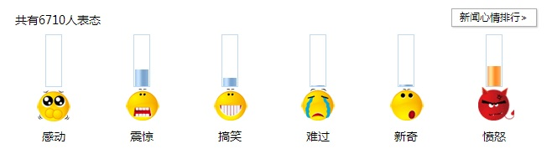
With the explosive growth of the Internet, a large number of social media have been produced and its influence continues to increase. Online news is an important form that attracts millions of users to read and express their feelings among kinds of social media. Users often express their subjective emotions such as sadness, surprise and happiness by rating emotion tags after reading news. Figure 1 shows an example emotion tagging from a popular Chinese news website (i.e. The Society Channel of Sina News).
Fig. 1. An Example of Emotion and User Ratings
It is a challenging research problem to do emotion tagging for online news automatically. Naturally, we classify news to each emotion tags based on the content of news article, as the news article is what they read and directly influences their emotion rating. What is more, an increasing number of social news websites provide comment service where users can share what they feel after reading news articles. Thus news comment provide another significant source for emotion tagging.
Sentiment classification model generally fall into two categories, generative models and discriminative models. As the second one has attractive theoretical properties, we adopt logistic regression as our basic method. Two basic classifiers are built to get the outputs of single source. Through utilizing the outputs of multiple sources including news article and comment, we propose a novel approach by two-layer prediction. Since different source has its own effect on emotion prediction in different situations, we match different source with different weighting parameters, making it more adaptable.
In addition, we provide an experiment on a real dataset after detailed analysis. In the experiment, we introduce the experimental environment and give the statistic data on dataset. Our proposed approach with multi-source are compared with basic approaches with single source in different size of dataset. Finally we verify the necessity of multi-source for emotion tagging and the effectiveness of the proposed model after experimenting on the dataset, society channel of Sina News .In particular, the proposed model has shown better performance on Sina dataset than baselines. The robustness of the proposed discriminative meta classification models is evaluated with different sizes of dataset.
The rest of the paper is organized as follows. In Section II, we review the state of the art on emotion tagging and make discussions regarding the difference between our work and previous work. In Section III, we propose our novel method with two layers. The experimental results are presented and discussed in Section IV. Conclusions and future work are given in the last section V.

Related Work
The Task of emotion tagging is to give an emotion label to texts. Early work in P. Ekman [1] defined six basic emotion labels: happiness, sadness, anger, fear, surprise and disgust, which laying a good foundation in some existing work on emotion tagging including (Liu et al., 2003) (Das and Bandyopadhyay, 2009, 2010; Aman and Szpakowicz, 2008). [2]– [5]. Specifically, Liu et al. [2] used an ensemble of rule-based affect models to classify sentences into six basic emotion labels. Another kind of methods based on supervised learning considering the problem as text categorization or analogous to topic classification (Alm et al., 2005) [6] has also gone a long way. Along the way of this kind of method, Das [3] and Bandyopadhyay [4] used Naive Bayes and Support Vector Machines based on some online dictionary. Aman and Szpakowics [5] proposed a method of building a dictionary derived from the Roget Thesaurus (Roget, 1852) [7].
In addition, Yang et al. [8] trained SVM model to investigate the emotion classification of web blog. Another work (Yang et al., 2007a) [9] used Yahoo Kimo Blog corpora to build emotion dictionary. By considering the relationships between words in a sentences, Neviarouskaya et al. [10] proposed a syntactical approach to recognition emotion automatically. Mishne and De Rijke [11] used several supervised and unsupervised machine learning techniques on blog data for comparative evaluation. Binali and Potdar [12] compared various text-based emotion detection techniques.
Moreover, Bao et al. [13] [14] proposed a topic model by augmenting latent Dirichlet allocation (LDA) with an intermediate layer for emotion modeling whose experiments were conducted on a dataset collected from the news website Sina. Lin et al. [15], [16] studied the classification of news articles into emotions that they invoke on their readers instead of the authors. On the other hand, people try to do emotion tagging for online news comments in (Zhang et al., 2012, 2014) [17] [18], which uses a fixed combination strategy to merge heterogeneous information sources. In this paper, we use a novel model with multi-source on a real-world dataset to evaluate the effectiveness of the proposed approach.

Multi-Source Emotion Tagging
In this section, a novel method named Multi-Source Emotion Tagging for online news is proposed based on combining multiple source’ results. We firstly define our research problem in section III-A. Then we apply basic logistic regression on news article and comment in section III-B and section III-C. Finally we propose the approach of two layers for the scenario combining multi-source prediction results to do a second prediction in section III-D.

Problem Definition
The problem setting of predicting emotions for online news is as follows. We have a collection of comment which are made by users after reading online news articles. All features in news article and comment are from, a word dictionary.
We also predefined emotion set 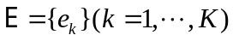 from which we select emotion for the news. The  news article 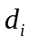 is associated with a user-generated comment combination over each emotion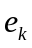. Each news article has an emotion rating variable 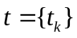 denotes how each emotion the reader expresses after reading news. As a result, 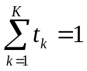.
We take the problem of emotion tagging into a multi-class classification that classifies news into different emotion tags. We adopt the nes article and its' own comment of online news to achieve the goal.

Emotion Tagging with News Article
Sentiment classification model generally fall into two categories, generative models and discriminative models. The second one has attractive theoretical properties. We adopt discriminative probabilistic models as a result of this. Formally, given the news article, we denote the conditional probability that the news will be tagged as a predefined emotion by a logistic regression as. The parametric form of can be expressed as follows in terms of soft-max function over a linear function of features,
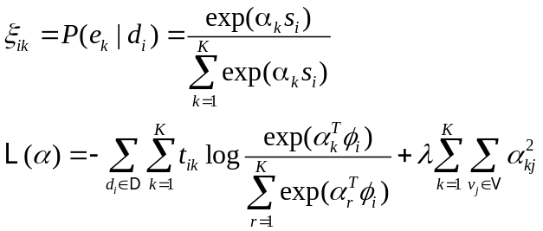
Here 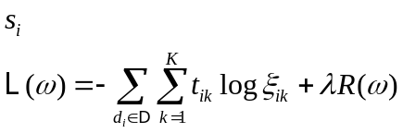 represents the feature vector of news, 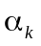 denotes the combination parameters for each term with emotion, and can be estimated by minimizing the loss function expressed as the following log-likelihood function with L2 (i.e., ridge) regularization,
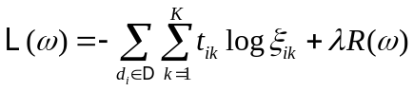
Here L2 regularization term can be written with the following notation,
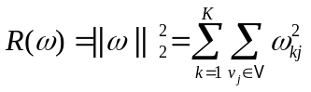
Finally, the loss function can be expressed as below,
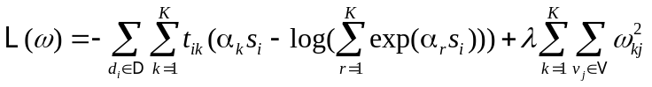

Emotion Tagging with Comment
Similar as section III-B, we describe the news comment emotion tagging in this section. In the news , we combine the top comment belonged to it together as. Also, it will be tagged as a predefined emotion as the news by the Equation 1, referred as.
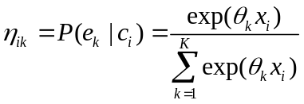
The combination parameters can be estimated by minimizing the following loss function with L2 (i.e., ridge) regularization in the training set.
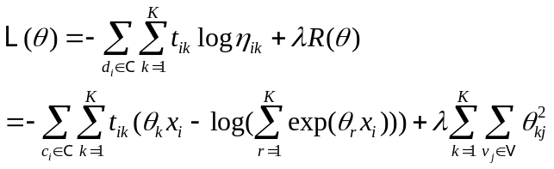
Here,  represents the feature vector of news comment and denotes the probability that the news comment will be tagged as an emotion

Multi-Source Emotion Tagging
As different information source can bring different insight on emotion tagging, our new proposed method named multi-source emotion tagging utilizing multiple source prediction result to gain more accurate result.
Firstly, we do single source emotion tagging train as section III-B and section III-C. Then we combine the two output predictions as a new feature vector, also adding a constant as bias. Let  denote the combined new features (i.e. 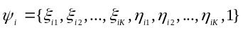), we train in the train set making a two-layer training approach. Formally, the probability that emotion will be assigned to the news can be estimated as below,
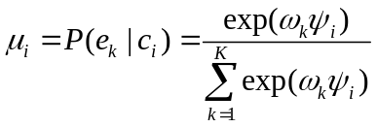
where  denote the combination parameters for the multiple source and extra bias. These parameters can be determined by maximizing the following loss function.
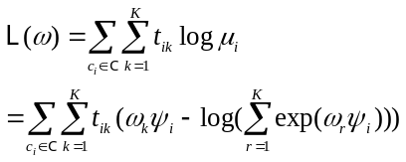
Here, 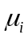denotes the probability that the news will be tagged as an emotion

Experiments
In this section, we firstly introduce our datasets. Then we describe experiments on real labeled data from the society channel of Sina website. Finally we compare the result on our method and single source baseline.

Datasets
Web crawler have downloaded most-viewed news article, its matching comment and its user rating from Society channel of Sina News, starting from 2014/5/1 and ending with 2015/5/1. Sina News is one of the largest news providers in China. Sina we have not find any user rating in English web service, we decide to use Sina dataset alone. However, our novel model is language is language independent.
Among all the data in Sina datasets, we set a threshold to the user rating (over 20) and take its top 20 comment. Finally, we get 6821 news and its matching comment and rating. TABLE I gives detailed statistics of the datasets.
TABLE I. THE STATISTICS OF LABELED NEWS ON SOCIETY CHANNEL
OF SINA NEWS
Emotion | Count | Proportion
Touched | 1281 | 18.78%
Shocked | 365 | 5.35%
Amused | 1519 | 22.27%
Sad | 940 | 13.78%
Surprised | 165 | 2.42%
Angry | 2551 | 37.40%

Text content like news article and comment are segmented to words by ICTCLAS and emotion words among them is chosen to be the terms as these terms are more likely to convey the emotions from users. In our text-based classifier, we utilize the emotion terms frequency in the content of documents as features.

Evaluation Metrics
We adopt two measures including Mean Reciprocal Rank () and Accuracy (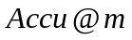) with a 10-fold cross validation.
1) Mean Reciprocal Rank ()
For a text , let 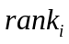 denote the position of its truth emotion in the predicted emotion ranking list , MRR of the collection will be expressed as
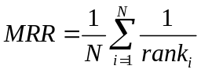
2) Accuracy ()
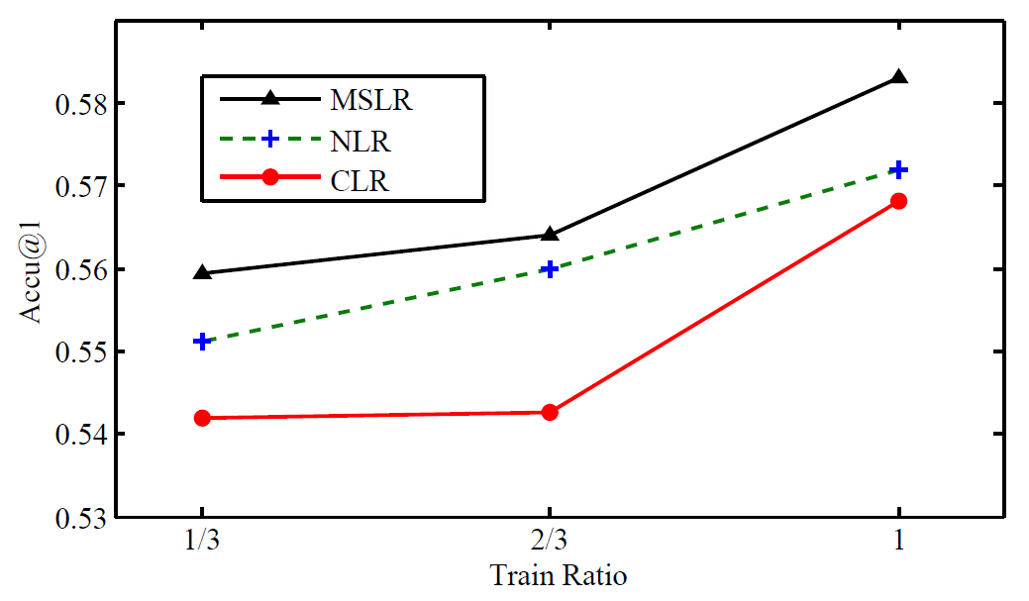
Given a text , its truth emotion and predicted emotion set 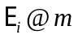 including m top ranked emotions, 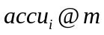 is defined as,
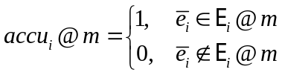
Thus, for the entire text collection is,

where  is the number of text in the dataset.

Experimental Methods
The following three methods are compared:
- Multi-Source Logistic Regression (MSLR)
This approach is proposed in Section III-D and based on a two level multi-source logistic regression.
- News Article Logistic Regression (NLR)
This approach is based on a news article logistic regression.
- Comment Logistic Regression (CLR)
This approach is based on a news comment logistic regression.

Experimental Results
Table 2 present the evaluation results in 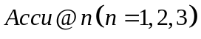 on each method. Through this table, our proposed method achieves the best result in.
TABLE II. THE SYMBOLS INDICATE STATISTICAL SIGNIFICANCE WITH P-VALUE < 0.001 WITH EACH MODEL IN COMPARISON TO NLR AND CLR RESPECTIVELY.

Method | Accu@1 | Accu@2 | Accu@3
MSLR | 0.5831 | 0.7738 | 0.8642
NLR | 0.5640 | 0.7518 | 0.8466
CLR | 0.5594 | 0.7433 | 0.8406

Experiment also explore the influence of data size to our proposed method and two baseline. 1/3, 2/3 and 3/3 of dataset have been selected randomly and repeated 100 times to observe the impact of dataset size.
The and  of the three models in different sizes dataset are plotted in Figure 2 and Figure 3 which shows more training data will bring more accurate prediction results to all models. In addition, NLR perform better than CLR and MSLR predict better than all baselines.
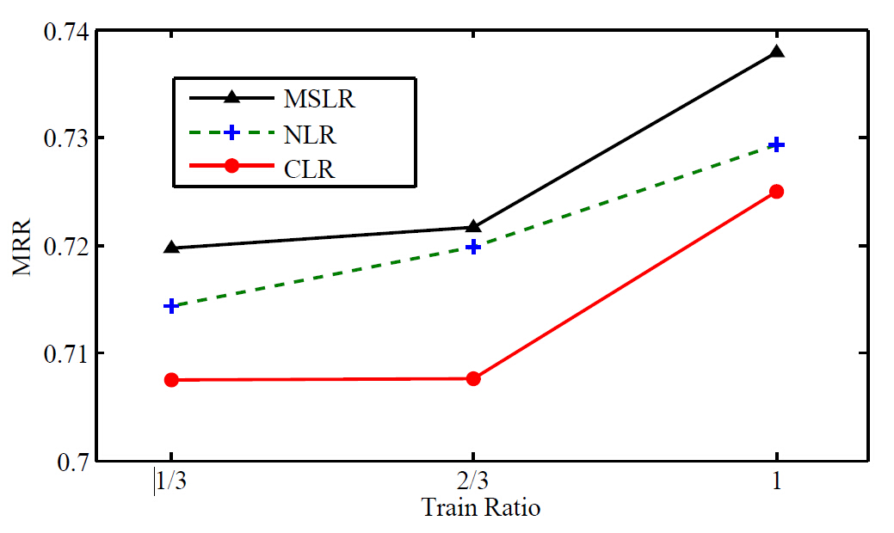
Fig. 2. The Accu@1 on three models in different sizes of Sina dataset

Fig. 3. The MRR on three models in different sizes of Sina dataset

CONCLUSION AND FUTURE WORK
The emergence of online news and social media has promoted the rapid evolution of global conversation. Emotion tagging is a new problem need to be solved. This paper focuses on emotion tagging for online news. We proposed meta classification models by treating emotion tagging for comment as a knowledge source combination problem. Our two-layer method has provided a convenient way to combine multi-source information in one model. An efficient learning algorithm based on Expectation and Maximization algorithm has been derived for parameter estimation. Thorough empirical experiments have been conducted on the Sina datasets to show the effectiveness of the proposed probabilistic models for predicting emotions for online news.
This work is an initial step towards a promising research direction. First of all, we plan to extend the work to the collection of social media. Various types of relational information may be available on social media, such as user social network, users tagging news, users voting for comment, and so on. The information can be utilized to improve emotion tagging and may lead to better personalization experience on social media. Moreover, it is worthwhile exploring the lexical structure of emotions, and integrating deeper semantic processing of the text into the meta classification methods.

Acknowledgment
The authors would like to thank the reviewers and the editors for their constructive suggestions.

References
- P. Ekman, “An argument for basic emotions,” Cognition & Emotion, vol. 6, no. 3-4, pp. 169–200, 1992.
- H. Liu, H. Lieberman, and T. Selker, “A model of textual affect sensing using real-world knowledge,” in Proceedings of the 8th international conference on Intelligent user interfaces. ACM, 2003, pp. 125–132.
- D. Das and S. Bandyopadhyay, “Word to sentence level emotion tagging for bengali blogs,” in ACL, 2009.
- D. Das and S. Bandyopadhyay, “Sentence level emotion tagging on blog and news corpora,” JIS, 2010.
- S. Aman and S. Szpakowicz, “Using roget’s thesaurus for fine-grained emotion recognition,” in Proceedings of the Third International Joint Conference on Natural Language Processing, 2008, pp. 296–302.
- C. Alm, D. Roth, and R. Sproat, “Emotions from text: machine learning for text-based emotion prediction,” in HLT/EMNLP, 2005.
- P. M. Roget, “Rogets thesaurus of english words and phrases,” Harlow, Essex, England: Longman Group Limited, 1852.
- C. Yang, K. Lin, and H. Chen, “Emotion classification using web blog corpora,” in Web Intelligence, IEEE/WIC/ACM International Conference on. Ieee, 2007, pp. 275–278. C. Yang, K. H.-Y. Lin, and H.-H. Chen, “Building emotion lexicon from weblog corpora,” in Proceedings of the 45th Annual Meeting of the ACL on Interactive Poster and Demonstration Sessions. Association
- for Computational Linguistics, 2007, pp. 133–136.
- A. Neviarouskaya, H. Prendinger, and M. Ishizuka, “Narrowing the social gap among people involved in global dialog: Automatic emotion detection in blog posts.” in ICWSM. Citeseer, 2007.
- G. Mishne and M. de Rijke, “Capturing global mood levels using blog posts.” in AAAI Spring Symposium: Computational Approaches to Analyzing Weblogs, 2006, pp. 145–152.
- H. Binali and V. Potdar, “Emotion detection state of the art,” in Proceedings of the CUBE International Information Technology Conference. ACM, 2012, pp. 501–507.
- S. Bao, S. Xu, L. Zhang, R. Yan, Z. Su, D. Han, and Y. Yu, “Joint emotion-topic modeling for social affective text mining,” in Data Mining, 2009. ICDM’09. Ninth IEEE International Conference on. Ieee, 2009, pp. 699–704.
- S. Bao, S. Xu, L. Zhang, R. Yan, Z. Su, D. Han, and Y. Yu, “Mining social emotions from affective text,” IEEE Transactions on Knowledge and Data Engineering, no. 99, pp. 1–1, 2011.
- K. Lin, C. Yang, and H. Chen, “What emotions do news articles trigger in their readers?” in Proceedings of the 30th annual international ACM SIGIR conference on Research and development in information retrieval. ACM, 2007, pp. 733–734.
- K. Lin, C. Yang, and H. Chen, “Emotion classification of online news articles from the reader’s perspective,” in Web Intelligence and Intelligent Agent Technology, 2008. WI-IAT’08. IEEE/WIC/ACM International Conference on, vol. 1.IEEE, 2008, pp. 220–226.
- Y. Zhang, Y. Fang, X. Quan, L. Dai, L. Si, and X. Yuan, “Emotion tagging for comments of online news by meta classification with heterogeneous information sources,” in Proceedings of the 35th international ACM SIGIR conference on Research and development in information retrieval. ACM, 2012, pp. 1059–1060.
- Y. Zhang, N. Zhang, L. Si, Y. Lu, Q. Wang, and X. Yuan. Cross-domain and cross-category emotion tagging for comments of online news. In The 37th International ACM SIGIR Conference on Research and Development in Information Retrieval, SIGIR '14, Gold Coast , QLD Australia - July 06 - 11, 2014, pages 627{636, 2014.

http://news.sina.com.cn/society/

